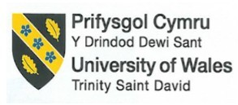

Assessment 1

Business Report - Comparison of Two Hospitality Organisations

Business Report – Comparison of Corinthia Hotels and Ibis Hotels

- Student ID number: 2133909
- Student name: Roxana Ionica Macarie
- The module title: Financial Management for the Hotel Industry
- Module code: BMIH5007
- Module Lead: Tristan Hawkins
- Word Count: 2149

Executive Summary
This report has compared two different hotels. In the case of revenue, they both ensured a rise over the periods in their total revenues. In comparison, Corinthia’s growth trends were quite steady. Marketing strategies are also different. Corinthia envisages a differentiation and IBIS follows a hybrid or low-price model according to Bowman’s Clock strategy. According to Ansoff's marketing strategy, Corinthia follows market development and IBIS focuses on implementing product development strategies. There are lots of market opportunities that can allow the business to grab the market. Besides, CSR activities and functions are also prominent in their business, as they have different ethical programs and goals.
Table of Contents
Introduction 4
1. Total Revenue: Analysis and comparison of the total revenue 5
2. Market Position: Assessing the market positioning of both hotel groups 7
3. Growth Potential: Evaluation of the growth potential of hotels 10
4. Financial Commitment to CSR: Analysis of the financial commitment of hotels’ CSR initiatives 11
Conclusion 12
Recommendation 12
References 13

Introduction
The hospitality sector is reliable in exploring service-based issues and the main intention of the business is to obtain 100% quality and efficiency in the business (Krebs, 2020). This report is going to envisage this hotel sector in the UK and for this, two divergent hotels including Corinthia Hotels and Ibis Hotels are going to be assessed. The main purpose will be to conduct an in-depth analysis that will focus on exploring various approaches to financial management, financial performance, and sustainability of hotels. For this purpose, total revenue, market position, growth potential, and financial commitments will be explored. That is why total revenue analysis will explore revenues, divergent sources of funds, and, growth trends; market analysis will represent Clock strategy growth potential and will highlight the possibility of expanding the business via Ansoff's marketing strategies; and CSR analysis will focus on exploring divergent sustainable issues that ensure social welfare and promote the brand reputation of businesses.

Total Revenue: Analysis and comparison of the total revenue
Revenue is a particular issue that is expected by each business and for this, businesses put their best efforts in terms of obtaining the ultimate objective which is to earn profit adding more economic value to the business (Rybkina, 2023). Hotel businesses need to focus on divergent issues in terms of maximizing their sales volume significantly. In table form, it looks like this:
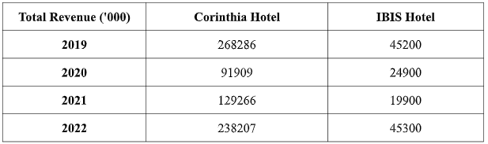
Source: (IBIS Hotel, 2024) and (Corinthia Group of Companies, 2023)
Both Corinthia and IBIS hotels generated revenues for themselves, though a noticeable divergence exists between their sales volume. In the financial year of 2022, the Sales (‘000) of Corinthia and IBIS hotels were €238,207 and €124,787 (Corinthia Group, 2024). The divergence between their sales is 113,420 euro meaning that the sales of Corinthia hotel were higher than IBIS hotel.
Both hotels’ operating profit before depreciation and fair value gains increased significantly. In this field, the operating profit of Corinthia Hotel is 51,706 in 2022 an increase of almost 1.5 times before (IBIS Hotel, 2024). On the other hand, IBIS experienced a slight rise in its operating profit, as its operating costs were high during 2022 and that is why its operating profit maximized significantly.
In the case of net profit, Corinthia experienced net losses in its financial year of 2022. On the other hand, IBIS Hotel skipped such losses in 2022, but in 2023, it also faced net losses.
Sources of revenue: Hotel services are the main source of revenue for hotels including Corinthia and IBIS hotels. From the annual reports, it is found that there are other comprehensive incomes in Corinthia Hotel including items that will not be subsequently reclassified to profit or loss, gross surplus arising on revaluation of hotel properties, deferred tax, currency translation, and so on ((IBIS Hotel, 2024)). In this case, deferred tax evolved from the divergences of currency translation. On the other hand, in IBIS’s financial report, there is a gross deficit arising on the revaluation of hotel properties, though it has also comprehensive income that includes deferred tax, translation reserve, and income tax relating to components of other comprehensive income.
Revenue trends: In the case of Corinthia, revenue has been following a trend that has been fluctuating over the periods, though its operational activities may incur divergent expenses or costs. Such as:
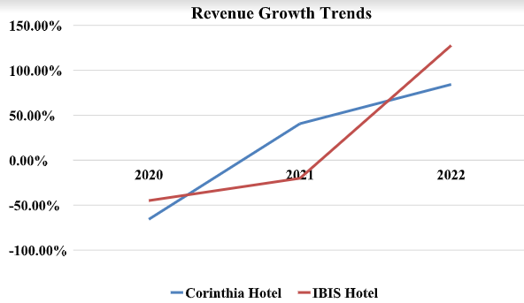
Source: (IBIS Hotel, 2024) and (Corinthia Group of Companies, 2023)
The trend of sales of Corinthia increased in 2021 significantly and continued in 2022, though it went up in 2023 again. In this case, the gap between 2022 and 2020 was quite noticeable and positive highlighting a well-efficient performance across the business. On the other hand, IBIS experienced a great fall from 2021 to 2022. It was found that the trend of sales of this hotel business did maintain a positive change (Davies, 2020); rather, the trend rose by a significant margin.
Factors driving the revenue growth or decline: In the case of Corinthia Hotel, high expenses due to depreciation, impairment loss, and other losses arising on property, plant, and equipment are the main reasons that affected the consequences of operating profit of this business. Besides, financial costs also increased which affected its profitability (Hyun & Cho, 2018). On the contrary, IBIS’s administrative costs increased significantly affecting its net profit. Even more, operating expenses and finance costs including interest expenses and similar charges were also significant factors that made the net profit decline.

Market Position: Assessing the market positioning of both hotel groups
Market share: Both hotels have their distinct market position. Corinthia has a great market reputation. In terms of exploring the online market, it has obtained almost 3,797 reviews and the rating is almost 5 out of 5. In the UK, it is ranked as the 13 best hotel, especially in London and England. Throughout Europe, it obtained 71 number positions. In the case of IBIS hotel, it raised awareness by 79%. Besides, it has gained 22% popularity and 13% usage (Kunst, 2023). However, its loyalty and buzz are quite low.
Customer demographics
Both Corinthia and IBIS have their distinct demographic segments. In this field, their target customers are also different. They are also differentiated in this field. Such as:
Corinthia Hotel focuses on customers who have a sense of and interest in 4 and 5-star hotel facilities. In this case, this business intends to explore the global market, but its special focus is on Europe (Corinthia Group of Companies, 2023). Unlike this hotel, IBIS hotel prioritizes the concept of grabbing the market gap and this is obtained by its consideration of customers’ psychographic and behavioral aspects.
IBIS Hotel is targeting both backpack and corporate customers; even, families are highly welcome at IBIS’s each branch (Davies, 2020). In this field, IBIS Hotel also intends to expand its branches across the world and that is why the number of rooms or accommodation keeps increasing.
Brand perception
To explore this issue appropriately, Bowman’s clock strategy is going to be envisaged because this can help identify divergent aspects and issues followed and implemented by such hotel businesses. It is such a kind of marketing strategy that aids in comprehending and comparing the relative strengths and weaknesses of divergent strategies (Rybkina, 2023). It looks like this includes several strategies:
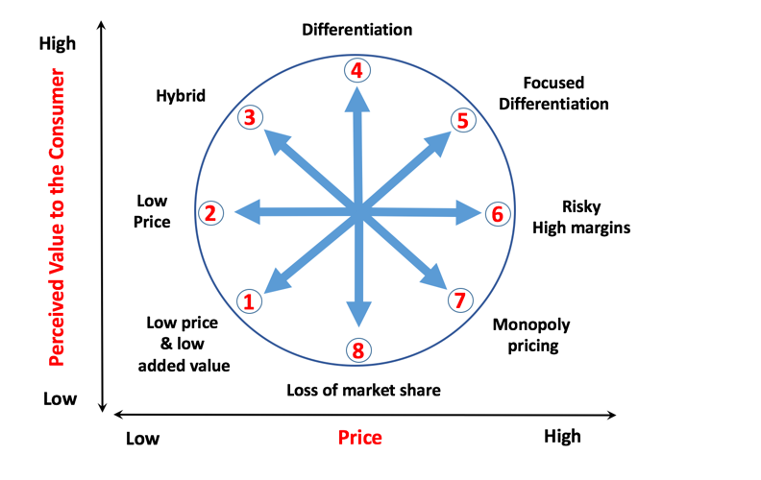
Figure 1: Bowman clockwise strategy
Source: (Kotler et al., 2022)
In this marketing theory and model, strategies are found clockwise. Such as:
Differentiation: From the aspects of Corinthia Hotel, it is found that this business indulges in following a yield and revenue management structure because it can support this hotel in tracking segment and sub-segment selling choices on room rates (Jayanti, 2023). The main purpose is to drive the highest room rates and high occupancy levels with assistance. Considering the market competition, it also concentrates on utilizing the latest technology in the business. That is why a hybrid business model is found throughout the hotel business. For example, IdeaS G3 is one of the most prominent technologies implemented that has started attracting potential customers for the business.
Low price: IBIS prioritizes being an economy-based hotel and for this, it indulges in offering customers an exclusive standard hotel. Besides, its economic pricing strategies support ensuring lower prices and generating higher sales volumes or large economic scale. That is why its entire strategies are broken down into several aspects (Rybkina, 2023). In the case of short-term strategy, it indulges in undercutting competitors and accelerating its market share.
Considering these strategies found in Bowman's lock-wise strategy, the demand curve and elasticity of Corinthia Hotel and IBIS hotel look like this:
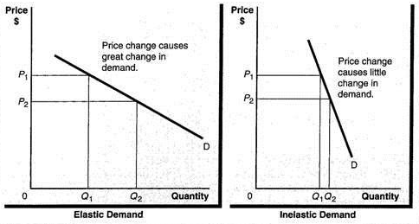
Figure 2: Demand and elasticity and inelasticity curve
Source: (Dransfield, 2014)

Growth Potential: Evaluation of the growth potential of hotels
Expansion strategies
To compare hotels’ strategies, Ansoff marketing mix is going to be applied. This marketing theory requires four different strategies that can impact targeting customers efficiently.
In the case of Corinthia Hotel, this business envisages both market development and penetration strategy (Marshall & Johnston, 2023). It mainly targets tourists, corporate events, and people who are fond of staying at a hotel flexibly. It intends to develop the market, though its initial strategies are based on market penetration exploring the concept of the existing market with existing products or services. Its market development strategies include the arrangement and management of a spa operated by Espa. Besides, it also lets the artist in residence be arranged in this hotel business.
Unlike this hotel, IBIS hotel mainly focuses on exploring the hotel sector, though it is now operated as a subsidiary hotel business as part of Accor Group. It also implements a market penetration strategy but it has gained popularity due to its quality services and efficiency in hotel services. As part of Accor, it mainly envisages the process of expanding the business continuously. Its uniqueness is found in serving the guests staying in the hotel. For instance, this business prioritizes a robotic system in the hotel premise that has made a painting based on the movements, sounds, and heat variations of the sleeper (Davies, 2020). Besides, the mobile app for all guests is also explored throughout the business. That means it emphasizes digitalization and technology-based operation and efficiency in the field of business.
Market opportunities: Corinthia focuses on expanding its branches throughout the world, especially across Europe. It has a great opportunity to grab the market in South and Southeast Asia regarding the population size in the market (Marshall & Johnston, 2023). IBIS Hotel can also follow this strategy, though it can explore the American and African markets efficiently. Besides, it also indulges in exploring digitalization, like robotic systems, and technological aspects throughout the business.
Potential barriers to growth: In the case of Corinthia Hotel, this business’s finance costs, and other operational costs have a significant effect on the business operation. Besides, it faces troubles due to the effect of Brexit and the rise of inflation (Rybkina,2023) that keeps fluctuating and impacting the currency rate of the business.

Financial Commitment to CSR: Analysis of the financial commitment of hotels’ CSR initiatives
Goals of their CSR activities: Corinthia’s CSR policy goals include divergent issues. Likewise, its CSR mainly contributes to sustainable development that includes safeguarding the well-being of its employees and the communities. In this field, it also envisages the expectations of all sorts of stakeholders including customers and employers (Sonuç, 2023). In addition, it also integrates its CSR throughout the organization and practices in its relationships with third parties.
On the other hand, IBIS aims to fight hunger and explore the sustainability of the business. This hotel explores the backbone of the entire ecosystem and major hindrances in operations. In this field, it focuses on strengthening the entire functions of hotel operations.
Community engagement: In this field, Corinthia Hotel prioritizes and tries to ensure an outstanding guest experience. As part of its sustainable business activities, it focuses on protecting the environment and its nature significantly (Rosenbaum, 2020). In this field, it also focuses on nurturing its colleagues and uplifting communities.
Unlike Corinthia, IBIS concentrates on the health and safety of people working in the business so that they can keep working significantly. In addition, it shows its accountability toward the people in society (Jayanti, 2023). Likewise, it mainly prioritizes the concept of its community engagement that supports reducing the effect of its business operation on the environment and showing respect, especially towards the society and ethical norms or behaviors of the business.
Ethical practices: Corinthia Hotel indulges in raising funds for the Sepsis Trust and this decision was undertaken after it started losing a colleague to septicemia in London (Rothschild, 2023). In addition, in Malta, this hotel has staged a Mother’s Day Gift Fair so that it can raise funds for the Beyond the Moon charity.
On the other hand, IBIS Hotel intends to its sustainable activities and for this, it focuses on monitoring and measuring energy and water consumption (Kunst, 2023).

Conclusion
This report has compared both hotels’ financial, marketing, operational, and CSR strategies. All issues of these hotels are interrelated to each other and aim to obtain the ultimate objective of the business. In the case of total revenue, Corinthia’s revenue has been rising, and IBIS’s revenue has been fluctuating, though their operational expenses have significant effects on the business operation. In addition, their marketing strategies are also different. Finally, their CSR activities have been compared. More or less their CSR strategies are quite similar where few divergences are found among their policies and strategies.

Recommendation
- Corinthia Hotel should find to expand its branches via the implementation of a market penetration strategy because Dransfield (2014) delineated that a hotel’s quality international services and exclusive brand image can aid in increasing profits and market shares in the global market.
- IBIS Hotel should focus on implementing a differentiation strategy through the utilization of digital and new technology systems. As a result, this can aid in exploring divergent and exclusive digital marketing strategies (Rybkina,2023).

References
Benhadda, L. and Chibili, M.N. (2022) ‘Managing change in the hospitality industry’, Modern Hotel Operations Management, pp. 508–565. doi:10.4324/9781003022329-15.
Corinthia-gb-development (2023) The corinthia standard, Corinthia. Available at: https://www.corinthia.com/en-gb/development/ (Accessed: 30 January 2024).
Corinthia Group (2024) Corinthia hotels: Luxury Hotels: Corinthia.com, Corinthia. Available at: https://www.corinthia.com/ (Accessed: 30 January 2024).
Corinthia Group of Companies (2023) 2022 annual report - Corinthia Group of Companies. Available at: https://www.corinthiagroup.com/wp-content/uploads/2023/06/37547-CORINTHIA-ANNUAL-REPORT-2022_WEB-min.pdf (Accessed: 30 January 2024).
Dransfield, R. (2014) Business economics. London: Routledge.
Davies, E. (2020) Ibis Hotels: Aggressive Direct Booking Marketing Strategy, LinkedIn. Available at: https://www.linkedin.com/pulse/ibis-hotels-aggressive-direct-booking-marketing-strategy-evan-davies (Accessed: 16 January 2024).
Ferrell, O.C. (2022) Marketing strategy. Florence: South-Western College Publishing.
Garrod, B. (2022) ‘Open review: An invitation to participate in tourism and hospitality’, Tourism and Hospitality, 3(1), pp. 161–163. doi:10.3390/tourhosp3010012.
Hyun, J. and Cho, H. (2018) ‘Deleveraging and decline in revenue‐expense matching over time’, Journal of Business Finance &amp; Accounting, 45(9–10), pp. 1031–1050. doi:10.1111/jbfa.12343.
IBIS Hotel (2023) Sustainability, Ibis Tallinn Center. Available at: https://www.ibistallinncenter.ee/sustainability/ (Accessed: 16 January 2024).
IBIS Hotel (2024) Book a cheap hotel with ibis – all our hotels, ibis.accor.com. Available at: https://ibis.accor.com/northamerica/index.en.shtml (Accessed: 30 January 2024).
IBIS-Accor (2024) Ibis Hotels - brand new ibis, Brand New Comfort: Accor, all.accor.com. Available at: https://all.accor.com/brands/ibis.en.shtml (Accessed: 30 January 2024).
Jayanti, J. (2023a) ‘Hotel Guest Rooms’, Hotel Housekeeping Management [Preprint]. doi:10.23912/9781911635543-5505.
Jayanti, J. (2023b) ‘Planning Housekeeping Operations’, Hotel Housekeeping Management [Preprint]. doi:10.23912/9781911635543-5500.
Kotler, P. author, Armstrong, G. author and Armstrong, P.K., and G. (2022) Principles of Marketing. 18th (Global). London: Pearson Education.
Krebs, R.A. (2020) Tourism and hospitality: Perspectives, opportunities and challenges. New York: Nova Science Publishers.
Kunst, A. (2023) Ibis Brand Profile UK 2022, Statista. Available at: https://www.statista.com/forecasts/1335566/ibis-hotels-brand-profile-in-the-uk#:~:text=Around%209%25%20of%20hotel%20customers,around%20Ibis%20in%20the%20UK? (Accessed: 16 January 2024).
Marshall, G.W. and Johnston, M.W. (2023) Marketing management. New York, NY: McGraw-Hill Education.
Rosenbaum, R. (2020) ‘Community engagement as collaborative inquiry’, Community Engagement Abroad, pp. 101–130. doi:10.14321/j.ctvthhcqg.10.
Rothschild, L. (2023) Council post: The rise of ethical and environmental certifications in business: How you can use them to build trust with customers, Forbes. Available at: https://www.forbes.com/sites/forbesbusinesscouncil/2023/07/03/the-rise-of-ethical-and-environmental-certifications-in-business-how-you-can-use-them-to-build-trust-with-customers/ (Accessed: 30 January 2024).
Rybkina, E.V. (2023) ‘Hotel business and problems of expanding the range of services provided’, Gostinichnoe delo (Hotel Business), (6), pp. 332–343. doi:10.33920/igt-2-2306-02.
Rybkina, E.V. (2023b) ‘Hotel Crisis Management’, Gostinichnoe delo (Hotel Business), (7), pp. 384–400. doi:10.33920/igt-2-2307-01.
Sharma, K.K. (2020) Tourism and hospitality. New Delhi: Sarup & Sons.
Sonuç, N. (2023) ‘Culture, tourism, and Sustainability (Cultural Heritage and sustainable tourism, social sustainability of tourism, socio-cultural sustainability of tourism)’, Encyclopedia of Sustainable Management, pp. 1083–1089. doi:10.1007/978-3-031-25984-5_457.
US News Portal (2023) Corinthia London Reviews & Prices | U.S. News Travel. Available at: https://travel.usnews.com/Hotels/review-Corinthia_Hotel_London-London-United_Kingdom-117986/ (Accessed: 16 January 2024).

