Introduction
The previous chapter has outlined the research methodology, this has followed on from the literature review which has highlighted there is a clear gap in the literature around objective 1:
An analysis of how effective police officers perceive their training to be in regards to mental health.
This chapter will present, analyse and interpret the primary research that has been conducted, with the primary goal of answering the above objective using the data gathered from questionnaires. The research will also attempt to gather the opinion of police officers to further answer the remaining two objectives
To critically analyse if it is the responsibility of the police and are they the correct service to deal with mental health emergencies.
Identify a better working model to ease pressure upon the police and other emergency services responding to mental health incidents.
Data Analysis
The raw data that has been collected will need to be analysed, the purpose of this is to bring meaning, structure and order to the data (Anfara et al., 2002), this will allow others to understand it. There will be distinct differences in the types of analysis used for the qualitative and quantitative data, this will allow for better interpretation and understanding of the reader.
Demographic and descriptive stats
A Questionnaire was completed by a target audience as described in the methodology, a blank copy of this questionnaire can be found in Appendix A. This questionnaire was distributed electronically achieving a total of 21 replies. Participants were firstly asked to confirm that they are working as a police constable in either Response, Criminal investigations department or Neighbourhood policing team. This is fundamental to the research because it ensures validity, which is the extent to which the concept is accurately measured and reliability, the consistency of the measurement (Heale and Twycross, 2015). Establishing reliability and validity will ensure the results are accurate ( Mohajan, 2017).
Training Frequency and Effectiveness
When analysing the results it is apparent that there is some disparity in the frequency that training is received, when asked “How frequently do you receive training to deal with mental health related incidents?” 76.2 % of participants reporting they have only received one singular training input, 19 % stating that they receive annual training and 4.8% half yearly (see figure 1). These findings show that training is not standardised, furthermore given the research shows a high majority of training is one singular training input, Scantlebury et al., (2017) study highlights this is inadequate thus casting doubt on the effectiveness of the training. Moreover this echoes the views of participants who when asked “Do you feel the mental health training you receive is adequate to deal with the incidents you face?” 57.1% strongly disagreed and 38.1% disagreed leaving 4.8% who did agree (see figure 2). Collectively over 95 % of participants do not feel that the training they receive is adequate to deal with the mental health incidents they face. These two findings demonstrate that not only is the training infrequent but also officers believe it to be ineffective.
What Works
Participants were asked “Of the mental health you’ve training you have received what do you think works well?” one theme that emerged strongly was that officers found their training around tactical communications and simply talking to the person in crisis worked well. Other officers explained that they felt having a good knowledge of their powers and the policies around mental health helped them. Similarly participants were asked “Of the mental health you’ve training you have received what doesn’t work so well?” In response to this question participants overwhelmingly stated that they felt training was poor and ineffective, one participant stated “I don’t feel I’ve received any effective training”. Some participants digressed into stating that the police should not be involved with mental health incidents at all.
Responsible service
When asked if they believed it to be the responsibility of the police to deal with mental health incidents 20 respondents 95.2% said it was not, with 1 respondent believing it is (see figure 3). This aligns with the publics belief who when surveyed only 2% believed it should be the responsibility of the police (HMICFRS, 2018). Respondents who answered stating it is not the responsibility of the police were further asked, who’s they believe the responsibility should be. All bar one responded by saying it is either the NHS, ambulance, crisis team or health service. Interestingly one person stated they believed there was no correct service as of yet and a new dedicated one should be formed to deal with the issues.
Mental health triage cars
It has been identified that various police forces have started to introduce mental health triage cars in an attempt to provide a better service and ease the strain on the police, as such participants were asked if they thought this was a better way to resource mental health incidents. 85.7% answered yes whereas 14.3% answered no (see figure 4). To follow this up participants were then asked why they think that, interestingly all who answered no did so on the basis that they believed this should not fall under the remit of a police officer, with 2 respondents also voicing safety concerns for the single crewed officer. The majority of the 85.7% who supported the idea did so because they believed it would provide a better service and allow persons direct access to mental health professionals.
Other alternatives
Participants were asked how else they would ease pressure on the police dealing with mental health incidents, two clear themes emerged from this broad question. Firstly participants believed that it should not be resourced by the police and at the first point of contact they should be signposted to the correct service, i.e. the crisis team. The next was that participants believed there should be some form of dedicated responding service which had appropriate powers to detain and if required take the person to a dedicated mental health setting.
Limitations
In the methodology it was stated that the questions in the questionnaire would be posed in a randomised order to avoid order bias as identified by Perreault (1975). This was not possible as certain questions were related, leading on from one another it would have be illogical to split them up, and this could have potentially confused the participants. It is also accepted that 21 responses is a small sample size and may not be generally reflective of the overall demographic, however the target audience was very specific and the results that were achieved unequivocal.
Conclusion
The research primarily set out to answer:
How effective police officers perceive their training to be in regards to mental health.
This has undoubtedly been achieved, there can be no ambiguity within the result as 95% of participants answering stating the training they receive is inadequate to deal with mental health incidents, furthermore the research has begun to highlight a possible cause of this may be due to a lack and infrequency of training. It has been highlighted that the participants strongly believe they are not the correct service to deal with mental health incidents and that this is the responsibility of various branches of the NHS. Participants on the whole have however shown a willingness, that they are ready to collaborate with other services in order to find a better working model, in particular they were receptive to the idea of a mental health triage car.

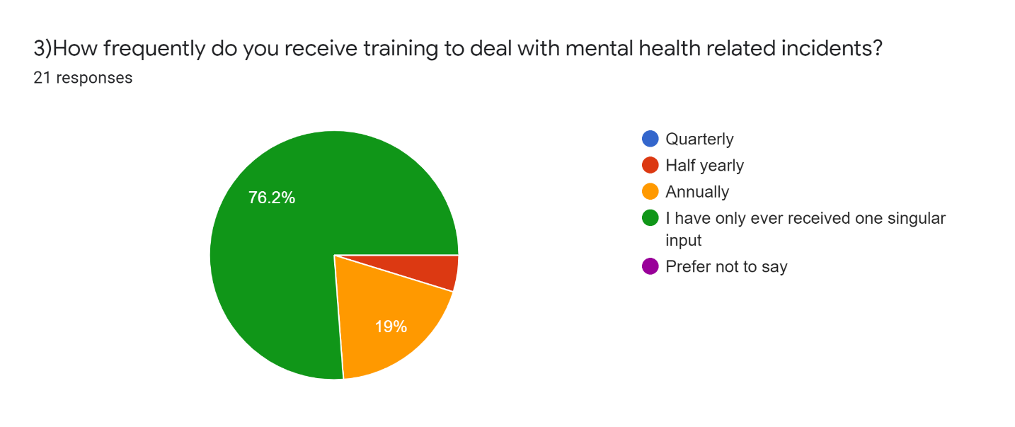
Figure 1

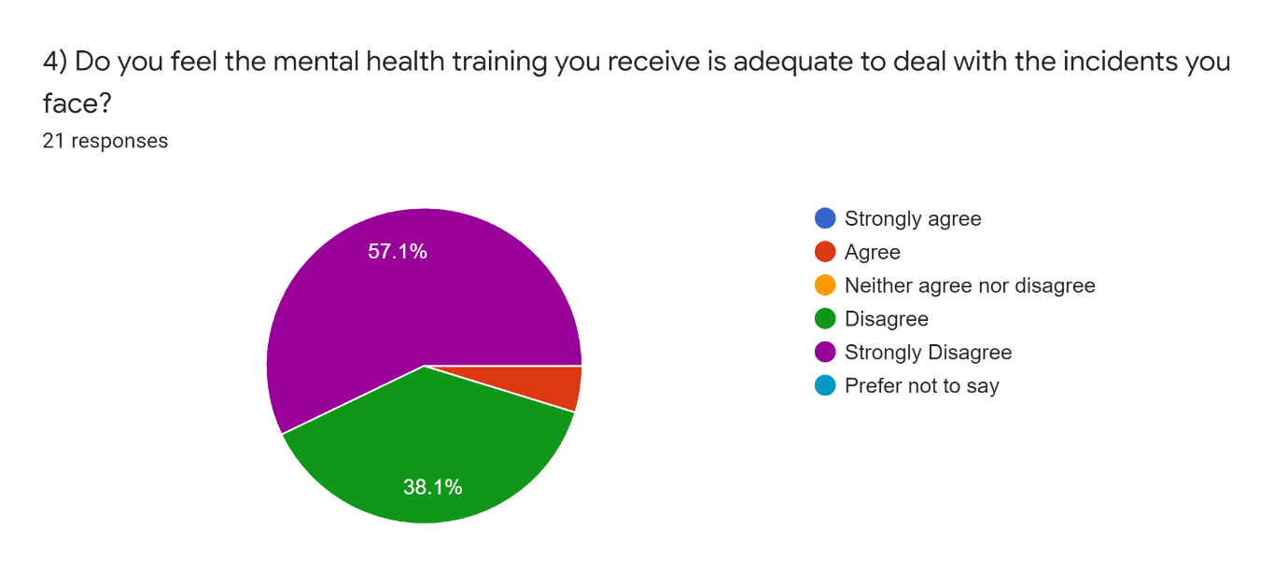
Figure 2
.
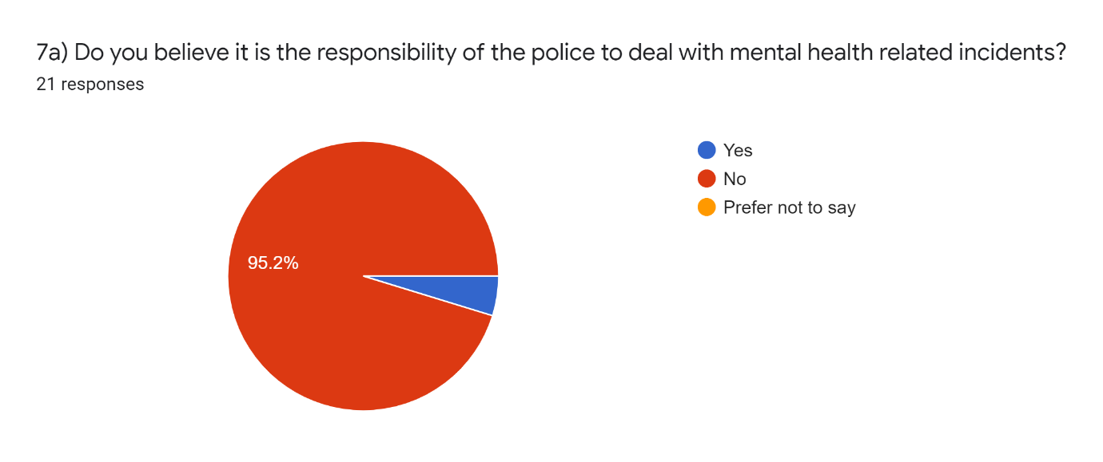
Figure 3

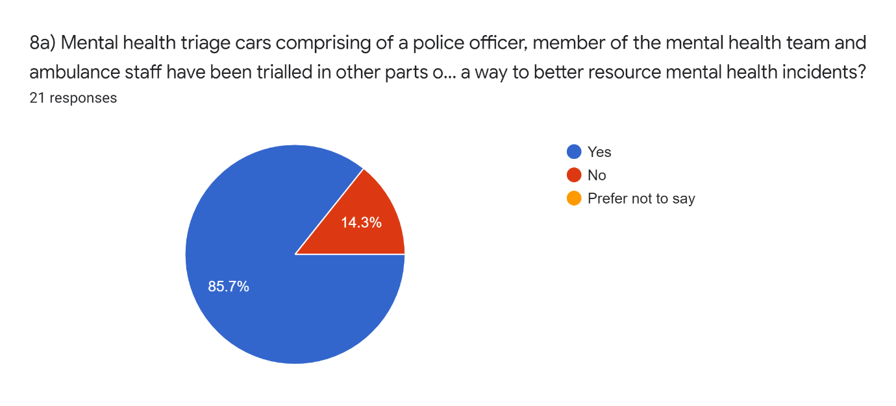
Figure 4

Bibliography
Anfara V, Brown K, Mangione T. (2002). Qualitative Analysis on Stage: Making the Research Process More Public. Educational Researcher. 31 (7), P28-38.
Heale R, Twycross A. (2015). Validity and Reliability in Quantitative Studies. Evidence Based Nursing. 18 (3), P66 - 67.
Her Majesty's Inspectorate of Constabulary and Fire & Rescue Services. (2018). Policing and Mental Health Picking Up the Pieces. Available: https://www.justiceinspectorates.gov.uk/hmicfrs/wp-content/uploads/policing-and-mental-health-picking-up-the-pieces.pdf. Last accessed 11th Jun 2021.
Mohajan, H. (2017). Two Criteria for Good Measurements in Research: Validity and Reliability. Annals of Spiru Haret University. 17 (4), P58 - 82.
Perreault, W. (1975). Controlling Order-Effect Bias. Public Opinion Quarterly. 39 (4), P544 - 551.
Scantlebury A, Fairhurst C, Booth A, McDaid C, Moran N, Parker A, Payne R, Scott W, Torgerson D, Webber M, Hewitt C., (2017). Effectiveness of a Training Program for Police Officers who come into Contact with People with Mental Health Problems: A Pragmatic Randomised Controlled Trial. Plos One. 12 (9)

