Reflective Review of Learning Journey

Daniela Adriana Muresan
Student no. 1816791
Profesional Career Development
BMSK4005_CARD
Table of Contents
1.Introduction 2
2.Learning styles 3
2.1 VARK learning styles 3
2.2 Peter Honey and Alan Mumford 4
3. Identifying personal goals. 5
3.1 SWOT Analysis 5
4.Identifying barriers to learning 6
4.1 PDP 7
5. Conclusion 7
6. References 8
7. Appendices. 9

1.Introduction

The purpose of this report is a reflection of my learning journey, it provides information about my personal development during the past five years, since I came in UK five years ago until now,currently I am a student at the University of Wales Trinity Saint David. This report identifies my future career development, using significant information learned throughapplying VARK Learning Style , HONEY and MUMFORD Learning Style Questionnaire, helpful understanding of my unique strenghts and weaknesses using SWOT analysis, how I can improve my effectiveness to achieve my goal to successfully graduate University of Wales Trinity Saint David.

2.Learning styles

This term refers to the fact that every person is different, every person has a different way to understand, learn, absorb and retain information. Kinaestethic is the most common learning style followed by visual, auditory and the last one is read and write.
Self awarenesspermits us to stand apart and examine even the way we ‘’see’’ ourselves- our self paradigm, the most indispensable paradigm of effectiveness. It influences not only our personal attitude and behaviour, but how we see other people.(Steven Covey, 1999, pg.66-67).

2.1 VARK learning styles

Information shoudn’t be just exposed, on the back board like it was in my previous school experience, it should be presented using images, slides, audio and body language to reflect the different way people learn.When I was in school, in my childhood, our teachers just wrote down on the black board our lesson, we had to listen very closely, had to be very quiet in class, but at UNI the courses are interactive, our lecturer makes the time we spend in the classroom very interesting.

Following completion of the VARK questionnaire (VARK, 1984), I discovered that my dominant preferred learning style is AUDITORY.
My VARK results were:
- Auditory - 7
- Visual - 2
- Read/Write- 2
- Kinaestethic- 3(FIG. 1)
Interestingly, the results surprised me because I had originally thought my preferred learning styes would be READ/WRITE, which presume traditional learning approach, learning through information as words, taking notes, doing lists, use dictionaries, however my results show that my dominant learing style is AUDITORY. I remember easily, reading verbal commands, information received, memorise easily if I discuss it, I understand and memorise better when the informations are passed on verbal way. It was in the past and it still is easy to learn new things in class. I can be easily distracted by the noises around me. Reading with aloud voice, talking about new information, theories and tasks make it easy to learn and understand, easily to remember what I said and what the others said, good memory of dates, explaining to others, mentoring, inducting new staff at work place, bringing arguments on how to do it. Also verbalised actions taken so I can go beyond learning, being necessary to explain and show it to me how it should be. As a consequence of learning this, I will record my courses on my phone to can listen in the car, in the bus, when I am traveling to and from university and work.
Auditory is a learning style, in other words it is the main way of learning is throught listening. In class i prefer to sit closer to lecturer to make sure I can hear and understand correctly what the lecturer wants to transmit to us. Aso it is important to take notes during the lecture, especially listen to important information passed on from the lecturer’s point of view. Furthermore, repeating to my colleagues or my friends the informations I found out during the class or reading a book, watching something on media improve my ability to remember those things. Also I like to listen what the others find out, ideas, opinions and what they’ve learned during the day or even during their life.
The place where I am more effective to learn is my house where is quiet and I can focus on my reading, because I can be easily distracted by the noises around me.

2.2 Peter Honey and Alan Mumford

Folowing completion of Learning Styles Questionaire(1986) developed by Peter Honey and Alan Mumford which is based upon David Kolb’s Learning Styles Cycle(1984), my results were:
- Pragmatists
- Theorists
- Activists
- Reflectors

Being a THEORIST/PRAGMATIST I ama person keen to try new ideas, to implement new theories in practise, to see if it is working and how. To see the benefits of application of new information, new theories, new equipment, attending trainings in my work. It is easy for me to adapt and integrate new ideas, observations into logically theories. I assimilate disparate facts, tend to analyse and synthetise until things are logically clear into my mind. I am essential practical, and I prefer to take practical decisions to solve problems.
Aditionally, I am capable of applying new techniques and new technologies in my work and study. Also I believe it is important to seize every opportunity to practice and apply what I learn, not merely into my work but for my self development as well.
I am opposite REFLECTORS who like to stand lower back and examine ponder ride from many perspectives, persons which are cautious, gather data, both first hand and from others, and decide on to assume about it,than coming to any conclusion. (FIG. 2)

3. Identifying personal goals.

It is essential to identify your personal goals because is the only way to achieve what you proposed, setting SMART goals to guide your life and career. Any goal can be achieved with hard work, implication, determination. My personal goal are learning how to apply references to improve the quality of my assignments, improve the quality of my assignments using academical language, read and review my work before submitt it, graduate UNI and apply for Senior Nursing Assistant or Deputy Manager.

3.1 SWOT Analysis

SWOT analysis is a strategic planningtechnique used to assist a person or business enterprise to discover strenghts, weakness, opportunities and threats. Strenghts and weakness are internally-related, opportunities and threats generally center the attention on the exterior environment.
- Strengths
-As a good team player. I apprehend my role clearly, embrace collaboration, commited to my team, flexible, likely to accept a team leader role if the opportunity occur, and confident enough to do the job and directing other members of the team.
- Weakness
-Lack of self-confidence, procrastinating, little computer skills
- Oportunity
-I have the opportunity offered by the Welsh Government to study to attain a degree, to develop my skills and knowledge.
- Threat
-Fear of failure and withdrawing from the course is the biggest threat which I face but studying towards to my degree make me learn more, seeking for informations and develop my skills.

4.Identifying barriers to learning

Dale Carnegie said: ‘’Success is getting what you want. Happiness is wanting what you get.’’ Five years ago I came in Cardiff with little luggage and speaking basic words in English. I applied for a job in health care sector. At the begining this was very hard because I did not have the skills and knowledge to do my job. I attend trainings to improve my work, I ask my friends and my colleagues to teach me new words, to explain the meaning of the words to be sure that I understand correct. Using daily the Romanian-English Dictionary and English-Romanian Translator helped me to improve my vocabulary.
Because of the barrier language I push myself to learn to read, write, understand, speak properly to be sure that everybody can understand me.I was scared, feel embarassed to talk with people because of my speaking, my accent, my lack of vocabulary.
Attending trainings in work, reading at home, watching television and listen other people speaking and with encouragement and help from my colleagues and friends I managed quickly to speak, read and write better, and I took my colleague advice to start to think in English not to translate word by word from my language. This has been a very successful strategie for me, I have began to use this at university to enhance my learning.

4.1 PDP

The trends of this century place us at the crossroads between the need to have time to relax and to develop personally, to be a good professional, to continue own specialisation, own development. Being the only one responsible of my career development I need constantly improve my knowledge and my skills.
Specific- achieve a merit in an assignment
Measurable- lecturer formal assesment feedback
Attainable- continue to commit to developing my Harvard referencing and academic skills.
Relevant – Reasonable and realistic to achieve
Time based- ongoing through year study until March 2020.
Good feedback at work, performing all tasks well, sharing my knowledge and experience with others as team leader, studying at University, to get the degree in business and management will help me to succesfully apply for a higher position at work as Senior Nurse Assistant or Deputy Manager.

5. Conclusion

Having a Certificate in Higher Education, improving the knowledge I have, I will be able to apply in practice to improve my work and personal skills, to advance my strenghts, using SWOT analysis, appying VARK, Honey and Mumford learning styles, setting SMART goals, gain business and management skills in order to being more confident, and most importantly apply myself to a higher position at work, as Senior Nursing Assistant or Deputy Manager.

6. References

Maund,A., Schriek,M., Tinckler,P.K., Certificate in Higher Education: Skills for the Workplace Student Year Book, SAGE, 2017
Peter Morgan, The Business Students Guide to Study and Management, SAGE, 2017
www.business dictionary.com
SWOT Analysis:Discover New Opportunities, Manage and Eliminate Threats, www.mindtools.com 1006.Retrieved 24 February 2018
Covey,S.R.,(1999)Seven Habits of Highly Effective People, pg.66-67
VARK QUESTIONNAIRE (1984)
Honey, P.,Mumford, A., Learning Styles Questionnaire(1986)
Kolb, D., Learning Styles Cycle(1984)
cmoe.com/blog/characteristics-great-team-player

7. Appendices.
FIG.1
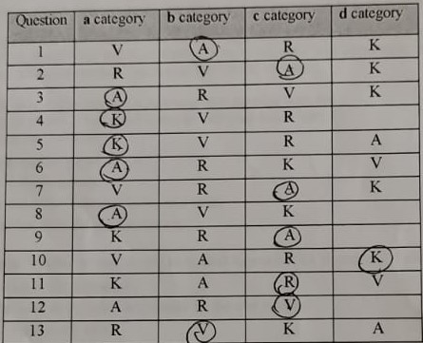

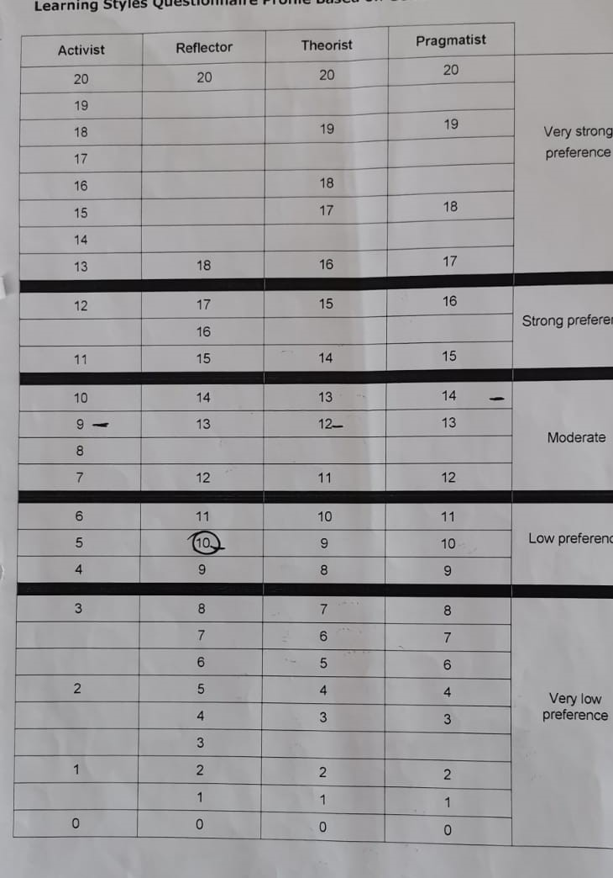
FIG. 2

