Systems Engineering – Fault Tree Analysis (FTA)

Author: Joseph S Rula (2317963)
University of Wales Trinity Saint David
Course Code: ACDA5021
Instructor: Mr Dave Holley
Due: 1500Hrs 20th April 2026

Contents
Table of Abbreviations 3
Table of Equations 3
Table of Figures 3
Table of Tables 3
Abstract 4
1.0 Introduction: 4
2.0 Foundations of a Fault Tree Analysis 4
2.1 High Level Faults – The System-Level 5
2.2 Low Level Faults – The Root Causes 5
3.0 Logic Gates 5
3.1 ‘AND’ Gates 5
3.2 ‘OR’ Gates 5
4.0 Evaluation of the Fault Tree Analysis 5
4.1 Fault Tree Analysis Assumptions 7
5.0 Probability Calculations 7
6.0 Human Factors: 10
6.1 Failure Caused Explicitly by Humans 10
6.2 Types of Human Error 10
6.3 Human Error Sources 10
7.0 Conclusion 11
8.0 References 11

Table of Abbreviations
Abbreviation | Description
FTA | Fault Tree Analysis
SE | Systems Engineering
D.P. | Decimal Places
HF | Human Factors
ICBM | Intercontinental Ballistic Missile

Table of Equations
Equation | Description
1 | ‘AND’ Gate Example Calculation
2 | ‘OR’’ Gate Example Calculation

Table of Figures
Figure | Description
1 | Fault Tree Analysis Provided for Producing Hot Beverage.
2 | Probabilities Assigned to the Fault Tree Analysis.
3 | Fault Tree Analysis Equations
4 | Fault Tree Analysis Equations
5 | Fault Tree Analysis Equations
6 | Fault Tree Analysis Equations
7 | Fault Tree Analysis Equations
8 | Fault Tree Analysis Equations
9 | Fault Tree Analysis Equations

Table of Tables
Table | Description
1 | ‘AND’ Gate Inputs versus Output.
2 | ‘OR’ Gate Inputs versus Output.
3 | Table of Calculated Event Probabilities
4 | Changes to performance with Human Factors.
5 | Calculated Event Probabilities after considering Human Factors.

Abstract
This report applies fault tree analyses, an analytical technique to a common task of preparing a hot beverage, in a manner to demonstrate how a system-level failure can be understood and avoided by recognising Boolean Logic relationships and pathways between basic-events. Probabilities, when assigned to basic-level events can be used to calculate probabilities of the system-level events succeeding, and how these probabilities are affected when human factors are taken into consideration. In specifics how when operator fatigue reduces the chance of success from 68% to 35%. Demonstrating the value of using a fault tree analysis to spot vulnerabilities and designate them for improvement, whilst recognising the interactions between mechanical and human components within the system.

1.0 Introduction:
A Fault Tree Analysis (FTA) is a structured analytical technique widely used within the Systems Engineering (SE) ecosystem to identify and evaluate the causes of system-level failures. Using a deductive top-down approach starting with the undesired top event, that of a system-level failure, and investigating the lower-level failures and their combinations through ‘AND’ and ‘OR’ logic relationships that would cause the system-level failure, this information can ultimately be used to more efficiently spend finite resources improving the resilience on specific high risk low-level failures to prevent system-level failures.
The FTA system was originally developed to troubleshoot minuteman intercontinental ballistic missiles (ICBM), in 1962 by Bell Labs [1]. An important development as the testing of the system to find system-level failures could have disastrous consequences.
In this report, the FTA technique is applied to the preparation of a hot beverage. The fault tree’s structure is pre-defined in terms of hierarchy and logic relationships. Only the basic failure event probabilities are defined whilst the combined probabilities for intermediate and top-level events must be calculated. The influence of human factors will also be considered, in the case of operator fatigue increasing the probability of some failures, influencing the larger system-level failures.[3]

2.0 Foundations of a Fault Tree Analysis
A Fault Tree Analysis is named after a tree due to its branching paths trickling back to a single point, the top-level system. These branches highlight the relationships between the lower-level and higher-level faults in each tier. These branches are connected via logic gates, and express when lower-level become severe enough for the fault to be expressed in a higher-level.

2.1 High Level Faults – The System-Level
The highest-level fault is the system-level failure. The entire purpose of the system has failed, and the only outcomes are unwanted. For the example used in this report, this is the complete lack of a potable, hot cup of tea.

2.2 Low Level Faults – The Root Causes
The lowest-level fault is the basic level root cause which cannot be further subdivided. As an example, used in this report, there is no tea in which to make a cup of tea.

3.0 Logic Gates
There are several types of Logic Gates coming from Boolean Theory, the same theory used with circuitry and wiring expressed through mathematical equations for success or failure pathways. [4]
In Boolean theory, the variables can only have two possible values, true and false. Expressed as either 1, true or 0, false.
The two gates used in the above FTA are the ‘AND’ gate and the ‘OR’ gate.

3.1 ‘AND’ Gates
An ‘AND’ Gate require all lower event inputs to be simultaneously at 1 for an output to be given to the higher event.
Input A | Input B | Output
0 | 0 | 0
0 | 1 | 0
1 | 0 | 0
1 | 1 | 1
Table 1 - 'AND' Gate Inputs versus Output.

3.2 ‘OR’ Gates
An ‘OR’ Gate only requires at least lower event input to be inputted at 1 for an output to be given to the higher event. A standard ‘OR’ gate will give an output of 1 if both inputs are 1 Where another type of ‘OR’ gate, which is not used in this assignment will output a 0.
Input A | Input B | Output
0 | 0 | 0
0 | 1 | 1
1 | 0 | 1
1 | 1 | Dependant
Table 2 - 'OR' Gate Inputs versus Output.

4.0 Evaluation of the Fault Tree Analysis

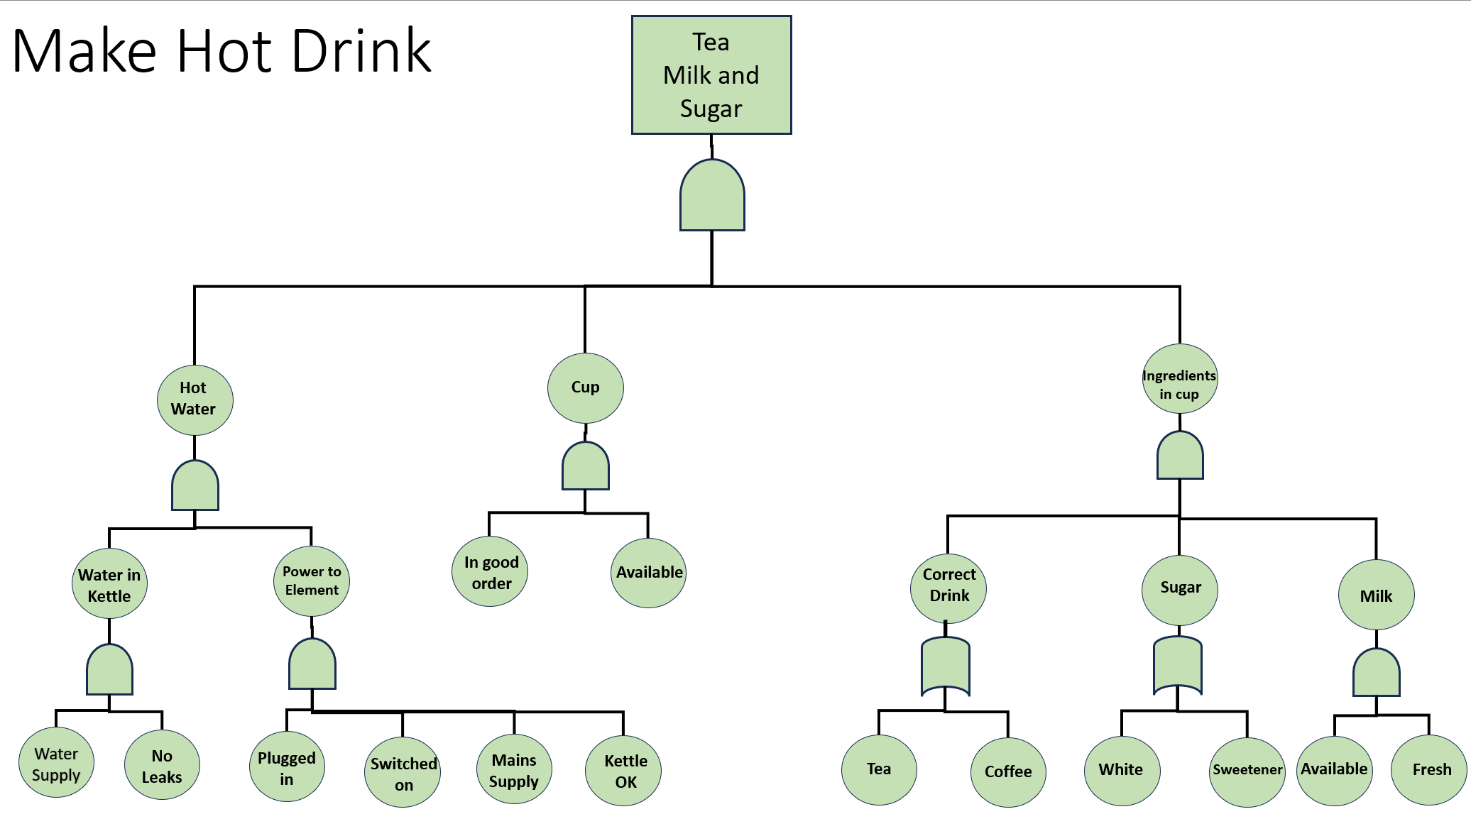
Figure 1 - Fault Tree Analysis Provided for Producing Hot Beverage.
The fault tree provided details how the failure events interact with each other, showing the relationship between them with either an ‘AND’ gate or an ‘OR’ gate where appropriate.
Where an ‘AND’ gate is used the probability of output is when both inputs simultaneously occur, this is calculated as the product of all the input probabilities.
Where an ‘OR’ gate is used the probability of output is calculated via the complement rule preventing the double calculation of overlapping probability.
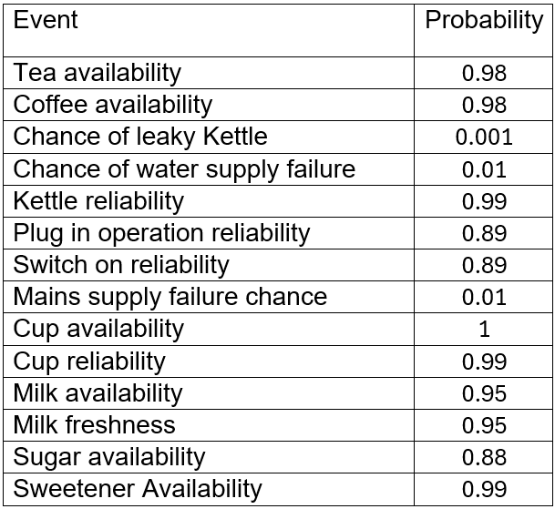
Figure 2 - Probabilities assigned to the Fault Tree Analysis

4.1 Fault Tree Analysis Assumptions
Fault Tree Analyses rely on several simplifications, the most significant is that all low-level events are always statistically independent from one another, and that the outcome of one event has no relation on the outcome of another event, this is done for ease of calculations, but this is often not reflected. In this scenario, “milk availability” and “milk freshness” are treated as statistically independent events. Whereas these two events are directly related, milk cannot be fresh if it is not available.
These assumptions are made to reduce the complexity of the top-level failure and to highlight failure paths allowing for easier troubleshooting. Although independence between basic-level events is not always true in practice, it simplifies the fault tree analysis calculations.
Regardless of this the ‘AND’ gate ensures that both events must be met for a failure to occur.

5.0 Probability Calculations
‘AND’ and ‘OR’ gates relations are calculated differently. An ‘AND’ gate multiplies the probability of all its lower-level faults together. Whereas an ‘OR’ gate uses the Compliment Rule. When an ‘OR’ gate outputs a value of 1, the probability of the event that occurred is equal to the probability of the other event that did not occur.
‘AND’ Gate example:
$$p(hot water ≡p\left(water in kettle\right)*p(power to element)$$
Equation 1 - 'AND' Gate Example Calculation
‘OR’ Gate example using Compliment Rule:
$$p\left(correct drink\right)≡1-\left(\left( 1-P\left(Tea\right)\right)*\left( 1-P\left(Coffee\right)\right)\right)$$
Equation 2 - 'OR' Gate Example Calculation
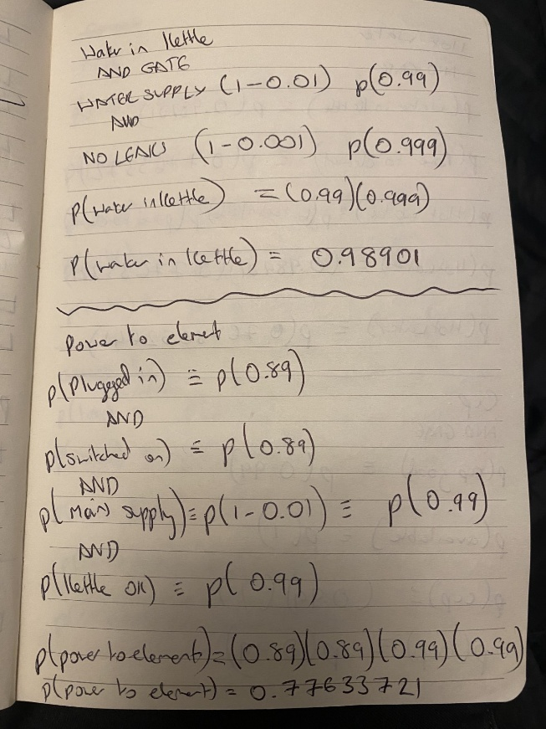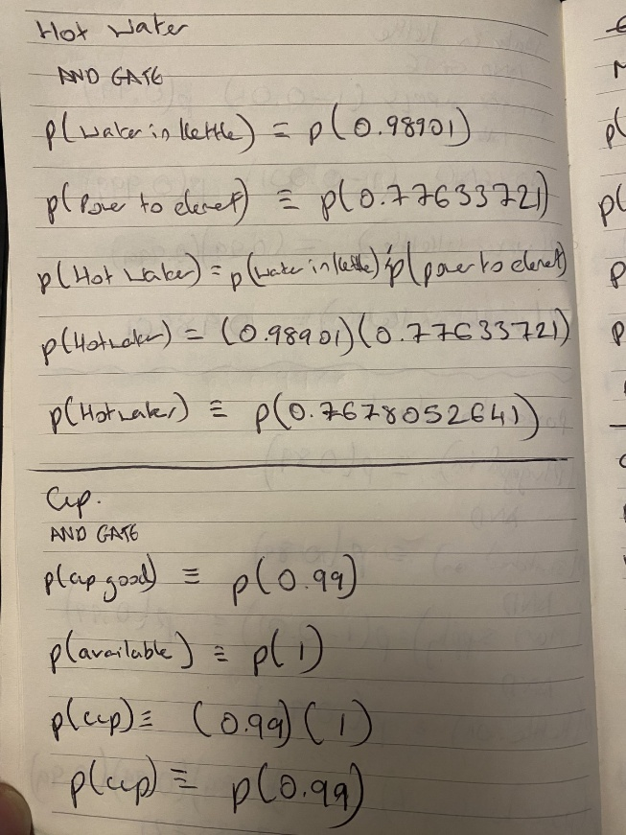
Figure 3 & 4 - Fault Tree Analysis Calculations
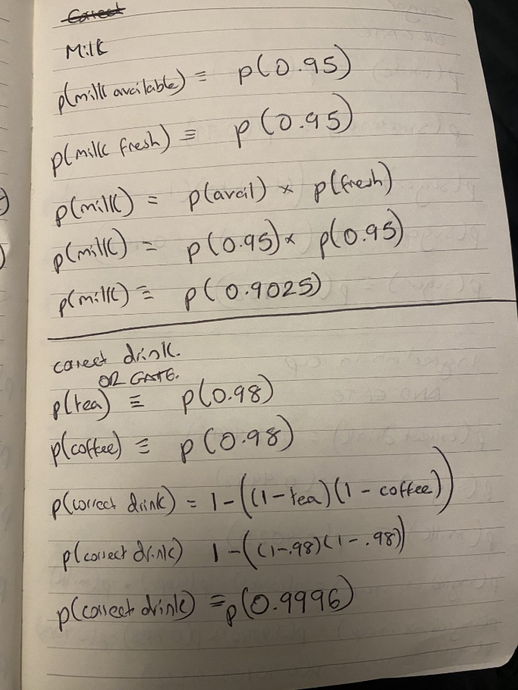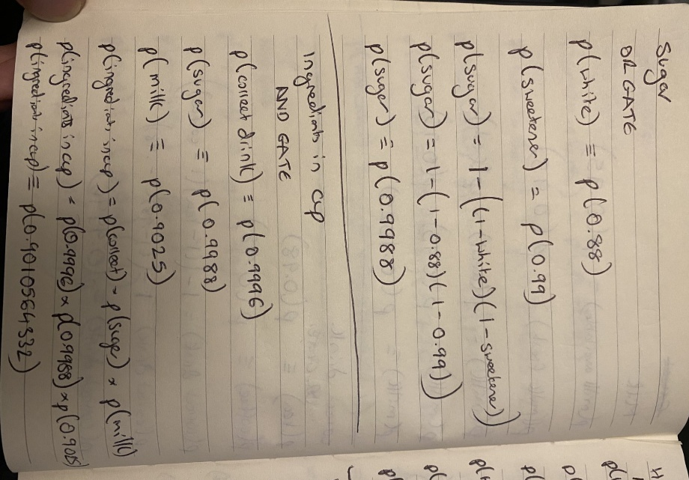
Figure 5 & 6 – Fault Tree Analysis Calculations
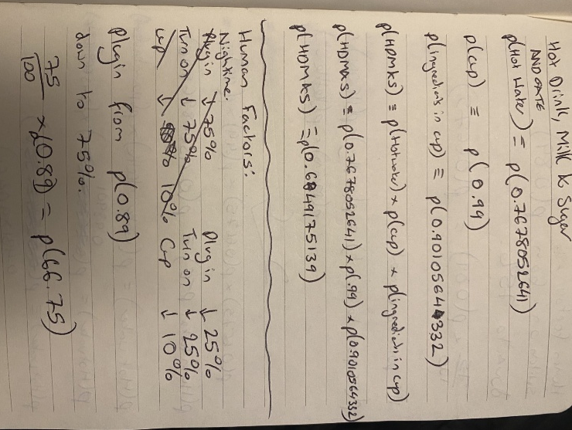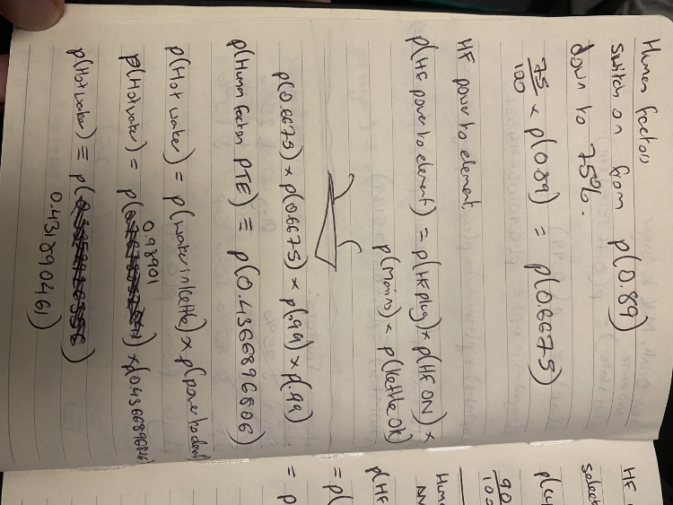
Figure 7 & 8 – Fault Tree Analysis Calculations
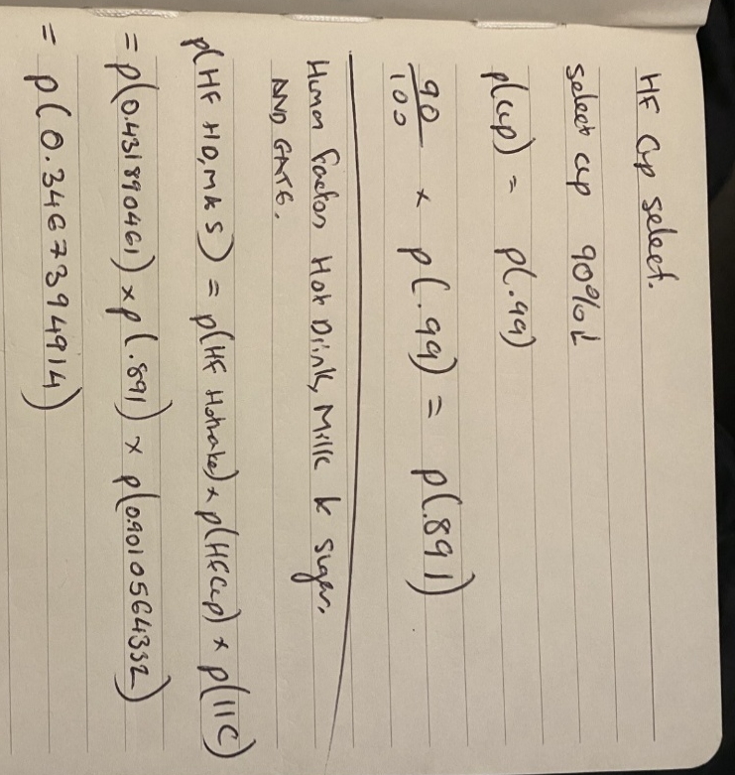
Figure 9 - Fault Tree Analysis Calculations
Event Probabilities |  | Rounded to 2 d.p.
P(Water in Kettle) | 0.98901 | 0.99
P(Power to Element) | 0.77633721 | 0.78
P(Hot Water) | 0.7678052641 | 0.77
P(Cup) | 0.99 | 0.99
P(Milk) | 0.9025 | 0.90
P(Correct Drink) | 0.9996 | 1.00
P(Sugar) | 0.9988 | 1.00
P(Ingredients In Cup) | 0.9010564332 | 0.90
P(Hot Drink, Milk & Sugar) | 0.6849175139 | 0.68
Table 3 - Table of Calculated Event Probabilities
This data shows that Bill has a 68% probability of successfully making a hot beverage; and the event probability that has the highest likelihood of causing the system failure is “Power to Element” a product of its lesser tier of events, “Plugged In” and “Switched On”. This pathway of failure is expressed up the fault tree analysis as Lack of “Hot Water” is the event with the highest probability of preventing Bill from making a beverage.

6.0 Human Factors:

6.1 Failure Caused Explicitly by Humans
Any system that involved humans, will be subjected to failure caused by human making mistakes, this is known as human error. In the example above, Bill making a hot drink is heavily reliant on a human, himself, in the chain. As a result, most areas of this fault tree are subject to human error.

6.2 Types of Human Error
There are four main types of human error: slips, lapses and mistakes, and then also violations. [2]
Slips and Lapses are most common, as they include incidentally performing an adjacent task instead of the correct task, e.g. making a coffee instead of tea, and forgetting to do a part of a task, e.g. add sugar to the beverage. These occur on tasks where the operator is familiar with the process.
Mistakes are actions believed to be correct by an unfamiliar operator. Such as cutting open a teabag with scissors to then pour into the cup.
Violations differ from the previous as they are intentional, sometimes malicious but most commonly employed as workarounds or shortcuts. Regardless a deliberate action that is incorrect, often with the best intentions. An example would be placing a cup of water into the microwave to boil, instead of using the kettle described in the fault tree diagram.

6.3 Human Error Sources
Human error has many sources though the one highlighted is fatigue. In the example Bill is attempting to make a hot beverage at night, he is fatigued, as the task is not strenuous, mental fatigue is the bigger concern over physical fatigue.
Bill’s fatigue has been calculated to drop his ability to perform the following tasks.
Event Probabilities | Original Probability | Performance Dropped To | New Probability
P(Plug In Kettle) | P(0.89) | 75% | P(0.6675)
P(Switch On Kettle) | P(0.89) | 75% | P(0.6675)
P(Cup Select) | P(0.99) | 90% | P(0.891)
Table 4 - Changes to performance with Human Factors.
When recalculated with the human factors (HF) we get the following new probabilities.
Event Probabilities |  | Rounded to 2 d.p
P(HF Plug In) | 0.6675 | 0.67
P(HF Switch On) | 0.6675 | 0.67
P(HF Cup Select) | 0.891 | 0.89
P(HF Power to Element) | 0.4366896806 | 0.44
P(HF Hot Water) | 0.431890461 | 0.43
P(HF Hot Drink, Milk & Sugar) | 0.3467394914 | 0.35
Table 5 - Calculated Event Probabilities after considering Human Factors.
When considering HF, Bill’s probability to successfully make his hot beverage has dropped to just 35%, whereas before consulting HF the probability was 68%, a 33% decrease. This change is significant and shows the importance of considering HF as it relates to FTAs to get accurate data.

7.0 Conclusion
The FTA framework, by breaking down system-level failures into simple, clear and structured relationships shows potential pit falls that cause failure and prevent a successful outcome, in this case a hot beverage, from occurring. Even with this simple scenario, the FTA shows how planning and awareness of relationships between factors can be planned around or prevented to ensure the desired results. [1]

8.0 References
[1] B. E. Goldberg, K. Everhart, R. Stevens, N. Babbitt, P. Clemens, and L. Stout, “System engineering toolbox for design-oriented engineers,” ntrs.nasa.gov, vol. 1, Dec. 1994, Available: https://ntrs.nasa.gov/citations/19950012517
[2] Health and Safety Executive, “Human factors/ergonomics – Managing human failures,” Hse.gov.uk, 2025. https://www.hse.gov.uk/humanfactors/topics/humanfail.htm
[3] “A Comprehensive Guide to Fault Tree Analysis for Maintenance,” eMaint, Aug. 27, 2025. https://www.emaint.com/blog/fault-tree-analysis/ (accessed Apr. 19, 2026).
[4] “Boolean Algebra Truth Tables for Logic Gate Functions,” Basic Electronics Tutorials, Mar. 05, 2019. https://www.electronics-tutorials.ws/boolean/bool_7.html

