

MSc Logistics

Research Methods (M7X01272)
Assignment 2: Data Analysis

Student: Alex Asafo-Adjei (P113369)
Lecturer: Graham Orr

Contents Page
1 Introduction………………………………………………………………………………………..3
1.1 Data Cleansing…………………………………………………………………………………3
1.2 Sorting and Deleting 98/99 – nil responses…………………………………………………3
1.3 Reverse coding of Questions…………………………………………………………………3
1.4 Variable Relevance…………………………………………………………………………….4
2.1 Valid Data Analysis – Frequencies…………………………………………………………..4
2.2 Assumption of Normalcy………………………………………………………………………5
2.3 Reliability Test - Cronbach’s Alpha…………………………………………………………..8
2.4 Cross Tabs and Chi Square Tests…………………………………………………………...9
2.5 Focus on Non-Residents Cross Tab…………………………………………………………10
2.6 Correlation………………………………………………………………………………………13
3 Questionnaire Critique…………………………………………………………………………...13
3 Conclusion………………………………………………………………………………………...15
References……………………………………………………………………………………….....16
Appendices………………………………………………………………………………………….17

Introduction
Data analysis is the process of evaluating data using analytical and logical reasoning to examine each component of the data provided (Businessdictionary.com).
It also involves the process of reviewing, purging, transforming, and modelling data which can then be used in deducing informed results in decision making.
Data analysis is one of the many stages involved in conducting a research experiment. Data from several sources are collected, reviewed, and subsequently analysed to generate a sort of conclusion or finding.

1.1 Data Cleansing
Data cleaning is the process of preparing input data for analysis. This process is done in order to fully prepare for analysis. Erroneous data left in SPSS or any data analysis application could lead to a misleading result from a survey analysis. The following describes the types of data cleansing that was conducted on this data set.
ID Deletion – Line one of the Variable view named ID was deleted due to irrelevance to the data survey and data analysis.
Besides, the series was inaccurately presented as the numbers did not correspond to line numbers.

1.2 Sorting and Deleting 98/99 – nil responses:
For variables in Q.1, Q3, Q20 and Q21 were sorted in descending order. Responses with 88 or 99 shown in these questions were deleted since they meant nil response and presents erroneous results during analysis.

1.3 Reverse coding of Questions:
Coding is a process of assigning a code, typically a number to each possible response in a questionnaire. The coding process may adopt the Likert scale technique.
Reverse coding is employed in a data set when there is a mixture of negatively and positively worded questions in a questionnaire that need aligning to a concurrent response pattern. Reverse coded variables are those that have a reverse interpretation on the Likert Scale compared to other similar variables on the measure. This procedure must be conducted prior to data analysis. The coding in the following questions were reverse coded as explained below.
Q4.15 – This question was grouped as part of questions 4.7-4.11 and it became clear that the coding contradicts the responses offered for this group.
A reverse coding was then applied to bring it in sync.
Reverse codes: 1-5, 2-4, 3-3, 4-2, 5-1 were applied.
Q4.17 – Same as in the case of Q4.15, this question was grouped as part of questions 4.12-4.14 and it was realised that the coding contradicts the responses offered as well.
A reverse coding was then applied to bring it in sync.

1.4 Variable Relevance
Some variables in the data collected had no significance to the study. For example, labels 1.9 (Visit once in 5 years) and 1.8 (Visit couple times in 5 years) showed no relevance to the survey due to the duration between visits.
Also, the variable ‘WalkGen’ was deleted since it doesn’t appear on the original questionnaire.

2 Descriptive Statistics
2.1 Valid Data Analysis – Frequencies
In a validity analysis, a test of the data is done using Frequencies.
A validity test of the Gender of respondents shown in Appendix 1 presented 33 nil respondents with 5 respondents stating their gender as Joint. For the sake of analysis involving Gender, all nil reply and Joint responses were excluded. Age was also included in the test of respondents which presented the frequency results in Table 1, with a mean, mode, median and standard deviation as shown.

Statistics
 |  | 20: Age of respondent | 21: Gender
N | Valid | 428 | 428
N | Missing | 0 | 0
Mean |  | 5.44 | 1.64
Median |  | 6.00 | 2.00
Mode |  | 6 | 2
Std. Deviation |  | 1.336 | .480
Table 1: Descriptive statistics for Age and Gender

20: Age of respondent
 |  |  | Frequency |  | Percent |  | Valid Percent |  | Cumulative Percent
Valid | Under 18 |  | 2 |  | .5 |  | .5 |  | .5
Valid | 18-24 |  | 7 |  | 1.6 |  | 1.6 |  | 2.1
Valid | 25-34 |  | 32 |  | 7.5 |  | 7.5 |  | 9.6
Valid | 35-44 |  | 63 |  | 14.7 |  | 14.7 |  | 24.3
Valid | 45-54 |  | 85 |  | 19.9 |  | 19.9 |  | 44.2
Valid | 55-64 |  | 132 |  | 30.8 |  | 30.8 |  | 75.0
Valid | 65+ |  | 107 |  | 25.0 |  | 25.0 |  | 100.0
Valid | Total |  | 428 |  | 100.0 |  | 100.0
21: Gender
 |  | Frequency |  | Percent |  | Valid Percent |  | Cumulative Percent
Valid | Male | 153 |  | 35.7 |  | 35.7 |  | 35.7
Valid | Female | 275 |  | 64.3 |  | 64.3 |  | 100.0
Valid | Total | 428 |  | 100.0 |  | 100.0
Table 2. Frequency Table on Gender and Age
The above frequency tables reveal a higher percentage of female respondents compared to males. The age range with the most frequency (mode) is 55-64.

2.2 Assumption of Normalcy
The bell-shaped curve on the histograms (Fig 1 and 2) shows a normal distribution showing the data is roughly symetrical which assumes normalcy in the data.

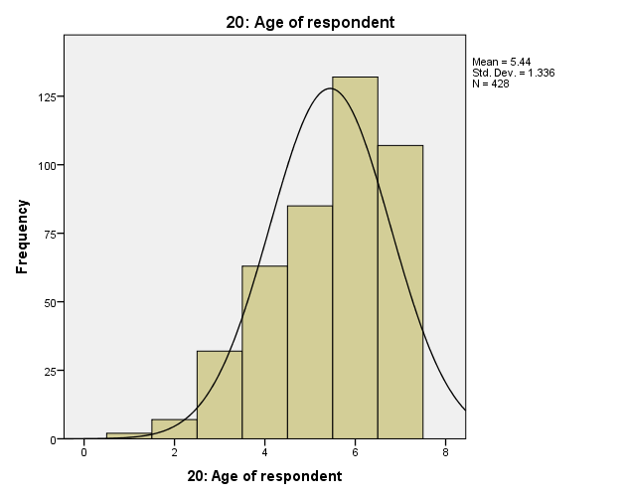
Fig 1. Normal distribution of Age

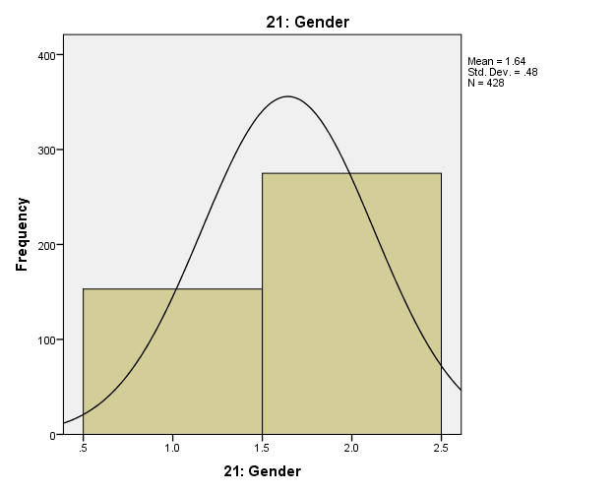Fig 2. Normal distribution of Gender

Next, a hypothesis test of Age-Gender distribution across respondents presented the following output which rejects the null hypothesis ‘Age of respondents is the same across categories of Gender’ with a significance level of .001.

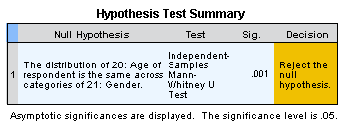
Fig 3: Hypothesis testing of Age and Gender

2.3 Reliability Test - Cronbach’s Alpha
Cronbach’s Alpha was used to measure the reliability of items on a scale.
It measures the internal consistency of items in a set of variables. The analyst must make sure not to mix positively and negatively worded questions. This results in a negative Alpha and to combat this possibility, reverse coding of the relevant variables is needed. Without reverse coding, the Alpha will be negative.

Cronbach’s Alpha Analysis
On a valid respondent total of 428 with nil exclusions, the reliability analysis using the variables 4.16 not interested in coastal activities, 4.18 organised walks, 4.19 Self Guided Walks, 4.20 walking information from the Internet and 4.21 walking information & maps on my smart phone produced a strong reliability with a Crombach’s Alpha value of .914 (see Table 3 and 4). A reverse coding of Q4.16 was done to align interpretation with the remaining variables.
In Table 3 (Crombach’s α = .915 indicating an excellent high stakes testing where Crombach’s α ˃ .7 is acceptable).

Reliability Statistics
Cronbach's Alpha | Cronbach's Alpha Based on Standardized Items | N of Items
.915 | .896 | 5
Table 3: Crombach’s Alpha Reliability test

Item-Total Statistics
 | Scale Mean if Item Deleted | Scale Variance if Item Deleted | Corrected Item-Total Correlation | Squared Multiple Correlation | Cronbach's Alpha if Item Deleted
4.16R: Not interested in coastal activities | 70.95 | 15174.703 | .244 | .101 | .972
4.18: Want organised walks | 62.18 | 9788.477 | .914 | .877 | .867
4.19: Want self guided walks | 62.09 | 9960.324 | .920 | .860 | .866
4.20: Want more walk info on web | 61.12 | 9789.588 | .916 | .886 | .867
4.21: Want info on mobile phone | 60.34 | 9631.302 | .914 | .872 | .867
Table 4: Crombach’s Alpha if variable is deleted.

2.4 Cross Tabs and Chi Square Tests
Cross tabulation is used to present results of a lead variable as well as sub-variables of survey responses. For this analysis, all nil responses and ‘question not asked’ were excluded.
Table 5 shows Cross tabulation of Residents and season for a visit, (in this case, Summer time). In the cross tabulation below, 254 (81.9%) out of 310 non-residents stated that they visited in the summer for recreational purposes. In a similar proportion, 96% of residents captured in the survey also visited in the summer.

1.1: I live Here * 2.2: Visited in Summer Crosstabulation
 |  |  | 2.2: Visited in Summer |  | Total
 |  |  | No | Yes | Total
1.1: I live Here | No | Count | 56 | 254 | 310
1.1: I live Here | No | Expected Count | 45.4 | 264.6 | 310.0
1.1: I live Here | No | % within 1.1: I live Here | 18.1% | 81.9% | 100.0%
1.1: I live Here | Yes | Count | 3 | 90 | 93
1.1: I live Here | Yes | Expected Count | 13.6 | 79.4 | 93.0
1.1: I live Here | Yes | % within 1.1: I live Here | 3.2% | 96.8% | 100.0%
Total |  | Count | 59 | 344 | 403
 |  | Expected Count | 59.0 | 344.0 | 403.0
 |  | % within 1.1: I live Here | 14.6% | 85.4% | 100.0%
Table 5. Resident/Non-resident Summer visitors

A Chi Square of independence reveals the significance of the above relationships in Table 6 below.

Chi-Square Tests
 | Value | df | Asymptotic Significance (2-sided) | Exact Sig. (2-sided) | Exact Sig. (1-sided)
Pearson Chi-Square | 12.605ª | 1 | .000
Continuity Correction^{b} | 11.445 | 1 | .001
Likelihood Ratio | 16.256 | 1 | .000
Fisher's Exact Test |  |  |  | .000 | .000
Linear-by-Linear Association | 12.573 | 1 | .000
N of Valid Cases | 403
a. 0 cells (0.0%) have expected count less than 5. The minimum expected count is 13.62.
b. Computed only for a 2x2 table
Table 6. Chi Square Test of Resident status and summer visits.

In the above Chi Square analysis, serial (a) at the bottom of the table tells us what percentage of the cells have expected count of less than 5. This is important because its an assumption of the Chi Square test. In this case 0 cells have an expected count of less than 5. The Pearson Chi Square value in this analysis is 12.605 with a 1df and a P-Value or significance value of .000.
This means that the result is statistically significant.
From the Cramers V output in Table 7, however, the value of .177 indicates a weak relationship in the level of association between the stated variables.
Appendix 2, however, presents a strong relationship between residential status and winter visits using Phi and Cramers V as well as a strong statistical significance for the variables tested.

Symmetric Measures
 |  | Value | Approximate Significance
Nominal by Nominal | Phi | .177 | .000
Nominal by Nominal | Cramer's V | .177 | .000
N of Valid Cases |  | 403
Table 7. Phi and Cramers V

Cramér’s V is shows an indication of how strongly two categorical variables are associated by deducing a number between 0 and 1.
The variables analysed here with a significance level close to zero means that they are very unlikely to be totally un-associated in a bigger population. It does not mean however that the variables are strongly associated. A weak association in a large sample size may also result in p = 0.000.
Cramér’s V is the measure that does indicate the strength of the association.

2.5 Focus on Non-Residents Cross Tab
Since this data seems to be about holiday or recreational visitors, a further exclusion was made to exclude residents who formed 23% of the total edited population of 403 used so far. This was performed for a deeper analysis of the visiting population.
A further cross tabulation analysis of the season of year visited reveals the following observation with associated Bar charts out of a total 310 non-resident respondents.

Crosstab
 |  |  | 2.2: Visited in Summer |  | Total
 |  |  | No | Yes | Total
1.1: I live Here | No | Count | 56 | 254 | 310
1.1: I live Here | No | Expected Count | 56.0 | 254.0 | 310.0
1.1: I live Here | No | % within 1.1: I live Here | 18.1% | 81.9% | 100.0%
Total |  | Count | 56 | 254 | 310
 |  | Expected Count | 56.0 | 254.0 | 310.0
 |  | % within 1.1: I live Here | 18.1% | 81.9% | 100.0%
Table 8. Non-residents visits in the Summer season

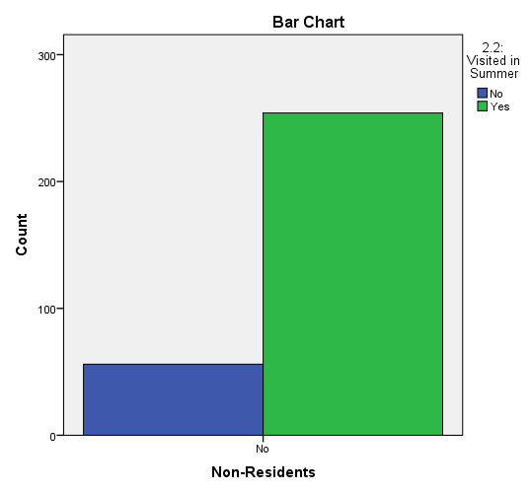
Fig 3. Non-residents visits in the Summer season

Crosstab
 |  |  | 2.4: Visited in Winter |  | Total
 |  |  | No | Yes | Total
1.1: I live Here | No | Count | 228 | 82 | 310
1.1: I live Here | No | Expected Count | 228.0 | 82.0 | 310.0
1.1: I live Here | No | % within 1.1: I live Here | 73.5% | 26.5% | 100.0%
Total |  | Count | 228 | 82 | 310
 |  | Expected Count | 228.0 | 82.0 | 310.0
 |  | % within 1.1: I live Here | 73.5% | 26.5% | 100.0%
Table 9. Non-residents visits in the Winter season

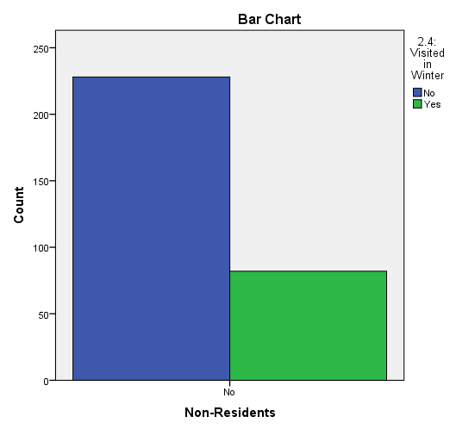
Fig 4. Non-residents visits in the Winter season

From the tables and charts above (also see appendix 3), the cross tab shows a gradual reduction of non-residents visiting from 81.9% during the summer season to 26.5% in the winter period.
2.6 Correlation
Spearman’s correlation coefficient also known as Spearman’s RHO is a non-parametric alternative to the Pearson’s. Spearman’s can handle ordinal data (i.e. ranked data).
The Analysis below correlates the Age of respondents and their interest in nature reserve.
Because age groups are categorical and ordinal, Spearman’s RHO was used in the correlation analysis in Table 8.

Correlations |  |  | 3.7: Nature Reserve | 20: Age of respondent
Spearman's rho | 3.7: Nature Reserve | Correlation Coefficient | 1.000 | .110*
Spearman's rho | 3.7: Nature Reserve | Sig. (2-tailed) | . | .027
Spearman's rho | 3.7: Nature Reserve | N | 403 | 403
Spearman's rho | 20: Age of respondent | Correlation Coefficient | .110* | 1.000
Spearman's rho | 20: Age of respondent | Sig. (2-tailed) | .027 | .
Spearman's rho | 20: Age of respondent | N | 403 | 403
*. Correlation is significant at the 0.05 level (2-tailed).
Table 8. Spearman’s RHO correlation of Age and interest in Nature Reserve.

Correlation coefficient (r) ranges between -1 and +1. -1 being a perfectly negative correlation and +1 implies a perfectly positive correlation. As shown in table 8, the correlation coefficient between Age of respondents and interest in nature reserves presents a small to moderate strength correlation. A look at the P-value (Sig, 2-tailed) however presents a P-value of .027.
Compared to a significant P-value of .05 can be accepted that this value of .027 makes this correlation statistically significant in our small-moderate positive correlation result. This determines that what was observed in the random sample is representative of the population. This concludes that there’s enough evidence to suggest that a small to moderate positive correlation also exists in this population.

3 Questionnaire Critique
There are set rules that govern the structure of questionnaires in a survey. Questions must be brief, clear and unambiguous.
Again, the questionnaire must be easy to complete and not too onerous on respondents by employing the use of ‘closed questions’ (Greasley 2008). A thorough thought put into the choice of options will ensure less work at the data analysis stage.
‘The desire to use open-ended questions appears to be almost universal in novice survey researchers, but is usually extinguished with experience’ (Robson, 2002).

In certain instance, however, ‘open questions’ may become a necessity in exploiting useful information. Such instances involve the need for respondents to expand on a response for an earlier choice of options.
A look at the Visits to the local coastal area survey throws some critique points as discussed in subsequent paragraphs.

Reverse coding – Some questions within certain categories were negatively worded which then required reverse coding to enable inclusion in some analysis. Set variables in Question 4 such as ‘Disabled access is sufficient’, ‘I do not have enough information about activities’ and ‘I, my friends and/or family are not interested in coastal activities’ required reverse coding in SPSS to enable analysis with other selected variables in the group. There are existing coding schemes that can be adopted for many variables (Saunders et al, 2016).

Which area/country do you live in - Home location could have been distance travelled presented in a range such as: 0-10 miles, 11-20 miles and 21-30 miles.
For the purpose of relevance to the survey, the questionnaire could have excluded second homes and visits of once or twice in five years. These variables have little significance to the aim of the survey and simply lead to a clutter of survey results.

Incomplete variables - Some questions to variables not asked in the survey were input on SPSS as ‘Question not asked’. These served as clutter on the data bank and needed exclusion or reconfirmation by asking the target respondents for an answer.
Not Known questions as found in some responses also play a big effect on the data.

Length of Questionnaire - The questionnaire was too long for the type of environment – i.e. holiday setting. The idea of such a questionnaire is to gather snapshot responses on key variables required from the survey. This questionnaire however is too long and very likely to take some time to fill. People in such a holiday location are unlikely to devote any length of time to religiously answer a lengthy questionnaire as presented in this case. This is evident in the amount of nil responses derived from the data.

Repetitions within the set variables – Certain variables could have been simply presented without the many sub-variables to then select options for response. This makes the analysis of data ambiguous and widely spread.

Conclusion
In summary, questionnaires aim at data collection through asking respondents to answer specific questions. This is to allow for a researcher to deduce descriptive and explanatory analysis through the use of computer data analysis tools.
A researcher’s choices of questions and answer options provided have a huge influence on the outcome. Data analysis tools are there to interpret what has already been collected and coded by the individual.
It is recommended that future surveys are kept short and concise, straight to the point to encourage respondent’s interest in completing as required.

References
Businessdictionary.com available at: http://www.businessdictionary.com/definition/data-analysis.html

Greasley, P. (2008) Quantitative Data Analysis Using SPSS; An Introduction for Health & Social Science. McGraw Hill.

Robson, C. (2002) Real World Research. Oxford. Blackwell.
Saunders, M., Lewis, P. and Thornhill, A. (2016). Research Methods for Business Students (7th ed.). Pearson.

Appendices
Appendix 1. Validity Test of Gender showing No reply and Joint.

21: Gender
 |  | Frequency | Percent | Valid Percent | Cumulative Percent
Valid | Male | 155 | 33.1 | 33.1 | 33.1
Valid | Female | 275 | 58.8 | 58.8 | 91.9
Valid | Joint | 5 | 1.1 | 1.1 | 92.9
Valid | No Reply | 33 | 7.1 | 7.1 | 100.0
Valid | Total | 468 | 100.0 | 100.0

Appendix 2 - Relationship between residential status and winter visits using Phi and Cramers V as and statistical significance

1.1: I live Here * 2.4: Visited in Winter

Crosstab
 |  |  | 2.4: Visited in Winter |  | Total
 |  |  | No | Yes | Total
1.1: I live Here | No | Count | 228 | 82 | 310
1.1: I live Here | No | Expected Count | 184.6 | 125.4 | 310.0
1.1: I live Here | No | % within 1.1: I live Here | 73.5% | 26.5% | 100.0%
1.1: I live Here | Yes | Count | 12 | 81 | 93
1.1: I live Here | Yes | Expected Count | 55.4 | 37.6 | 93.0
1.1: I live Here | Yes | % within 1.1: I live Here | 12.9% | 87.1% | 100.0%
Total |  | Count | 240 | 163 | 403
 |  | Expected Count | 240.0 | 163.0 | 403.0
 |  | % within 1.1: I live Here | 59.6% | 40.4% | 100.0%

Chi-Square Tests
 | Value | df | Asymptotic Significance (2-sided) | Exact Sig. (2-sided) | Exact Sig. (1-sided)
Pearson Chi-Square | 109.230ª | 1 | .000
Continuity Correction^{b} | 106.727 | 1 | .000
Likelihood Ratio | 114.157 | 1 | .000
Fisher's Exact Test |  |  |  | .000 | .000
Linear-by-Linear Association | 108.959 | 1 | .000
N of Valid Cases | 403
a. 0 cells (0.0%) have expected count less than 5. The minimum expected count is 37.62.
b. Computed only for a 2x2 table

Symmetric Measures
 |  | Value | Approximate Significance
Nominal by Nominal | Phi | .521 | .000
Nominal by Nominal | Cramer's V | .521 | .000
N of Valid Cases |  | 403

Appendix 3 – Crosstab for Non-residents visits in the Spring and Autumn season

Crosstab
 |  |  | 2.1: Visited in Spring |  | Total
 |  |  | No | Yes | Total
1.1: I live Here | No | Count | 118 | 192 | 310
1.1: I live Here | No | Expected Count | 118.0 | 192.0 | 310.0
1.1: I live Here | No | % within 1.1: I live Here | 38.1% | 61.9% | 100.0%
Total |  | Count | 118 | 192 | 310
 |  | Expected Count | 118.0 | 192.0 | 310.0
 |  | % within 1.1: I live Here | 38.1% | 61.9% | 100.0%
Non-residents visits in the Spring season

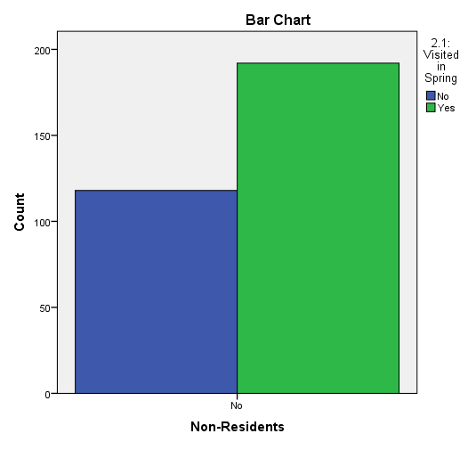
Non-residents visits in the Spring season

Crosstab
 |  |  | 2.3: Visited in Autumn |  | Total
 |  |  | No | Yes | Total
1.1: I live Here | No | Count | 126 | 184 | 310
1.1: I live Here | No | Expected Count | 126.0 | 184.0 | 310.0
1.1: I live Here | No | % within 1.1: I live Here | 40.6% | 59.4% | 100.0%
Total |  | Count | 126 | 184 | 310
 |  | Expected Count | 126.0 | 184.0 | 310.0
 |  | % within 1.1: I live Here | 40.6% | 59.4% | 100.0%
Non-residents visits in the Autumn season

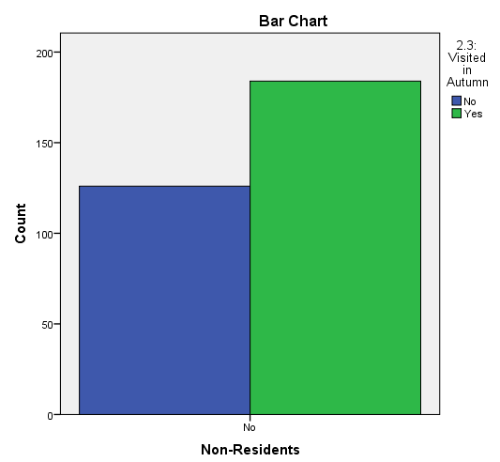
Non-residents visits in the Autumn season

