University of Wales Trinity Saint Davies

Daniela Alina Cioranu
Student ID: 1914830
Cross Cultural leadership and migrant employees' performance in the distribution industry
Supervisor: Dennis Pepple

Abstract
The significant research highlights various factors and the importance of cross-cultural leadership and the performances of migrant workers in the distribution industry. Researchers used various types of methods, and theories and identified a few issues which needed to be implemented within the time. HRM also plays a potential role in the decision-making process which is necessary for better productivity and monitoring the activity of employees.

Table of Contents
CHAPTER 1: INTRODUCTION 5
Background & Problem Statement 5
Research Aim 6
Research Objectives 6
Research Questions 6
Significance / Relevance of Study 7
Brief Research Methodology 7
Structure of the rest of the project 8
CHAPTER 2: LITERATURE REVIEW 9
Introduction 9
Research Areas 9
Performance of migrant employees in the distribution industry 9
Importance of Cross-Cultural Leadership 9
Workplace culture impact on migrant employees' performance 10
Decision-making process of HRM 10
Conceptual Framework 11
Conclusion of Chapter 12
CHAPTER 3: RESEARCH METHODOLOGY 13
Introduction 13
Research Philosophies 13
Research Design 13
Research Approaches 14
Data Collection Methods 14
Ethical Considerations 14
Conclusion 15
References 16

CHAPTER 1: INTRODUCTION

Background & Problem Statement
Background
The research shed light on cross-cultural leadership as well as the performance of migrant employees in the distribution industry. Cultural leadership is a type of leadership that helps to keep individuals from various cultures together as well as direct employees toward a significant common goal. It also enables employees or workers to reveal their special talents. It can be stated that it is leadership that helps to manage workplace diversity in an effective way (Shepherd et al., 2021). The cross-culture leadership is associated with different variables which are motivation, communication techniques, decision-making patterns, gender, age, individual personalities, and many more.
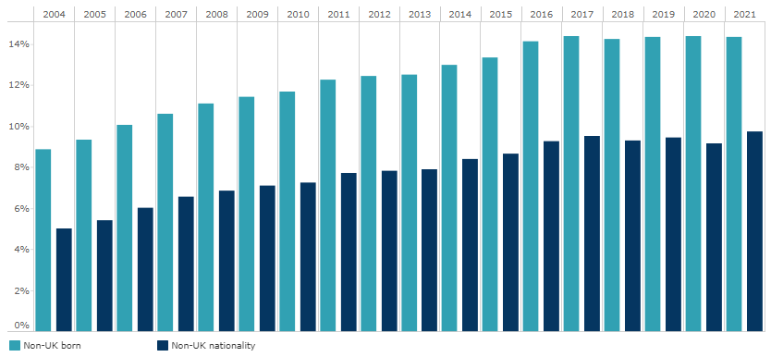
Figure 1.1: Share of migrants in the UK population
(Source: Migration Observatory, 2022)
The above-mentioned diagram is a visual representation of migration share in the UK population which impacted the distribution industry in different ways. However, the purpose of the research is to find out the problem that influences factors of cross-cultural leadership on the behaviour of migrant employees in business. On the other hand, based on the research it has been found that London has the largest range of migrant employees rather to all regions of the UK which is around 3,346,000 or 37% of the total born population of foreigners (Migration Observatory, 2022). It can be stated that the significant impact of migration employees on the wages as well as employment prospects for UK-based employees is small.
Problem Statement
The main challenges that cross-cultural leadership faces are various styles of communication and unwanted attitudes that create conflicts. Migrant employees come from different foreign countries in the UK and work in smaller firms. Migrant employees come from different zones as well as regions and for that, they have subcultural differences (Stiles et al., 2021). It becomes difficult for leaders to maintain a diversified workplace at the same time, especially for the distribution industry. Another problem is the failure to identify differences between religion and subcultures (Guang and Charoensukmongkol 2020). The leadership of cross-culture is working with various consumers and employees and for that leaders are required to adjust in this critical situation.

Research Aim
The research aims to figure out appropriate issues faced by cross-cultural leadership and the performance of migrant employees in the distribution industry. The research aims to find possible solutions for better evaluation.

Research Objectives
- To identify the importance of cross-cultural leadership in the UK distribution industry
- To objectify the way that HRM supported the factors of cross-cultural leadership
- To analyse the significant impact cross-cultural leadership has on the behaviour of migrants in the distribution workplace

Research Questions
1. Why cross-cultural leadership is important in the UK?
2. How does HRM support cultural leadership?
3. What impact does cross-cultural leadership have on migrants' behaviour at work?

Significance / Relevance of Study
The significance of the study is to highlight various factors of cross-culture leadership in the behaviour of migrant employees from the distribution industry. Due to having a foreign language as well as qualification it biome difficult to hire those employees for the work (Eid and Agag 2020). Additionally, with each passing time, the rate of unemployment is getting higher and at some point, those people are claiming benefits for being unemployed.
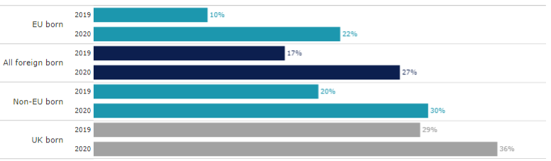
Figure 1.2: Unemployed workers claiming benefits of unemployment
(Source: Migration Observatory, 2022)
The above-mentioned diagram is a visual representation of the workers who are deliberately claiming additional benefits for staying unemployed in the UK. According to the information, migrant workers are less likely to demand benefits which are around 27% for being unemployed rater than workers who are legal residents of the UK which is around 36% (Migration Observatory, 2022). It also created difficulties for leaders to maintain workplace diversity effectively.

Brief Research Methodology
The significant research will be followed by secondary research to get authentic information with appropriateness. Secondary research is an important part of a research paper and a useful tool that helps to get effective information which is analysed and collected by other researchers. Therefore, it helps to save time as well as money which helps to gain insights into the chosen topic which the present researchers are searching for.

Structure of the rest of the project
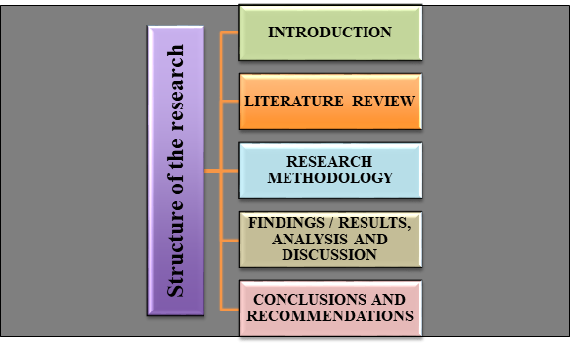
Figure 1.3: Structure of the total research
(Source: Created by the learner)

CHAPTER 2: LITERATURE REVIEW

Introduction
The research identically introduced factors of migrant employees' performance in the workplace as well as the importance of having cross-cultural leadership in the workplace. It is an important responsibility of HRM who choose leadership to maintain the workplace environment with effectiveness. Besides, due to having different languages and regions many workers are facing significant issues in the workplace. The section of literature of this research paper helps to identify its impact on an effective research outcome. It can be stated that leadership has a greater impact on the organisation especially in the industry of distribution in the UK.

Research Areas

Performance of migrant employees in the distribution industry
Every company requires labour power to increase its production power with greater effectiveness. According to the information from various journals millions of migrant workers from different foreign countries have been distributed among major regions which are Europe, Central Asia, the UK, Arab States, and others. Based on the statement of Shen et al. (2019), workers who come from other regions often get stigmatised as well as face discrimination. Due to their language, ethnicity, and cultural variations and their lack of legal protection, it becomes difficult to access justice while their rights are being violated. Most of them face difficulties in the workplace and it heavily impacts their performances. On the other hand, migrant workers have a greater contribution to the development and growth of the host country such as the UK. As per the statement of Ivanov et al. (2022), having skilled workers in the workplace helps to increase the profitability of the business which is needed for better development. Therefore, it is important to observe their performances in the workplace for better revolutionary results.

Importance of Cross-Cultural Leadership
A company needs to have appropriate leadership to manage the workplace environment with effectiveness. In that case, cross-culture leadership is one of the appropriate to maintain a diversified workplace with efficiency. As per the statement of Nandeesh et al. (2022), this leadership help employees in the professional field, deal with significant challenges, and take necessary steps which are needed for better evaluation. The distribution industry of the UK needs to adopt this leadership because most of the migrant workers are working in the distribution sectors of any industry. According to the viewpoint of Putri et al. (2020), this type of leadership helps organisations or businesses ensure that everyone in a distribution team has equal rights and can feel comfortable. Implication of significant theories can help to improve the process with effectiveness. In that case, the Implicit theory of leadership is one of the appropriate ones for the development of cross-cultural leadership.

Workplace culture impact on migrant employees' performance
Employees are the core components and providing them a better working platform with a positive workplace environment is necessary. The findings help to confirm that migrant workers and their employment, as well as career outcomes, are significantly not influenced by any human capital and qualifications. Based on the statement of Cherian et al. (2021), culture has a greater impact on employees and it also attracts workers through inspiration for better productive work. It also helps to reduce the high rate of turnover from business and leaders are responsible for hiring qualified candidates from migrant workers for better evaluation. On the other hand, completing tasks and understanding approaches are important in business which become difficult for migrant employees of the distribution industry. The significant cultural risk in the business is falling regarding the adaptation of different business models for the local market.

Decision-making process of HRM
HRM of an organisation is an important part because most of the business decisions are taken by this management department. As per the statement of Fahmi and Ali (2022), an effective decision-making process of HRM is focused on consideration for the best availability of effectual evidence which is in combination with critical thinking. Migrant employees come from different foreign countries and for that having foreign accents and qualifications is a bigger issue in business. All of those factors also impacted or affected employee performance in the distribution industry. It can be stated that the maintenance of workplace culture, leadership process, and performances of migrant employees are the responsibilities of HRM. Making decisions based on performance is important to make the workplace better.

Conceptual Framework
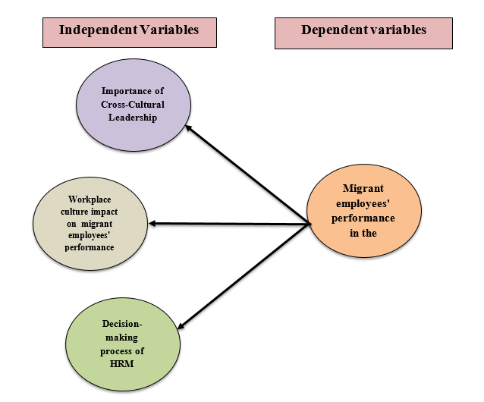
Figure 2.1: Conceptual Framework
(Source: Created by Learner)
The conceptual framework is an appreciated visual representation of dependent as well as independent variables. It helps to identify potential relationships among dependent and independent variables which has been finding out through the analysis of research (Varpio et al., 2020). The conceptual framework can be created based on the systematic literature review for the preset research based on specific topics.
Independent Variables
This variable are standing alone as well as does not change due to other variables which need to be measured for better outcomes (Varpio et al., 2020). Independent variables of this research are the importance of cross-culture leadership and, the impact of workplace culture on the performances of migrant employees. The process of decision-making of HRM is also part of the independent variables. It influences as well as manipulates all types of changes and is assumed to directly influence the dependent variables.
Dependent Variables
It is a significant variable which helps to change the outcome of an independent variable with manipulation (Varpio et al., 2020). The dependent variable of this research is migrant workers' performances in the distribution industry of the UK. It can be stated that those significant variables are dependent on independent variables and that is why it is called dependent variables.

Conclusion of Chapter
It can be concluded that after analysis of this section cross-culture leadership has a greater impact on the distribution business industry. There has been discussion on dependent as well as independent variables which help in the identification of different issues and objectives. All related data and information which is based on the unemployment rates as well as the performance of migrants’ employment in the distribution industry of the UK. Researchers need to collect all information regarding the proposed topic to get an appropriate outcome.
CHAPTER 3: RESEARCH METHODOLOGY

Introduction
The section on methodology helps to provide legitimacy as well as allows scientifically sound findings to the research paper. It helps researchers to get a clear view regarding which method, philosophy, approaches and other things will be used in that research. Using appropriate things can help to get effective knowledge regarding different research perspectives to get a better outcome. Besides, the maintenance of ethics in the paper is another significant matter because it helps to increase the value of the paper effectively. The main purpose of this section is to explore, explain, and describe research factors by increasing understanding regarding the proposed research topic. All of that phase also included familiarising the research topic with researchers and improving understanding.

Research Philosophies
Interpretivism research philosophy is focused on supposition that the reality might be subjective, socially, and multiple constructed. This significant research will be adopting interpretivism for secondary research purposes (Tamminen and Poucher 2020). The effectiveness of adopting this philosophy is that it is an identical approach associated with the consideration of different types of social realities including practitioners as well as multiple stakeholders for additional data collection. The advantage of using this philosophy is that it helps to understand human behaviour rather than social structure which is also relatable to the chosen research topic. Researchers of that research can choose this as a process of research for goes far from the empirical collection process of data and information.

Research Design
Researchers of this significant research paper need to choose a suitable research design to get an effective outcome with effectiveness. In that case, the researcher will choose an explanatory research design as the process of research progresses (Newman and Gough 2020). The advantage of that design is that it can help to increase understanding in a deeper way and techniques that fill all types of research gaps which might affect the expected outcome. It helps researchers to get a clear understanding as well as how to ascertain why accurate phenomena are certainly occurring as well as predict occurrences in future. Besides, all of this, it can be stated that this particular research design helps in the adaptability as well as enables several testing hypotheses which might enhance the flexibility of the proposed research topic.

Research Approaches
In this research, researchers will choose the deductive research approach as the research approach to increase the value of the paper with greaterness. This particular research design helps to get the possibility for a better explanation of the relationship between different variables and concepts. Even this research design included a few advances which helped the research paper to get an effective outcome associated with effective information (Rezigalla, 2020). It helps regarding measurements of different concepts of quantitative and generalise findings to some certain extent. It can be stated that the deductive research approach is a powerful tool which helps provide logical information for researchers which develops their critical thinking power and skills for problem-solving.

Data Collection Methods
All data and information needed to be collected in an authentic way to avoid unreasonable stoppage in the research process. Additionally, for that purpose, researchers will go with qualitative “data collection methods” to avoid any type of error that might impact negatively the possible outcome (Mwita,2022). All respective data as well as information will be collected from authentic resources which are Google Scholar, articles, and journals. Marinatance of ethics while collecting data is necessary for better authentication.

Ethical Considerations
All rules and regulations need to be followed in research to avoid any type of difficult situation or circumstance. Most of the time research faces legal issues for being unable to maintain ethics and confidential research which affects the research procedures. Additionally, to avoid these types of circumstances maintenance of the "Data Protection Act 2018" of the UK is important (Li et al., 2021). It helps to avoid unnecessary stoppage and also increases the value of the research with greater effectiveness. Besides, the principle of ethical consideration helps by guiding practices as well as the research design of the research paper.

Conclusion
It can be concluded that the section of the research methodology provides a clear view which helps the researchers to get a better outcome. Maintenance of ethics as well as collection of all resources in an authentic way is important for better evaluation. Researchers need to protect confidential data and information from leakage by including the Protection Act for better evaluation. All of the processes of research should be followed with effectiveness which helps to increase the value of the paper for evaluation. Collecting all resources and information which have been used in the research should be authentic which helps to increase the value of the research.

References
Cherian, J., Gaikar, V., Paul, R. and Pech, R., 2021. Corporate culture and its impact on employees’ attitude, performance, productivity, and behaviour: An investigative analysis from selected organizations of the United Arab Emirates (UAE). Journal of Open Innovation: Technology, Market, and Complexity, 7(1), p.45.
Eid, R. and Agag, G., 2020. Determinants of innovative behaviour in the hotel industry: a cross-cultural study. International Journal of Hospitality Management, 91, p.102642.
Fahmi, I. and Ali, H., 2022. Determination of Career Planning and Decision Making: Analysis of Communication Skills, Motivation and Experience (Literature Review Human Resource Management). Dinasti International Journal of Management Science, 3(5), pp.823-835.
Guang, X. and Charoensukmongkol, P., 2020. The effects of cultural intelligence on leadership performance among Chinese expatriates working in Thailand. Asian Business & Management, pp.1-23.
Ivanov, S.H., Webster, C., Stoilova, E. and Slobodskoy, D., 2022. Biosecurity, crisis management, automation technologies and economic performance of travel, tourism and hospitality companies–A conceptual framework. Tourism Economics, 28(1), pp.3-26.
Li, Q., Wen, Z., Wu, Z., Hu, S., Wang, N., Li, Y., Liu, X. and He, B., 2021. A survey on federated learning systems: Vision, hype and reality for data privacy and protection. IEEE Transactions on Knowledge and Data Engineering.
Migration Observatory, 2022. Migrants in the UK: An Overview. [Online] Available at: <https://migrationobservatory.ox.ac.uk/resources/briefings/migrants-in-the-uk-an-overview/#:~:text=London%20has%20the%20largest%20number.> [Accessed 22 Sep. 2023]
Migration Observatory, 2022. Migrants-in-the-uk-labour-market-an-overview. [Online] Available at: <https://migrationobservatory.ox.ac.uk/resources/briefings/migrants-in-the-uk-labour-market-an-overview/> [Accessed 22 Sep. 2023]
Mwita, K., 2022. Factors to consider when choosing data collection methods. International Journal of Research in Business and Social Science (2147-4478), 11(5), pp.532-538.
Nandeesh, N.S., Raja, Y.N. and Bhandari, A., 2022. Cross-Cultural Leadership: A Systematic Literature Review. Journal of Positive School Psychology, 6(7), pp.2596-2609.
Newman, M. and Gough, D., 2020. Systematic reviews in educational research: Methodology, perspectives and application. Systematic reviews in educational research: Methodology, perspectives and application, pp.3-22.
Putri, S.A., Mirzania, A. and Hartanto, D., 2020. The importance of a transformational leadership model in managing organizational culture.
Rezigalla, A.A., 2020. Observational study design: Synopsis for selecting an appropriate study design. Cureus, 12(1).
Shen, J., Wang, S., Liu, W. and Chu, J., 2019. Does migration of pollution-intensive industries impact environmental efficiency? Evidence supporting “Pollution Haven Hypothesis”. Journal of Environmental Management, 242, pp.142-152.
Shepherd, R., Lorente, L., Vignoli, M., Nielsen, K. and Peiró, J.M., 2021. Challenges influencing the safety of migrant workers in the construction industry: A qualitative study in Italy, Spain, and the UK. Safety Science, 142, p.105388.
Stiles, S., Golightly, D. and Ryan, B., 2021. Impact of COVID‐19 on health and safety in the construction sector. Human factors and ergonomics in manufacturing & service industries, 31(4), pp.425-437.
Tamminen, K.A. and Poucher, Z.A., 2020. Research philosophies. In The Routledge International Encyclopedia of Sport and Exercise Psychology (pp. 535-549). Routledge.
Varpio, L., Paradis, E., Uijtdehaage, S. and Young, M., 2020. The distinctions between theory, theoretical framework, and conceptual framework. Academic Medicine, 95(7), pp.989-994.

