Assessment Title: Component 1 – Online Portfolio of Set Exercises
Student Name: Salma Rashid
Student Number: 2332571
Module Title: Change Makers Creativity & Value Creation
BMHP5014
Lecturer: Precious Igbinigie

Task 1 – Concept Map
Operating through a trinity of innovation, value, and improvement, the health and social care sector has turned innovation into a major advantage for all the parties involved. In this context, creativity which is the ability to generate new and slightly modified ideas can help determine the service gaps, inefficiencies, or patient needs that are being served. According to Amabile and Mueller (2024), if the patient care professionals feel secure and free in their positions, they will be more inclined to participate in creative activities especially if they get to question the existing methods and propose changes.
Through the proper execution of these concepts, the provision of measurable benefits that improve the quality, accessibility, and sustainability of care is transformed into value creation. Donetto et al. (2021) contend that the value in health and social care goes beyond monetary returns and encompasses emotional support, empowerment, and an overall better quality of life for the patients. This never-ending pursuit of value is the very reason for the constant improvement of health care, which, on its part, stimulates the development of cultures of learning and shared accountability.
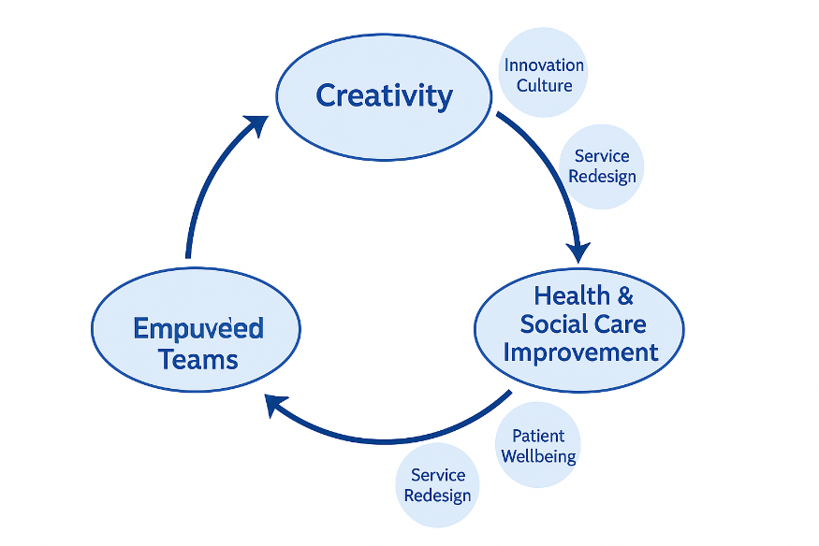
Figure 1: Concept Map
The three concepts function as an infinite cycle: the creative insight leads to value-oriented innovation, which further strengthens the networks and attracts more creativity. This reciprocal relationship allows the development of person-centered, sustainable, and community needs-responsiveness innovations in care delivery through the evolution of the healthcare system.

Task 2 - Self-Reflection of Group Activity
The class talking about convergent and divergent thinking really was an eyeopener for me in terms of how the whole process of creative thinking works through experience and unstructured discussion. Based on Kolb's (2014) experiential learning model I looked back at the whole process and the activity indeed led me to the use of the two types of problem-solving: open and critical.
Concrete Experience:
Our assignment consisted of coming up with new and creative ways to improve staff-patient communication in nursing homes. At first, I was unsure since divergent thinking involved the sharing of unrefined, spontaneous ideas. But, as the conversation progressed, I came to the conclusion that every idea, no matter how bizarre, could open up new avenues.
Reflective Observation:
At the time of the transition to the convergent phase, I noticed that the group started to dissect, merge and polish the ideas. The phase presented me with a new perception of the impact of systematic evaluation on the conversion from imagination to real-life problem solving.
Abstract Conceptualisation:
According to me, it was pointed out that creativity in health care was manifested by some forms of art and also concerned with making a change in the case of systems and processes that improve patient-related outcomes.
Active Experimentation:
I would like to practice divergent thinking in the future group projects first to foster open-mindedness in the team and then to conduct through reasoning to evaluate the practicality of the ideas. This combination of creative and logical thinking can bring about the improvement of innovation and collaboration in the care sector.

Task 3 - Case Study of a UK innovation
One of the most amazing instances of invention and benefit creation in the UK health care system is the “Organ Donation Digital Registration Campaign” by NHS Blood and Transplant which was started as a part of the NHS Digital Transformation Strategy. This campaign effectively used technology in combination with the knowledge of human behavior to gain even more support from the public and thus boost the organ donation rate in England.
The campaign was designed to make the donor registration process easier and, at the same time, to increase the visibility of the donor registration process through online and social media channels. NHS Blood and Transplant (2022) reports that the use of a creative approach allowed for the incorporation of registration possibilities directly into the most popular digital platforms, the NHS App and DVLA services. People who were reluctant to register due to cumbersome forms or ignorance of the process were not an issue anymore. The nudges employed during the registration process were tailored reminders and straightforward decision prompts, which not only made the entire process easy for the user but also kept an emotional bond with him.
The project, from the viewpoint of value creation, addressed social and systemic challenges simultaneously. The social aspect was the creation of value by granting people the power to make life and death decisions and views to the ethical side of public health enhancement. The novel solution not only improved the data sharing process but also reduced the amount of paperwork done by the NHS staff and contributed to better partnership between the hospitals and the transplant centers. A study by Ferlie and Ongaro (2022) stated about these and similar digital public services that "they not only make access better but also help gain trust, especially when the power of decision making is felt by the users”.
Through this initiative, the creativity further overflowed the realm of only technicality and into the floor of collaboration and communication. The project was a joint effort of the IT specialists, clinicians, policymakers, and representatives of patient advocacy organizations who together devised solutions that took into account the individual's rights and cultural sensitivities. Such teamwork from different disciplines is an example of the NHS's drive towards inclusive innovation, and it guaranteed that the new digital instruments would not overpower the ethical issues and the respect for the patients' dignity.
In summary, the Organ Donation Digital Registration Campaign is an example of how the power of creativeness can change the whole paradigm of policymaking and still maintain the health sector and citizens as the main beneficiaries of the change. Furthermore, with the use of digital technology and at the same time being aware of the public behavior, the NHS not only proved that it is technologically savvy but also that it offers a very human, caring, and data-based solution to patients.

Task 4 - Research Task
A continuously huge issue in the UK health and social care system has been continuously the burnout of the workforce, which in particular concerns nurses and frontline workers. The situation has become worse because of the pandemic, as the factors for the increase in the problem are heavy workloads, emotional exhaustion, and scarcity of staff. Studies have repeatedly pointed out that burnout is one of the biggest threats to the quality of service, retention of staff and safety of patients.
West et al. (2020) assert that the main cause of burnout among health care workers is the persistence of heavy workloads, low job control and poor management support. In the course of their research into the wellbeing of NHS workers, they found that employees suffering from excessive emotional stress and being set impossible targets are more prone to experience disconnection and burnout in relation to patients. The authors also pointed out that structural problems like shortage of personnel and prolonged working hours lead to low spirits and restriction of inventive power, thereby affecting the potential for innovation in care places directly.
Maben and Bridges (2020) further mentioned that organizational culture is another major factor that causes burnout. Their study based on interviews showed that healthcare organizations that fail to provide psychological safety and recognition make employees feel worthless and, consequently, get the employees’ freight that the organization’s aim is not the same as theirs. This not only adversely affects the employees' health but also hampers collaboration and communication among the staff members. According to the writers, supportive workplaces where staff-mentors, and emotional resilience courses are at the forefront should be constructed.
The investigations in the combination clarify that employee exhaustion is a complex issue caused by the interaction of systemic and cultural factors plus the lack of mental health services. Fighting it causes the top management to be committed, the workforce to be enough and the money to be spent on mental health support to keep the health and social care professionals motivated and compassionate to be the requirements.

Task 5 – Podcast
Bridging the Digital Divide – The Inclusion Support Hub
Click Link Below
Salma.Rev Podcast

Task 6 - NHS Leadership Framework Analysis
The NHS Leadership Framework (2011) is a joint strategy that focuses on the development of leadership habits throughout all the health and care industries. The framework identifies seven interlinked areas, which are - personal qualities demonstration, teamwork, service management, service improvement, direction setting, vision creation and strategy delivery. They all combine to create a foundation for compassionate, responsible and creative care.
The exhibition of personal traits forms the basis of ethical self-discipline and honesty, while the collaboration among the people concerned facilitates the formation of problem-solving through teamwork. The function of the management of services guarantees that the systems are operating smoothly and fairly, and the field of service improvement is accountable for the use of intentional quality and the collection of patient feedback to pinpoint the areas of poor quality. Direction setting grants the leader the ability to be a policy-maker, to anticipate the needs of the people and to manage the changes, while vision creation unites the individuals under one purpose. Finally, the area of strategy execution concerns the transformation of plans into practical activities, thus enhancing the outcome for the users of the service.
Improving services is the domain that most closely aligns with my values. One of the main takeaways from my practical projects was the need for critical reflection and data analysis to help in identifying the gaps and even suggesting new innovative ways to tackle them. The feedback we received on the digital literacy barriers older people face eventually helped the group come up with support resource materials that were specifically designed for the users’ needs. The processing of this case made me realize that leadership is really a never-ending cycle of learning, evaluating and partnering. The application of the improving services domain is a sure fire path for the evidence-based innovations that are compassionate and can really be very effective, these are the values that contemporary health and social care practice espouses.

Task 7 - Self-Reflection Journal Entry
The completion of this module made a marked improvement in my knowledge of the area of creativity and value creation in a health and social care context. Initially, I considered creativity to be an intangible thing; however, with every weekly task, I realized its vast and important role in everyday problem-solving, promoting cooperation, and among others, service improvement. I was also able to grasp the importance of using different types of thinking through the activities conducted on divergent and convergent thinking as each type of thinking leads to new and inventive solutions in care practice.
The case study focused on digital transformation and the NHS leadership framework, coupled with my own experiences, has deepened my meaning of leadership as a driver of innovation. I found out that compassionate and inclusive leadership has the power to allow and to facilitate the staff to think, work together and produce high-quality outcomes for the patients. As for me, this situation increased my self-assurance in giving opinions in group works and made me more critical in considering ways in which care systems can change. From now on, I will be using these learnings to inspire teamwork, open the gates to fresh ideas and keep on finding new and creative ways to support both patients and staff.

Reference List
Amabile, T.M. and Mueller, J.S. (2024) ‘Studying creativity, its processes, and its antecedents: An exploration of the componential theory of creativity’, in Handbook of Organisational Creativity. London: Psychology Press, pp. 33–64.
Ferlie, E. and Ongaro, E. (2022) Strategic Management in Public Services Organisations: Concepts, Schools and Contemporary Issues. London: Routledge.
Kolb, D.A. (2014) Experiential Learning: Experience as the Source of Learning and Development. Harlow: FT Press.
Maben, J. and Bridges, J. (2020) ‘Covid‐19: Supporting nurses’ psychological and mental health’, Journal of Clinical Nursing, 29(15–16), pp. 2742–2750. https://doi.org/10.1111/jocn.15307
NHS Blood and Transplant (2022) Organ Donation and Transplantation. [online] London: NHS Blood and Transplant. Available at: https://www.nhsbt.nhs.uk/what-we-do/transplantation-services/organ-donation-and-transplantation/ (Accessed: 24 October 2025).
NHS Leadership Academy (2020) Healthcare Leadership Model: The Nine Dimensions of Leadership Behaviour. [online] London: NHS England. Available at: https://www.leadershipacademy.nhs.uk/wp-content/uploads/dlm_uploads/2014/10/NHSLeadership-LeadershipModel-colour.pdf (Accessed: 24 October 2025).
West, M., Bailey, S. and Williams, E. (2020) The Courage of Compassion: Supporting Nurses and Midwives to Deliver High-Quality Care. London: The King’s Fund.
West, M.A. and Lyubovnikova, J. (2023) ‘Illusions of team working in health care’, Journal of Health Organization and Management, 27(1), pp. 134–142.

