BMSW5104
PROJECT MANAGEMENT

TECHER: PAUL RANSON
ZAHED AHMED 1714926

Contents
INTRODUCTION 2
THE WATERFALL PROJECT TECHNIQUE 2
THE STEERING GROUP 3
IRON TRIANGLE 7
SCOPE 7
TIME 10
COST 12
CONCLUTION 13
References 14

VINTNERS ANTIQUES

INTRODUCTION
Vintners Antiques is a traditional high street shop is located in Shirley, Solihull. It is a family run traditional shop providing service to the local communities on their third generation. the business is not doing well during the pandemic covid-19 and the Vintners’ family has an offer from a retail supermarket which is very attractive to sell the shop. The Vintners family realised the businesses are moving toward the online platform and the offer from the retail shops is reasonable also Vintners family need the capital to invest to the warehouse to make it useable for the purpose of online trading. The family decided to move the shop to a warehouse in Sparkhill, Birmingham. The warehouse has been using for the storage for the items. The warehouse has no infrastructure of the shelving or no electricity neither gas nor any internet facilities. The family decided the business is going to be online for the future and trade to the people such as salvage hunting business because they this is a third generation of unique business that the experienced will help to do well. They wanted the warehouse is design to have all kinds of facilities to carry out the business. Vintners’ family have a group of people who can support and can have success in this business. As a project manager I can offer a management plan to move the Vintners Antique Shop to move into the warehouse in Sparkhill in a very effective way that the project will be done on time as predicted and the quality of the work will be ensured to meet the standard.

THE WATERFALL PROJECT TECHNIQUE
On this project I am presenting myself as a project manager. “Predicting the future is easy. It’s knowing what’s going on now that’s hard,” R. S. Dressler. To manage this project, I am going to use the waterfall model approach to complete this project. Waterfall model project management technique was introduced by Dr. W Royce in 1970 and it gives us the idea of how to work on a project very effectively without any interaction of the tasks each-others. The waterfall technic is very famous on project management because it helps to do the tasks very efficiently and with this technique the whole process of software development is divided by different phases. On this process there are each phase must be completed before the next phase began and there is no chance of overlapping with these phases. On this project I am willing to use the waterfall model because this is very simple and easy to understand the progress by the people involved on the project and the progress of the tasks and will be a clear indication of the approaches. Each phase develops and complete at a time and the steps are very clearly defined. With this technique the target is clear and arrange the next task accordingly also the process of the work and the results are very visible and well documented by the management. By using this technique there are greater chance of success of the project and also, reduce the risk of failure of the projects.

THE STEERING GROUP

THE STEERING GROUP
Steering group or the committee is to guide the project from the start to finish of the project and the ultimate target of the group is to achieve the goal. Steering committee is to provide help the project manager by giving the advice, monitoring the project and the quality of the project also, providing the budget of the project. The members of the steering committee do not work on the project usually. The project manager is the person inform the progress of the project to the steering committee and explain the project. The project steering group is accountable for the success of the project. They are the people to set the expectations of the business to fit in to the project to meet. The project steering group can be considered the highest authorities and senior personals of the business. Project managers on a project has lots of limitations and the procedure to follows and purpose of the project managers to complete the tasks with I the resource and budget provided by the project owners. Any changes of the plan needed to be authorised by the authority on the top that has no responsibility of the project managers (P. Robarts 2011, p-29).


DOREEN VINTNER

On this project the project sponsor is the owner of the Vintners Antique Doreen Vintner who is the responsible to run this business and looking after the business and the maintaining all the aspect of this business. According to the PMBOK from the Project Management Institute (PMI) “the project sponsor is a person who provides resources and support for the project, program or portfolio for enabling success.” The project sponsor is the responsible person for the success of the project and the highest responsible person who is ultimate decision-making authority of the project. Doreen has the experience of maintaining he books and the administrative experience that will help to guide the project also the interest on the business will enhance the success of the project.

DENIS VINTMER

On the steering group Denis vintner who has a passion of hunting the antiques and drives a van. Denis is the person to take the responsibility of the development because the interest of the business he is one of the stake holders of the Vintners family business. He is the co-owner of the business. He has more responsibilities to develop the project how the family wants to set the business. Denis can be involved physically in this project and save some money by doing some of the tasks as well. To move the antique to the warehouse in Sparkhill Denis can help with the removal people with his van lead the task and be the responsible for the job. There will be recruitment of removal people as a labourer who can help him to move the items in to the warehouse. Denis has the responsibility to arrange the builders and the electrical contractors and also the paint and decorators to negotiate the price and deals and make the contract sign with them.

SUHA MADANI
Suha Madani is the experienced customer service personal been working for the business for a long time and very friendly personality in the business. She can be the co-ordinate on this project by looking after the finance on this project because she is one of the reliable friendly and have very good communication skill. Suha can take the responsibility to organise the office and the order the stationaries and deal with the broadband service and the utility companies and get better deals.

OMAR KING

Omar King is the person who knows the shops everything and he is expert of the restoring item and can fix thigs. He has been working for this business for long time. Because he knows every part of the business and he if the person spends most time in the warehouse at work, he can play the role of the by defining the problems and help the teams by stablishing the project. He works in the warehouse it would be best for him to plan for the items to decide placing the stock also he will audit the stocks and restore the items and observe the activities.

PAUL RANSON
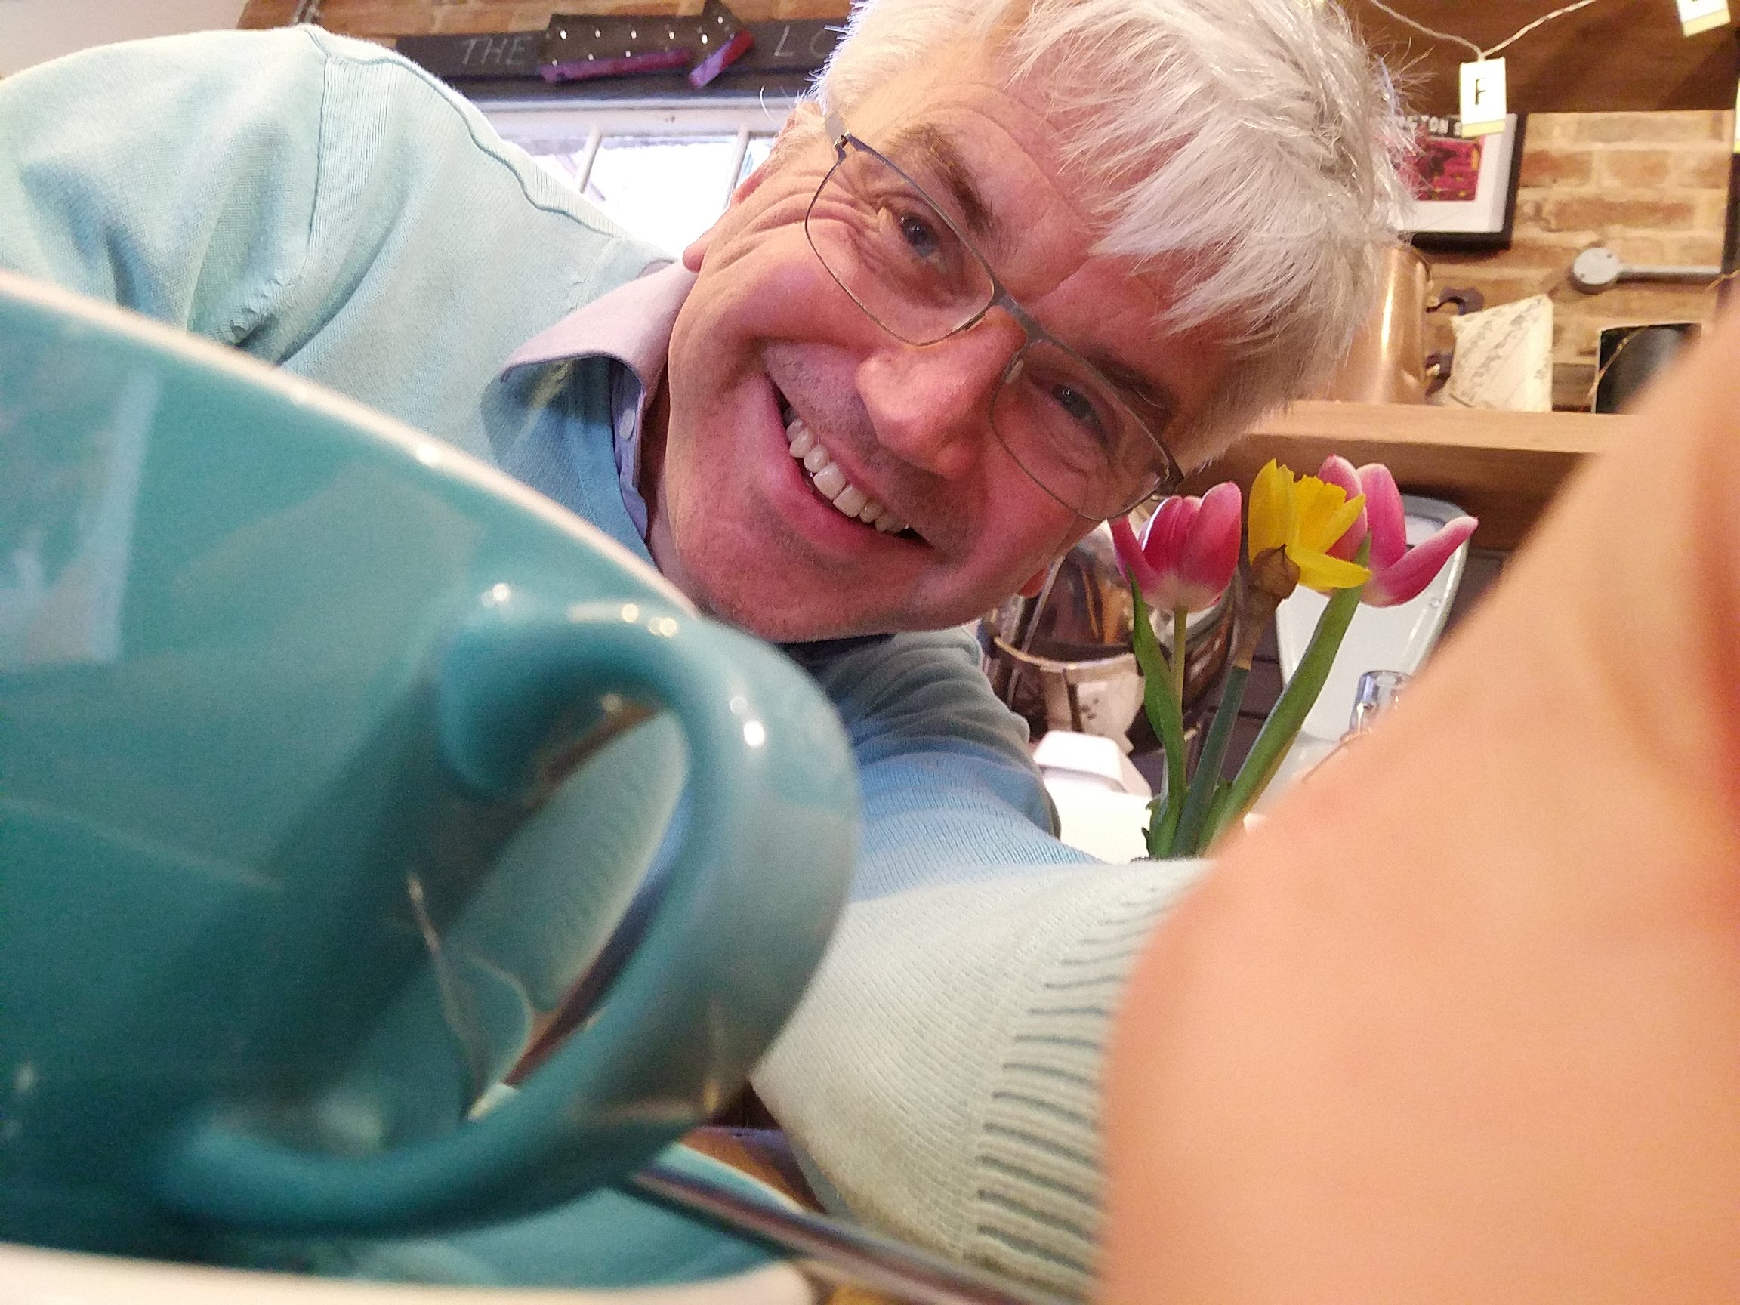
Paul Ranson is the family friend of the Vintners family who help every occasion and visits very often to the Vintners shop. Paul helps to designs the warehouse because he is designer by profession, he always feels free to provide help for the Vintners family.

IRON TRIANGLE
The iron triangle is a constraint of project management to balance the projects time, the budget, and the scopes. The Iron Triangle is re-presenting the time of the project the scheduled time to complete the project. The Scope or the problem of the project that identified by the stakeholders that to be done to complete the project and the most important Cost of the project estimated by the sponsor and the steering committee to complete the project on the allocated time. By balancing these of these three elements the outcome is defines the project the quality. Any of these constraints change or compromise than need to change on others to compromise as well otherwise the quality of the project will suffer (Lock,2007, p21 & 22).

SCOPE
Project scope is the detailed outlined aspect of the project that including the activities, resources and all the project boundaries. To identify the scope, need to work with the key stake holders and collaborate to ensure the essential problems to mention. The project is to take all the antiques in to the Sparkhill warehouse and setup the business online. But the warehouse is not ready because there is no electricity and gas. Because these items are very valuable need the security in the warehouse. Also, there are no structured for the office or the show room. The warehouse needs to design for the items, and it is shelfing also need the photography room for the online shopping also need the broadband service for marketing. The tasks to do lists is below:
Design the warehouse where the office room, show room, photography room and kitchen and how all the facilities have to be in place to create a nice environment. The design already provided by the family friend Paul and finalised in a group mitting to go ahead with this.
We will use the Trello software to gather all the problem and issue to deal with this project. Trello software is very organised to manage the tasks, manages and share with the teammates. The user stories can share on the application to define the tasks to do and analyse what necessary things to do. Then will use the chevron technique to prioritise the tasks by defining it importance by what we must do and want to do also nice to have in this project.

The scope we found on this project to do are bellow.
- Design the project – the design was provided by Paul and approved by the steering committee that to be completed.
- Arrange security systems- there are lots of valuable items in this business that is why the security system need on the side that ensuring the items are secure.
- Stock audit- the family business has been running for the third generation need to know what items have in the stock to take in the warehouse and what stocks have in the warehouse in total.
- Electric and Gas installation- to start the project it is essential to have the utility facility on side to work on side by the contractors.
- Arrange the builders- need the builders to build the facility such office room, renovation/ photography room and the kitchen and others to build.
- Paint and decorating- when the builder finished the building need to be painted and decorated.
- Office and other furniture- furniture need to be installed when the painting finished.
- Shelfing and organizing products- shelfing and organise the products accordingly to serve and accessibility of the products purpose.
- Broadband facility- this business going to online that is why it is important to have internet facility to be installed to do the business.
- Online banking facility- need to have online transaction facility for the online activities.
- Photography facility- for the online business to advertise the product need a photography room and accessories.
- Renovation facility- renovation is important for the antique products to make it perfect to present to the audience.
- Health and safety assessment-it is very important to have the health and safety assessment on side to protect people and the employees out from the danger.
- Hire some removal staffs- need to hire few manual labourers to help and bring the items to the warehouse.
- Order the stationary- for the office need to buy the stationery products.
- Online marketing & advertisement- because the business going to be online the advertisement is necessary to expand the business.
- IT team- need expert IT professional to deal with the online business.
- Wrapping facility- need the wrapping facility for the online business.

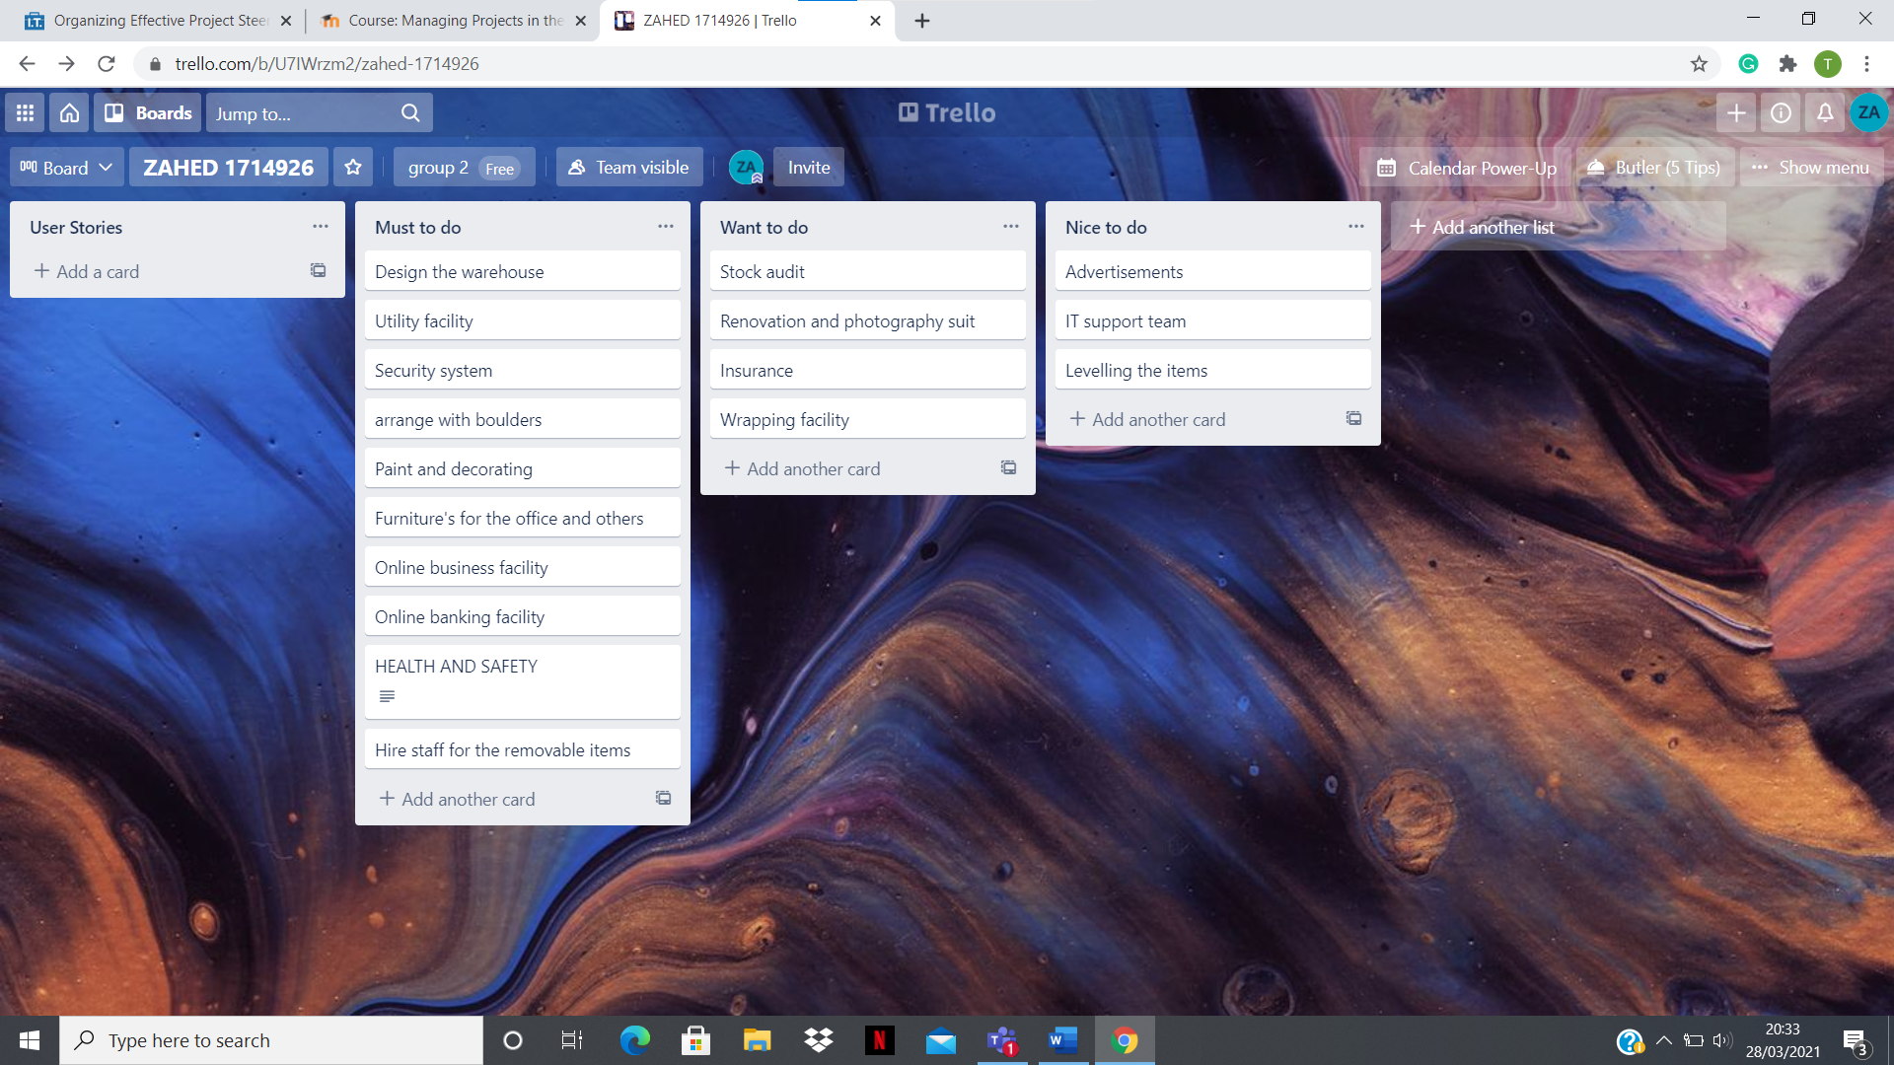
Trello software to use and share on the bord where everyone can view and share the stories also, share the opinions of the stakeholders and select the user story and prioritise the necessary tasks to complete on this project. The tasks need to do on this project considered by the project committee are below on the Trello bord.

TIME
The project starting date and the finishing date to hand over the project has to clarified on the project plan. The project managers responsibility to hand over the project on time completed unless any alteration or agreed transformation on the project. The time and the tasks have to be realistic otherwise the quality will disappear. On the reality it is very difficult to set the time but can have an estimated time to complete on the nearest time. “Every estimate is an informed or educated guess (Roberts, 2012)”.
To estimate the time on the project I will use “the wisdom of the crowd” to have a good guess for the project estimated time. The people working on the project will have better view on the project to deliver within the time limited. The estimated duration of this project is about 21 days by the prediction of the wisdom of crowd technique. In this estimated time if there are any changes or any delays by the other contractors then subsequently have consider the time as well as the budget as well. Because the iron triangles any of these elements change it has a direct impact on others and the quality.
The Trello bord where are stories and problems are mentioned by the group members and these user stories are being sorted by the specialist and prioritise them by the chevron technique according to the importance. The steering committee has considered and selected some of these tasks to be completed. Also, the estimated time agreed by these contractors to complete and the tasks have also been compromised as well. Also, there are some of the jobs are independent and some are dependent on the others to be finished. By deciding the projects tasks and the arranging with the contractors than defining the work dependence on others that clarified on the project (P. Roberts 2011, P 111-137).

THE ESTIMATED TIME AND CONTRACTORS DEPENDANCIES ON THE PROJECT
Story number | Story name | Estimated time | Contractor | Dependencies
1 | Design the project | 1 | Paul | -
2 | Utility facility | 3 | Geoff electrical | 1
3 | Security system | 2 | Elite security | 2
4 | Builder’s activities | 10 | Bob construction | 2
5 | Paint and decorating | 4 | Ali & Co | 4
6 | Furnishing | 3 | SK furniture | 5
7 | Broadband service | 1 | Suha | 4
8 | Online banking facility | 1 | Suha | -
9 | Health &safety procedure | 1 | Denis | 4
10 | Hire removal people | 2 | Denis | 5
11 | Stock audit | 2 | Omar | -
12 | Renovation and photography suit | 2 | Omar | 5
13 | Insurance | 1 | Suha
14 | Wrapping facility | 1 | Denis | 5
15 | Advertisements | 1 | Paul | -
16 | IT support team | 1 | Suha | -
17 | Levelling the items | 2 | Omar | 11

With this diagram we can easily define the time how long takes on each task and also shows there are some of the contractors are relied on the others to finished than they can start their work.

The Gantt chart Project planning map is to share the map with the stakeholders to report and the other contractors to understand the projects work progression on this project. The Gantt chart needs to update every day by holing a stand-up meeting for 10 minutes where can report by the contractors on their work progressions and share with others that the dependent tasks are not to be interrupted. The actual estimated time for the project to hand over by the contractor agreed by the 22nd day of the staring date of the project. Remember that the duration of the project time is an estimate time but any delays on the contractors or changes of the plan that will change the whole templates duration time of the work and also effect on the budget as well.
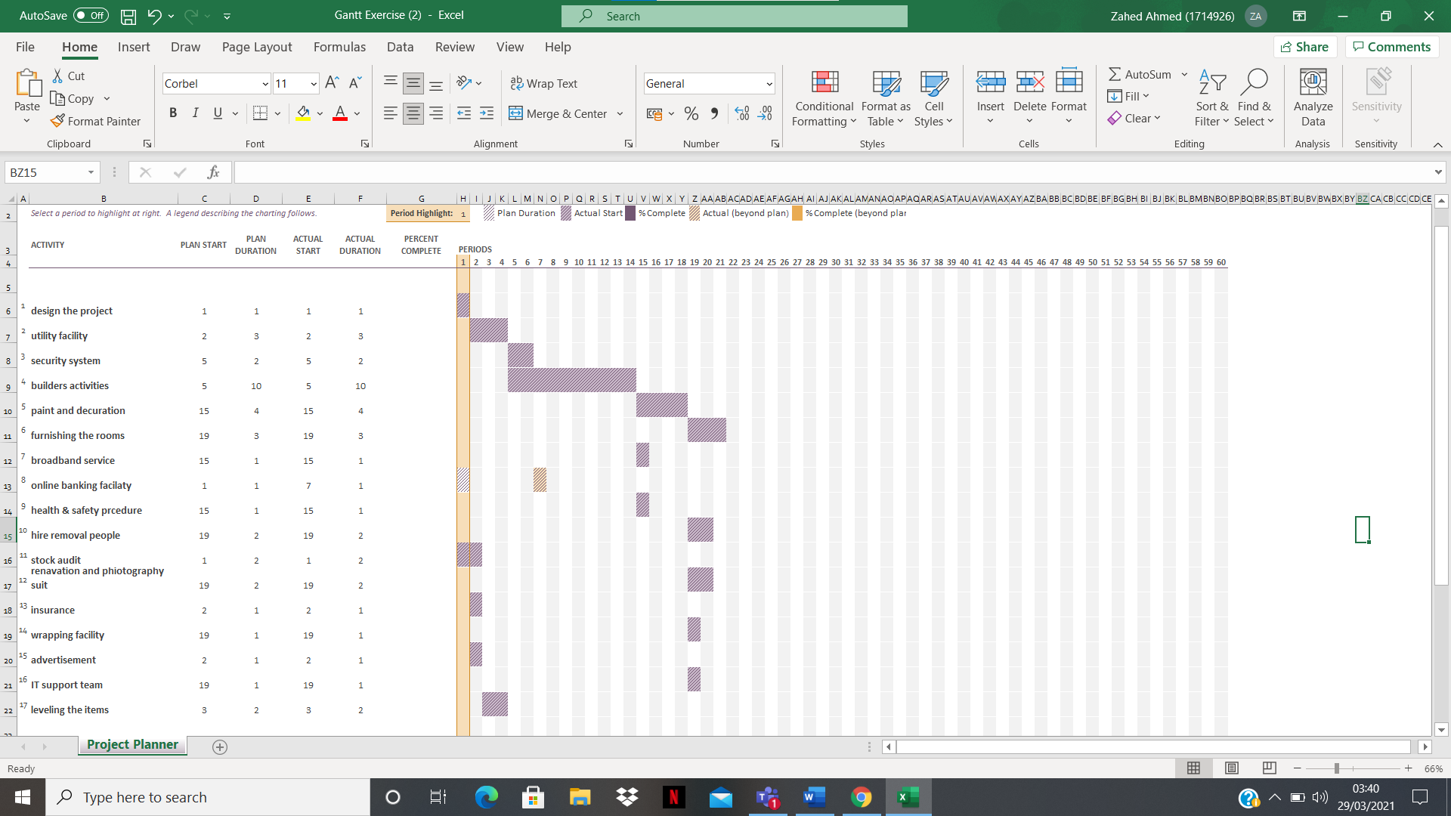
THE GANTT CHART

COST
This project is to complete with in a prepared budget that the Vintners family want to promote the business online also, the traders can visit the warehouse to buy the antiques. The budget of the project will prepare by the estimations of the tasks by negotiation with the contractor’s price and also, using the wisdom of the crowd technique. The budget on this project is estimated by the owner of the project is £25,300 and it is not going to be the accurate with the estimation, it is agreed to be +/_ 10% of the estimated price accepted.
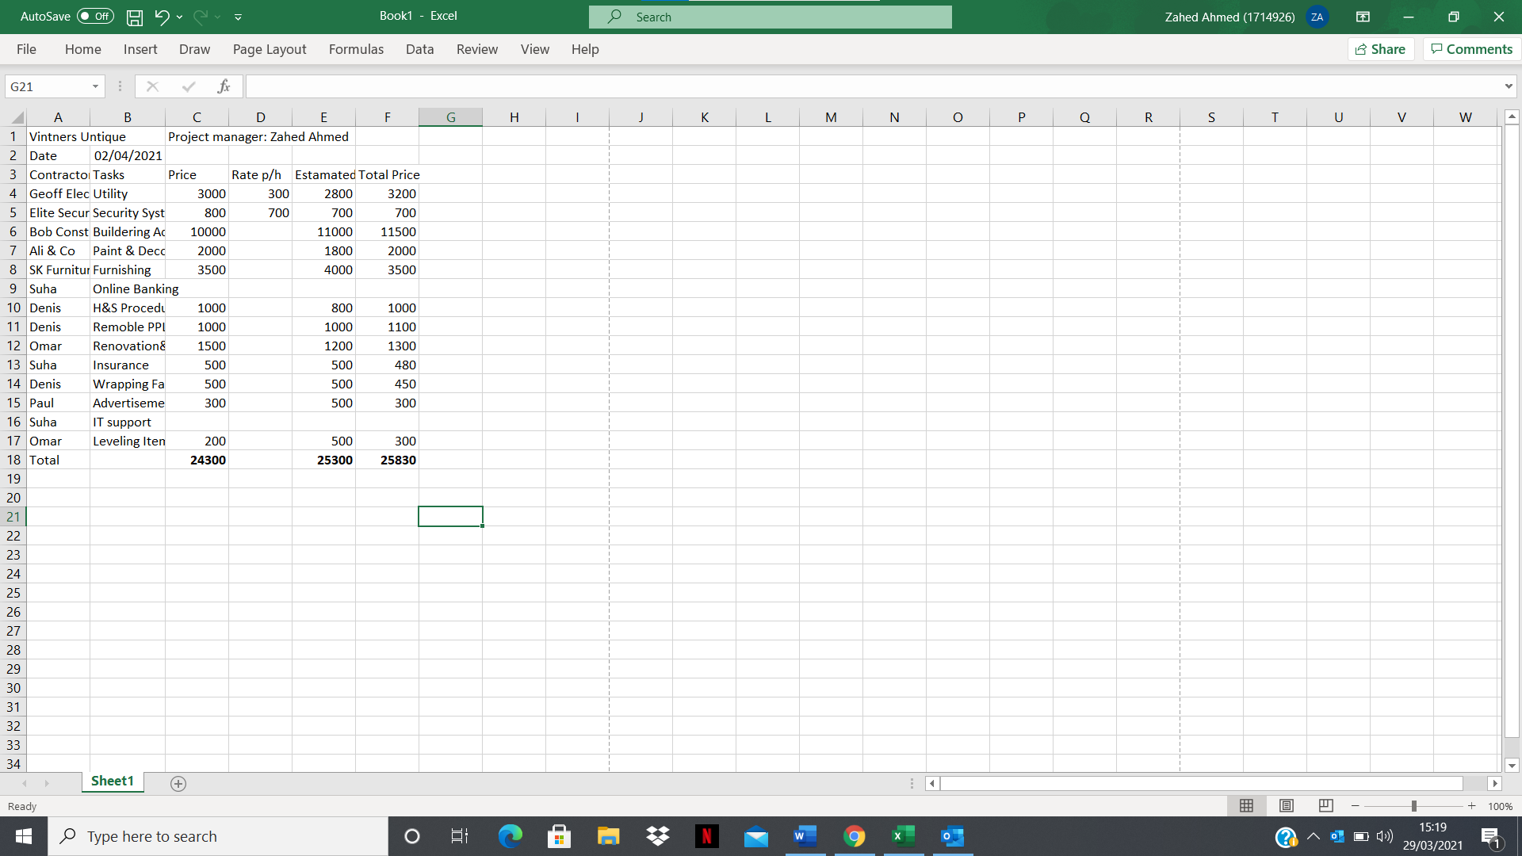

CONCLUTION
As a project manager my role on this project is to plan and oversee all the aspects of the project and meet the target of the project on time as possible also, complete the tasks within the estimated budget. As a project manager my job is to lead the planning and implementation on the project by defining the projects scope and goals. Schedule the scopes and time allocate for the tasks also, co-ordinating with the contractors. The quality assurance of the project and providing the progression of the project to the steering group. As a project manager I have some limited power on the project that I can only co-ordinate with others and support and guide them to accomplish the tasks but the are not everything goes on your way there some issues can occur on this project where I have no control and that could delay the project such as supplier limitations, human limitations so and so. The ultimate power on the project is on the project sponsor to control the project and complete the projects prospective to be a successful outcome.

REFERENCES

- 2021. What is Project Management?. [online] Available at: <https://www.pmi.org/> [Accessed 31 March 2021].
- Heagney, J., 2016. Fundamentals of project management. p 36-58.
- Kissflow. 2021. 9 Project Management Challenges and How to Overcome Them. [online] Available at: <https://kissflow.com/project/project-management-challenges/> [Accessed 31 March 2021].
- Management, P. and Triangle, P., 2021. Project Management Triangle - Time, Cost and Quality - Iron Triangle. [online] Stakeholdermap.com. Available at: <https://www.stakeholdermap.com/project-management/project-triangle.html#:~:text=The%20Project%20Triangle%20or%20Iron,impact%20the%20other%20two%20points.> [Accessed 31 March 2021].
- Mrsic, M., 2021. What are Roles and Responsibilities of Project Manager? [8 Key Roles] · ActiveCollab. [online] ActiveCollab. Available at: <https://activecollab.com/blog/project-management/project-manager-roles-and-responsibilities> [Accessed 1 April 2021].
- Roberts, P., 2011. Effective project management. London, UK: Kogan Page, p 29-60.
- Roberts, P., 2011. Effective project management. London, UK: Kogan Page, p 111-137.
- Vicki M, J., 2011. Project sponsorship. [online] Available at: <https://www.pmi.org/learning/library/importance-of-project-sponsorship-9946> [Accessed 31 March 2021].
- Villanovau.com. 2021. How to Maximize Project Quality with the Iron Triangle of Project Management. [online] Available at: <https://www.villanovau.com/resources/project-management/iron-triangle-project-management/> [Accessed 31 March 2021].
- Westland, J. and Westland, J., 2021. Time Estimation for Projects: Tips & Techniques - ProjectManager.com. [online] ProjectManager.com. Available at: <https://www.projectmanager.com/blog/time-estimation-for-project-managers> [Accessed 31 March 2021].

