Roxana-Oana Imbrea

2124855

Marketing fundamentals – LCBB4004

Assessment 1

2nd of September 2022

Tutor’s name: Md Sadeque Imam Shaikh

Blogging to Communicate: Costa Coffee
In this report I will present a series of 6 blogs that will focus on the Costa Coffee company that aims to engage the audience to understand and stimulate interaction with the company in regards to the company's Aims and Objectives, Target and Segmentation, Marketing Strategies (The Marketing Mix), Overview of Costa’s position in the market, Customer Satisfaction and, Trends.

Blog 1: Why is Costa Coffee unique and why choose us?
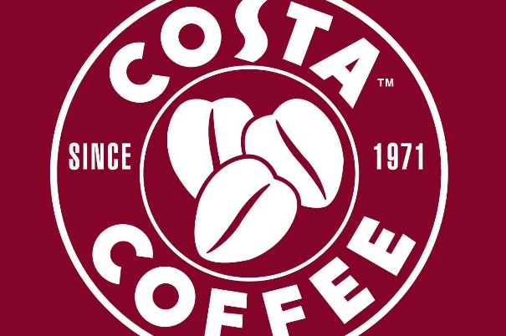
Who doesn’t love an energizing cup of flavored coffee to start the day with? I know I do… So, what are you waiting for?
Our perfectly roasted Arabic coffee beans have been carefully hand-picked and prepared to give your coffee the best flavor for a mild to strong aromatic taste. We are focused on delivering the best hot or cold beverage to either start you day or just to give you that needed break.
Ever since 1971 Costa Coffee has ensured to offer the best range of coffee and great service for it’s customers, keeping up with trends that will satisfy everybody’s wants and needs.
Apart from the distinctive coffee, Costa is also offering other types of drinks such as creamy, iced frappes, iced coffee customed for every taste with different types of milk, from whole cow milk to the flavored vegan coconut option, chai, and tea. We also offer treats so you can fully enjoy your coffee from fruity muffins to chocolate fudge or butter croissants, and if you haven’t got too much of a sweet tooth you can choose one of our sandwiches or fajitas to keep your hunger under control.
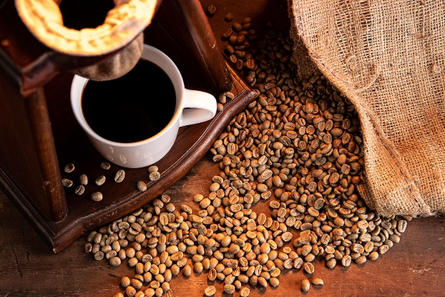
Why not have a look on our website and let us know what would you like to see at Costa Coffee?
Is it a new drink, maybe some more options of food or deserts? Feel free to leave your opinion, we take into consideration all our customers opinions and try to satisfy them.
P.s: We also accept constructive criticism.
Blog 2: Do you want to enjoy your favorite coffee abroad?
We are very pleased to be part of our customers morning routine and midday treat so we are looking to expand even more to share our happiness with other cultures too, because it does not matter wherever people come from, coffee brings us together. 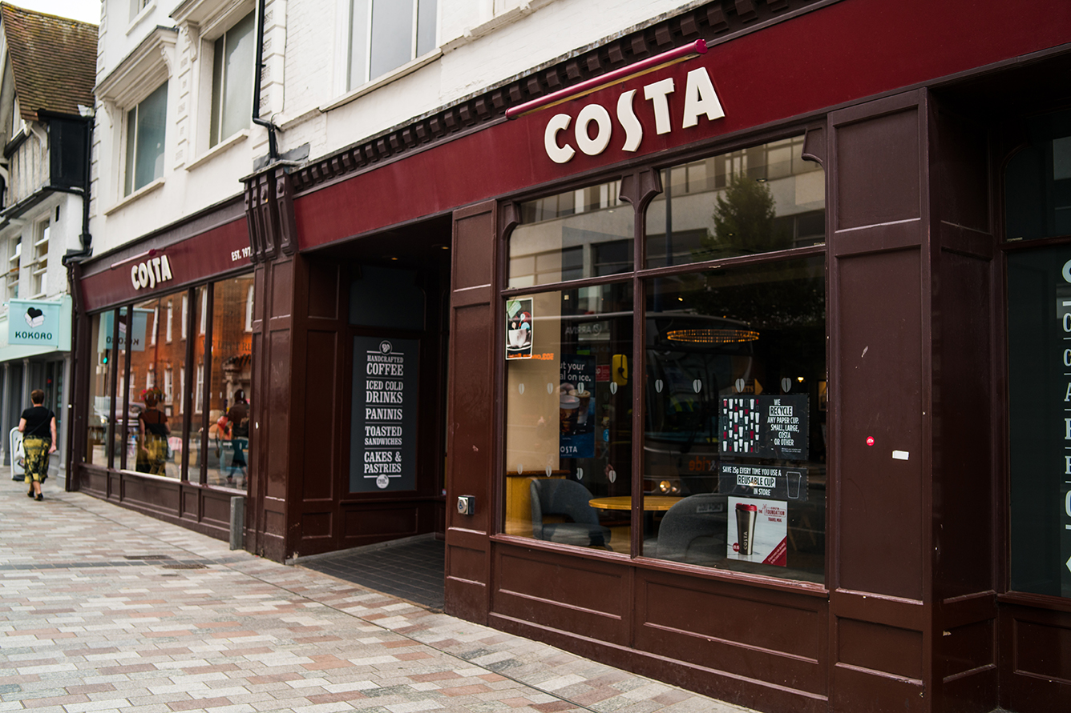
At the moment Costa Coffee is operating in 32 countries, however we are planning to expand even more as we want you to be able to enjoy a savory coffee wherever you have planned to go on holiday. Don’t worry, we have you covered.
So… Where do you think we should consider when it comes to expanding abroad?
We we’re looking into placing venti machines abroad to see how people abroad interact with other coffee and to find out what are the preferences for the specific products we have.
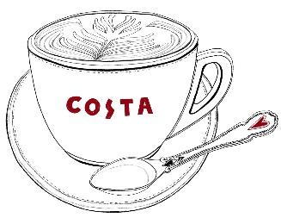
Let us know what you think about our strategy. Would you, as a person leaving abroad, be interested in our venti machines?
Also, we are thinking to expand to USA, great people also deserve great Coffee, right? We know that they already have a favorite coffee, but they haven’t tried ours yet.

Blog 3: How did Costa become so popular?
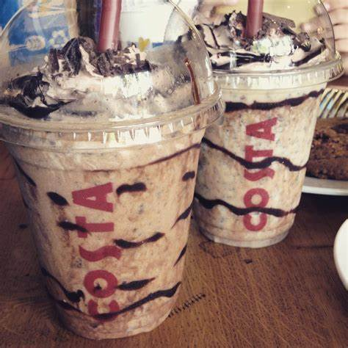
It is no doubt that Costa Coffee is very strict when it comes to delivering the best flavored and aromatic coffee and always looking to reach out perfection, however, is not just our coffee that made us so popular.
We believe that every voice should be heard, and we like to interact with our customers and reward their loyalty. We at Costa like to be very pro-active on our social media accounts and spread the love as well as the news of our seasonal collections or new products. Therefore, our customers cannot miss a possible new favorite drink or just a new range of healthier food choices that we have introduced.
But our goal is not to only make a profit, we are also considerate of our customers and appreciate their loyalty so, occasionally we like to reward them with a free drink (either bottled or handmade). Moreover, we know how important birthdays are, and we offer our loyal customers birthday gifts, the only thing you must do is make sure you download our app, and we will offer you a free drink and a treat so we can celebrate together.
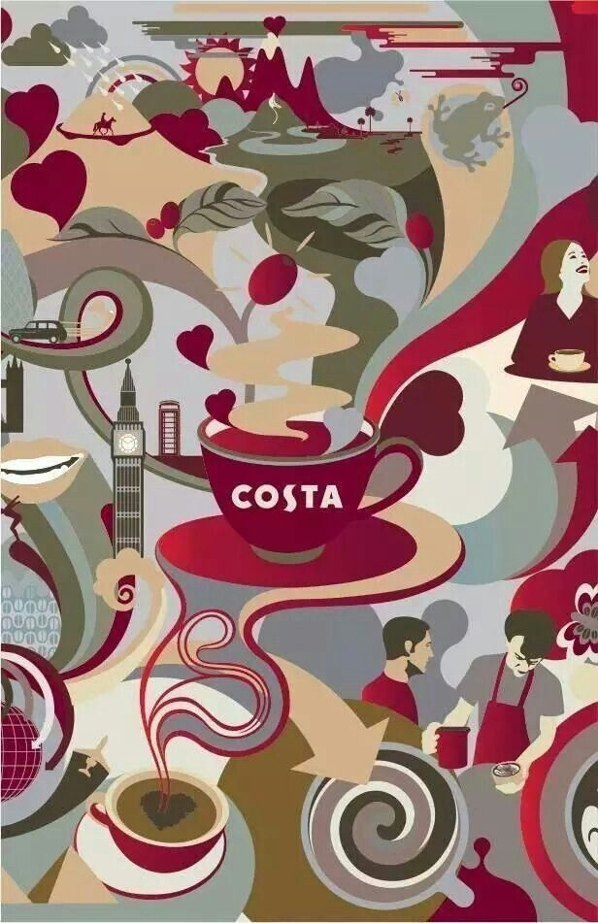
Apart from these promotions and free products we ensure to price our products accordingly as we care about our customers ability to manage their finance and we try to ensure that our products are affordable for anyone who wants to enjoy our coffees.
Costa Coffee is also engaging with other companies for the benefit of both parties involved.
For example, we became partners with channel 4 and they are helping us spread the word about what we do so even more people can enjoy the taste of our uniqueness. Celebrities like Sandi Toksvig, Joe Thomas and Omari Douglas are the people who accepted to link their names with the nation’s favorite coffee brand.

Blog 4: And Award of Nation’s Favorite Coffee Shop goes to … Costa
We know, we know… We have divulged this information in the previous blog, but we are so excited to be named the Nation’s Coffee Shop in the UK and we want to share our happiness with you too.

This is a great achievement for the company, and it is amazing to see that our efforts have been rewarded and that we are heading into the right direction. We must give credit to our partners and customers as they help our business grow and flourish day by day. Therefore, we want to say a big thank you to everyone who has helped Costa get to where it is now.
We definitely do not want to stop here because we feel like more people should be able to enjoy what we have to offer and be part of our big family. Costa Coffee is not as expanded as the second place on the rank when it comes to coffee, but we want to ensure that we can offer the best products and services in all our outlets before we decide to take our taste to other countries.
With your continuous support of you and our partners’ we like to think that we will get to spread even more and one day maybe we can get the award for the Most loved Coffee shop worldwide.
What are your thoughts on this? Do you think we are strong enough to do this together?

Blog 5: Working on giving out the best for our customers
Costa Coffee is not just an usual coffee shop, it is a gathering of people that love great coffee and appreciate a good service, a community… a big family.
From the perfected roasted coffee beans and multitude of options of milk and syrups to friendly staff and our welcoming, specially designed coffee shops, we want to ensure that the overall experience with Costa is unique and unforgettable.
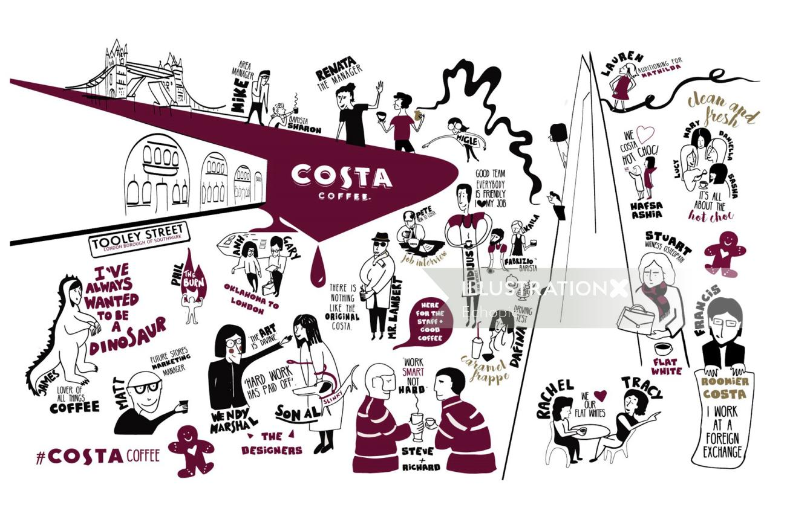As a reward to our efforts of ensuring customer’s satisfaction we are market leader in the UK holding the award of Nation’s favorite coffee. Therefore, we are pleased to know that we are appreciated for what we do and will continue in this direction in the future.
So don’t you ever think that we can be stopped.
We will continue introducing innovative products to our range as well as keeping up with the ne trends and expectations will surely be not met but exceeded.

Blog 6: Are you aware of the new Summer Trends?
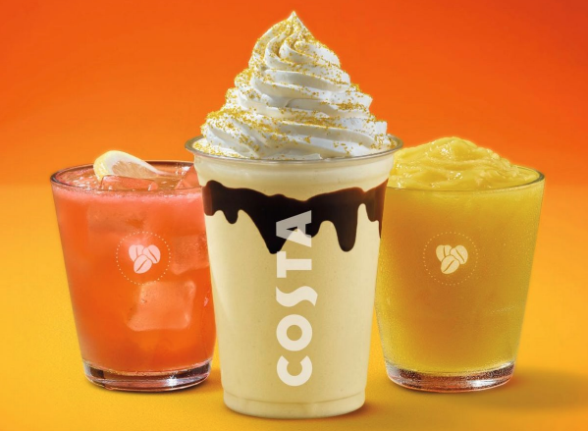
Costa Coffee is 51 years-old but it does not mean that it does not keep up with the new trends out there. We love to spice up your experience with us a little bit from time to time and now is the moment to introduce our summer range of frappes that will leave you speechless.
What do you prefer the most? A fruity frappe that will refresh you in the heat or would you go for a coffee frappe to enjoy the taste of a coffee in the blend of your favourite frappe?
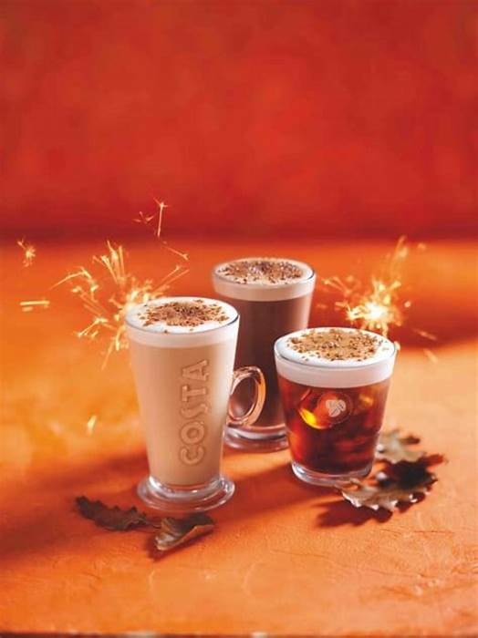
We are waiting for you to come and check out the full range in our shops or on our app and let us know how we did. But hurry…this is limited edition only!
But do not panic, we promise to surprise you with a new range soon as the new season is approaching. We do not want to let the secret out just yet, but we can give you a tip: Our pumpkin spice latte might be back on the menu so make sure you don’t miss it out!

In conclusion, the aim of the blogs presented above is to engage the audience in interacting with the business. This is an easy and effective way of finding out what are the needs and the expectations that customers have from Costa Coffee. In addition, the blogs helps the audience to find out more about the history of the company, what are the next steps, where it is at the moment and what are the trends, all covered in an engaging style of communication, that includes a more formal language and eye catching images.

References

Principles of Marketing (15th edt) Author: Kotler, P., and Armstrong, G Binding, USA, 2014
Costa Coffee - Home | Facebook
The Nation's Favourite Coffee Shop | Costa Coffee
Costa | The Coffee Blog | Page 2
The ultimate Marketing Plan, Dan S. Kennedy, New Delhi, 2006
Essentials of Marketing. 3rd ed., Blythe, J. Essex, 2015
Customer satisfaction. International Journal of Health Care Quality Assurance, Vukmir, R., 2006.
The fundamentals and practice of marketing, Wilmshurst, J. and Mackay, A., Oxford, 2002
Strategic Marketing Management: planning, implementation, and control. 2nd ed., Wilson, R. and Gilligan, C., Oxford 1997
Analysis for marketing planning. 4th ed., Lehmann, D. and Winer, R. London, 1997

