

International Business Communication

Business expanded from UK to Sweden

Major: International Business Management
Name:JiaLuo Lin

University of Wales Trinity St David

Table of Contents
1.0 Introduction 2
2.0 Main Body 2
2.1 The definition and importance of intercultural communication 2
2.2 Social Science Approach analysis 2
2.3 Intercultural communication challenges and the way to overcome them 3
2.4 Cultural differences 4
2.5 Differences Examples in UK and Sweden 5
3.0 Recommendations 6
4.0 Conclusion 7
5.0References 7

- Introduction
The analysis of intercultural communication is very important between countries. Understanding the culture of the target country and mastering the local cultural differences can reduce unnecessary conflicts and troubles in international exchanges, so as to improve the efficiency of communication. This essay will analyze the importance of cultural differences from several aspects. The focus will be on two countries: Britain and Sweden. First, this essay will analyze the definition and importance of cross-cultural communication. In addition, social science approach analysis will be used to analyze them. Then, the whole essay will analyze the challenges of cross-cultural communication and how to overcome them. This paper focuses on the analysis of cultural differences between Sweden and Britain. In order to better achieve the purpose of communication, this essay also gives corresponding suggestions.

2.0 Main Body

2.1 The definition and importance of intercultural communication
The existence of intercultural communication is due to the inconsistency of cultural background, so a correct understanding of different cultures is of great significance to intercultural communication. Then feedback is an important form for us to understand cultural differences (Arasaratnam, 2013).

Intercultural communication is very important for the communication between different cultures. Its essence is communication across different cultural boundaries. In short, it is a kind of information sharing, the sharing of people with different cultural backgrounds at different levels of consciousness (Chen & Starosta, 1998). Moreover, intercultural communication has many functions. It can produce common meaning for people in different cultural backgrounds. Cross cultural communication has the characteristics of symbolization, transactional and contextualization.

Countries, regions, businesses, and even people may gain greatly from effective intercultural communication (Lustig & Koester, 2007). To begin with, it may help to decrease or even eliminate unwanted cultural disputes, as well as contribute to the creation of a pleasant communication environment. Furthermore, strong intercultural communication may assist executives of businesses extend their commercial relationships, whether they are working in their home nation or in other countries. Furthermore, efficient intercultural communication is a must for successful international company, and collaboration with individuals from many cultures can help to lessen cultural offenses.

Intercultural communication is very important for international trade. It can not only improve the internal communication of diversified cross-cultural teams, but also recruit top talents for enterprises (Goodman, 2013). In all aspects of international trade business, cross-cultural exchanges can have a positive impact (Ng & Lillevik, 2017).

2.2 Social Science Approach analysis
The model of Social Science Approach emphasizes the observation of people's behavior from different cultures to compare cultures. In addition, the model also studies that people will adjust the corresponding communication methods under different circumstances (Stella Ting-Toomey , 2010). For example, when we share a thing, the way we share it with our colleagues and parents is different.

When the British begin to speak with others, they maintain a safe distance and then gradually approach. In conversation, they pay more attention to decorum and gentlemanly behavior. Furthermore, the British have a keen sense of time (Prostko, 1985). They stick to the schedule and frequently visit the British or conduct business with them. They must schedule an appointment, and it is preferable to be early to earn their confidence and respect. Promises made by British businesspeople are kept. It is unusual for something to alter once it has been signed. When speaking with British people, avoid discussing the future of Ireland, the benefits and drawbacks of republican and monarchical governments, or the reasons for the British Empire's demise（Gibson, 2002). The British are known for their calmness and caution. British merchants maintain a certain distance from their negotiators throughout the early stages of the negotiation, particularly during the initial encounter, and rarely express their thoughts openly. They gradually approach and grow comfortable with their opponents as time passes, and you will notice that they are good communicators, personable, and easy to get along with.

When it comes to interacting with people and things, the majority of Swedes are introverted and calm. They consider it a virtue to be able to regulate their emotions. Swedes will not be furious under any circumstances. They believe that being quickly stimulated is an indication of a lack of self-control (Nishikawa, Norlander, Fransson, & Sundbom, 2007). Furthermore, Swedes dislike social interaction and prefer to remain alone. Swedes are stable, calm, and restrained when it comes to interpersonal interactions. They excel at being alone, but struggle with active communication with others. Swedes place a high priority on their appearance. They are concerned not only with making themselves behave properly and treating others with politeness in interpersonal interactions, but also with whether others pay attention to themselves and treat themselves with civility in accordance with their identity (Daun, 2021). Swedes are the world's most punctual people. In their social intercourse, they will never miss the time and break the appointment, and it is difficult to tolerate people who miss the time and break the appointment.

Countries with strong inclusiveness can form a diversified voice. This plays an important role in international business. A diversified team can not only enhance customer relations, but also improve the public reputation of the enterprise. In addition, in order to better operate and manage the company, it is very necessary to respect every employee (Post, Preston, & Sachs, 2002). Therefore, Sweden's culture of respecting people will help to form good enterprise norms and improve enterprise efficiency. It can also enable executives to achieve effective global communication.

The British and Swedes have a strong sense of time, and people in both countries are very polite. Therefore, when communicating with people in the other country, we must pay attention to time and be polite. In addition, for the British, some sensitive political topics are taboo and it is best not to mention them. Swedes are more direct in communication than Britons (Tixier, 1996). Britons usually don't openly disagree with a certain point of view and usually answer in a circuitous way.

2.3 Intercultural communication challenges and the way to overcome them
One of the most difficult aspects of cross-cultural communication is ethnocentrism, the widespread and mistaken belief that one cultural group is superior to others. This problem can be solved through openness and acceptance of culture.(Stella Ting-Toomey, 2013). Another hurdle is the assumption that other cultures are similar to your own rather than distinct. As a consequence, you may act as you would in your own culture yet end up offending or worsening the situation simply because you are uninformed that the other culture has different standards and conventions (Adrian Toomey, Tenzin Dorjee, Stella Ting-Toomey, 2013). Finally, anxiety is probably the most common barrier to intercultural dialogue. It's natural to feel uncomfortable when you don't know what is expected of you and what to do. You're more concerned about your work in the multicultural field.

Before communication, we must do research in advance, such as understanding each other's historical or political background. Whether there is a factual basis for everyone's common views should be investigated. It is often said that Swedes tend to adopt an equal collectivist structure. Is this true? All information must be investigated in advance (Karen Anderson-Lain, 2017).Don't rush to judgment. In addition, avoid using idioms when communicating. Be sure to keep simple communication to ensure that everyone can understand. It is very important to understand the differences between individual differences and cultural differences. Maybe a Swedish lifestyle will make us think that all Swedes do so. We must learn to distinguish between a person's unique personality and the values held by their culture. Let every participant speak and respect everyone.

2.4 Cultural differences
Cultural difference in society is the difference in information exchange caused by individual cultural difference.(Moran, Harris & Moran, 2007). These differences are reflected in the way communicators think and act, changing communication and results. Cultural difference refers to the diversity of a country's members, races and nationalities in belief, behavior, language, behavior style and representation form.

Culture refers to the same psychological program shared by all people living in the same environment. It is not simply a personal trait, but it also represents a common psychological program established by individuals seeking social experience and higher education (Geert Hofstede, 1980). Power distance, Uncertainty Avoidance Index, individualism against collectivism, masculinity versus femininity, and long term orientation versus short term orientation are five variables that may be used to better understand cultural differences.

Power distance refers to the degree of power concentration and leadership dictatorship in an organization, as well as the amount to which a society may accept power distribution inequity in an organization (Belias & Koustelios, 2014). It may be defined as the social gap between employees and supervisors in a company. Whether a culture has a wide or small power distance, the values of people with varying levels of authority in the society are obliged to reflect it. As a result, we may evaluate a society's acceptance of the power imbalance by looking at the values of its members.

In terms of the uncertainly avoidance index, persons in any context will feel threatened by unsure situations. As a result, several preventative measures will be developed. Provide more professional stability, establish more formal regulations, prohibit aberrant attitudes and actions, seek totally legitimate goals, and so on (Wennekers, Thurik, van Stel, & Noorderhaven, 2010). Various nations, countries, and areas have different priorities when it comes to avoiding ambiguity. People in a community with a low level of uncertainty avoidance have a greater sense of security, are more relaxed in their attitudes about life, and promote risk-taking. People in a culture with a high level of uncertainty avoidance tend to have a high feeling of urgency and an inventive spirit, making it simple to develop an inner motivation to work hard.

Individualism refers to a loosely integrated social organizational system, whereas collectivism refers to a tightly linked social organization in which people are often distinguished by "inside the group" and "outside the group." (Chen, Chen, & Meindl, 1998). They expect to be looked after by those "inside the group," but only in exchange for complete commitment to the group.

The primary value standards in society are masculinity and femininity. Masculinity, such as self-confidence, arbitrariness, entrepreneurial and competitive, persistent and calm about the quest for money, dominates male culture; women's society is the polar opposite. Surprisingly, the wider the disparity in values between men and women, the higher a society's assessment of "masculinity." (Hofstede, Hofstede, Arrindell, & Hofstede, 1998).

Short-term values respect tradition, meet social obligations, and love "face." Long-term values emphasize on economy and firmness; short-term values respect tradition, fulfill social responsibilities, and love "face."

2.5 Differences Examples in UK and Sweden
Both nations have low distance power scores, with Britain scoring 35 and Sweden scoring 31. The concept of fair competition is well-known. Everyone wishes to be treated in a fair manner. The balance of power is decentralized, and the relationship between employees and management is informal and direct. Direct communication might also be a factor.

In terms of individualism, Britain outperforms Sweden and is only outperformed by a few Commonwealth nations. Children are educated from an early age to be self-aware and to set their own life objectives (Van Niewerburgh, 2018). People in both nations favor a flexible social structure as a result. Each person is exclusively responsible for himself and his immediate family. Employer-employee relationships are more akin to a mutually beneficial contract.

It is apparent that Britain is a typical macho country in terms of masculinity and feminization. Britons have distinct life and domestic work goals and, to a large part, live for work (Mac an Ghaill, 1996). Sweden is an example of a feminine society. It is more likely to strike a balance between life and work in this circumstance. Conflicts are generally addressed via compromise and negotiation when they emerge. Before the Swedes can reach an agreement, they must have a lengthy debate. Workers place a higher value on equality, togetherness, and the quality of their labor.

Both nations score poorly when it comes to avoiding ambiguity. In this instance, society adopts a more laid-back attitude. Practice takes precedence over principle, and divergence from norms is more easily condoned. People feel there should be no more regulations than are absolutely essential. These regulations should be abandoned or amended if they are confusing or ineffective. The timetable is flexible, and hard work is done when it is required, but not for the sake of the labor itself. Precision and punctuality are not innate traits.

In terms of long-term stance, neither the United Kingdom nor Sweden appear to have a clear preference.
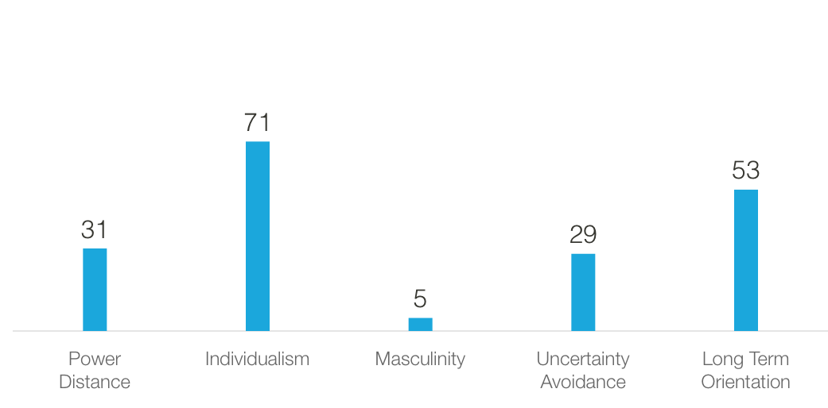
Source from: https://www.hofstede-insights.com/country-comparison/sweden/
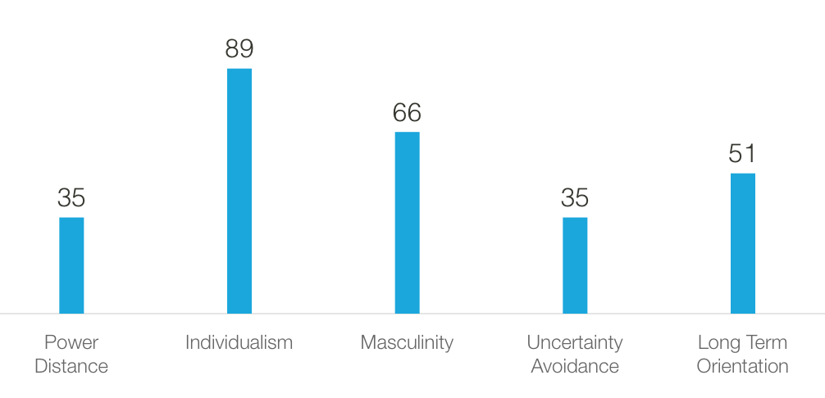
Source from: https://www.hofstede-insights.com/country-comparison/the-uk/

3.0 Recommendations

Sweden and the United Kingdom have numerous commonalities on a global scale. As a result, when Britain wants to conduct business in Sweden, it will not face a significant cultural influence, but it should keep a few things in mind.

First and foremost, while doing business overseas, we must make enough preparations and planning to avoid cultural differences having a significant negative influence on commercial transactions (Johnson, Lenartowicz, & Apud, 2006). Although there are many parallels between the United Kingdom and Sweden, there are also significant variations in terms of tolerance and cultural diversity. The British still have a lot of work to do when it comes to avoiding fights at the start of a new relationship. The Swedes are a country that values tolerance and acceptance. Don't become irritated if the conversation devolves into an argument and the Swedes abruptly change the subject. As previously said, Swedes will speak for a long time before finding fresh common ground, yet all of their agreements are built on steady emotions.

Additionally, when conversing, avoid employing complex jargon. Swedes, with their aversion to embellishing the facts, like to be direct. They despise the rank or status symbol.

Finally, don't bring up the subject of privacy. Swedes want to strike a healthy work-life balance (Hobson, Fahlén, & Takács, 2011). Work is work, after all. Private issues should be avoided throughout the early stages of a relationship's development. Swedes are proud of their own society, not to mention their social structure and way of life.

Finally, avoid prejudice and discrimination based on gender. Despite the fact that Sweden is a typical feminized society, it is merely a social culture that cannot be compared to Britain, which is a typical masculine society.

4.0 Conclusion
It is critical to learn multicultural communication in order to properly carry out international interactions. This study compares and contrasts the cultures of the United Kingdom and Sweden. It is examined on five separate levels. Cultural distinctions between the two countries, on the other hand, are minor. Many civilizations are similar to one other in various ways. As a result, compared to countries with significant cultural differences, the trade barriers that the two countries would face will be minor. The related ideas are presented at the end of the section in order to increase communication, efficiency, and bring advantages. In any instance, be completely prepared by thoroughly understanding the other party's nation, grasping potential issues and analyzing and preventing them ahead of time.

5.0References
Arasaratnam, L. A. (2013). Intercultural communication competence. In A. Kurylo (Ed.), Intercultural communication: Representation and construction of culture (Chap 3, pp. 47-68). Los Angeles, CA: SAGE Publications.

Chen, G. M., & Starosta, W. J. (1998). Foundations of intercultural communication: Boston, MA: Allyn & Bacon.

Lustig, M. W., & Koester, J. (2007). Intercultural competence: interpersonal communication across cultures (5th ed.). Shanghai, China: Shanghai Foreign Language Education Press.

Moran, R.T., Harris, P.R., & Moran, S. (2007). Managing Cultural Differences (7th ed.). Routledge. https://doi.org/10.4324/9780080471488

Karen Anderson-Lain. (2017) Cultural identity forum: Enacting the self-awareness imperative in intercultural communication. Communication Teacher 31:3, pages 131-136.

Adrian Toomey, Tenzin Dorjee, Stella Ting-Toomey. (2013) Bicultural Identity Negotiation, Conflicts, and Intergroup Communication Strategies. Journal of Intercultural Communication Research 42:2, pages 112-134.

Stella Ting-Toomey. 2013. Face-Negotiation Conflict Theory. The Encyclopedia of Cross-Cultural Psychology, pages 535-539.

Stella Ting-Toomey (2010) Applying Dimensional Values in Understanding Intercultural Communication, Communication Monographs, 77:2, 169-180, DOI: 10.1080/03637751003790428

Geert Hofstede (1980) Culture and Organizations, International Studies of Management & Organization, 10:4, 15-41, DOI: 10.1080/00208825.1980.11656300

Belias, D., & Koustelios, A. (2014). LEADERSHIP AND JOB SATISFACTION--A REVIEW. European Scientific Journal, 10(8).

Wennekers, S., Thurik, R., van Stel, A., & Noorderhaven, N. (2010). Uncertainty avoidance and the rate of business ownership across 21 OECD countries, 1976–2004. In Entrepreneurship and Culture (pp. 271-299). Springer, Berlin, Heidelberg.

Chen, C. C., Chen, X. P., & Meindl, J. R. (1998). How can cooperation be fostered? The cultural effects of individualism-collectivism. Academy of management review, 23(2), 285-304.

Mac an Ghaill, M. (1996). Understanding masculinities: Social relations and cultural arenas. McGraw-Hill Education (UK).

Hofstede, G. H., Hofstede, G., Arrindell, W. A., & Hofstede, G. H. (1998). Masculinity and femininity: The taboo dimension of national cultures (Vol. 3). Sage.

Hofstede Insights, 2021. Accessed Dec 17, 2021. https://www.hofstede-insights.com/country-comparison/sweden/

Hofstede Insights, 2021. Accessed Dec 17, 2021. https://www.hofstede-insights.com/country-comparison/the-uk/

Van Niewerburgh, C. (Ed.). (2018). Coaching in education: Getting better results for students, educators, and parents. Routledge.

Johnson, J. P., Lenartowicz, T., & Apud, S. (2006). Cross-cultural competence in international business: Toward a definition and a model. Journal of international business studies, 37(4), 525-543.

Hobson, B., Fahlén, S., & Takács, J. (2011). Agency and capabilities to achieve a work–life balance: A comparison of Sweden and Hungary. Social Politics, 18(2), 168-198.

Ng, E. S., & Lillevik, W. (2017). 27. Intercultural communication in the world of business. In Intercultural Communication (pp. 597-616). De Gruyter Mouton.

Gibson, R. (2002). Intercultural Business Communication: An Introduction to the Theory and Practice of Intercultural Business Communication for Teachers, Language Trainers, and Business People. Oxford University Press.

Prostko, J. (1985). Instructive and delightful talk: conversation and eighteenth-century English literature. Stanford University.

Goodman, M. B. (2013). Intercultural communication for managers. Business Expert Press.

Nishikawa, S., Norlander, T., Fransson, P., & Sundbom, E. (2007). A cross-cultural validation of adolescent self-concept in two cultures: Japan and Sweden. Social Behavior and Personality: an international journal, 35(2), 269-286.

Daun, Å. (2021). Swedish mentality. Penn State University Press.

Post, J. E., Preston, L. E., & Sachs, S. (2002). Managing the extended enterprise: The new stakeholder view. California management review, 45(1), 6-28.

Tixier, M. (1996). Cultural adjustments required by expatriate managers working in the Nordic countries. International Journal of Manpower.

