Inclusive education

Additional Needs in Context ECIE4003
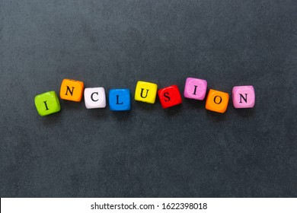
Catherine Anne Salter (2009547)
2021

Contents

Cover page 1
Contents 2
Introduction 3
Element 1: Poster – Demonstrate your understanding of the different models of disability. 4
Reference list for poster 5
Element 2: How do current policies, legislation and frameworks link to the theoretical approaches on the poster. 6
Element 3: Identify how your setting supports the development of a pupil or a group of pupils with an additional learning need/additional learning needs. 8
Element 4: Discuss the support provided to your chosen pupil or a group of pupils and compare with the key principles/ approaches and policies that guide inclusive practice. 10
Conclusion 12
References 13
Appendices 16
Appendix 1 16
Appendix 2 17

Introduction

“The 1918 Education Act, made schooling for all disabled children compulsory. It was a very significant piece of legislation” (Historic England, 2021). This was a positive move forward, and although before this legislation the local authorities were responsible for the education of the deaf and blind, children with physical and mental learning disabilities, were often hidden and forgotten (Historic England, 2021).
Elements 1 and 2 of this portfolio the author is going to demonstrate their understanding of different models of disability and looking at the history of changes and how they relate to current legislation, policies, and frameworks.
This is going to be focused primarily on how they are link to the current educational sector and how children and young people with special educational needs and disabilities are supported to achieve in mainstream schools and not just placed in special schools or hidden from society.

Elements 3 and 4 are looking at a case study of a child with Cerebral palsy. According to the pace centre there is estimated to be 30,000 children in the UK diagnosed with Cerebral palsy, in a paper released in 2021 on the Determinants of inclusive education of 8–12-year-old children with cerebral palsy in 9 European regions it showed that out of 115 children with cerebral palsy in the north of England only 60% of them attended mainstream school (Sentenac et al, 2012, p. 590). The case study focuses on a 7 year old boy with cerebral palsy and how his current mainstream school support or not support his educational and developmental needs. Looking at barriers which are and have been in place, along with how new legislation coming into force across the UK, is making sure that all schools are working together with the child, their parents/carers, and other outside agencies, to make sure that all needs are being met for the child to reach their full potential.

Element 1: Poster – Demonstrate your understanding of the different models of disability.
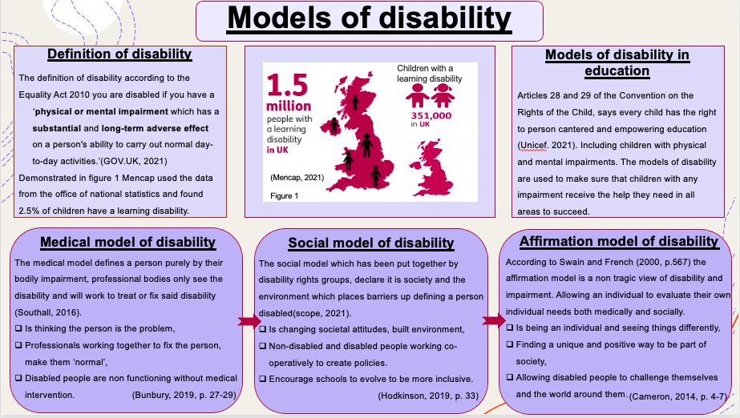

Reference list for poster
Bunbury, S. (2019) ‘Unconscious bias and the medical model: How the social model may hold the key to transformative thinking about disability discrimination’, International Journal of Discrimination and the Law, 19(1), pp. 26–47. DOI: 10.1177/1358229118820742. (Accessed: 11 August 2021).
Cameron, C. (2014) Disability Studies: A Student's Guide. London: SAGE
Hodkinson, A. (2019) Key issues in special educational needs, disability & inclusion. 3rd Ed. London: Sage.
John, S and S, French. (2000) ’Towards an Affirmation Model of Disability’, Disability & Society, 15(4), pp. 569-582. DOI: 10.1080/09687590050058189 (Accessed: 11 August 2021).
Mencap (2021) Learning disability explained. Available at: https://www.mencap.org.uk/learning-disability-explained/research-and-statistics/how-common-learning-disability (Accessed: 12 August 2021).
Scope (2021) Social model of disability. Available at: https://www.scope.org.uk/about-us/social-model-of-disability/?gclid=EAIaIQobChMI7uHM8o6m8gIV0OvtCh0stA-tEAAYASAAEgINZfD_BwE (Accessed: 11 August 2021).
Southall, J. (2016) Models of disability. Available at: https://jboccupationaltherapy.co.uk/models-of-disability/ (Accessed: 15 August 2021).
UK government guidance and support (2021) Definition of disability under the equality act 2010. Available at: https://www.gov.uk/definition-of-disability-under-equality-act-2010 (Accessed: 11 August 2021).
UNICEF (2021) Rights respecting schools, the right to education. Available at: https://www.unicef.org.uk/rights-respecting-schools/the-rrsa/the-right-to-education/ (Accessed: 13 August 2021).
Figure1
Mencap (2021) Learning disability explained. Available at: https://www.mencap.org.uk/learning-disability-explained/research-and-statistics/how-common-learning-disability (Accessed: 12 August 2021).

Element 2: How do current policies, legislation and frameworks link to the theoretical approaches on the poster.
According to Mencap, (2021) There are over 351.000 children in the United Kingdom with a learning difficulty and under the UN convention on the rights of the child, every child is intitled to an inclusive education (unicef, 2021). So how does this work, before 1978 education was heavily influenced by the medical model of disability, children who could not function within the everyday classroom due to an impairment was classed as ‘sub-normal’ or ‘maladjusted’. These children were identified by their impairment as handicapped and sent to special schools which would be equipped to deal with their “category’ (Clough, 2006, p. 3-4). In 1973 the Secretary of State for Education Margaret Thatcher, put together a committee of educational and medical professionals, and one parent. This committee was to enquire into the education of handicapped children and young people (Great Britain and Warnock, M, 1978). The final report known as the Warnock report was presented to parliament in 1978, this report highlighted the failures of providing special educational provisions, through the findings of this report, special educational needs (SEN) was introduced to Britain (Lindsay et al, 2020, p164). The Warnock report played a huge part in the education act being updated in 1981 focusing on the student’s needs, “The local educational authorities were given the responsibility to identify needs that required provision in addition to what was normally available in schools” (Wearmouth, 2019, p. 65). This is the first step forward to all children being educated in mainstream schools, along with parents being consulted on how best to meet their child’s needs and allowing them to appeal against decisions made for their child by the local authority (Wearmouth, 2017, p. 36). The Warnock report influenced a shift from the medical model of disability into the social model of disability, recognising the individual not the impairment, the report has continued to influence legislation, with a change in the Education Act 1996, and the introduction of the Children and families Act in 2014 (Lindsay et al, 2020, p164).
Alongside these Acts the four nations across Britain started to develop their own codes of practice regarding Special educational needs and disabilities (SEN/ SEND), its these codes of practice that further influenced the movement away from the medical model by emphasizing the child’s development in four key areas ( Squires, 2012, p. 17 ) however it was the nationwide Equality Act 2010 which consolidated all previous legislation relating to disability and education discrimination, that is moving the educational and medical professionals forward in understanding there is a need for both medical and social model of disability but from the perspective of the individual, the affirmation model of disability allows the disabled person to have control of their own outcomes (Hodkinson, 2019, p. 39). With these changes in legislations and current SEND codes of practice for 0-25 year olds, schools are forming their Special educational needs and inclusion policies to ensure that their SEND provisions have a holistic vision, making sure there are good multi agency relations, as well as keeping the student and the family at the centre of all decisions (School A, 2021). Currently in Wales there is a change regarding SEND with the introduction of the Additional Learning Needs (ALN) Bill.
The Additional Learning Needs and Education Tribunal (Wales) Act 2018 (The Act) makes provision for a new statutory framework for supporting children and young people with additional learning needs (ALN) (Gov.Wales. 2018).
The ALN bill has uniformed plans, creating a single statutory document, the individual development plan (IDP) (see appendix 1), IDP will replace the existing variety of statutory and non-statutory SEN plans such as behaviour plans, pastoral support plans, personal handling plans. The IDP will be developed once a leaner has been identified with ALN and will follow a person-centred approach. The IDP will be reviewed annually or following a significant event in the life of the child or young person. This will be creating a consistent document that follows the child through their educational journey (Gov.Wales. 2018).

Element 3: Identify how your setting supports the development of a pupil or a group of pupils with an additional learning need/additional learning needs.

This section is going to be looking at a young boy (child A) who is aged seven, who has a diagnosis of Cerebral Palsy and how his current school is providing for his needs.
Child A comes from a family of five containing, mum, dad, teenage sister, and his twin brother. Mum and dad have recently separated, and the three children remain living with mum. Child A is one of twins, the other twin has no additional learning needs or medical issues. Child A attends the same mainstream school alongside his twin brother and joins in with the same friendship group.

What is Cerebral palsy?
Cerebral palsy is the name for a group of lifelong conditions that affect movement and co-ordination. It's caused by a problem with the brain that develops before, during or soon after birth (NHS, 2021).
All children who have a diagnosis of cerebral palsy have movement difficulties, however as cerebral palsy is due to a disturbance to the development of the fatal brain, this can also affect learning, perception, communication, eating and drinking. Although the brain of a child with cerebral palsy is permanently damaged and cannot be changed, care and experiences can affect a child’s development (Cerebral palsy Cymru, 2021)
There have been several studies that have looked at cerebral palsy and multiple births, one study by Pharoah, Price and Plomin (2002), Cerebral palsy in twins: A national study was carried out in 1994-1995, their aim was to see if birthweight had any contributing factors to cerebral palsy in children. This study highlighted there is a greater risk of cerebral palsy in multiple births, rather than singletons and an even greater risk if they are same sex.

How does cerebral palsy affect child A?
When child A was born, he suffered a perinatal lack of oxygen due to complications during his birth. This influences Child A’s development, his gross motor function scores a level 2 according to the Gross motor function classification system (see appendix 2), this means he has a wide range of movement however he struggles with balance and coordination, hopping, skipping, and walking a narrow line is difficult. He finds fine motor skill tasks difficult due to lack of strength in fingers, he has little grip which is a problem holding and controlling a pencil or paint brush, leading to his written work being illegible. Both his gross and fine motor skill issues influence his self-care, such as brushing his teeth or getting himself dressed. His speech is slow, quiet, and slurred, resulting in him having to repeat what he is saying a few times before he is understood. Along with his developmental delay child A has intellectual impairment, meaning his thought process is affected, although Child A is seven, and just completed year two in primary he has a reading level of a three-year-old and is struggling in both with literacy and numeracy functioning at a much lower level then his peers (Child A’s IDP, School A, 2021).

How does the school support Child A?
Child A has a completed IDP which highlight what is needed for him to successfully access an inclusive education. As soon as all the children arrive on a school morning before register is take, the children part take in dough disco, dough disco was invented by Shonette Bason a fun activity using dough and music, dough disco aids their fine motor skills, squeezing the dough helps to build the muscles in their hands and fingers (Spread the happiness, 2021). Every day for thirty minutes Child A is taken out of class to receive catch up sessions with Miss J who is a higher-level teaching assistant. Miss J covers literacy, reading and numeracy, through games and worksheets. Child A is not always alone during these sessions and other children of similar development will attend. After lunch Child A is again removed from class by his class higher level teaching assistant, who will run through fine motor skill activities; pencil control, threading beads, nuts, and bolts and his daily speech and language exercises using picture cards to help with word association, mirrors for mouth formation and repetition so he can get use to the sound and feel of the word.

Element 4: Discuss the support provided to your chosen pupil or a group of pupils and compare with the key principles/ approaches and policies that guide inclusive practice.

There have been two barriers in place which has stopped child A from receiving much needed support in his early years of education.
Child A has always attended the same mainstream primary school; however, it has only been the last eighteen months child A and many others have received the necessary support. This was due to a lack of senior leadership within the school, the head had been on long term sick and the deputy head who was also the ALNco at the time was not full filling their duties. Eighteen months ago, the school underwent a reform, with a new Head teacher appointed, and a new ALNco put in place. Since this restructuring of staff there has been a significant change in support for children within the school.
The other barrier was his parents, as child A has mild cerebral palsy his parents didn’t want to label him and hoped he would just grow out of it as he got older. Combined with his parents’ attitude, little to no action from the ALNco early on and little information being passed on to class teachers, child A only received basic support resulting in his development deteriorating.
Since the change in ALNco who is now following the new ALN bill, there has been a meeting with the parents, where child A’s IDP was started. This led to a joint referral from both parents and school to child A’s doctor, for him to be assessed by a consultant regarding his physical development, this resulted in him being assigned a physiotherapist. Physiotherapist’s main goal for a child with cerebral palsy is to help the child stay as mobile and independent as possible, developing a daily routine of exercises which will help with mobility. The physiotherapist will work with both parents and key members of school training them to assist the child to complete their daily exercise program (Chartered society of physiotherapy, 2021).
The school also put in a referral to the local authority inclusion services, who are committed in making sure all children with additional needs gain the support they need allowing them to be fully included in mainstream school (Local authority A, 2021). The inclusion team will work with the school, parents, and child to assess what is needed and they will assist in putting in the relevant referrals. In Child A’s case a referral was submitted for speech and language therapy (SLT). Speech and language therapists will assess all areas of communication, how well can the child communicate as well as how much they can understand, they will also aid in any feeding issues, as the muscles which are used in speech are the same used to chew and swallow (Stanton, 2012, p. 67). The SLT team attended the school assessing child A and put together a program of exercises and activities which will help progress child A’s speech and communication.
Under school A’s ALN policy, following the result of all the referrals child A’s IDP has been continuously updated and all parties concerned in Child A’s education, health and welfare have been kept up to date with any changes, the IDP is reviewed every 6 weeks (School A, 2021). The current support and strategies in place for child A are all practised outside of the classroom, under the new ALN bill this will be changing with the focus being that all interventions are to be inclusive in the classroom, this helps the child to stay part of the class and continue to work and develop alongside their peers. With these changes and the implementation of a unified plan (IDP) will hopefully help to develop closer multi-agency and cross-sector working practices, which will assist in providing the person cantered approach which is needed for Child A to thrive and develop to his full potential.

Conclusion

The new additional learning needs legislation coming in to force across all education sectors, is helping to pull together all resources to aid a child with learning difficulties succeed in mainstream school, these new ALN laws are reenforced by the equalities act 2010, which states every child has the right to inclusive education within a mainstream school (Welsh government, 2019). Looking at the disability models in elements 1 and 2, it was clear the medical model and the social model worked in their own way; however, they have become outdated, and a new approach is needed, the affirmation model is getting closer to where societies outlook should be. The reform of inclusive education is helping to make a child with learning difficulties experience a person cantered approached through their educational journey assisting them to achieve their full potential.
Schools are working hard to implement the new ALN policies and procedures, all staff are being trained on ALN awareness as well as focused training for staff to support learnings in their inclusive education. Its still not perfect as was demonstrated with child A, the school failed this child in his early years and thankfully with new staffing and multiagency cooperation child A will hopefully continue to receive the help and support to exceed in his learning and development.

References
Armstrong, D and Squires, G. (2012) Contemporary issues in Special educational needs considering the whole child. Maidenhead: Open university press.

Cerebral palsy Cymru (2021) What is Cerebral palsy?
Available at: https://www.cerebralpalsycymru.org/about-cerebral-palsy/what-is-cerebral-palsy/cerebral-palsy (Accessed: 19th August 2021).

Clough, P and Corbett, J. (2006) Theories of inclusive education. London: Paul Chapman publishing.

Chartered society of physiotherapy (2021) How can physiotherapy help with cerebral palsy?
Available at: https://www.csp.org.uk/conditions/cerebral-palsy#how-can-physiotherapy-help-cerebral_palsy (Accessed: 19th August 2021).

Lindsay, G et al. (2020) ‘40 Years on: The Development of Special Educational Needs Since the Warnock Report and Implications for the Future’, Frontiers in Education, 4, pp. 164. DOI=10.3389/feduc.2019.00164 (Accessed: 19th August 2021).
Great Britain., & Warnock, M. (1978). Special educational needs: Report of the Committee of Enquiry into the Education of Handicapped Children and Young People. London: H.M.S.O.
Historic England. (2021) The Right to Education - the Growth of the 'Special' School for Children with Disabilities. Available at: https://historicengland.org.uk/research/inclusive-heritage/disability-history/1914-1945/the-right-to-education/ (Accessed: 19th August 2021).
Hodkinson, A. (2019) Key issues in special educational needs, disability, and inclusion. 3rd Ed. London: Sage publications ltd.
[Local Authority A] (2021) Inclusion services. [Local Authority A] web page (Accessed: 19th August 2021).

Mencap (2021) Learning disability explained. Available at: https://www.mencap.org.uk/learning-disability-explained/research-and-statistics/how-common-learning-disability (Accessed: 12 August 2021).

NHS (2021) Cerebral palsy. Available at: https://www.nhs.uk/conditions/cerebral-palsy/ (Accessed: 18 August 2021).

Palisano, R et al. (1997) Gross motor function classification system
Available at: https://cparf.org/what-is-cerebral-palsy/severity-of-cerebral-palsy/gross-motor-function-classification-system-gmfcs/?gclid=EAIaIQobChMIpfPUhanR8gIVn4FQBh0ZCQOyEAAYASAAEgILGvD_BwE (Accessed: 13 August 2021).

Pharoah, P et al (2002) ‘Cerebral palsy in twins: A national study’. Archives of disease in childhood. Fatal and neonatal edition, 87, pp. 122-124. Available at: https://www.researchgate.net/publication/11193762_Cerebral_palsy_in_twins_A_national_study (Accessed: 19 August 2021).

[School A] (2021) Child A’s IDP. [Local authority A]: [School A]. Unpublished.

[School A] (2021) Blank IDP. [Local authority A]: [School A]. Unpublished

Sentenac, M et al (2012) ‘Determinants of inclusive education of 8–12-year-old children with cerebral palsy in 9 European regions’, Research in Developmental Disabilities, 34 (1), pp. 588-595. Available at: https://research.ncl.ac.uk/sparcle/Publications_files/Published%20article%20Schooling%20and%20%20cerebral%20palsy.pdf (Accessed: 19 August 2021).

Spread the happiness (2021) What is Dough Disco? Available at: https://www.spreadthehappiness.co.uk/dough-disco/ (Accessed: 19 August 2021).

Stanton, M. (2012) Understanding cerebral palsy, A guide for parents and professionals. London: Jessica Kingsley publications.

UNICEF (2021) Rights respecting schools, the right to education. Available at: https://www.unicef.org.uk/rights-respecting-schools/the-rrsa/the-right-to-education/ (Accessed: 13 August 2021).

Wearmouth, J. (2017) Special educational needs and disability in schools. London: Bloomsburg.

Wearmouth, J. (2019) Special educational needs and disability the basics, a critical introduction. 3rd Ed. Oxon: Routledge.

Welsh government (2018) Additional learning needs and education tribunal (Wales) Act. Available at: https://gov.wales/sites/default/files/publications/2018-02/additional-learning-needs-and-education-tribunal-wales-act-2018-explanatory-memorandum.pdf (Accessed: 18 August 2021).

Welsh government (2019) The Additional Learning Needs (ALN) Transformation Programme Frequently Asked Questions (FAQs). Available at: https://gov.wales/sites/default/files/publications/2019-02/aln-frequently-asked-questions-2_0.pdf (Accessed: 18 August 2021).

Appendices
Appendix 1
A copy of a blank IDP
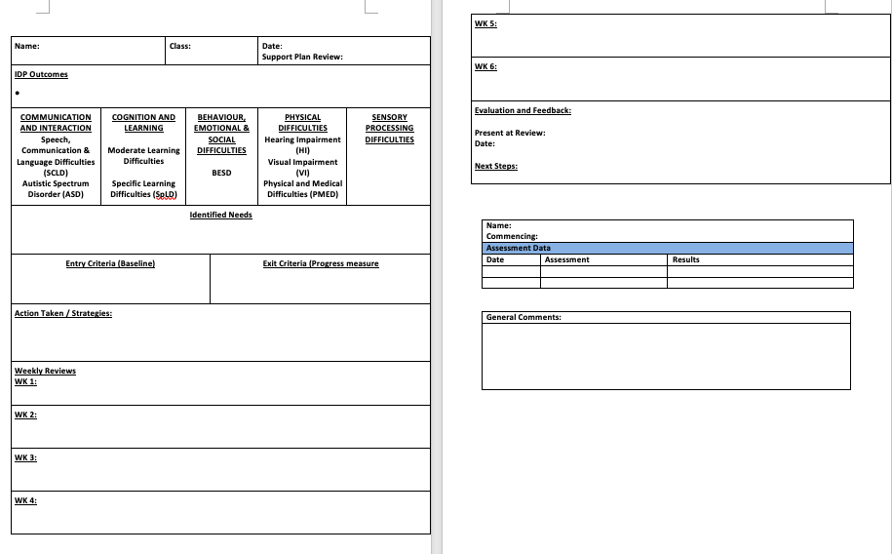.
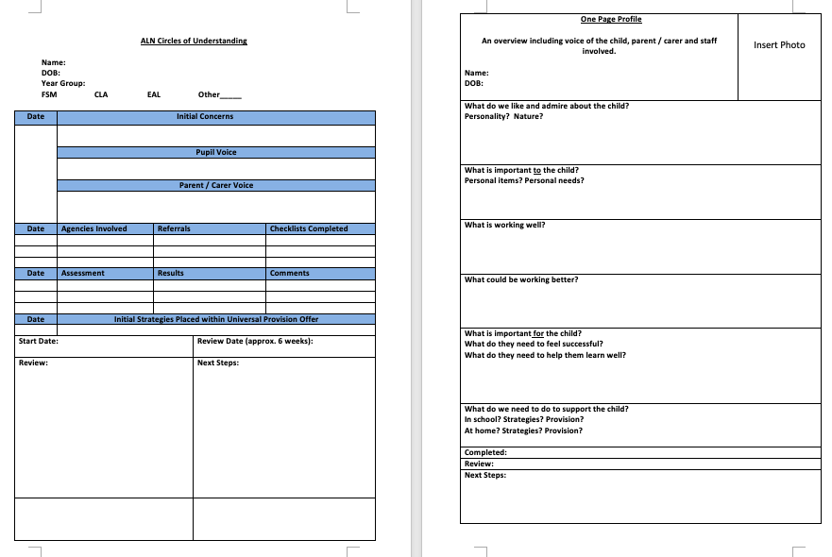

Source: [School A] (2021).

Appendix 2

Gross motor function classification system

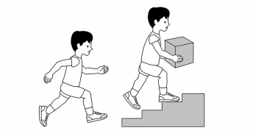

GMFCS Level I
- Can walk indoors and outdoors and climb stairs without using hands for support
- Can perform usual activities such as running and jumping
- Has decreased speed, balance, and coordination.
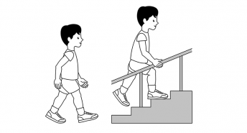

GMFCS Level II
- Has the ability to walk indoors and outdoors and climb stairs with a railing
- Has difficulty with uneven surfaces, inclines or in crowds
- Has only minimal ability to run or jump.
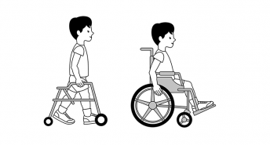

GMFCS Level III
- Walks with assistive mobility devices indoors and outdoors on level surfaces
- May be able to climb stairs using a railing
- May propel a manual wheelchair (may require assistance for long distances or uneven surfaces).
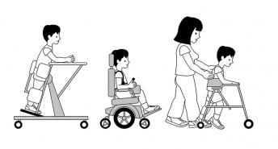

GMFCS Level IV
- Walking ability severely limited even with assistive devices
- Uses wheelchairs most of the time and may propel their own power wheelchair
- May participate in standing transfers.
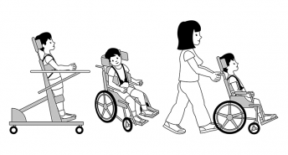

GMFCS Level V
- Has physical impairments that restrict voluntary control of movement and the ability to maintain head and neck position against gravity
- Is impaired in all areas of motor function
- Cannot sit or stand independently, even with adaptive equipment
- Cannot independently walk, though may be able to use powered mobility.

Source: Palisano, R et al. (1997).

