

Programme: BSc Health and Social Care
Student Name: Sophia Pitter
Student number: 2409134
Module: Changemakers: Building your Personal Brand for Sustainable Employment
Module code: BMHP5015
Assignment title: Component 1: Online Portfolio of Set Exercises
Lecturer Name: Olufemi Oluranti
Word count: 406
(Research Proposal)

Task 1 – Personal Brand
A personal brand is the professional standing, morals, abilities and conducts that differentiate a person from others and impact how they are perceived in the workplace (CIPD, 2024). In the health and social care area, my personal brand is centred on sympathy, professionalism, active communication and a dedication to providing person-centred care. I believe these potentials allow me to build trusting relations with clients, equals and multidisciplinary teams, while keeping high morals of ethical practice (NHS England, 2023).
My lasting career aim is to become a registered healthcare expert employed within the NHS. To realise this desire, I know that I need to carry on improving my knowledge, medical skills and self-assurance over education, work knowledge and reflective practice. Improving emotional intelligence will likewise support my capability to manage challenging circumstances, determine compassion and communicate successfully with persons from varied backgrounds (Goleman, 2020). Additionally, appealing in on-going professional development (CPD), joining training developments and looking for positive feedback from managers will support me enhance my professional ability (HCPC, 2024).
Additional significant aspect of my individual brand is indicating consistency, responsibility and esteem for equality, diversity and inclusion. Companies in health and social care value workforce who may work jointly, acclimatise to shifting settings and deliver safe, compassionate care (NHS England, 2023). By keeping a constructive online professional attendance, expanding my professional system and maintaining my knowledge up to date with NHS approaches and evidence-based practice, I may improve my employability (CIPD, 2024). In general, improving my personal brand will allow me to determine the professional conducts projected in the health and social care area and augment my opportunities for future career development.

Task 2 - Network Map and Rationale

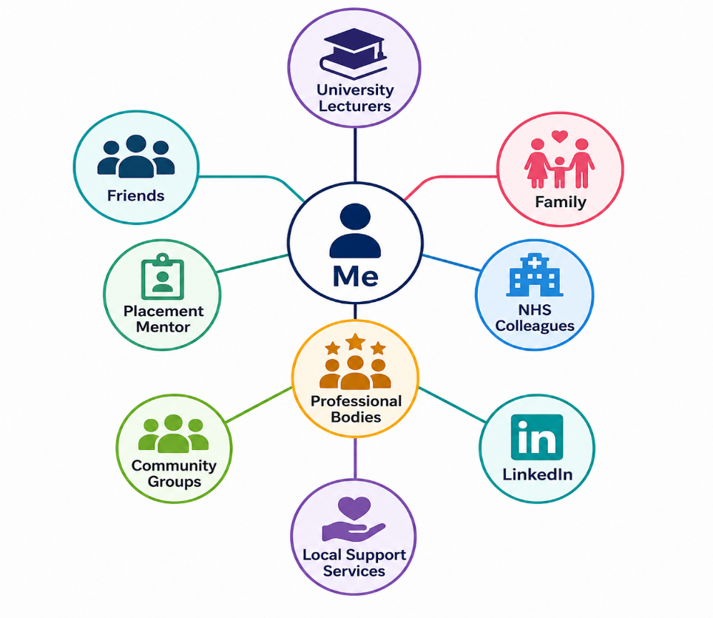

Rationale
My professional and individual system plays an imperative role in supporting my career growth in health and social care. At the core of my system is myself, as I am accountable for building and keeping constructive relations that subsidise to my individual and professional growth (CIPD, 2024).
My household and friends give emotional inspiration, incentive and practical support through periods of study and work-related strain. University lecturers present academic direction, positive feedback and profession advice that support me develop knowledge and critical thinking abilities. Placement counsellors and NHS equals offer chances to improve practical knowledge, enhance clinical ability and comprehend professional standards in healthcare environments (NHS England, 2023).
Professional bodies for example the appropriate Royal College offer access to continuing professional development, study, networking chances and evidence-based practice direction. LinkedIn allows me to build a professional online attendance, link with healthcare specialists and identify job opportunities. Community bodies and voluntary groups widen my comprehension of diverse people whereas strengthening communication and collaboration abilities (Health Education England, 2022).
Keeping a varied link augments access to data, mentoring and career opportunities. Conferring to Granovetter's theory of weak ties, expert contacts outside close individual relations frequently offer valued job opportunities and new understandings (Ryan, 2016). Networking likewise subsidises to career flexibility by presenting support through transitions, promoting knowledge sharing and encouraging lifetime learning (CIPD, 2024). Thus, actively evolving my network will reinforce my employability and support me realise my long-standing career objectives in the UK health and social care area.

Task 3- Blog

The Importance of Mental Health Support for NHS Staff
Working in the UK health and social care subdivision may be worthwhile, but it is likewise bodily and psychologically challenging. Healthcare specialists often care for individuals facing disease, trauma and end-of-life circumstances whereas handling heavy workloads and workforce shortages. Accordingly, safeguarding the mental health and wellbeing of NHS personnel has become more and more significant (NHS England, 2023).
This blog is intended at health and social care learners and recently employed NHS workforce who are preparing to enter the personnel. The comprehension of the significance of keeping better mental health from the start of a career may enhance resilience, job pleasure and the quality of patient care.
Strain, exhaustion and anxiety have become important worries inside the NHS. Long shifts, psychological burden and staff shortages may negatively impact personnel wellbeing, leading to augmented illness absence, decreased morale and problems in retaining skilled staffs (Health and Safety Executive (HSE), 2023). Stress might likewise affect attentiveness and decision-making, possibly compromising safety of patients. Thus, supporting personnel wellbeing profits both healthcare workforces and the patients they are caring for (NHS England, 2023).
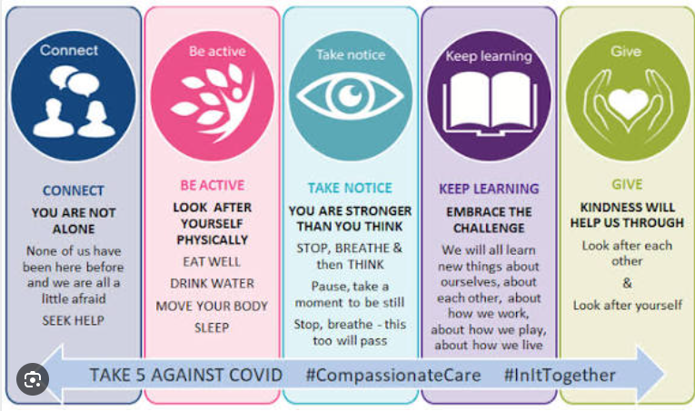
Source: NHS England (2023).
The NHS has presented numerous creativities to enhance personnel wellbeing. These consist of access to mental health facilities, wellbeing carers, occupational health support, flexible working provisions and private counselling facilities. Many NHS bodies likewise inspire personnel to speak clearly concerning mental health and generate emotionally safe places of work where staffs feel relaxed raising concerns deprived of fear of discrimination or culpability (NHS England, 2023).
Healthcare specialists likewise have an individual duty to safeguard their individual wellbeing. This might include preserving a healthy work-life stability, looking for support from equals, practising stress-management methods and knowing the early signs of exhaustion. Systematic reflective practice, supervision and on-going professional growth may help personnel build resilience and grow effective coping approaches (Skills for Care, 2024).
Generating a culture where mental health is valued is indispensable for the future of health and social care. Leaders must carry on encouraging equality, inclusion and wellbeing whereas certifying personnel have access to suitable support facilities. When healthcare workforces feel valued, supported and appreciated, they are more probable to keep on in the profession and offer compassionate, high-quality care. Investing in personnel wellbeing is thus not just helpful for staffs but also subsidises to healthier patient results and a stronger NHS (NHS England, 2023).

Task 4- NHS Equality, Diversity and Inclusion Quiz
- What is the primary goal of the NHS Equality, Diversity, and Inclusion Improvement Plan?
The main objectives are to generate a reasonable, inclusive and respectful NHS where all personnel have equal opportunities to flourish, feel valued and are capable to offer high-quality patient care regardless of their contextual (NHS England, 2023).

- How does the NHS EDI Improvement Plan propose to tackle the gender pay gap?
The plan purposes to enhance pay transparency, support reasonable staffing and promotion procedures, and augmented career development opportunities for women across the NHS personnel (NHS England, 2023).

- What is meant by the term ‘intersectionality’ as used in the NHS EDI Improvement Plan?
Intersectionality knows that persons might face various forms of discrimination or disadvantage since of the blend of their protected features and individualities (NHS England, 2023).

- Why is it important for the NHS to create a psychologically safe work environment?
A emotionally safe workplace allows personnel to speak openly, report worries, learn from errors and contribute thoughts deprived of fear of bullying, blame or discrimination (NHS England, 2023).

- How does the NHS EDI Improvement Plan suggest improving the experience of internationally recruited staff?
The plan suggests healthier induction programs, pastoral support, reasonable career progress opportunities and action to stop discrimination and mistreatment (NHS England, 2023).

- What role does leadership play in advancing EDI objectives according to the NHS Improvement Plan?
Leaders are projected to model inclusive behaviours, encourage equality, challenge discrimination and certify responsibility for attaining EDI aims across their establishments (NHS England, 2023).

- Identify one way the NHS EDI Improvement Plan aims to reduce health inequalities within the workforce.
The plan encourages fair staffing, equal access to training and career development, and targeted support for under-represented staff groups (NHS England, 2023).

- Why does the NHS EDI Improvement Plan emphasise the importance of collecting and analysing data on protected characteristics?
Gathering staff information helps establishments detect inequalities, monitor improvement and develop evidence-based activities to enhance equality and inclusion (NHS England, 2023).

- Explain how flexible working policies can contribute to equality and inclusion in the NHS workforce.
Flexible working allows staffs with caring tasks, infirmities or health conditions to keep on in employment whereas attaining a well work-life balance and equal career opportunities (NHS England, 2023).

- What is one strategy mentioned in the NHS EDI Improvement Plan to combat bullying and harassment in the workplace?
The plan reassures establishments to apply clear reporting actions, deliver leadership responsibility and take quick action contrary to bullying, harassment and discrimination whereas supporting affected workforce (NHS England, 2023).

Task 5- A Letter to Yourself

Dear Self,

I acknowledge that there were instances when you had feelings of overwhelm due to uncertainty, self-doubt, and the challenge of reconciling your academic obligations with personal duties. You previously perceived requesting assistance as a manifestation of weakness; nevertheless, I now recognise that seeking support is among the most significant strengths one can exhibit. One lesson I would impart is to trust yourself and acknowledge that problems present possibilities for progress rather than justifications for surrender.
A highly valuable skill I have acquired is emotional intelligence. Comprehending your own emotions and discerning the feelings of others might have facilitated a more composed response in stressful times. Rather than responding to setbacks with exasperation, one should have contemplated the circumstances, derived insights from the experience, and progressed with enhanced assurance. Enhancing empathy would have fortified your relationships with family, friends, classmates, and colleagues, particularly in health and social care, where compassion and good communication are crucial.
I have also learned that resilience entails not evading challenges but rather adjusting to and recuperating from them. Obstacles, disappointments, and instances of unfulfilled plans will invariably arise. Nonetheless, each difficulty contributes to the development of confidence, knowledge, and resolve. Prioritising your welfare through the maintenance of a healthy work-life balance, the practice of self-care, and the solicitation of support, when necessary, would have facilitated the management of numerous challenging situations.
Bear in mind that success does not occur instantaneously. Exercise patience towards yourself, acknowledge your advancements, and refrain from juxtaposing your journey with that of others. Pursue knowledge, embrace constructive criticism, and have confidence in your capacity to attain your objectives. Each event, whether favourable or unfavourable, shapes the individual and healthcare professional you are evolving into. Maintain kindness, uphold determination, and never forget the rationale behind your pursuit of a career in health and social care—to effectuate a positive impact on the lives of others.

With appreciation,

Yours Sophia

Task 6- GANTT Chart
Tasks | 2026 | 2027 | 2028 | 2029
Complete current qualification
Achieve good academic grades
Develop communication and teamwork skills
Attend mandatory training (Safeguarding, BLS, Infection Control)
Gain work placement/volunteering experience
Build a professional LinkedIn profile and CV
Join a professional body
Continue CPD and additional training
Apply for NHS jobs
Attend interviews
Secure NHS employment
Progress through CPD and career development

Explanation:
This Gantt chart delineates a systematic schedule for attaining my prospective employment objectives in the health and social care industry. My primary objective is to conclude my present qualification while attaining excellent academic achievements, as they are crucial prerequisites for work within the NHS (NHS Health Careers, 2024). During this phase, I also plan to cultivate vital employability skills, including communication, teamwork, and professionalism, through academic instruction and work placements.
In conjunction with my studies, I will undertake compulsory training in safeguarding, infection prevention, and basic life support to enhance my understanding of safe practices. Creating a good CV and LinkedIn page will enable me to showcase my talents successfully to prospective employers (CIPD, 2024).
In the forthcoming years, I intend to advance my professional development by affiliating with a relevant professional organization, participating in CPD activities, and acquiring further practical experience. Upon qualification, I will pursue NHS employment, prepare for interviews, and solicit feedback to enhance my employability. Upon obtaining employment, I will pursue continuous education and additional professional credentials to facilitate career advancement. This systematic method will assist me in staying organised, motivated, and concentrated on realising my long-term work objectives.

Task 7- Making Changes- Report

Topic: Improving Communication Through the Introduction of Digital Handover Records in a Care Home

Introduction
As the manager of a care home, I propose implementing a digital handover recording system to enhance communication among staff during shift transitions. Effective communication is vital in health and social care as it fosters continuity of care, reduces errors, and enhances resident safety (Care Quality Commission (CQC), 2024). Paper-based handover notes may be inadequate, challenging to decipher, and prone to misplacement. Establishing a secure digital system will facilitate staff access to precise and current information expeditiously, resulting in enhanced quality of service.
Implementation Plan
The suggested modification will adhere to Lewin's Three-Step Change Model: unfreezing, altering, and refreezing (Lewin, 1951). During the thawing phase, personnel will be apprised of the rationale for the alteration via discussions and consultations. Encouragement of their feedback will mitigate resistance and foster engagement.
During the transition phase, personnel will undergo training on the use of the digital handover system. Training sessions, user manuals, and continuous technical assistance will enhance employees' confidence in using the new technology. Managers will oversee implementation and promote personnel to express any problems or recommendations for enhancement.
The concluding refreezing phase will integrate the new system into routine operations. Systematic audits, employee input, and performance assessments will determine if the digital handover process enhances communication, reduces documentation errors, and improves resident care.

Skills Required and Potential Barriers
Successful implementation necessitates robust leadership, efficient communication, collaboration, problem-solving abilities, and digital competencies (NHS Leadership Academy, 2023). Managers must articulate the advantages of the transition explicitly, inspire personnel, and offer ongoing support throughout the process.
Possible obstacles encompass opposition to change, insufficient digital proficiency, time constraints, and apprehensions regarding heightened effort. These obstacles can be surmounted by employee engagement, extensive training, transparent communication, continuous oversight, and acknowledgement of staff accomplishments during execution. Facilitating avenues for employees to propose suggestions will enhance ownership and acceptance of the change.
Conclusion
Implementing a digital handover system will promote communication, improve the precision of care records, and bolster patient safety within the care home. Implementing Lewin's Change Model guarantees that the transformation is methodically planned, adequately supported, and sustained. Through the exhibition of proficient leadership and the engagement of personnel during the process, the organization may successfully execute this enhancement while upholding superior standards of person-centered care.

Reference List
Care Quality Commission (CQC) (2024) The state of health care and adult social care in England: 2023/24. Available at: https://www.cqc.org.uk/publications/major-report/state-care (Accessed: 27 June 2026).
Chartered Institute of Personnel and Development (CIPD) (2024) Building your personal brand and career development. Available at: https://www.cipd.org/en/knowledge/factsheets/personal-branding-factsheet/ (Accessed: 27 June 2026).
Goleman, D. (2020) Emotional Intelligence: Why It Can Matter More Than IQ. Updated anniversary edn. London: Bloomsbury Publishing.
Health and Safety Executive (HSE) (2023) Work-related stress and mental health. Available at: https://www.hse.gov.uk/stress/ (Accessed: 27 June 2026).
Health Education England (2022) Developing people for health and healthcare. Available at: https://www.hee.nhs.uk/ (Accessed: 27 June 2026).
Health and Care Professions Council (HCPC) (2024) Continuing professional development (CPD). Available at: https://www.hcpc-uk.org/cpd/ (Accessed: 27 June 2026).
Lewin, K. (1951) Field Theory in Social Science: Selected Theoretical Papers. Available at: https://archive.org/details/fieldtheoryinsoc0000lewi (Accessed: 27 June 2026).
NHS England (2023) NHS Equality, Diversity and Inclusion Improvement Plan. Available at: https://www.england.nhs.uk/long-read/nhs-equality-diversity-and-inclusion-improvement-plan/ (Accessed: 27 June 2026).
NHS England (2023) NHS People Plan: Improving staff experience and wellbeing. Available at: https://www.england.nhs.uk/ournhspeople/ (Accessed: 27 June 2026).
NHS Health Careers (2024) Explore roles in the NHS and healthcare careers. Available at: https://www.healthcareers.nhs.uk/ (Accessed: 27 June 2026).
NHS Leadership Academy (2023) Leadership and management development. Available at: https://www.leadershipnhs.uk/ (Accessed: 27 June 2026).
Ryan, L. (2016) 'Looking for weak ties: Using a mixed methods approach to capture elusive connections', The Sociological Review, 64(4), pp. 951–969.
Skills for Care (2024) The state of the adult social care sector and workforce in England. Available at: https://www.skillsforcare.org.uk/ (Accessed: 27 June 2026).

