Software Development – ACCB4017
Name: Ellis Bennett
Lecturer: Gaynor Thomas

Part A

A1. What is a variable and why are they important in writing programs? Discuss the way variables are handled in Python (e.g. weakly- or strongly- typed)
[1] A variable is data that has been stored by the program created that has been assigned to a name or symbol. This Data can be changed in the program depending on the purpose of the variable. Variables are important because without them every piece of data used would need to be hard coded as the variable is where the data is stored. It also means that no user input would be able to be taken as there is nowhere for the variables to be stored to. Python is a strongly typed programming language, this means that any variables will not change in unpredicted ways, every change of data will need direct instructions to change the data in a variable. Python is also a dynamically typed programming language, the first difference between this and static typing is that dynamic languages carry out type checking at run time and static languages carry this out when the program is compiled, This means that a python program can be compiled even if the script has errors in as oppose to a static language would allow the program to compile until the errors are fixed. The second difference is that dynamically typed programming languages don’t need to have a data type declared to a variable, whereas a static programming language requires the variable to have an assigned data type.

A2. Explain what an if/else statement is, how and why they are used, and give a code example of when you would use one. Include in your answer a discussion of the use of multiple conditions.
One key aspect to programming is the ability to make a decision is the programme, one way this can be done in python is to use an IF/ELSE statement. IF/ELSE statements work by executing code when a specific condition is met the code under the IF statement is run and if it is not met then the code under the ELSE statement will run.
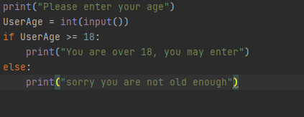
This example shows a program to check if the user is over 18. It asks the user to enter their age and then compares the value of the UserAge to “18” in the IF statement. If the user is 18 or over then this is the output that will be received.
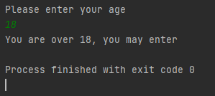
If the user is not 18 then the if statement is not carried out and the else statements code runs. Bellow is the output received if the age of the user is under 18.
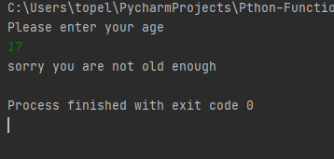
Multiple conditions can also be used in an IF/ELSE statement in Python, this is done by using “or” and “and”. “or” will check the first condition entered and if it has not met that condition then it will check the next, if neither condition have been met then the ELSE statement will be run. “and” will check if all conditions have been met, if one of the conditions in the IF statement is not then met then the IF statement will not run, and the ELSE statements code will run. This can be used to decide based on multiple different factors in the program.

A3. Explain why loops are needed in a program and when you might use a for and a while loop. Give examples of each in Python
[2] Automation is one the key benefits of computer programs, they can repeat the same task over and over with no errors or fatigue as appose to humans who get bored and fatigued and make mistakes after long repetitive tasks. By using loops, you can reduce this error and perform long repetitive tasks with no error if programmed correctly. There are two primary ways in which loops can be used. “While” loops and “For” Loops. A While loop iterates over a set piece of code while the condition for the while loop is being met. While loops are often used when the number of times needed to iterate over the code is unknown. After each iteration of the loop the conditions are tested and if they are met it will iterate again. This will iterate until the conditions of the “While” loop is no longer met.
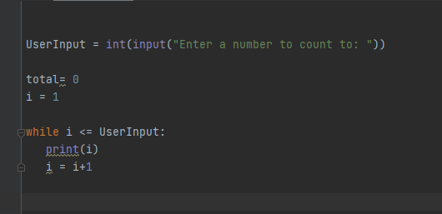

This programme asks the user for to enter a number that it would like the programme to count to. The variable “i” starts with the value of 1 and has a value of 1 added to it each time until the value of “i” matches the user input. Each iteration prints out a number in the output counting to the number the user has input.
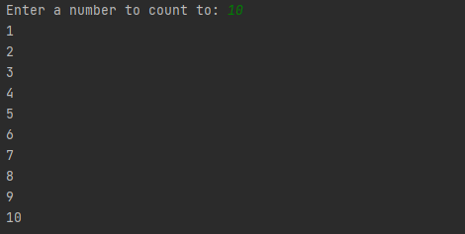
The other type of loop which is used in Python is a “for” loop. For loops are commonly used in order to iterate over a set of variables. This could be a list, tuple, dictionary, set or a string. This can be used to print out the names from a list in order to display them.
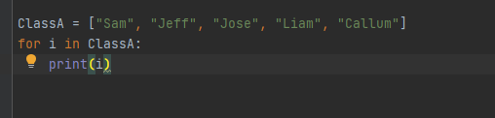
This programme stores a list of names of children in a class. The for loop is used to iterate over the names and when run prints them out individually.
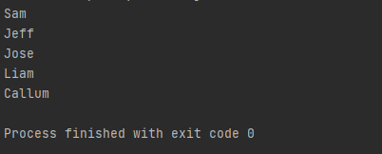

Part B

Exercise 1:
Show how variables can contain different types of values by using four variables to hold a car make, a car model, mileage and number of doors. Write a program to allow the user to input these values and then display them on the screen. The variables should be appropriately typed for the data required.
- Logical stages
- Prompt user to enter Make of car
- Store as variable
- Prompt user to enter Car model
- Store as a variable
- Prompt user to enter mileage of the car
- Store as a variable
- Prompt user to enter number of doors
- Store as a variable
- Print car details onto screen
- Code with annotations
- # Ask user for input
print("Please enter car make")
# Store input as a variable
CarMake = input()
# Ask user for input
print("Please enter car model")
# Store input as a variable
CarModel = input()
# Ask user for input
print("Please enter the mileage of the car")
# Store input as a variable
CarMileage = input()
# Ask user for input
print("Please enter the number of doors the car has")
CarDoors = input()
print("The car make is " + CarMake + ". The car model is " + CarModel +
". The mileage of the car is " + CarMileage + ". The car has " + CarDoors + " doors.")

Exercise 2:
A person wants to grow carrots in a vegetable bed. The person has never grown carrots before, but has read that each carrot requires 64cm² of soil area for optimum growth. (8cmx8cm patch per carrot)
Allow the person to enter the dimensions of their vegetable bed (you can assume that the vegetable bed is square or rectangular). Calculate how many carrots the user can grow in their vegetable bed.

- Logical stages
- Prompt user for length of grow patch
- Store and validate input
- Prompt user for width of grow patch
- Store and validate input
- Calculate the number of carrots that can be grown ((width * length)/64)
- Round the number down (can’t grow half a carrot)
- Output number of carrots that can be gown to the user
- Code with annotations
import math
print("Please enter length of vegetable bed in cm")
# user enters length and stores as variable
length = int(input())
# check if the number entered is above 8
while (length < 8):
print("please try again length is not big enough")
length = int(input()) # stores input as variable named length
print("Please enter width of vegetable bed in cm")
# user enters width
width = int(input())
# user enters width and stores as a variable
# check if the number entered is above 8
while (width < 8):
print("please try again width is not big enough")
width = int(input()) # stores input as variable named width
# math to calculate number of carrots
area = length * width
numberOfCarrots = area/64
# round down the number because you cant grow half a carrot
numberOfCarrots = math.floor(numberOfCarrots)
print("the number of carrots you can grow is " + str(numberOfCarrots)

- Testing
- Normal values
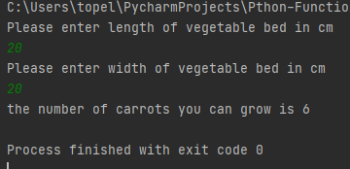

Result: Program performed as expected outputting 6 carrots

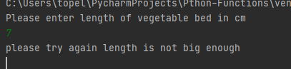

Result: As expected, user could not enter a length bellow 8

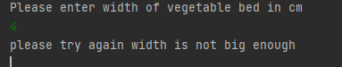
Result: performed as expected, user could not enter a width of less than 8

Exercise 3:
Write a program that allows the user to enter the names of five products into a list and the prices of the products into a second list. When all the products and prices have been entered, print them on the screen, then calculate the total price of all the products. Finally, calculate the total price with a 15% staff discount.
- Logical stages
- Create lists for product prices and names
- Use a loop to ask for product prices and names till it reaches 5 products
- Check if the prices are above 0
- Append products to the list
- Print out the product names and prices
- Print the total of the prices
- Print the total with staff discount

- code with annotations

productList = [] # create a list for products
priceList = []# create a list for the prices
count = 1
while count != 6: # while loop to count 5 products
print("Please enter product", count) # prompting user to enter product
productList.append(input()) # adding product to the list
print("please enter product price", count) # prompting user to enter price
price = float(input())
while price <= 0:
print("please try again number too low") #testing if the number is too low
price = float(input())
priceList.append(price) #adding price to the price list
count += 1 #adding one to the count
print("Products Entered") # printing out the products and prices
print(productList[0] + " £" +str(priceList[0]))
print(productList[1] + " £" +str(priceList[1]))
print(productList[2] + " £" +str(priceList[2]))
print(productList[3] + " £" +str(priceList[3]))
print(productList[4] + " £" + str(priceList[4]))
totalPrice = sum(priceList) #math for total price
fifteenPercent = totalPrice * 0.85 #math for staff discount
print("total price is £" + str(totalPrice)) # printing the total price
print("staff discount is £" + str(fifteenPercent)) # printing the total price with staff discount

- Testing
- In range numbers

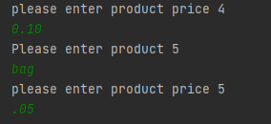
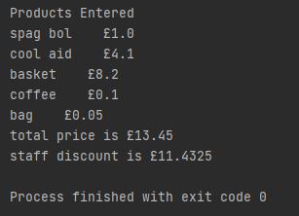
Result: As expected, the prices entered were accepted
- 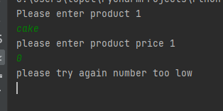
Result: As expected, the number was too low so asked the user to try again.

Exercise 4
- Logical stages
- Create a list with 16 numbers
- Choose a random number from the list and store as an int
- Prompt user for input
- Check if number is in bounds
- Check if user input matches the random number in the list
- Try again if not
- Change number selected in list to X and re print the list
- Congratulations if correct
- Run function to end program

- Code with annotations
import random
gameList = [1, 2, 3, 4, 5, 6, 7, 8, 9, 10, 11, 12, 13, 14, 15, 16] #create list with all numbers
WinningNumber = random.choice(gameList) #choose a random winning number
def EndProgram(): #function to end the program
print("End of program")
exit()
print("Please choose a number between 1-16")
UserInput = int(input()) # prompt and take user input
while UserInput < 0 or UserInput > 16: # check input is in bounds
print("please try again number is out of bounds")
UserInput = int(input())
while UserInput != WinningNumber: # loop to test if the number is correct
gameList[UserInput -1] = "X"
for i in gameList:
print(i)
print("sorry wrong number try again")
UserInput = int(input()) # retake user input if answer is incorrect
else:
print("Congrats correct number selected") #congratulate user on winning
EndProgram() # function to end program
- Testing

- 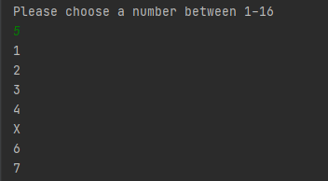
Result, as expected. The number was in range so outputted the list of numbers with the slected number chasnged to X
- 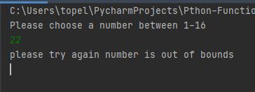
Result, as expected. The number was out of bounds so the user was asked to try again.

