BSc Health And Social Care
Changemakers: Creativity and Value Creation

Student Number- 2410084

Student Name- kiera handley

Module code- BMHP5014

Tutors Details – Zarah Ahmed

Component 2 -Poster with 1000-word pitch

Submission Date- 16/17/2026

Poster
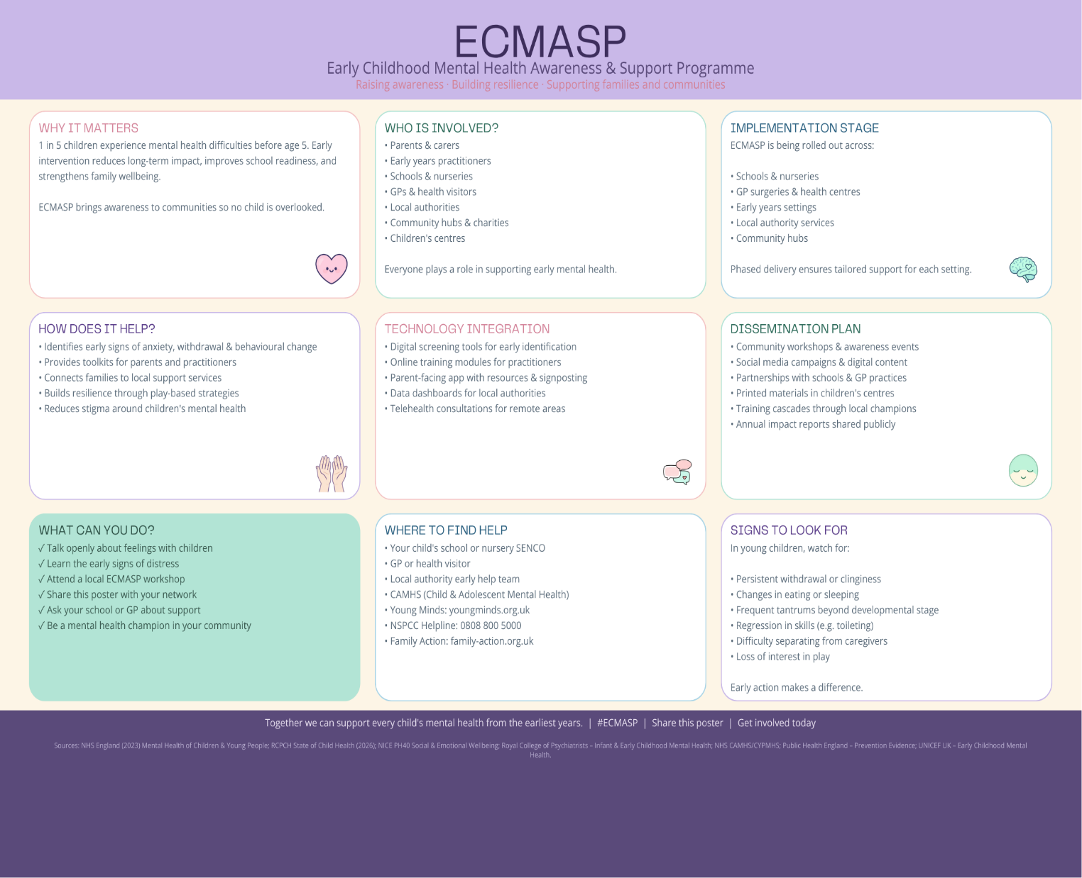

Pitch

Childhood early years is a very important time for the development of emotional, social, and cognitively which will set the foundations for their well-bring in later life. Evidence shows continuously that in the first years of life shapes the ability they have to form relationships, regulate emotions, and strive in education as well as the community setting (UNICEF,2023). However, across the UK, there are many children suffering by living with a unnoticed mental -health difficulties until they escalate, which then creates long term challenges on families, schools, and health services, (NHS England, 2023). The early childhood mental health awareness and support programme (ECMASP)aims to address the gap by making a stronger early identification, improving awareness, and more clear pathways to support across education, health, and community sectors (ECMASP,2026).
The need for ecmasp is urgent, mental health problems is growing with extremely high wait times and many barriers delaying any help and support in a suitable way (NHS CAHMS, 2024). Research shows that in early years mental health is missed or even understood, despite being highly prevalent. The royal collage of psychiatrists’ stresses that the first five years of life are important for development, and protection against future mental health conditions, and that society has a large role in securing positive relationships and supporting children’s emotional and cognitive growth (Royal Collage of Psychiatrists, 2023). This aligns with the national concerns about growing childhood vulnerabilities, including emotional distress, behavioural difficulties, and challenges with social relationships (RCPCH, 2026).
Ecmasp responds to these challenges by promoting the early identification of childhood mental health needs and giving them structed pathways and support though schools, GP, and community services. This approach is supported with evidence which shows that the high Quilty early care setting, emotionally supportive communication, and pro-active behavioural strategies largely improve children’s psychosocial outcomes (Public Health England, 2021). For example, early year childhood mental health consultation models have been seen to grow children’s self-regulation, prosocial behaviour, and emotional resilience over time (NICE, 2012). These findings strengthen the importance of professionals and families having the knowledge and tools to identify the early signs and step in quickly.
A core strength of Ecmasp is the multi-agency design. Children’s mental health cannot be addressed by one sector on its own, it needs coordination action from education, health, and social care. Multi-component interventions involving parents, teachers and health professionals. This has been shown to improve children’s developmental outcomes and parental well-being. Particularly when it’s combined with emotional support, behavioural guidance and structed communication pathways (UNICEF UK, 2023). Ecmasp builds on this evidence by creating a unified framework that connects the schools, GP, early years settings, and community organisations, making sure that children receive consistent and time effective support regardless of where the concern first began (Department for Education and Department of Health, 2015). The program also prioritises the family’s involvement research indicates that secure parent and child relationships are fundamental to emotional resilience and long-term wellbeing (centre for mental health,2026). Insecure or disorganised attachment in early childhood is linked to poorer outcomes in later life, including problems with emotional regulation, trust and forming stable relationships. Up to 45% of UK’s babies experience insecure or disorganised attachment, especially families effected by poverty, trauma, or mental health difficulties (UNICEF, 2023). Ecmasp includes this evidence by making sure families are the centre of the decision-making, support planning, and interventions delivered. By enabling parents with the knowledge and guidance, the program strengthens the home environment and enhances children’s emotional security.
Ecmasp also address inequalities in early childhood mental health. Research from the born in Bradford evaluation highlights that children from Hardship background’s face a worsened health and well-being outcomes including high rates of mental health difficulties, communication challenges, and reduced school readiness (BMJ paediatrics open, 2026). Place -based early years interventions that embed community partnerships and research- informed practice has been shown to lower inequalities and improve outcomes to scale (Public Health England, 2021).
ECMASP adopts similar ways by tailoring support to local needs, making stronger community networks, and ensuring that vulnerable families get targeted, accessible interventions.
The program’s implementation strategy is grounded in evidence with what works, early years interventions are most effective when they are delivered consistently, embedded with everyday routines and supported by trained professionals (NICE,2012). The NICE evidence reviews on early years wellbeing stresses that interventions promoting emotional development, secure relationships and cognitive growth can highly improve outcomes for vulnerable children, especially if delivered though integrated education and health systems. ECMASP includes these findings by giving training to teachers, early years practitioners, GPs, and community workers, helps all professionals working in children’s life’s see early signs, respond appropriately and collaborate effectively (NHS England,2023).
In addition to the training, ECMASP includes public awareness campaigns designed to aid families see the early signs of mental health difficulties. Signs may include constant sadness, or worry, withdrawal from friends, difficulty concentrating, irritability, sleep or eating changes, and daily routine challenges NHSD Digital, 2022).National data shows that these symptoms are common indicators of childhood mental health problems and should prompt support and assessment (Public Health England, 20221).By increasing awareness among parents and care givers ECMASP helps ensure that concerns are identified early, reducing the risk of escalation and improving long-term outcomes.
The programme also promotes resilience-building interventions. For example, child-led -play approaches, such as those evaluated in the watch me play! Feasibility study, have been shown to enhance mental health resilience, strengthen caregiver-child relationships, and reduce the barriers to support in the early year’s services (Cambridge University Press, 2024).
ECMASP integrates similar evidence-based practices to support children’s emotional development, self-regulation, and social skills. Ultimately ECMASP aims to create a coherent, accessible, and evidence-informed system that supports children’s mental health from the earliest stages of life. By combining awareness, early identification, professional training, family involvement, and multi-agency collaboration, the programme addresses the implementation gap identified in national reports and strengthens the foundations of children’s wellbeing (RCPCH,2024).
The Royal collage of psychiatrists highlights that early year’s mental health interventions must be prioritised to prevent future difficulties and ensure that children grow up in environments that support their emotional and cognitive development (Royal Collage of psychiatrists, 2023) ECMASP embodies this vision by providing a structured, scalable, and community-based driven model that can be adopted across the UK.
In conclusion, ECMASP offers a transformative approach to early childhood mental health. It is grounded in robust evidence, aligned with national priorities, and designed to empower families, professionals, and communities, by investing in early identification, strengthening support pathways, and promoting emotional resilience. ECMASP has the potential to improve the outcomes for thousands of children and create a more healthier, more equitable future (NHSD England,2023).

Reference
BMJ Paediatrics Open (2026) BMJ Paediatrics Open (2026) Reimagining early years services to address childhood inequities.
Cambridge University Press (2026) Cambridge University Press (2026) Watch Me Play!: Feasibility Study.
Centre for Mental Health (2026) Centre for Mental Health (2026) Why babies’ first relationships matter.
Department for Education and Department of Health (2015) Department for Education and Department of Health (2015) Special educational needs and disability code of practice: 0 to 25 years. London: DfE & DoH.
ECMASP (2026) ECMASP (2026) Early Childhood Mental Health Awareness and Support Programme. Available at: https://www.ecmat.nhs.uk (Accessed: 18 July 2026).
Loades, M.E. et al. (2020) Loades, M.E. et al. (2020) ‘Impact of social isolation and loneliness on the mental health of children and adolescents’, Journal of the American Academy of Child & Adolescent Psychiatry, 59(11), pp. 1218–1239.
NHS CAMHS (2024) NHS England (2024) Children and Young People’s Mental Health Services (CYPMHS): Guidance and Service Overview. London: NHS England.
NHS Digital (2022) NHS Digital (2022) Mental Health of Children and Young People in England. London: NHS Digital.
NHS England (2019) NHS England (2019) The NHS Long Term Plan. Available at: https://www.longtermplan.nhs.uk (longtermplan.nhs.uk in Bing) (Accessed: 18 July 2026).
NHS England (2023) NHS England (2023) Mental Health of Children and Young People in England. London: NHS England.
NICE (2012) National Institute for Health and Care Excellence (2012) PH40: Social and emotional wellbeing: early years. London: NICE.
Public Health England (2021) Public Health England (2021) Improving young people’s health and wellbeing. London: PHE.
RCPCH (2026) Royal College of Paediatrics and Child Health (2026) State of Child Health Report 2026. London: RCPCH.
Royal College of Psychiatrists (2023) Royal College of Psychiatrists (2023) Infant and early childhood mental health: The case for action. London: RCPsych.
UNICEF UK (2023) UNICEF UK (2023) Understanding and supporting mental health in infancy and early childhood: A toolkit to support local action. Available at: https://www.unicef.org.uk/wp-content/uploads/2023/04/Understanding-and-supporting-mental-health-in-infancy-and-early-childhood-A-toolkit-to-suppot-local-action.pdf (Accessed: 18 July 2026).

