Thomas Rhys Evans
Student Number: 1810164
Smart and Connected Devices I - ACDA5005

Table of contents
 | Page Number
1.Introduction | 1
2. Log-in | 1
3. Data Display | 4
4. Graphs | 8
5. Layout | 10
6. Conclusion | 11

Abstract
A website has been created to facilitate the transfer of rainfall data from 3 separate sensors into a database. The website allows the user to view the data and query the database.

1. Introduction
The website created has been set up to allow a user to log in and from there navigate the site to view data, from the most recent readings to data from individual sensors. A search page also allows the user to view data from a query. A graph page also visualises the data from each sensor and displays the information as a bar chart.

2. Log-in
For security purposes, access to the site is protected by a username and password. Only authorised users are permitted to use the site and view the data. This is done by querying a “users” table in the database where the usernames and passwords of the authorised users are stored.
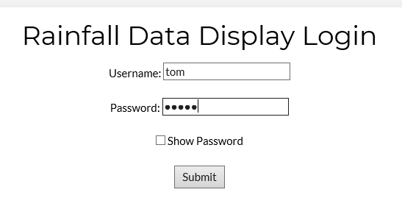

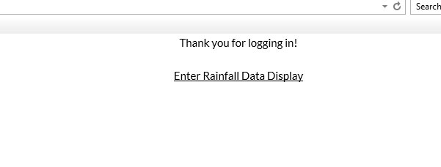
If an unauthorised user attempts to gain access to the page, then access is prohibited.
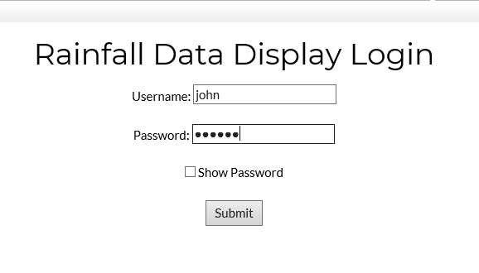
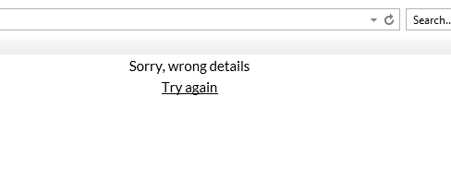
The password field has also hidden the password when typed in, in order to avoid the password being viewed by anyone in close proximity to an authorised user that is logging in. Prepared statements have also been implemented to ensure that the login page isn’t susceptible to SQL injection attacks.
------------------------------------------------------------------------------------------------------
Code example:
include "conninfo.php";
$un=$_POST["username"];
$pw=$_POST["password"];

$query="SELECT * FROM users WHERE username like ? AND password like ?";

$stmt = mysqli_stmt_init($link);
mysqli_stmt_prepare($stmt, $query);

mysqli_stmt_bind_param($stmt, "ss", $un, $pw);

mysqli_stmt_execute($stmt);

$result=mysqli_stmt_get_result($stmt);
$num=mysqli_num_rows($result);
--------------------------------------------------------------------------------------------------------------

The session stays with the user until they either select “logout”, or they close their browser.

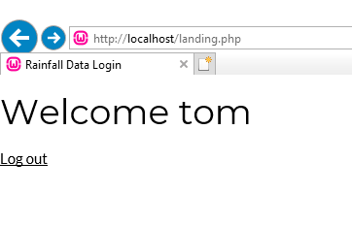
3. Data display
A pre-prepared query displays the most recent readings under the “recent readings” tab. This page displays data from a query that pulls the 20 most recent readings from the database and displays them in a table, in descending date order.
----------------------------------------------------------------------------------------------------------------
Code Example:
include "conninfo.php";

$query="SELECT * from rainfalldata ORDER BY thedate DESC LIMIT 20"; //set up the query

$result = mysqli_query($link,$query) or die("Couldn't execute query");

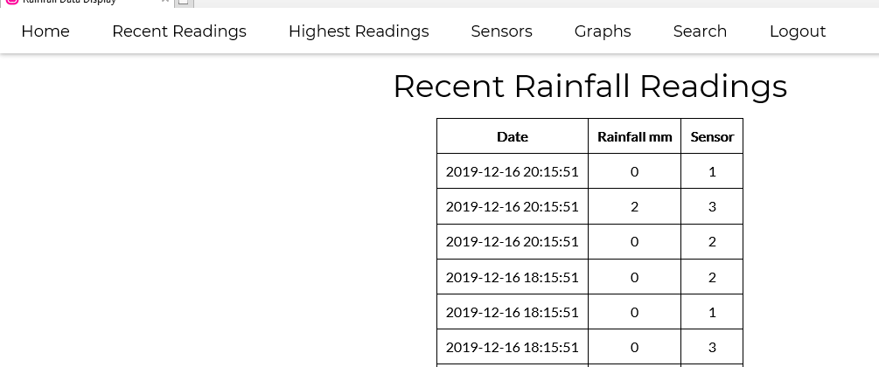
The “Highest reading” tab displays the data with the highest rainfall readings. This is done by querying the rainfall data database and sorted the results on the ‘mydata’ field, in descending order. This page gives the authorised user a snapshot of the dates of the highest rainfall days.
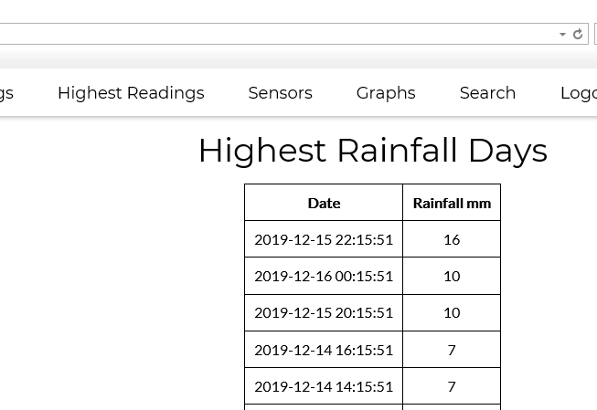
The “sensors” tab allows the user to view the data from each individual sensor. The drop down box allows the user to toggle the different sensors and submit the query, which displays the data on the same page.
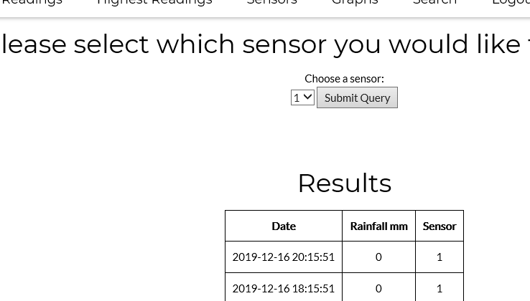
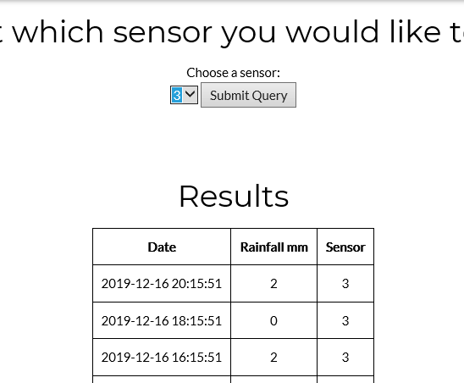
On the search page, the user is allowed to enter a selection to view all rainfall equal or above a certain level. This is useful for the user if they need to search for specific dates with varying amounts of rainfall.
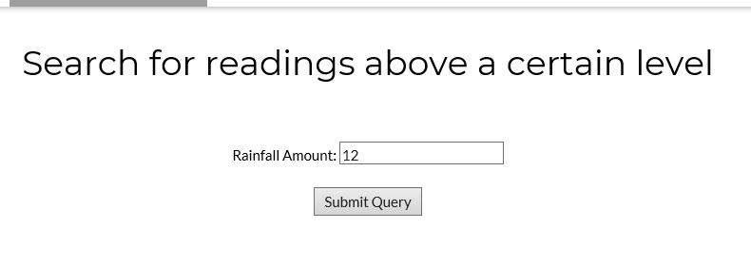

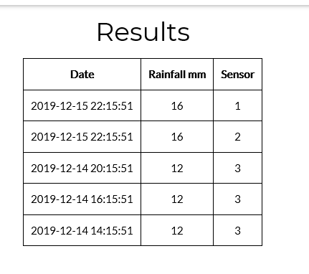

The query includes a prepared statement to prevent SQL injection attacks.
---------------------------------------------------------------------------------------------------------
Code Example:
include "conninfo.php";

$search1=$_POST["rain"];

$query="SELECT * FROM rainfalldata WHERE mydata >= ? ORDER BY mydata DESC ";

$stmt = mysqli_stmt_init($link);
mysqli_stmt_prepare($stmt, $query);

mysqli_stmt_bind_param($stmt, "i", $search1);

mysqli_stmt_execute($stmt);

$result=mysqli_stmt_get_result($stmt);
$num=mysqli_num_rows($result);
------------------------------------------------------------------------------------------------------------
If too high a number is searched for, the website will notify the user that nothing has been found

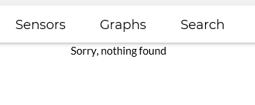
All of the data outputs are displayed in a html table, allowing the data to be viewed easier due to the fact its layout is uniformed and neat.
4. Graphs
Graphs are used to visualise the rainfall amount over time for each sensor. This allows the user to more easily view trends in the data.
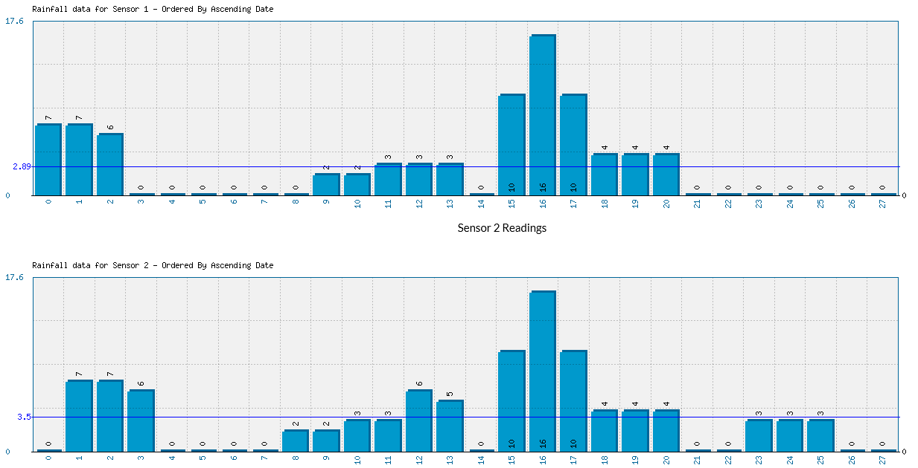
4. Data
Upon logging in, the user has the option to refresh the rainfall data. This runs the query to pull data from the 3 text files, which are the sources of the data. Any new data is inserted into the database and is then available for the user to view.
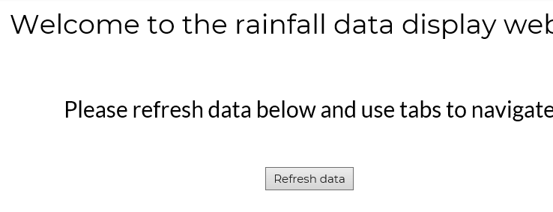
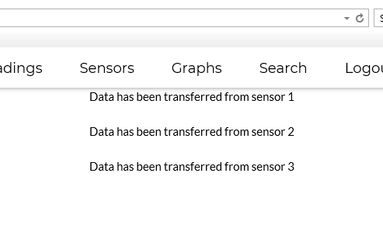
Upon insertion into the database, the text files are then emptied of their data to avoid duplicate entries being added.

5. Layout
The website is simplistic and clear in it’s design.
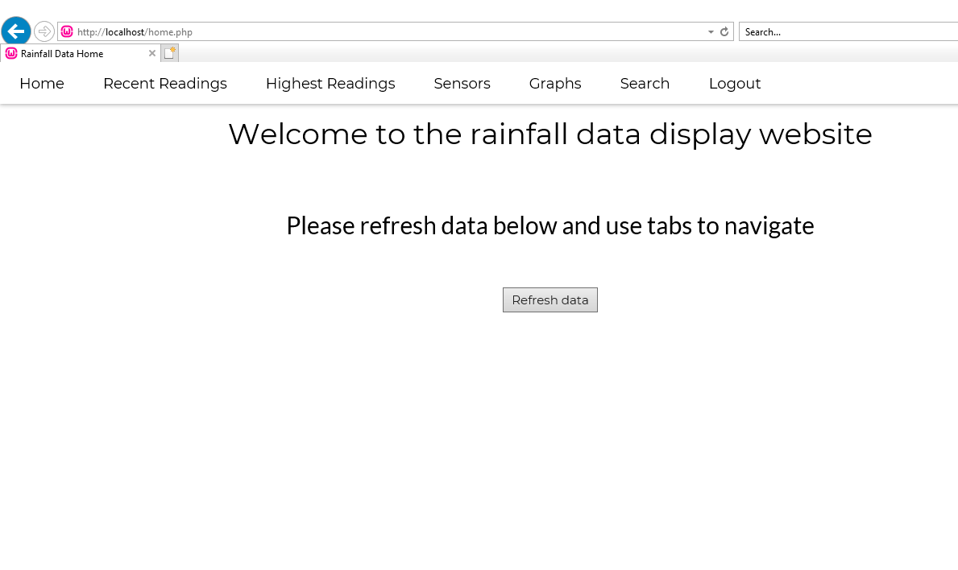
The tabs are clearly described to allow the user to traverse the website and carry out the task they require to undertake. The black and white colours are high contrast and are suitable for users with poor eyesight or colour blindness.

6. Conclusion
The website that has been created functions as a useful way of interpreting and querying the database data. Pre-prepared queries are used to give the user the most useful data and the user is able to amend the their selections for some of the queries, allowing the data to be tailored to what the requirement is.
The site is secure. The log in page not only stops unauthorised access, but the fields themselves have been sanitized to stop the possibility of SQL injection attacks. This has also been implemented on the search page to stop any possibility of an attack happening here.
The graphs are relevant and allow the visualisation of data over a time period, which is useful for the user, giving them the ability to identify and view trends in the data.
The website is clean, colour-blindness friendly and simple enough to traverse due to the appropriately named tabs. It’s clear these tabs are meant for navigation and any button or field that requires user input is obvious.

