Personal Resourcing and Development (M5X01921_BIRM)

Research Proposal based on the Hotel Industry

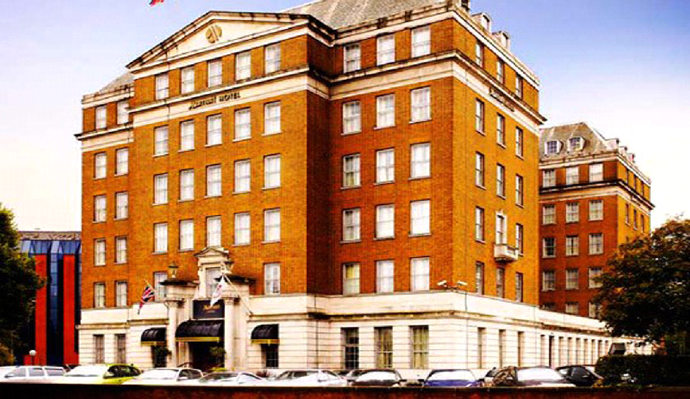

Student: Andreea Sandru
Student number: 1815220
Lecturer: Abdi Rahman

Content

Introduction………………………………………………………………….2
Marriott Hotel Birmingham………………….……………………………2
Good Practices/Bad Practices……………………………………………4
Suggestions for Marriott to develop a workforce.……………………5
Primary research/Secondary research………………………………….6
Conclusion……………………………………………………………………7
References…………………………………………………………………….8

Introduction

The intention of this assignment is to encourage the development of research based on the hotel industry. This department is one of the key essentials of the hospitality business. Hotels include countless services that give people everything they want for their free time as its purpose is to create a very relaxing and carefree environment for guests. Traveling has become increasingly popular and everything related has turned into a profitable business. According to Roosevelt (2000), “the true hospitality consists of giving the best of yourself to your guests.”

Marriott Hotel Birmingham

The hotel that I chose for this research is the Marriott Hotel Birmingham, placed in the Birmingham city centre, with a lot of big organisations and universities near the location. I would like to mention that the research is mainly based on my own experience during my three months practice in this hotel. Having the opportunity of working in each department, I’ve learnt a lot of interesting things about the hotel from the staff, including the managers from each department. All of them were more than happy to help me with everything and they made sure to provide all the information necessary from my growth. The 4 stars hotel is equipped with 104 rooms, based between the 1st and 5th floor, whilst the offices of the staff are located on the 6th floor. The Marriott location also presents 4 meetings rooms, restaurant, bar, pool, spa, jacuzzi and gym, all of those being situated on the premises.
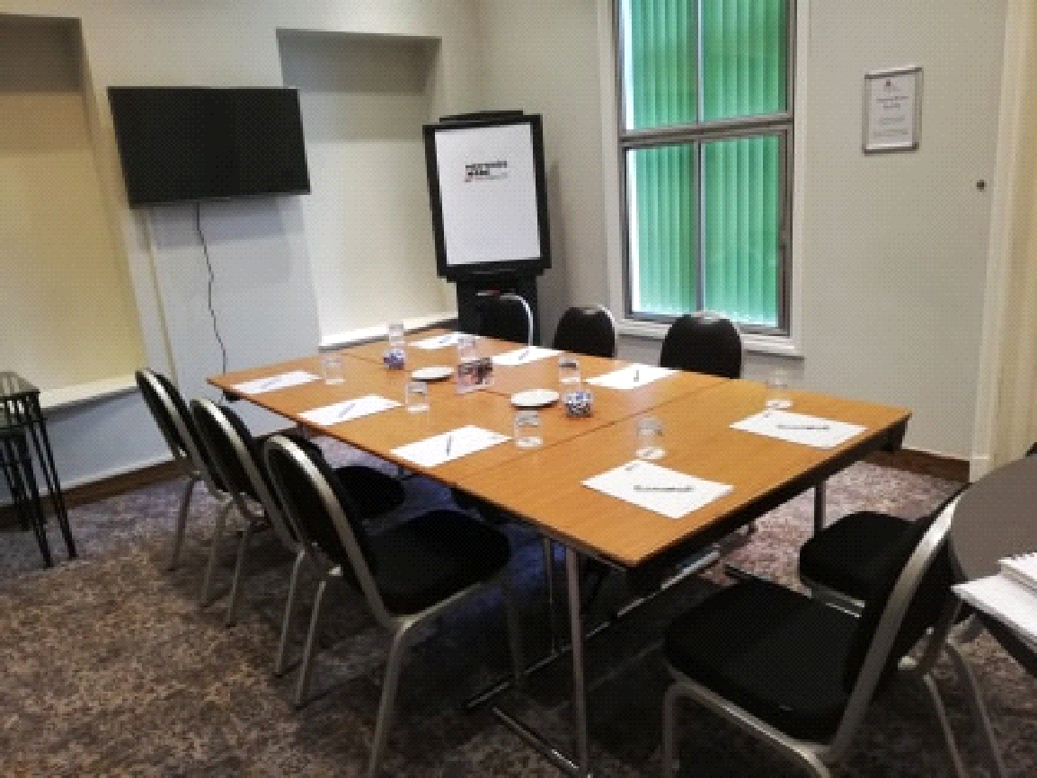
Fig.1 Meeting Room West 1

All the employees were hired depending on their skills, flexibility and capacity of work. What makes this hotel different from other locations? Well, the company’s focus is to provide comfortable and often luxurious accommodation, with a simple booking system thanks to their own app, which makes reservations very fast and easy to make. Another interesting and unique thing about Marriott is their Bonvoy card, which is based on points that could offer an entire series of perks to their clients such as discounts, free rooms, and free breakfast. The website for their hotel is different from other such websites, as it’s constantly updated with all the information customers might need, and it also has support for multiple languages. The hotel staff are making free online training sessions. Each department has a WhatsApp group created by the manager of the department, and all the employees from their respective departments are part of their own group. The hotel provides its employees with a free meal at the cantina and a half hour break. The housekeeping department receives fifteen-minute break every 2 hours. There is a designated Smoking area at the back of the Hotel, outside, where employees can smoke. There are rules in place for hygienic purposes, after finishing smoking employees must wash their hands with soap for twenty seconds and afterwards also use hand sanitiser.
One thing that sets the hotel, is that they always look to hire talented, hardworking individuals and strive in finding ways to keep their employees motivated. This includes employees across all departments and stations. For instance, a good Manager is key for keeping a Hotel as a business together. Having a good set of skills and experience, a Manager can find the most efficient way to run a Hotel, boost employee performance and customer satisfaction.
Good practices/Bad practices in the hotel
Marriott versus Premier Inn

As stated, the manager is a key component, he has to come up with new ideas and improvements on a regular basis. Checking on how other hotels are doing business, how they motivate their own staff and what they do differently but successfully. One aspect that falls under the bad practices section of the Marriott Hotel is customers having to pay for car parking and there are only 15 parking spots available. This does not include employee parking spots, employees not having where to park. On the other hand, one good practice of the hotel is staff having access to the pool, spa, gym, jacuzzi free of charge. Compared with Premier Inn, which is a three-star hotel, in Wolverhampton, customers are paying for car parking, but there are enough parking spots, including for staff members.
A bad practice at the Premier Inn, something which can easily be found from hotel reviews on TripAdvisor, is that some of the rooms lack bathrooms, have thin walls making privacy and too much noise an issue, some of the rooms are also subjected to getting very cold. The position of the hotel is also not very favourable because there is a train station next to it, something which regularly disturbs the peace. While at Marriott, while working in each department, I asked the staff members what changes they would make. I received plenty of answers, from salaries to carpets and curtains. The hotel is old, most notably, the furniture and carpets. But at the same time, and more importantly, the hotel is clean. During my visit at Premier Inn, staff members were nice, but not very determined to make their customers feel special, and food allergens are put on the menu but are written with small letters. Bill Gates said that “Your most unhappy customers are your greatest source of learning”. The Manager should take customer reviews seriously and do something.

Suggestions for Marriott to develop a workforce

“A manager is defined as a person who, alone or together with others, "is vested with the continuing exclusive authority to make the management decisions necessary to conduct the business." Prop. Regs. Sec 1.1402(a)-18(c)(3). Luckily, Marriott has an excellent Manager, Behram Kotwal. He has a very friendly attitude towards the rest of the employees. Every morning when he comes to work, he shakes hands with all the staff members, asking how they are, and is determined to make more out of less each day. Of course, the hotel is not perfect, but it can always benefit from improving itself. Even though Marriott Hotel already has partnerships with a few universities, they should take only brilliant students with higher degrees at the hotel to prepare them for future jobs, offering training and support to learn about hospitality instead of doing it by placement. The hotel also needs more space. A lot of interviews took place in the restaurant, which is not an adequate place for such things since it can get very noisy. The manager should take steps to change this by providing them a meeting room situated on the 1st floor of the Hotel. The lack of space for parking is also a concern, something should be done regarding the number of parking spots. Another issue to be pointed out is having to pay a parking fee for multiple cars when sharing the same room. Practices such as these are not good for customers. Bonvoy customers should also benefit from a VIP room since most of them like to work from their laptops during breakfast, this would offer them a good place where they can work in silence. This would give existing Bonvoy customers and future ones more reason to stay and feel like they are treated as valuable customers.
Salary is the biggest issue for employees. But since most of them don’t have degrees, they should be motivated and offered support to study. The manager can improve the company’s ability to attract, retain and improve productivity with the PRIDE process help: Provide a positive working environment, Recognize, Reward and Reinforce the right behaviour(Mark Twain: “I can live for two months on a good compliment.”), Involve and Engage, Develop skills and potential, Evaluate and Measure. Employees should be allowed and encouraged to contribute with their own ideas and suggestions, in turn, this would give them a sense of ownership. “If you are not humble and think you are the smartest person in the room, pretty soon you'll be the only person in the room.” (Marriott B, 2013). Talented employees are always interested in growth, especially when it comes to their personal one. Therefore, offering constant feedback and building a development plan for each employee is detrimental.
A good way to learn what needs to change and what can be improved would be to create employee surveys more than once per year, give surveys to customers to learn about the real reasons why people come to the Hotel or why they leave and will not be coming back. Managers should be held responsible for employee retention in their departments.
The Marriott hotel has a partnership with AC Hotel, which is close to the Marriott and if one of them is overbooked, they send the customers to the other hotel. Interesting move and very smart, as Marriott will never lose customers this way.

Primary research/Secondary research

According to Goodyear-Smith (2003), “primary data is originated by a researcher for the specific purpose of addressing the problem at hand”. Primary research can simply ask people questions through surveys, interviews, by organizing focus groups, thus acquiring new information which is crucial for development purposes.
According to Largan, “secondary data is data which has already been collected for purposes other than the problem at hand”. Luckily, this type of data can be located quickly and inexpensively.
Each of these types of research has its own advantages and disadvantages. Some of the primary research methods are more effective when it comes to data interpretation, as targeted issues are more easily addressed. Another advantage is that the price of information differs as the cost is lower, since it poses a greater control of strategies while addressing more on-point research issues. The most compelling advantage is that these methods are contoured to match your research needs. Some of the disadvantages are quite paradoxical, as good research methods can prove inexpensive but depending on the circumstances, it could turn into quite a financial hassle. Some of the advantages of secondary research are that the information can be easily gathered without considerable expenses, especially since the researcher does not depend on others when it comes to obtaining the information that he needs. Some of the disadvantages are that this type of research is not fool proof as there is no guarantee that the data that has been obtained will always be reliable. Another negative influence might be represented by the market trends or by the constant evolution and transition of the consumers. Also, being a researcher doesn’t mean that you can have access to every kind of file hence there might be issues with acquiring certain documents.
Personally, I would consider primary research as my first option even if there is a high chance of increased expenses, but on the other hand, I would be the first person to have access to all the information needed. Especially during an interview, the body language can emphasize responses and the best part is that the competition doesn’t have any access to my information, as the method is designed to grant me the answers for the exact purpose that I need. That makes the information as I need it to be and the understanding of is deeper at the end of the day. The most important factor is that primary data has not been published yet and it is proved to turn out more reliable, authentic and objective, as it hasn’t been changed or altered by human beings. Therefore, its validity is greater than secondary data when looking in comparison. I would choose these methods each time I consider them to be necessary only because it is authentic.

CONCLUSION

In conclusion, the main purpose of this assignment was to develop research proposal which is to be based on the hotel industry. As we saw, there are a lot of responsibilities, tasks and strategies that a manager must apply for the business he is involved in. The most important idea is that he must be talented and must have a motivated team supporting him all the way, otherwise alone, he wouldn’t be able to implement growth and wealth. Luckily, the Marriott brand rules some of the best hotels in the industry and it’s no wonder, knowing the fact that it is being kept in the race by a motivated staff that knows that excellence and strong teamwork is the key to success. Even if it may not be perfect when it comes to certain aspects, they are trying their best each day, which helps them surpass their competition. As for me, it was easy to work with primary research and I was lucky to have the opportunity to have access to all the information.

References

- Anonymous. Definition of "manager" under Proposed Regulations."Tax
Management Memorandum 36.7 (1995): 110. Web.
- Brainy Quote. 2020. Mark Twain Quotes. [online] Available at:
<https://www.brainyquote.com/quotes/mark_twain_100358> [Accessed 26 March
2020].

- EISEN, D., 2015. Marriott International's BILL MARRIOTT. Hotel Management,
- 230(9), pp. 18-18,20.
- Goodyear-Smith, F. and Mash, B (2003). International Perspectives on Primary Care Research.
- Largan, C. and Morris, T., n.d. Qualitative Secondary Research. 6th ed. America.
- Vinter, O., Lauesen, S. and Pries-Heje, J., 1998. A Methodology for Preventing Requirements Issues from Becoming Defects (PRIDE). København.
- Marriott International. 2020. Marriott Birmingham. [online] Available at: <https://www.marriott.com/hotels/hotel-reviews/bhmmc-marriott-birmingham/> [Accessed 21 March 2020
- 2009. Customer Loyalty. [online] Available at: <Bill Gates http://bit.ly/1Fl7JdB via @apptentive #CustomerLoyalty> [Accessed 21 March 2020].
- TripAdvisor. 2020. Premier Inn. [online] Available at: <http://ps://www.tripadvisor.co.uk/Hotel_Review-g190762-d729481-Reviews-Premier_Inn_Wolverhampton_City_Centre_hotel-Wolverhampton_West_Midlands_England.html> [Accessed 21 March 2020].

