Report on Waveguide and Dipole Antenna Design and Simulation

Daniel Garton (2219350)

2219350@student.uwtsd.ac.uk
Daniel.garton@baesystmes.com
Abstract
This report outlines the design and simulation of two electromagnetic devices: a rectangular waveguide with Perfect Electric Conductor walls, filled with vacuum and Teflon, and a half-wave dipole antenna. The waveguide is analysed for its behaviour across a frequency range of 2 GHz to 30 GHz, identifying dominant modes, field distributions, and cutoff frequencies. The dipole antenna is designed based on the student's ID to radiate electromagnetic waves at a specific wavelength. Simulation results include S-parameter plots and radiation patterns, offering insights into the device's performance.

Contents
Introduction 2
Method 2
Task 1: Rectangular Waveguide Design 2
Task 2: Half-Wave Dipole Antenna Design 3
Results 4
Task 1a: Waveguide with Vacuum 4
As shown in the figure above M1 is very similar to the theoretical max being only 0.17% higher, This could just been the difference between theoretical and simulated results. M2 and M3 however weren’t as accurate. 4
Task 1b: Waveguide with Teflon 4
Task 2: Half-Wave Dipole Antenna 4
Discussion 5
Conclusion 5
References 5

Introduction
Understanding the Electromagnetic wave propagation is crucial to designing effective communication systems. This Report explores the characteristics of the halfway dipole antenna and the rectangular waveguide. These simulations are made in Ansys using HFSS, High frequency structure simulation software. The waveguide dimensions are derived from the student number of the writer which will affect many properties of the waveguide and antennas. The report investigates how material can affect the Electromagnetic wave propagation. The report also compares theoretical theory and simulation data to analyse aspects of the waveguide and antenna.

Method

Task 1: Rectangular Waveguide Design

Waveguide Dimensions
- Width (a): First two numbers of the student ID - 22mm
- Height (b): (Third and fourth numbers of the student ID) / 2 - 19/2=9.5
- Length: 50 mm

Simulation Setup

The waveguide is made from PEC (Perfect electronic conductor) [1] and filled with either Vacuum or Teflon. The vacuum has a relative permeability of 1 and the Teflon has relative permeability of 2.1. The frequency is set to sweep and ranges from 2GHz up to 30GHz. There are 2 ports, one at the top an bottom of the rectangle, there’s 3 modes at each port.

Theoretical Formulas
- Cutoff Frequency: fc(mn)= C/a √((m/2)^2 + (n/b)^2)
- C = speed of light - 3.00x10^8 m/s
- M and N are mode indices

Steps
- Design Waveguide Model in HFSS with the specified dimensions and materials defined above. Created on Ansys.
- Assign Wave Ports at both ends of the rectangle for modal analysis.
- Perform Frequency Sweep from 2 GHz to 30 GHz.
- Identify the mode types, Specifically the dominant mode out of the 3 modes.
- Record Port Field Displays at Wave Port 1 and 2.
- Obtain Field Magnitudes and Vectors for electric and magnetic fields.
- Calculate Theoretical Cutoff Frequencies for the first three modes.
- Plot Cutoff Frequencies and identify from the plot.

Task 2: Half-Wave Dipole Antenna Design

Antenna Dimensions
- Radius: 1 mm
- Wavelength (λ): First three digits of the student ID - 221

Simulation Setup
The halfway dipole is made up from PEC (Perfect electronic conductor) [1]. Unlike the rectangular waveguide it needs no filling. It has a excitation of a lumped port with a 50 Ohm impedance. It has s radiating surface is in the centre of the antenna and is a rectangle.

Theoretical Formulas
- Dipole Length: L=λ/2
- 𝜆=first three digits of the student ID
- Operating Frequency: f=c/λ
- C = speed of light = 3 X 10^8 m/s

Steps
- Design Dipole Antenna Model in HFSS with specified dimensions defined above.
- Apply Lumped Port Excitation and set port impedance to the specified 50 ohms.
- Perform Frequency Sweep to find the operating frequency.
- Plot S-Parameter and identify the operating frequency.
- Obtain Radiation Pattern for the antenna to analyse how the antenna radiates EM waves

Results

Task 1a: Waveguide with Vacuum
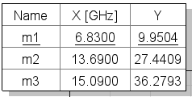
The theoretical Cut off frequency is calculated by using Cutoff Frequency [2]: fc(mn)= C/a √((m/2)^2 + (n/b)^2). The different modes are calculated by changing the M and N. Te1 is M=1 and N=0, Te2 IS M=0 and n=1 and Te3 M=1 and N = 1. Using these values in the formula it can be calculated to be Te1 = 6.8181GHz, Te2 = 15.7894GHz and Te3 = 17.1998GHz. This is then simulated using the Ansys software package and the result are shown in the figure below.
Figure 1 - Simulation cut off frequency

As shown in the figure above M1 is very similar to the theoretical max being only 0.17% higher, this could just be the difference between theoretical and simulated results. M2 and M3 however weren’t as accurate. These were both 2GHz out. This could be down to a simulation error as it is 15.3% and 13.97%. over in respect to M2 and M3.
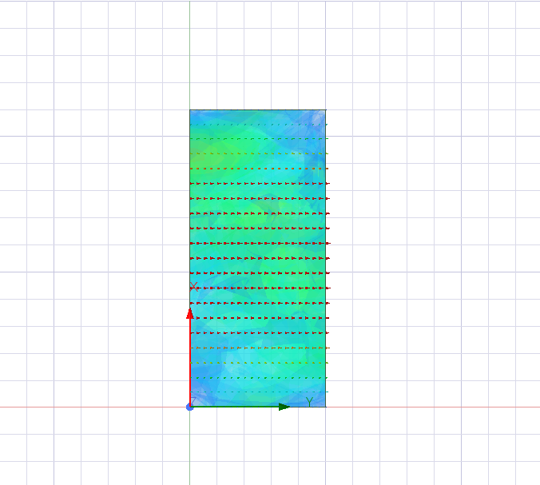
The figures 2-7 show the port fields for Each port and mode. The ports on waveguide are where the Electromagnetic waves [2] enter and exit the waveguide, usually port 1 is input and port 2 is the output. Modes refer to the specific patterns of the electromagnetic field that can propagate through the waveguide. These patterns are affected by the geometry and the dimensions of the waveguide.
Figure 2 - Port 1 Mode 1

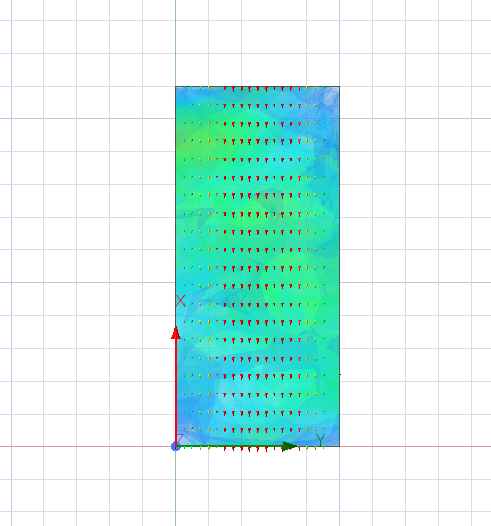
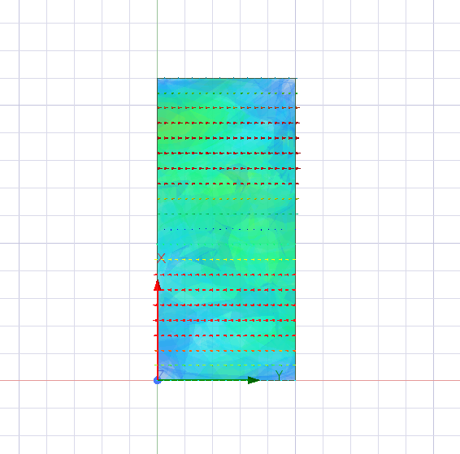
Figure 3 - Port 1 Mode 3
Figure 4 - Port 1 Mode 2

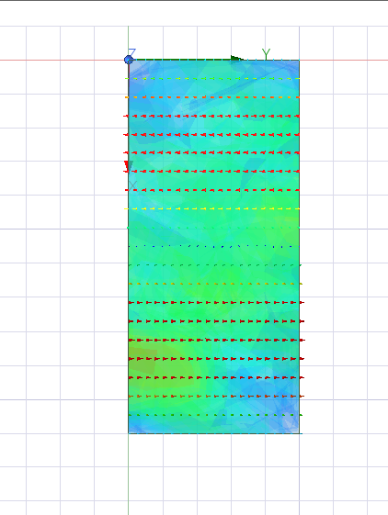
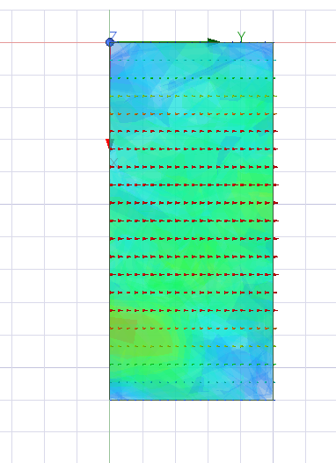
Figure 5 Port 2 Mode 2
Figure 6 - Port 2 Mode 1
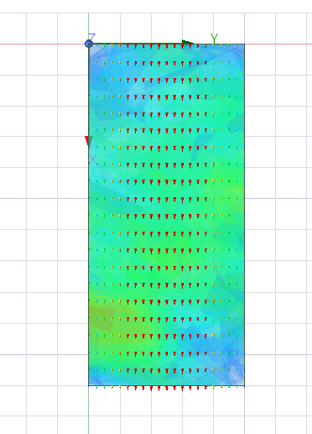
Figure 7 - Port 2 Mode 3
Dominate Mode identifiaction
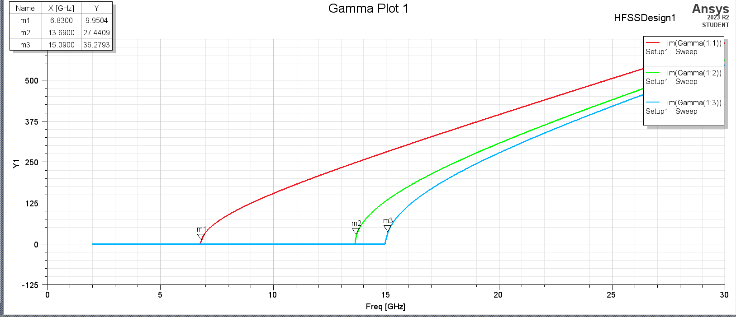
The dominent mode is is identifed with the lowest cut off frequency [3]. As shown in the graph above M1 is the dominent mode, the cut off frequency is 6ghz below M2

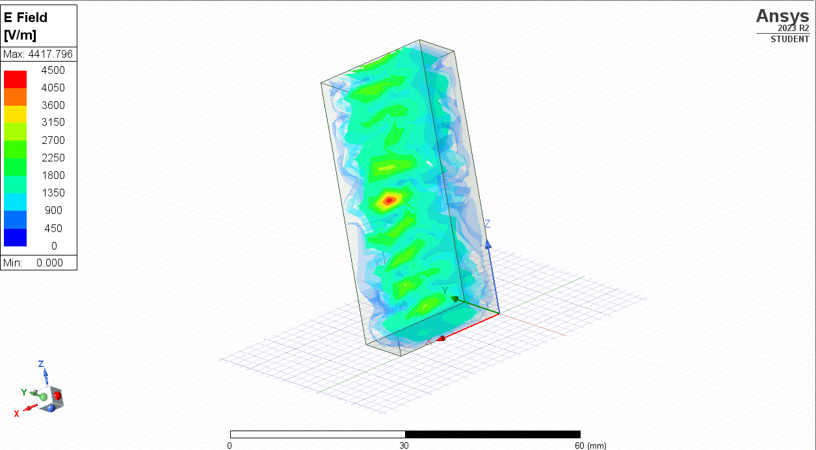

Task 1b: Waveguide with Teflon
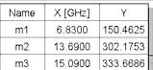

The cut off Frequency is not dependent on the material of the waveguide and therefore the cutoff frequency is the same as in a vacuum. The different modes are calculated by changing the M and N. Te1 is M=1 and N=0, Te2 IS M=0 and n=1 and Te3 M=1 and N = 1. Using these values in the formula it can be calculated to be Te1 = 6.8181GHz, Te2 = 15.7894GHz and Te3 = 17.1998GHz. This is then simulated using the Ansys software package and the result are shown in the figure below.

The ports and modes don’t change between the two types of material. These components of a waveguide simulation are not material dependant unlike the EM wave.

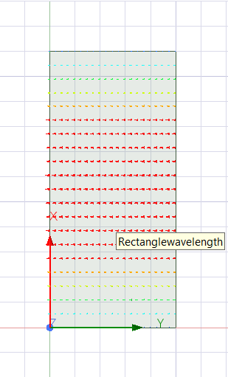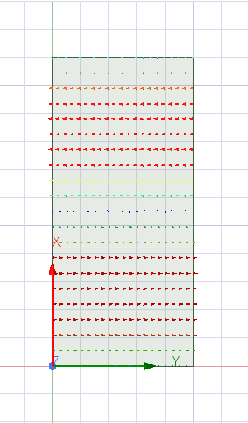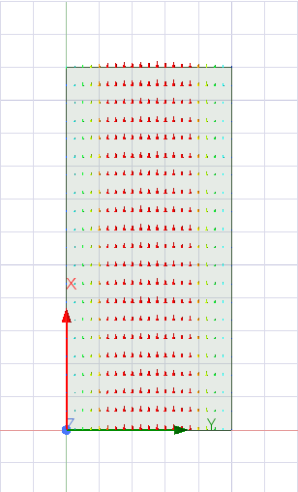
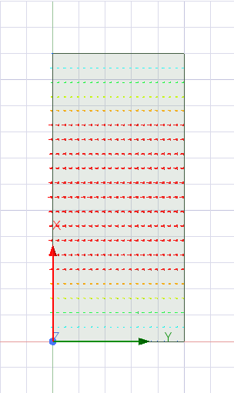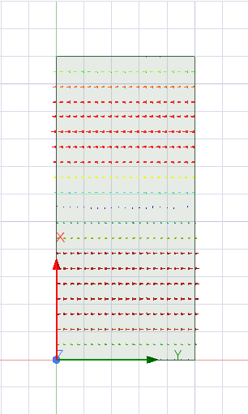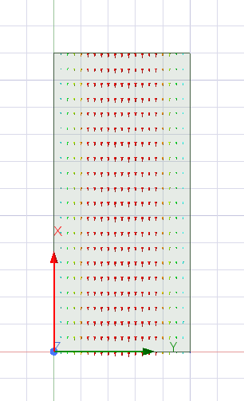

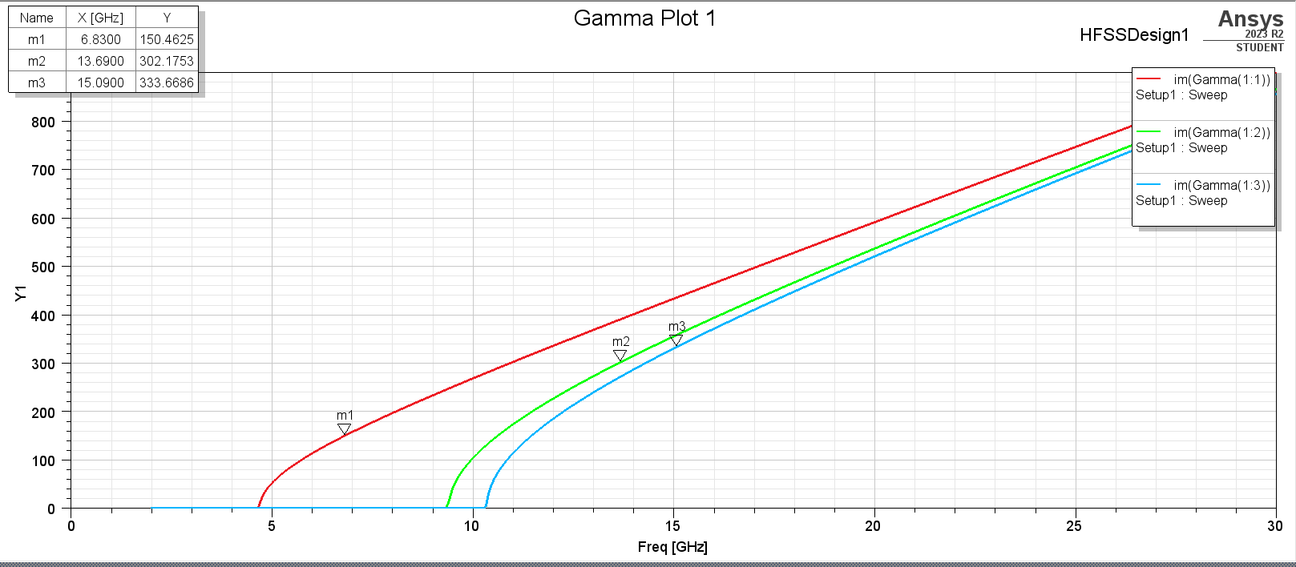
The cutoff frequency simulated in the Teflon waveguide is the same as the vacuum waveguide. The simulated cut off frequency’s is M1 is 6.831, M2 is 13.6900 and M3 15.090. The Y axis represents the magnitude of reflection of the EM Wave. The purpose of gamma plotting is for impedance matching, bandwidth analysis and resonance identification. Impedance matching is a method of analysing how well a waveguide is matched to its load across a range of frequencies. A low t value indicates a good matching. Bandwidth analysis a method to identify frequency range over which the device operates effectively with low reflections. Resonance identification is to identify the frequency’s where the waveguide resonances, which are often identified by sharp peaks or dips in |T| plot.
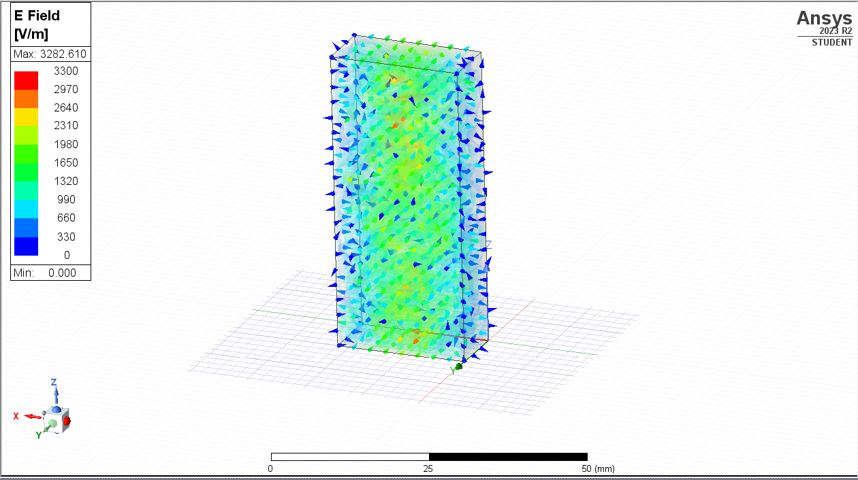

Task 2: Half-Wave Dipole Antenna
The dipole has a radius of 1mm and a length of 𝜆/2, 221/2=110.5. This creates a full cylinder to act as the dipole. Then a smaller cylinder is created within the dipole shown below [4].
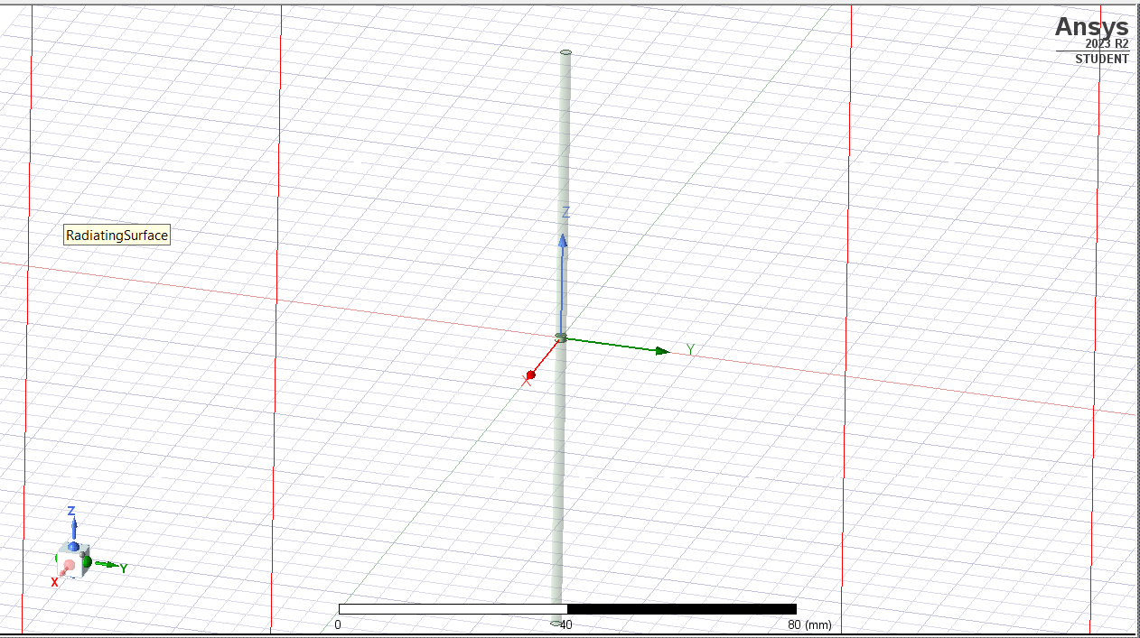
To calculate the operating frequency, it is C/𝜆 - 3x10^8/110.5 = 2714932.127Hz = 271.49GHz. The operating frequency is where the maximum radiation efficiency is reached.
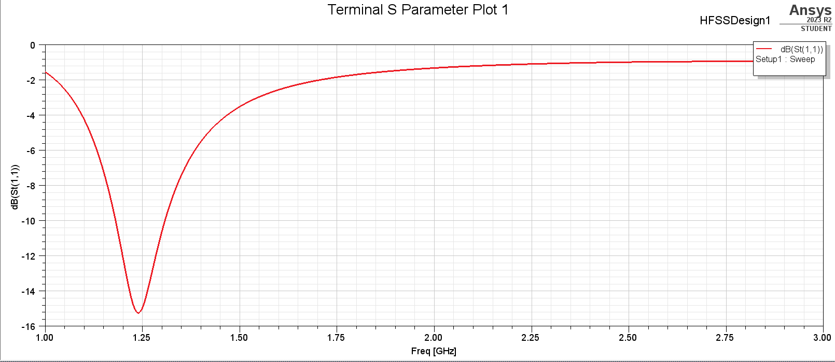
Using the graph above from the dipole simulation, the operating frequency is 1.22Ghz. This is shown by the drop of dB, this shows the impedances of the input and the impedance of the device is well matched. Usually, 10db or lower is deemed good and shows less then 10% of the energy is reflected [5].
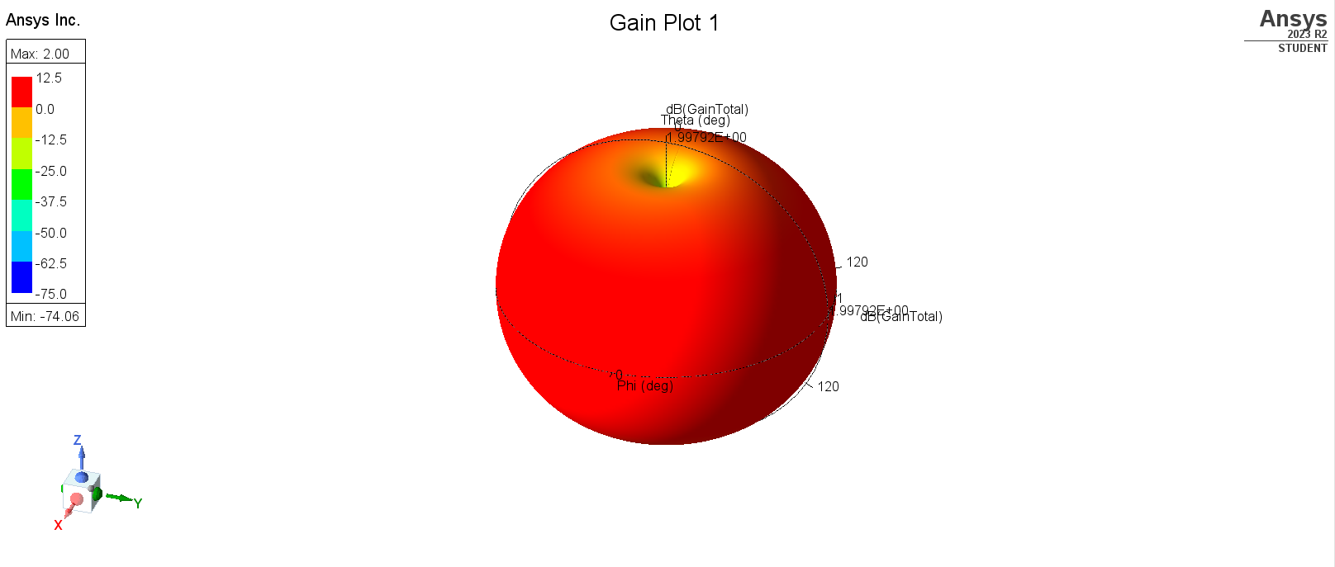
The gain plot shows how an antenna radiates electromagnetic energy and how efficiently it converts input power into radiated power. There are 2 types of gains directivity and realized gain. Directivity is how concentrated the radiated power is in specified directions. Realized gains is directivity minus any losses
The gain plot is a 3D radiation display, the colours indicate the magnitude in dB. The Magnitude ranges from -74.06 – 2dB. The pattern shown by the simulation is accurate to a dipole gain plot which is near omnidirectional. The maximum direction of magnitude is upwards.

Discussion
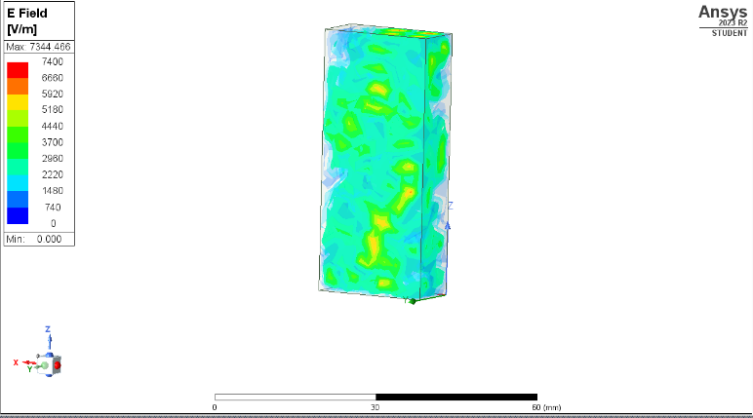
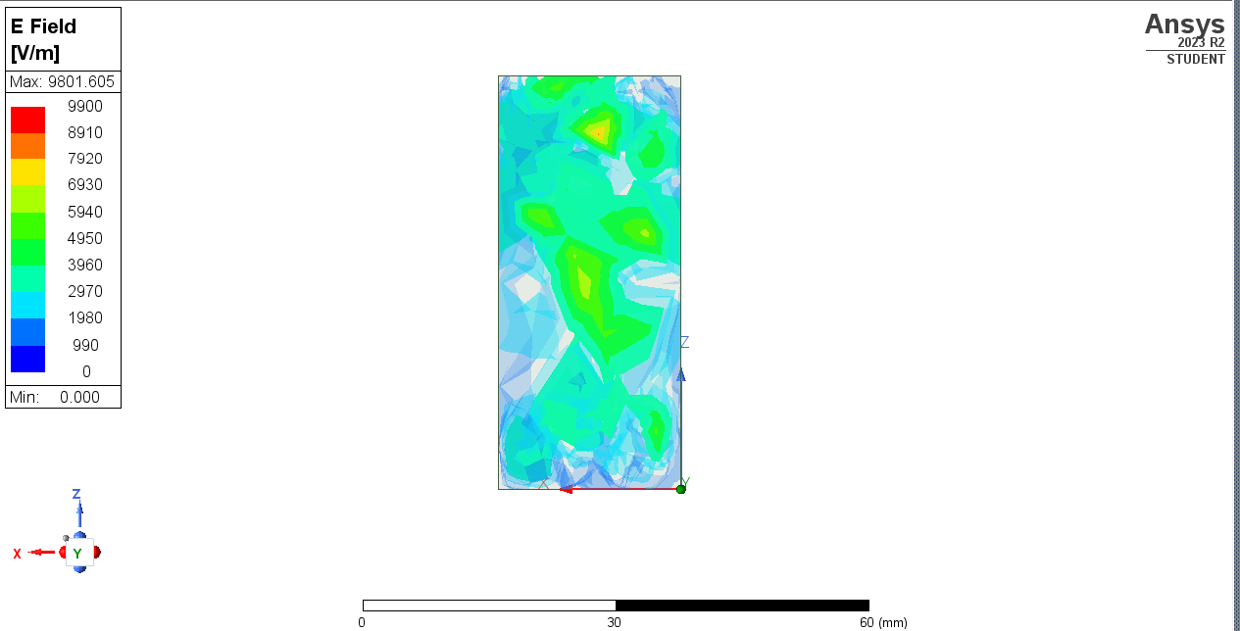
Comparing the simulation electromagnetic field directly is impossible due to the different scales set by Ansys. The vacuum EMF covers a wider spectrum due to the higher peak of 9801.6 compared to 7344.5 in the Teflon waveguide. The Teflon waveguide is shown is have more EM in the 3its midpoint of 3700 the vacuum waveguide. The vacuum waveguide has its peaks EMF towards the top of the waveguide compared to the Teflon which has its Peak EMF towards the middle bottom. AS mentioned above the cutoff frequencies and modes are all identical across the 2 materials.
Figure 8 - Teflon waveguide EMF
Figure 9 - Vacuum waveguide EMF

Below is the EMF depicted by vectors. The scales the same to the scales show in the figures above. These scales range from 0 - 7400 for Teflon and 0 – 9900 for a Vacuum. To create a clearer and more representable image on the simulation the arrow tails were turned off and increasing the spacing between the vectors. As shown in the vacuum the vectors are mainly in the lower bands in dark blue. Green is a common vector being around 4950V/m. The EMF Peaks in the top right hand and bottom right-hand corners both experiencing 7920V/m and above. The top right-hand corner is the peak experiencing the max 9801V/m.

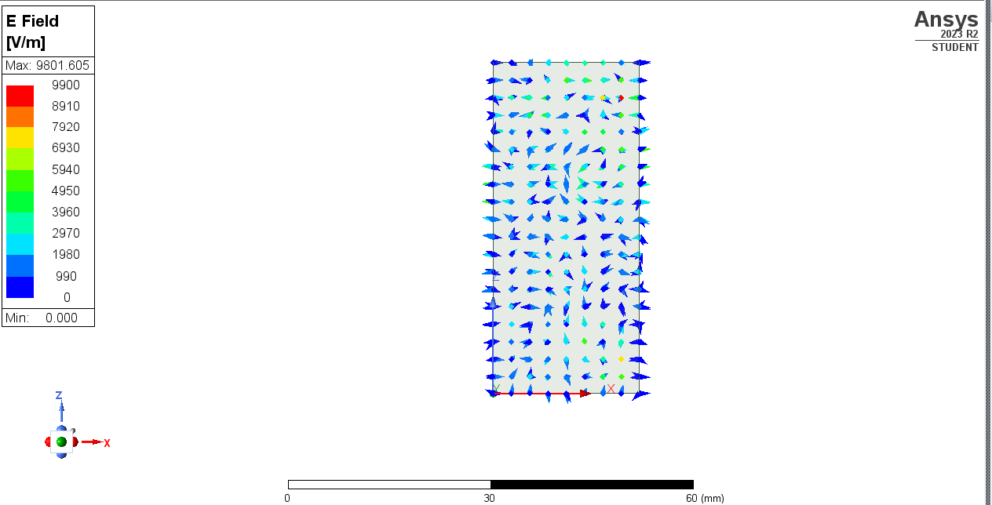
Figure 10 - Vacuum filled waveguide
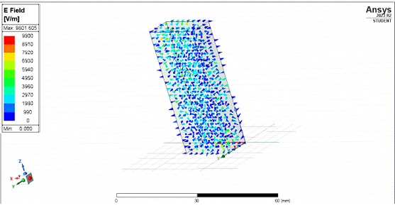
Figure 11 - Teflon filled waveguide

Conclusion
This study successfully designed and simulated a halfway dipole antenna and a rectangular waveguide. The significant findings were the identification of cutoff frequency, dominant modes and radiation patterns. The comparison between vacuum and Teflon waveguides highlighted the impact materials have on wave propagation. The halfway dipole antenna created the expected radiation of EMR.

Bibliography

[1] | COMSOL, “Comsol - perfect electronic conductor,” [Online]. Available: https://doc.comsol.com/5.5/doc/com.comsol.help.rf/rf_ug_radio_frequency.07.11.html#:~:text=Perfect%20Electric%20Conductor&text=is%20a%20special%20case%20of,a%20symmetry%20type%20boundary%20condition..
[2] | J. J. Carr, “The technican EMI handbook,” in Low pass filter , Science direct, 2000.
[3] | “Isaac physics - Electromagnetic waves,” Isaac physics, [Online]. Available: https://isaacphysics.org/concepts/cp_em_waves?stage=all. [Accessed 12 07 2024].
[4] | M. Adams, “THe dipole antenna,” in signal recepton, 2004.
[5] | “electronics note - dipole antenna or aerial explained,” Electroncis note, [Online]. Available: https://www.electronics-notes.com/articles/antennas-propagation/dipole-antenna/dipole-antenna-aerial.php. [Accessed 10 07 2024].
[6] | NASA, “NASA - Anatomy of an Electromagnetic Wave,” [Online]. Available: https://science.nasa.gov/ems/02_anatomy/.
[7] | “All about circuits - waveguides,” All about circuits, [Online]. Available: https://www.allaboutcircuits.com/textbook/alternating-current/chpt-14/waveguides/. [Accessed 26 02 2024].

