Student name: Reyhaneh Mehrabi
Student number:2323032
Module code: ACCA5019
Submission date: 24 July 2026
Business and Web Management

HealthyHarvest Website Redesign

Table of Contents
In Microsoft Word: References → Table of Contents → Automatic Table. Update the table after the report is complete.
1. Introduction
2. HealthyHarvest Website Redesign
3. Responsive Design Implementation
4. Implementation
5. Conclusion
6. References

1. Introduction

HealthyHarvest is an online business that sells fresh organic food and healthy products. The company aims to offer high-quality groceries through a simple online shopping experience. However, the current website has several design and usability problems. The navigation is unclear, the layout looks outdated, and customers may find it difficult to locate products quickly. The website is also not fully responsive, which creates problems for people using mobile devices.
The purpose of this project is to redesign the HealthyHarvest website using modern user interface (UI) and user experience (UX) principles. The new design aims to improve navigation, accessibility, visual appearance, and usability across different screen sizes.
This report examines the problems with the existing website and explains the proposed improvements. It also discusses the importance of responsive design. As part of the project, I created a moodboard, low-fidelity wireframes, five desktop pages, one mobile Home page, and an interactive prototype to demonstrate the new design.

2. HealthyHarvest Website Redesign

2.1 Current Website Issues

2. HealthyHarvest Website Redesign

2.1 Problems with the Current Website

HealthyHarvest is an online grocery business that sells organic produce, pantry products, prepared meals and weekly grocery boxes. Although the business offers useful products, its current website has several design and usability problems.

The first problem is navigation. The menu is not clear, so customers may find it difficult to locate products and important pages. New visitors may also feel confused because the website does not provide a simple shopping journey.

The visual design is another problem. The colours, fonts and spacing are not consistent across the website. Some pages contain too much information and do not have enough empty space. This can make the website look crowded, outdated and difficult to read.

The product pages also need improvement. Product cards are not presented consistently, which makes comparing products more difficult. The search and filter options are limited, so customers may struggle to find specific items. Product information, sourcing details and trust information are also not always clear.

The checkout process is too long and complicated. The delivery and payment steps are not organised clearly, which may confuse customers. If checkout takes too much time, some customers may leave the website without completing their purchase.

The website also has accessibility problems. Some text has poor colour contrast, buttons are too small, and keyboard navigation is limited. These issues can make the website difficult to use, especially for people with disabilities.

Finally, the website is not fully responsive. Some content may not display correctly on mobile phones and tablets. Text and images can appear too large or too small, which creates a poor mobile shopping experience. These problems can reduce customer satisfaction and may also affect sales.

2.2 Proposed Design Solutions

2.2 Proposed Improvements
Navigation
In my redesign, I used a simple and consistent navigation bar at the top of the desktop pages. It includes links to Shop, Subscriptions, Our Growers and Recipes. I also included a search bar, Account and Cart options. This structure helps users find the main areas of the website more easily.
Visual Design
I used green, cream and orange because these colours represent nature, fresh food and warmth. The colours were selected during the moodboard stage. I used Fraunces for display text and Inter for interface text. Rounded corners, consistent spacing and more white space were also used to make the pages feel clean and welcoming.
Real Product Images
The original product illustrations were replaced with real photographs of fruit, vegetables, bread and prepared meals. This makes the website feel more realistic and helps customers recognise the products. The images also support the fresh and natural style of the HealthyHarvest brand.
Product Cards and Filters
I created consistent product cards showing an image, product name, short description, weight or quantity, price and an add button. The Shop page also includes filters for Vegan, Gluten-free, Within 50 miles, Soil Association and Price. A search bar was added to help customers find products more quickly.
Connected Pages
I designed five desktop pages: Home, Shop, Product, Subscription and Checkout. They use the same colours, typography, logo and visual style. In the interactive prototype, buttons and product cards connect the main pages. For example, users can open the Shop page, view a product and continue towards checkout.
Checkout and Accessibility
I organised the Checkout page into clear sections for contact information, delivery address, delivery time and the order summary. The page also includes a clear Continue to payment button. Readable text, clear labels, suitable colour contrast and larger buttons were used to make the interface easier to understand and use.
Responsive Design
I created a separate mobile version of the Home page to show how the design could work on a smaller screen. The content is arranged vertically, while images, product cards and buttons are resized to fit the available space. This makes the important information easier to view on a mobile phone.

3. Responsive Design Implementation

3. Responsive Design

Responsive design is important because people use websites on different devices, including desktop computers, tablets and mobile phones. A responsive layout should make content clear and easy to use on different screen sizes.

In this project, I considered responsive design while creating the HealthyHarvest redesign in Figma. The five main pages were designed for desktop screens. I also created a separate mobile version of the Home page to demonstrate how the design could be adapted for a smaller screen.

The desktop Home page uses a wide layout. It has a navigation bar across the top, a large hero image and a row of product cards. This layout uses the extra space available on a desktop screen and allows users to view more information at the same time.

For the mobile Home page, I created a narrower layout and arranged the main sections vertically. The logo appears at the top, followed by the hero image, introductory content and product section. Two featured product cards are displayed next to each other. Their images, text and buttons were resized to fit the smaller screen.

The mobile design includes less content than the desktop version. This keeps the page simple and helps users focus on important information. The Shop fresh food button remains clear and easy to select. Rounded corners, consistent spacing and white space were used to separate different sections of the page.

Images were resized and cropped to fit their containers while keeping the products visible. Text was kept short to prevent the mobile layout from becoming crowded. Green text and buttons were placed against light backgrounds to provide clear contrast and support readability.

Only the Home page was adapted for mobile in this prototype. However, the same design approach could later be applied to the Shop, Product, Subscription and Checkout pages. This would include stacking content vertically, resizing images and buttons, and simplifying navigation for smaller screens.

Overall, the mobile Home page demonstrates how the HealthyHarvest design could remain clear, attractive and easy to use on a smaller device while keeping the same colours, images and brand style as the desktop version.

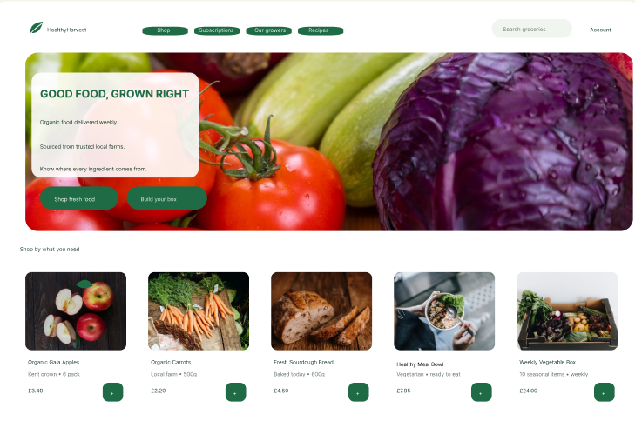
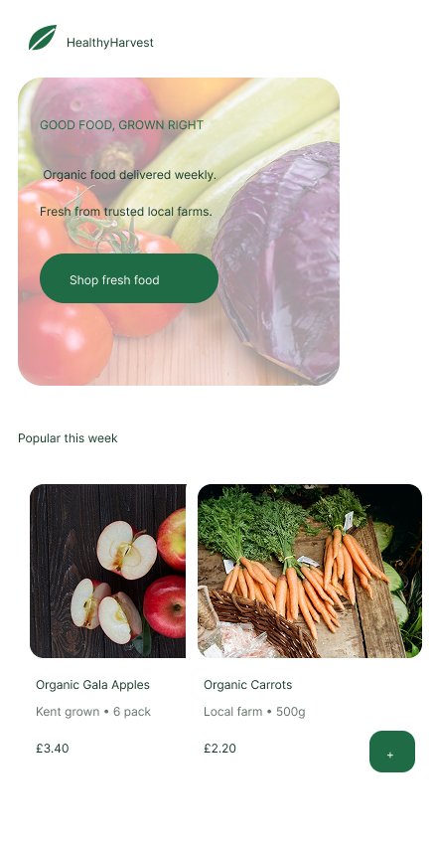

Comparison of the mobile and desktop Home page designs created in Figma.

4. Implementation

4.1 Moodboard

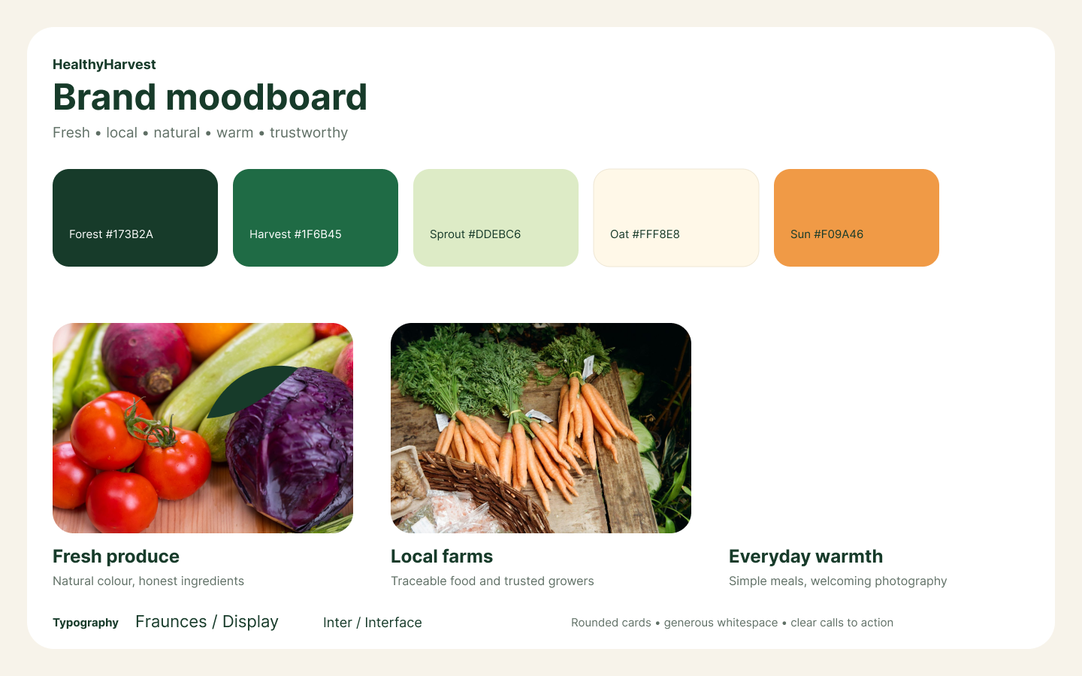

HealthyHarvest moodboard showing the selected colours, typography and visual style.

4. Implementation

The implementation stage focused on creating the design materials for the HealthyHarvest website in Figma. The main stages included developing a moodboard, producing low-fidelity wireframes, creating five high-fidelity desktop pages, designing a mobile Home page and connecting the main pages as an interactive prototype.

4.1 Moodboard

The first stage was creating a moodboard to establish the visual direction of the website. The moodboard included the main colours, typography, images and general design style. Dark and medium green were selected to represent nature, freshness and healthy food. Cream was used for light backgrounds, while orange was used as an accent colour to add warmth.

Fraunces was selected for display text, while Inter was chosen for interface text. Rounded cards, generous white space and natural food photography were also included in the moodboard. These choices helped create a friendly and trustworthy identity for HealthyHarvest.

4.2 Wireframes
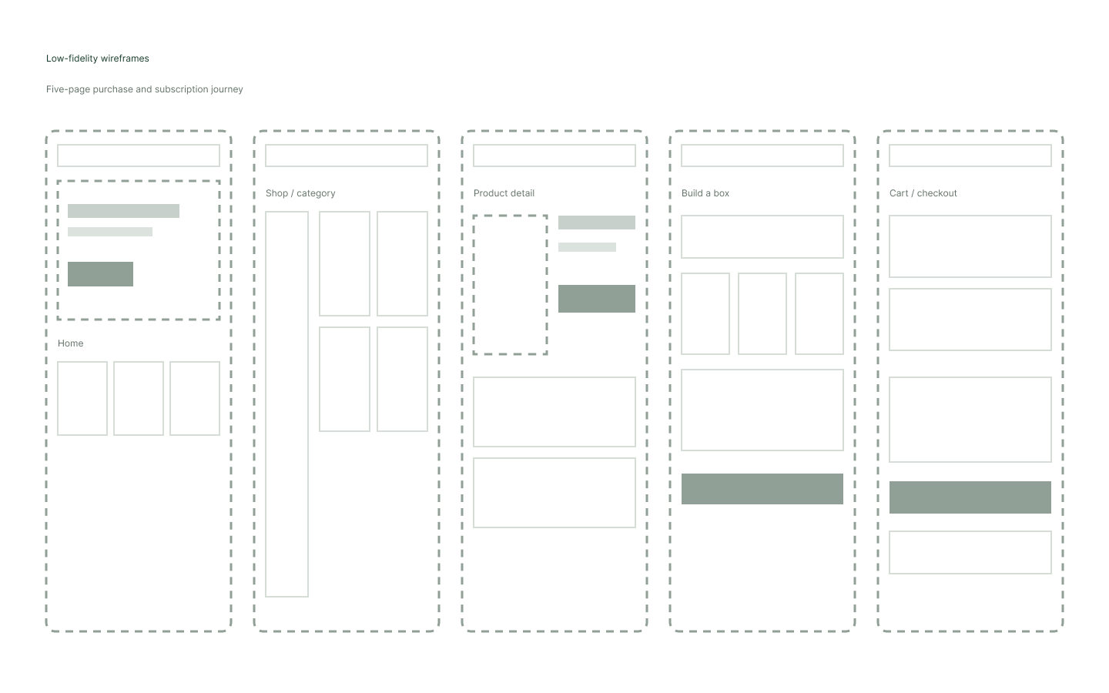
Low-fidelity wireframes showing the five-page customer journey

4.2 Low-Fidelity Wireframes

The next stage involved creating low-fidelity wireframes. Five pages were planned: Home, Shop, Product, Subscription and Checkout. The wireframes focused on page structure and the position of important content rather than colours and detailed images. Simple boxes and placeholders were used to represent navigation, images, product cards, buttons and forms.

This stage made it possible to review the shopping journey before creating the final visual design. It also helped maintain a clear structure across the five pages

4.2 Low-Fidelity Wireframes

The next stage involved creating low-fidelity wireframes. Five pages were planned: Home, Shop, Product, Subscription and Checkout. The wireframes focused on page structure and the position of important content rather than colours and detailed images. Simple boxes and placeholders were used to represent navigation, images, product cards, buttons and forms.

This stage made it possible to review the shopping journey before creating the final visual design. It also helped maintain a clear structure across the five pages.

4.2 Low-Fidelity Wireframes

The next stage involved creating low-fidelity wireframes. Five pages were planned: Home, Shop, Product, Subscription and Checkout. The wireframes focused on page structure and the position of important content rather than colours and detailed images. Simple boxes and placeholders were used to represent navigation, images, product cards, buttons and forms.

This stage made it possible to review the shopping journey before creating the final visual design. It also helped maintain a clear structure across the five pages.

4.3 High-Fidelity Pages

After completing the wireframes, I developed the high-fidelity desktop pages. The Home page contains the HealthyHarvest logo, navigation, a large hero image, introductory text, action buttons and featured product cards. Real photographs were used instead of simple illustrations to make the page appear more natural and realistic.

The Shop page includes a product grid and filters for Vegan, Gluten-free, Within 50 miles, Soil Association and Price. Each product card displays a photograph, product name, short sourcing information, price and an add button. A search bar was also included at the top of the page.

The Product page presents a large product image together with its name, rating, price and description. It also contains an Add to basket button, information about where the product comes from, its environmental impact and a personalised product suggestion.

The Subscription page allows customers to build a weekly box. It shows three recommended products and a summary panel explaining the selected items, weekly price, saving and delivery offer. A Review my box button provides a clear next action.

The Checkout page contains sections for the customer’s email address, delivery address and preferred delivery time. An order summary shows the selected products, delivery charge and total price. The Continue to payment button shows the next stage, although a separate payment page was not designed.

4.3 Interactive Prototype
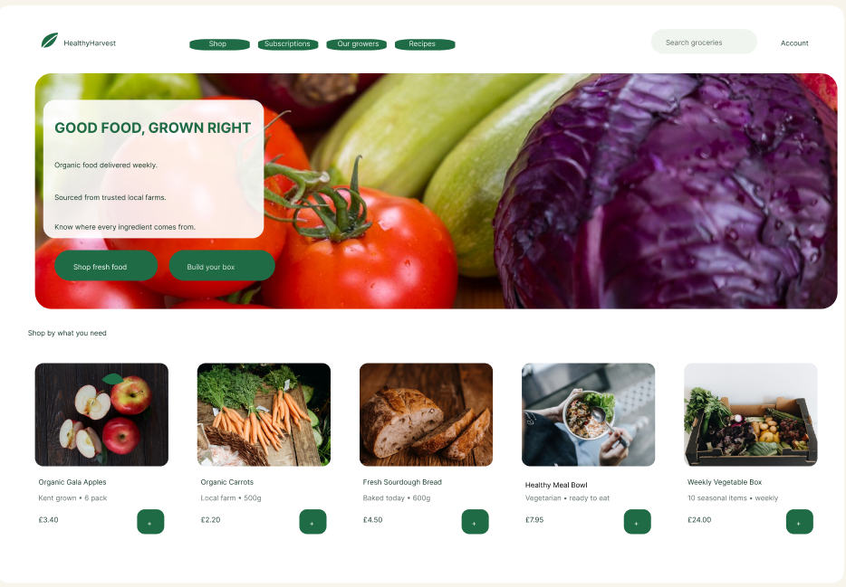
Desktop Home page
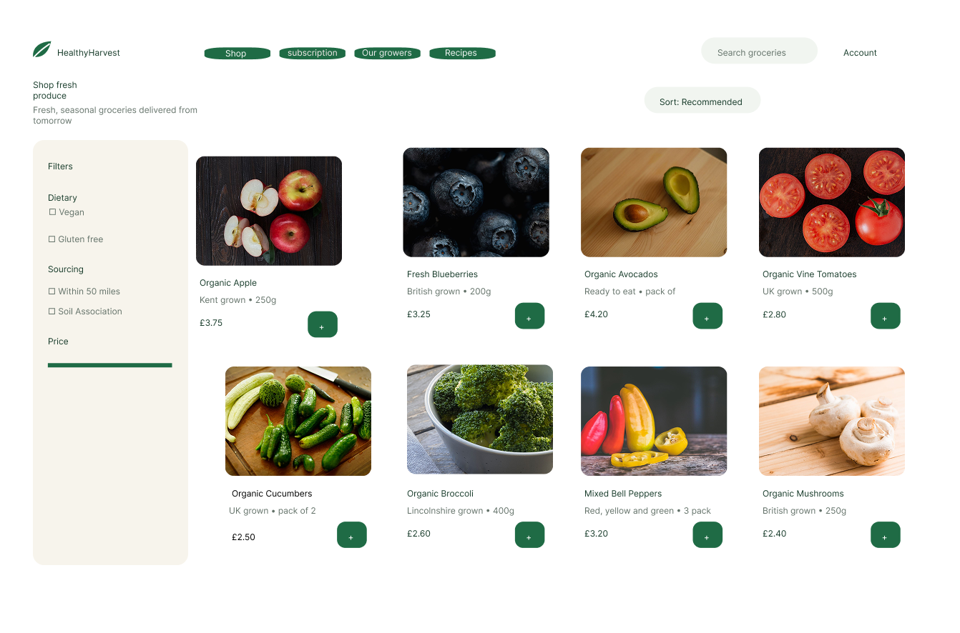
Shop page
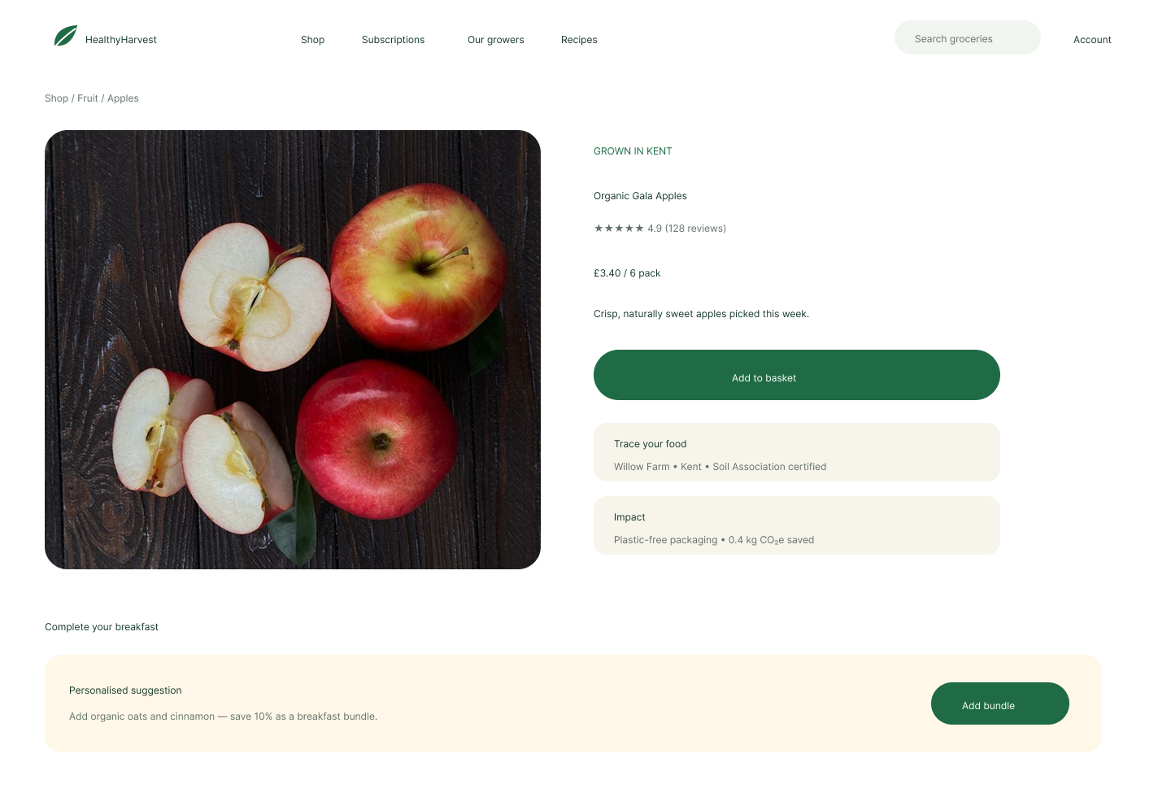
Product detail page

High-fidelity designs for the Home, Shop and Product pages

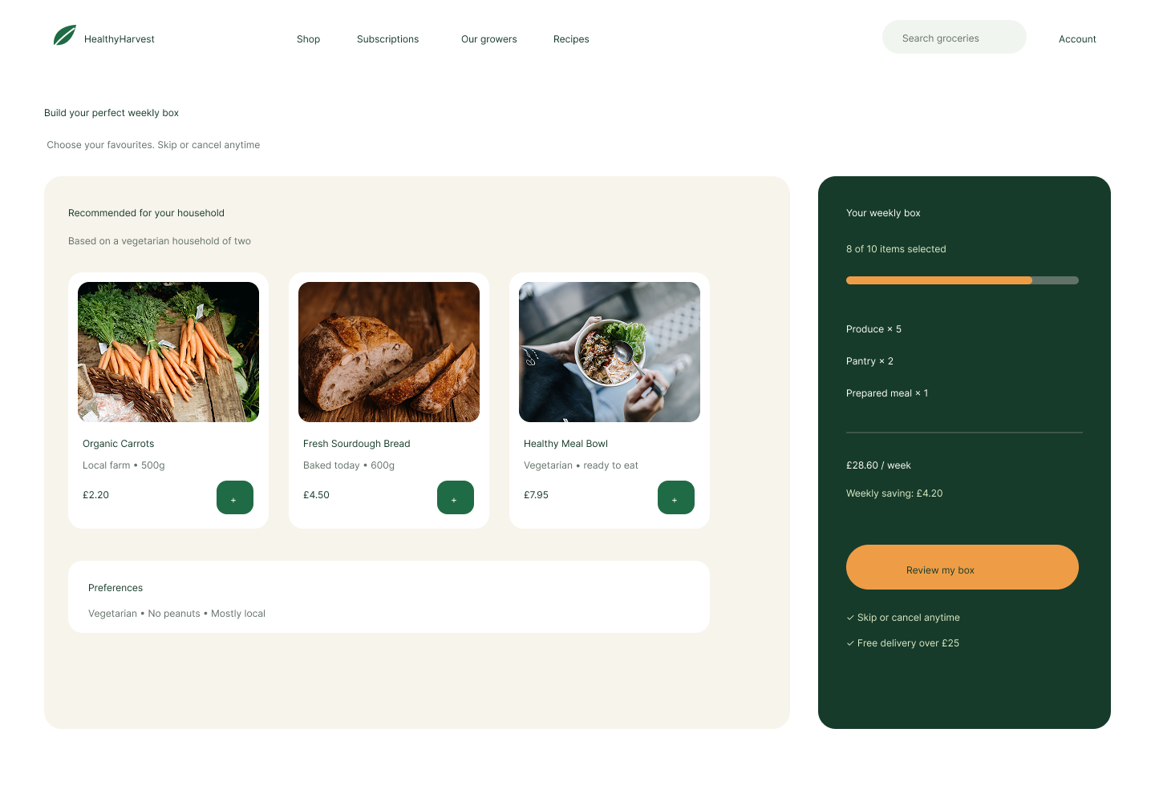
Subscription box page
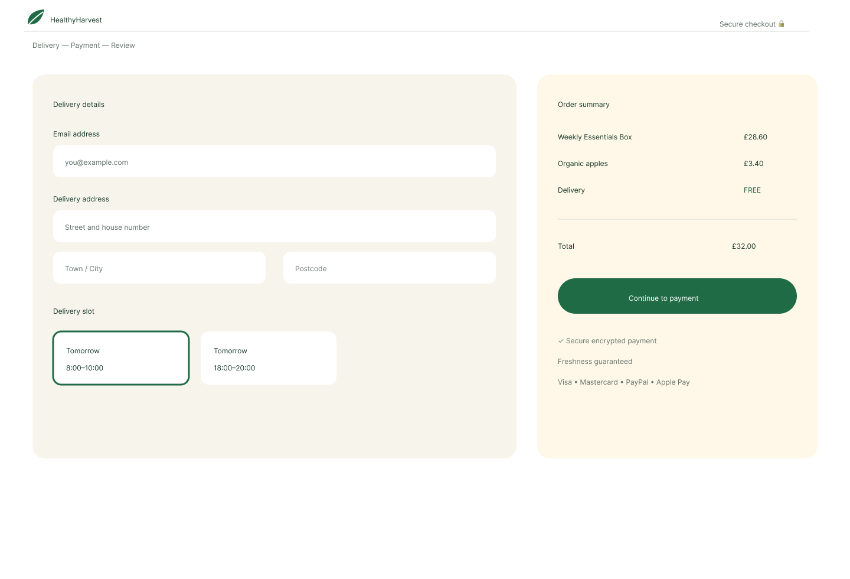
Checkout page

High-fidelity designs for the Subscription and Checkout pages

4.4 Mobile Design and Interactive Prototype
To demonstrate how the redesigned HealthyHarvest website could work on a smaller screen, I created a mobile version of the Home page in Figma. The mobile design keeps the same colours, photographs, typography and rounded shapes as the desktop version.
The layout was adjusted to fit a narrower screen. The logo appears at the top, followed by the hero image, introductory text and the Shop fresh food button. The product section contains two featured product cards displayed next to each other. Their images, text and buttons were resized to fit the available space. Short text, clear spacing and suitable colour contrast were used to keep the content readable.
Only the Home page was designed in a mobile format. Therefore, this design demonstrates how the visual style could be adapted for mobile devices rather than showing a fully responsive version of all five pages.
After completing the page designs, I used Figma’s Prototype feature to create interactions between the five desktop pages: Home, Shop, Product, Subscription and Checkout. Buttons and product cards were connected using On click and Navigate to interactions.
For example, the Shop fresh food button connects the Home page to the Shop page. A product card on the Shop page opens the Product page. The Build your box button leads to the Subscription page, where customers can view recommended products for a weekly box. The main journey then continues towards the Checkout page.
These interactions do not provide the full functionality of a developed online store. However, they demonstrate the intended navigation and allow the main customer journey to be tested before development. Overall, the mobile Home design and interactive prototype help show how the proposed website could provide a clear and consistent shopping experience.

Mobile Home page designed for a smaller screen.

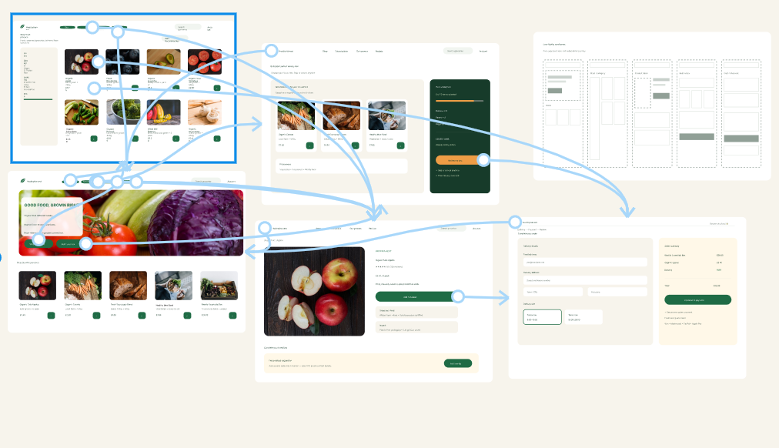

Interactive prototype connections between the HealthyHarvest pages in Figma

5. Conclusion
In conclusion, this project presented a redesign of the HealthyHarvest website using modern UI and UX design principles. The proposed design focuses on clearer navigation, consistent page layouts, readable text and a simpler shopping journey. Green, cream and orange colours, natural product photographs and rounded cards were used to create a fresh and welcoming visual style.
During the project, I created a moodboard, low-fidelity wireframes and five high-fidelity desktop pages in Figma. These pages included Home, Shop, Product, Subscription and Checkout. I also created a mobile version of the Home page to demonstrate how the design could be adapted for a smaller screen. Prototype interactions were added to show how users could move between the main pages.
The final prototype is not a fully developed website, but it clearly presents the proposed design and customer journey. If developed and tested with real users, it could improve usability, customer satisfaction and the overall online shopping experience.

6. References
6. References
[1] E. Jongmans, F. Jeannot, L. Liang and M. Dampérat, “Impact of website visual design on user experience and website evaluation: The sequential mediating roles of usability and pleasure,” Journal of Marketing Management, vol. 38, nos. 17–18, pp. 2078–2113, 2022, doi: 10.1080/0267257X.2022.2085315.
[2] M. Wijaszka and M. Dzieńkowski, “A usability analysis of e-commerce systems: Prestashop, Magento and Joomla,” Journal of Computer Sciences Institute, vol. 32, pp. 239–245, 2024, doi: 10.35784/jcsi.6313.
[3] E. Özmen, E. Karaman and N. Alkış Bayhan, “Users’ emotional experiences in online shopping: Effects of design components,” OPUS Journal of Society Research, vol. 19, no. 45, 2022, doi: 10.26466/opusjsr.1063894.
[4] World Wide Web Consortium, “Web Content Accessibility Guidelines (WCAG) 2.2,” Dec. 2024. [Online]. Available: https://www.w3.org/TR/WCAG22/. [Accessed: Jul. 24, 2026].
[5] MDN Web Docs, “Responsive web design.” [Online]. Available: https://developer.mozilla.org/en-US/docs/Learn_web_development/Core/CSS_layout/Responsive_Design. [Accessed: Jul. 24, 2026].
[6] Figma, “Guide to prototyping in Figma.” [Online]. Available: https://help.figma.com/hc/en-us/articles/360040314193-Guide-to-prototyping-in-Figma. [Accessed: Jul. 24, 2026].
.

