Action Research Project ECPT6009
Action research: Exploring the adoption of Generative AI in Welsh language medium courses
Emma Jones (2219874)
2024
Contents
Introduction 3
Research questions 4
Literature review 4
Welsh language in higher education 4
Generative AI and higher education 4
Welsh language and Generative AI 5
Methodology 8
Results and discussion 9
Quantitative results 9
Qualitative results 11
Conclusion 15
Limitations 16
References 17
Appendices 20
1. Participant information sheet 20
2. Questionnaire - Use of Generative AI in Welsh Language courses 24

Introduction

Considering recent developments in technology, namely Generative Artificial Intelligence (Generative AI), the world of higher education has been disrupted. We know that technology can be of great assistance to both educators and students, however the rapid developments of Generative AI has raised many concerns since its launch in November 2022 (JISC, 2024). For example, its impact on literacy, writing and critical thinking skills (UK Parliament, 2024), and the impact on assessment and academic integrity (JISC, 2024).
“What is Generative AI?
Technology that allows computers to create new content, such as text, images, sound, music, code, and even scientific data. Unlike traditional artificial intelligence (AI) methods that focus on analysing and interpreting existing data, generative AI aims to learn the underlying patterns and structures of a dataset and then generate entirely new content based on that information”
(Welsh Government, 2024b)

Regardless of the concerns raised to date, none of the advice or guidance at a local level includes reference to how this new technology can be harnessed by students through the language of Welsh. With the many benefits that Generative AI can bring to course design, student support and employability, we need to ensure that our Welsh language students are not being excluded or deprived of the knowledge and skills required to live and work in the future world of AI (QAA, 2023a).
I have experienced these concerns first-hand. Generative AI guidance has been provided at the university, but I am struggling to understand how to approach its use, and develop training opportunities to members of staff and students who are experiencing difficulties in adopting this technology through the language of Welsh. According to Baltaci-Goktalay & Ocak (2006, p. 6), ‘for an effective technology adoption, faculty’s different stages of concern should be acknowledged and appropriate support should be provided’.
It is the aim of this research therefore to reflect on my own practice and delivery design, as well as help inform future practitioners through developing a set recommendations to further support the adoption of Generative AI in Welsh language medium education.

Research questions

The research project will aim to answer the following questions. This is to help develop and improve my own practice and delivery by recognising how academic staff are adopting this technology in Welsh medium education, as well as offer guidance and support that can be shared wider across the university.
The research will be guided by ‘8 Conditions that Facilitate the Implementation of Educational Technology Innovation’ (Ely, 1990), which is rooted within sociological theory linked to practice and implementation of innovation and technology.
- What are the thoughts of Welsh language academic staff on the use and integration of Generative AI to support teaching and learning in their Welsh medium language courses?
- How are Welsh language academic staff using Generative AI to support teaching and learning in their Welsh language courses?
- What are the opportunities and limitations of using Generative AI to support teaching and learning in Welsh language courses?

Literature review

Welsh language in higher education

According to Article 30 of the United National Convention on the Rights of the Child (UNCRC) (UNICEF, 1990) ‘a child belonging to … a [linguistic] minority … shall not be denied the right … to use his or her own language’. In Wales, students have the option to study their courses through the language of Welsh. As part of the Welsh Government initiative to satisfy the Well-being of Future Generations (Wales) Act 2015 (Welsh Government, 2021), they have a duty to promote and facilitate the use of Welsh in education. This also aligns with their Cymraeg 2050 strategy which aims to promote and facilitate the use of the Welsh language and reach 1 million Welsh speakers by 2050 (Welsh Government, 2017). With an increase of 12% of students enrolling through the medium of Welsh in 2021/22 (Welsh Government, 2023), it is clear that there is a growing need to ensure we can provide equitable experiences for our Welsh language students.
As one of the leading universities in Wales for the provision of Welsh language education opportunities, the University of Wales Trinity Saint David (UWTSD) scores highest in the number of students (3,100) receiving teaching through the medium of Welsh (Welsh Government, 2023). This accounted for 21% of all students enrolled in 2021/22. This is quite a significant figure that requires attention to ensure our students can access suitable digital tools through the Welsh language. According to a research paper by Le Cordeur (2012, p. 4), they suggest that the ‘role of language is therefore critical to higher education as it impacts on access and success, and affirms diversity, while the right of students to instruction in the language of their choice’.

Generative AI and higher education

Established education organisations such as UNESCO, QAA, Advance HE and JISC are sharing advice and guidance for educational institutions on how to approach Generative AI. From primary, secondary all the way through to higher education, they share ideas on how these tools can be used to support teaching and learning. According to Nah, et al., (2023), AI is forecast to be used in a variety of industries, not only IT such as Healthcare, Human Resources, Finance, Education, Research, Game design, Marketing and more. The Quality Assurance Agency for Higher Education (QAA) states that the use of Generative AI and AI literacy (QAA, 2023a) has emerged as a key graduate attribute. When used correctly, this provides students with a valuable skill for future employment.
The Russell Group launched their guiding principles in 2023, to help universities ensure students and staff are AI literate to take advantage of this new technology for the purposes of teaching and learning (Russell Group, 2023). Since then, a number of universities followed suit in developing their own AI strategies and policies. This includes our very own UWTSD Generative Artificial Intelligence Guidance where the university recognises the impact of Generative AI within higher education (UWTSD, 2024). The guidance sets out the university’s stance on Generative AI; providing both staff and students guidance on how it can be used whilst maintaining academic integrity. However at the moment, it only aligns the guidance with the use of Generative AI and academic integrity. This has raised questions from Welsh language staff on how they can begin to explore these tools within their courses.
Since its launch in 2022, consumers and academic staff have identified concerns from the beginning. For example, concerns around providing inaccurate information (hallucinations), bias (Open AI , 2024) and academic integrity (JISC, 2024). From a Welsh language perspective, there are additional concerns around its use for Welsh language courses and their students. Cañestro, (2024) acknowledges that the lack of data in order to support Generative AI experiences through minority languages could have a serious impact. This is due to the lack of data that it requires for training purposes which according to Brookings (2023) will lead to the widening of the digital divide for underrepresented communities.
A recent UK Parliament report on the ‘Use of artificial intelligence in education delivery and assessment’ (UK Parliament, 2024) addresses concerns around the use of Generative AI, including learners developing an over reliance on AI, and its impact on literacy, writing and critical thinking skills. However, although the concerns are representative and include issues such as exacerbating inequalities and increasing the digital divide, it does not include concerns around language barriers that Welsh language students may face. The guidance is heavily aimed towards English education establishments and is not representative of Welsh medium education establishments. A recent JISC report on ‘Student perceptions of Generative AI’ (JISC, 2023) listed how students are currently using Generative AI, and how they believe it can greatly benefit them in their educational experience. Once again, the language barrier is not addressed. It is only addressed as a benefit, where ‘international students and those for whom English is a second language’ (JISC, 2023, p. 2) would be able to use Generative AI for transcription, translation and to clarify meanings of words and images. This aligns with the thoughts of Farrelly & Baker (2023, p. 3) where this ‘reinforces the existing culture of privileging one form of knowledge representation—written text, and particularly that written in English— over others’.

Welsh language and Generative AI

The Welsh Government released a Welsh Language Technology Action Plan (Welsh Government, 2018) in 2018, outlining its ambitious plans to ensure the Welsh language can be used in a variety of digital contexts. For example, through voice, text and other means of human interaction. The report looks at how they will focus on three areas consisting of Welsh language speech technology, computer-assisted translation and conversational artificial intelligence. This was written by the 2018 Minister for Welsh Language and Lifelong Learning Eluned Morgan AM, who shared her vision of developing technology opportunities that support the Welsh Language.
“I’d like to see a situation where Welsh is used in as many situations as possible— education, work and home, and in all those situations which technology reaches. I already use voice technology on my phone. I’d like to be able to do that in Welsh. Like me, most Welsh speakers live or work in a bilingual atmosphere. So as I work, the technology I use will have to be able to handle Welsh and English at the same time.”
Eluned Morgan AM, Welsh Language and Lifelong Learning
(Welsh Government, 2018)
Although conversational AI is listed as one of their main focus areas, this report doesn’t go into detail on the use of AI within education. With the widespread of Generative AI only being developed and made publicly available in November 2022 (JISC, 2024), it is clear that this wouldn’t necessarily be on the Welsh Government agenda in 2018.
A recent BBC report stated that the Welsh Government strategy in relation to Generative AI will be renewed soon. Their report ‘AI: More Welsh data needed to improve accuracy, says business’ (BBC News, 2023) shared business concerns on being able to develop applications that make use of Generative AI, due to the lack of Welsh language data which leads to inaccuracies in the results. This is expected when compared with larger data sets of languages such as English, German and Spanish. We know that Generative AI can provide what is called hallucinations, where the AI will generate inaccurate results (Open AI , 2024). It is a concern therefore that the Welsh Language is already at a disadvantage.
A post on the Say Something in Welsh forum (Say Something in Welsh, 2022) suggests that initially, ChatGPT was able to respond to Welsh but with limited success. A further update in 2022 stated that it claimed it could not speak Welsh (Figure 1). This suggests a response from ChatGPT in the acknowledgement of its poor performance.

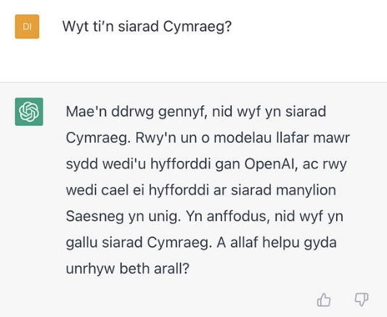
Figure 1. A screen capture of ChatGPT included in the forum discussion on the Say Something in Welsh website (Say Something in Welsh, 2022)

However in 2023, a follow up post claimed that it can now speak Welsh once more. In response to the rapid developments of Generative AI, it seems the Welsh Government has been working with Open AI to improve how their language model ChatGPT can process the Welsh Language. A recent release of the Welsh Language Technology Action Plan – Final Report (Welsh Government, 2024b) outlines the work that has been undertaken to date to address this issue.
“We want to ensure that anyone can use the Welsh language in technology in more and more situations, without having to ask or go out of their way to do so.”
Jeremy Miles, Minister for Education and Welsh language
(Welsh Government, 2024a)
This is a positive move towards a more equitable experience with Generative AI technology. However it’s use in education is still unclear.
Ultimately, whilst it is acknowledged that the use of Generative AI through the language of Welsh is not as efficient as through the English language, it’s important to ensure Welsh language students are not left behind. In light of the lack of information and guidance on how to adopt Generative AI within Welsh language courses, this research will aim to find out how other Welsh language lecturers are using Generative AI in their courses, whilst ensuing its use underpins teaching and learning delivery, ensuring an equitable experience for students studying through the language of Welsh.

Methodology

To explore how Welsh language lecturers use AI in their practice, this research follows an Action Research methodology, in order to ‘acquire information having practical application to the solution of [a] specific problem related to work’ (Punch, 2014, p. 136). Due to the nature of the research questions, a pragmatic approach will be adopted to help develop a solution to the problem. This is used often in education, where the ‘starting point is a problem that needs a solution or a question that needs answers’ (Punch, 2014, pp. 15-16).
In line with the Ethics Approval process at the university, this project was approved on the 18th of January 2024. This ensured the project meet the requirements of ethical considerations and data protection (GDPR) aligned with Ethical Guidelines for Educational Research (BERA, 2018).
Assuming the role of an ‘insider’ (Kemmis, et al., 2014), the research will utilise the Participatory Action Research (PAR) approach, leveraging practitioners’ knowledge and understanding of the subject from within. In particular, it will adopt a critical participatory approach. According to Kemmis, et al., (2014), critical participatory action research does not always follow the cyclical steps of planning, acting, observing, reflecting. Instead, they emphasise that the research should be critical, and should interrogate our own practices, focussing on initial concerns with the help of others. This secures the commitment of those most affected by this topic, leading to suitable action outcomes (Dick, 2000).
In this first phase of research, an invitation to take part was sent to academic staff that met eligibility criteria; which was Welsh speaking academic staff, who deliver courses through the language of Welsh. This invitation included a participant information sheet outlining what was involved before participants agreed to take part (UWTSD, 2022) (Appendix A). Aligning to SMART goals methodology, this was sent to a specific number through convenience sampling (Kemmis, et al., 2014) due to the short deadline. Once participants accepted the invite, the questionnaire was sent out to them. A copy of the questionnaire can be found in Appendix B, which was designed to capture primary data consisting of both quantitative and qualitative data collection methods.
Aligning to the UK Professional Standards Framework (UKPSF), this first cycle of research will help identify recommendations to satisfy the professional values of V1, V2 and V3; where through the use of technology we should respect diverse learning communities, and ensure we are providing equitable learning experiences through evidence-informed approaches (Advance HE, 2011).

Results and discussion

Quantitative results

Out of three responses, only two participants returned the anonymous questionnaire. The initial quantitative questions were used to determine the level of adoption. This was to establish the level of adoption, knowledge and skills of the participant that would inform later responses to identify the level of validity.
Out of the two responses, both responded that they had indeed heard of Generative AI. Interestingly, only one of the participants had used Generative AI in a personal capacity, in comparison with both answering ‘yes’ to using it in a professional capacity. Both participants also confirmed they have used Generative AI in their courses. This may have been influenced by attending UWTSD AI workshops that were offered last year.
Participants were asked to score their level of confidence when using Generative AI tools (Figure 2). The scale was numbered 1 – 10 (with 1 being low in confidence and 10 being high in confidence). Both participants scored themselves relatively high, which resulted in an average score of 8. The same question was then asked to score their level of confidence when using Generative AI tools for use within their Welsh language courses (Figure 3). They scored themselves much lower and resulted in an average score of 3. This isn’t surprising at all, given the use of Generative AI through the language of Welsh is poor.

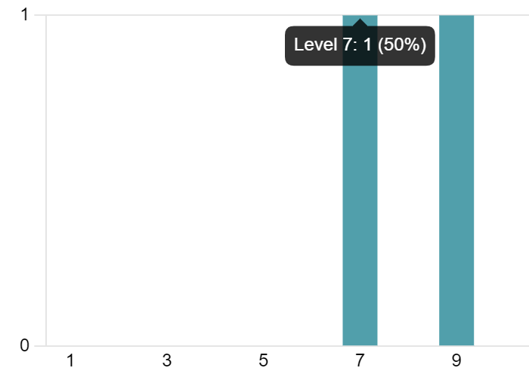

Figure 2. Question 6: On a scale of 1 – 10 (with 1 being the lowest, and 10 being the highest), what is your level of confidence in using Generative AI?

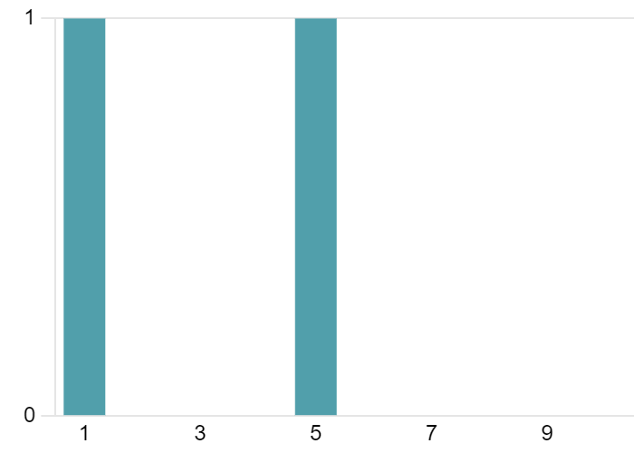
Figure 3. Question 7: On a scale of 1 – 10 (with 1 being the lowest, and 10 being the highest), what is your level of confidence using Generative AI to support the development of content and activities for Welsh Language medium courses?

To assist with knowledge sharing and help inform recommendations for suitable platforms, a list of Generative AI platforms were provided. Both participants had used ChatGPT, one had used Microsoft Copilot, and one had used Canva AI (Figure 4). It is useful to see which platforms are currently being used by the participants, to help build relevant resources that can be shared wider with staff. However, I was a little surprised that no other additional platforms had been used and unfortunately, specific examples of how they were used were not included in the quantitative responses as I had hoped.

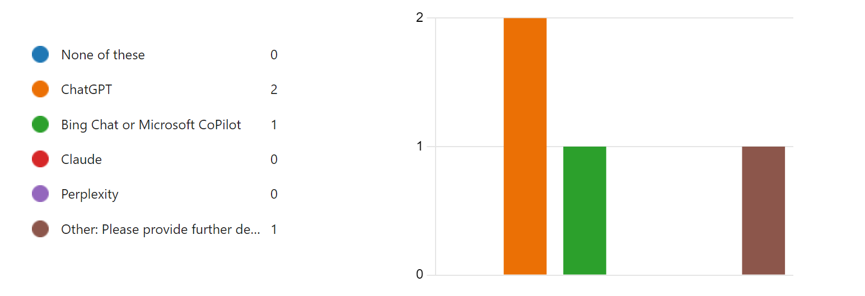
Figure 4. Question 8: Have you used any of the following platforms? (Tick all that apply)

Qualitative results

The remainder of the questionnaire comprised of qualitative questions, to gain a deeper understanding. A thematic analysis method was used to analyse the results. According to McAteer (2013), this is a suitable method in identifying patterns of meaning suitable for free text responses.

Theme 1: Barriers and considerations

As expected, there was a lack of confidence and use of Generative AI in the development of Welsh language content. It was clear that Generative AI platforms such as ChatGPT aren’t yet capable of being able to converse through the language of Welsh.
“Again, there may be a better platform for this, but, ChatGPT is not ready for the kind of usage I read about…in Welsh. E.e. chatting in target language - level of Welsh is too formal, despite level being requested. Not 100% correct (which I COULD use as a teaching tool).”
This aligns with my own experience. Regardless of the benefits that Generative AI can bring, it simply isn’t ready or good enough to be adopted fully within Welsh language courses. However, one participant did state that they continued with the use of English language activities. Unfortunately, they did not go into further detail in providing an example of the activity.
I have also resorted to using English Generative AI platforms within a Welsh setting. This is to ensure that students are still receiving an insight into the use of Generative AI to help develop their AI literacy. According to Ng, et al., (2021), teaching staff should strive to address the learning needs of under-represented groups, by broadening the participation in the use of AI. They suggest developing a set of guidelines that support teachers use of AI to ensure inclusivity, equitable access as well as sharing their work with others. This can help reduce the widening of attainment gaps for marginalised groups of students (QAA, 2023a, p. 5).
Another barrier identified was a lack of time to experiment with suitable platforms which can result in increased workload. According to Mercader & Gairín (2020), this is a common barrier when it comes to the adoption or integration of digital technology in education.
“Only used ChatGPT only due to lack of time to experiment with other platforms and tools”
“I am not confident that the data bases are relevant or that the expression is appropriate / correct. This increases a workload”

Recommendation 1
JISC (2022) highlights how staff require time and support to develop confidence in the use of digital technology. Staff must be provided with sufficient time and space to attend training, as well as explore and identify suitable Generative AI tools for their course content and delivery. Currently, Generative AI doesn’t perform well through the language of Welsh. However it is still important for staff to gain the knowledge and skills in using Generative AI, and identify what could work well for Welsh language courses. According to Ely, (1990), this falls into 1 of 8 vital conditions that facilitates adoption of educational technology innovations. Namely number 4 – ‘Time is available’, which requires paid (within company) time that allows staff to learn, adapt, integrate and reflect on what they are doing.

Theme 2: Use of Generative AI

Although it is recognised that Generative AI isn’t reliable through the language of Welsh, there were a few activity ideas shared within the results. One participant shared that they used Generative AI to showcase how these tools can assist with creation, communication and collaboration. These activities were used to reduce the fear amongst students, providing them with an opportunity to develop their AI literacy in a safe space (Ng, et al., 2021). One participant shared how they would like to see it being used more for content creation to support with Welsh course delivery. For example, image generation, creating historical characters, and checking pronunciation. Both participants recognise they would value the support and ideas of others.
“Ddim yn gwybod sut / ble gyda phwy byddai dechrau'r sgyrsiau hyn.
[I don’t know how / where or with who to start these conversations with]"
“I have very few WL [Welsh language] peers. I am aware of some ongoing excellent projects but have very little time to explore with them”
Farrelly & Baker (2023), recognises the potential for inequity in the use of Generative AI, for example those who speak languages other than English. However highlights that they are hopeful that these tools do hold the potential to provide support for a range of diverse groups. For example, the potential use of AI to act as a personal tutor. This does mean that further investigation into the use of Generative AI Chat Bots is needed to discover the level of investment. Another example includes Toronto Metropolitan University’s ProfBot (Toronto Metropolitan University, 2023), which has only been trained on the information of the course it has been provided with.
‘Models could even be trained in local terminology and idioms so that they could explain these to learners in context’ (Farrelly & Baker, 2023, p. 5)

Recommendation 2
Identify areas where the use of Generative AI can support with course content, design or delivery that is subject specific and suitable for Welsh language courses (OECD, 2023). This relies on Recommendation 1 being implemented. According to Salas-Pilco, et al., (2022), the adoption of AI technologies must support the appropriate pedagogical approach to ensure effective use in course design. Solutions such as chat bots that can be trained on specific data (in this case Welsh language content), could be investigated. Projects such as the Asaqeni Chatbot (Moyo, 2023) could be used as examples.

Recommendation 3
Support others on their journey of adoption, share findings and help build a community of practice using a socially constructivist approach. As suggested by Bali (2023), experiment with your students and what works best for you, ‘there isn’t one right way, there is the way that works for you within the parameters of your situation’. This aligns with Ely’s (1990) 2nd condition (Knowledge and Skills) that facilitates adoption of educational technology innovations. This ensures that the proven experiences and examples of its use can be shared with staff, to help them develop the knowledge and skills required to use these tools in their practice.

Theme 3: Professional development

Participants confirmed that they believe that the use of Generative AI will become part of their teaching toolkit.
“I think that this will become a part of what we use with the methodology, resource creation element of our course. Teachers will be encountering this with their [students] and we need to provide ways to teach Welsh with evolving technologies”
Academic staff recognise the use of these tools and require training and support in order to develop appropriate ways of integrating this into practice, specifically from a Welsh language perspective. One response provides further detail on how they acknowledge that Welsh students also need to be mindful of the appropriateness of AI tools the same way as English students do.
According to Farrelly & Baker (2023) AI literacy needs to be addressed in the same way as traditional literacies which is essential in the AI era. They go on to suggest that we adapt our programmes to include AI literacy and competencies within our disciplines, which Ng et al., (2021) suggest is becoming one of the most important technology skills in the 21st Century.
One participant uses Generative AI tasks in their course for this very purpose (although through the medium of English), to reduce the fear of students and enhance their personal development. However, it is clear that further training and development is needed.

“I've explored using AI with our 20 credit course title (which is in English - for beginner learners in their field) - and suggested using AI to create an essay by using the prompts and questioning as part of the assessment. I would really like further training on this.”
It is therefore in the first instance, a priority for academic staff to first develop their own knowledge and skills before they can consider integrating tools into their courses (Ng, et al., 2021). This aligns with Ely’s (1990) 2nd condition that facilitates adoption of educational technology innovations – Knowledge and Skills. This is where staff must first possess sufficient knowledge and skills in order to use and implement the technology. Ng, et al. (2021) provides a suitable AI Literacy Framework that could be used to develop suitable resources which can be adapted to support Welsh language students (Figure 5). They suggest this can be used to support staff whilst prioritising appropriate pedagogies, learning artefacts and assessment criteria which can be used to help ‘define, implement and evaluate AI literacy in the future’ (Ng, et al., 2021, p. 9). Farrelly & Baker (2023) further recommend working with students themselves, to explore the challenges they face when using AI tools.
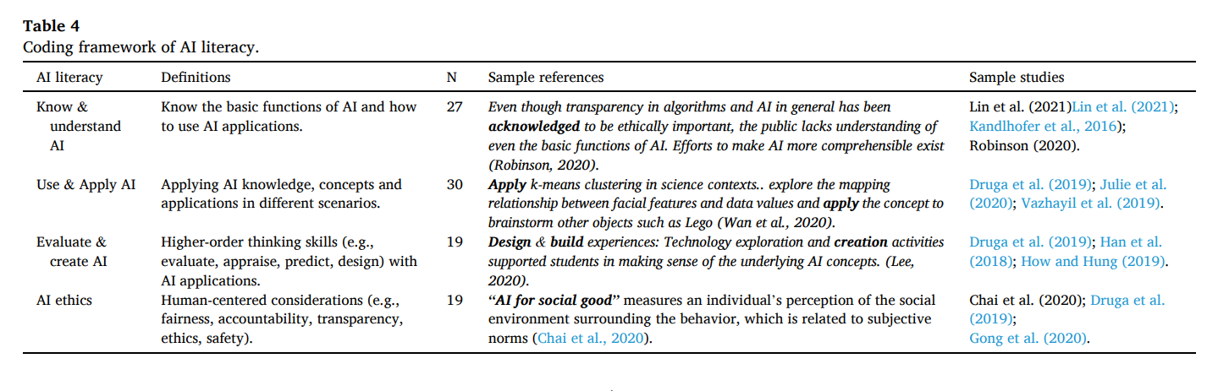
Figure 5 – Coding framework of AI Literacy, (Ng, et al., 2021, p. 4)

The QAA (2023b) also recommend the use of a 5 step process (PACES) that can be used to help identify and understand how to integrate AI (Figure 6).
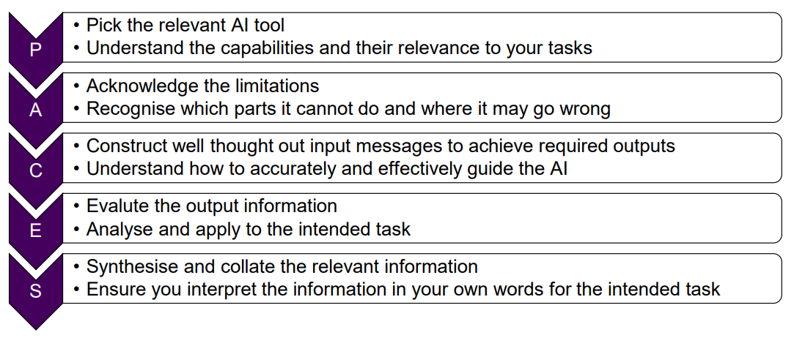
Figure 6 – Using PACES to effectively apply AI in higher education courses (QAA, 2023b, p. 1)

Recommendation 4
Develop suitable frameworks that are appropriate for Welsh language lecturers to support their students in the development of AI literacies. These can be achieved by working with students, to identify uses and challenges of using AI tools, and align them with suitable teaching strategies. QAA (2023a) suggests this should be linked to wider policy, which one of the participants state they are waiting on before researching appropriate tools. Another participant confirmed they felt there has not been a consideration of Welsh in the guidance. In which case, this framework should be included in the UWTSD AI Guidance that is provided to staff. This aligns with Ely’s (1990) 7th condition, ‘Commitment’ which recognises support and endorsement from the university; providing confidence to staff.

Recommendation 5
Once suitable frameworks, activities and strategies have been identified, training opportunities can then be designed and communicated with staff. According to QAA (2023a), this can engage and empower staff where they become familiar with how these tools work. This aligns with Ely’s (1990) 3rd condition to support adoption of technology (Resources are available), providing accessible ways for staff to access training and resources.

Conclusion

This research project initially aimed to improve my practice, develop new teaching strategies that utilise this new technology, whilst ensuring equity of its use for Welsh language students. On the whole the results were as expected, due to the lack of usability of most current Generative AI tools that can be used through the medium of Welsh. However, this process has allowed me to gain a deeper understanding of practitioners, which I hope will contribute to the development of a community of practice within the university. Whilst I acknowledge that there are, and will be many barriers in using Generative AI in Welsh language courses, the many benefits to using these tools are essential when it comes to developing the AI literacy of our students (Farrelly & Baker, 2023). It is key that we continue to develop our AI skills as practitioners and share these with students in the best way possible to reduce the inequity of learning experience for our Welsh language students.
“Students with the resources to…access the best AI tools will have an advantage over those who cannot…This reinforces existing inequities, potentially unfairly targeting learners with the least access to resources, and suggests that institutionally procured or developed and supported AI systems may be necessary to ensure equitable access for all students” (Farrelly & Baker, 2023, p. 5)
Aligning the research to the ‘8 Conditions that Facilitate the Implementation of Educational Technology’ (Ely, 1990), I feel that I have been able to identify appropriate recommendations to further develop my practice and delivery. Through ensuring that I have thoughtfully considered elements of technology adoption theory, it has helped identify ways in which I can improve the design of training opportunities and resources to effectively support the adoption of Generative AI for Welsh language lecturers.
According to Baltaci-Goktalay & Ocak (2006), adoption of new technology can take months or even several years. However, in this instance, with Generative AI developing at a rapid pace we must not wait to adopt Generative AI in Welsh language medium courses. It is the hope that future cycles of research will follow, measuring the impact of the recommendations outlined in this report to evaluate the effectiveness of the adoption of Generative AI in Welsh medium education. In accordance with critical participatory research, Kemmis, et al., (2014, pp. 86-87) suggests that ‘as we put our plan into action, [we need to] document and monitor what happens to see if we are now preventing, avoiding or ameliorating the untoward consequences of our previous ways of working, and to check that our new ways of working are not producing new or difference untoward consequences’.

Limitations

This study was conducted using only a very small sample of two participants. The perspectives of those who did respond may also skew the results as they were confident users of AI. This did not include any responses from less confident members of staff, which may of course influence the results and recommendations.

References
Advance HE. (2011) The UK Professional Standards Framework for teaching and supporting learning in higher education. [Online]
Available at: https://www.advance-he.ac.uk/knowledge-hub/ukpsf-2011-summary-document
[Accessed September 2022].
Bali, M. (2023) What I Mean When I Say Critical AI Literacy. [Online]
Available at: https://blog.mahabali.me/educational-technology-2/what-i-mean-when-i-say-critical-ai-literacy/
[Accessed March 2024].
Baltaci-Goktalay, S. & Ocak, M. A. (2006) 'Faculty adoption of Online Technology in Higher Education'. The Turkish Online Journal of Educational Technology, 5(4).
BBC News. (2023) AI: More Welsh data needed to improve accuracy, says business. [Online]
Available at: https://www.bbc.com/news/uk-wales-66656339.amp
[Accessed November 2023].
BERA. (2018) Ethical Guidelines for Educational Research. 4 ed. London: British Educational Research Association.
Brookings. (2023) How language gaps constrain generative AI development. [Online]
Available at: https://www.brookings.edu/articles/how-language-gaps-constrain-generative-ai-development/
[Accessed January 2024].
Cañestro, J. (2024) The impact of Generative AI on minority languages. [Online]
Available at: https://www.linkedin.com/pulse/impact-generative-ai-minority-languages-javier-ca%C3%B1estro-uz1mf#:~:text=In%20the%20case%20of%20minority,AI%20models%20for%20these%20languages.
[Accessed March 2024].
Dick, B. (2000) A beginner's guide to action research. [Online]
Available at: https://www.aral.com.au/resources/guide.html
[Accessed March 2024].
Ely, D. P. (1990) 'Conditions that Facilitate the Implementation of Educational Technology Innovations'. Journal of research on computing in education, 23(2), p. 298–305.
Farrelly, T. & Baker, N. (2023) 'Generative Artificial Intelligence: Implications and Considerations'. Education sciences, 13(11), pp. 1109-.
JISC. (2023) National Centre for AI in tertiary education: Student perceptions of Generative AI. [Online]
Available at: https://repository.jisc.ac.uk/9218/1/NCAI-Students-Perceptions-of-generative-AI-Report.pdf
[Accessed February 2024].
JISC. (2024) Generative AI - A Primer. [Online]
Available at: https://repository.jisc.ac.uk/9407/1/Jan_2024_generative_AI_primer-final.pdf
[Accessed January 2024].
Kemmis, S., McTaggart, R. & Nixon, R. (2014) The action research planner : doing critical participatory action research. Singapore: Springer.
Le Cordeur , M. (2012) 'Afrikaans as medium of instruction within a transformed higher education system'. Educational Research in South Africa: Practices and Perspectives, pp. 55-76.
McAteer, M. (2013) Action Research in Education. Los Angeles: SAGE.
Mercader, C. & Gairín, J. (2020) 'University teachers' perception of barriers to the use of digital technologies: the importance of the academic discipline'. International Journal of Educational Technology in Higher Education, 17(4).
Moyo, L. M. (2023) Language Matters: How a Chatbot Can Help Preserve and Promote Minority Languages. [Online]
Available at: https://www.linkedin.com/pulse/language-matters-how-chatbot-can-help-preserve-promote-likhwa-m-moyo
[Accessed March 2024].
Nah, F. F.-H. et al. (2023) 'Generative AI and ChatGPT: Applications, challenges, and AI-human collaboration'. Journal of Information Technology Case and Application Research, 25(3), pp. 277-304.
Ng, D. T. K., Leung , J. K. L., Chu, S. K. W. & Qiao , M. S. (2021) 'Conceptualizing AI literacy: An exploratory review'. Computers and Education: Artificial Intelligence, Volume 2, pp. 1-11.
OECD. (2023) Digital equity and inclusion in education: An overview of practice and policy in OECD. [Online]
Available at: https://one.oecd.org/document/EDU/WKP(2023)14/en/pdf#:~:text=In%20order%20to%20use%20digital,designed%20with%20inclusion%20in%20mind.
[Accessed March 2024].
Open AI. (2024) Does ChatGPT tell the truth?. [Online]
Available at: https://help.openai.com/en/articles/8313428-does-chatgpt-tell-the-truth
[Accessed January 2024].
Punch, K. F. (2014) Introduction to Social Research Quantitative and Qualitative Approaches. 3rd ed. London: SAGE Publications Ltd.
QAA. (2023a) Maintaining quality and standards in the ChatGPT era: QAA advice on the opportunities and challenges posed by Generative Artificial Intelligence. [Online]
Available at: https://www.qaa.ac.uk/docs/qaa/members/maintaining-quality-and-standards-in-the-chatgpt-era.pdf?sfvrsn=2408aa81_10
[Accessed July 2023].
QAA. (2023b) Steps to effectively using artificial intelligence (working draft for QAA Member engagement). [Online]
Available at: https://www.membershipresources.qaa.ac.uk/quality-and-standards/academic-integrity/artificial-intelligence
[Accessed March 2024].
Russell Group. (2023) Russell Group principles on the use of generative AI tools in education. [Online]
Available at: https://russellgroup.ac.uk/media/6137/rg_ai_principles-final.pdf
[Accessed July 2023].
Salas-Pilco, S. Z., Xiao, K. & Oshima, J. (2022) 'Artificial Intelligence and New Technologies in Inclusive Education for Minority Students: A Systematic Review'. Sustainability, 14(20).
Say Something in Welsh. (2022) Mae ChatGPT yn siarad Cymraeg. [Online]
Available at: https://en.forum.saysomethingin.com/t/mae-chatgpt-yn-siarad-cymraeg/37554
[Accessed November 2023].
Toronto Metropolitan University. (2023) ProfBot, a new AI-powered chatbot, could be student’s next study-buddy. [Online]
Available at: https://www.torontomu.ca/tedrogersschool/news-events/2023/05/ai-powered-chat-bot-study/
[Accessed February 2024].
UK Parliament. (2024) Use of artificial intelligence in education delivery and assessment. [Online]
Available at: https://researchbriefings.files.parliament.uk/documents/POST-PN-0712/POST-PN-0712.pdf
[Accessed February 2024].
UNICEF. (1990) The United Nations Convention on the Rights of the Child. [Online]
Available at: https://www.unicef.org.uk/wp-content/uploads/2010/05/UNCRC_united_nations_convention_on_the_rights_of_the_child.pdf
[Accessed February 2024].
UWTSD. (2022) UWTSD Research Data Management Policy. [Online]
Available at: https://www.uwtsd.ac.uk/media/uwtsd-website/content-assets/documents/strategies-policies/RDM-Policy-2022-v3-28-04-22.pdf
[Accessed October 2023].
UWTSD. (2024) Generative Artificial Intelligence Guidance. [Online]
Available at: https://uowtsd.sharepoint.com/teams/NexusLearningTeachingCafe_GRP/Shared%20Documents/Forms/AllItems.aspx?FolderCTID=0x01200074F3404049620E46A12ACD670A93631D&id=%2Fteams%2FNexusLearningTeachingCafe%5FGRP%2FShared%20Documents%2FGeneral%2FUWTSD%20AI%20Guidan
[Accessed January 2024].
Welsh Government. (2017) Cymraeg 2050: A million Welsh speakers. [Online]
Available at: https://www.gov.wales/sites/default/files/publications/2018-12/cymraeg-2050-welsh-language-strategy.pdf
[Accessed February 2024].
Welsh Government. (2018) Welsh Language Technology Action Plan, Cardiff: Welsh Government.
Welsh Government. (2021) Well-being of Future Generations (Wales) Act 2015: A journey to a more equal Wales. [Online]
Available at: https://www.futuregenerations.wales/wp-content/uploads/2019/11/FINAL-Equality-Wales-Topic-2.pdf
[Accessed January 2024].
Welsh Government. (2023) Welsh Language in Higher Education, 2021/22. [Online]
Available at: https://www.gov.wales/sites/default/files/statistics-and-research/2024-01/welsh-language-higher-education-september-2021-august-2022-revised_0.pdf
[Accessed February 2024].
Welsh Government. (2024a) Welsh language better prepared for artificial intelligence developments, thanks to Welsh Government investment. [Online]
Available at: https://www.gov.wales/welsh-language-better-prepared-artificial-intelligence-developments-thanks-welsh-government
[Accessed February 2024].
Welsh Government. (2024b) Welsh language technology action plan - Final Report (2018 - 2024). [Online]
Available at: https://www.gov.wales/sites/default/files/publications/2024-02/welsh-language-technology-action-plan-final-report-2018-2024.pdf
[Accessed February 2024].

Appendices

Participant information sheet

The title of the research project:

The use of Generative AI in Welsh Language medium courses

Invitation to take part

You are being invited to take part in a research project. Before you decide it is important for
you to understand why the research is being done and what it will involve. Please take time
to read the following information carefully and discuss it with others if you wish. Ask us if
there is anything that is not clear or if you would like more information. Take time to decide
whether you wish to take part.

Who is organising/funding the research?

This research will be conducted by Emma Jones, a student studying the PCET programme at the University of Wales Trinity Saint David as part of the Action Research Module. It is not funded and is simply a part of the Action Research module assignment.

Who has ethically reviewed the project?

This project has been ethically approved by UWTSD Research Ethics Committee. This was approved on the 18th of January 2024.

What is the purpose of the project?

As a student lecturer, studying the PCET course here at the university, it is the requirement of one of the modules to complete action research. This project is therefore satisfies the requirement of the assignment criteria in conducting action research, and writing a 4,000 word report along with producing an academic poster.
It is important to point out that I am also a member of staff at the university. My role is the Digital Learning Technologist. This research, however, is to support the development and skills as a post-16 practitioner, and not to support my role as a Digital Learning Technologist.
The research itself however is in relation to the use of Generative AI within courses delivered through the language of Welsh.
As part of my placement, I was able to experience first-hand, some of the concerns around utilising Generative AI in a Welsh language medium course. It is therefore the aim of this research to find out how other Welsh language lecturers are utilising this technology to help support me in my practice, as well as further understanding the thoughts, concerns or barriers that Welsh language lecturers may face when using Generative AI in their courses. This will help me develop my own practice and utilisation of Generative AI in future sessions that I deliver through the language of Welsh, as well as being able to share ideas and approaches wider with staff.
This project will last for 5 weeks. The deadline for the questionnaire responses will be Friday the 22nd of February.
The following statement will be shared at the beginning of the questionnaire, to provide you with clarity and transparency of the process. You will need to confirm you have read this within the questionnaire itself before you will be able to proceed. A link to the questionnaire will be provided once you have given consent for me to forward it on to you:
- The deadline for responses for this questionnaire is Friday the 22nd of February 2024.
- This questionnaire is completely anonymous. It does not track your name or e-mail address.
- If you are not happy with your responses, you can contact me at any time to remove any comments from the final report.
- You can also withdraw from the process at any time, without any reason.
- A copy of the anonymised data that will be used in the report will be provided to you on Friday the 29th of February, allowing you further opportunity to comment on or withdraw from the process. A deadline of when you can edit or remove data will be provided in this correspondence.
- The report will be submitted as part of an assignment, which is due on Thursday the 14th of March. You will not be able to withdraw after this date. However, this is for the purpose of an assignment as part of the PCET programme that I am studying for and will therefore not be published externally.
- Upon submission of my assignment, a copy of the findings and academic poster will be shared with you.
- Depending on the detail of your responses, it could take between 10 and 20 minutes to complete this questionnaire.
- Due to the short timescale of this research project, this questionnaire is not available in Welsh. I am also studying this course through the language of English, and therefore will be writing my report in English. I apologise for this. However, if this is an issue, and you would prefer for this to be conducted through the language of Welsh, please let me know.

If you have any concerns, please contact me at: 2219874@student.uwtsd.ac.uk.

Why have I been chosen?

You have been chosen as you are a Welsh speaker, who also lectures or delivers courses through the medium of Welsh. As a Welsh language lecturer, the research will be able to provide me with an insight into how you use Generative AI in your teaching, along with any concerns or barriers that you may or may not face.
Due to the short timescale of the project, it is anticipated that I will receive around 10 responses to this questionnaire.

Do I have to take part?

It is up to you to decide whether or not to take part. If you do decide to take part, you will be given this information sheet to keep and be asked to sign a participant agreement form. We want you to understand what participation involves, before you make a decision on whether to participate.
If you have an on-going relationship with UWTSD or the research team, e.g. as a member of staff, as student or other service user, your decision on whether to take part (or continue to take part) will not affect this relationship in any way.

Can I change my mind about taking part?

Yes, you can stop participating in study activities at any time and without giving a reason.

If I change my mind, what happens to my information?

After you decide to withdraw from the study, we will not collect any further information from or about you. As regards information we have already collected before this point, your rights to access, change or move that information are limited. This is because we need to manage your information in specific ways in order for the research to be reliable and accurate. Further explanation about this is in the Personal Information section below.
All questionnaire responses are collected anonymously. This means that your name or email address will not be collected. Any information you do provide which may contain any identifiable information will be removed. A copy of this data will be provided to you to ensure you are happy with the content that will be used in the final report. You will be able to withdraw from the process at any time, however as this is a part of an assignment, a deadline for final responses will be provided to you to ensure I have enough time to complete the report in preparation for the submission of the assignment. This will be provided to you in the correspondence shared on Friday the 29th of February as outlined in the statement above.

What would taking part involve?

You will be asked to complete a questionnaire. This is completely anonymous, and you should not include any personal or identifiable information. If you do, this will be anonymised before being included in the final report. Please be as descriptive as possible.

What are the advantages and possible disadvantages or risks of taking part?

Whilst there are no immediate benefits to you participating in the project, it is hoped that this work will contribute to a growing area of practice, in supporting Welsh language lecturers and Welsh language medium courses in integrating Generative AI into their courses.
Whilst we do not anticipate any risks to you in taking part in this study, if you do feel uncomfortable answering the questionnaire, you can withdraw from this process. This research is not intended to observe the digital or AI literacy skills of academic staff, it is intended to develop my own professional practice in the development and use of Generative AI in Welsh medium courses. It is hoped that this will highlight and engage a wider conversation with staff on its use and promotion to ensure equity of access for our students. A further identified list of risks can be found in the Ethics Form that was provided to you as part of this communication.

What type of information will be sought from me and why is the collection of this

The questions asked will form part of the action research project, in helping me to identify how to improve my own practice, widen my understanding of the use of Generative AI in Welsh language medium courses and understand any concerns or barriers that others face. This information will not only help me in my practice but is information that can be shared with others who are in a similar position. Action research as a methodology will help provide further recommendations to help support staff in their practice which I hope will be of help to many.
The questionnaire will be using the Microsoft Forms product, where the settings have been amended to ensure the questionnaire will be completely anonymous. Only I will have access to this data, along with my research supervisor. Once my course has come to an end in July 2024, my students account will be deactivated and thus the information will be deleted.
All data will be stored on UWTSD cloud storage, thus following the data security processes and policies of the university. No personal data will be held on a personal device, or personal cloud storage. No unnecessary or unsuitable personal data questions will be asked in accordance with the UWTSD Research Data Management Policy.
Your rights will be in line with their participant rights and exemptions as outlined in the UWTSD Research Data Management Policy.
Research data will be used only for the purposes of the study.

Questionnaire - Use of Generative AI in Welsh Language courses



Use of Generative AI in Welsh Language courses

Thank you taking time to complete this questionnaire. This questionnaire is completely anonymous and does not track your name or e-mail address.

* Required

Before you begin
Please read the following statement before you begin. You must first consent to the following statement before proceeding with the questionnaire:

The deadline for responses for this questionnaire is Friday the 22nd of February 2024. This questionnaire is completely anonymous. It does not track your name or e-mail address.
If you are not happy with your responses, you can contact me at any time to remove any comments from the final report.
You can also withdraw from the process at any time, without any reason.
A copy of the anonymised data that will be used in the report will be provided to you on Friday the 29th of February, allowing you further opportunity to comment on or withdraw from the process. A deadline of when you can edit or re- move data will be provided in this correspondence.
The report will be submitted as part of an assignment, which is due on Thursday the 14th of March. You will not be able to withdraw after this date. However, this is for the purpose of an assignment as part of the PCET programme that I am studying for, and will therefore not be published externally.
Upon submission of my assignment, a copy of the findings and academic poster will be shared with you.
Depending on the detail of your responses, it could take between 10 and 20 minutes to complete this questionnaire. Due to the short timescale of this research project, this questionnaire is not available in Welsh. I am also studying this course through the language of English, and therefore will be writing my report in English. I apologise for this. However, if this is an issue, and you would prefer for this to be conducted through the language of Welsh, please let me know.

If you have any concerns, please contact me at: 2219874@student.uwtsd.ac.uk.

- I confirm I have read and understood the statement before continuing with this questionnaire. *

I confirm

Your understanding and use of Generative AI as a Welsh Language lecturer

- Have you heard of Generative AI? *

Yes No

- What is your understanding of Generative AI? *

- Have you used Generative AI in a personal capacity? *

Yes No

- Have you used Generative AI in a professional capacity? *

Yes No

- On a scale of 1 – 10 (with 1 being the lowest, and 10 being the highest), what is your level of confidence in using Generative AI? *

- On a scale of 1 – 10 (with 1 being the lowest, and 10 being the highest), what is your level of confidence using Generative AI to support the development of content and activities for Welsh Language medium courses? *

- Have you used any of the following platforms? (Tick all that apply) *

None of these ChatGPT
Bing Chat or Microsoft CoPilot Claude
Perplexity

Other: Please provide further details

- If you chose 'Other', please provide further details

- Have you used Generative AI in your teaching? For example, during your sessions or within your course content? *

Yes No

- If no, what are the reasons why you do not include Generative AI in your course? Include information on any barriers or difficulties you may face when using Generative AI in your Welsh language course, or any information on the suitability for your course or student group. *

- If these barriers did not exist, how would you like to use Generative AI in your Welsh language medium course? *

- If yes, briefly describe how you use Generative AI tools in your Welsh language courses. Please highlight any specific strategies or activities you find effective. *

- What resources or materials do you currently use to support the integration of Generative AI in your Welsh language courses? Are there specific tools, platforms, or materials that you have found particularly effective? *

- Why do you use Generative AI in your teaching? Include reasons on why you’ve decided to use Generative AI, and how you feel it would benefit your students or align to learning outcomes for example. *

- Do you experience any challenges or barriers when using Generative AI in your Welsh language courses? *

Yes No

- If yes, please provide further details and examples of the barriers you face. Please elaborate on any concerns or difficulties you've encountered. *

- If no, please provide a brief overview on how you've approach the integration of Generative AI into your Welsh course to avoid any barriers. This may include examples of how you were able to use Generative AI to avoid specific concerns or barriers. *

Student Experience

- How have your students responded to the use of Generative AI in their course or activities? *

- Do your students experience any issues in relation to using Generative AI? For example, any issues with access, or any further barriers or concerns? *

- In your opinion, how does the integration of Generative AI in Welsh language courses contribute to enhancing students' employability skills? Are there specific skills or competencies that you believe students gain through this integration, and how do these align with industry demands? *

- Considering the language differences, how do you ensure that Welsh language students using Generative AI have an equitable learning experience compared to their English counterparts? Are there specific measures or strategies you implement to address potential disparities in access, engagement, or outcomes? *

Training and support

- There have been a number of Generative AI discussions and sessions happening across the university since the beginning of 2023. Have you attended any of these sessions? Or received any training, guidance or support relating to the integration of Generative AI tools? *

Yes No
I wasn't aware of any

- If yes, please list what level of support or training you’ve received in relation to the integration of Generative AI tools in teaching Welsh language courses. This doesn’t have to be limited to university led training. *

- Is there any further information or support would you like in the use and integration of Generative AI within Welsh Language medium courses? For example, guides, resources, access, community of practice, training, etc.? *

- What additional support or training, if any, would you find beneficial? *

- Do you engage in any collaborative efforts or share best practices with other Welsh language lecturers regarding the integration of Generative AI? If so, how has this collaboration influenced your approach, and what insights have you gained from your peers? Please include details of any formal communities of practice. *

This content is neither created nor endorsed by Microsoft. The data you submit will be sent to the form owner.
Microsoft Forms

