BA (HONS) LEADERSHIP AND MANAGEMENT SKILLS IN THE WORKPLACE

MUMTAZ BEGUM 2236508
LCLM 6004
RESEARCH METHODS FOR BUSINESS
LECTURER: KOSHIK DAS SARMA

RESEARCH PROPOSAL

Table of Contents

The Impact of Workload Intensity on Mental Health Among NHS Nurses in Acute Care Wards in the UK 2
1. Introduction 2
2. An overview of significant discussions and advancements in the field 3
3. Research Aim 4
4. Research questions 4
5. Research Objectives 5
6. Preliminary Literature Review 5
7. Research Gaps and Contribution to the Field 7
8. Research Methodology 7
9. Data Collection: Qualitative Data 7
10. Sampling Strategies 8
11. Ethical Considerations 8
12. Business Relevance & Practical Implications 8
13. Plan of work and schedule (Gantt chart) 9
14. Research Plan and Timeline (12 Weeks) 9
15. Conclusion 10
16. Reference list 11

The Impact of Workload Intensity on Mental Health Among NHS Nurses in Acute Care Wards in the UK

1, Introduction

The UK’s National Health Service (NHS) faces a persistent workforce crisis marked by high vacancy rates, rising patient demand, and widespread staff burnout. (Royal College of Nursing, 2023). According to the NHS Staff Survey conducted in 2024, almost half of the participants said they experienced stress at work, and a considerable number thought about quitting their positions because of mental health issues (NHS England, 2024). Long-term understaffing puts nurses under pressure to manage more patients, longer shifts, and mandatory overtime, which lowers job satisfaction and causes psychological distress. Increased absences, lower-quality patient care, and higher turnover are all linked to burnout, which is marked by emotional depletion, depersonalisation, and decreased professional efficacy (Hall et al., 2016).
According to (West et al.2020), despite the implementation of Employee Assistance Programs and mental health centres, there is little empirical data relating certain workload characteristics (such as overtime and patient-to-nurse ratios) to quantifiable burnout and mental health outcomes in acute care NHS settings.
This research seeks to fill that gap and provide actionable insights for NHS workforce planning. This issue is therefore highly significant. Addressing workload intensity and staffing shortages is not only essential for protecting nurse well-being but also for ensuring patient safety and maintaining the long-term performance of the NHS.
According to Finlayson et al (2002), the NHS faces significant challenges in hiring and keeping nurses and midwives. The root reasons of these issues include salary, the evolving nature of work, employees' sense of value, and alternative career options.
In inner cities and teaching trusts, especially in London, where turnover rates can vary from 11% to 38%, the situation is most severe.
High turnover raises expenses, depresses morale, and may compromise patient care.
The government is working to address the crisis, but the issues are complex, and reform is taking considerable time. More research is required to determine why 34% of recently graduated nurses do not register to practise.
Therefore, this study aims to investigate how organisational factors, particularly workload intensity, task-shifting, and workplace culture, contribute to nurses’ mental health outcomes, with a view to informing NHS management strategies.”
2. An overview of significant discussions and advancements in the field
Whether hospitals should have set guidelines regarding the number of patients each nurse can care for is a hotly debated topic. According to several researchers, this enhances patient safety and staff well-being (Rafferty et al., 2000).
There is disagreement over whether systemic problems (such as understaffing and long hours) or personal variables (such as coping mechanisms) are more responsible for nurses' poor mental health. Research indicates that burnout is primarily caused by systemic pressures rather than personal weakness (West et al., 2020).
Many nurses in the NHS work 12-hour shifts. Although the goal of these shifts is to provide patients with continuity of treatment, they are associated with increased levels of burnout, stress, and exhaustion (Dall’Ora et al., 2020). Nurses may benefit from shorter shifts, although staff scheduling may become more difficult.
In the opinion of most researchers, patient care and nurse well-being are tightly related. According to Hall et al. (2016), burnout increases the likelihood of errors and lowers the standard of care provided by nurses. This supports the argument for increased staffing; however, some researchers contend that patient outcomes are influenced by other factors as well.
Although the NHS has implemented well-being initiatives and mental health hubs, adoption has been uneven (NHS England, 2024). Safe staffing laws are still being pushed for by the Royal College of Nursing (Royal College of Nursing, 2023). Although nursing stress has become more widely recognised since the COVID-19 pandemic, many interventions have
focused on temporary rather than long-term solutions (West, Bailey, and Williams, 2020).

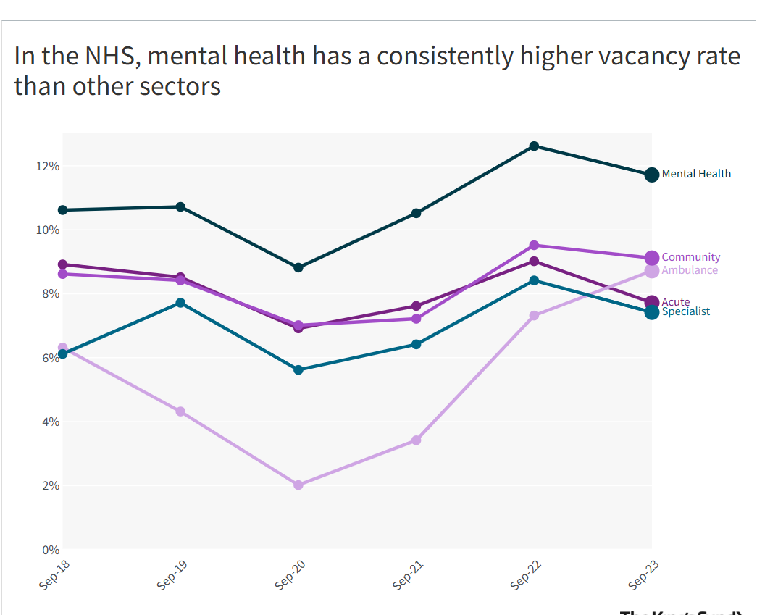

Fig 1 (The King's Fund, 2024)

3. Research Aim
To examine how workload intensity and high vacancy rates contribute to mental health problems among NHS nurses working in acute care wards, and to identify practical organisational strategies for improvement. The study will also explore how nurses’ experiences of performing additional responsibilities, such as covering doctors’ duties during staff shortages, and exposure to workplace bullying or disrespect from medical staff can further affect their stress, job satisfaction, and intention to leave.

4. Research questions

4.1, How do workload intensity and working in acute care wards affect the mental health of NHS nurses?
4.2, In what ways does taking on doctors’ duties, or extra clinical tasks, contribute to nurse stress and burnout?
4.3, How do experiences of bullying or lack of respect from doctors and senior staff impact nurses’ well-being and job retention?
4.4, What organisational or management changes do nurses believe could help reduce stress, improve teamwork, and support their mental health?

5. Research Objectives

5.1, To examine how workload intensity and disrespect from senior medical staff affect the mental health and job satisfaction of NHS nurses working in acute care wards.
5.2, To examine the impact of role strain, where nurses are expected to take on doctors’ responsibilities or additional clinical duties during staff shortages.
5.3, To identify organisational and managerial strategies that could reduce workload pressure, improve professional relationships, and promote better mental health among nurses.

6. Preliminary Literature Review

This section reviews existing research related to the mental health and workload of NHS nurses, grouped into four key themes: (1) workload and burnout, (2) role expansion and task-shifting, (3) bullying and workplace culture, and (4) staffing levels and patient care outcomes. The aim is to identify current trends, key debates, and research gaps relevant to this study.
Theme 1: Workload and Burnout
Many studies indicate that long hours and heavy workloads lead to stress and burnout among nurses. Hall et al. (2016) found that nurses working longer shifts feel more tired and emotionally drained. Dall’Ora et al. (2020) also discovered that 12-hour shifts often increase fatigue and errors, even if they help with patient continuity.
However, other researchers, such as West et al. (2020), believe that burnout is not only about workload but also about poor management and lack of support.
Summary:
Most researchers agree that high workloads increase burnout, but they disagree on how to solve it. Some suggest building nurses’ resilience, while others argue that hospitals need better staffing and support systems.
Theme 2: Role Expansion and Task-Shifting
Nurses today often take on extra duties that were once done by doctors. Rashid (2010) found that this can make nurses feel anxious because of higher responsibility. Ball and Pike (2005) also noted that extra duties are added without reducing other tasks, leaving nurses feeling overworked.
While some nurses enjoy the professional challenge, many feel unsure about their boundaries and experience extra stress.
Summary:
Expanding nurses’ roles can be empowering but also increases pressure and confusion. Few studies have looked closely at how this affects nurses’ mental health in NHS hospitals, which is an important gap.
Theme 3: Bullying and Workplace Culture
Workplace bullying and lack of respect from senior staff or doctors are recurring issues in NHS nursing. Quine (2001) reported that 44% of community nurses experienced bullying within a year, leading to increased anxiety, depression, and turnover intentions. Similarly, Chatziioannidis et al. (2018) found bullying associated with higher absenteeism, poorer performance, and lower productivity.
Williams and Smith (2013) further highlight that interpersonal conflict with doctors and senior staff is one of the most potent daily stressors for nurses. These studies suggest that the NHS workplace culture is often hierarchical and high-pressure, which can undermine morale and mental health.
Summary:
Bullying and poor teamwork clearly harm nurses’ mental health. However, few studies have explored how these problems relate to workload or role pressure, something this research aims to address.
Theme 4: Staffing Levels and Patient Care
Several studies have linked staffing levels to both nurse well-being and patient safety. Griffiths et al. (2020) found that wards with more registered nurses experienced fewer patient deaths and mistakes. Aiken et al. (2021) also discovered that inadequate staffing results in lower satisfaction for both nurses and patients.
The King’s Fund (2022) and the Royal College of Nursing (2023) report that staff shortages lead to increased stress, burnout, and staff leaving the profession.
Summary:
Low staffing levels put both patients and nurses at risk. However, most research looks at these issues separately, not together. This study aims to combine these factors to give a clearer picture of how they affect nurses’ mental health.
Overall Summary
Overall, research shows clear links between workload, staffing, bullying, and mental health among nurses. However, most studies focus on just one issue at a time. Very few explore how these challenges combine to affect nurses, especially in NHS acute care wards, where pressure is highest.
This study aims to fill that gap by looking at how workload, role expansion, and workplace culture together influence nurses’ mental health and their decision to stay or leave the profession.

7. Research Gaps and Contribution to the Field
Although many studies link workload and staffing levels to nurse burnout, most rely on brief surveys and self-reported data, providing limited insight into the real organisational causes. Few combine objective staffing information such as vacancy rates, overtime, and patient-to-nurse ratios, with mental health outcomes. Research on nurses performing doctors’ duties or facing bullying from senior staff is also limited, and the combined effect of these pressures is rarely explored. In addition, little evidence compares different acute ward settings or tracks long-term impacts on mental health and retention.
This study will fill these gaps by integrating staffing and vacancy data with nurse surveys and interviews about workload, role strain, and bullying. It will provide a fuller understanding of how these factors affect well-being and turnover, offering practical recommendations for NHS managers to improve staffing, teamwork, and workplace culture.

8. Research Methodology
This study will use a qualitative research approach. The aim is to explore nurses' lived experiences of workload, role expansion, and workplace culture, and how these factors affect their mental health and job satisfaction. A qualitative method is preferred over a quantitative one because it allows for an in-depth understanding of feelings, attitudes, and personal experiences, rather than just measuring numerical data.
Quantitative data, such as surveys, could show how many nurses experience stress, but would not explain why or how these experiences occur. A qualitative design gives nurses the chance to describe their challenges in their own words, providing richer insights into the problem.

9. Data Collection: Qualitative Data
Semi-structured interviews will be conducted with approximately 5-10 NHS nurses from different acute care wards (e.g., ICU, surgical, emergency). These interviews will explore perceptions of workload, role strain (including performing doctors’ duties), and experiences of workplace bullying or incivility. The qualitative data will provide deeper insight into how these factors affect morale, mental health, and retention.

10. Sampling Strategies
This study will employ a non-probability sampling method to select nurses who work in acute care wards, such as intensive care, surgical, or emergency units. Only nurses with at least one year of experience will be invited to take part, as they can describe their work pressures more accurately.

11. Ethical Considerations
Ethical approval will be obtained from both the university ethics committee and the NHS Research Ethics Service. Participation will be voluntary, and all nurses will be given information about the study’s purpose, confidentiality, and their right to withdraw at any time.
Informed consent will be obtained before collecting data. Participants will remain anonymous, and no personal details will be used in reports. All data will be securely stored and deleted once the project is completed. Since the study covers sensitive issues such as bullying and mental health, nurses will receive contact details for occupational health and counselling services in case they experience distress during or after participation. Informed consent will be collected before each interview. All data will be kept confidential and stored securely following GDPR guidelines. Participants will have the right to withdraw at any time without penalty.

12. Business Relevance & Practical Implications
This research is highly relevant to the NHS and to wider healthcare management practices. By understanding how workload intensity, staff shortages, and poor workplace culture affect nurses’ mental health, this study can support better decision-making and workforce planning within the organisation.
The findings could help NHS managers and policymakers make evidence-based decisions about staffing levels, shift patterns, and support programmes. For example, identifying the relationship between vacancy rates and burnout may guide the development of safe staffing policies and resource allocation across acute wards.
The study could also influence management strategies by promoting stronger policies against workplace bullying and encouraging teamwork and respect between doctors and nurses. This would help create a healthier organisational culture and improve staff morale. At an industry level, the study contributes to NHS workforce reforms and supports national initiatives aimed at improving staff well-being and reducing turnover. The insights can help shape long-term strategies for sustainable healthcare staffing, promoting a healthier and more productive workforce that delivers higher-quality patient care.

13. Plan of work and schedule (Gantt chart)

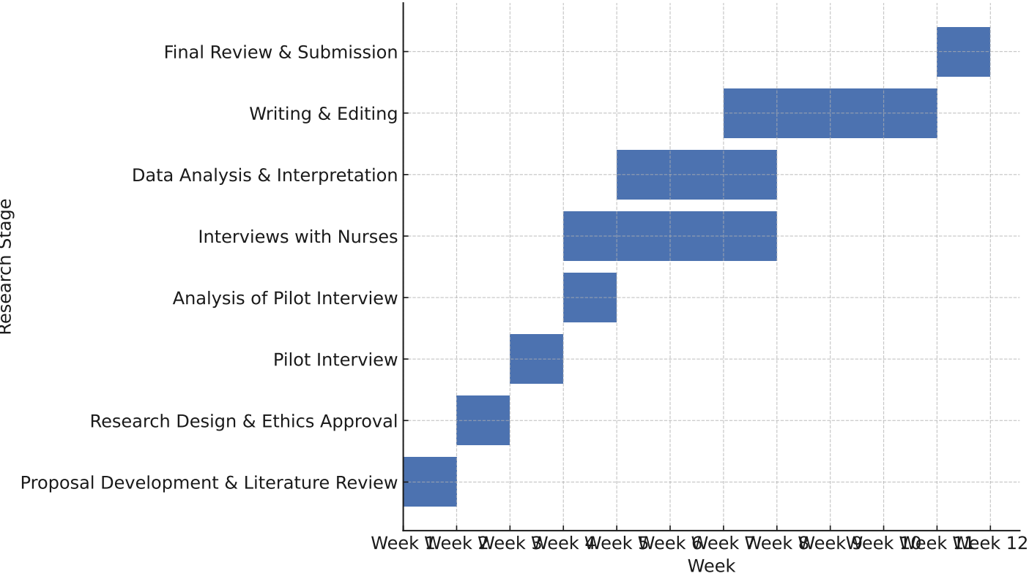
(Fig 2)

The 12-week Gantt chart visually represents the main stages of the research process, from initial planning to final submission. The first two weeks focus on refining the research proposal and conducting a detailed literature review. Weeks 2–3 involve finalising the research design and securing ethical approval. Data collection takes place during Weeks 3–5, through interviews with NHS nurses. Weeks 6–8 are devoted to analysing the collected data and interpreting the findings in relation to existing literature. The final phase, Weeks 7–12, focuses on writing, editing, and completing the final review before submission. This structured timeline ensures that all research tasks are completed efficiently and on schedule.

14. Research Plan and Timeline (12 Weeks)
The research project is planned to be completed over a period of 12 weeks. The table below outlines each stage of the project, describing the main activities and the corresponding time frame for completion.

Stage | Description of Activities | Timeline (Weeks)
1. Proposal Development & Literature Review | Refine the research topic, aims, and objectives; review academic and NHS literature to establish a theoretical foundation. | Weeks 1 – 2
2. Research Design & Ethics Approval | Develop a methodology, design interview questions, and submit ethics applications to the university and the NHS. | Weeks 2 – 3
3. Pilot Interview | Conduct a pilot interview to test the interview structure and questions. | Weeks 3 – 4
4. Analysis of Pilot Interview | Evaluate pilot results, refine interview questions and process as needed. | Weeks 4 – 5
5. Interviews with NHS Nurses | Conduct semi-structured interviews with NHS nurses in acute care wards. | Weeks 4 – 7
6. Data Analysis & Interpretation | Transcription, coding, and thematic analysis of interview data. | Weeks 5 – 8
7. Writing & Editing (Draft Report) | Write methodology, findings, discussion and conclusion chapters; revise and edit drafts. | Weeks 7 – 11
8. Final Review & Submission | Proofreading, formatting, incorporating supervisor feedback, and final submission. | Weeks 11 – 12

15. Conclusion
This research will explore how heavy workloads, staff shortages, and added role pressures affect the mental health of NHS nurses working in acute care wards. While many studies link stress and burnout to nursing, few examine how vacancy rates, task shifting, and workplace pressures together impact nurses’ well-being. By collecting real experiences from nurses and comparing them with organisational factors, this study aims to provide a clearer understanding of these challenges. The results will help NHS managers and policymakers develop better strategies to support nurses’ mental health, improve retention, and maintain high-quality patient care.

16. Reference list
Aiken, L.H., Sloane, D.M., Ball, J., Bruyneel, L., Rafferty, A.M. and Griffiths, P., 2021. Patient satisfaction with hospital care and nurses in England: an observational study. BMJ open, 8(1), p.e019189.
Ball, J. and Pike, G., 2005. Managing to work differently: Results from the RCN Employment Survey 2005. RCN.
Chatziioannidis, I., Bascialla, F.G., Chatzivalsama, P., Vouzas, F. and Mitsiakos, G., 2018. Prevalence, causes and mental health impact of workplace bullying in the Neonatal Intensive Care Unit environment. BMJ open, 8(2), p.e018766.
Dall’Ora, C., Ball, J., Reinius, M. and Griffiths, P. (2020) ‘Burnout in nursing: A theoretical review’, Human Resources for Health, 18(1), pp. 1–17.
De Paoli, A., 2025. Modelling and Simulation support to Concept Development and Experimentation. : Cognitive Warfare concept validation use case.
Finlayson, B., Dixon, J., Meadows, S. and Blair, G., 2002. Mind the gap: the extent of the NHS nursing shortage. Bmj, 325(7363), pp.538-541.
Griffiths, P. et al. (2020) ‘Nursing workload, nurse staffing methodologies and tools: A systematic scoping review and discussion’, INTERNATIONAL JOURNAL OF NURSING STUDIES, 103. Available at: htt
Hall, L.H., Johnson, J., Watt, I., Tsipa, A. and O’Connor, D.B. (2016) ‘Healthcare staff wellbeing, burnout, and patient safety: a systematic review’, PLoS One, 11(7), e0159015.
King’s Fund (2022). The NHS workforce: Trends and pressures. Available at: https://www.kingsfund.org.uk (Accessed: 3 October 2025).
Kinman, G., Teoh, K. and Harriss, A., 2020. The mental health and well-being of nurses and midwives in the United Kingdom.
NHS England (2024) NHS Staff Survey 2024. London: NHS England. Available at: https://www.nhsstaffsurveys.com (Accessed: 3 October 2025).
Quine, L., 2001. Workplace bullying in nurses. Journal of Health Psychology, 6(1), pp.73-84.
Rafferty, A.M., Clarke, S.P., Coles, J., Ball, J., James, P., McKee, M. and Aiken, L.H. (2007) ‘Outcomes of variation in hospital nurse staffing in English hospitals: cross-sectional analysis of survey data and discharge records’, International Journal of Nursing Studies, 44(2), pp. 175–182.
Rashid, C. (2010) ‘Benefits and limitations of nurses taking on aspects of the doctors’ work’, Nursing Management, 17(3), pp.26–31.
Royal College of Nursing (2023). Safe staffing: Nursing on the brink. London: RCN.
The King's Fund (2024). Staff Shortages. [online] The King’s Fund. Available at: https://www.kingsfund.org.uk/insight-and-analysis/data-and-charts/staff-shortages.
West, M., Bailey, S. and Williams, E. (2020) The courage of compassion: Supporting nurses and midwives to deliver high-quality care. London: The King’s Fund.
Williams, J. and Smith, A.P., 2013, April. Stress, job satisfaction and mental health of NHS nurses. In Contemporary Ergonomics and Human Factors 2013: Proceedings of the international conference on Ergonomics & Human Factors 2013, Cambridge, UK, 15-18 April 2013 (p. 95). CRC Press.

