  UNIVERSITY OF WALES TRINITY SAINT DAVID  managing Projects in the in the organisation (bmsw5104_swan)  Lecturer: Shehla Khan  Report on MacMillan Financial Support Project | Cyrille Rene Tounoudjou (1914188)  05/07/2022

Executive Summary
The research it on Macmillan Financial Support System project which seeks to raise public awareness of the financial assistance offered to cancer patients. The research team opted to develop strategies for propagating the knowledge to cancer patients after learning that most cancer patients struggle with financial support, and training. The project team will use their knowledge on Belbin’s team roles and relies on project management tools such as Quad chart, stakeholder analysis, SWOT analysis, WBS (Work Breakdown Structure) and risk analysis.
Contents
Executive Summary 1
1.0 Introduction 3
2.0 Main Body 3
MacMillan Project Phases 3
2.1 Project Initiation phase 3
2.2 Project Planning 4
3.0 Conclusion 5
4.0 References List 6

Introduction
Organisations view projects as a series of tasks that are required to accomplish a specific outcome while project management is the application of methods, skills, and processes on activities to achieve the goal (Picciotto 2020, p.482). Project management forms the backbone of success for any given project in an organisation. Successful projects are guided by qualified project leaders who can practice the Belbin roles in every phase of the project. The Belbin roles which include resource investigation, coordination, implementation, and project shaping among others ensure that the project leader treats every project resource uniquely and understands how resource incorporates with the project activities to achieve project goals
This report introduces the Macmillan Financial Support System project which seeks to increase public knowledge of the financial assistance offered to cancer sufferers. The research team opted to develop strategies for disseminating this knowledge to cancer patients after learning that most cancer patients struggle with treatment, support, and training. Flyers were used by the team to show the target group proof of financial support. The project team relies on project management tools such as Quad chart, stakeholder analysis, SWOT analysis, and risk analysis to gather information concerning the project in some aspect such as allocation and implementation of budgets (Özkan 2019, p.19). Also, the project uses WBS (Work Breakdown Structure) and Network diagrams to track the project timelines and phases.

Main Body

MacMillan Project Phases
The processes needed for project managers to successfully oversee a project from beginning to end are outlined in the project life cycle. The main phases that should be followed by every project manager include project initiation, project planning, project execution, and project closure. After completion of the project, the team involved evaluates to find out whether the project attained its goals (Mavi 2018, p.756)

Project Initiation phase
The project initiation phase aims to determine the business need, the problems that the business is experiencing, or the opportunities that be invested in. This phase also determines whether the organisation can solve the current problems with the available team or whether they will need to outsource to seize the opportunity (Nicholas, 2020). The project lead determines the feasibility probability of the project and whether it is the anticipated output of rolling out the project. The phase tackles four major activities that include feasibility study, identifying scope, identifying project stakeholders, and developing the statement of work. The project scope documents different project objectives and identifies the scope surrounding the identified objectives. This phase forms the foundation of the project and therefore it should be handled with a lot of keenness when planning to roll out a project. The team lead may identify separate roles of the project team brief before proceeding to the planning phase.
In different workplaces, various individuals are assigned to different tasks based on their professional capabilities and project activities. This culture is also carried into projects where the project manager should learn to use a resource utilisation chart to allocate duties and tasks to the project team (Sabini 2019, p.826). In that perception, the project management tools help in ensuring no employee will be overworked or underworked. The chart ensures that the right task is also assigned to the right personnel hence promising a project success. Several parties are involved in the Macmillan project, and they include the lecturer, the Macmillan project team, family members, and cancer patients. Every stakeholder in the project has different responsibilities and roles to make sure the project is successful. The team members will use information from the Macmillan website to create awareness of financial and social support. The lecturer's job is to lead the team through each stage of the project. Based on their own experiences and the website for Macmillan, the friends and families who are external stakeholders offer vital information that will help in project management.

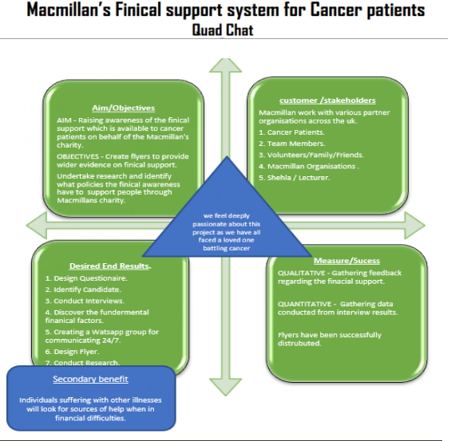

Figure 1: MacMillan's Financial Support System Quad Chart

Before initiating the project, stakeholder analysis comes in handy to help the project manager to identify the stakeholders and group them according to their expected input in the project. The analysis also helps the project manager to clarify the communication process that will be used to communicate with each stakeholder in the project life cycle (Eskerod 2018, p.164). The stakeholders are grouped based on perspective, and priority. Some of the stakeholders can be internal or external that is working within the organization or people from outside the organisation, respectively. In the McMillan project, the key stakeholders include team members, cancer patients, and the McMillan website that will help provide essential information to be shared with the cancer patients. Further division and elaboration of stakeholder features are shown in the table below.
MacMillan’s Financial Support System for Cancer Patients
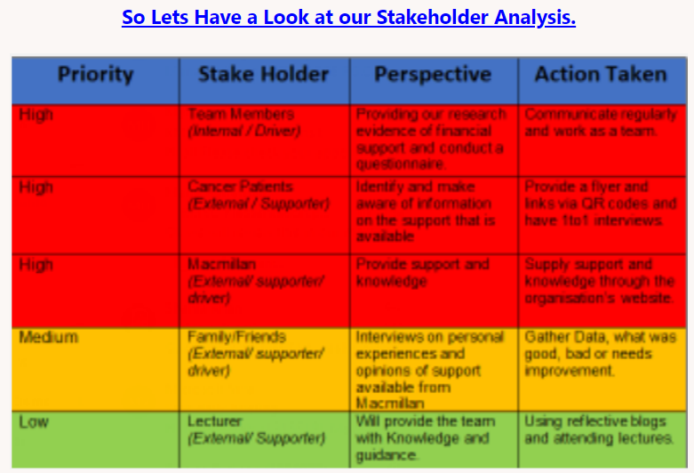
The stakeholder analysis is beneficial to the project team since it reveals and eliminates numerous obstacles to comprehension of the project's development. Learning about project supporters, opponents, and their relative relevance to the project, also removes obstacles to the release of successful initiatives. However beneficial, the stakeholder analysis has several disadvantages that include consuming a lot of time to analyses and engage with every stakeholder. Allocation of priority is also based on probability and errors created while identifying priorities can affect the outcome of the project.

Project Planning
In the execution stage, the business plan is put into practice. Keeping work on the track, organizing team members, managing timelines, and ensuring that the work is completed by the original plan are all responsibilities of the project manager throughout this stage of the project management life cycle. The major tools used in accomplishing activities in the third phase include the Work Breakdown Structure (WBS) and the Gantt charts.
A Gantt chart is advantageous in planning all the project phases and outlining all the tasks that will be involved in a specific phase. Gantt charts also help in representing the project timeline in terms of task sequences, allocated duration, and the start and completion dates for all activities in a particular phase. Also, they provide scheduling and monitoring resources allocated to different activities in the project (Young. 2020) Using Gantt charts in project management has some disadvantages such as requiring more time to create and manage the chart, and also provides information about the project time and does not quote unit hours for a specific activity. Figure 2 below provides the Gantt chart for the MacMillan project.

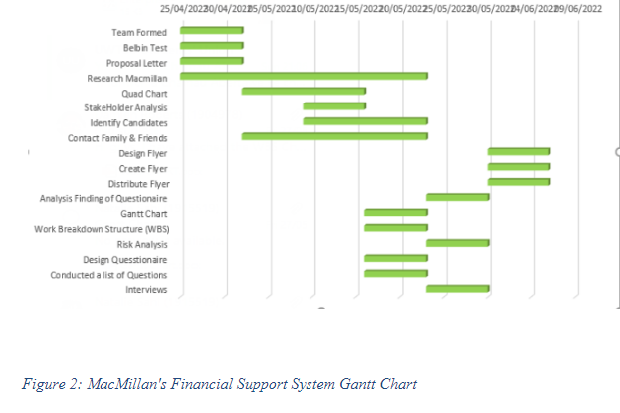

A WBS is a project management tool that focuses on deliverables and organizes all project activities in a hierarchy. The advantage of using WBS is that it assists project managers in dividing difficult jobs into more manageable subtasks while keeping cost, scope, and time baselines in mind. Also, it ensures that the other team members may manage various project activities concurrently, enhancing team productivity (Burghate 2018, p.458). Some of the shortcomings associated with WBS include confusion of orientation, and charts becoming outdated faster. The WBS groups many tasks ago and therefore can confuse team members using it to track the activities. Figure 3 below provides the WBS for the MacMillan project.
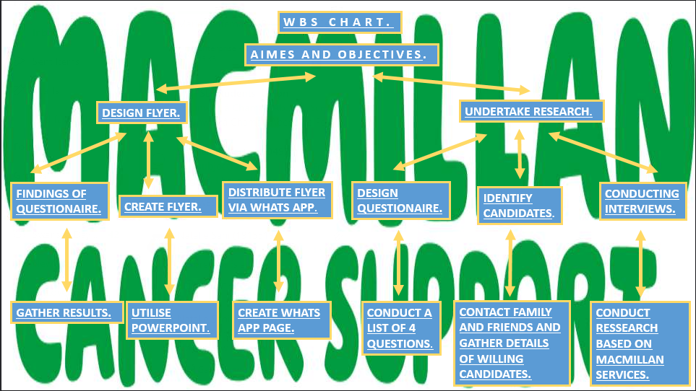
Figure 3: MacMillan's Financial Support System Work Breakdown Structure (WBS)

Project Closure Phase
The project moves into the closure phase once the project team has finished its work on it. The project team offers final deliverables, releases project resources and assess the project's success during the closure phase. Nevertheless, the project manager's job does not end just because the main project work is finished; there are still vital tasks to complete, such as analyzing the project's successes and failures (Zheng et al 2022, p.6). In the MacMillan project, the final phase aims to analyze the project performance by determining the problems that have may have raised along the project cycle and how they were solved. The phase also analyzes how the team's performance and how they worked towards achieving the project goals. Through post-implementation reviews, the project team conducts the final analysis of the project guided by the project manager to identify lessons learned for future projects.
With the help of the Risk analysis tool which figures out the misfortunes that may arise in a project, the project was prepared adequately to figure out any impact before it occurs (Nagendra 2018, p.27). The project used a table and past data of related projects to evaluate the probability of a risk occurring and the scale of its impact. The McMillan coexists with the society and therefore, the project management team employed PESTEL and SWOT analysis skills to monitor the macro-environmental factors that might have an impact on the organisation. Due to adequate preparation that informed the team of possible risks and their solutions, the project accomplished all the activities listed in the Gantt without alteration. The risk identified is shown below.

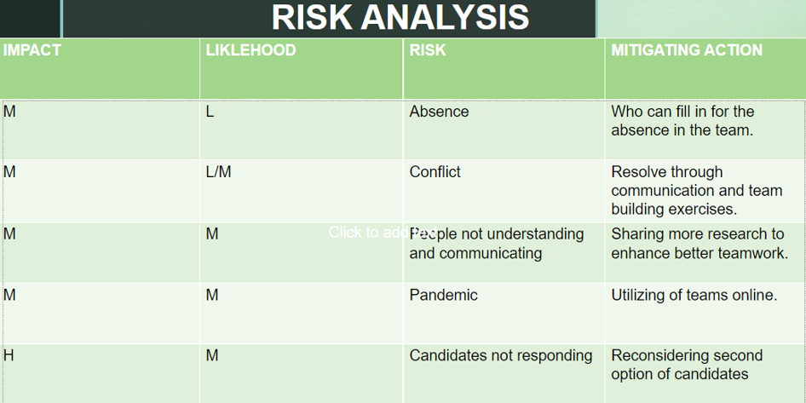
Figure 4: MacMillan's Financial Support System Risk Analysis

Project Evaluation
Organisations refer project evaluation as the process of gauging a project or program's success. The process is accomplished by obtaining project-related data and employing an evaluation strategy that enables evaluators to identify areas for performance improvement. Based on the gathered data, the project outcome can be hard or soft (Pereira 2022, p.143). The hard outcomes are definable and measurable while soft outcomes are less tangible and hardly measured. the assessments used in analysing the gathered data are either objective or subjective depending on the project scope. In the Macmillan project, the outcomes were both hard and soft where the team measured visible outcomes versus people's experiences respectively as shown in figure 5 below.
The Macmillan project was successful, based on the data gathered because it mostly achieved the objectives specified during the planning stage. It is clear from the information in the project finding and Quad chart that the project and its goals were accomplished. Additionally, the project closure phase results in the anticipated outcomes listed in the Quad chart. In addition to producing and distributing flyers to cancer patients, the project team was effective in creating questionnaires, conducting interviews, and performing research. The team appears to have gained a better understanding of how difficult it is for cancer patients to find information regarding cancer management based on soft outcomes and behaviors. Through the flyers, the staff can provide information vital for securing financial help from Macmillan. The project adhered to the nine Belbin roles hence pushing the project to be successful. As a project manager, it’s wise to learn to use the available resources to cover gaps in case of shortages.

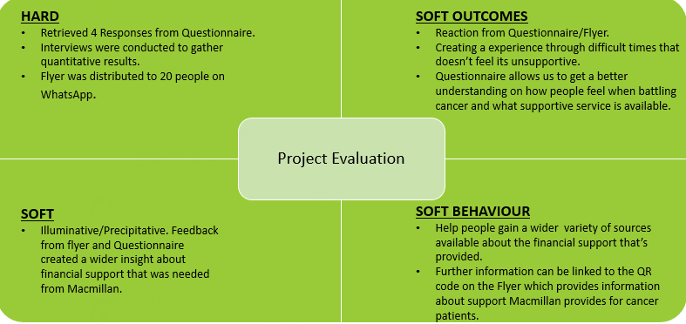 Figure 5: MacMillan's Financial Support System Monitoring and Evaluation

3.0 Conclusion
In conclusion, project management will always be essential to a project's success. To successfully guide a project from the planning stage to the completion stage, organisations should concentrate on investing in the hiring of competent project managers who have at least 70% of the necessary abilities. The success of the MacMillan project was highly contributed by the availability of competent leaders who adhered to Belbin's roles and encourage teamwork. Using project management tools such as Quad Charts, Gantt charts, and WBS among others is highly recommended in every project. Project review and documentation should be mandatory deliverables for the preparation of future projects.

4.0 References List
Burghart, M., 2018. Work breakdown structure: Simplifying project management. International Journal of Commerce and Management, 3(2), pp.453-461.
De, S. and Vijayakumaran, V., 2020, November. An Efficient Algorithm in Project Management for Resource Scheduling and Conflict Management using Graph Coloring Technique. In 2020 IEEE International Conference for Innovation in Technology (INOCON) (pp. 1-6). IEEE.
Eskerod, P. and Larsen, T., 2018. Advancing project stakeholder analysis by the concept ‘shadows of the context’. International Journal of Project Management, 36(1), pp.161-169.
Mavi, R.K. and Standing, C., 2018. Critical success factors of sustainable project management in construction: A fuzzy DEMATEL-ANP approach. Journal of cleaner production, 194, pp.751-765.
Nagendra, A. and Sharan, A., 2018. Risk Analysis for Project Management. Journal of Applied Management-Jidnyasa, 9(2), pp.22-31.
Nicholas, J.M. and Steyn, H., 2020. Project management for engineering, business, and technology. Routledge.
Özkan, D. and Mishra, A., 2019. Agile Project Management Tools: A Brief Comprative View. Cybernetics and Information Technologies, 19(4), pp.17-25.
Pereira, J., Varajão, J. and Takagi, N., 2022. Evaluation of information systems project success–Insights from practitioners. Information Systems Management, 39(2), pp.138-155.
Picciotto, R., 2020. Towards a ‘New Project Management’movement? An international development perspective. International Journal of Project Management, 38(8), pp.474-485.
Sabini, L., Muzio, D. and Alderman, N., 2019. 25 years of ‘sustainable projects’. What we know and what the literature says. International Journal of Project Management, 37(6), pp.820-838.
Sanchez, B. and Haas, C., 2018. Capital project planning for a circular economy. Construction Management and Economics, 36(6), pp.303-312.
Young Illies, M. and Stachowski, A.A., 2020. Improving students’ teamwork experience: Evaluating a project management application. Scholarship of Teaching and Learning in Psychology, 6(1).
Zheng, Y., Fattahi, H., Agram, P., Simons, M. and Rosen, P., 2022. On Closure Phase and Systematic Bias in Multilooked SAR Interferometry. IEEE Transactions on Geoscience and Remote Sensing, 60, pp.1-11.

