Draft of Assignment 1 Resit -Marketing Audit

The importance of effective Learning and Development strategies

Shuwen Zeng
2231725
BMBM6012 Leading and Developing People

Based on the results of the research, I believe that the current leadership development will be more flexible, and managers will pay more attention to the ideas and attitudes of employees. Agile leadership can improve the work efficiency of employees more quickly, and it can also allow managers to change work plans more quickly according to actual conditions, so as to improve the performance of the team or enterprise and maximize the benefits.
An increasingly competitive business environment, rising levels of complexity, and the ongoing impact of the digital revolution are all factors that are changing the workforce and contributing to its ongoing transformation (Bacon, 2013). At the same time, persistent unpredictability, a multigenerational workforce, and a short knowledge shelf life make it all the more necessary to reskill and upskill. In my view, the value of a company may be significantly increased by having agile leadership and skilled workers.
The relevance of the learning and development (L&D) role is only going to grow as a result of all of these trends. One of the fundamental tasks of Learning and Development (L&D) is to manage the development of people, and they must do so in a way that is supportive of other important business priorities. As can be seen in the following diagram, the strategic role of L&D spans five different domains (Erskine & Johnson, 2012).
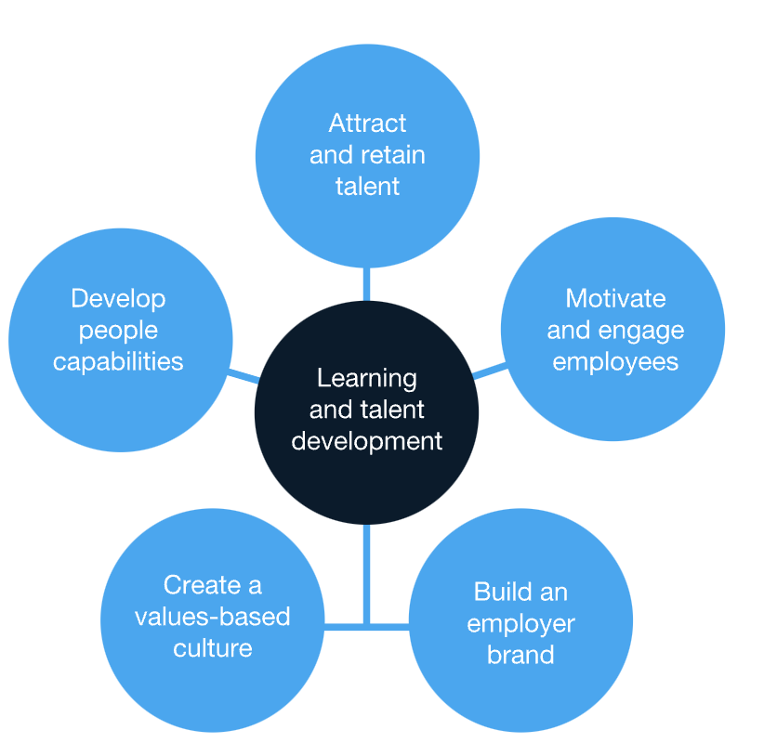
Agile managers of learning and development have to take on a bigger role within the business and set an ambitious vision for the function in order to get the most out of the organization's investments in training programs and the development of curriculum (Loshali & Krishnan, 2013). A thorough and coordinated approach that engages the organization and encourages collaboration is an essential component of this effort and should not be overlooked. Learning and development (L&D) can assist managers in improving their functions and making them more useful to the firm.
Recruit and keep the best people. Learning has, throughout history, been solely centered on increasing levels of output. Learning also plays a role in one's employability in today's world, which has seen a change away from the traditional employment model of staying with the same employer for one's whole working career to one in which employees are only kept on if they offer value to the organization. People rank "learning and development opportunities" as the most important factor to consider before joining an organization (Vohra & Bhatnagar, 2011). This is one of the reasons why people rank "learning and development opportunities" as the most important factor to consider before joining an organization. On the other hand, a lack of opportunities for professional growth and learning is one of the primary reasons why people leave their jobs.
For the value of human capital to be preserved throughout time, there must be ongoing investment in learning and development. The value of human capital decreases if previous knowledge is rendered inapplicable or lost, and in order to restore it, fresh education and experience gained in relevant fields are required (Day, 2001). Companies who invest in the next generation of leaders are seeing substantial financial rewards for their efforts. In addition, businesses that make an investment in the development of agile leaders amid large organizational shifts have a 2.4 times greater chance of meeting their performance targets.
L&D has the potential to assist in the development of a values-based culture as well as a sense of community even as the workforces of many firms grow increasingly virtual and geographically separated. Millennials, in particular, have a strong interest in enterprises that are sustainable, built on core values, and make a positive contribution to the overall wellbeing of society.
One of an organization's most valuable assets is its brand, which generally reflects the company's achievements in the market, its financial strength, its standing in the industry, as well as its products and services. A firm's brand and its reputation as an employer of choice can both benefit from investments in learning and development made by the company. Employers are going to have to up their game in order to compete for a talent pool that is getting smaller because a huge section of the workforce is getting ready to retire. To accomplish this, they need to effectively communicate the power of their brand to potential employees by developing an employer value proposition.
Providing employees with opportunities to learn new skills and develop existing ones is the single most essential thing that can be done to engage employees. According to the findings of numerous studies, continuous education is beneficial to one's health. They are more likely to be motivated by new opportunities on the work and feel content with their existing company when highly engaged individuals are challenged and obtain the skills to grow and develop in their chosen career path through professional training and development chances.
Companies have to become more adaptable and ready to modify their business processes and practices as new tools and technology continue to emerge. This requires them to become more agile. building a governance structure in which executives will set the people capacity agenda for each division of the business and ensure its alignment with the company's overall strategic goals will help L&D deepen its partnership with business leaders. This can be accomplished by building a governance structure. Senior executives of the company will also contribute to the process of fully integrating the learning function as well as all learning and development activities into the culture of the organization. The participation of top leadership allows the Learning and Development department's long-term vision to be fully achieved, and this is a significant achievement.
Leaders are coming to the realization that very few organizations are actually putting large-scale transformation projects into action, while the majority are instead gradually altering their strategies and courses of action according to the requirements of the situation. Human capital is more important than it has ever been and will continue to be a key aspect in retaining a competitive edge for many years to come as technology continues to advance at an accelerating rate and R&D executives can no longer afford to postpone.
Agile leaders may revolutionize their approach by establishing a learning and development unit, building a learning strategy that is aligned with business goals, and identifying and supporting the competencies that are necessary to achieve success. The most successful businesses make investments in creative forms of learning and growth.

Reference list
Bacon, R. (2013). A comparison of approaches to importance-performance analysis. International Journal of Marketing Research, 45(1), 55–77.
Erskine, L., & Johnson, S. (2012). Effective learning approaches for sustainability: A student perspective. Journal of Education for Business, 87(4), 198–205.
Loshali, S., & Krishnan, R. (2013). Strategic human resource management and firm performance: Mediating role of transformational leadership. Journal of Strategic Human Resource Management, 2(1), 9–19.
Vohra, N., & Bhatnagar, D. (2011). Leadership development in organizations in India: The why and how of it (Part-I). Vikalpa, 36(3), 61–118.
Day, D. (2001). Leadership development: A review of best practice. Alexandria, VA: Fort Leavenworth Research.

