Deconstructing Freedom

Abstract:
My dissertation will explore the ideas surrounding freedom of expression in western societies. Throughout my dissertation project I will look into deconstructing the perceived perception of how westerners believe/think freedom should appear to fit the ‘norm’ and the majority opinion in their culture. My dissertation will explore topics that constitute western ideals (today) such as post colonialism, Greek philosophy, imperialism and the narrative of ‘the other’.
I will analyze how different narratives are given to specific people belonging to different cultures to fit a one-way narrow idea that is often associated with a specific group of people. An example of this will be to examine how black people are often given platforms in music videos, films etc. They play a certain role to fit the stereotype of how black people should be perceived.
It is no misconception that there is stereotypes about black African people ‘having’ “violent, ignorant, lazy, superstitious and joyous traits” (blackinstitute, black stereotypes, accessed 2018). Throughout my dissertation project I will look into how these narratives may affect a class of people and may also impact youngsters by socializing them to aspire to act or be a certain way.
For example, often the majority of male and female black singers narrate lyrical songs in music video that play into the archetypal view of how the black community is perceived.

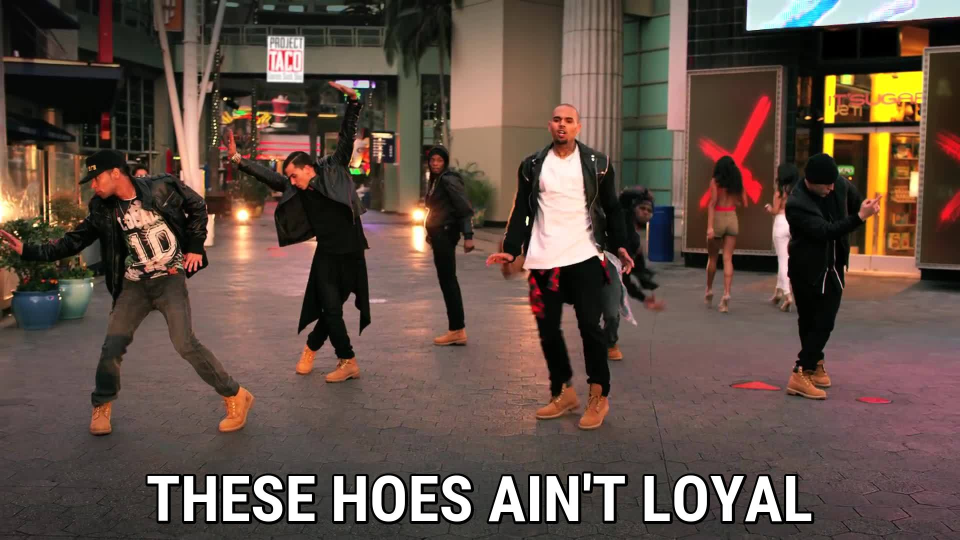
Figure 1

These singers use derogatory terms that objectify and reduce women to sexual objects and causally throw in the words like ‘bitch, nigga/ah and such’ these singers attempt to normalize these terms by socially conditioning youngsters into believing that this is the norm and a form of expression. Although there are many different opinions among the black African communities on whether the word “nigga/ah” encourages further racism and stereotypes black people or empowers them by giving them control over the word. Some believe that this word has been reinvented in a way to mean more than just a racist term that was once used by the colonizers to demonize black people during slavery times. However, now it is used by some black folks as a form of empowerment or so it is believed. This word has become part of the cultural identity of black folks who identify with rap music and hip-pop culture. It is widely spread and causally used amongst these groups of people. (blackinstitute, black stereotypes, accessed 2018)

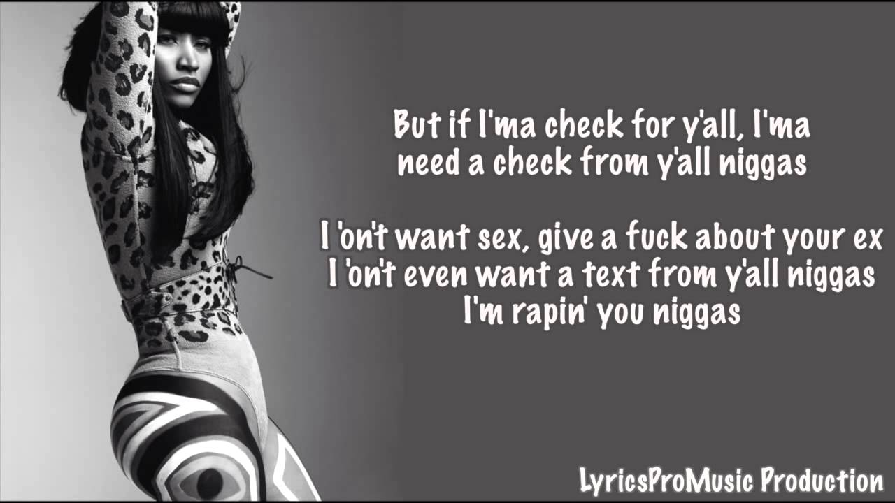
Figure 2

My research will also compare and examine other narratives that are prevalent in western media. It is not a startling statement to suggest that the other is given a particular narrative to play in mainstream media, it is one of the main reasons why it is believed that some groups of people hold misinformed ideas about diverse communities’.
My research will heavily be impacted by the classical works of Edward Said who identifies and clarifies the ideas orientalists have derived about the eastern world. Said argues that often these post-colonialists paint an image and portray the Arab/Muslim world in a very limited and superficial way which fits in perfectly to the stereotype that westerners have developed about the middle east. Said also points out many critical factors about the western interpretation and portrayal of east Asian’s as belonging to a culture that encourages prostitution and violence.

Looking into Said’s classical works will enable me to further my knowledge about orientalism, imperialism, foreign affairs and the idea of a post colonialism narrative that is constantly imposed on the other. (the lily, tamara k nopper, accessed 2018)

My dissertation research project will also explore the works of Louis Althusser, Michael Michalko, Ibn Khaldun, Al-Ghazali, Averroes and Voltaire. Incorporating these classical works in my research essay will help me map out my final conclusions for my dissertation project. I have chosen to factor these particular works into my research process as I interpret the main themes and narratives discussed therein as related to each other. In my research case I will conclude and show that they are heavily linked and can become inspirable in place of the archetypal narratives that the controlling powers try to saturate society with. What I mean by this is I will clarify to the reader by suggesting ideas about the western encroachment as a result of colonising and conquering lands by force or otherwise that has been exercised throughout history and is still prevalent today. These western powers were able to secure future relations that would make the West be recognised for what it is often perceived as “a force for good”. Said argues in one of his lectures, “The Myth of Clash of Civilisations”, that the western colonial powers tactics consisted of many theories and rhetoric’s. Said illustrates, “in the battle for the empty spaces in Africa, the so called ‘dark continent’ France, Britain, Germany, Belgium and Portugal resort not only to force but to a whole slew of theories and rhetoric’s to justify their plunder. Perhaps the most famous of such devices is the French notion ‘the civilising mission’”. (myth of clash civilisation, Edward said, 2018)

The European colonial powers constructed and mapped out many parts of the world, particularly places of high interest in regards to trade and resources. This is believed to be common knowledge and widely accepted by both western and eastern historians and humanities scholars. (European history, benedict stuchtey, accessed 2018)
The tactics that were introduced by the colonial powers were anything from, we will bring the people ‘civilisation’, to master of all tactics - divide and conquer the lands. Said suggests this notion clearly in his essay “The Myth of Clash of Civilisations” as a response and a critique of the works of Samuel P. Huntington titled “The Clash of Civilisations”. Said argues throughout his writings that western tactics had to include many informative and convincing works of literature and films. This was and is to act as a tool in order to shift the perception the populace had of their actions as a nation so they considered themselves as being on the ‘good side’ and to further marginalize the Muslim other. Said illustrates clearly that the populace was indoctrinated by western films, literature works, art works and such. The western world implies that it values good common principles such as democracy, freedom of thought and expression. Often it attempts to portray itself as a nonbiased and progressive force, yet there is an argument against this narrative. Said and other intellectuals like Noam Chomsky suggest that the western world fails to acknowledge the achievements made by the Islamic world that is also responsible for progressing their native lands before western civilisations embarked on the Golden Era. He argues that often the West dismisses that the same ‘intolerant’ Islamic world was responsible for the creation of Baghdad’s intellectual and cultural centre of mathematics, art and science. The fact that it is the same Islamic world that has pioneered mathematics and science has introduced algebra, Art, music and so forth into Europe to facilitate further progression would contradict the current narrative about the Islamic world.
My dissertation project will explore how these elements are strategized and implemented through literary work, films and cinema.
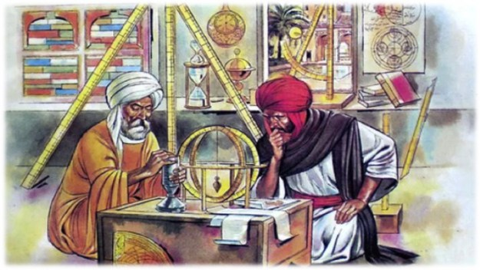
Figure 3

In the western world it is no longer the time of Christianity, Judaeo-Christian views no longer inform western policies and foreign policies. Now it is the time of secularism, liberalism and democracy. The western world has a strong ideological encroachment on the rest of the world because of its hegemonic position. It wants us to believe in that which it believes, it makes sense for its power positions and foreign policies to adopt this stance.
Taking Althusser classical works into consideration the book titled, “Ideologies” he argues that the most effective way for consistent control is by introducing an ideological belief which will in turn provide the mechanism that is required to allow power to manifest itself. His theories are based on how “institutions (superstructure) and economy (base) work together to create inequalities within society’’. (ideology and ideological state, Althusser, accessed 2018)
Althusser portrays in his writings that colonial powers often secured their ideological systems to enforce a one way thinking on the populace, this allows the colonizers control over the lands and the people they conquered. However, it is not always successful to secure an ideology where there is a particular belief system that rejects the ideals of a new system. Although my research will be heavily based on the works of Said’s writings, I believe my final outcome for my dissertation will consist of challenging the idea of freedom perception in mainstream media today. To illustrate my argument further my focus will mainly involve the portrayal of Muslim women in media today. My work will examine how the archetypal role of women who identify as Muslim are given roles that feed the current mainstream misconception narrative about these particular women being ‘’oppressed, ignorant, submissive and require saving’’. (our ignorance is hurting Muslim women, Ariel smith, 2018) It is believed that there are growing hostile attitudes towards Muslim women in the media today. My work will challenge how the predominate voices in mainstream media speaks not for all women, particularly for those women who choose to appear in a burka or women who choose to appear in what is considered sexually provocative attire. Advocators can not speak for every women as expression is a subjective and an individualistic choice that will differ for every woman. In a lot of debates against or for the burka dress, advocators who argue against fail to understand the fact freedom of expression is a relative and subjective, it is not something that can be measured therefore it remains a personal choice. Not only that but the hijab is also part of one(s) identity. It is believed by Freud that identity is not an aspect about one’s character that can easily be deconstructed because it is what makes you who you are. Having said that there are also many theories that debunk Freud theory of self-identity.
My essay dissertation has been inspired by this quote which I believe has impacted my subject matter to further my research regarding different philosophical opinions. The quote is as follows, ‘’Freedom is absolute, they proclaimed; you are either free or you are not. But freedom is not absolute, it is a relative and subjective concept. Freedom cannot be measured, the degree to which a person is or is not free can only be determined through comparison and that comparison is completely subjective.’’ (bankable insight, Keith Farrell, accessed 2018)

Internet References

Demonization of Islam and orientalism in western media. (2018).
https://www.iapss.org/wp/2015/03/10/demonization-of-islam-and-orientalism-in-western-media/

Creative thinking. (2018) Michael Michalko.
http://creativethinking.net/different-perspective/#sthash.MrCrBKjc.dpbs

The black institute. (2018) can we really ever reclaim the “N” word
http://www.theblackinstitute.org/can_we_ever_really_reclaim_the_n_word

The French orientalism. (2018) The imagined other.
https://www.gla.ac.uk/media/media_192650_en.pdf

the myth of clash civilisation. (2018). Edward said.
https://www.youtube.com/watch?v=qkK4pApcwMc

our ignorance is hurting Muslim women. Ariel. (2018)
https://medium.com/applied-intersectionality/stop-the-oppression-of-muslim-women-by-recognizing-your-oppressive-ways-6a8ac2fc4d05

Opinion/ it boils down to stereotypes. (2018)
https://www.thelily.com/the-alt-right-likes-asian-american-women-we-shouldnt-be-surprised/

Bibliography
Books:
Louis Althusser. (2018) on ideology.
John Stuart Mill. (2018) on liberty.
Edward Said. (2018) the myth of clash civilisations writings.
Averroes. (2018) the incoherence of the incoherence volume 1 and 2.
Henry Corbin (2018) translates Hossein Nasr works.

Secondary sources (images) referencing
Fig 1. Picylyrics. Google image search. (2018)
Fig 2. Pinterest. Blog search. (2018)
Fig 3. Centre for Islamic studies/ Islamic golden age. (2018)

