University of Wales Trinity Saint David
Wales Institute of Science & Arts

Lean and Six Sigma Manufacturing Principles for Improving Operational Performance



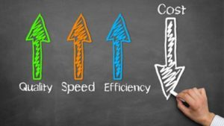

By Craig Worsley (2213643)
​CertHE Skills for Engineering
ACMA4012
​10/05/2023

Contents Page
1 Introduction 1
2 Literature Survey 2
2.1 Overview of Lean Six Sigma Techniques and Implementation 2
2.1.1 Six Sigma (6σ) 2
2.1.2 Lean Manufacturing (LM) 2
2.1.3 3 Ms of waste 2
2.2 House Of Lean Principles 3
2.2.1 Just in Time (JIT) 3
2.2.2 Cellular Production 3
2.2.3 Standard Work 3
2.2.4 Levelling (Heijunka) 4
2.2.5 Jidoka 4
2.3 Quality Improvement and Management 4
2.3.1 TQM and Kaizen 4
2.3.2 Time-Based Management 5
2.3.3 5s - Sort, Sustain, Set in Order, Shine and Standardise 5
2.3.4 Poka-yoke Principles 6
2.4 Supporting and Resisting Forces of Lean Implementation 6
3 Conclusion 7
4 References 8
6 Appendices 9

List of Figures
Figure 1: Historical Evolution of Lean Production (Saleem, Khan et al. 2012) 4
Figure 2: Detailed Analysis of Assembly Operations (Barker 1994) 5
Figure 3: Figure 10: Structure of Lean Production (Modrák, Semančo 2014). 6
Figure 4: Historical Evolution of Lean Production 8
Figure 5:Phases of Factory Structuring Over the Last Five Decades 10

Introduction
This paper will start by giving a brief description of what lean manufacturing and 6σ principles are, proceeding into the techniques used, by implementing each of these principles the literature review will demonstrate how much of a dramatic impact these techniques have had on developing businesses.
Lean manufacturing and Six Sigma are two complementary methods that when combined will help enable an organization to continuously improve their performance and thrive in a competitive market, with a reduction of customer dissatisfaction as well as reduced cycle times these techniques can be used in any industry (Tetteh, Uzochukwu 2015).
Lean Six Sigma is often the techniques of preference for many organizations looking for a systematic approach to process improvement, this practice has been shown to be very successful throughout many deployments around the world with large, medium, and small organizations (Tetteh, Uzochukwu 2015).

Literature Survey

Overview of Lean Six Sigma Techniques and Implementation

Six Sigma (6σ)
A common technique of 6σ is the DMAIC process (define, measure, analyse, improve and control) through statistical process control, hypothesis testing, design experiments, root cause analysis and process mapping, 6σ has a wide range of tools for system improvement (de Mast, Lokkerbol 2012).

Lean Manufacturing (LM)
Lean manufacturing is value identifying from the customers perspective, to refine a production process and remove as much waste as possible without compromising on the quality of the product, by reducing waste and only producing what is needed when it’s needed, this will create flow and help in the strive for perfection, the technique emphasizes on a continuous improvement to improve the process to as near perfection as possible (Modrák, Semančo 2014).
Lean 6σ manufacturing is a mixture of the methodologies that emphasises on minimising waste and maximising efficiency in the manufacturing process, by mapping the process, identifying waste and reducing non-value-added tasks, the entire system that delivers the product is reviewed, this can show where time can be saved, value can be added and by seeing the entire process the critical parts of the production can be reviewed to improve the product/processes (Zhang, Irfan et al. 2012).
Establishing pull, by creating a system where each process produces only what is needed for the next process in the value stream, this is based on customer demand.
The pursuit of perfection, to continuously review all the processes and continuously implement improvements, by means of eliminating waste, streamlining the process, and improving quality.
By adhering to lean manufacturing processing principles, companies can reduce cost, increase efficiency, and improve customer satisfaction.

3 Ms of waste
The 3m’s of waste are muda - none value added waste, mura - inconsistency and muri - overburden in the system. In the journal (Radin Umar, Tiong et al. 2023), it is clear to see there is a priority gap between the 3Ms of waste and lean production improvement/planning, usually two different teams manage these improvement processes, ergonomics however, does not have clear financial gains, the ergonomics of a structure seems to be a reactive improvement instead of a constant progressive process, industrial practitioners tend to restrict ergonomics and indirectly create occupational health concerns, increase work pace, increase workload, increase stress levels, reduced productivity, creates poorer working conditions and inadvertently can lose the business its competitive edge.
An over defined standardisation of processes can cause similar negative effects, if set by uneducated practitioners with limited knowledge, workers lose the ability to set their own system of work through inflexibility and are restricted in being allowed to improvise completion of work through better knowledge of the processes that can be more comfortable for them (Radin Umar, Tiong et al. 2023).
Safety efficiency value stream mapping (SEVSM) is a tool that has shown to improve production, performance and reduce health and safety concerns in operational activities (Radin Umar, Tiong et al. 2023).
Implementation of 5S, Visual management and One Point Lessons in warehouse and workshop settings, can improve the work environment by reducing health and safety related risks with better risk communications, better accessibility to items, and better item layout and organisation (Radin Umar, Tiong et al. 2023).
In the journal (Radin Umar, Tiong et al. 2023), it was expressed that through utilising 5s and visual management it improved the workers perception towards health & safety by as much as 40%, the implementation of lean manufacturing gave the workers a better motivation towards safety while performing work activities.

House Of Lean Principles

Just in Time (JIT)
The just in time production system reduces the workforce and waste as much as possible so it only just meets the requirements of the next process, while having focus on health and safety to reduce accidents and breakdowns (Modrák, Semančo 2014).
The Kanban system was designed for control, to maximize the potential of the Toyota production system, it is a system with its own independent structure and principles (Modrák, Semančo 2014).

Cellular Production
Cellular production is a reduction of movement to reduce waste, by storing products and a combining of processes into cells it can have a dramatic effect on waste time, to quote (Barker 1994) “in some organizations where product derived cellular manufacturing is in place, it has been possible to combine component production and assembly cells in one area to design, in effect, a “mini” factory or total conversion in one cell”.

Standard Work
Standard Operations are operations that have been developed to preserve an effective process on a combination of people or goods and machines, to produce high-quality products in an economical, repeatable, quick and safe manor (Modrák, Semančo 2014).

Levelling (Heijunka)
The idea of levelling is to reduce bottle necks and strain on specific parts of the production process by dividing work to create a level and smooth process that is as evenly distributed as possible, as a result, levelling is fundamental both in JIT production and in flow manufacturing (Modrák, Semančo 2014).
In (Spenhoff, Wortmann et al. 2022) it was stated that Heijunka addresses the stability-flexibility paradox however, Heijunka was designed for short setup times which meant it was not designed for their purpose and because of this was considered not directly applicable, but by adopting Heijunka into its manufacturing process and creating/developing a production control concept, it enabled both the required stability and flexibility needed simultaneously, a variation of the principle was integrated into the system, “by adapting Heijunka and combining it with the cyber-physical systems” (Spenhoff, Wortmann et al. 2022). The combination of lean production and Industry 4.0 exhibits exceptional potential in advancing operations management and production of new more intelligent control systems.

Jidoka
Jidoka is to aid automation in the reliability, flexibility and precision of manufacturing by bringing humans in to monitor the process (Modrák, Semančo 2014), I found this quite interesting as machines are put in place because of the human error, yet Jidoka identifies that a person is irreplaceable in the manufacturing process also.

Quality Improvement and Management

TQM and Kaizen
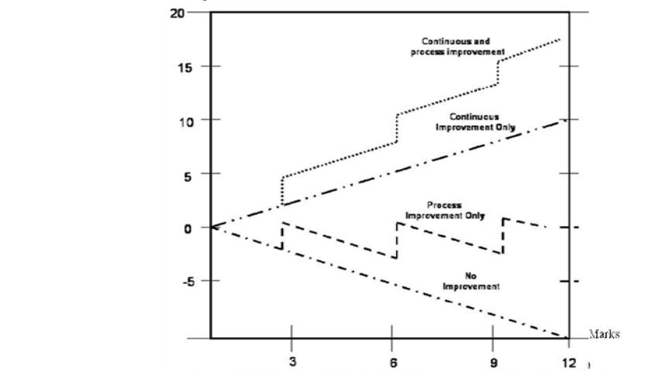
In the journal (Saleem, Khan et al. 2012), the definition TQM against Kaizen and the way we use the definition at different levels is interesting, most companies use both to have the greatest improvement, but what’s interesting is to see how the different techniques impact and change the efficiency with different stages of implementation, the next set off quotes comes from (Saleem, Khan et al. 2012), “TQM is a management approach that aims at long-term success by focusing on customer satisfaction, based on the participation of all members of an organization through improvements of quality, processes, services, and the culture in which they work”, however the term Kaizen is "to take apart and put back together in a better way". The definition on applying Kaizen is "small incremental but continual improvement", the next quote shows how close a broad definition can look “in order to improve process, quality and of course performance of the organization”. The broad definitions can sound very similar but once reviewed they are in fact completely different.
Figure 1: Historical Evolution of Lean Production (Saleem, Khan et al. 2012)

Time-Based Management
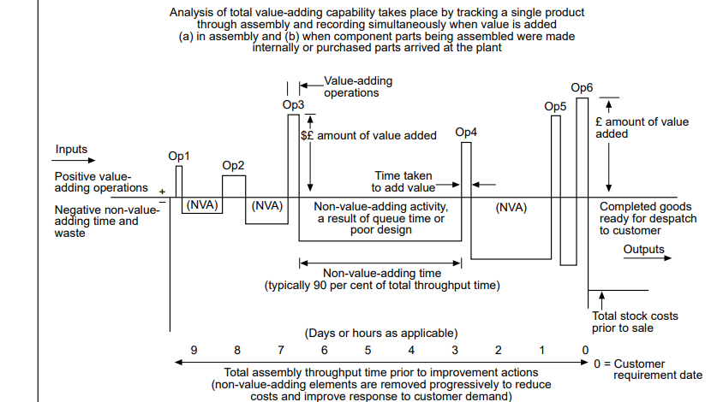
Time based management is a collection of data to determine value added time, waste time and to calculate the entire process time, to ascertain a full breakdown of the system structure to implement organisational improvement, system structure refinement, layout of production system and control system improvements. Then calculating the predicted value to be added at each machine and section of the product flow (Barker 1994). Another name for this process is Value stream mapping, in (Santos, Santos et al. 2021) they enhance the utilisation of a business by mapping the entire process and environment then breaking it down. Event software is a fantastic piece of software to start the implementation of this technique.

Figure 2: Detailed Analysis of Assembly Operations (Barker 1994)
To highlight the importance of time analysis, a quote from (Barker 1994) tells us, “To identify and remove non-value-adding activity which separate value-adding operations, these typically account for 90 per cent of the time a product is in the production system”.

5s - Sort, Sustain, Set in Order, Shine and Standardise
In the case study (Rojasra, Qureshi 2013), a statement is made showing just how important lean manufacturing and the 5s are, “The results after the 5S implementations states that production system efficiencies improved from 67% to 88.8% in the successive week”.
Lean manufacturing is a fresh look and a common-sense approach to reviewing processes and applying streamlining techniques, these changes can have a vital effect on businesses to the degree of success or failure, “small businesses contribute more than 50% of the industrial production in value addition terms and generates one third of the export revenue”, “Lean Manufacturing is the hymn of survival and success of any organization” (Rojasra, Qureshi 2013), It is also expressed that in such a tough market lean manufacturing has kept these businesses competitive.

Poka-yoke Principles
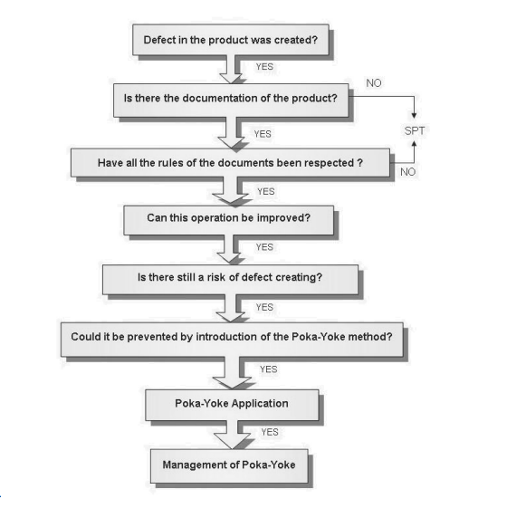
The method Poka-Yoke is an immediate response in the operation when a defect occurs and an action to produce a result that corrects or highlights the defect.

Figure 3: Figure 10: Structure of Lean Production (Modrák, Semančo 2014).
Poka-Yoke Identifies defects in two stages, a defect that has occurred calling for defect detection, or that will occur meaning defect prediction is needed, there are three ways in which Poka-Yoke can respond they are shutdown, control or warning. The Poka-Yoke techniques are used in a multitude of tools and philosophies such as QC story, QRQC, MQA, 5D and basic tools quality (diagrams, histograms, research systems of the sample, graph Pareto-Lorenza, charts of quality control process) (Widjajanto, Purba et al. 2020).

Supporting and Resisting Forces of Lean Implementation
There are multiple issues towards implementing manufacturing systems and techniques, one is towards employees, with a wide range of factors to consider for example job satisfaction, age, culture and progression opportunities, resistance of new ways of working can become challenging to implement. A strong quote stands out to highlight just how much of an impact this has on businesses from (Modrák, Semančo 2014),” Many employees find the lack of a step career ladder with even more elaborating titles and job descriptions both disappointing and disconcerting”, and “In LP system, workers feel they have reached an early death in their careers”. These statements are quite powerful considering these people will be the back bone of the company and have a substantial effect on product, flow, environment (moral) and quality, however a great deal of work and research has provided a multitude of solutions, one is Mass Career Customisation (MCC), this structure has been evolving in the workplace for some time and can solve many of the issues towards reducing resistance by customising career opportunities, paths, engagement and developing a more secure future for the employees, in turn its creating lower staff turnover, reduced costs and a substantial increase in fulfilment of company goals also (Modrák, Semančo 2014).

Conclusion
To conclude, it is clear to see that a lot more work will follow in the pursuit for perfection, lean manufacturing is not only a practical guide for a successful business, but the techniques are advancing into the software systems that run the production system, which shows the versatility of the structure of these principles and complexity of their design.
Throughout my learning towards exploring manufacturing systems in the pursuit of refining a near perfect system structure, I have gained a great deal of insight into these principles and the level of ingenuity that goes into the analysis of a production line, also the widespread implications that small changes can make.

References
BARKER, R.C., 1994. The design of lean manufacturing systems using time-based analysis. International Journal of Operations & Production Management, 14(11), pp. 86.
MODRÁK, V. and SEMANČO, P., 2014. Handbook of Research on Design and Management of Lean Production Systems. Hershey, PA, USA: IGI Global.
RADIN UMAR, R.Z., TIONG, J.Y., AHMAD, N. and DAHALAN, J., 2023. Development of framework integrating ergonomics in Lean's Muda, Muri, and Mura concepts. Production planning & control, ahead-of-print (-), pp. 1-9.
ROJASRA, P.M. and QURESHI, M.N., 2013. Performance improvement through 5S in small scale industry: a case study. International Journal of Modern Engineering Research (IJMER), 3(3), pp. 1654-1660.
SALEEM, M., KHAN, N., HAMEED, S. and ABBAS, M., 2012. An analysis of relationship between total quality management and Kaizen. Life Science Journal, 9(3), pp. 31-40.
SANTOS, D.M.C.D., SANTOS, B.K.D. and SANTOS, C.G.D., 2021. Implementation of a standard work routine using Lean Manufacturing tools: A case Study. Gestão & Produção, 28.
SPENHOFF, P., WORTMANN, J.C. (. and SEMINI, M., 2022. EPEC 4.0: an Industry 4.0-supported lean production control concept for the semi-process industry. Production planning & control, 33(14), pp. 1337-1354.
TETTEH, E.G. and UZOCHUKWU, B.M., 2015. Lean Six Sigma Approaches in Manufacturing, Services, and Production. Hershey, PA, USA: IGI Global.
WIDJAJANTO, S., PURBA, H.H. and JAQIN, S.C., 2020. Novel POKA-YOKE approaching toward industry-4.0: A literature review. Operational Research in Engineering Sciences: Theory and Applications, 3(3), pp. 65-83.

Appendices
Appendix 1 - The Evolution of Manufacturing
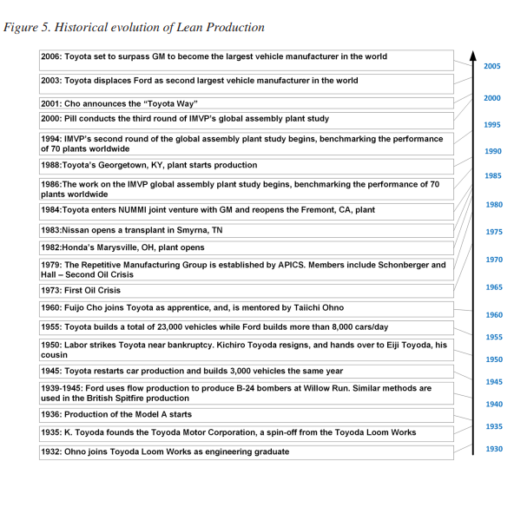
Each stage in the evolution of manufacturing had its own era and was supported by its own manufacturing system working to an individual business model (Modrák, Semančo 2014).
Figure 4: Historical Evolution of Lean Production

Appendix 2 - Advancements in Manufacturing Systems and System Structures
Craft Production | 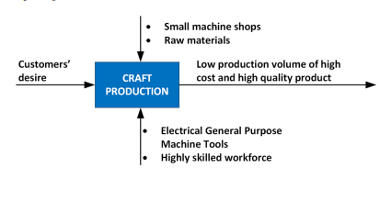
Figure 2: Structure of Craft Production
Source: Adapted from (Modrák, Semančo 2014).
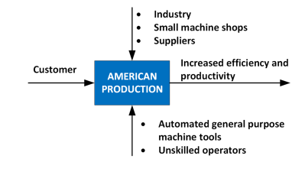 | American Production
Figure 3: Structure of American Production
Source: Adapted from (Modrák, Semančo 2014).
Mass Production | 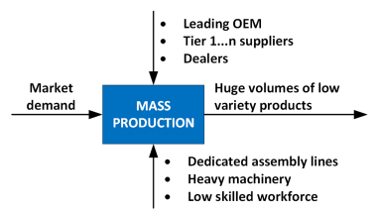
Figure 4: Structure of Mass Production
Source: Adapted from (Modrák, Semančo 2014).
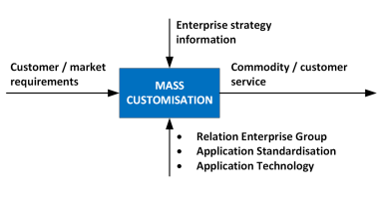 | Mass Customisation
Figure 5: Structure of Mass Customisation
Source: Adapted from (Modrák, Semančo 2014).
Lean Production | 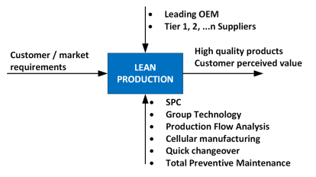
Figure 6: Structure of Lean Production
Source: Adapted from (Modrák, Semančo 2014).

Appendix 3 – Development of Production systems over the last decade

The following systems are all focused on the general goal of increasing profit, improved customer satisfaction and achieving objectives: Toyota Production Systems (TPS), Lean Production (LP), Mass Customisation (MC) and other instantiations such as Agile Manufacturing (AM), Holonic Manufacturing Systems (HMS) and Quick Response Manufacturing (QRM) (Modrák, Semančo 2014).
TPS and Lean Manufacturing are focused on the elimination of waste and the improvement of the production process QRM and AM help to make the organisation respond (Modrák, Semančo 2014).
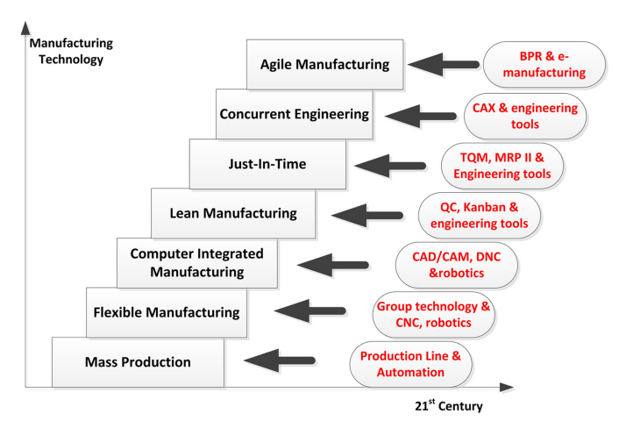

Figure 5:Phases of Factory Structuring Over the Last Five Decades

Appendix 4 – Lean 6σ Training and Advanced Simulation Learning
A computer simulated learning platform for manufacturing techniques could be something we see more of in the future, this is not to say that physical on the job learning is not necessary as deep understanding can only be learnt through experience however, serious game simulation could aid in the training of the next generation through a more evolved accessible computer simulation, where background lean principles are executed (Modrák, Semančo 2014).
Appendix 5 - Lean Production and the Environment
The link between environmentally friendly manufacturing and lean 6σ has been made abundantly clear, by incorporating these principles it has a reduction in pollutants, energy consumption and waste products (Modrák, Semančo 2014).

