Component 2 - Research Report
Student Name: Hafsa Begum
Student Number: 2016779
Lecturer Name: Olu Adegbite
LCHS4002_BIRM
Digital Skills and Research Methods.

Contents
1. Introduction 3
2. Research design 3
2.1. Research Question 3
2.2. Method 3
2.3. Ethical Considerations 3
3. Results 3
4. Discussion 3
5. Conclusion 3
6. Reference List 3
7. Appendix A – A blank copy questionnaire. 3

Introduction The purpose of this Research report is to carry out research to find out which Digital Skill is the most important to UWTSD students.
In this research report I will be covering the following:
- What are digital skills and why is it important to students?
- What is an example of digital skills?
Digital skills may include efficient literature searching, data management, communication and collaboration skills and being able to learn and reflect using digital skills.
Digital skills allow students to find and understand information by using MS Word, MS PowerPoint, MS Forms and MS Teams. It improves your online research skills and your ability to critically analyse source of information.
MS Teams allows you to connect with friends and lecturers. Microsoft teams allows UWTSD students and staff to share content or use other apps. Enables you to join a group or help you create your own team.
Most jobs nowadays expect you to have knowledge and understanding of technology, this why it is important for UWTSD students to understand digital skills.

The benefits of digital skills could enable people to benefit from things such as:
- Costing and saving time by shopping online.
- Stay connected with family and friends.
- Completing assignments.
- Screen recording during a video call.
- Communicating using via email.
- Safely using Microsoft teams.

Research design
In this Study a quantitative research design was a descriptive technique was utilised because the goal of the current study was to look at the digital tool that students used the most. In simple words, research design can be referred as key factor that is important for the successful completion of research project

Research Question
Firstly, I created a questionnaire on MS Forms for student at UWTSD to fill out. This questionnaire is about which Digital Skills do UWTSD students think is important.
Which Digital Skills do UWTSD students think is most important?

- I consent to take part in this research voluntarily.
(Tick ‘Yes or No’)
- Yes
- No

- Do you think being able to send emails is the most important?
(Tick ‘Yes or No’)
- Yes
- No

- Rank these applications in order of how important you think they are to you.
(Put these in order)
MS Teams
One Drive
MS Words
WhatsApp
Moodle

- Rank these words in order according to how you feel about your level of Digital Skills.
(Choose your response)
Sad
Happy
Worried
Angry
Confident

- I feel that using outlook emails is the most important Digital skills to have.
(Choose one response)
- Strongly agree.
- Agree.
- Disagree.
- Strongly disagree.

- I feel that using social media tool successfully is the most important Digital Skill to have.
(Choose one response)
- Strongly agree.
- Agree.
- Disagree.
- Strongly disagree.

Method
As a group, myself, and my teammates we create a questionnaire to gather information to find out Which digital skill do UWTSD students think is most important?
We used MS Forms to conduct our questionnaire.
We opened MS Forms on OneDrive then, selected the app icon and clicked on MS Forms. We opened a new Form to allow us to create a new survey. Click on untitled form and write a title and description for the form. Click on add new and it gave us a set of features to help us create our questionnaire. Select the type answer you want to get from users completing the survey. Options available, include:
(Huc. M) (2020)
- Choice – adds a multiple-choice question.
- Text – adds a question that requires a written answer.
- Rating – adds a question requesting a rating, and you can use stars or numbers for symbols.
- Date – adds a question requesting a specific date.
- Ranking – adds a question requesting to sort the answers by ranking.
- Likert – adds a question that holds 5 to 7 options with choices ranging from strongly agree to strongly disagree.
- Customize the question and answer as necessary.
- Repeat the steps for the next questions.
The setting option allowed us to select the option for the forms; accept response, email notification from each response, end date and start date.
Once we completed the questionnaire, we were able to copy and paste and then send the link to each other also the lecturer. We got our responses through face-to-face contact with students. We printed the research project and gave it out to student at UWTSD.

Ethical Considerations
It is still important to provide participants with the information they need to make an informed decision about whether to complete the questionnaire or not. Did not force the students to take part. I asked them for consent before taking part. Data gathered by students was ethically evaluated.
- Results
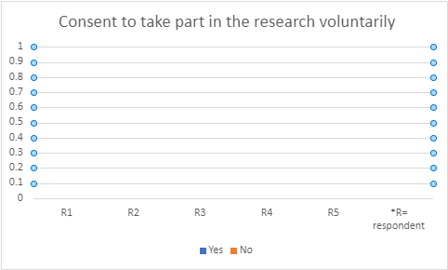

Figure 1. Shows consent to take part in the research voluntarily.
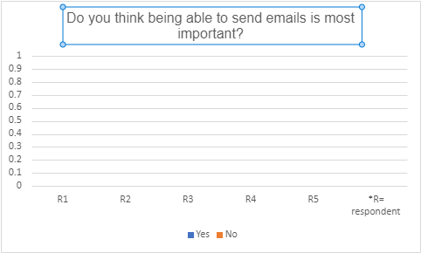

Figure 2. Do you think being able to send emails is most important?

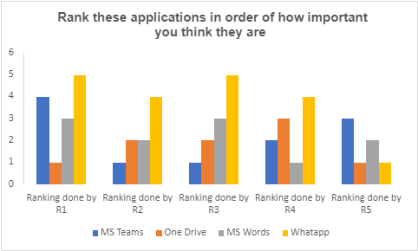

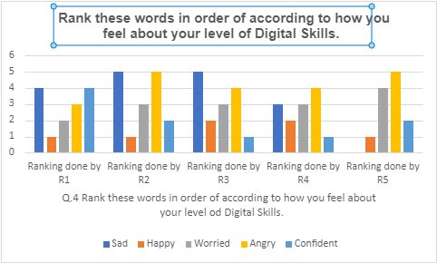
Figure 3. Rank these questions in order of how important you think they are?

Figure 4. Rank these words in order of according to how you feel about your level of Digital Skills.
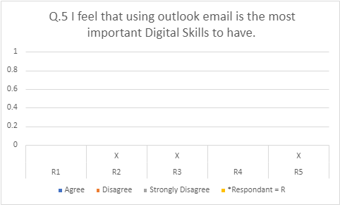
Figure 5. I feel that using email is the most important digital skills to have.
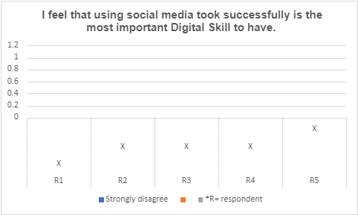

.
Figure 6. I feel that using social media tool is the most important digital skills to have.

Discussion

What does the results show?
Figure 1 shows the table is based on giving consent to UWTSD students, because it’s important to get participants permission before going ahead with the questionnaire. All students agreed to take part in this question ethical consideration are vital in a research study.
The respondents were male and female students that took part in this questionnaire. Ages were between 30-45 year olds.

- Conclusion

- Reference List
- (Huc. M) (2020) ‘How to create survey with Microsoft Forms’. https://pureinfotech.com/create-survey-microsoft-forms/ (Date accessed, March 28, 2023).

- Appendix A – A blank copy questionnaire.

