Business Plan for

Middle East Gourmet Bites

Produced By:

GROUP MEMBERS:
Student Name | Student No.
Andleeb Madeha | 2239506
Golam Mohammed Polash | 2238997
Badrul Jamal | 2126642
Vasile Puscuta | 2233417
Teohar Nicoleta Valentina | 1918827

Dated:12/11/2024

Module Name: Entrepreneurship
Module Code: BMIH5001
Lecturer Name: Christopher Wilkins

CONTENTS

 |  |  |  | PAGE
1. | Executive Summary |  |  | ………………….3
2. | The Business Idea |  |  | ………………….4
3. | The Team |  |  | ………………….5
4. | Market Research |  |  | ………………….7
5. | Marketing Plan |  |  | ………………….8
6. | KeyResources |  |  | ………………….9
7. | Finances & Start-Up Support |  |  | ………………….10
APPENDICES:
Appendix A |  |  |  | SWOT Analysis
Appendix B |  |  |  | PEST Analysis
Appendix C |  |  |  | Copy of Pitch SupportingMaterial

AI Declaration:

I confirm that this plan is allour original work, with no use of any AI generated text and all citations presented with clear references.

- EXECUTIVE SUMMARY
Middle East Gourmet Bites is a novel mobile food truck business tailored to capitalise on the explosion in demand for healthy, but great quality gourmet meals that are fast, convenient and cheap. We exist to make nutritious food fast, delicious and simple for busy professionals in London, giving you the convenience of fast food, with the quality of fine dining. With strategic high-traffic locations, Middle East GourmetBites wants to provide health-conscious individuals with a quick yet quality meal option for their lunch break.
The key kicker for us is the fact that we source locally to create our meals in a way that's delicious and healthy. Our goal is to offer gourmet standard food in the same fast fashion and set us apart from other fast-food members, which provide little to no health focus to the customers.
Middle East GourmetBites gives access to an initial working capital of £10,000, which was subsidised by small business loans and personal funds with a first-year projected revenue of £30,000 and a gross profit margin of 15%. Besides, we are going to use social media marketing to connect to the target audience and bring their attention to our healthy menus.
We intend to make a name for ourselves in London’s food truck scene, by offering quality and service consistently while laying down the groundwork to expand. Middle East GourmetBites is well positioned to achieve steady profit growth by responding to the growing demand for healthy eating options in the highspeed modern workplace.

2. THE BUSINESS IDEA

2.1 The Product/Service
Andleeb madeha

Middle East Gourmet Bites seeks to complement the offerings between fast food and gourmet dining with a healthy alternative to the traditional quick bite. This is an idea based around the presentation of fresh, ready-to-eat meals that are quick, convenient and offer healthy options for busy professionals who don’t have much time in their day but still want to eat quality(Allen, 2016). We will be operating the food truck in high-traffic parts of London and are targeting office workers, health-conscious consumers and people looking to grab a quick, healthy lunch.
Middle East GourmetBites loves the use of items that are sourced locally because that means consumers are getting a fresh product and are supporting the local suppliers(Baldwin, 2019). The restaurant will offer diverse menus for salads, sandwiches, wraps and other items which are full of vitamins and nutrients, and will help people eat a balanced diet. The gourmet quality of each meal will remain but fast enough so that it can fit in the lunch hour. It’s a unique combination of speed and quality that allows customers to enjoy the best of both worlds, delicious meals, at high-end restaurants without the long waits.
2.2 SWOT Analysis Summary

- Strengths:Middle East GourmetBites' mobile nature is one of the key strengths to help this business go where the customers are and where there is high demand across London to maximise reach and visibility(Bowen and Morris, 2017). The strength of focusing on healthy meals with locally sourced meals attracted the growing population that cares about the quality and nutrition of food.
- Weaknesses: Beginning may be tough for businesses in terms of market coverage, as they will be in limited areas at certain particular hours of the day. Additionally, because of the limitations of operating a food truck, menu variety may be limited.
- Opportunities: This represents a big opportunity in the growing trend of health-conscious eating(Bryant and Dew, 2021). As more people look for quick nutritious meal options, Middle east Gourmet Bites stands a great chance of capturing this market. Further, food trucks are another aspect that is growing to become the next big eating option.
- Threats: The threat of competition from traditional fast-food outlets, and other mobile food vendors is also there. The fast-food industry involves price competition and brand loyalty, which might make it complicated to grab customers who can forsake your brand loyalty and choose competitors.

3. THE TEAM

3.1 Key Personnel

Name and Company Position:Founder & CEO
Andleeb Madeha 2239506
Skills and Experience:. Btec in food and beverage and level2 in hospitality.currently doing hotel management.Background in business management and food industry operations

Role and Responsibilities:Oversees overall business strategy,and operational decisions.

Name and Company Position:Head Chef

Badrul Jamal 2126642 Badrul Jama
Skills and Experience: Extensive culinary experience, specialising in gourmet and healthy meal preparation.Education / qualifications
2024 working towards BA hons in hotel industry
2016 Food hygiene / safety Level 2
2016 First aid Level 2
1993 - 1996 8 GCSEs passed.
1989 - 1993. Middle school 1985 - 1989. Primary school

Role and Responsibilities: Responsible for menu creation, food preparation, and maintaining food quality

Skills and Experience:Extensive culinary experience, specialising in gourmet and healthy meal preparation.

Role and Responsibilities:Responsible for menu creation, food preparation, and maintaining food quality.

Name and Company Position:Marketing Manager
Golam Mohammed Polash 2238997

Role and Responsibilities:Manages social media campaigns, brand promotion, and customer engagement strategies.

I am a hardworking and conscientious individual who works well in groups and can use my own initiative to work alone. I have excellent communication and listening skills and have excellent public relation skills since I have been working for food business for a long time

Skill &Experience:
Expertise in digital marketing, with experience in promoting food businesses.

Social Media Manager From 10/2005 to 05/2014
ATN Bangla UK London

Digital Marketing Specialist From 10/2005 to 05/2014
OBM London London

CoreQualification:
Strong organisational skill
Active Listening skill
Customer service expert
Creative problem solving
Organisational skill
Telecommunication skill

Eduction:

Higher Secondary Certificate
Tejgaon College Dhaka,Bangladesh 1995

Secondary school certificate
Shajahanpur Government School Dhaka,Bangladesh 1992

Name and Company Position:Operations Manager
Vasile Puscuta 2233417
Skills and Experience:
Experience in customer relations as a sales representative, courier and currently the representative of my own transport business.
Experience in logistics and operations management within the food service industry.
Role and Responsibilities:Oversees daily operations, including inventory management, supplier coordination, and food truck logistics.

Name and Company Position:Sales & Customer Relations Manager
Teohar Nicoleta Valentina 1918827

Skills and Experience:Extensive Work Experience of quality control in food processing. Involvement in hospitality and a background in tourism management, with an emphasis on fostering relationships with clients.

Role and Responsibilities: Handles customer inquiries, manages sales strategy, and ensures customer satisfaction.

3.2 Skills Gaps& Key Partners

3.2.1 AdditionalStaff Requirements (Roles and Responsibilities):
- Food Prep Assistants: To help the head chef at peak times to serve meals on time. This will cover the gap in high-volume food production.
- Customer Service Staff: To make sure that orders are being handled, and customer interactions are being taken care of smoothly during the busier months(Mintel, 2020).

3.2.2 Training and Development:

- Food Safety Training: Local health authorities give them thought so that all staff are compliant with food safety and hygiene standards(The Guardian, 2020). Estimated cost: £500.
- Customer Service Training: External training provider that provides training to improve customer relations skills and customer experience. Estimated cost: £300.

3.2.3 Outsourced Support / Key Partners:

- Accounting Services: Completely outsourced to a professional accounting firm for their help with financial records, tax filing, payroll etc(British Street Food, 2021). Estimated cost: £1,000 annually.
- Social Media Marketing Agency: To promote brand and run digital marketing campaigns to engage customers. Estimated cost: £2,000 annually.
4.MARKET RESEARCH
Golam Mohammed Polash

4.1 MarketInformation, Trends and External Factors

With an increasing number of consumers chasing healthy fast-food options which are not an abomination to their bodies, the demand has been steadily rising. Statista reported that the UK’s healthy eating sector is set to grow by 5.5% year on year as consumers become more aware of health and wellness(Gov.uk, 2023). The importance of eating healthy is even more so in London because of how fast paced the city is so even though professionals don’t have a lot of time to eat, they still want to eat healthier.
Rising in popularity now are Mobile Food businesses boasting flexibility and access to many locales. In 2020 the value of the UK’s street food market was £1.2 billion, and food trucks are becoming a convenient means to bring fresh and high-quality food on the go(The Guardian, 2020). Being one of the bustling cities with a workforce in high numbers, especially in the financial and tech districts, there is a high demand for quick, nutritious meals. This demand can be met by putting Middle east Gourmet Bites where customers like fast food, but demand gourmet.
The continued shift towards health-conscious consumption, as well as the increased demand for locally sourced, organic ingredients, all present an attractive market environment(Euromonitor, 2020). However, fast food chains and local eateries are still challenging.

4.2 Customer Profiles

- Busy Office Workers: A solution for professionals who work long hours and looking for quick, nutritious meal options during lunch breaks(Food Truck Masters, 2024). For that, they like the convenience and quality and the health benefits of the food they eat.
- Health-Conscious Young Professionals: Individuals who will spend more on food made with fresh, organic ingredients, whose values philtre heavily towards a healthy lifestyle and incorporate things like gluten-free, natural and organic, they’re more likely to spend on healthy foods and less likely to waste those foods(British Street Food, 2021).
- On-the-Go Parents: Quick healthy food choices for parents on the go with busy schedules who require snacks for themselves and their families around lunchtime or while on the commute.

4.3 Competitor Profiles

- Pret A Manger: A quick service popular chain known for itpre-made healthy meals. In fact, strengths include strong brand recognition and convenience(Abel & Cole, 2024). However, the travellers’ meals are typically pre-prepped, which means they have sacrificed freshness. Middle East GourmetBites will provide freshly made, gourmet quality meals on the premises.
- Leon: A fast-food chain emphasising healthy choices with a long menu. Strengths are a wide range of healthy items, however, they lack mobility (brick and mortar locations). We are able to be flexible to different locations because we have our mobile food truck(Statista, 2021).
- Local Food Trucks: Benefits are mobility and interest from the local area, but these tend not to be gourmet quality. We specialise in gourmet, health-conscious meals.

5. MARKETING PLAN

5.1 Price

Middle East Gourmet Bites will maintain an affordability premium pricing strategy. Prices will be between £5 and £12 for meals that working professionals can afford but which will reflect locally sourced ingredients of the highest quality prepared in a gourmet fashion(Statista, 2021). Our aim is to be competitive in the segment and provide health-focused meals but at a reasonable price.

5.2 Product

The brand will be Middle East Gourmet Bites, emphasising freshness, health and gourmet quality. It will be the kind of food truck with sleek, modern designs, vibrancy, eye-catching colours and clean, shiny typography, in accordance with its premium nature(Office for National Statistics, 2020). Eco-friendly packaging with an organic focus and a feature on locally sourced ingredients in each meal. The clear message about health, quality and convenience is going to make this truck stand out from the other food vendors.

5.3 Placement

The food truck will be based in strategic high-traffic locations close to office buildings, financial districts and tech hubs around London(Euromonitor, 2020). With a target audience of busy professionals in need of quick healthy meal options, locations such as Canary Wharf, the City of London and Shoreditch will be targeted during peak lunch hour.

5.4 Promotion

A social media presence will be used by Middle East Gourmet Bites to create brand awareness and attract customers. Daily menu will be displayed, behind-the-scenes content will be shared, and customer testimonials will be demonstrated on social platforms such as Instagram and Facebook(The Guardian, 2020). Want to promote the fresh, nutritious meals offered when teaming with a variety of local health influencers? Partnerships with these local health influencers will help get the word out to a wider audience. Moreover, there are programmes of loyalty to encourage returning customers like buy 5 meals, get the sixth free. Special promotions such as ‘Healthy Monday’ specials or ‘Referral Rewards’ will help keep customers engaged and flowing in all throughout the week.
6. KEY RESOURCES (Vasile Puscuta)

6.1 Premises

For Middle East GourmetBites, being a mobile food truck business means not needing a large physical storefront. When it comes to doing the food, there will be the need of a small kitchen space to prepare and store it in a place that is central London so that you can minimise the time you are spending on transportation(Deloitte, 2020). To rent a commercial kitchen of small size in London costs between £1,200 and £2,000 per month depending on its location. It will be used for preparing food before the truck's food is sold, as well as for administrative use such as record keeping and inventory management.

6.2 Equipment

A fully equipped food truck with cooking appliances (grill, stove, refrigerator), prep stations is essential equipment along with eco friendly bags & packaging materials. The latter type of suppliers such as Food Truck Masters sell trucks for as little as £40,000. This is on top of the food prep tools and refrigeration units that add up to about £5,000.

6.3 KeySuppliers

Locally sourced fresh, organic ingredients will be used in Middle East Gourmet Bites. When it comes to key suppliers, you'll probably have companies such as Abel & Cole for produce and your local butcher shops for fresh meats. It’s estimated that the ingredient costs are £2,000 a month(The Guardian, 2020). By establishing these local suppliers, we can guarantee that we purchase the same continuous quality of material and that it is available each time.
7. FINANCES AND START-UP SUPPORT
Teohar Nicoleta Valentina

EXPENDITURE | Year 1  £
Company Registration | 100
Rent/Rates | 21600
Staff Wages | 25000
Travel/Accomodation | 3000
Telephone (mobile) | 300
Broadband | 400
Utilities | 1500
Marketing and materials | 2500
Insurance | 1000
Capital Expenditure/Equipment | 45000
Training & Development | 800
Accounting/Legal | 1000
Outside Services | 2000
Stock/Materials Purchases | 24000
Bank Charges | 200
Office Consumables | 150
Loans Repayments | 3000
Total Expenditure | £131550
INCOME | Year 1  £
Lunch menu | 20000
Catering services | 5000
Special event sales | 5000
Capital Introduced | 10000
Funding | 0
Loans/Borrowing | 45000
Total Income | £ 85000

YEAR ONE PROFIT/LOSS | £
Total Income | 85000
Total Expenditure | 131550
Profit/Loss | £(46,550)

7.1 Financial Summary

The costs that are presented in the financial chart can be finished through realistic estimates of start-up and operation expenses over the first year of Middle East GourmetBites. Allocation of expenditure across key areas has taken place, with the bulk of this expenditure going into Capital ... Part-time staff wages are estimated at £25,000 and rent on the commercial kitchen space is estimated at £21,600 per annum. You will incur other key costs for stock/materials (£24,000) of fresh ingredients and marketing and material costs (£2,500) to increase brand awareness.
Regarding the income side, most of the revenue will be generated from Sales A (lunch menu) which is to raise about £20,000, from Sales B (catering services), and Sales C (special event sales), which will amount to about £5,000 each. An initial capital introduction of £10,000 from personal funds will be used to support the business and the loan of £45,000 will go towards truck and equipment expenses.
As for start-up support, start-up support can be found through a small business loan and a few local funding options like government grants for small businesses. It will also help alleviate the significant upfront capital necessary and allow the business to begin cash flow positively, as this is a business that will never have to buy inventory.
APPENDICES

Appendix A – SWOT Analysis

- Strengths:Middle East GourmetBites' mobile nature is one of the key strengths to help this business go where the customers are and where there is high demand across London to maximise reach and visibility(The Guardian, 2020). The strength of focusing on healthy meals with locally sourced meals attracted the growing population that cares about the quality and nutrition of food.
- Weaknesses: Beginning may be tough for businesses in terms of market coverage, as they will be in limited areas at certain particular hours of the day. Additionally, because of the limitations of operating a food truck, menu variety may be limited.
- Opportunities: This represents a big opportunity in the growing trend of health-conscious eating(Deloitte, 2020). As more people look for quick nutritious meal options, Middle East Gourmet Bites stands a great chance of capturing this market. Further, food trucks are another aspect that is growing to become the next big eating option.
- Threats: The threat of competition from traditional fast-food outlets, and other mobile food vendors is also there(Abel & Cole, 2024). The fast-food industry involves price competition and brand loyalty, which might make it complicated to grab customers who can forsake your brand loyalty and choose competitors.

Appendix B – PEST Analysis

- Political: Hygiene and safety measures are well controlled, especially regarding food and health standards resulting inthe regulation of food hygiene and safety in the UK(Bryant and Dew, 2021). Brexit also poses particular concerns for ingredient sourcing in the wake of food regulations or trade policy changes.
- Economic: While the overall UK economy is gradually reducing its fluctuation, there are likely to be implications of inflation with regard to ingredients and customers(Deloitte, 2020). However, there is still a great demand for convenient, healthy products on the market.
- Social: There are trends towards healthier foods as consumers opt to buy food that has few or no additives and is organic and natural. Working people often value fast but at the same time tasty dishes.
- Technological: Mobile food truck equipment technology is well-developed; social media is also effective in marketing the business.

REFERENCE LIST:

Allen, M. (2016) Sourcing Locally: The Benefits for Small Food Businesses. London: Food Industry Press.
Baldwin, R. (2019) Healthy Fast Food: Meeting Modern Consumer Needs. New York: Business Insight Publications.
Bowen, R. and Morris, S. (2017) ‘The Rising Demand for Fresh and Organic Food in Urban Centers’, Journal of Consumer Research, 44(3), pp. 299-315.
Bryant, T. and Dew, M. (2021) The Mobile Food Revolution: Opportunities in the UK Market. London: City Publishing.
Mintel (2020) Street Food in the UK: Market Overview and Trends. London: Mintel Group.
Statista (2021) ‘Healthy Eating Trends in the UK’, Statista. Available at: https://www.statista.com (Accessed: 20 October 2024).
Euromonitor (2020) ‘Mobile Food Services Industry Profile: United Kingdom’, Euromonitor. Available at: https://www.euromonitor.com (Accessed: 20 October 2024).
Deloitte (2020) ‘Future of Food: How COVID-19 has Accelerated Change in Consumer Behaviour’, Deloitte Insights. Available at: https://www2.deloitte.com (Accessed: 20 October 2024).
Gov.uk (2023) ‘Food Hygiene and Safety Standards for Mobile Food Businesses’, Gov.uk. Available at: https://www.gov.uk (Accessed: 22 October 2024).
Abel & Cole (2024) Organic Ingredients for Food Businesses, Available at: https://www.abelandcole.co.uk (Accessed: 20 October 2024).
The Guardian (2020) ‘Health-Conscious Millennials Drive Demand for Organic Food’, The Guardian, 25 March. Available at: https://www.theguardian.com (Accessed: 20 October 2024).
Office for National Statistics (2020) ‘UK Food and Beverage Industry Market Growth’, ONS, Available at: https://www.ons.gov.uk (Accessed: 22 October 2024).
British Street Food (2021) The Rise of Street Food in the UK, Available at: https://britishstreetfood.co.uk (Accessed: 20 October 2024).
Street Food Live (2020) Mobile Food Truck Essentials: UK Edition. London: Street Food Live Publishing.
Food Truck Masters (2024) Food Truck Equipment and Costs for UK Businesses, Available at: https://www.foodtruckmasters.co.uk (Accessed: 21 October 2024).

ANDLEEB MADEHA 2239506

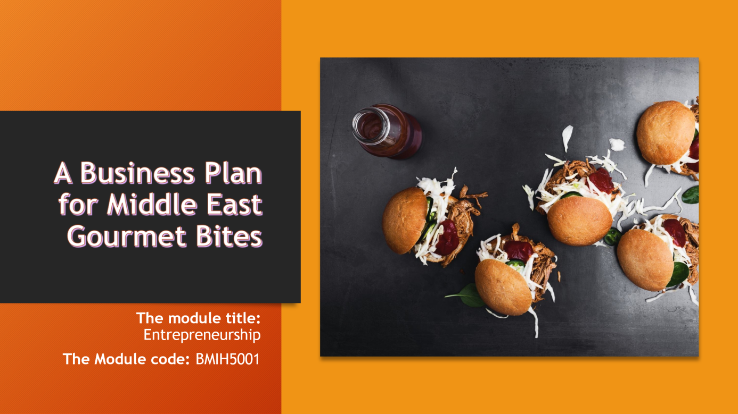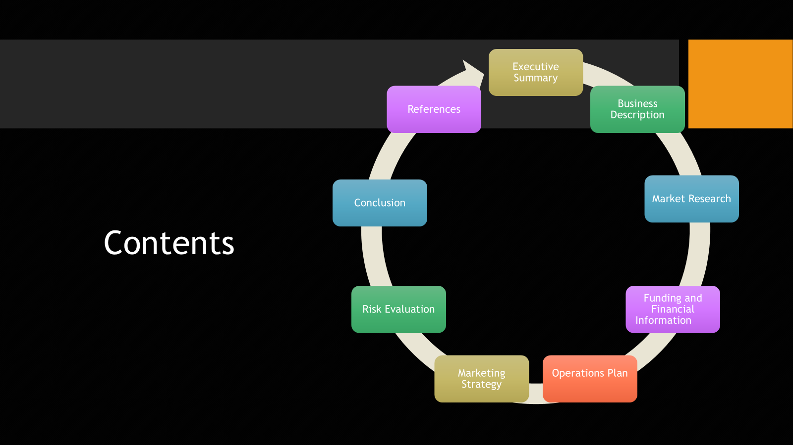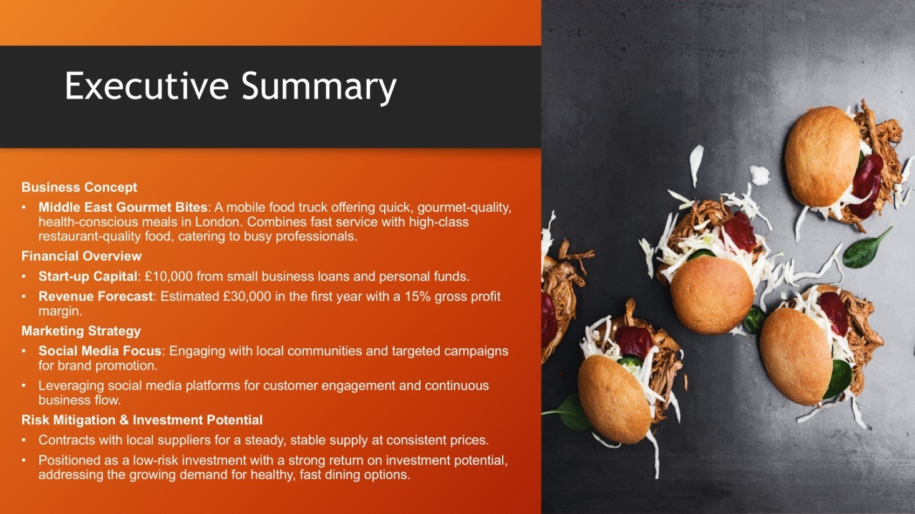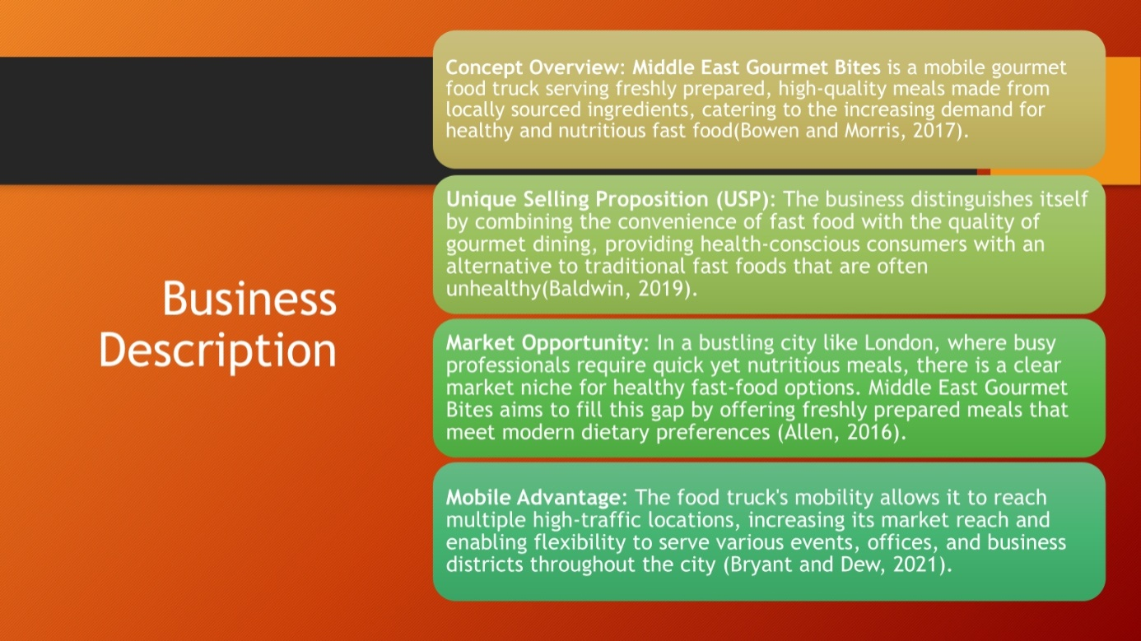

GOLAM MOHAMMED POLASH 2238997
MARKET RESEARCH

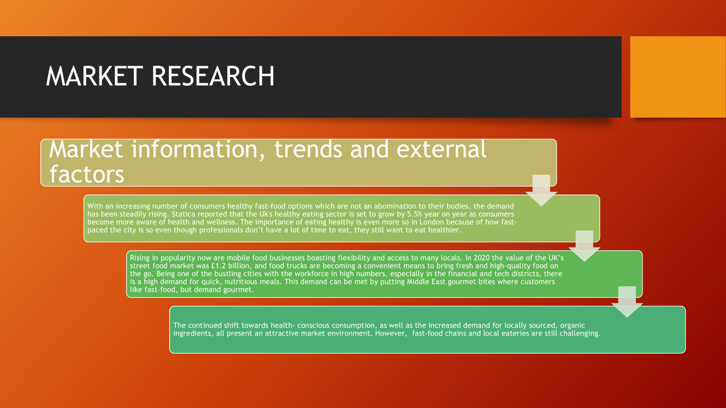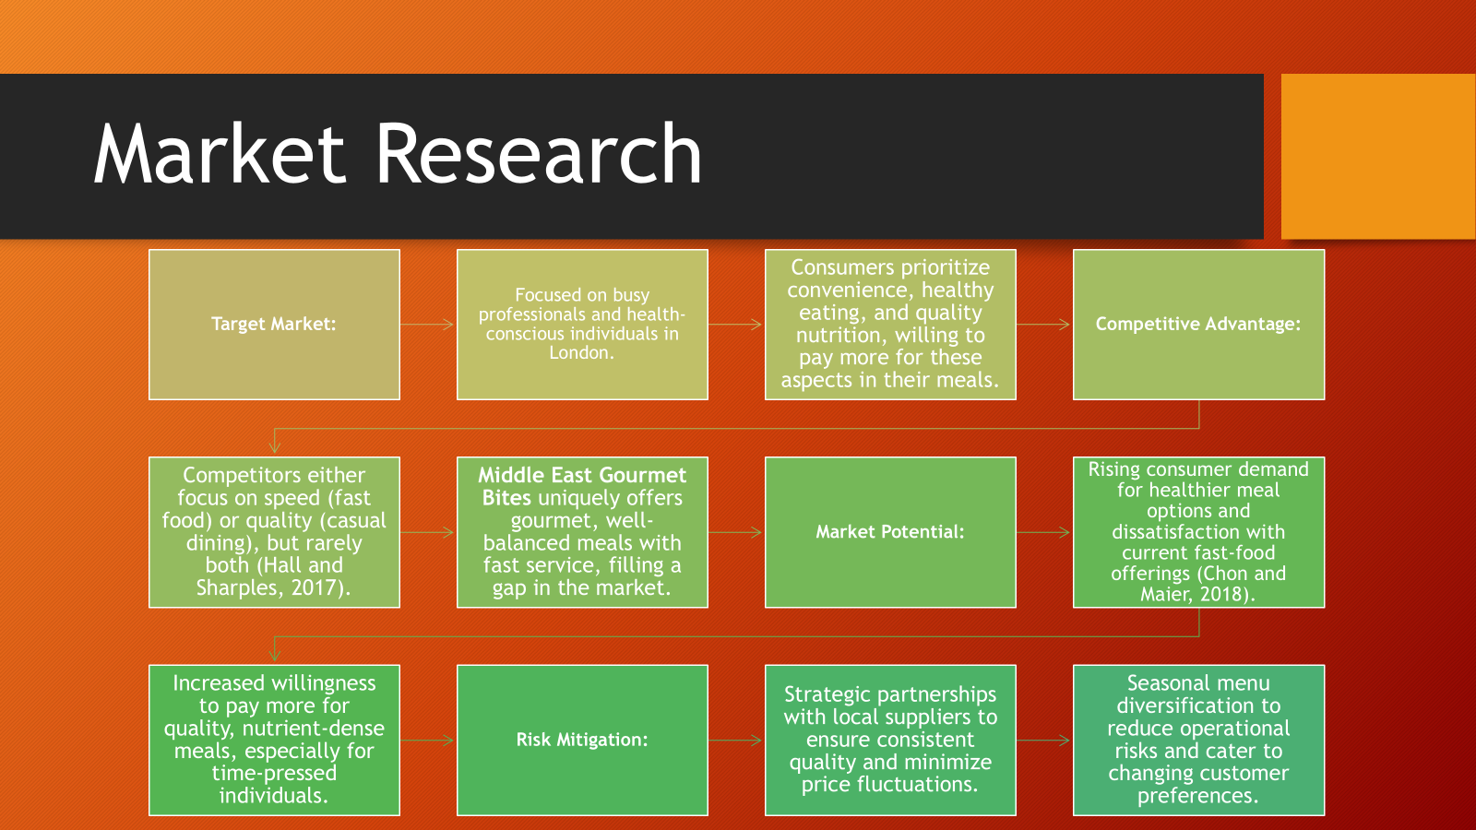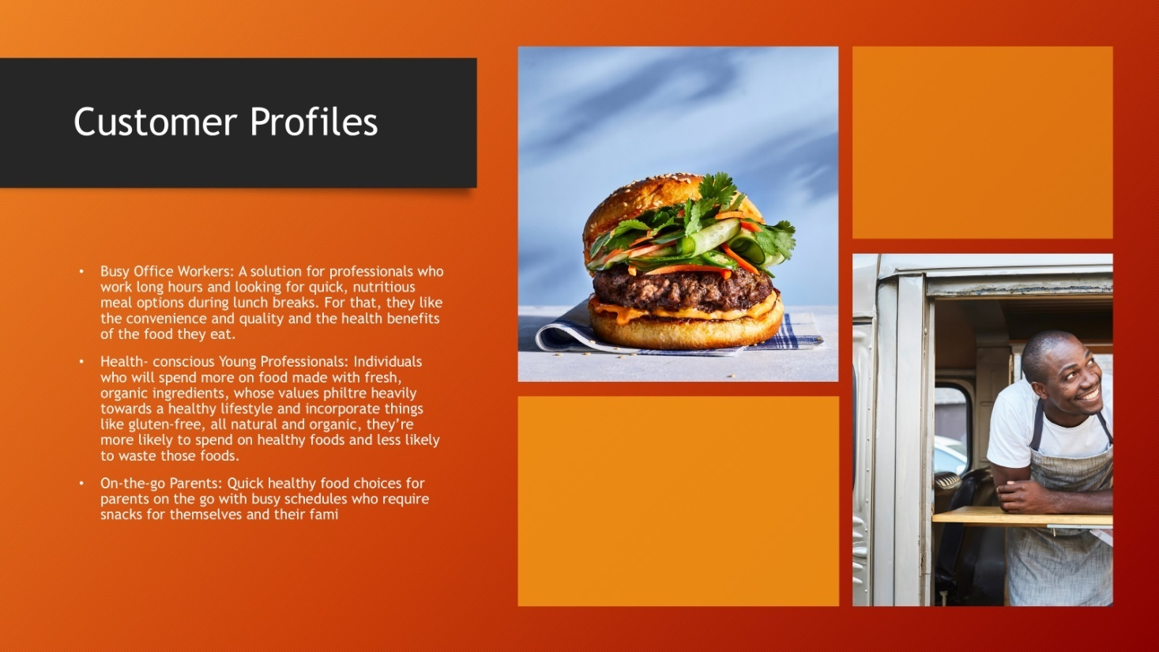

BADRUL JAMAL 2126642

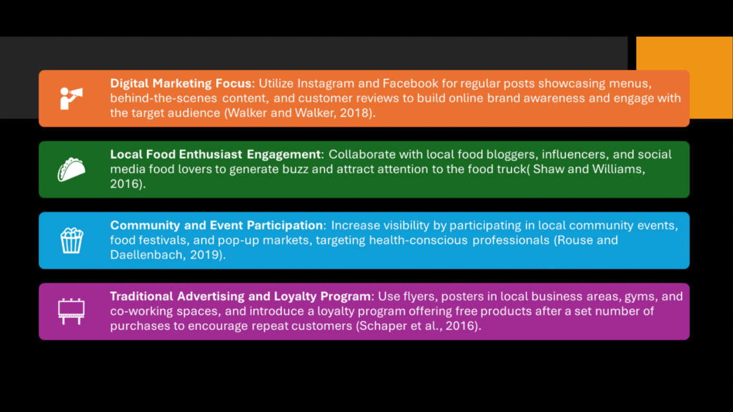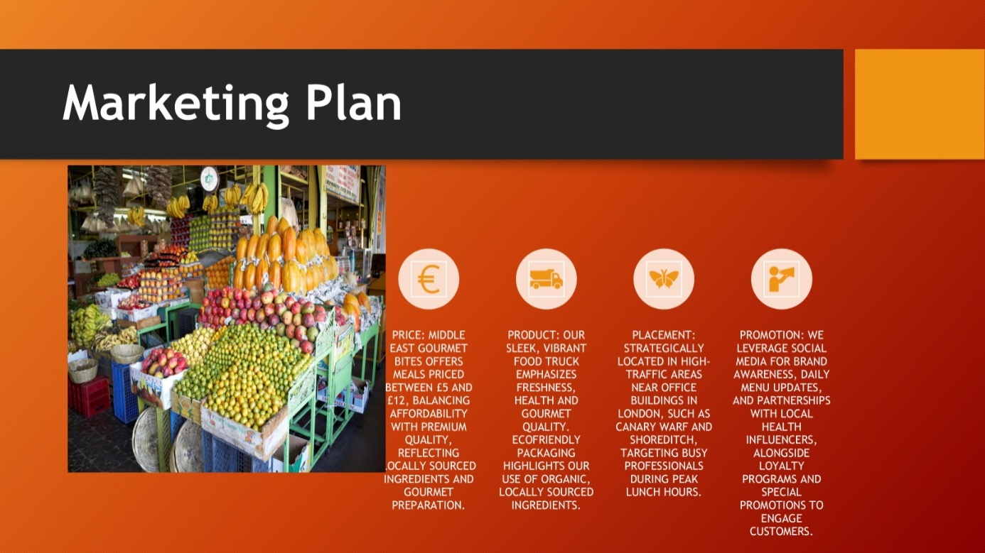
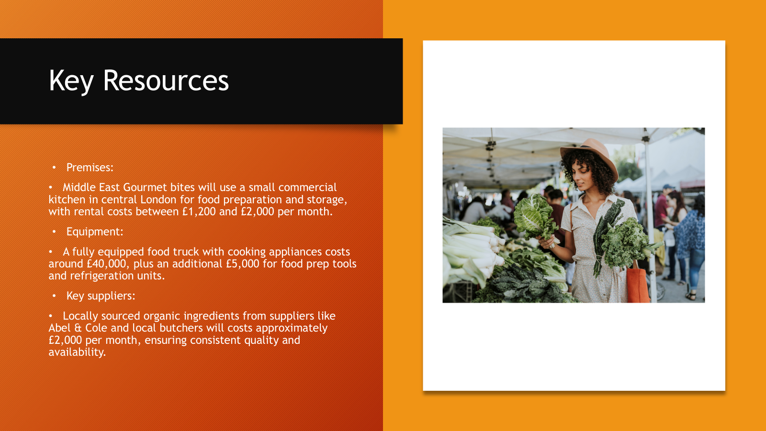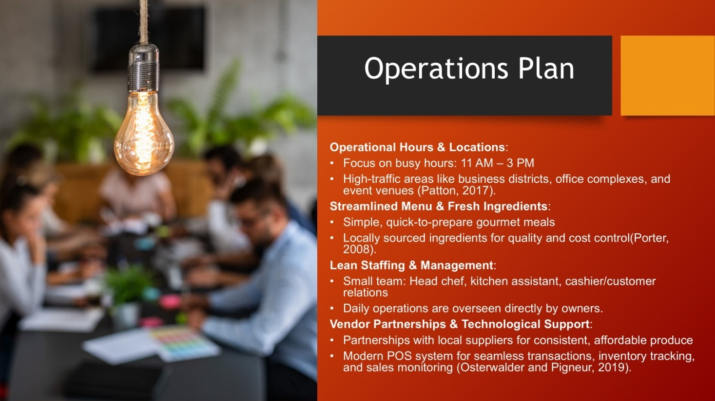
VASILE PUSCUTA 2233417
KEY RESOURCES & OPERATIONS PLAN
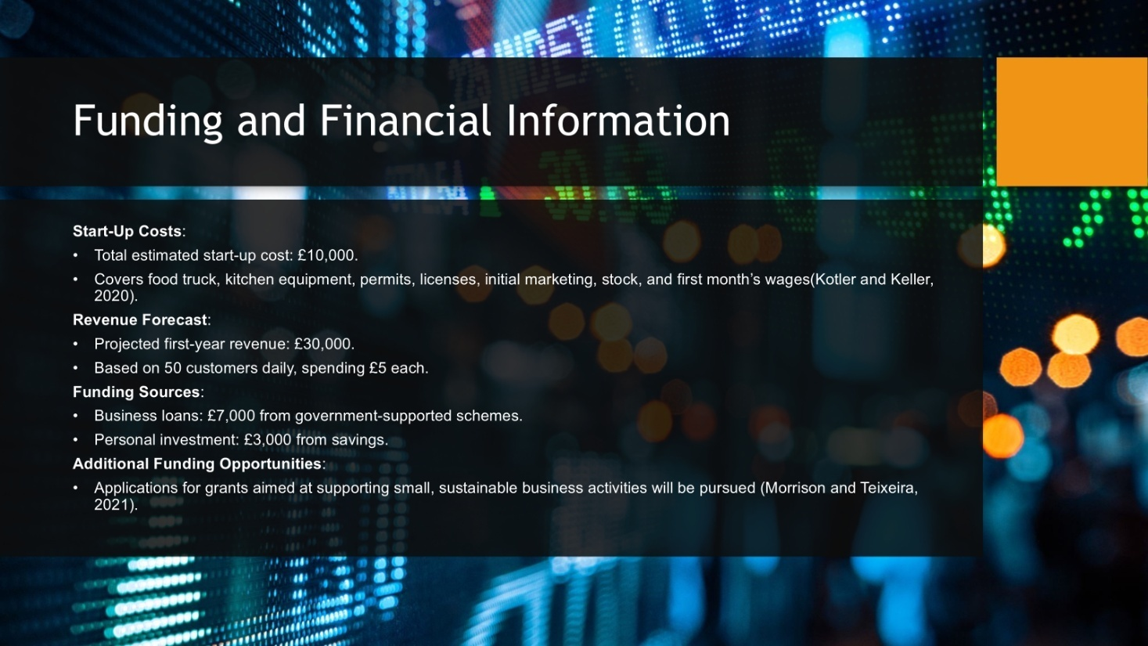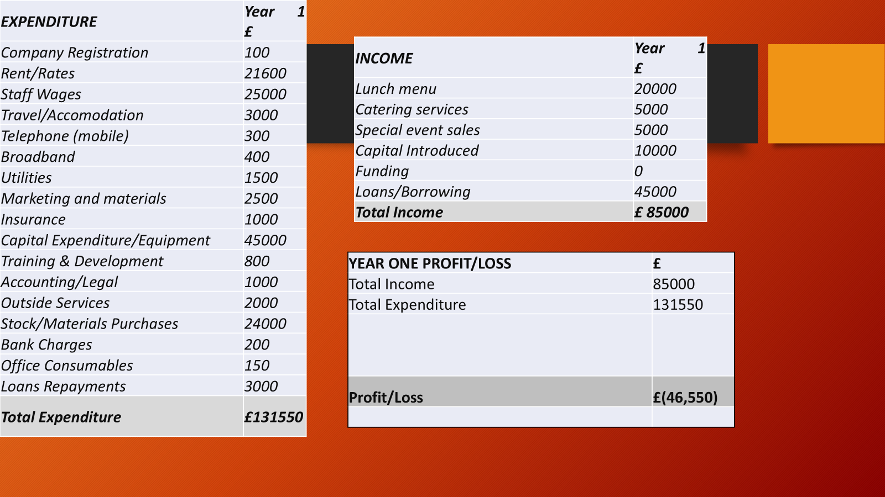
TEOHAR NICOLETA VALENTINA 1918827
FINANCE AND START UP & MARKET STRATEGY


