

LCLM4004
Component 2 - Individual Report
Reviving Basil’s Bakery: A Digital Pre-Order and Delivery Strategy for Sustainable Sales Recovery

Student Name: RAHELA IASMINA ILIE
Student ID: 2520533

Word Count: 1600

Table of Contents
Introduction 3
1. Case Study and Problem Analysis 3
2. Possible Solutions 4
Solution 1: A digital pre-order system with local delivery options. 4
Solution 2: Corporate lunch partnerships 4
3a) PMI Evaluation of Proposed Solutions 4
3b) Preferred Solution 5
4a) Implementation Plan 5
4b) Justification of Implementation Plan 6
5 a) KPI and SMART Objectives 6
5b) Monitoring and Evaluation 7
6) Key Findings 7
Conclusion 8
References 9
Appendix 10
Appendix A 10
Appendix B 11

Introduction
This report identifies the causes of the reduction in sales for Basil's Bakery and suggests a solution to improve customer access and decrease queue times to help sales recover. About the assessment requirements, the report will provide a problem analysis, two possible solutions, the PMI technique, an action plan, and a KPI evaluation.

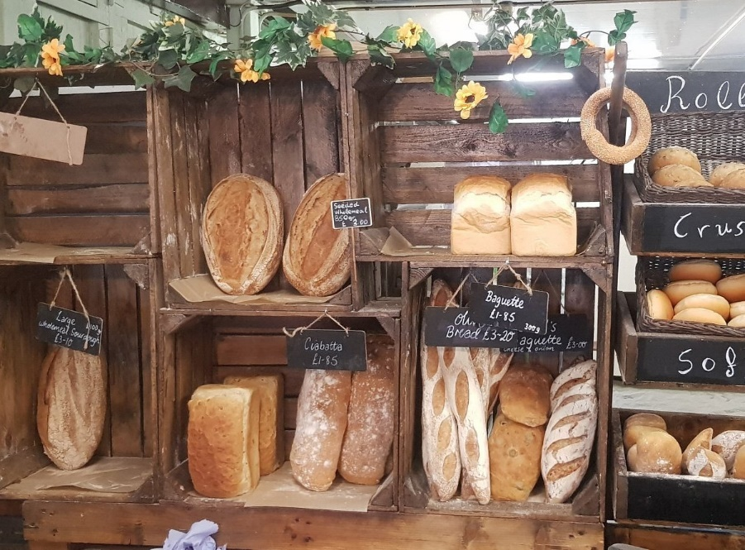
Figure 1: Basil’s Bakery
Source: (Tripadvisor, 2026)

1. Case Study and Problem Analysis
Basil's Bakery is an artisan Bakery located in a Coventry retail park. Since its opening in 2015, sales have increased, but sales from 2023 to 2025 remained 25% lower than in 2019. The primary issue is not the reduced quality of products but the decreased accessibility for customers. Fewer people are visiting the retail park, some workers from nearby retail stores have lost their jobs, and some office workers have a hybrid work schedule, resulting in fewer workers buying lunch daily. This is in line with the trends of the UK as a whole; according to reports from BRC-Sensormatic, total UK foot traffic in 2025 was 0.8% lower than in 2024, and the ONS reports that in the first three months of 2025, 28% of the working population of Great Britain worked in a hybrid manner (BRC, 2026; ONS, 2025).

2. Possible Solutions

Solution 1: A digital pre-order system with local delivery options.
Basil can launch an online cake and pastry ordering system via WhatsApp Business, a Google Business Profile, or easily integrated website forms. He can also consider affordable food ordering system applications. Customers can pre-order items for collection or delivery within a small local radius. The solution captures the need for delivery and pre-ordering. The collection system alleviates the issue of customers lining up during busy times because they can show up at the designated time. The system captures the opportunity presented by the shift in consumer behaviour for small food services. The system provides a means for small food services to access customers beyond the brick-and-mortar establishment. (Abidin et al., 2024).

Solution 2: Corporate lunch partnerships
Basil can target local businesses and offer lunch boxes, meeting platters, and weekly bakery bundles. This solution builds on the good work Basil has done with local businesses and creates a routine, repeat order opportunity. Unfortunately, this solution still does not address the issue of post-covid, flexible work arrangements and the new, inconsistent office work routine. The ONS (2025) data show that flexible working is here to stay, and Basil cannot depend on lunchtime work demand returning to pre-2020 levels.

3a) PMI Evaluation of Proposed Solutions
The PMI technique evaluates the positive and negative aspects and the interesting components of proposed solutions. Considering Basil’s Bakery’s challenges with decreasing footfall and sales, along with changing customer behaviour, this technique will evaluate the practicality of each proposed solution. The PMI technique is helpful because it focuses on possible risks of the proposed solutions, along with potential future opportunities. This technique is helpful because it is not solution-centric. It is very easy to focus on the benefits of a proposed solution, but using this method will also evaluate the potential risks of the proposed solution.

3b) Preferred Solution
The preferred option is the digital pre-order and local delivery system. Compared to the option of corporate partnerships, the preferred option is more successful as it caters to individual customers, former loyal customers, hybrid workers, and the local community in which Basil is situated. More importantly, it allows Basil to manage his business offering by letting customers place orders in advance. While corporate lunchtime partnerships ought to be rejected, they are a feasible option for the near future after Basil creates an operational online menu with an ordering system. This option is also more financially viable, as it is feasible with no large financial commitments or the need for Basil to rent another unit. Basil is also able to introduce the option of pre-order collection only for as long as he desires, and have limited local delivery during certain timeframes. This serves as an opportunity to test if digital options will recover at least a portion of the 25% sales that have been lost.

4a) Implementation Plan
The execution of this plan will stretch over a period of twelve weeks. In week one, 15-20 products will be added to the online menu by Basil, who will select those products based on sales data. In the second week, WhatsApp Business will be set up by Basil, along with a Google order link and a rudimentary online form. Week three will have a test run for click and collect during lunch to minimise lines. Basil will set up part-time delivery support for week four, and delivery will happen in a 2-3 mile radius in weeks five and six. During weeks seven and eight, delivery would be promoted with flyers, posts on social media, loyalty cards, and Facebook groups. The last four weeks (weeks 9-12) will evaluate how many orders were made, how long people waited, how many people were repeat customers, and the overall profit.

4b) Justification of Implementation Plan
Basil must make product selection a priority to minimise challenges in the preparation, packaging, and delivery of products. In addition, just-in-time ordering will be integrated before delivery is offered. This is because implementing a click and collect system is less costly and a simpler option to validate. Delivery will not be offered for the first five weeks in order to understand and validate the true customer demand and avoid Basil overextending. Promotions will then be initiated as the system will be validated to avoid creating a negative first customer experience through system failure. The measured implementation plan protects the time Basil has available. The way the system has been designed to work should minimise interruptions based on phone orders. A digital order form will enable customers to place orders with Basil in a more time-efficient manner, so he will not be interrupted. This improves the system based on the challenges outlined in the case where Basil struggles to answer calls during busy periods.

5 a) KPI and SMART Objectives
Key Performance Indicator:
Weekly digital order sales as a percentage of total sales for that week should be the main KPI. This KPI is justified since Basil’s main problem is a decrease in sales due to less foot traffic to the physical store.
SMART Objectives:
Specific: To enhance customer access and lessen reliance on walk-in customers, Basil's Bakery will implement a system for digital pre-orders and click-and-collect options.
Measurable: Elevating weekly sales by 10% and obtaining 20% of weekly sales through online orders will be the new sales targets for Basil's Bakery.
Achievable: Using tools like WhatsApp Business, online forms, and social media will make this goal attainable for Basil.
Relevant: This goal focuses on the bakery's key issues of decreased walk-in customers, lengthy waiting times, and decreased sales.
Time-bound: This goal will be set for six months after the digital pre-order and click-and-collect system is implemented at Basil's Bakery.

5b) Monitoring and Evaluation
Basil needs to look at the KPI data weekly with a simple spreadsheet. Each order needs to include the date and product, order type and value, the status of the order (collection or delivery), customer name, and whether the order was a repeat purchase. Performance measurement helps small businesses decide if a new strategy is bringing in new results and helps in the decision-making process (Ocloo et al., 2024). This will help Basil look at walk-in sales versus online sales and help show if the system is really bringing in new sales or just moving customers from one system to another. To see how long customers have to wait in a line during peak times, see if customers who pre-ordered can pick up their orders after the planned time. If customers are constantly waiting too long, then Basil might need to downsize the menu, pull out the most popular items and get them ready ahead of time, or have one of the staff members only pack and hand off orders. Customer feedback is helpful for looking at and improving the quality of a digital food ordering system (Abidin et al., 2024). Basil also needs to collect customer feedback with short WhatsApp messages or with a survey QR code. Basil must analyse whether total weekly sales have increased by 10% after 12 weeks. If sales increase and margins decrease, minimum order values, food delivery fees, and service fees will be adjusted. Small food businesses need to increase sales and margins due to rising operational costs (FSB, 2026).

6) Key Findings
- Low product quality is not a main concern for Basil. Instead, limited access is the main concern for consumers.
- Consumer access is limited due to reduced foot traffic in the retail park and due to the hybrid work model.
- Increasing utility costs and food prices are causing additional strain.
- Digital solutions that offer a pre-order system provide a solution to the loss of foot traffic by eliminating wait times.
- A local delivery system offers Basil a solution to reach their former customers.
- Corporate lunch delivery service should be pursued, but only in the later phases.
- The best measure for success would be weekly digital sales.

Conclusion
Basil's Bakery should pursue a digital pre-order and local delivery system. It offers a solution to the effects of hybrid work on customers and the associated loss of foot traffic. The delivery system should begin with click and collect, and only deliver after, in order to limit costs and provide a system to gradually adjust to the market. This should be pursued in order to restore profits without jeopardizing artisan style of Basil.

References
Abidin, I.H.Z., Zainal Abidin, A., Abdullah, N. and Anuar, F.I. (2024) ‘Adoption of online food delivery by micro food service businesses: A conceptual paper’, Journal of Tourism, Hospitality & Culinary Arts, 16(1), pp. 139–153. Available at: https://fhtm.uitm.edu.my/images/jthca/Vol16Issue1/Chap_9.pdf
BRC (2026) Footfall falters as shoppers hold out for sales. British Retail Consortium. Available at: https://brc.org.uk/news-and-events/news/corporate-affairs/2026/ungated/footfall-falters-as-shoppers-hold-out-for-sales/
Federation of Small Businesses (FSB) (2026) SMEs brace for April energy cost cliff edge. Available at: https://www.fsb.org.uk/resources/article/navigating-the-energy-cost-cliff-edge-MCQLRZJCUOFJBJRMYMLL5YHLSJF4
House of Commons Library (2026) The impact of food inflation on the cost of living. Available at: https://commonslibrary.parliament.uk/research-briefings/cdp-2026-0004/
Ocloo, E.C., Coffie, I.S., Bukari, Z. and Bashiru, S. (2024) ‘Digitization of small and medium-size restaurant enterprises: The mediating role of owner/manager IT skill and moderating influence of COVID-19’, Cogent Business & Management, 11(1), 2358549. Available at: https://doi.org/10.1080/23311975.2024.2358549
Office for National Statistics (ONS) (2025) Who has access to hybrid work in Great Britain? Available at: https://www.ons.gov.uk/employmentandlabourmarket/peopleinwork/employmentandemployeetypes/articles/whohasaccesstohybridworkingreatbritain/2025-06-11
Tripadvisor (2026) Basil’s Bakery, Bath - restaurant reviews and information. Available at: https://www.tripadvisor.co.uk/Restaurant_Review-g186370-d24113798-Reviews-Basil_s_Bakery-Bath_Somerset_England.html (Accessed: 2 July 2026).

Appendix

Appendix A
PMI Evaluation of Proposed Solutions
Solution | Plus | Minus | Interesting
Digital pre-order and local delivery | Reaches customers who no longer visit the retail park; reduces waiting time; creates a new sales channel; supports repeat orders | Requires basic digital skills; delivery may add cost; Basil may need support during busy times. | Can begin with click-and-collect first, then expand to delivery once demand is proven
Corporate lunch partnerships | Builds regular bulk orders; uses existing product quality; targets nearby offices and warehouses | Demand may be inconsistent because of hybrid working; it requires active selling to businesses; it does not fully serve home-working customers. | Can later be added as a business-to-business menu through the same online system

Appendix B
Implementation Plan
Week | Activity | Responsibility | Expected Outcome
Week 1 | Select 15–20 best-selling items suitable for pre-order | Basil | Clear online menu
Week 2 | Set up WhatsApp Business, Google ordering link and simple online form | Basil with freelance digital support | Basic ordering system ready
Week 3 | Test click-and-collect during lunch hours | Basil and part-time assistant | Shorter queues and smoother collection
Week 4 | Recruit part-time delivery support for peak days | Basil | Delivery capacity arranged
Weeks 5–6 | Launch delivery within 2–3 miles of the bakery | Basil and delivery helper | Access for home-based customers
Weeks 7–8 | Promote through flyers, social media, loyalty cards and local Facebook groups. | Basil | Customer awareness increased
Weeks 9–12 | Review order numbers, waiting times, repeat customers and profit margins | Basil | Decision on expansion or adjustment

