Critical Review
Report

For this paper I will be looking over the work I have done throughout University. This will be mainly the way I have approached my work and exercised a professional practice. I will be focusing on the modelling side of the animation work for the most of this paper.

Entering university, I had my sights set on Visual Effects as what I would be focusing on. Due to the way the course was set up, it meant id need to do a year of animation before selecting to move onto Visual Effects. Although throughout this year I’d find myself becoming more interested in the character design and animation aspect of the course over the Visual Affects.
The first year of university would allow me to explore many stages of animation from the creation of the models to the animating itself. One of our first assignments would be to create an environment. This was to be our choice of what environment we would like to create.
My interests at the time normally strongly impacted my choice in what I wish to create. During the time of this assignment I was strongly influenced by GTAV (Grand Theft Auto IV a Rockstar game), more specifically the environments in the game.
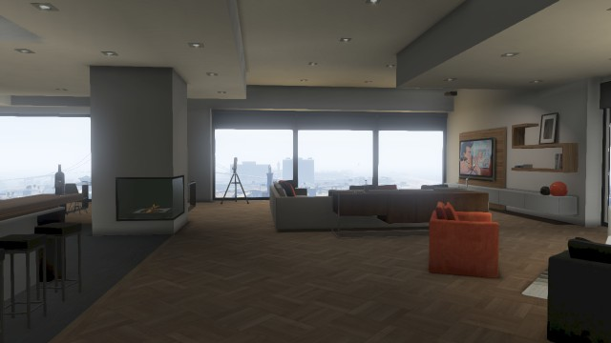
Image Source: http://gtaforums.com/topic/612156-apartmentsgarages-share-yours/ 5/6/2018
The aim to make an environment like in game along with wanting to create the environment like a new unused apartment (like a show room) caused me to fall into a common error when making an artificial environment.

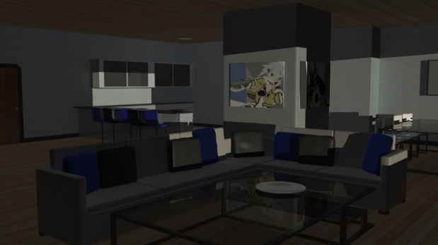
Image Source: my work from Year 1.
Nothing in life is ever perfectly aligned or clean. Yet I had created and aligned mostly every piece of furniture with a 90-degree angle. Corners furniture and walls were sharp and place at perfect 90-degree angles. My limited knowledge of Maya also proved to be a factor in the use of sharp edges as I kept my poly count low and stayed within Maya while modelling (excluding pillows made in mud box). This source of inspiration was also picked as I would be confident I could create something like it myself. Although it turned out looking artificial I was proud of the work at the time but looking at it now I wish I had pushed myself more with a complex environment.
I also tend to lock my colours when creating media. Such as the colours of the environment were selected from the art I used on the walls, this I believe also resulted in the environment looking unnatural. Creating my work based of an artificial source of inspiration is something I should not have done and instead should have focused on real life reference/inspiration.

After the environment creation, an opportunity to create an living model was presented. We were tasked with creating a creature that did not need to exist. This would be my first attempt at creating anatomy on a 3D model. My creature was based mostly on large wild cats. This creature did not go though much design as the focus was to create and animate the animal.
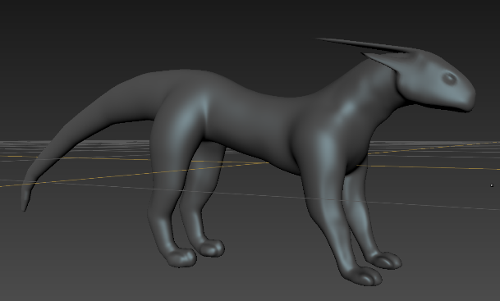
Image Source: My work from year 1.
At the time of creation, I was happy with this model. Looking at it now, the model lacked any obvious anatomy and details. The finished Model was not textured, and the material used along with the lack of any form of anatomy made the animal look plastic and fake.

After creating the creature, I got the opportunity to model a human character with the emphasis on the anatomy of that character. To start we were all asked to create a male character although I found myself becoming stressed with trying to get the anatomy correct causing myself to give up and start again. When starting again I decided to try create a female character as I had found reference outline images and also some tutorials. The problem with the anatomy I followed while making the model was that it was very comic book styled (longer legs, over exaggerated shape etc).
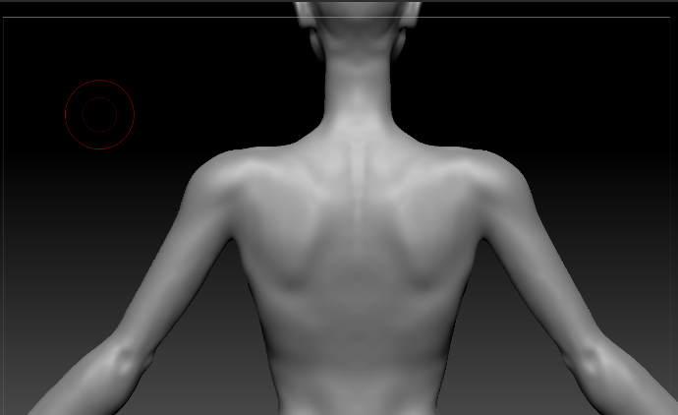
Image Source: My work from Year 1.
I was really happy with the results when adding the anatomy to the back of the character, focusing on getting the bones and muscle correct and looking real. However timewise I spend too much time working on the anatomy as even though it was emphasized, the model was going to be clothed. Looking now the arms are too thin and also neck too elongated, the character is also abnormally thin. This was likely due to me following the comic styled reference. The focus on anatomy with this model was defiantly a massive improvement over the creature model I had created before.
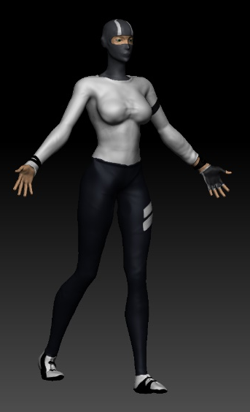
Image Source: My work from Year 1
When clothing the character my inspiration came from another video game again that was currently in the works (Mirror’s Edge). The Design would not be as heavily inspired as the environment but would still take some themes from the game.
Clothing on this chacter was basic looking at it now. Time was not managed well during this assignment, spending too much time on anatomy and too little on the clothing/texturing. All clothing was made by drawing masks onto the model and face covered due to my lack of knolege and time to texture a realistic face or add hair. Along with the clothing being basic, due to my use of “clay build up” brush to fix parts of the mesh, sertain proptions ended up being unnaturaly sized expecaly when extrackting the clothing over the body.

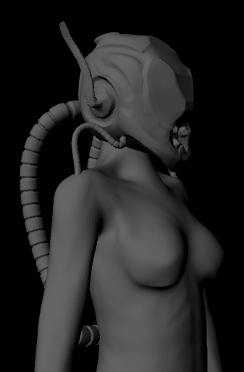
Image Source: My work from Year 1.
After being proud with the result from the human model I had created, when assigned to create a cyborg model I stuck to my comfort zone of creating a female model for the base of the cyborg. The helmet/head of this cyborg was the first attempt at hard surface modelling inside of ZBrush, which proved a challenge. The Anatomy of this model was also more realistic compared to the older female model. However, shortcuts were taken with this model, the feet were left unshaped or detailed as the plan for the animation would not including the render seeing the feet of the character.
The helmet was created as I learned the tools inside Zbrush so was mostly made up on the spot asides from minor planning to how I wanted it to look. Time with this project was not managed well though as too much time was spend modelling the character, leaving little time to rig and animate the cyborg. The over use of time on modelling ended up forcing the animation to be really limited as there was no time for any problems I would run into when animating. Focusing on creating the model over animation would become a problem on a future projects also.
During the group project with the working title of “Adar”, I was tasked with creating the main character. The character was a stylised bird. With the model I ended up breaching my deadline set on the Gantt chart by the group, obsessing over the little details within the model. It got to the point that I was making changes, only to reverse them. I requested a restart of the bird but due to time, this was not an option. The group however approved of the model I was currently working on and it was passed onto another group member to finalise as it started looking wrong to me no matter what I did. The character was simplified (details like feathers removed), this may have been due to time or due to the rest of the group wanting a more cartoon like feel to the final project.
After the cyborg I took an interest in older animated film I had grown up knowing such as Disney’s Robin Hood. This inspired me to use the current creative research assignment to look into Anthropomorphism and how it was used thought the entertainment industry. This was also likely fuelled by the recent announcement of Disney’s Zootopia and the introduction of Rocket Raccoon in Guardians of the galaxy. The way the creators had put human emotion and language into animals without this communication (naturally) was mind-blowing to me. These tools we had for 3D animation gave us the power to make anything we want, even things that do not exist. From this point on I started to see no point in creating what already exists. What was the point in trying to make a human look as real as possible when you can simple film one with a lot less hassle. At the start of every assignment from now on id ask myself the same question, “Why make what already exists?”. If I had no answer to this, then I’d make something only possible with 3D animation.
Our first “big” project was now approaching. A short animation with created characters and story. When this assignment approached I was currently planning a small mobile game I wanted to try make. As I was struggling to come up with a story I decided to simply evolve the story around my favourite animal, a raccoon. Again, heavily influenced by recent events of my trip to the USA where we saw many raccoons and also the appearance of Rocket Raccoon in Guardians of the Galaxy. My raccoon was designed to stand on his back legs for the majority of the animation (like a human) but also run on all fours to allow the character to keep an animal feel.
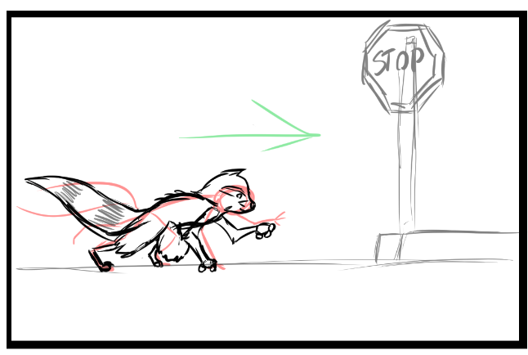
Image Source: My Work from year 2 (project Rocco)
This design was heavily based on rocket raccoon from the new comic books. However, I made him cuter making his ears and hands more cat like as I felt this would make the audience instantly on the characters side (root for the character). I designed him to be fluffy also to follow the theme of making the character cute. Keeping his legs and arms skinny also made him look nimbler and therefore more mischievous.
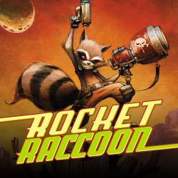
Image Source: http://marvel.com/comics/series/18806/rocket_raccoon_2014_-_present (Rocket Raccoon Comic 2014)

I would fall into the problem I faced with older assignments again with this one. I focused too much time modelling and creating the character how I wanted him to look. I focused on getting every part of this character exactly as I had versioned in my head and my designs. I left no time for errors in the animation process as I had pushed so much time into the creation of the character. Id focus so much on getting one thing right, that id lose track of what needed to be done and how much time was left. I pushed the time I had left so much that when errors happened, or life got in the way It became impossible to meet the deadline. This failure to get the project done by the deadline frustrated me beyond anything before this. This character I became obsessed with to get right, causing me to become blind to how much time the rest of the project would need. My want to get this project finished pushed me to consider a late submission, capping my mark just to get this work finished. This would have been a better choice to have taken as the work I handed over did not get a pass grade but was close enough to be excused. I will defiantly come back to this project in the future, even if its just to finalise the character. 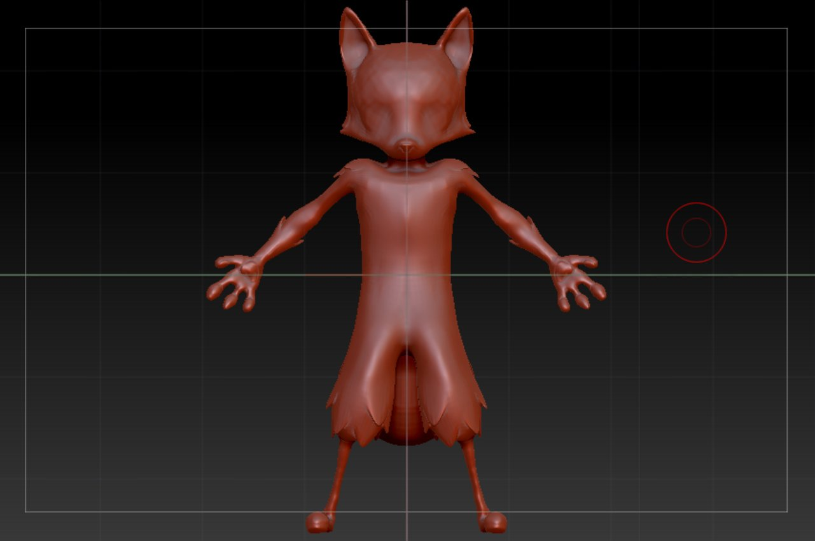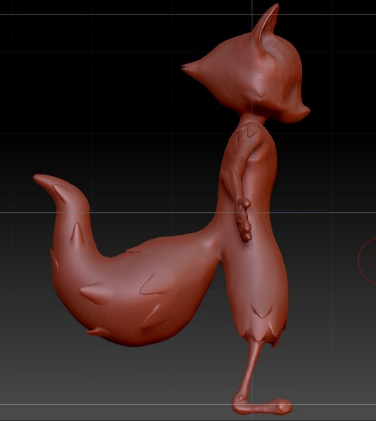
Image Source: My Work from year 2 (Project Rocco)
The bad time management of using too much on modelling happened thought out multiple assignments and ended up causing an assignment to be submitted no where near the standard I wanted it to be submitted as. Time management is something I really need focus on, maybe even setting strict deadlines for separate stages so I do not have this problem again for future work and assignments.
Also, during major Project I worked as part of a group. My key role was to create the character’s weapon. The deadline Setout on the original Gantt chart was also missed, this may have been due to my want to get the weapon perfect, but I believe it was mostly due to a lack of communication between the production group which resulted in feedback not getting back to the modeler of the items in question until later than necessary. There was also a huge delay in our story as it was reworked multiple times, even after exiting the pre-production stage. The gun I was also asked to work on was also requested to be changed to a different version of the weapon really late into production, however I managed to create this model along with other props in time for rendering. The Major project work showed an improvement of time management as all things were modelled on time to get into the scenes needed. With this project though, communication became the problem. In future group assignments communication will have to be focused on as the lack of it during major project caused many unnecessary delays and problems throughout production.

Bibliography

Gunn, J. (2014) Marvel Entertainment (2014, July 31). Guardians of the Galaxy

Wolfgang Reitherman (1973). Disney’s Robin Hood. Robin Hood [Movie-Video]

Young, S., Wyatt, J., & Beaulieu, J. (2015). Rocket Raccoon(Vol. 1). Tunbridge Wells, UK: Panini Books.

Byron Howard and Rich Moore (2016). Zootopia [Motion picture on DVD]. Estados Unidos: Walt Disney Animation Studios.

Rockstar Games, Grand Theft Auto IV (2013) [Video Game, PC, Play Station, XBox]

EA DICE, Mirror’s Edge Catalyst (2016) [Video Game, PC, Play Station, Xbox]

