Module Title: Problem solving decision making

Report: Challenge’s faced by the energy sector

Name: Abdul Jabed

Student ID: 1905668

Date: 09/11/2022

Word Count: 2000

Content page

Introduction. 1.0

Main findings. 2.0

Nature, Scope and Impact. 2.1

SWOT Analysis. 2.2

PESTLE Analysis 2.3

Recommendation/Options 2.4

Conclusion 3.0

Reference List 4.0

1.0 Introduction

The purpose of this report is to provide an analysis of the current problem faced by the Energy Sector, by using analytical methods such as Nature, scope and Impact, S.W.O.T analysis. Also use Conversion Strategies, PESTLE analysis and to recommend key solutions to resolve the recent problems.

2.0 Main Findings

2.1 The Nature of the problem

Since the war in Ukraine by Russia, the whole world has been effected leading to the cost of living crisis being caused by the enormous energy crisis. This resulting in 4.5 million families in the UK experiencing fuel poverty in October.
Now 6.7 million, according to National Energy Action.
The livelihoods of the poorest households in the UK are already being harmed by frigid homes.

The power industry is steadily undergoing a digital transformation.
Data exchange and gathering are expanding at an exponential rate, posing digital hazards but also offering the sector great opportunities.
The electric, nuclear, coal, wind, solar, and natural gas industries all have suppliers and distributors within the power industry.
The regulatory framework in which power companies operate, the location of their operations, the structure of their asset portfolio, changing consumer demands, economic maturity, and required level of technological adoption will all influence how they react. One thing is certain: the global electricity sector is poised for significant upheaval, regardless of the various future scenarios that have been put forth.

The Scope of the problem

All this problem has an affect on the Economy, the cost of living has gone all time high, with prices rises from food, electricity, and gas households are finding it hard to cope. On up of this the inflation rate going up with home owners at risk of losing homes if unable to keep up with paying their mortgage.

The UK gas prices have increased by more than four times in the past year,
reaching highs of 180pence an increase of 40p. A whipping 70% increase just in
the last month.
While it’s possible that the UK won’t run out of fuel, it would still be a problem if gas became very expensive.

The Impact of the problem

UK households are affected due to the increase in their energy bills.
People are still impacted from post covid from the last 2 years and now with this new crisis due to the war in Ukraine.

Supply companies are also affected with this and they had no choice but to up their prices, because of huge demand and supply needed for this winter.

The Government has to step-in to help people who are struggling to pay their bills, they had to negotiate with energy companies to reduce their prices in order for the UK household to get through this winter.

Stakeholders had to sign new contracts with energy companies to get supply, otherwise they will have a huge loss in business and energy companies will look else where to provide there goods.

Below is a diagram of a fishbone illustrating the Nature, scope and Impact of the Energy Crisis:
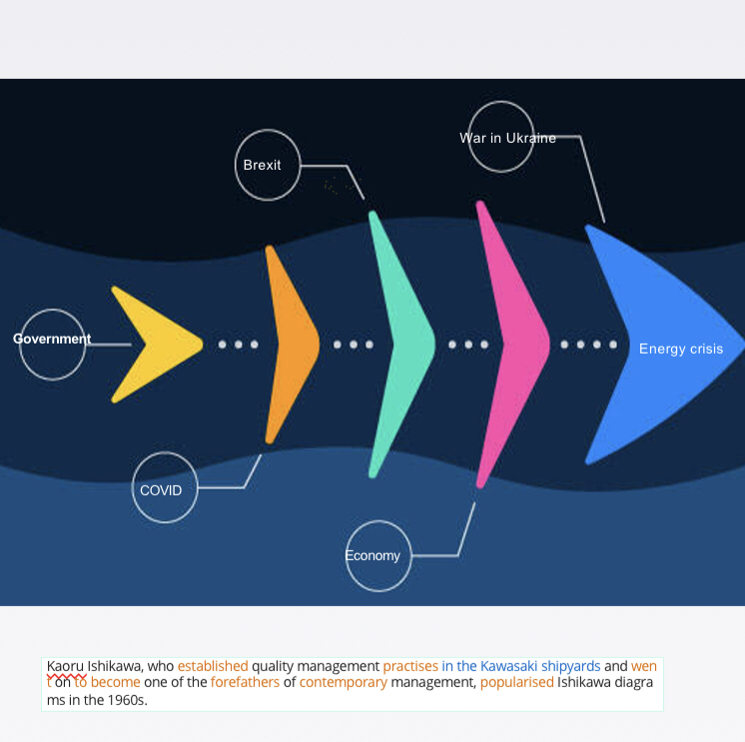
2.2 SWOT Analysis

In terms of both internal and external factors, a SWOT analysis of the energy sector identifies the industry’s following strengths, weaknesses, opportunities and threats.

Strengths
Power is unquestionably a major force behind human advancement.
A SWOT analysis of the power sector's strengths reveals characteristics that are a good sign. These attributes must be typical of regions that the industry has considerable control over.

The power sector has a number of advantages, including:

- An increase in the rate of investment in renewable energy
- dependable infrastructure
- improved and more energy-efficient technology adoption

Weakness
Weaknesses in a SWOT analysis assist in locating elements of a sector that are underperforming or ineffective. Humanity's insatiable appetite for energy has reached unparalleled heights as a result of the expanding global population and accelerating industrialization in developing countries.

Typical flaws of businesses in the electricity sector include:

- rising energy demand
- increasing cost of electric networks
- Attrition among employees

Opportunities

The SWOT analysis can help companies in the power sector locate numerous growthhotspots. The energy sector is seeing new opportunities due to the accelerating rate of data gathering and interchange.
Opportunities exist from generation to customer relationship management along the entire value chain of the electricity industry.

For businesses in the power sector, some of the major potential are:

- more tax breaks for cars that use less energy
- The number of daylight hours has risen seasonally.
- prohibitions on offshore drilling have been lifted

Threats

Threats to the power sector's growth are illustrated by a SWOT analysis, which also reveals factors from outside the sector that could be dangerous.
Frequently, the power sector corporations have little influence over them.
Companies in the industry are under constant pressure to increase their efficiency and become more cost competitive at the moment because of the sector's social and economic effect.

Companies in the power sector are mostly at risk from:

- danger of regulation and compliance
- Climate change legislation and carbon price are uncertain
- fluctuation in energy prices

Below is a diagram illustrating the SWOT Analysis:

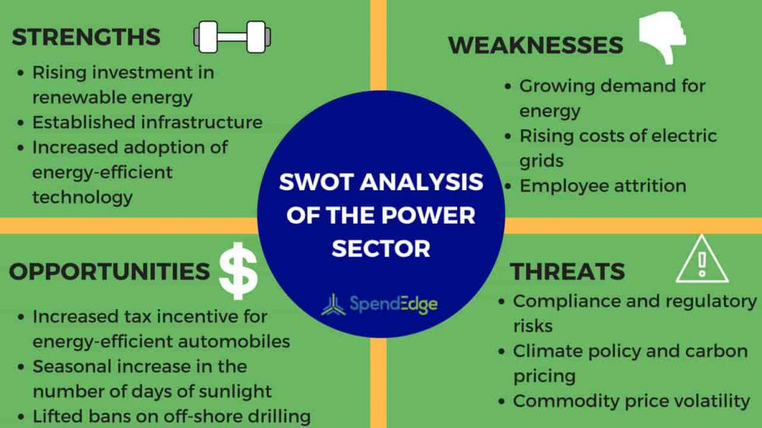
(https://www.spendedge.com/blogs/swot-analysis-power-sector, June 12. 2018)

2.3 PESTLE Analaysis
PESTLE analysis has been applied to the external examination of the UK's renewable energy industry to show the impact of macroeconomic factors on the market performance of enterprises producing renewable, sustainable energy.

Below is an illustration of each PESTLE analysis component:

Political

According to Cotula (2012), political limits related to contracts and regulations are one of the main political elements that can have an impact on renewable energy enterprises.
The UK market for renewable energy can be favourably impacted by policies related to research and development and tourism.
The security of the energy supply to the local market is, however, seriously threatened by terrorism and political unrest in the UK.
As a replacement for a disproportionate reliance on the importation of renewable energy, it is projected that the sector of renewable energy will likelyreceive significant political support from the government institutions of the UK.
This will create favourable conditions and prospects for investment in the UK's renewable energy sector.

Economic

According to Boons et al. (2013), the market performance of the UK's renewable energy sector can be impacted by economic growth or crises.
The UK's GDP increased annually in 2017, which indicates that more renewable energy products will be developed and improves the market performance and position of the UK's energy renewable market globally.

Social

The sustainability and size of the energy industry raise constant concerns about the performance and usefulness of renewable energy as a substitute and ecologically friendly energy source. In order to succeed and remain competitive in the market, a company that produces renewable energy must seek corporate social responsibility. People may be more likely to use renewable energy as a fuel or an electrical source if social acceptance and evaluation of climate change are present, according to Panwar, Kaushik, and Kothari (2011). This demonstrates that when generating renewable energy goods, the social impact of those products is a crucial component that must be taken into account.

Technological
To meet the rising demand for renewable energy sources, the proper technological aptitudes and abilities are needed.
According to Cronin et al. (2011), the energy market's technical development pushes businesses to create products that can satisfy the needs and desires of suppliers and consumers.
Regarding this, companies that produce substantial amounts of renewable energy need to think about growing, keeping, and managing their human capital.
The effectiveness of the UK's renewable energy industry can also be impacted by advances in energy and biotechnology.

Law

Regional laws, environmental safety standards and regulations, and taxation policy are only a few examples of legal issues that may have an impact on the market performance of the UK's renewable energy business.
In light of this, UK-SE must take these things into account when releasing a new product.

Environmental
The performance of the renewable energy sector is expected to be impacted by environmental issues such as climate change, resource management, and sustainable generation of renewable energy.
In order to introduce a new product in the UK renewable energy market, UK-SE must concentrate on environmental factors.
The PESTLE analysis of the UK renewable energy market showed that it is viable to design a new product offered by the UK-SE given the external environment or circumstances.

2.4 Recommendations/Options in solving the recent problem

The UK is currently experiencing a severe energy crisis. Simply paying bills on the cheap for a while won't cut it. The government will also need to take action to cut energy use and diversify the energy source, which may involve collaborating with other nations. Due of the costs, they will also need to think about how to generate income to pay for it.

Below is a five-point emergency strategy to deal with the impending energy storm:

1. Financial assistance for households.

The Government should implement a new, enhanced support programme to replace the current Cost of Living support programme. This new programme should for the first time give extra benefits to families with children who have higher energy expenditures. These payments should be made in six monthly instalments during the winter (January, February, March, and October, November, December 2023). This reflects the reality that energy costs are significantly increasing.
2. A windfall tax to help pay for support on cheap electricity generators.

Wind, solar, nuclear, and biomass generators have seen tremendous profitability during this crisis. They might collect between £4 billion and £10 billion each year from a windfall tax, which could be used to fund further household assistance.
The marginal cost of power has contributed to some of these earnings.
One effect of marginal pricing is that producers with lower operational costs (such as wind, solar, nuclear, and biomass) are compensated using the price of gas rather than their actual costs.
This means that even if their actual costs haven't increased, these "low-cost generators" are paid more if gas prices rise.

3. Use alternative fuels, such as coal and diesel, more frequently.
The government needs to look into alternate fuel sources to quickly lower the demand for gas because of the limited supply. The only possibilities are coal and oil due to the urgency of the situation (diesel). The government should investigate ways to extend the operating hours of coal- and diesel-fired generators in order to encourage fuel switching, including quickening the issuance of new permits and maybe suspending some air quality regulations in an emergency. This awful trade-off will result in more local air pollution and fewer blackouts
4. A deliberate effort to lower energy demand
The government must be upfront with the public about the fact that the greatest strategy to lower energy market prices in the short term is to reduce. demand. Ministers should: start an energysaving campaign for homes and small businesses; enact a new energy efficiency requirement for landlords and housing associations; and require firms to take energy
saving measures comparable to those in place throughout Europe.

5. Maintain an energy flow across borders.

If nations restrict energy exports in the case of shortages, Europe (including the UK) is at risk of sliding into "energy nationalism."
As a result, shortages would get worse.
Through smart diplomacy with our neighbours, the future prime minister will need to stop this.
To establish guidelines to ensure that energy can continue to flow through this crisis, the government should create a new "European Energy Emergencies Forum" made up of the UK, the EU, and Norway.

The fivesteps suggested will make the next prime minister of the UK feel uneasy from an ideological standpoint. However, if these things aren’t done, it might swiftly become politically unviable.
There will be ways to modify the package so that it is more in line with their principles, but in the face of this crisis, the incoming prime minister must put pragmatic considerations before ideological ones.
The longterm solutions to the energy crisis involve reforming the energy market, increasing the UK's energy supplies through new renewable energy sources, nuclear energy, domestic gas production and storage, and reducing consumption through insulating buildings.
These initiatives will naturally be a primary focus for the future prime minister.
However, they won't have enough room to achieve this unless they implement a package that deals with scale.

3.0 Conclusion
From undertaking this report and using various analysis like Nature, Scope, Impact and SWOT Analysis have found many problems which has effected the UK population, businesses and the surrounding borders. These problems started from 2 years of COVID and now with the War in Ukraine, which impacted on people health, work, transport, NHS and living cost. The UK government is also struggling with dealing with these issues as they have there on problem with the PM being charged 3 times in a year which is history in the making. The UK’s population are struggling with one problem to another this time with the Energy crisis, prices on gas and electric has gone high for people to pay their bills. The Government have stepped in to help with household who are finding it hard to manage, also they have had decision’s with supplier companies to keep supplying the power. The supply companies are cashing in with the problem because demand has gone up and they are rising prices, this is not helping the UK household as pre- covid people are still struggling. Finally the government need to make swift decision regarding the energy problem by investing in renewable energy/power with new ideals and ideas to help the ongoing problem which is expected to last for few more years.

.

