

Postgraduate/Distance Learning
Assignment coversheet & feedback form

THIS SHEET MUST BE THE FIRST PAGE OF THE ASSIGNMENT YOU ARE SUBMITTING (DO NOT SEND AS A SEPARATE FILE)

For completion by the student:
Student Name: Barbara Jedlinska

Student University Email: 2116626@student.uwtsd.ac.uk

Module code: HPCA7016  Module title: Researching Contemporary Cosmologies | Student ID number:  2116626 |  |  | Educational support needs:  No
Assignment title: Research Project in Contemporary Cosmology

Assignment due date: 16/05/2023
This assignment is for the 1st 2nd 3rd X 4th 5th 6th module of the degree
I confirm that this is my original work and that I have adhered to the University policy on plagiarism.
Signed ……………… Barbara Jedlinska ……………………………………………
Email submission:if you are submitting this form via email, please tick this box □
(as a substitute for your signature) to confirm that you agree to the above declaration.
Assignment Mark
1st Marker’s Provisional mark
2nd Marker’s/Moderator’s provisional mark
External Examiner’s mark (if relevant)
Final Mark

NB. All marks are provisional until confirmed by the Final Examination Board.

For completion by Marker 1 :
Comments:

Marker’s signature: |  |  | Date:
For completion by Marker 2/Moderator:

Comments:

Marker’s Signature: |  | Date:
External Examiner’s comments (if relevant)

External Examiner’s Signature: |  | Date:

Introduction
Astrology is claimed to be experiencing a rise in popularity within the recent decade. This research investigates the current societal uptake in this interest and aims to examine what do people think of astrology– and further what are their beliefs around the potentiality for correlation between transit movement of the planets and their personal experiences. For this purpose, a group of expats living in London have been invited to share their opinions, first through surveying the respondents’ general beliefs and experiences around the subject, and further inquiring into their specific beliefs of several participants through interviews. The research results have varied significantly depending on the respondent, however several common themes regarding the planets could be identified. Moreover, some potential for beliefs could be noted under assessment through this enquiry, around the cycles (in particular those of Jupiter and Saturn) corresponding to events that influenced the decisions to move into an expat lifestyle. Altogether on a broader level, the research concludes that astrology is perceived to be a rather logic-based tool for self-enquiry for the participants who can see at least some value in it or are open to exploring - rather than a matter of the concept being based purely around belief. In fact, only the participants who had strong views around astrology – as in strongly not believing in it – connected the concept to matters of belief only, whereas the respondents who could allow a belief there is something to the practice perceive it as something much more logical and structured, potentially even scientific.

Literature Review
The investigation into the topic has been driven by an opinion shared by James Davidson, namely “I don’t believe in astrology, but I am rather fond of it”. Based on the author’s comment, the concept of astrology he connects with is one accessible through magazines and media, in form of horoscopes and discussions of Mercury retrogrades. This seems to be in line with the current boom in popularity of the topic of astrology observed amongst the millennial and younger generations. The business models of mainstream publications targeting these generations operate with inclusion of and potentially even a certain reliance on the topic – seen in examples of media powerhouses such as Vice Media, claimed to be the largest independent youth media company in the world. Social media hashtags for #astrology on platforms reflect this popularity, with examples of respectively 12.9million Instagram posts and 57.8billion TikTok video views tagged in relation to this generic phrase only.
Nevertheless, within existing research on the topic, when assessed based on direct questions, general volumes ‘for’ belief in astrology are placed between 20% and 29% within the sampled population. This implies that even though astrology seems to be surrounding us, not a large share of the general public actually believes in it. Astrology as a belief has been researched in depth by Nicholas Campion, according to whom the ‘low’ astrology which consists of the horoscopes in mainstream media, is “fundamentally a normal part of popular culture”. There remains however room for fresh research enquiry whether this understanding of astrology is sufficient for the population or are people generally looking to go deeper than what is presented to them.
The above can be assessed within a sample of the population who share a common characteristic, such as expats. Among expats there exists a recurring belief that while the choice to leave the country of one’s origin might have been triggered by varying themes, it often required a ‘spark’ to convert the choice into action, which oftentimes can be seen as traumatising experiences. An experience of leaving one’s roots can be seen as a physical representation of a journey of self-discovery in the wider context of the world. Such basis can further be combined with words of Liz Greene exploration of the Saturn themes, and how “human beings (…) do not attempt self-discovery until things become so painful that they have no other choice”. Treated together, a question has been raised whether the expat experience of the respondents has been conjunct with any other event that could be identified as painful or challenging – leading to further enquiry around potential influence of Saturn. Equally, an investigation of Jupiter, with its symbolic connection to higher education and expansion, has also been identified as potential for investigation to see if any patterns emerge.
Rather than focusing on in-depth analysis of the individual charts of the respondents, the research focuses around the individual participants’ beliefs on potential for correlations. The topic further links to the astrological transits of the planets, which can be used as ‘checkpoints’ for the self-enquiry of the population when reflecting on subjective personal experiences. In this case, work of Robert Hand can be of particular benefit, specifically his descriptions of key planetary cycles themes. Once the potentially impactful life themes have been identified, these can be then further linked to potential belief of the individual around connection between the planetary cycle and observed changes in one’s journey.
Finally, it is important to note the claim of Glock and Stark (1966), that there is a difference between having a belief and attaching importance to it. Hence, it must be kept in view that the results discussed further have been obtained within one specific moment in time, and especially the qualitative research taking place in a context that encouraged discussing the particular beliefs around astrology. It does not mean however, that these findings in fact have a significant impact on the everyday lives of the respondents, but rather likely reflect a theme that is recurrent in their lives.

Methodology
This research has been carried out using mixed methods, applied sequentially, to achieve alignment between the data sets. The sample has been selected as a representative for potentially opening a room for a wider investigation as to overall UK expat population’s preferences – as 35% of UK migrants lived in London as of the most recent available data from June 2021. First, a questionnaire consisting of 2 dedicated research sections has been shared with the participants, investigating beliefs around astrology, and beliefs around planetary cycles, with one open question at the end of each. The most potentially sensitive topic (around Saturn’s cycle) has been placed at the end of the questionnaire, as recommended by Kronick & Presser (2018). Research has been successful in the sense described by Rowley that “Questionnaires should not only suit the research and the researcher, but also the respondents”, in result prompting the participants to engage in deeper self-reflection. Based on these responses, sample representation of varying viewpoints has been invited to a follow-up in-depth interview. This method has been applied to allow “more in-depth insights on participant attitudes, thoughts, and actions” as recommended by Kendall (2008).
The participant group has initially been sourced through available means on the social media platforms, namely Facebook Groups centred around the women expat communities and generic expat-specific topics. The initial approach has been significantly affected by the rules applied to the Groups, where the administrators (multiple Community Managers) have internally disagreed with each other over the permissions to post links to surveys within their communities. The problem of miscommunications between several stakeholders affecting the planned access to the target groups led the research to at first expand from women-only analysis to target communities where both genders could participate, which however did not bring significant results. The reach has been further expanded to attempt sourcing expat respondents in the groups pertaining to their broader areas of interest (such as marketplace topics), also to no result. It is possible that the public is rather used to being incentivised to respond, offered a reward for their time investment, which has not been something considered in this research.
Ultimately, with the approach not yielding the desired outcomes, the participant targeting strategy has shifted towards requesting support within researcher’s network-connected communities to either participate in the research if fitting the prerequisite demographics of expats living in London, or share the questionnaire with own secondary network of individuals fitting the profile.
While ethically the research has been rather predictable, there are several potential areas for bias that ought to be highlighted.
From the very stage of participant recruitment for the questionnaire the selection bias can be noted, as the sample has not gathered representation from all possible areas represented by the broad expat community in London. Furthermore, the research is influenced by the sampling bias, due to the issues encountered with the participants recruitment – with the representation of the sample population ultimately relying on some relation to the researcher. Such sampling bias could have further affected potential for social desirability bias, with participants desiring to support their community – or adversely, the participants could have been biased based on pre-conceptions around social stigma surrounding astrology practice.
In qualitative part of the research, confirmation bias needs to be considered – as the respondents were only selected based on the preliminary survey results, to discuss their beliefs further. This could therefore have led the responses to be in favour of the research responses they believed they are asked to support. This is also the case with the possibility of the recall bias – in particular, when requesting the participants to evaluate whether a time in their lives could be correlated with a planetary cycle movement concept, the memories could have been distorted to suit the scenario the participant believed they want to support.
In summary, the potential for bias in this research was rather high due to sampling difficulties, and what could be expected in terms of qualitative research.
The bias has further influenced the research in terms of reflexivity aspect. With the researcher known to be an astrology practitioner within their network circles, the recruited participants would have entered the research with possible pre-conceptions about what the researcher’s bias might be. Perhaps this could have enhanced the participant responses, either becoming more favourable or unfavourable towards the topic of astrology. Looking at the insider-outsider scale, the route the research has taken in search of participants has placed the researcher closer to the insider status. This can have some benefits, especially compared to claim of Rabe (2003) that “insiders can provide major insight into communities that would not have been achieved by outsiders on their own”. However, it has moved away from the initial design of the project to maintain the outsider perspective at the core.
Additionally, while critically reviewing the research and the methods applied, it would be of benefit to repeat the methodology with a shift into analysing themes and coding of the planets, but without naming them while in the interview stages – rather analysing potential dynamics than revealing the associations upfront. This has not been achievable due to scale of this research, while would be prudent to consider in any further developments.

Findings and Discussion

Background and Respondents’ Demographics
Taking a macro-level view on the survey responses, some conclusions can be drawn regarding the sampled population who took part in the initial survey. The responses did not align with the expected between 20% and 29% volumes ‘for’ belief in astrology – with only 25% of total surveyed categorically stating “I don’t really believe in astrology”, and with the rest allowing some degree of belief in it. Furthermore, based on the participants’ willingness to take part in further interviews, it can be deducted that the topic is one that the sample population was rather interested in sharing their personal views around. Of 16 participants, there was only one ‘prefer not to disclose’ preference, which was specifically about personal religious beliefs – ergo rather a supporting demographics question. Furthermore, 6 participants out of 7 invited have continued to the qualitative phase of the research, with one decline resulting rather from scheduling issues than preference to not participate further.
Prior to further investigation into the details of the research, it is important to start with briefly discussing the general demographic of the respondents. All have identified as an expat living in London, which has been a pre-requisite to taking part in this research. While initially the research has been oriented towards female respondents only, it has over time been extended towards male population also – leading to 75-25 female-to-male representation. 50% of respondents identified within 35-44 age bracket, 43.8% in 25-34 bracket, and one respondent represented the 45-54 age group population. The largest share of respondents (40%) identified their country of origin as Poland, with further representation from New Zealand (20%), and individual representation from Australia, Bulgaria, Germany, Switzerland, Turkey and USA. Finally, a clear majority identified with no religion at 62.5%, followed by Christian religion at 31.3%, with one preference not to disclose. The above suggests that majority of the research group has been represented by female group in the age of millennial / gen-z, with either no religions affiliation or Christian faith. Similar ratios have been further attempted in recruitment of the qualitative data sample, to varying degree of success, primarily due to limited amount of the quantitative research respondents.

General Views on Astrology
Initial investigation into the views on astrology revealed that 50% of respondents ‘believe there is some value’ in the practice. Both segments of ‘There might be something to it, but I need more proof’ and ‘I believe astrology practice is important’ aligned with views of 12.5% of the sample population each. To confirm already mentioned result, 25% of respondents reported that they ‘don’t really believe in it [astrology]’.
Interestingly, every respondent who reported lack of belief in the practice has also answered ‘I have not had much experience with astrology’ in the question on the experience level. This reflects a potential for certain determination to uphold a value and use the questionnaire to express a rather inverted view – a belief in that astrology is not a valuable practice. One of qualitative responses to the survey has used the space to share the belief that “It has absolutely no scientific merit”, which suggests a rather strong opinion / belief on the matter. Another of this same segment has shared “I’m new to the topic”, hence allowing some more room for potential further exploration – however further proven unlikely through the interview stage responses. Upon a question around association of thought or feeling that comes up when hearing of astrology, this participant answered “disbelief”. Given the wider context of the participant’s religious beliefs, it is likely that they represented the segment of population similar to findings of Nick Campion, with Christian and atheist -affiliating respondents scoring low on astrology belief. Furthermore, when assessed in the context of James Davidson’s statement, “I don’t believe in astrology, but I am rather fond of it”, the insights into the non-believer group in this research do not support it, as they do not appear fond of the topic.
A cultural context also has to be noted, as 100% respondents answered ‘yes’ to whether they know their zodiac sign. Qualitative insights on beliefs around their accuracy varies, however the knowledge of the signs suggests that the individuals overall had already had an experience on assessing their beliefs about astrology at some point in the past, having first come across the concept.
Based on the survey data in this research, majority of respondents do believe that ‘there is some value in astrology practice’. Looking into the details further, it is important to note that the question around current experience with the practice allowed multiple answers, with the following count results:
Table 1. Experience with astrology.
Experience Level | Count
I have not had much experience with astrology | 6
I read horoscopes / use horoscope mobile apps | 5
I had my natal chart reading | 6
I regularly consult a professional astrologer | 0
I study astrology as a hobby | 1
I am a qualified astrology practitioner | 0
Prefer not disclose | 0

The above result suggests similar levels of experience between respondents who read horoscopes and who have taken a step beyond into having their chart read – with slight skew of the focus away from the ‘low’ astrology based only on horoscope readings, as quoted by Campion. It is also important to note that none of the respondents identified with being a practicing astrologer. This brings forth a question related to aforementioned Glock and Stark, on the difference between holding belief and it having an importance . With majority of participants in this research holding at least some degree of belief in the topic, it remained unclear whether that belief would hold any importance – which is why further enquiry into the effects of the planetary cycles has been developed.
Further enquiries into potential value of astrology as perceived on individual level has appeared aligned with the views of “the wise man rules his stars, the fool obeys them” as quoted by Nicholas Campion. Almost all of interviewees associated the practice with tools helpful to one for understanding the Self. One particular belief described it as “a subtle undercurrent [that] can be valuable to explore, among many other factors in life”.
The understanding of the concept of planetary cycles has been noted as rather high – with only 31% identifying as ‘no’. Further enquiries into the definitions found a common theme in the interviewed respondents, who each drew on scientific phenomena in physics and the operations of the Solar System, rather than anything metaphysical.
Table 2. Belief in potential for relationship between the planetary cycle and personal experiences at given life stage %
Planet | Yes | Maybe | No | Prefer not disclose
Mercury | 18.75 | 62.5 | 18.75 | -
Venus | 12.5 | 56.25 | 31.25 | -
Mars | 6.25 | 68.75 | 25 | -
Jupiter | 12.25 | 56.25 | 31.25 | -
Saturn | 25 | 50 | 25 | -

Mercury
According to the quantitative research results, planet Mercury has received the overall strongest confidence of the respondents as to the cycles believed to at least have a potential for having common patterns with individual daily lives – with the lowest % of ‘no’ answers among all planet cycles at 18.25, and with 18.75% responses at clear ‘yes’ and further ’62.5%’ at ‘maybe’. This result could have been affected by the timing of the respondents filling the survey, which happened to coincide with the noted Mercury Retrograde season 21st April – 14th May 2023. The timeliness of the question around potential impacts of retrograde could have therefore allowed the respondents to analyse the related concepts of communication, intelligence, travel on the spot.
Further looking at the qualitative part of this investigation, Mercury received second-best attention time amongst all planets, following Saturn. Almost all respondents had some further thoughts to share, where in particular an interesting common theme emerged, where two participants admitted to consciously avoiding updates about the retrogrades schedules. According to one, “events didn’t only happen due to retrogrades (…) [so it] became harder to believe and hold onto as a concept”. The other mentioned the “running joke about things not working because of it”, but highlights the problem identified when “then started looking for signs (…) [identifying] things becoming self-fulfilling prophecy”. On the other hand of these two opinions, another has emerged where responded admitted that is not “on top of these cycles [but] if was on top of it (…) [then] could appreciate it” – implying and interesting take on the belief aspect, where it appears to exist, but is not grounded in observed experiences as in the former two cases.

Venus
The belief around the impact of the cycle of Venus on one’s experience has been investigated in terms of correlations between the respondents’ romantic lives as well as any noticeable uplifts in the areas of harmony, creativity, and arts – in case of lack of love-oriented patterns. With Venus cycles lasting relatively short, majority of the interviewees reported that they are just unable to accurately access the time. According to the questionnaire, it was one of the two cycles (alongside Jupiter) where respondents have found it the most challenging to draw any patterns.
Furthermore, only one qualitative insight allows concluding some belief into the cycle having a reflection in the personal life – which interestingly has likely only been recalled at the point of the call due to respondent’s recent learning about the cycle’s impact itself, which allowed some time for reflection. For this respondent, the cycle corresponds to the time she met her long-term partner, and further suggests a cycle “when things started getting better following a decline, (…) I have seen big improvement when the cycle is supposed to have happened”. Such experience meaningfully aligns with interpretation of Venus by Robert Pelletier, that “Venus shows adjustments made to encourage a relationship. It is the hand extended in the hope that it will be warmly received”. The respondent further added that she was “trying not to look into these deeper but seems like correlation” – thus implying fundamentally some belief in the cycle’s connection to own experience, but no further interest in delving into the topic further.

Mars
Some similar results have further transpired through analysis of impact of Mars cycles on the respondents’ experiences. This section seemed to receive the most ‘maybe’ responses to the questionnaire. Put into context of the total ‘yes’ and ‘maybe’ responses versus categorically ‘no’, it appears that the cycle got similar level of confidence to Saturn, with strict ‘no’ accounting for 25% of the responses in each case. This would imply that the share of ‘maybe’ has potentially been influenced by lack of clarity on the exact timings of the cycles in relation to one’s life, similar to the case of Venus. In qualitative section of the research, basing on the works on transits interpretations by Robert Hand, only one respondent could draw some pattern between the planet cycle and own life. Based on concept of “it is a transit of beginnings”, when compared to their personal experience, one respondent identified that has been “changing jobs every two years or so, and now [is] freelancing for 2nd year and starting to consider [changing the work mode into] permanent”. This reflection further led to a rise in interest around the topic, noticeable through the change in tone of voice – implying some potential undergoing changes in belief around the impact of this cycle.

Jupiter
While initially expected to be one of the key belief indicators for this research, Jupiter and its cycles has been a challenging theme to evaluate in this specific research. Starting with challenges around questionnaire, as it was one of the least believed in cycle in terms of correlation to personal experiences – even though the cycles of 12 and 24 years should have in theory provided more easy access to context of one’s life than compared to Mars or Venus.
Further in terms of qualitative analysis, participants clearly struggled with identifying the stages of their lives related to the cycles, let alone associating them with any beliefs around relation to personal expansion, successes or luck. However, themes connected to university have come up, which with a leap could be connected to the cycle at age of 24. One participant indeed has felt the huge expansion having just started her new career, however noted that “prior to it was the time of disillusionment (…), one of first times in life when I was very down” – further leading to belief that while Jupiter cycle might be somewhat associated with expansion, “perhaps it was because of this dark time [that] the next [phase] felt like a huge success”. Perhaps some linkage can be made between this experience and Pelletier’s interpretation of Jupiter such as “a distinction between right and wrong is established”, however the respondent did not pick up this topic when mentioned, implying it did not reflect her beliefs on the experience. A potential for belief has been noted with a responded who realised that at age of 12 started studying a foreign language as extracurricular activity, and at the age of 24 decided to enrol into a postgraduate study that would further shape her career development. Combined with her Saturn experiences, this respondent has expressed a level of belief that the planetary cycles could have had some influence on her decision to become an expat from country of origin.

Saturn
Perhaps due to the nature of Saturn returns, which a large share of the respondents would have experienced or picked up on, this planetary cycle has achieved the highest rank in the belief in link between the planetary cycle and personal experiences of the respondents already at the questionnaire level – with 25% of all participants confident enough in their belief to mark a ‘yes’ response. In the open-ended sections of the questionnaire, one of responses specifically used this space to share that ‘Saturn themes did indeed start become prominent at around 29, and still do with 30 and soon 31’ – even though earlier has reported on “I have not had much experience with astrology”. This implies that the Saturn cycle might have been identified as a period of sufficient significance for the respondents to associate their to-date life experience with, in order to be able to investigate their belief.
Further when assessing the cycle with qualitative methods, 5 out of 6 interview participants had an opinion to share about it, which suggests a heightened interest. The common theme between interviews has been naming the phase as “interesting period of time” by 3 independent interviewees. One of the most in-depth self-analyses, where the respondent spent several minutes recalling own life experiences around the time, summarised their belief in that it felt like a period of “solidifying the personality”. Specifically, through heightened awareness that “things that I’m doing now will be impacting the future” of “things to quit, like certain behaviours that I need to quit – [knowing that] I need to do it NOW” (with emphasis on the last word). The level of emotion of the participant reflects the belief is one rather firmly grounded in her perspective. The same participant also mentioned that in her immediate environment there is a perception that around 30 “things start clarifying and making more sense, after that dark period”. Such observation closely aligns with what Robert Hand has shared about the transit, as “consciously or unconsciously, you are pruning your life of anything that is not relevant to what you really are as a human being”. This belief also seemed to be shared by another respondent, who “100% can see correlation [as has] moved to the UK, and moving wasn’t very planned (…) [as she] wasn’t happy in Italy anymore so that needed to end”. For other respondents, the events did not appear so firmly related to endings and new beginnings, however each has admitted they could acknowledge a belief in correlation of this cycle to personal experiences – found even in the case of a respondent who initially identified as “do not really believe in astrology” in the questionnaire.

Conclusion

This research has been undertaken to understand what people think about astrology, with further investigation around their beliefs on potential relation between transit movement of the planets and their personal experiences. The research results suggested that sampled expats in London are rather open to the concepts of astrology and the potential relationships between the transits and their experiences, however this significantly depended on the planets themselves. While Venus and Mars hardly triggered any belief, Saturn and Mercury drew the most correlation opportunities. Specifically in the cases of analysis of one’s experiences that led them to a decision to move abroad, only the planets with the longest cycles ie Jupiter and Saturn have been considered potentially impactful, if at all. Based on the participants of this research, while beliefs in astrology might not have a significant impact on their everyday lives, the practice is by majority perceived as a potential tool for self-enquiry, and a rather logic-based one than a form of divination.

BIBLIOGRAPHY

Campion, Nicholas. Prophecy, Cosmology and the New Age Movement: The Extent and Nature of Contemporary Belief in Astrology. (PhD thesis, Bath Spa University/University of the West of England, 2004)
Davidson, James. London Review of Books, Vol 26 No 23 (2004)
Glock, Charles and Rodney Stark. Religion and Society in Tension. Chicago: Rand McNally, 1966 [1965]
Rabe, Marlize. ‘Revisiting 'insiders' and 'outsiders' as social researchers’, African Sociological Review / Revue Africaine de Sociologie, Vol. 7, No. 2 (2003), pp. 149-161
Greene, Liz. Saturn: A New Look at The Old Devil. (San Francisco: Red Wheel / Weiser LLC, 1976)
Hand, Robert. Planets in Transit: Life Cycles for Living. Atlgen: Whitford Press (1976)
Kendall, L. (2008). The conduct of qualitative interview: Research questions, methodological issues, and researching online. In J. Coiro, M. Knobel, C. Lankshear & D. Leu (Eds.), Handbook of research on new literacies. New York: Lawrence Erlbaum Associates. Lai & Waltman. pp. 133-149.
Krosnick, J. and Presser, S. Question and Questionnaire Design. Handbook of Survey Research, 2 (2010), pp.263-314
Pelletier, R. Planets in Aspect: Understanding Your Inner Dynamics. Atlgen: Whitford Press (1974)
Rowley, J. Designing and Using Research Questionnaires. Management Research Review,Vol. 37 I 3 (2014) pp.308-330

Websites
https://migrationobservatory.ox.ac.uk/resources/briefings/migrants-in-the-uk-an-overview/ [last accessed on 30/04/2023]
https://www.vice.com/en/topic/astrology [last accessed on 30/04/2023]

APPENDIX – SURVEY

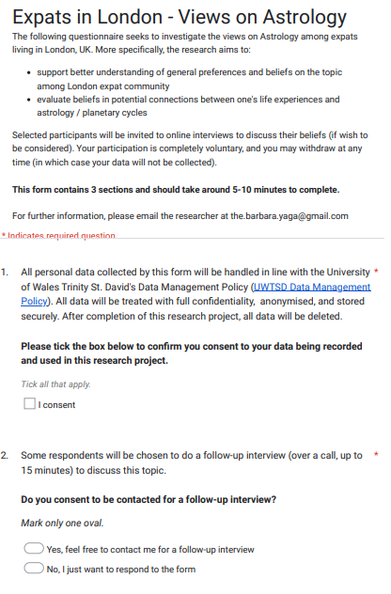
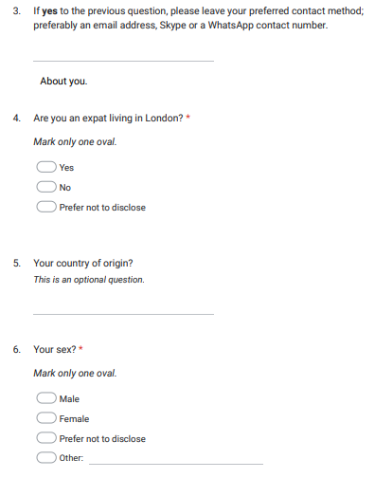
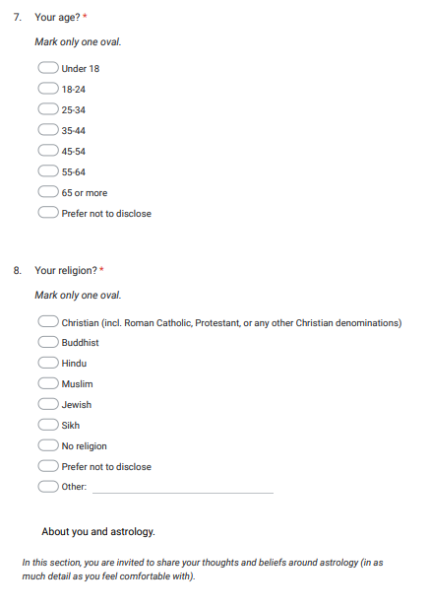
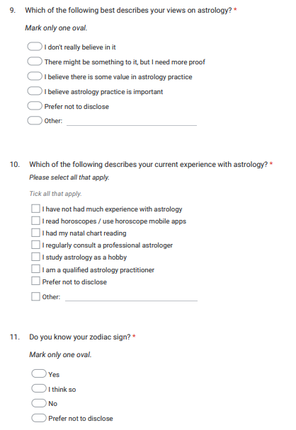
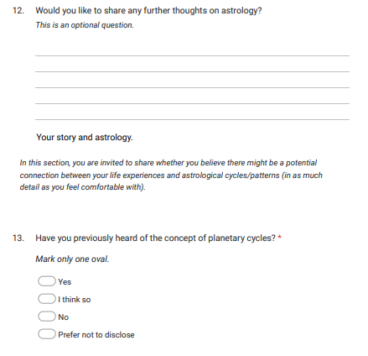

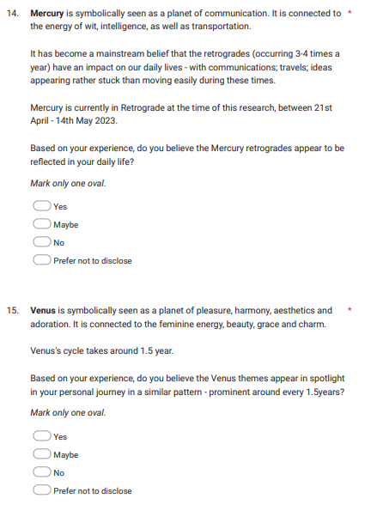
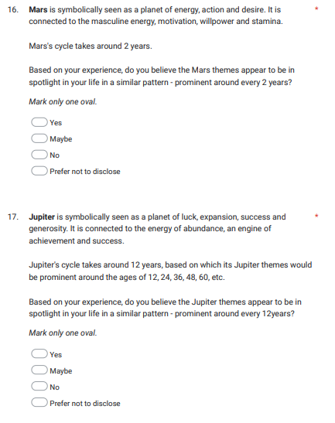
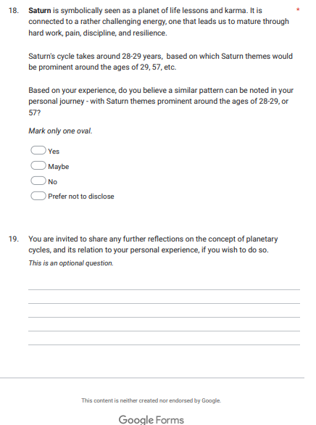

James Davidson, London Review of Books, Vol 26 No 23 (2004)
https://www.vice.com/en/topic/astrology
Gallup, George H. quoted by Nicholas Campion, Prophecy, Cosmology and the New Age Movement: The Extent and Nature of Contemporary Belief in Astrology. (PhD thesis, Bath Spa University/University of the West of England, 2004), p.219
Nicholas Campion, Prophecy, Cosmology and the New Age Movement: The Extent and Nature of Contemporary Belief in Astrology. (PhD thesis, Bath Spa University/University of the West of England, 2004), p.212
Liz Greene, Saturn: A New Look at The Old Devil. (San Francisco: Red Wheel / Weiser LLC, 1976), p. 12
Robert Hand. Planets in Transit: Life Cycles for Living. Atlgen: Whitford Press (1976)
Glock, Charles and Rodney Stark. Religion and Society in Tension. Chicago: Rand McNally, 1966 [1965], p.25
https://migrationobservatory.ox.ac.uk/resources/briefings/migrants-in-the-uk-an-overview/
Krosnick, J. and Presser, S. Question and Questionnaire Design. Handbook of Survey Research, 2 (2010), pp.263-314, p. 264
Jennifer Rowley. Designing and Using Research Questionnaires. Management Research Review,Vol. 37 Iss 3 (2014) pp. 308 – 330, p. 312
Kendall, L. (2008). The conduct of qualitative interview: Research questions, methodological issues, and researching online. In J. Coiro, M. Knobel, C. Lankshear & D. Leu (Eds.), Handbook of research on new literacies. New York: Lawrence Erlbaum Associates. Lai & Waltman. pp. 133-149.
Marlize Rabe, ‘Revisiting 'insiders' and 'outsiders' as social researchers’, African Sociological Review / Revue Africaine de Sociologie, Vol. 7, No. 2 (2003), pp. 149-161, p.156
Gallup, George H. quoted by Nicholas Campion, Prophecy, Cosmology and the New Age Movement: The Extent and Nature of Contemporary Belief in Astrology. (PhD thesis, Bath Spa University/University of the West of England, 2004), p.219
Nicholas Campion, Prophecy, Cosmology and the New Age Movement: The Extent and Nature of Contemporary Belief in Astrology. (PhD thesis, Bath Spa University/University of the West of England, 2004), p.221
James Davidson, London Review of Books, Vol 26 No 23 (2004)
Nicholas Campion, Prophecy, Cosmology and the New Age Movement: The Extent and Nature of Contemporary Belief in Astrology. (PhD thesis, Bath Spa University/University of the West of England, 2004), p.212
Glock, Charles and Rodney Stark. Religion and Society in Tension. Chicago: Rand McNally, 1966 [1965], p.25
Nicholas Campion, Prophecy, Cosmology and the New Age Movement: The Extent and Nature of Contemporary Belief in Astrology. (PhD thesis, Bath Spa University/University of the West of England, 2004), p.113
Robert Pelletier. Planets in Aspect: Understanding Your Inner Dynamics. Atlgen: Whitford Press (1974), p.5.
Robert Hand. Planets in Transit: Life Cycles for Living. Atlgen: Whitford Press (1976), p. 235.
Robert Pelletier. Planets in Aspect: Understanding Your Inner Dynamics. Atlgen: Whitford Press (1974), p.5.
Robert Hand. Planets in Transit: Life Cycles for Living. Atlgen: Whitford Press (1976), p. 348.

