REPORT:
Effective Teamwork and Communication

Author: Iurie Chetrari
Lecturer: Soban Sadiq

Introduction
In this research, I'd want to discuss how communication impacts our workplace and how it may help teams get stronger. Conversely, a lack of communication can play a significant role in a team's inefficiency.
I want to start out by defining communication. Griffith and Dunham define it as nothing more complicated than a conversation between at least two individuals. It refers to communicating ideas under the condition that the recipient can understand them. For this communication to be transmitted, we will need a sender, a recipient, a message, and a medium. Everything begins with an idea that the sender has in their head. The sender then chooses how to communicate the concept by encoding it in meaningful symbols (words, gestures, or visuals), and how to do it via any technological transmission medium, face-to-face conversation, or by leaving a message. Communication may seem straightforward, but there are several factors that can affect it and make it difficult. These factors include the medium of transmission, cultural context, and educational background.
Because it determines the very connections between team members, a company's degree of communication can determine its success or failure. An organisation may be productive and each team member can improve professionally and personally with effective communication amongst them. Naturally, when we work to create a successful team, we may run across various communication challenges that result from the educational, cultural, and social environments of each team member. Additionally, background noise might make conversation difficult. A successful team can typically overcome these obstacles and challenges, and in fact, every obstacle conquered helps the team succeed by fostering trust and greater communication among team members. On the other hand, it is quite simple to fail as a team because of obstacles that might lead to a toxic workplace and a team that is less successful.

Models of Communication
I'll discuss the benefits and drawbacks of each of the three major communication models that were created during the past century.

Shannon and Weaver Model of Communication
This communication model was created in 1948 by Weaver, a physicist, and Shannon, a mathematician. It was developed as a linear model to describe technical communication. The sender, who initiates communication and selects the transmitter who encrypts the message, is one of its six components. The encoded message from the transmitter is sent to a channel, which is sometimes referred to as the communication medium, as the following stage. Noise has an impact on the channel, according to Shannon and Weaver, which makes it difficult to deliver the right information. The message is being decoded by the recipient, who then gets the data. Initially, this communication model did not have a feedback component, which was a significant drawback for classifying this communication as effective.
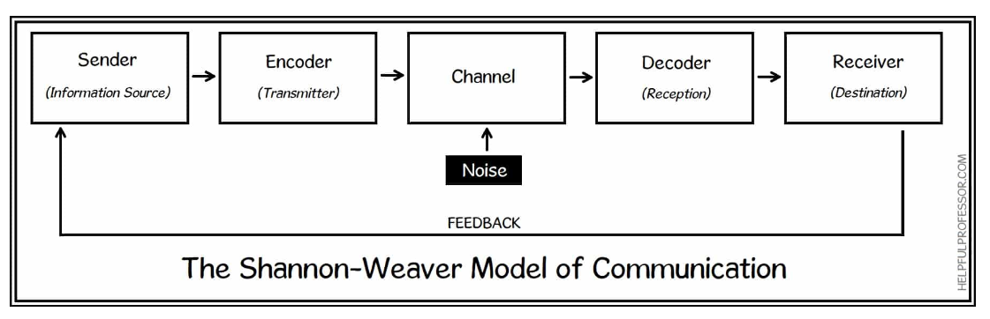
(AN ELITE CAFEMEDIA PUBLISHER, 2022)
The case study that was given during one of the lectures and included Maria and Pedro as the primary characters was a pertinent illustration. Pedro receives a call from Maria (the sender) on his mobile device (the encoder and channel) asking if he can pick up a chicken on the way home. Pedro doesn't provide any input about the message he heard since he had difficulty understanding it due to the background noise. When he gets home, he enters the kitchen (he mistook the word chicken for kitchen), and Maria realises that Pedro did not adequately understand the message she was trying to convey.
The same thing happened with me on my workplace. In my team I have an Ethiopian boy. He doesn’t speck English very good, but I always try to explain him very detailed. So, one day I give him the keys for one gate, that I think he know which gate, and tell him to open it for the scaffolders. He just gone and didn’t give me any response. I was carrying on my job. After half an hour the scaffolders ring me and start shouting and screaming why I didn’t open the gate for them. I was Shure that that boy will open the right gate, when I ring him, he was in a completely wrong space, but near a black gate. So, at the end this was and my and his fault. My because I didn’t ask him if he understand which gate and his foul was why he didn’t ask me what gate, or give me a response.
Schramm’s Model of Communication
This cyclical model of communication was created in 1964 by Wilber Schramm. He believes that the most crucial steps in communication are encoding and decoding the message. According to him, if the decoding doesn't take place, the message is meaningless. Additionally, he asserts that the receiver's primary duty for the communication's success is to provide feedback. The primary distinction between this communication model and the S&W paradigm is the presence of feedback.
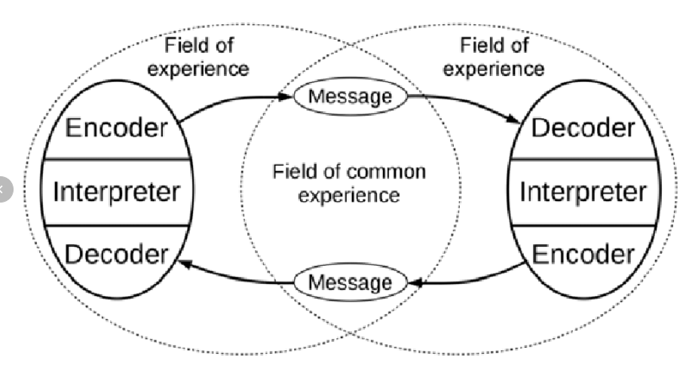
(ResearchGate GmbH, 2008-2022)
In the instance of the Maria and Pedro research, the comments would have been quite helpful. If Pedro was providing useful input, the communication was efficient and left no room for misunderstanding.

The case with the black gate wasn’t only one, I have these problems every single day. But after the case with scaffolders and the black gate a learn a very good lesson. Better ask twice, always ask people to give you feedback. Because a lot of people when you told them something, they just agree with you, without understanding you. And they just gone and think about what you tell them after. That is not right, we are humans we need to talk to each other, this how we develop this modern society, and is not a shame to ask twice. This what I trying to do now. Every time, when I have to do something, or I give to someone a task, I explain it or waiting for explaining give a feedback or wait for it and after star the task or send the man to do it.

Berol’s Model of Communication
There are four components to this communication model: Sender, Message, Channel, and Receiver (SMCR). Each component, according to Berol’s linear model of communication, is impacted by several factors. The Sender's communication abilities, attitude, expertise, social structure, and culture all have an impact on him. Content, Elements, Treatment, Structure, and Code all affect the message. Hearing, Seeing, Touching, Smelling, and Tasting all have an impact on the channel, and the receiver component is also directly impacted by the same senses as the transmitter. The fundamental drawback of this model is the same as that of the Shannon & Weaver model in that it lacks a communication feedback component, despite the fact that Berol identifies external noise as a source of disturbance inside the communication process.
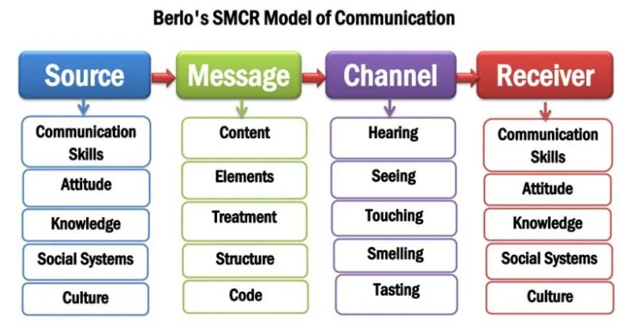
(M M Kobiruzzaman, 2021)
We will use the example of a professor who lives in a remote village as the case study for this model. One night, a fire starts in his home, and since he is unable to put it out on his own, he goes to the village to ask for assistance. He uses an advanced vocabulary to sound the alarm, but because of the educational gaps between him and the other villagers, who are the recipients, he is not understood, and the fire spreads. This case study supports Berol’s idea that the communication process is significantly influenced by the educational backgrounds of the sender and the recipient, and that occasionally the intended information that was supposed to be communicated is completely different from the one received.
I have the same problems when I first came to United Kingdom. I never was before in a English speak country. I go to work in building, but my English on that moment wasn’t for building, I knew what to do, but didn’t understand it or explain it. So, my manager was thinking that I am a useless man and stuff like this. I was trying to explain him to don’t speak to me in proper building terms, but something simple, but he didn’t have enough patience. At the same time the main contract manager sees what can I do, and he was happy with me, even if my English wasn’t perfect. After a wile my manager fired me off because he didn’t explain me proper what to do. When the main contract manager see that I am going home he told me to come back tomorrow, and he will sort it. He explained to the manager that we live in a multinational country and you need to have enough patience to each other, and try to explain him on his level of communication, and if you can not do it is your fault not your workers. This case shows exactly the Berol’s model of communication.
Communication Skills
The ability to communicate effectively in the job is among the most crucial and sought-after abilities. But why are businesses searching for employees with great communication abilities more and more? To summarise, current research reveals, for instance, that 61% of workers believe that poor communication is to blame for their bad morale at work, according to Woods (2010) in an article published regarding the relationship between employees and managers. 30% of those surveyed said that poor communication results in business loss, and 60% of them believe that poor communication is the primary cause of confusion for the company's clients or customers. Good teamwork is built on effective communication because it fosters bonds between members that extend beyond the workplace and fosters empathy and understanding among team members. As a consequence, the team will be more effective and powerful.

Verbal communication
It alludes to the spoken communications produced by language. The key need is that the recipient correctly perceives the information that was intended to be given; otherwise, it is meaningless. Your language abilities will help you better express yourself and comprehend the things people are trying to convey to you, which will improve your verbal communication skills (Quintanilla, 2020, pp 20-60).
When we talk about verbal communication, specific laws of communication apply. When speaking, we must take into account the situation we are in since some concepts are suitable to communicate in a particular setting while others are not.
Non-verbal communication
It consists of all other verbal and nonverbal means of communication. Nearly 90% of all communication is nonverbal, as is well known. All nonverbal communication, including body language, gestures, and facial emotions, falls under the umbrella of nonverbal communication.
An employee named Mark is asked by the company's CEO, Mrs. Brown, to express her congratulations on his significant professional accomplishments as part of a case study designed to highlight the significance of nonverbal communication. To help him unwind and gain confidence, Mrs. Brown is asking him simple questions. Her plan succeeds, and he starts to relax, cross his legs, and act too comfortable while simultaneously criticising his employer and the manner he is performing his duties. Having had enough, Mrs. Brown tells him that the secretary will throw him out. Using this type of verbal and nonverbal communication is inappropriate while speaking with our supervisor. As we can see, everything we express and say is crucial and has the potential to immediately affect us.
Active Listening
Active listening is a crucial step in the communication process because it helps us grasp and interpret what the person speaking is attempting to convey as well as their body language. It also helps us hear what they are saying.
In order to emphasise the significance of attentive listening, a case study on Max the event planner was given in class. When Tamara and her 300 guests arrived at the designated venue for the event, she realised that Max hadn't changed the date as he was supposed to have because he hadn't been paying attention to her when she asked for the change in date. Max was trying to plan Tamara's parents' wedding anniversary, but due to the high volume of calls he was receiving to plan other events, he forgot to do so.

Technology in Communication
Communication is significantly influenced by technology. Long distances become irrelevant thanks to technology, which makes communication quick and opens up channels of connection from all over the world in a matter of seconds. Privacy invasion, social isolation, and addiction are a few drawbacks.

Conclusion
I this report I was talking about, effective team work and communication. I cover all module that was teaching by our lecturer. According to our team project we try to develop all this communication skills to make a good team and to pass our goal. We use all this and have a good and strong team.
Everyone can communicate, but to do it in the right way is not so easy. And it doesn’t matter, language, colour, ages, sex or the other thing. If you have communication skills you avoid all this, and send your message and receive a response.

References
- Quintanilla, Kelly M. (2020) Business and professional communication: keys for workplace excellence SAGE Publications, Inc.
- Woods, D. (2010) Poor communication between managers and employees wastes time and impacts productivity, Available at: https://www.hrmagazine.co.uk/content/news/poor- SAvailable at: communication-between-managers-and-employees-wastes-time-and-impacts-productivity (Accessed: 15 August 2022)
- Shannon and Weaver Model of Communication. Available at: https://helpfulprofessor.com/shannon-weaver-model/ (Accessed: 26 August 2022)
- The interactive model of communication presented by Schramm. Available at: https://www.researchgate.net/figure/The-interactive-model-of-communication-presented-by-Schramm-14_fig1_311739283 (Accessed: 26 August 2022)
- Berlo’s Model of communication. Available at: https://newsmoor.com/smcr-model-of-communication-david-berlos-smcr-model-of-communication-example/ (Accessed: 26 August 2022)

