SPC Assignment on
Smart Home Device Manager System for Bright Minds Academy
8/17/2026
University of Wales Trinity Saint David
London Campus

Module Name: Scripting and Programming Concepts
Module Code: ACCA 5036
Student Name: Jasin Navas
Student ID:2426726
Lecturer’s Name: Koushik Modak

Code Link: https://github.com/jas7799/Scripting-and-Programming-Concepts-ACCA5036_LON-.git

Table of Contents
Introduction 2
Main Body 2
Analysis 2
Requirements Analysis 2
Software Design and Development 4
Design: 4
Flowcharts: 4
Pseudo-code: 6
Implementation Decisions 7
Programming Constructs: 8
Source Code 9
Testing and Debugging Report 15
Evaluation 18
Conclusion 19
References 19

Introduction
Bright Minds Academy is introducing smart devices such as smart lights, thermostats, and projectors to improve the learning experience in their classrooms. Now, staff members manage these devices manually, which makes it difficult to remember where each device is located, whether it is online or offline, and when it was last used. As more devices are added, this manual method becomes confusing and unreliable. The academy needs a simple digital system that can store device information clearly and help staff check device status quickly.
In this assessment, I developed a basic Python program called the Smart Home Device Manager to solve this problem. The system allows staff to add new devices, update their status, view all devices, and search for a specific device by name. I used simple Python data structures such as lists and dictionaries, so the program does not require a database. The design process included analysing the requirements, creating flowcharts and pseudocode, and then implementing the solution using user-defined functions and input validation.
This report explains how the system was planned, designed, implemented, and tested. It also includes a reflection on the development process and possible improvements for future versions. The goal of the project is to provide Bright Minds Academy with an easy-to-use tool that makes managing smart classroom devices more organised and efficient.

Main Body

Analysis

Requirements Analysis
Bright Minds Academy needs a simple digital system to help staff manage smart classroom devices more efficiently. Nowadays, devices such as smart lights, thermostats, and projectors are tracked manually, which makes it difficult to remember their locations and statuses. As the number of devices increases, this manual method becomes unreliable and time-consuming. To solve this problem, I analysed the scenario and identified the essential features that the Smart Home Device Manager must include. The aim is to design a basic Python program that stores device information clearly and allows staff to update and retrieve details easily.

Functional Requirements
Functional requirements explain what the system needs to do. Here I describe the main tasks and actions that the Smart Home Device Manager must support so staff can manage devices properly.

Add New Devices
The system must allow staff to add new devices to the list. When adding a device, the user should enter the device name (e.g., “Smart Light A1”) and the room where it is located. This ensures that all devices are recorded in a structured and organised format.

Update Device Status
Staff can update the status of any device when needed. They can mark a device as online, offline, or under maintenance. This helps the staff easily see the device’s condition and quickly know if it needs fixing or any kind of attention. This makes it simple for the staff to check the device’s status and know straight away if something is wrong.

View Device List
The system can show all devices together with their rooms and current statuses. This helps the staff see everything in one place and understand what devices are available. It also makes it easier for them to organise and prepare classrooms because they can quickly check which devices are ready to use.

Simple Search
The system includes a search feature where the staff can type the name of a device and instantly see all its details, such as the device name, the room it is located in, and its status. This helps the staff quickly check if a device is working and find its exact location without looking through the whole list. It also saves time when preparing classrooms because they can easily confirm whether a device is ready to use.

User Friendly Interface
The system should be easy for the user to use. The user can follow clear steps on the screen to move through each option without needing technical skills. This makes the system simple to understand and helps avoid mistakes. It also helps the user finish tasks faster because everything is easy to follow.

Scalability
The system should be flexible so more features can be added in the future. The system can update itself when the academy’s needs change. It will stay useful for a long time because we can add new features whenever needed. This makes the system easy to improve over time.

Non‑Functional Requirements
Non-functional requirements describe how the system should behave and the quality it must provide. Here I explain the important conditions the Smart Home Device Manager needs to meet so staff can use the system easily, smoothly, and without any issues.

Reliability
The system should always work properly and show correct information. This helps staff trust what they see on the screen. It also makes the system dependable because the information stays accurate every time they use it.

Performance
The system should work fast when staff add, update, or search for devices. Quick responses make the system easier to use. It also helps staff finish their tasks faster because they do not need to wait for the system to load.

Security
The system should keep all device information safe. It should stop data from being changed or lost by mistake. This protects the information and makes sure everything stays correct and secure.

Accessibility
The system should be easy to open and use on any academy computer. Staff should be able to use it without special setup or extra steps. This makes the system simple for everyone to access and use anytime.

Software Design and Development
Here I explain how I planned and built the software. I describe the steps I followed to create the Smart Home Device Manager and the design choices I made during development. I also show how the system’s logic was organised and how each part of the program was developed from these ideas.

Design:
Here I explain how the design of the system works on the inside. I describe the logic of the program, the order of actions it follows, and how each feature is supposed to work. This part shows how the system processes information step by step and how the main functions are organised to make the Smart Home Device Manager run smoothly.

Flowcharts:
Here I explain how flowcharts show the steps of the system in a simple visual way. It helps us understand how the program moves from one step to another and how it decides what to do next. Flowcharts make everything clearer because they show each step in a simple and organised way.
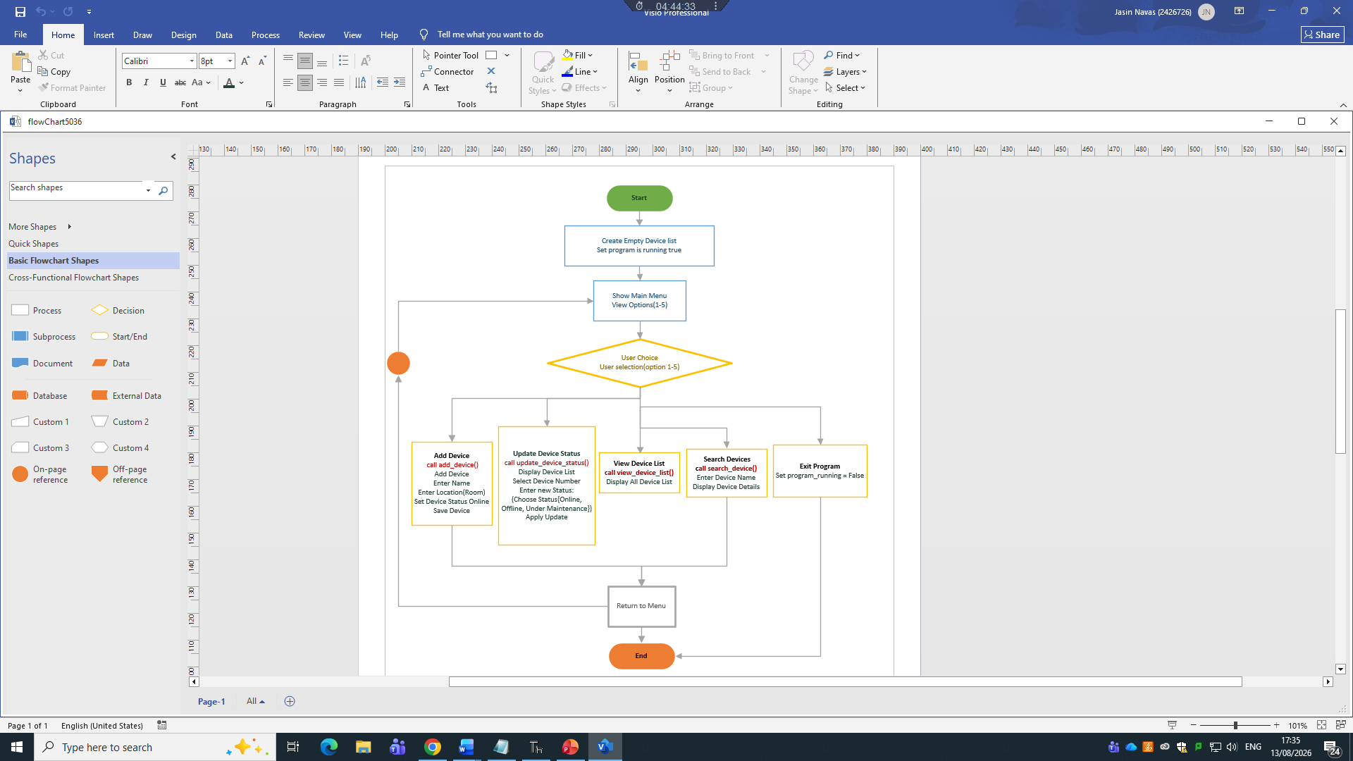
Figure 1: Flowchart of the Smart Home Device Manager Program
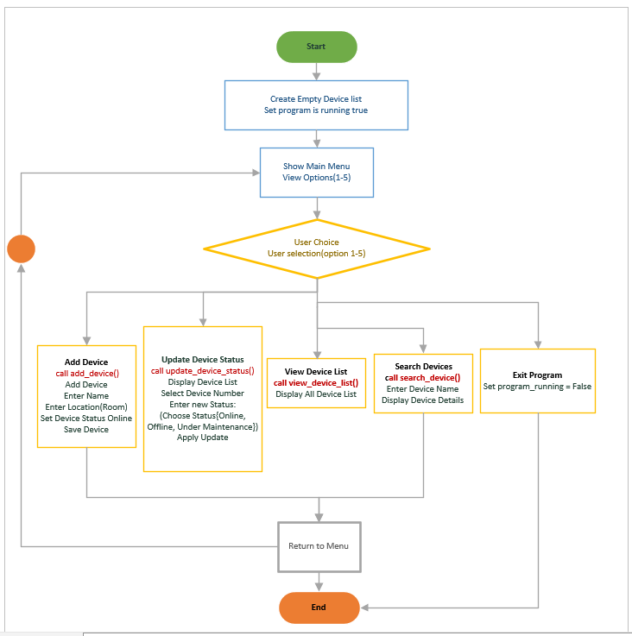
Figure 2: Flowchart of the Smart Home Device Manager Program.

Pseudo-code:
In this part I explain how pseudo-code is used to show the basic steps of the system. It gives a simple, text-based outline of what each function should do before writing the real Python code. Pseudo-code helps us understand the logic in a clear and easy way by breaking the program into small, organised steps that are simple to follow.
START
Create empty list called device_list
Call main_menu
END
FUNCTION main_menu
Set program_running = True
WHILE program_running is True
Display menu options (1–5)
Ask user for selection
IF selection = "1" THEN
Call add_device
ELSE IF selection = "2" THEN
Call update_device_status
ELSE IF selection = "3" THEN
Call view_device_list
ELSE IF selection = "4" THEN
Call search_device
ELSE IF selection = "5" THEN
Display "Exiting Program..."
Set program_running = False
ELSE
Display "Invalid option"
END FUNCTION
FUNCTION add_device
Display "Add New Device"
Ask user for device name
Ask user for room
Set status = "Online"
Create new_device with name, room, status
Add new_device to device_list
Display "Device Added Successfully"
END FUNCTION
FUNCTION update_device_status
Display list of devices with numbers
Ask user for device number
Convert number to index (number - 1)
IF index is valid THEN
Ask user for new status
Update device_list[index]. status
Display "Status Updated"
ELSE
Display "Invalid device selection"
END FUNCTION
FUNCTION view_device_list
Display "Device List"
FOR each device in device_list
Display device name, room, and status
END FUNCTION
FUNCTION search_device
Ask user for device name to search
Set found = False
FOR each device in device_list
IF device name matches THEN
Display device details
Set found = True
BREAK
IF found = False THEN
Display "Device Not Found"
END FUNCTION

Implementation Decisions

Data Structures:
In this project, I used a list of dictionaries to store all device information. This structure is simple, clear, and suitable for a small Python program. The list is used to hold all devices together, and each dictionary stores the details of one device. This makes the information organised and easy to work with.
A list in Python keeps items in order and can grow or shrink whenever needed. This is helpful for the Smart Home Device Manager because new devices may be added over time. Lists are commonly used in Python programs because they allow developers to store many items and access them easily [1].
A dictionary is used for each device because it can store several pieces of information under clear labels. In this program, each dictionary stores the device’s name, the room it is located in, and its current status. Dictionaries are useful for grouping related information together, which makes updating and searching simple [2].
Using a list of dictionaries is a good choice for this project because it keeps the data organised, easy to update, and simple to search. It also avoids the need for a database, which makes the program easier to run on any computer. This type of structure is often recommended for beginner-level Python projects because it is easy to understand and flexible [3].
Why this Data structure is used for the Smart Home Device Manager
- Easy to add new devices: Each new device is appended to the list.
- Easy to update: The dictionary format makes it simple to change the status of a device.
- Easy to search: The program can loop through the list and check dictionary keys.
- Readable and organised: Staff can clearly see each device’s name, room, and status.
- Beginner-friendly: Lists and dictionaries are basic Python structures that are easy to learn and use. They allow new programmers to store and organise information without needing advanced programming knowledge.
- No external storage needed: The program runs fully in Python without requiring a database.

Variables Used
Variable Name | Data Type | Purpose / Description
device_list | List | Stores all devices. Each device is saved as a dictionary inside this list.
program_running | Boolean | Controls the main loop. True keeps the program running; False stops it.
user_selection | String | Stores the menu option chosen by the user.
name | String | Stores the device name entered when adding a new device.
room | String | Stores the room where the device is located.
status | String | Stores the default device status (“Online”).
new_device | Dictionary | Stores one device’s details (name, room, status) before adding it to the list.
counter | Integer | Used to display device numbers (1, 2, 3…) when listing devices.
choice_index | Integer | Converts the user’s device number into the correct list index.
new_status | String | Stores the updated status entered by the user when modifying a device.
search_name | String | Stores the device name typed by the user during a search.
found | Boolean | Tracks whether a device was found during a search.
device | Dictionary | Temporary variable used in loops to access each device in the list.
Table 1

Programming Constructs:
In this project, I used several basic programming constructs to control how the Smart Home Device Manager works. These constructs help the program make decisions, repeat actions, organise tasks into smaller parts, and handle incorrect input safely. They were chosen because they are simple, easy to understand, and suitable for beginner-level Python development.

Control Flow (if, elif, else)
The main menu uses if, elif, and else statements to decide which action to perform based on the user’s choice. When the user enters a number between 1 and 5, the program checks the value and runs the correct function. Control flow is important because it allows the program to react differently depending on the user’s input [1].

Loops (while and for)
A while loop keeps the menu running until the user chooses to exit. This allows the user to perform multiple actions without restarting the program. For loops are used to go through the list of devices when displaying them or searching for a specific device. Loops help repeat tasks automatically and make the program shorter and easier to maintain. Python loops are commonly used for scanning lists and processing items one by one [2].

Functions (methods)
The program is divided into small functions such as add_device(), update_device_status(), view_device_list(), and search_device(). Each function handles one task, which makes the code organised and easier to test. Using functions also avoids repeating the same code in different places. Modular design is recommended in Python because it improves readability and reduces errors [3].

Basic Error Handling
Basic input validation is used to prevent the program from crashing. The program checks whether the user entered a valid menu option and whether a device number exists before updating it. Instead of stopping the program, it prints a clear message such as “Invalid option” or “Device Not Found.” This makes the program more reliable and user-friendly. Error handling is an important part of Python programs because it helps maintain stability and prevents unexpected failures [4].

Source Code
GitHub Link: https://github.com/jas7799/Scripting-and-Programming-Concepts-ACCA5036_LON-.git
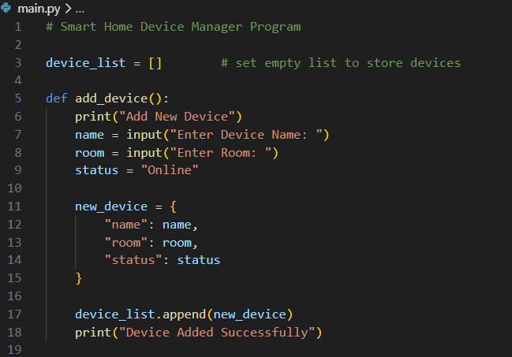
Figure 3: Source code of the add_device function.
This screenshot shows the source code of the add_device function inside main.py. The function begins by printing a small heading, so the user knows they are on the Add Device screen. It then collects two pieces of input, the device name and the room, and sets status to Online by default, since a newly added device is assumed to be working when it is first registered. These three values are combined into a dictionary called new_device, which gets appended to device_list. A confirmation message is printed at the end, giving the user immediate feedback that the device was saved. This directly implements the Add New Devices functional requirement described earlier in the report.
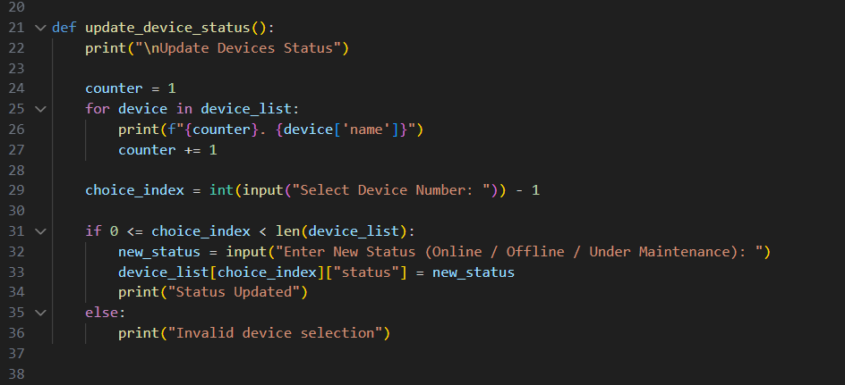
Figure 4: Source code of the update_device_status function.
This is the source code of the update_device_status function. It loops through device_list and prints each device with a number beside it, so staff can select a device by number instead of typing its full name. The chosen number is converted into a list index by subtracting one, since Python lists start counting from zero. Before changing anything, the code checks that this index actually falls inside device_list, which stops the program from crashing if someone enters a number that is too high or too low. When the index is valid, the status field is replaced with whatever the user types next; if it is not, an invalid selection message is printed instead. This implements the Update Device Status requirement, and the index check is the basic error handling mentioned in the Implementation Decisions section.
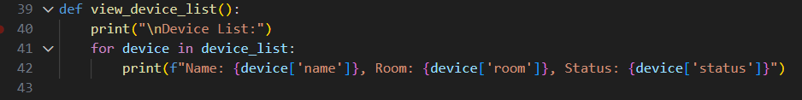
Figure 5: Source code of the view_device_list function.
The view_device_list function is the simplest of the main functions shown here. It prints a heading and then loops through every dictionary stored in device_list, printing the name, room, and status of each device on its own line using an f-string. Because it takes no input from the user, this function exists purely to give staff a quick, read-only overview of every device currently registered in the system. This corresponds to the View Device List requirement, giving staff the simple overview described in the Requirements Analysis.
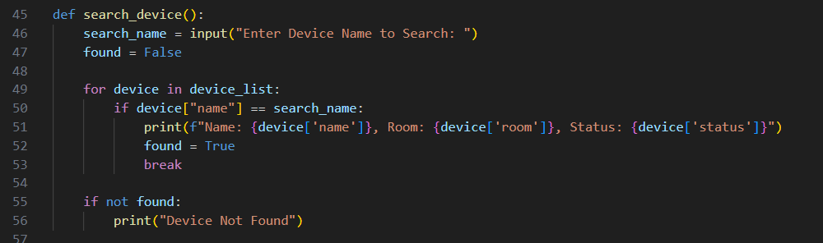
Figure 6: Source code of the search_device function.
This function lets staff search for a specific device by name. A found flag is set to False before the loop begins, and the code checks each device in device_list to see whether its name matches the search term entered by the user. When a match turns up, the device's name, room, and status are printed, found is set to True, and the loop breaks early so the program stops searching once it already has an answer. If the loop finishes without finding a match, found stays False and the program prints a Device Not Found message instead. This implements the Simple Search requirement, letting staff find a device instantly instead of scrolling through the whole list.
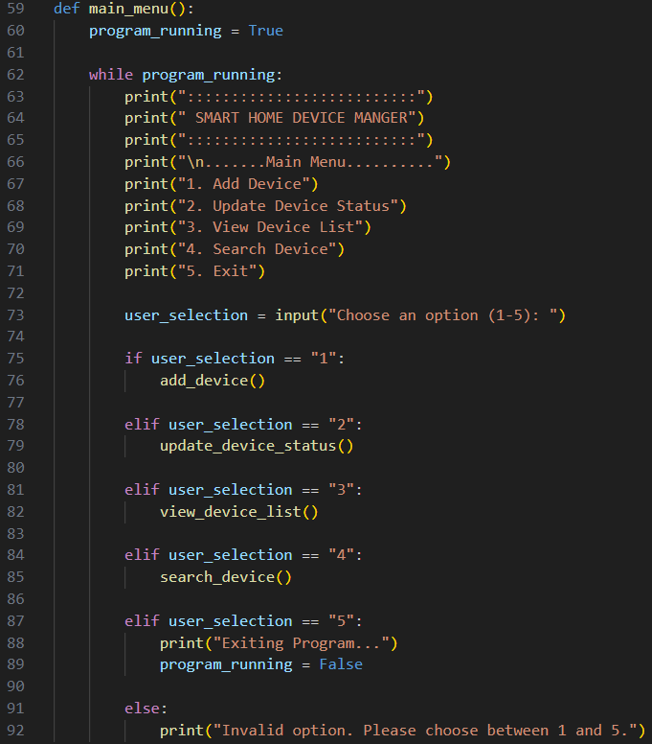
Figure 7: Source code of the main_menu function.
The main_menu function is what controls the whole program while it is running. A while loop keeps the menu on screen for as long as program_running is True, and on every pass, it prints the title banner and the five numbered options. Based on the number the user types, an if and elif chain calls the matching function, add_device, update_device_status, view_device_list, or search_device. Selecting option five sets program_running to False, which breaks the while loop and closes the program cleanly. Anything typed outside the range 1 to 5 falls into the final else branch, which prints an invalid option message rather than letting the program crash. This function ties all four features together behind the User-Friendly Interface requirement, since it is the single screen staff interact with.
Figure 8: Program entry point calling main_menu.
This is the last part of main.py, the point where the program actually starts running. The if __name__ == "__main__" check makes sure main_menu only runs when this file is executed directly, rather than every time it is imported somewhere else. This matters later on, because test.py imports main to reuse its functions without wanting the menu to launch on its own. Once main.py is run directly from the terminal, this line calls main_menu and the program begins. Keeping this separate from the function definitions above also supports the Scalability requirement, since new code can be added above this line without changing how the program starts.

Output main.py
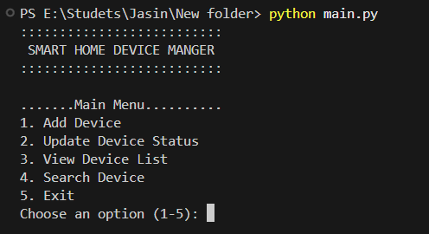
Figure 9: Main Menu when the program is start.
This is the terminal window right after running python main.py. The program prints the title banner and then the five numbered options: add device, update status, view list, search device, and exit. It waits at the bottom for the user to type a number between 1 and 5, showing that the menu is displaying correctly before any device information has been entered yet. This confirms the interface described under User Friendly Interface actually appears as intended when the program runs.
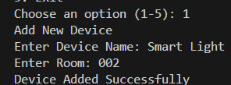
Figure 10: Option 1 Output
After choosing option 1 from the menu, the program asks for a device name and a room in turn. Here the user types of Smart Light for the name and 002 for the room, and the program responds with Device Added Successfully. This output confirms that the add_device function is reading the typed input correctly and storing it as a new entry in device_list. It shows the Add New Devices feature working end to end, not just in the source code but in a real run.
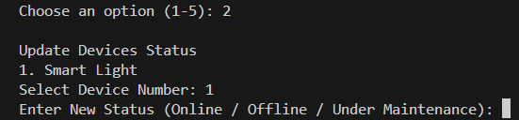
Figure 11: Option 2 Output
Choosing option 2 first lists the devices currently stored, showing Smart Light as device number 1. The program then asks the user to select a device number, followed by a prompt for the new status: Online, Offline, or Under Maintenance. This output shows that update_device_status has correctly located the chosen device and is waiting for the replacement status before it updates the record. It shows the Update Device Status feature responding to a real device already stored in the list.
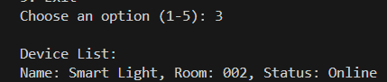
Figure 12: Option 3 Output
Selecting option 3 prints the full device list. The output here shows Smart Light in room 002 with status Online, which confirms that the earlier add and update actions were actually saved and that view_device_list can read every stored device back out correctly. It shows the View Device List feature returning accurate, up to date information after changes were made.
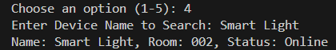
Figure 13: Option 4 Output
After choosing option 4 and typing Smart Light, the program searches device_list and prints the matching device's name, room, and status. This output shows that search_device compares the typed name against each stored device and correctly returns the details of the one that matches. It shows the Simple Search feature correctly returning a match on a real run of the program.

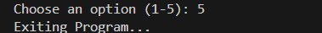
Figure 14: Option 5 Output
Choosing option 5 prints an Exiting Program message and the while loop inside main_menu ends. This is the expected behaviour once a user has finished working with the system, and it confirms the program closes normally instead of continuing to loop. This confirms the exit option shuts the program down cleanly instead of leaving it stuck in the loop.

Testing and Debugging
During this project, I learned how important testing and debugging are for making a program work properly. Testing helped me check each feature to make sure it responded correctly to both good and bad user input. It also showed me where the program needed fixing. Debugging then helped me find the exact problems by checking the code step by step and correcting mistakes like wrong menu choices or invalid device numbers. This process made my program more stable and taught me how testing improves software quality [5], and how fixing errors early helps create cleaner and more reliable code [6].
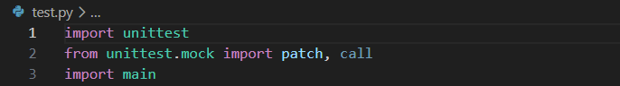
Figure 15: Imports used in test.py.
test.py begins by importing the unittest module, which supplies the framework used to write and run automated test cases. It also imports patch and call from unittest.mock, used later to replace the real input and print functions so the tests do not need a person sitting at the keyboard, and imports main itself so its functions can be tested directly from this file. These imports set up everything needed to test the program automatically, supporting the Reliability requirement discussed earlier.
Figure 16: Declaration of the TestSmartHomeDeviceManager test class.
This screenshot shows the declaration of TestSmartHomeDeviceManager, the class that holds every individual test written for this project. It inherits from unittest.TestCase, which lets the unittest module automatically discover and run each test method inside the class rather than needing every test to be called manually. Structuring the tests this way also makes the test file easier to read and maintain as more tests get added.
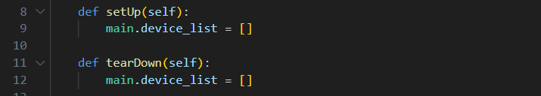
Figure 17: setUp and tearDown methods.
The setUp method runs automatically before every test and resets main.device_list to an empty list, while tearDown does the same thing again once each test has finished. Resetting the list at both ends keeps every test independent, since data created inside one test cannot leak into and change the result of the next test. Without this reset, an earlier test could leave data behind and cause a later test to fail for the wrong reason.
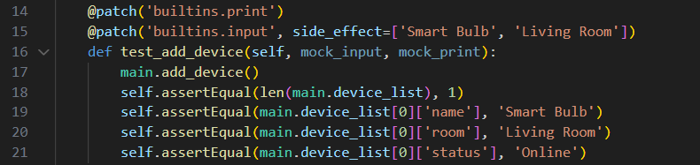
Figure 18: test_add_device test case.
This test checks that add_device behaves correctly without needing anyone to type anything by hand. The patch decorators replace input so it automatically returns Smart Bulb and Living Room in order, and replace print so nothing actually appears on screen during the test. After add_device runs, the test asserts that device_list contains exactly one entry, and that its name, room, and status fields match what the mocked input provided. Testing this way avoids needing a person to manually add a device every time the test suite runs.
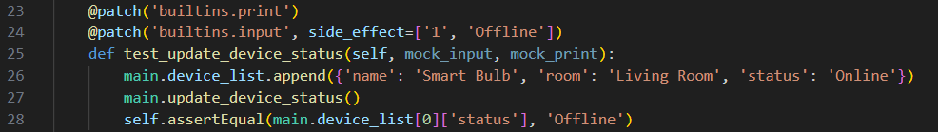
Figure 19: test_update_device_status test case.
Here the test first appends a sample device directly to device_list, then mocks the input needed to select device number 1 and change its status to Offline. After calling update_device_status, the assertion checks that the status stored in device_list was actually changed to Offline, confirming the function edits the correct entry. This test protects against future changes accidentally breaking the update feature.
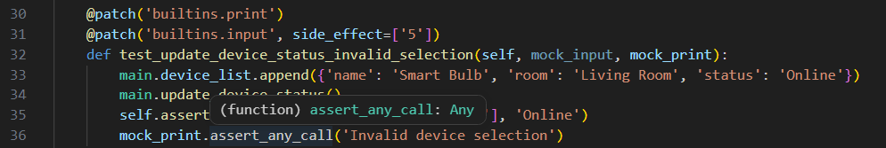
Figure 20: test_update_device_status_invalid_selection test case.
This test checks what happens when a user selects a device number that does not exist, simulated here by mocking the input as 5 while only one device is stored. It confirms that the existing device is left unchanged and checks that mock_print was called with the Invalid device selection message, proving the error handling branch actually runs. Tests like this one are what catch bugs before staff would ever encounter them.
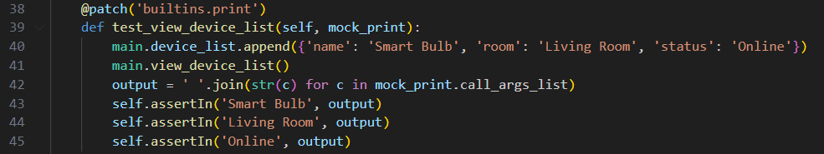
Figure 21: test_view_device_list test case.
After adding one sample device, this test calls view_device_list and joins everything sent to the mocked print function into a single string. It then checks that Smart Bulb, Living Room, and Online all appear somewhere in that output, confirming the function prints every field of the device instead of leaving one out. Checking for all three fields makes sure no part of the device record gets left out silently.
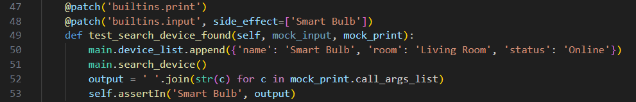
Figure 22: test_search_device_found test case.
This test mocks the search input as Smart Bulb, matching the device already stored in the list, then calls search_device and checks that Smart Bulb appears in the mocked print output. It confirms that the function correctly finds an existing device and prints its details when the name matches.
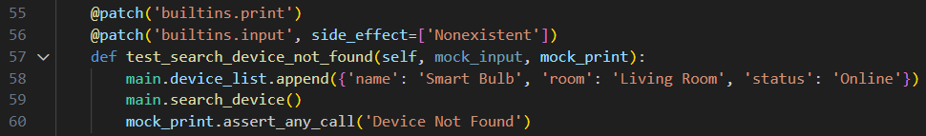
Figure 23: test_search_device_not_found test case.
Here the mocked input is Nonexistent, a name that does not match the one device already stored in the list. The test checks that print was called with the Device Not Found message, confirming the function correctly reports when no match is found instead of failing quietly or returning the wrong result. Handling the not found case correctly is just as important as handling a successful search.
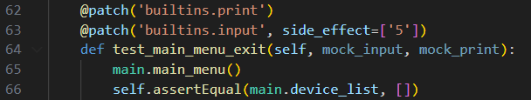
Figure 24: test_main_menu_exit test case.
This test mocks the menu input as 5 and calls main_menu directly. Since option 5 is meant to end the program immediately, the test checks that device_list is still empty afterwards, confirming the while loop exits on its first pass without calling any of the other menu functions.
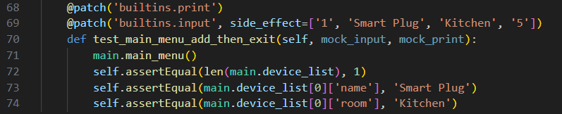
Figure 25: test_main_menu_add_then_exit test case.
This test is a more complete run through the menu. It mocks a sequence of inputs, 1 to add a device, Smart Plug and Kitchen for its details, then 5 to exit, and calls main_menu with that sequence. The assertions confirm that device_list ends up with exactly one entry named Smart Plug in the Kitchen, showing that the menu correctly chains the add function and the exit option together. Chaining two actions together like this checks that the menu keeps working correctly across multiple choices in one session, not just in isolation.
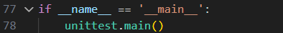
Figure 26: Entry point that runs the test suite.
Just like main.py, test.py ends with an if __name__ == '__main__' check. When the file is run directly from the terminal, this line calls unittest.main(), which automatically finds and runs every test method inside TestSmartHomeDeviceManager. This mirrors the same entry point pattern used in main.py, keeping the two files consistent.
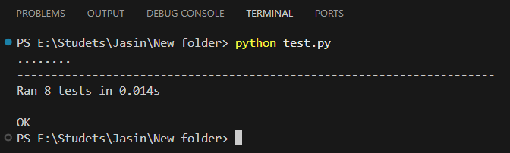
Figure 27: Terminal output after running the test suite.
This is the result of running python test.py in the terminal. Each dot on the second line represents one test that passed, and there are eight of them in total. The summary line below confirms that all eight tests ran in 0.014 seconds, and the final OK shows that every test in TestSmartHomeDeviceManager passed without any failures or errors. A clean OK result across all eight tests gives confidence that the core features described throughout this report work as intended.

Evaluation
The Smart Home Device Manager meets the main goals of the project. It allows staff to add devices, update their status, view all devices, and search for a specific device. These features work correctly and were confirmed through manual testing and automated unit tests. Using simple Python structures such as lists and dictionaries made the system easy to build and suitable for beginner-level development [7]
Challenges Faced
One challenge I faced during the project was organising the program, so each function worked correctly without causing errors in other parts of the system. At first, the program crashed easily when users entered wrong input, such as typing letters instead of numbers. I solved this by adding simple validation checks and clear error messages. This helped me understand how important input handling is in Python and improved the stability of the program [7].
Another challenge was learning how to write automated tests using the unittest () module. Mocking user input and capturing printed output was confusing at first, and I struggled to make the tests run correctly. By practising and reviewing examples, I learned how to test each function properly. This improved the reliability of the program and helped me gain confidence in writing Python tests [8].
Future Improvements
Although the system works well for basic device management, it can be improved to make it more practical. One important improvement is adding data storage, such as saving devices to a JSON or text file. This would stop information from being lost when the program closes. The search function could also be improved by allowing partial matches or case-insensitive searches, making it easier for staff to find devices even with small typing mistakes [9].
Another useful improvement would be adding a graphical user interface (GUI) to make the system more user-friendly. A GUI would help staff interact with the system more easily compared to a text-based menu. Additional features such as sorting devices, filtering by status, or showing offline devices first would make the tool more helpful and support future growth of the software [10].
The Smart Home Device Manager is simple, reliable, and meets the main requirements. It provides a good foundation for future improvements and helped me understand how to design and test a complete Python program [10].

Conclusion
Through this assessment, I learned how to plan, build, and test a small Python program from start to finish. I understood how important it is to organise code into clear functions and use simple data structures like lists and dictionaries to store information. I also learned how to handle user input safely so the program does not crash when someone types something wrong. This helped me see why good structure and validation are important in real programs.
Overall, this project helped me improve my programming skills and understand how to design and test a complete Python program. I learned how to organise code, handle user input safely, and write automated tests to check each function. The system provides a strong foundation for future improvements, such as adding data storage, a graphical interface, and more advanced features. This experience has helped me grow as a developer and prepared me for more complex software projects in the future

References

[1] | M. Lutz, “Learning python: Powerful object-oriented programming,” 6 ed., 2025.
[2] | J. Zelle, in Python programming: an introduction to computer science, 2nd ed., pp. 105-107.
[3] | D. C. R. Severance, “Python for Everybody”.
[4] | M. Summerfield, Programming in Python 3.
[5] | Paul Ammann and Jeff Offut, “Introduction to Software Testing”.
[6] | A. Pajankar, “Python Unit Test Automation”.
[7] | A. Downey, “Think Python,How to Think Like a Computer Scientist”.
[8] | B. Slatkin, Effective Python: 125 Specific Ways to Write Better Python.
[9] | L. Ramalho, Fluent Python: Clear, Concise, and Effective Programming.
[10] | J. Hunt, “Advanced Guide to Python 3 Programming,” Springer Nature Link.

