Student : Ionela Frusinica Cuciurean (2129289)
BMIH5005
Lecturer: Jemma Smith
Personnel Resourcing and Development
Assessment 1 – Essay
Topic: Discuss how the evolution of HRM facilitates the strategic development of an international hotel brand through workforce planning, recruitment and selection
Human resource management is an inseparable practice of the corporate sectors which is associated with effective planning, organising, directing, and controlling of the employees. According to the verdict of Michael Armstrong,1997 human resource management has been defined as the strategic practices undertaken for acquiring development management, motivation and to achieve the commitment of the organisation’s primary resources – its employees (Bratton et al., 2021). However, Edwin Flippo has described human resource management as a combination of effective planning, organising, directing, controlling, developing and overall maintenance of the human resources to achieve the pre-defined corporate objectives. HR has been also perceived as the process of acquiring training, appraising compensating the staffs along with assuring their workplace safety issues and health aspects as defined by Gary Dessler (Dessler, 2020).
Aligning with the topic of essay priority shall be given to explore the evolution of HRM down the time line followed with explaining the strategic HR planning and role of HR function citing a hospitality business of international cadre. The subsequent section of essay shall consider evaluating the employee recruitment and selection process citing real time examples from the employee recruitment practices of the selected hotel brand.
Established in 1987 and operational as a subsidiary private limited company with Whitbread as its parent organisation, Premier Inn is recognised as a British limited-service hotel chain. It is also enlisted as UK’s largest hotel brand. The referred organisation is operational at an international level; and has more than 800 hotel and over 72, 000 rooms. Dominic Paul in the precent Group CEO and Dunstable of England is the location for the company headquarter (premier inn., 2023).
Human resource management is evident to have evolved gradually across several decades with its inception history traced back during the early section of the 20th century wherein focus was to maintain records and assure compliance with labour laws (Pattanayak, 2020).
Hence the evolution of HRM can be segregated under following stages:
The pre industrial revolution era of HRM – depict the early evolutionary stage of HRM with absence of formal HRM practices. Priority was solely on manual labours with demand for long working hours.
The industrial revolution and HRM – witnessed visible changes in HRM practices with advent of steam power and mechanised equipment’s. Main emphasis was given on increasing productivity and efficiency and HRM practices were designed to achieve the same (Mahapatro, 2021).
The onset of personnel management concept in HRM – marked a visible shift with the existing HRM practices with greater priority of people management. During this period formal practices of HRM started growing and concept of employee welfare surfaced.
The era of human relations and HRM – a vital phase of HRM evolution initiated during 1930s and lasted till 1950s. Shift towards HRM practices that were individual centred with greater focus on communication and employee engagement. During this period focus was on establishing relations between the managers and staffs (Stone, 2024).
Advent of strategic HRM practices or SHRM – reflected huge shift in HRM practices and assured strategic management oi workforce. SHRM emerged during 1980s with an objective to establish high performance workplace culture
Technology and evolution in HRM – resulted in effective streamlining of HR practices and HR information system or HRIS was introduced facilitating digital and automated management of employee data.
Globalisation of HRM -resulted in HRM practices to go beyond national boundaries and facilitated effective management of culturally diverse employee pool.
The Contemporary era of HRM- indicated shift to inherit HRM related tools and technologies (Boxall and Purcell, 2022).
The HR functions comprise of various roles like recruitment and hiring, training and development. Restoration of employer-employee relations, to maintain the company culture and manage employee benefits. Additionally, emphasis to create a safe workplace and efficient management of disciplinary cations are other key roles included under HR functions (Anwar and Abdullah, 2021).
Referring to Premier Inn, its HR managers are responsive to carry out strategic roles in context of HR function. This further indicated their focus on maximize workplace productivity along with efficient planning, organising, directing and controlling of staffs. The workforce planning actions are part of strategic HR role within Premier Inn. Therefore, HR managers of Premier Inn are associated with formulation of integrated HR strategies to meet with the corporate goals. Workplace planning is identified as another strategic role of HR function applicable within Premier Inn (Stewart and Brown, 2019).
The phenomena of strategic HR planning being a crucial activity under HRM is associated with forecasting the future HR related needs of an organisation after evaluating the company’s present human resources and external labour market. Referring to the example of Premier Inn, its HRM department has also focussed on strategic HR planning process which comprise of certain steps. Efforts are given by the HR managers of Premier Inn to recognise the present supply of employees. Determine the future of its workforce along with focus on establish a balance between labour supply and demand. The subsequent HR related plans are further formulated by the HR managers of Premier Inn based on the predictions made (Armstrong and Taylor, 2020).
Forecasting the labour demand and supply considered as crucial aspect of strategic HR planning which is carried out at Premier Inn by its HR managers. This prediction of labour supply and demand is accomplished with analysis of the seasonal trends and workforce patterns of the organisation. Evaluation of the employee attendances, calculation of resignation incidents within a certain time span etc has been carried out at Premier Inn to forecast the demand and supply. This practice of strategic HR planning is important for the organisation enabling the same to limit additionally operational expenses by recruiting staffs to work overtime or appointing temporary employees. Moreover, employee burn out rate is also reduced by this assuring employee wellbeing and motivation (Mathis et al., 2017).
Goal setting practices identified as a vital aspect under strategic HR planning process which provide the concerned organisation with a clear sense of direction and purpose. At Premier Inn, its HR managers focus on goal setting practices by considering the corporate vision, mission, and value of Premier Inn. Goal setting is carried out by HR managers of Premier Inn by inheritance to SMART objectives along with recognition of potential barriers. Regular monitor of the strategic plan developed followed with goal setting practices is an important activity of HR managers in this context (Dowling, 2017).
Strategic planning practices are also evident with the HR department of Premier Inn which is distinct from goal setting practices. The latter is believed as broader and with long run outcomes that can be reasonably achieved over a certain time duration. However, strategic planning being distinct from goal setting practices depict formulation of a practical plan of action enabling the business to achieve its pre-defined objectives.
Hence the HR mangers of Premier Inn through effective goal setting and strategic planning has been able to remain updated with future state of scopes and changes applicable within the company. An effective anticipation of possible business-related risks with an ability to understand the optimisation of resource utilisation are other advantages obtained by HR managers in this context (Noe et al., 2020).
Another important activity of strategic planning is program implementation and its evaluation. Following effective communication of the HR strategy within Premier Inn, implementation to communicate the strategy to the entire employee base is the first step. Hence implementation of strategic HR plan within the organisational premise of Premier Inn is accomplished within the organisation through a systematized process of eliminating the company’s internal roadblocks to change. Hence formulation of a communication plan, organising staff training and development programs and offering them with support and guidance are key aspect of HR strategic plan and its subsequent implementation (Noe et al., 2020).
Referring to the above analysis it can be stated that HR managers of Premier Inn by execution of effective and strategic HR planning has been able to mitigate the operational risks along with benefitting the organisation’s employee engagement and retention status, increased productivity, and succession planning. It is by priority on strategic HR planning the organisation has effectively and proactively addressed the potential skill shortages and gaps within its current employee base (Greer, 2021).
The HR managers of corporate sector own a primary responsibility of recruiting and selecting employees and is considered as a vital HR practice. Presence of adequate extent of planning, organising, directing, and controlling skill of the HR managers are demanded to execute recruitment and selection flawlessly.
Therefore, the process of employee recruitment and selection are perceived as a multi layered process. Recruitment is associated with proper advertising of the position vacant while selection is the process of determining the best candidate from the pool of applicants (Boon et al., 2018).
Referring to the example of Premier Inn, its HRM department like other hospitality business are concerned with execution of effective staff recruitment and selection practices. The cited hospitality business regularly conducts staff recruitment and selection offering vacancy for various designations (Guest, 2017).
At Premier Inn the employee recruitment process is accomplished through internal and external recruitment practices. Internal recruitment is carried out at Premier Inn by advertising for a job position internally and selectin io made based on references and internally conducted interviews. It is observed that internal sourcing of candidates at Premier Inn being a cost-effective process can facilitate an efficacious avenue of talent sourcing to fill up the vacancies. The organisation executes internal recruitment by transferring of redundant yet experienced employees of same designation from one branch to another. Also, internal recruitment at this organisation is accomplished through promotion. No external advertisement for a position vacant is carried out during internal recruitment. This recruitment process is favoured by the organisation as it is cost effective, lesser time taking and significant information regarding the background of the applicants are already present (Ivancevich and Konopaske, 2013).
Followed with internal recruitment practices, the HR department of Premier Inn is also evident to execute external recruitment practices. For this purpose, advertisement for position vacant in posted at the company website, online social medial sites and advertised with the help of printed media. External; recruitment although tedious and incur an additionally expenditure but facilitates the organisation to select fresh talent from a diverse pool of talent. However, the HR managers while carrying out external recruitment practices are concerned to thoroughly judge the skills and attributes of the applicants with a priority to select the right candidate for the right job position. At Premier Inn external recruitment of employees is executed by job fairs, employee referrals, through recruitment agencies, job boards and by publicly posting for job positions. Advertisement based sourcing of profiles of distinct candidates is the primary means of external recruitment at Premier Inn. Recruitment of staffs through campus selection is also evident but a time-consuming process. Incorporation of third party-based placement agencies is also active in recruitment process of Premier Inn. During this process, the organisation focus on keeping track of the potential candidates that can be suitable for meeting the requirements of hospitality sector along with assuring the inclusion of adequate human talents within the employee pool of the concerned business (Wood, 2018).
After completion of the recruitment process, the HR managers of Premier Inn execute staff selection procedure. Employee selection is considered as the procedure of thoroughly assessing the candidates’ qualities, expertise, and experiences to narrow down and pool the deserving candidates for final selection. At Premier Inn in series of interviews are conducted after the candidates have qualified through the written examination for finally selecting the right candidate (Gary, 2011).
Hence understanding the overall process of employee recruitment and selection carried out by the HRM department of Premier Inn it can be further stated that this HR practice is a crucial one enabling the business to efficiently source, attract and recognise the best candidate for the right job role. An effective recruitment and selection hence helped the company to minimise attribution, an increased productivity followed with viability of the concerned business. Moreover, Premier Inn is also benefited by ability to attract the best talent, reduced employee burns out rates through its effective recruitment and selection system (Stewart and Brown, 2019).
On the concluding ground, HRM is an inseparable function of Premier Inn with direct impact over the company’s long run viability. The presence of competent HR managers of Premier Inn has contributed in formation of a highly productive employee base paving the organisation’s path to achieve the recognition of UK’s largest hotel chain business.

References

- Anwar, G. and Abdullah, N.N., 2021. The impact of Human resource management practice on Organizational performance. International journal of Engineering, Business and Management (IJEBM), 5.
- Armstrong, M. and Taylor, S., 2020. Armstrong's handbook of human resource management practice. Kogan Page Publishers.
- Boon, C., Eckardt, R., Lepak, D.P. and Boselie, P., 2018. Integrating strategic human capital and strategic human resource management. The International Journal of Human Resource Management, 29(1), pp.34-67.
- Boxall, P. and Purcell, J., 2022. Strategy and human resource management. Bloomsbury Publishing.
- Bratton, J., Gold, J., Bratton, A. and Steele, L., 2021. Human resource management. Bloomsbury Publishing.
- Dessler, G., 2020. Fundamentals of human resource management. Pearson.
- Dowling, P.J., Festing, M. and Engle, A.D., 2017. International human resource management. Cengage Learning.
- Gary, D., 2011. Human resource management. Pearson Education India.
- Greer, C.R., 2021. Strategic human resource management. Pearson Custom Publishing.
- Guest, D.E., 2017. Human resource management and employee well‐being: Towards a new analytic framework. Human resource management journal, 27(1), pp.22-38.
- Ivancevich, J.M. and Konopaske, R., 2013. Human resource management. McGraw-Hill.
- Mahapatro, B., 2021. Human resource management. New Age International (P) ltd..
- Mathis, R.L., Jackson, J.H., Valentine, S.R. and Meglich, P.A., 2017. Human resource management. Cengage learning.
- Noe, R.A., Hollenbeck, J.R., Gerhart, B. and Wright, P.M., 2020. Fundamentals of human resource management. McGraw-Hill.
- Pattanayak, B., 2020. Human resource management. PHI Learning Pvt. Ltd..
- Stewart, G.L. and Brown, K.G., 2019. Human resource management. John Wiley & Sons.
- Stewart, G.L. and Brown, K.G., 2019. Human resource management. John Wiley & Sons.
- Stone, R.J., Cox, A., Gavin, M. and Carpini, J., 2024. Human resource management. John Wiley & Sons.
- Wilton, N., 2022. An introduction to human resource management.
- Wood, S., 1999. Human resource management and performance. International journal of management reviews, 1(4), pp.367-413.

Appendix
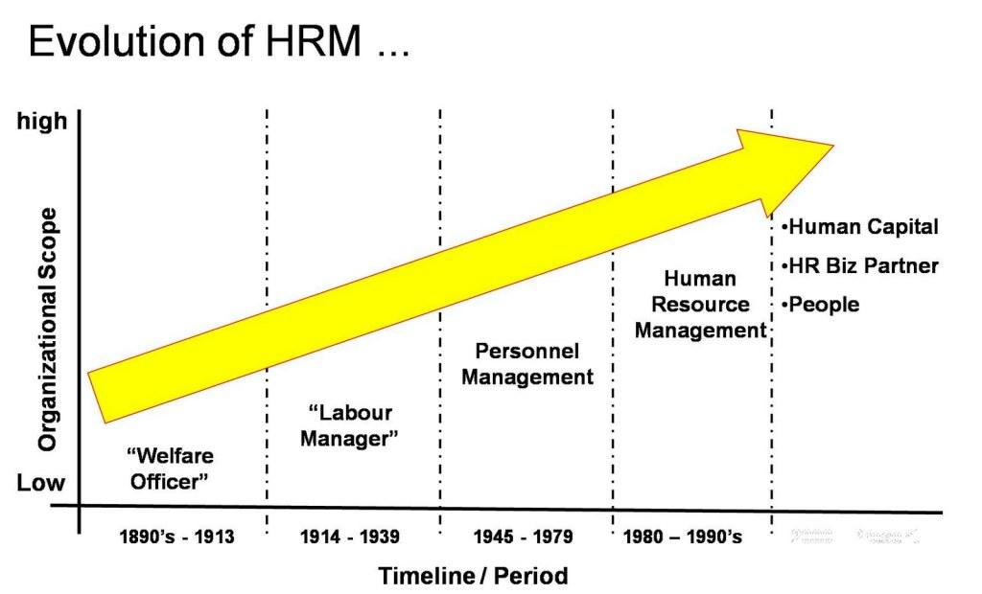
Source: (Wilton, 2022)

Source: (Stewart and Brown, 2019)
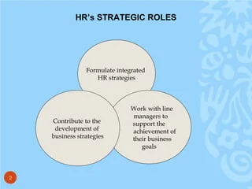
Source: (Armstrong and Taylor, 2020)

