Evaluate the reasons for staying in the EU?
Georgia Finselbach
18th October 2019
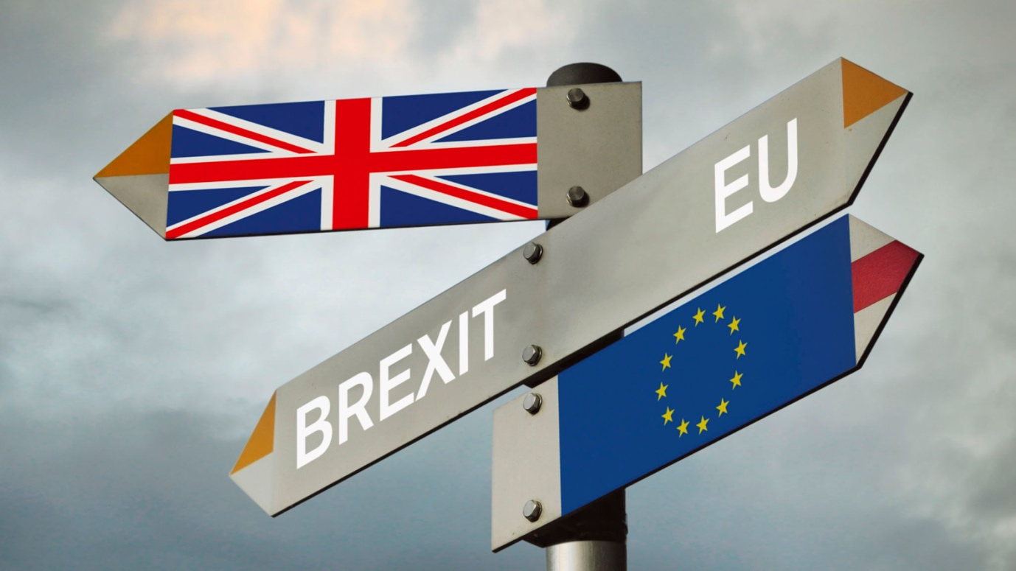

Contents Page.

Contents Page… 2

Executive Summary… 3

Introduction… 4

Main Findings… 5-7

Conclusion… 7

References… 8

Executive Summary.

This report states reasons for staying within the European Union. The United Kingdom voted to leave the European Union on 23rd June 2016. However has still not managed to physically leave and is still in the process of agreeing a deal. The European Union is the United Kingdom’s main source of trade. Which would result in higher tax tariffs and making it harder to trade with the remaining countries in the European Union. Another reason for staying is that the free movement of people between the countries in the European Union will no longer apply to the United Kingdom. This will cause people to need visas and other travel document, which is a negative impact on the citizens of the United Kingdom. Also the previous hard border between Northern Ireland and The Republic of Ireland may have to be reinstated if the United Kingdom leaves the European Union. Funding from the European Union will also stop, for example European Structural and Investment (ESI) funds which support under developed areas in their aid of catching up with other more developed areas. Overall staying in the European Union would benefit the United Kingdom greatly.

Introduction
In 1973, countries across Europe banded together to create a political and economic union. Since then, the union has grown to include 28 member states and is known as The European Union. Being in the union has a range of benefits, including free movement of goods and services between member states and allows people to live and work in any member state of their choice (UK Government 2019). The United Kingdom joined the European Union on January 1st in 1973, but 43 years later, on the 23rd of June 2016, the British public voted to leave the EU. As a result, on the 29th of March 2017, the European Union was officially informed of the UK’s intention to terminate their relationship (Parliament 2019). This was formally known as the date that article 50 was triggered by the then prime minister, Theresa May. Once triggered, article 50 meant the United Kingdom was set to leave the European Union in 2 years, however the date has been delayed twice (BBC 2019). This report will discuss the reasons why the United Kingdom should stay in the European Union and how these reasons would effect the UK.

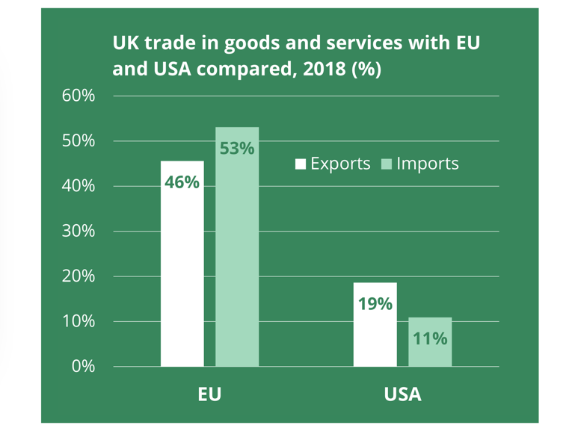
Main Findings

To begin, it’s clear to see that trade relationships with all 27 member states will be affected due to Brexit. Overall the European Union is the United Kingdom’s largest trade partner. As shown in figure 1, 54% of the United Kingdom’s imports are from the European Union. In his book, Statistics on UK-EU Trade, Mathew Ward (2019) says that “Wales, followed by Northern Ireland and the North East of England had the highest percentage of goods exports going to the EU of all the countries and regions in the UK in 2018. The East of England followed by Northern Ireland had the joint highest proportion of goods imports from the EU” (M. Ward, 2019). Being a member of the European Union means that tariffs are lower and trade costs are reduced between the European Union and the United Kingdom. These findings mean that staying in the European Union would result in cheaper goods and services for consumers and would allow businesses in the United Kingdom to export more. Therefore, this shows that staying in the European Union would avoid any disruption to the trading systems and tax tariffs that are currently in place and are abundantly in use. After brexit, this will be lost unless a deal is made agreeing to the European Union’s terms of trade as a single market.
Figure 1: https://researchbriefings.parliament.uk/ResearchBriefing/Summary/CBP-7851#fullreport

As the European is a single market it allows people to travel between the 28 different countries without needing a visa. European Union (2019) says a passport is only needed to prove identity of the travelling party and a visa is not needed which allows United Kingdom nationals to travel freely between the 28 state members. This is a strong reason for staying in the European Union as it allows the United Kingdom nationals to move freely without the hassle of applying and possibly being rejected for a visa. However the European Union (2019) states that until the transition period ends, EU citizens and UK nationals will be able to continue travelling freely, with just a valid passport or identity card.

Due to the launch of the European Union’s Single Market in 1992 and the the peace process being in place, the border between Northern Ireland and the Republic of Ireland has become a soft border and staying in the European Union means that this soft border would remain stable. However, if the United Kingdom leaves the European Union it means that Northern Ireland would no longer be part of the European Union whilst the Republic of Ireland remains. Therefore this would cause massive uncertainty for the soft border and could possible reinstate the previous hard border (C. Berberi 2019)
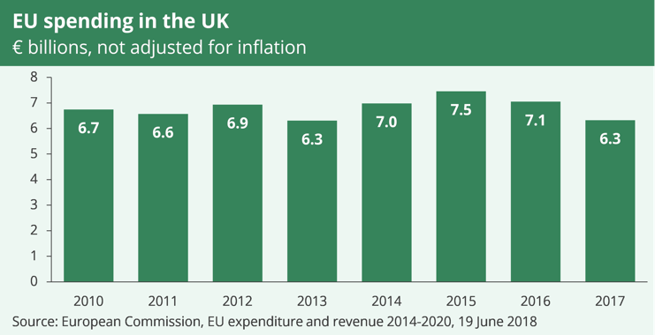
Another reason for staying in the European Union is for the benefits that the United Kingdom receives through European Union funded investments and schemes. As seen in the figure 2, the UK received €6.3 billion (£5.5 billion) of European Union investment in to public and private sector organisations. (Brien, 2018)
Figure 2: https://researchbriefings.parliament.uk/ResearchBriefing/Summary/CBP-7847#fullreport
According to Brien (2018), the two main channels through which the United Kingdom receives European Union funding are the European Structural and Investment (ESI) funds.
The ESI funds focus on letting under-developed areas catch up. Therefore we see a large amount of funding spent on developing local areas across the UK, with areas of West Wales and South West England receiving the most funding per person (Brien, 2018). This therefore greatly benefits certain areas of the UK and is a great example of reasons to stay in the European Union.

Conclusion

To conclude, there are many strong reasons for the United Kingdom to stay in the European Union. The European Union is the largest trade partner of the United Kingdom which allows the consumers to have goods and services cheaper and businesses to export more. Another strong reason is the free movement of people between the European countries will no longer exist and United Kingdom citizens will require a visa to travel to European countries. The hard Irish border could be reinstated causing more strife for people travelling between Northern Ireland and The Republic of Ireland. A final reason for staying in the European Union is that the sheer amount of funding that the United Kingdom receives, if the United Kingdom left this funding would stop, stopping funding to major areas of the United Kingdom. Overall the United Kingdom would benefit greatly from staying within the European Union.

References
BBC (3 October 2019) https://www.bbc.co.uk/news/uk-politics-32810887 (Accessed October 2019)
Berberi, C. Northern Ireland: Is Brexit a Threat to the Peace Process and the Soft Irish Border? Revue Française De Civilisation Britannique 22.2 (2017): Revue Française De Civilisation Britannique, 01 May 2017, Vol.22.2 https://journals.openedition.org/rfcb/pdf/1370
European Union (2019) https://europa.eu/youreurope/citizens/travel/entry-exit/eu-citizen/index_en.htm
Government for Institute (2018) The Options for the UK’s trading with the EU https://www.instituteforgovernment.org.uk/explainers/options-uk-trading-relationship-eu (Accessed October 2019)
Jonathan Portes, Giuseppe Forte, The economic impact of Brexit-induced reductions in migration, Oxford Review of Economic Policy, Volume 33, 1 March 2017, Pages S31–S44, https://doi.org/10.1093/oxrep/grx008
Parliament (2019) Living Heritage. https://www.parliament.uk/about/living-heritage/transformingsociety/tradeindustry/importexport/overview/europe/ (Accessed October 2019)
Phillip Brien (2018) UK Funding From the EU; https://researchbriefings.parliament.uk/ResearchBriefing/Summary/CBP-7847#fullreport
The London School of Economic and Political Science (2016) BREXIT (2016) Policy Analysis from the Centre of Economic Performance http://cep.lse.ac.uk/pubs/download/brexit08_book.pdf#page=40
Ward, M. (2019) Statistics on UK-EU Trade. Briefing Paper Number 7851. House of Commons Library.
UK Government (2019) Countries in the EU and EEA https://www.gov.uk/eu-eea (Accessed October 2019)

