
Soledad Alcon
Student ID: 2610979
Module ID: LCLM4001_LON
Lecturer Name: Toyin Adisa
Assessment Title: Academic Skills

Assessment 1 – Reading Task Template
PART 1: Upload your photo of your A3 in-class notes here:
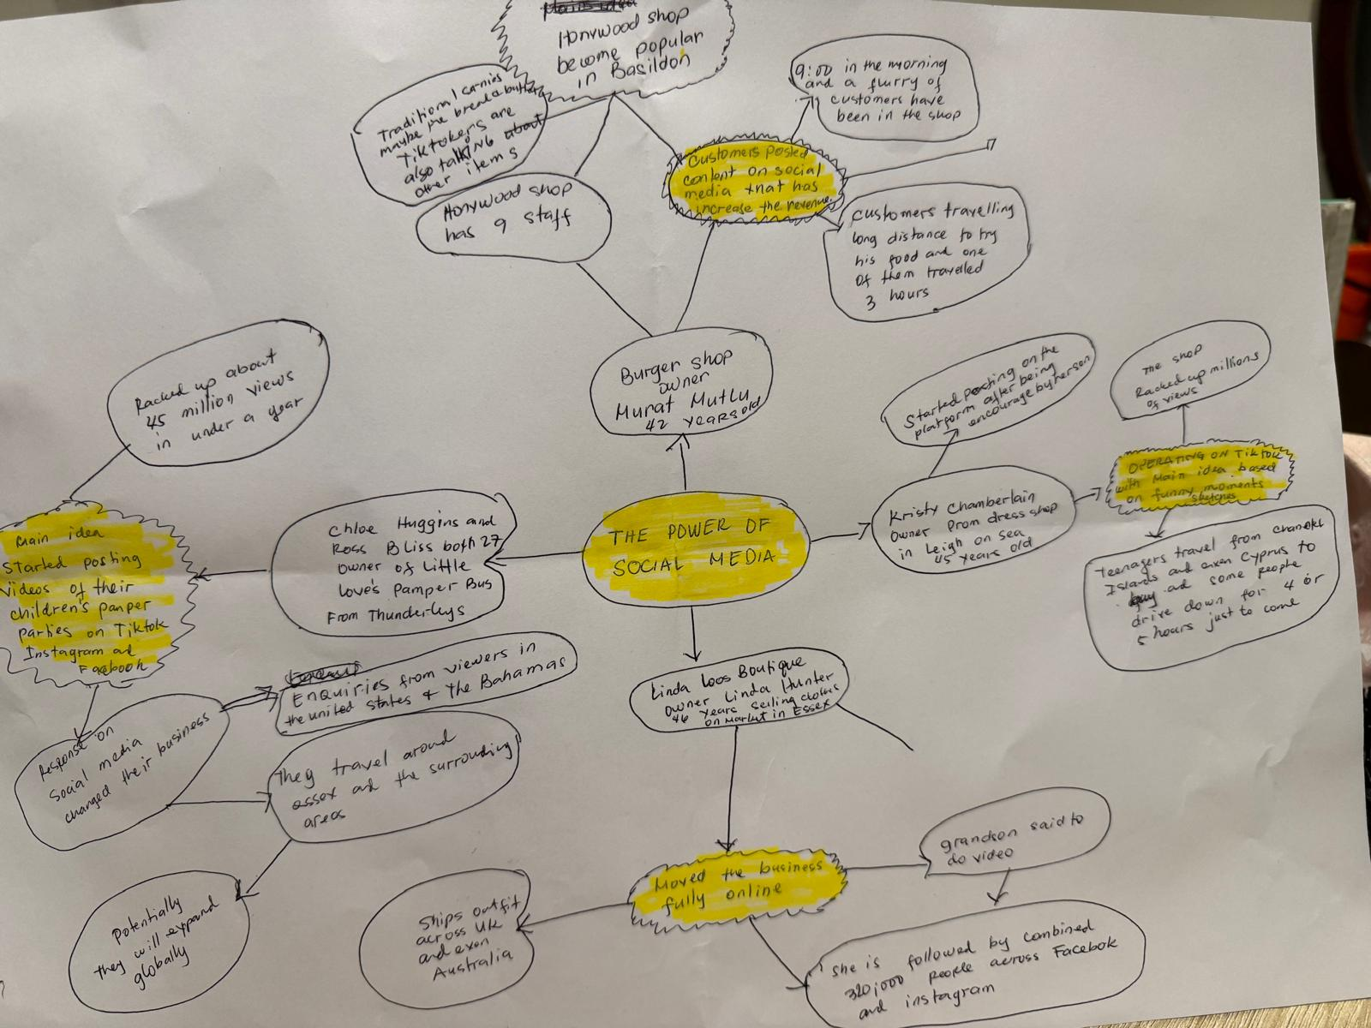

PART 2:
- Answer every question below in 1-3 full sentences.
- Use your own words. Do not use generative AI to answer these questions.
- Include a specific detail from the text when asked.
REMINDER
- The main idea is the overall message of the whole text.
- A key point helps to explain the main idea.
- A specific detail or example from the text shows that the key point is true.

- What is the main idea of the whole text?
That social media is a key factor to expand one’s business and can help a large amount of people discover a small business.

- What is one key point that supports the main idea, and which specific example from the text shows this?
A key point that supports this idea is that through the use of social media, business can become more popular than if they were to use regular advertisements since most people online now use social media. The specific example from the text that shows this is businesses such as “Binley Mega Chippy” or “Spudman” have gained large attention on social media platforms

- What is a different key point that supports the main idea, and which specific example from the text shows this?
A different key point is that social media helps people connect with business owners. An example from the text is “Krystalls Boutique” which shows that many people came to her business after finding their skits funny and wanted to buy dresses from that shop specifically.

- Which part of the text do you think is most important, and why?
I think that the most important part of the text is the part where it’s explained that social media can be used to gain popularity to a business as this can be useful for people who own small businesses and want to find a quick and easy way to grow their business.

Reflection:
- What did you find difficult in this task (including in-class components), and why was it difficult?
It’s a bit difficult for me and challenging because I cannot really express and understand the topics.

- What helped you with this difficulty, and how did it help you?
Reading the text slowly and properly helped me understand the key points of the text.

