PROPOSED HOTEL DEVELOPMENT
BUILD ABILITY AND SUSTAINABILITY ASSESSMENT

Project Name: Swansea Hotel Development
Client: Property Developer
Location: Singleton Campus, Swansea
Prepared by: Robyn Watts
Date: 11th May 2026

Table of Contents
1.Introduction 3
2. Environmental Impact 3
2.1 Orientation 3
2.1.1 Solar Optimisation 3
2.1.2 Wind Loading and Ventilation 3
2.2 Life Cycle 4
2.3 Aesthetic Integration and Environmental Context 5
3. Façade Greening 5
4. SUDS 6
4.1 Proposed SuDS Strategy 7
4.2 Performance and Runoff Reduction 7
4.3 Wider Benefits for the Hotel Development 7
4.4 Critical Considerations and Limitations 8
4.5 Case Study: IKEA Greenwich 8
5. Build ability 9
5.1 Construction Methods and Practicality 9
5.2 Construction Sequence and Programme 9
Proposed Construction Sequence Storyboard – Swansea Hotel Development 10
5.3 Site Logistics, Materials and Labour 10
5.4 Challenges and Environmental Constraints 11
5.5 Efficiency, Safety and Sustainability 11
References 12

1.Introduction
This report builds on the earlier structural and construction proposal for the Swansea Hotel Development, focusing on how the design performs in terms of build ability and sustainability. The earlier design showed a reinforced concrete frame with post-tensioned slabs, a central core, piled foundations, and a ventilated rain screen façade. These choices were made in response to the site conditions, structural requirements, and the exposed coastal environment.
The proposed development is found within Singleton Campus, presents several challenges. It is close to the seafront, meaning it is exposed to high winds and salt-laden air, and it is also near a hospital and public areas, which limits space for construction activities. Because of this, decisions around orientation, materials, and construction methods need to be carefully considered.
This report examines how the building performs environmentally, including its site orientation, material performance over time, and integration with its surroundings. It also explores sustainable strategies such as green façades and SuDS, before assessing how practical the design is to build.

2. Environmental Impact

2.1 Orientation
The building's orientation plays a key role in how energy-efficient and comfortable it will be. In Swansea, both sunlight and wind need careful consideration.

2.1.1 Solar Optimisation
The building has been positioned to make the most of natural daylight, particularly from the south. This helps reduce the need for artificial lighting during the day, improving energy efficiency and creating more comfortable internal spaces. However, too much sunlight can cause overheating, especially in summer. To address this, the design includes recessed windows and façade detailing that provide natural shading.

2.1.2 Wind Loading and Ventilation
Because the site is located close to the coast, wind loading is a significant design consideration, particularly for the proposed 10-storey hotel. Wind speed increases with height due to the wind gradient effect, which can be estimated using the power law relationship:
Vh= Vr (h/hR)
Assuming:
- Reference wind speed = 24 m/s at 10 m height
- Building height = 30 m
- Terrain exponent = 0.14 for open coastal terrain
V30 = 24 (30/10) 0.14
V30 = 28.1m/s
Wind pressure acting on the façade can then be estimated using:
q = 0.5pv2
Using an air density of 1.25 kg/m³ gives an approximate pressure of:
Q = 0.5pv2
Applying a pressure coefficient of 1.2 for exposed coastal conditions results in an estimated design pressure of approximately:
0.59 kn/m2
This shows that the façade, glazing systems, and green façade supports must be designed to resist significant lateral wind forces. At the same time, the orientation allows natural ventilation by aligning openings with prevailing winds, helping reduce reliance on mechanical systems. However, excessive exposure may increase discomfort around entrances and upper floors, meaning careful façade detailing and landscaping are required.

2.2 Life Cycle
When considering sustainability, it is important to consider how the building will perform throughout its lifespan, not just during construction.
Riley and Cotgrave (2018) suggest that reinforced concrete is a strong choice for multi-storey buildings because it is durable, fire-resistant, and provides good thermal mass. In this design, post-tensioned slabs are used, which reduces the amount of material needed while still providing strength, making the structure more efficient.
The rain screen façade also plays a key role. It protects the main structure from weather, particularly important in a coastal environment, and makes maintenance or replacement easier if needed. Instead of using traditional solid stone, lightweight stone cladding is used. This keeps the same visual appearance while reducing structural loads and environmental impact.
As Chudley and Greeno (2020) point out, choosing durable materials reduces maintenance over time, which is especially important in harsh environments like this one.

2.3 Aesthetic Integration and Environmental Context
The design aims to fit into its surroundings while still functioning as a modern hotel. This is done by combining traditional visual elements with modern materials and performance.
The windows follow a consistent vertical pattern, which reflects typical local architectural styles. At the same time, modern glazing is used to improve insulation and reduce noise. The recessed positioning of the windows also helps protect against wind-driven rain and reduces solar gain.
The use of stone-effect cladding helps the building blend into the local environment while staying practical to construct. This balance between appearance and performance is important.
Green façades also help visually connect the building to nearby green spaces. As noted by Urban Green-Blue Grids (n.d.), they can also improve air quality and reduce heat gain, thereby contributing to both aesthetics and environmental performance.

3. Façade Greening
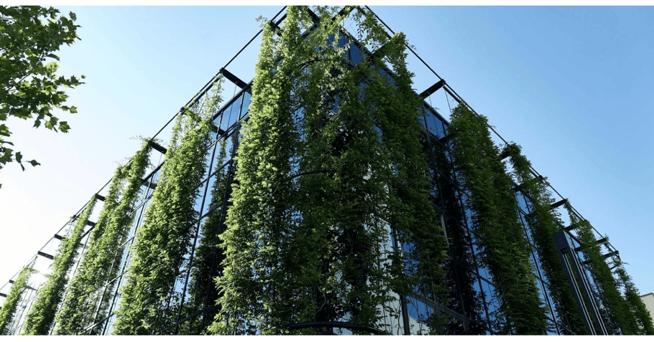
The proposed hotel incorporates a green façade system along the promenade-facing elevation, using a trellis-supported climbing system. This approach enhances environmental performance while staying practical in terms of construction, maintenance, and durability in a coastal setting.
Trellis systems support climbing plants on a lightweight frame rather than embedding vegetation within the façade. New Earth Solutions (2024) note that this avoids the complexity of living walls, which require irrigation systems, heavier substrates, and higher maintenance. In this context, the simpler system is more appropriate, as exposure to wind, salt spray, and moisture would increase the risk of failure in more complex solutions.
Green façades provide environmental benefits by reducing surface temperatures through shading and evapotranspiration, improving internal thermal comfort, and reducing cooling demand. They can also improve air quality by capturing particulate matter (Urban Green-Blue Grids, n.d.), which is particularly relevant for a hotel located along a busy seafront. In addition, the façade enhances visual integration with surrounding green spaces, softening the building’s appearance and improving guest experience.
However, limitations must be considered. As vegetation grows, wind loads increase, which is significant in this exposed coastal location. The system must therefore be designed following Eurocode wind loading requirements (BSI, 2005). Maintenance is also required, including pruning and inspection, and poor upkeep could negatively affect the building’s image. Seasonal variation may also reduce visual consistency.
The coastal environment increases corrosion risk, particularly for metal components, requiring materials to comply with BS EN ISO 12944 (BSI, 2018). Overall, while living walls may offer greater visual impact, they would introduce higher structural loads and maintenance risks. The trellis system is therefore a more balanced and realistic solution, providing environmental and aesthetic benefits while staying practical for this hotel development.

4. SUDS
The proposed hotel development incorporates Sustainable Urban Drainage Systems (SuDS) to manage surface water runoff in a controlled, environmentally responsible manner. Rather than relying on traditional drainage systems that quickly remove water from the site, SuDS aim to slow down runoff, improve water quality, and replicate natural drainage processes. This approach follows guidance set out in the CIRIA SuDS Manual (CIRIA, 2015), Welsh Government standards (2019), and Building Regulations Part H (HM Government, 2015).
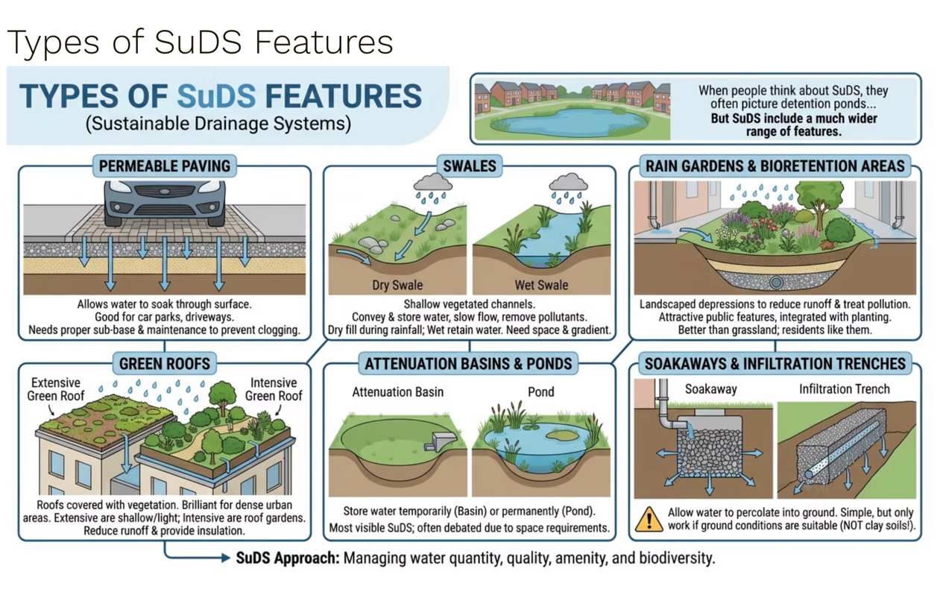
This is particularly important for the Swansea site. The combination of coastal exposure, high rainfall typical of South Wales, and limited site space means that unmanaged runoff could increase flood risk and place pressure on local drainage infrastructure. As a result, an integrated SuDS strategy has been developed, combining multiple components into a treatment train.

4.1 Proposed SuDS Strategy
The design includes a combination of green roofs, permeable paving, swales, and rain gardens. Each element plays a specific role, but their effectiveness is greatest when working together.
The green roof acts as the first stage of the system by intercepting rainfall at source. It absorbs a proportion of the water and slows the rate at which it reaches the drainage system. This is particularly beneficial for a hotel, as the large roof area offers a significant opportunity to reduce runoff while also improving thermal performance.
Permeable paving is proposed for external hardstanding areas, including pedestrian routes and parking zones. This allows water to infiltrate through the surface into a granular sub-base, where it can be temporarily stored before slowly draining away. This reduces peak flow rates and helps prevent surface water accumulation.
Swales are positioned along site boundaries to convey and temporarily store runoff. These shallow, vegetated channels not only manage water flow but also contribute to the landscape design, enhancing the site's visual quality. Rain gardens provide a final stage of filtration, improving water quality by removing pollutants and supporting biodiversity.

4.2 Performance and Runoff Reduction
The effectiveness of the system can be shown through a simple runoff calculation:
Runoff = Area x Rainfall x Coefficient
For a 1000 m2 roof area with 50 mm rainfall:
- Without SuDS intervention: approximately 45 m3runoff
- With green roof attenuation: approximately 25 m3of runoff

This is a reduction of around 20 m3, showing how early-stage interception can significantly reduce the volume of water entering the drainage system. When combined with the additional storage and filtration provided by permeable paving, swales, and rain gardens, the overall system can manage rainfall events more effectively and reduce peak discharge rates.

4.3 Wider Benefits for the Hotel Development
Beyond drainage, SuDS offer a range of additional benefits, particularly relevant to a hotel environment. CIRIA (2015) emphasises that SuDS can enhance amenity and biodiversity while improving water quality.
For this project, landscaped SuDS features, such as swales and rain gardens, improve the site's appearance, creating a more attractive environment for guests. This is important, as external spaces contribute to the overall user experience. Green roofs and planted areas also support biodiversity, which aligns with sustainability aims and planning expectations.
In addition, reducing surface water runoff lowers the risk of localised flooding, which is critical for maintaining building operations and protecting infrastructure. For a hotel, disruptions caused by flooding would have direct operational and financial impacts, so this would add practical value as well as an environmental benefit.

4.4 Critical Considerations and Limitations
While the proposed SuDS strategy offers clear benefits, it also presents challenges that must be considered. One of the main limitations is space. The site is constrained, which restricts the size and capacity of SuDS components such as swales and rain gardens. This means that careful design is needed to ensure sufficient storage capacity without compromising usable space.
Maintenance is another crucial factor. SuDS systems rely on regular upkeep to remain effective. For example, permeable paving can become clogged over time, and vegetation within swales and rain gardens must be managed to ensure proper performance. In a hotel setting, poor maintenance could negatively affect both functionality and appearance. Therefore, maintenance requirements must be considered at the design stage to ensure systems are accessible and manageable.
There is also a balance to be achieved between aesthetics and performance. While landscaped SuDS features improve visual quality, they must still be designed to function effectively during heavy rainfall events. This requires careful detailing and coordination with the overall site layout.

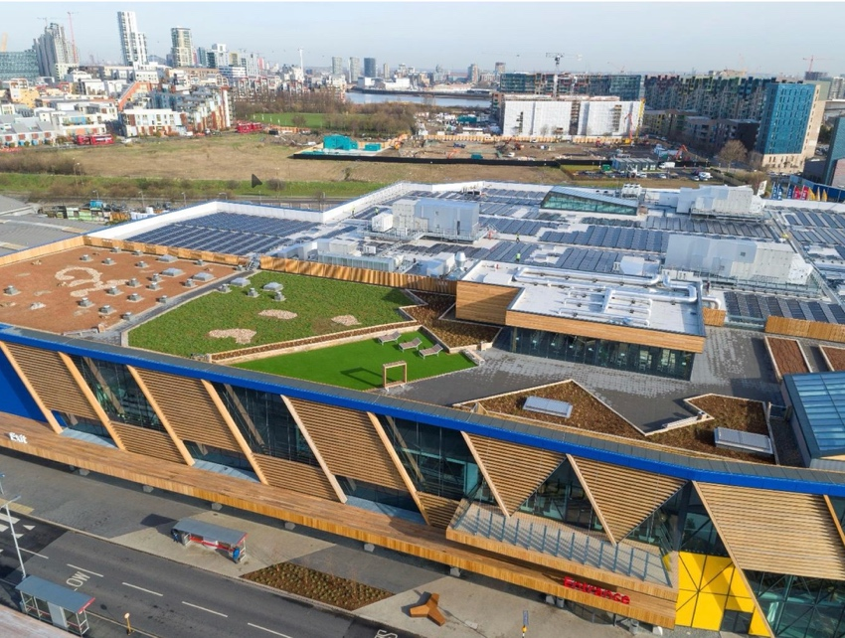
4.5 Case Study: IKEA Greenwich
The IKEA Greenwich development provides a useful example of how SuDS can be successfully integrated into a commercial project. The scheme incorporates green roofs, rainwater harvesting, and landscaped drainage features to manage water at source while also enhancing biodiversity and user experience (Susdrain, n.d.).
A key strength of the project is its use of a treatment train approach, in which multiple SuDS components work together to manage water progressively. This principle has been applied to the Swansea hotel design, although at a smaller scale. The case study shows that SuDS can deliver multiple benefits beyond drainage, supporting both environmental and social aims.
Overall, the SuDS strategy for the proposed hotel is a well-integrated and sustainable approach to surface water management. By combining multiple systems, the design reduces runoff, improves water quality, and enhances the site’s environmental value.
Importantly, the approach is also practical. The selected systems are simple to construct and maintain, making them suitable for the site's constraints. While there are challenges related to space and maintenance, these can be addressed through careful design and management.
For this hotel development, SuDS provide more than just a drainage solution. They contribute to the overall quality of the building, improving resilience, enhancing the external environment, and supporting a more sustainable design outcome.

5. Build ability
Build ability is a key consideration in ensuring that the proposed Swansea Hotel Development can be constructed efficiently, safely, and within realistic programme constraints. While the design performs well structurally and environmentally, it must also be practical to deliver on site, particularly given the coastal location and surrounding constraints.

5.1 Construction Methods and Practicality
From a construction perspective, a reinforced concrete frame with post-tensioned flat slabs is a practical and appropriate choice. Riley and Cotgrave (2014) suggest that reinforced concrete is well-suited to buildings with repetitive layouts, such as hotels, as it allows for consistent construction processes and improved efficiency. This is directly relevant to the proposed design, which repeats floor layouts across multiple levels.
Post-tensioned slabs further improve build ability by reducing slab thickness and limiting the number of internal columns. This simplifies formwork and allows for more flexible internal layouts, which is beneficial during both construction and future use.

5.2 Construction Sequence and Programme
The construction process is expected to follow a logical and structured sequence. Initial site setup and enabling works would be followed by the installation of bored piled foundations, which are suitable for the ground conditions and minimise vibration compared to driven piles. Pile caps and ground beams would then be constructed, followed by the reinforced concrete core, which provides early structural stability and establishes vertical circulation.
The superstructure would then be constructed floor by floor in a repetitive cycle, followed by façade installation, internal fit-out, and external works such as SuDS and landscaping.
The repetitive nature of the structural system supports an efficient construction programme, as floor cycles can be standardised and repeated. This improves predictability and reduces the risk of delays. However, timeline feasibility must also consider external factors. The exposed coastal location means that high winds may affect crane operations and slow down construction progress, particularly during façade installation. As a result, contingency time should be included within the programme to ensure realistic scheduling.

Proposed Construction Sequence Storyboard – Swansea Hotel Development
(Source: Author’s own drawing, 2026)
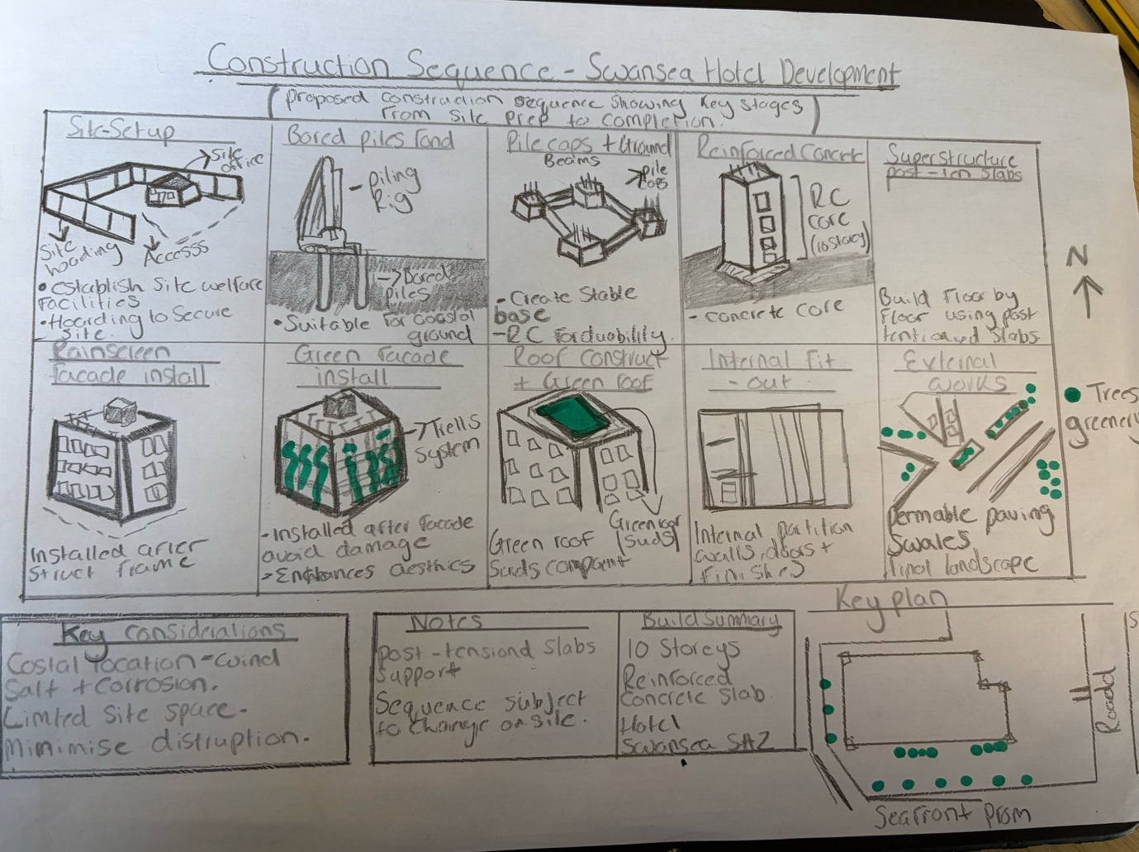

5.3 Site Logistics, Materials and Labour
The site presents several logistical challenges due to its limited size and proximity to Singleton Hospital. There is limited space for material storage, so deliveries must be carefully planned. A just-in-time delivery approach is likely to be needed to minimise congestion and support site efficiency.
Construction activities must also be managed to minimise disruption to surrounding areas, particularly noise, dust, and access. This requires careful planning and coordination throughout the construction process.
In terms of material availability, reinforced concrete is widely used in the UK construction industry, meaning materials and ability are readily accessible. This reduces procurement risk and supports programme reliability. Labour requirements are also relatively straightforward, as the repetitive building layout allows for consistent workforce deployment and improved productivity. However, specialist labour is needed for post-tensioning operations, which may introduce additional coordination requirements.

5.4 Challenges and Environmental Constraints
The coastal environment introduces additional challenges, particularly regarding material durability and weather conditions. Exposure to salt-laden air increases the risk of corrosion, especially for metal components. To address this, materials must be specified following BS EN ISO 12944 (BSI, 2018), ensuring long-term protection.
Weather conditions may also affect construction progress. High winds and heavy rainfall can disrupt crane operations and external works, requiring flexible planning and sequencing to minimise delays.

5.5 Efficiency, Safety and Sustainability
The design supports efficient construction through a regular structural grid and repetitive floor layouts, reducing complexity and improving productivity. Safety is enhanced by reinforced concrete's inherent fire resistance and structural stability, providing a safer working environment during construction.
In terms of sustainability, the use of durable materials reduces long-term maintenance requirements. The potential use of prefabricated façade elements can also minimise waste, improve quality control, and reduce on-site labour, contributing to a more efficient construction process.
Overall, the proposed design shows good build ability. While site constraints and coastal conditions pose challenges, they have been addressed through appropriate construction methods and design decisions. The combination of a practical structural system, efficient sequencing, and careful coordination to ensure the building is delivered safely, efficiently, and sustainably.

References
BSI (2005) BS EN 1991-1-4: Eurocode 1 – Actions on structures – General actions – Wind actions. London: British Standards Institution.
BSI (2018) BS EN ISO 12944: Paints and varnishes – Corrosion protection of steel structures by protective paint systems. London: British Standards Institution.
Chudley, R. and Greeno, R. (2020) Building Construction Handbook. 12th edn. London: Routledge.
CIRIA (2015) The SuDS Manual (C753). London: CIRIA.
HM Government (2015). Approved Document H: Drainage and Waste Disposal. London: HMSO.
New Earth Solutions (2024) Outdoor green walls: The power of the trellis. Available at: https://newearthsolutions.com/2024/08/19/outdoor-green-walls-the-power-of-the-trellis/ (Accessed: 10th April 2026).
Riley, M. and Cotgrave, A. (2014) Construction Technology 2: Industrial and Commercial Building. 3rd edn. Basingstoke: Palgrave Macmillan.
Riley, M. and Cotgrave, A. (2018) Construction Technology 1: House Construction. 4th edn. London: Bloomsbury Visual Arts.
Susdrain (n.d.) IKEA Greenwich Case Study. Available at: https://www.susdrain.org/case-studies/case_studies/ikea_greenwich_-_light_case_study.html (Accessed: 1st May 2026).
Urban Green-Blue Grids (n.d.) Green facades. Available at https://urbangreenbluegrids.com/measures/green-facades/ (Accessed: 15th April 2026).
Welsh Government (2019) Statutory National Standards for Sustainable Drainage Systems (SuDS). Available at: https://www.gov.wales/sites/default/files/publications/2019-06/statutory-national-standards-for-sustainable-drainage-systems.pdf (Accessed: 1st May 2026).

