
How can a local initiative “Cuppa with a Copper” help with community engagement?

Jonathan Morgan
2236252

Declaration
This work has not previously been accepted in substance for any degree and is not being concurrently submitted in candidature for any degree.
Signed: JKMorgan
Date: 05/10/2025
Statement 1 –
This dissertation is being submitted in partial fulfilment of the requirements for the degree of BSc.
Signed: JKMorgan
Date: 05/10/2025
Statement 2 –
This dissertation is the result of my own independent work/investigation, except where otherwise stated. Other sources are acknowledged by footnotes giving explicit references. A bibliography is appended.
Signed: JKMorgan
Date: 05/10/2025
Statement 3 –
I hereby give consent for my dissertation, if accepted, to be available for photocopying and for interlibrary loan, and for the title and summary to be made available to outside organisations.
Signed: JKMorgan
Date: 05/10/2025
Statement 4 –
I hereby give consent for my dissertation, if accepted, to be available on the university’s IT system to those who have consent to use the system.
Signed: JKMorgan
Date: 05/10/2025

Abstract
The aim of this dissertation is to evaluate the effectiveness of the ‘Cuppa with a Copper’ initiative in enhancing community engagement with South Wales Police.
The researcher conducted a review of existing literature on community policing, engagement strategies, and public confidence to provide context. Primary data was collected through questionnaires distributed to attendees at events, and responses were thematically analysed to explore perceptions of trust, accessibility, and communication. Questionnaires were also provided to collect information from the PCSO’S who organised the different events in and around the City and County of Swansea.
Findings indicated that the initiative improves officer approachability and public confidence, while highlighting challenges in engaging underrepresented groups and sustaining long-term impact.
These results were critically compared with the literature, leading to recommendations for embedding informal engagement within broader neighbourhood policing strategies to strengthen community relationships.

Table of Contents
Chapter 1. 6
1.1 Introduction 6
1.2 Background and Rationale 6
1.3 Aims and Objectives 7
1.3.1 Aim 7
1.4 Research and Structure 8
1.5 Conclusion 8
Chapter 2 Literature Review 9
2.1 What role does community engagement play in policing? 9
2.2 Findings from the Research 10
2.3 Gaps in research 11
2.4 Conclusion 12
Chapter 3 Research Methodology 13
3.1 Introduction 13
3.2 Research Design and Theoretical Framework. 13
3.3 Rationale for Methodological Choice 14
3.4 Sampling Strategy 15
3.5 Data Collection Method 16
3.6 Data Analysis 16
3.7 Ethical Considerations 16
3.8 Limitations of the Methodology 17
3.9 Conclusion 17
Chapter 4 Analysis of Results 18
4.1 Introduction 18
4.2 Response Rate and Venue Impact 19
4.3 Public Questionnaire Analysis 19
4.3.1 Demographics 19
4.3.2 Awareness and Motivations 21
4.3.3 Comfort and Approachability 22
4.3.4 Issues Raised 22
4.3.5 Satisfaction and Future Attendance 23
4.4 PCSO Questionnaire Analysis 24
4.4.1 Profile of Respondents 24
4.4.2 Views on Effectiveness 24
4.4.3 Observations on Demographics 25
4.4.4 Barriers and Challenges 25
4.4.5 Recommendations from PCSOs 25
4.5 Comparative Findings 26
4.6 Differences in emphasis: 26
4.7 Conclusion 26
Chapter 5 Findings and Conclusions 27
5.1 The achievement of the objectives 27
5.2 Overall Conclusion 29
5.3 Main Findings 29
5.5 Reflection 31
Chapter 6 Bibliography 32
References 32
Chapter 7 – Appendices 34
7.1 APPENDIX A – Questionnaire for members of the public 34
7.2 APPENDIX B Questionnaire for PCSO’S 38
7.3 Appendix C Research Proposal Form 40
7.4 Appendix D Application for Ethical Approval 43

Chapter 1.

1.1 Introduction
This dissertation seeks to explore how informal, community-based police engagement initiatives contribute to improving public perceptions of the police, encouraging community participation in local safety, and fostering procedural justice.
Although broader community policing models have been the subject of considerable research, little academic attention has been directed toward micro-engagement initiatives such as Cuppa with a Copper. This dissertation seeks to address that gap by critically examining the theoretical foundations, practical delivery, and potential outcomes of the scheme, drawing on both existing literature and primary data.

1.2 Background and Rationale
The Crime and Disorder Act 1998 represented a landmark development in formalising partnerships between police and community agencies across England and Wales. Designed to address rising concerns about crime and anti-social behaviour, the Act introduced a range of preventative and corrective measures, including the establishment of Youth Offending Teams, Anti-Social Behaviour Orders (ASBOs), and community reparation orders. It also enhanced the statutory powers of police and local authorities, reinforcing their ability to respond to both crime and broader forms of social disorder. Importantly, the Act embedded the notion of addressing “quality of life” crimes—such as graffiti and noise pollution—that directly impact community wellbeing.
The principles underpinning the Act align with the broader shift towards community and neighbourhood policing, which emphasises collaboration between police forces and residents. Effective community engagement enables the joint identification and resolution of localised policing concerns, fostering positive relationships and mutually beneficial outcomes (Stuart Lister , Deborah Platts Fowler , Andrew Stainforth , 2006). The College of Policing highlights, engagement involves empowering communities to participate actively in shaping policing priorities, whether through formal structures or informal dialogue. Such practices not only provide citizens with a voice in decision-making but also encourage shared responsibility in tackling persistent local issues. (College of Policing , 2013).
Micro-engagements are a particular type of informal engagement. They are small, low-cost activities designed to give the public easy opportunities to meet officers and raise concerns. Unlike structured meetings, these initiatives are deliberately relaxed and conversational. Their value lies in breaking down barriers, showing that officers are approachable, and giving residents confidence that their voices are being heard.
One example of a micro-engagement initiative is Cuppa with a Copper. Originating as a grassroots idea and now adopted by South Wales police, the scheme invites the public to meet officers informally in community centres, libraries or open venues. There is no set agenda, allowing residents to drop in, ask questions, and raise concerns in a relaxed setting. The strength of this model lies in its informality, as it removes the formal atmosphere often linked to police stations or official meetings. Conversations can cover anything from local concerns such as anti-social behaviour to wider issues around vulnerability and community safety.
The Strategic Policing Requirement, as outlined within Policing Vision 2025, highlights the need for forces to not only address national threats such as terrorism, cybercrime, and serious organised crime, but also to sustain strong community-level engagement. For South Wales Police, this means ensuring that local policing remains visible, accessible, and trusted, with initiatives designed to build meaningful relationships between officers and the public. By embedding these grassroots interactions within a national strategic framework, South Wales Police demonstrate how localised engagement can support the wider aims of Policing Vision 2025, ensuring both community reassurance and strategic resilience. (National Police Chief's Council , 2016)
Alongside in-person initiatives, South Wales Police has also developed digital tools to enhance community dialogue. South Wales Listens is a free, two-way messaging platform that allows residents to connect directly with their neighbourhood policing team. The system enables the public to raise concerns, suggest improvements, and receive updates about local policing. (South Wales Police , 2025)
The platform plays a key role in making policing more accessible, particularly for individuals who may not be able to attend face-to-face events. It also enables information to be shared at scale, reaching large audiences quickly with safety updates, crime prevention advice, or details of engagement opportunities such as Cuppa with a Copper.

1.3 Aims and Objectives

1.3.1 Aim
The aim of this project is to evaluate the local community engagement initiative Cuppa with a Copper.
This aim will be achieved by completing the following objectives.

- Objective 1: Evaluate the local initiative to help with community engagement.

- Objective 2: To establish the views of PCSO’s involved in community initiatives

- Objective 3: To establish the views of members of the public

- Objective 4: To evaluate the best practices for community engagement

1.4 Research and Structure
This dissertation is divided into five chapters, each contributing to the overall aim of evaluating the effectiveness of Cuppa with a Copper in fostering community engagement
Chapter One introduces the research by outlining the background, aims, and four key objectives that guide the study. It also explains the use of both primary and secondary data, combining questionnaire responses that capture public perceptions with a review of existing academic and policy literature to provide a balanced perspective.
Chapter Two presents the literature review. This chapter examines community engagement as a concept, exploring how it contributes to building trust between the police and the public. By critically analysing existing studies and debates, the review establishes the theoretical foundation for the research and identifies the gaps that this dissertation seeks to address.
Chapter Three outlines the research methodology. It explains the primary research methods employed in this study, with particular focus on the use of questionnaires, and discusses how these approaches were designed to generate reliable and relevant data. Consideration is also given to ethical issues, limitations, and the reasoning behind the chosen methods.
Chapter Four presents the findings of the primary research. The data collected from the questionnaire is analysed and interpreted, with statistical results and thematic insights used to explore public perceptions of policing and the Cuppa with a Copper initiative.
Chapter Five provides a discussion of the findings in relation to the wider literature. This chapter draws together insights from both the primary and secondary data, evaluating the extent to which Cuppa with a Copper achieves its intended outcomes. It concludes by reflecting on the implications for policing practice and offering recommendations for future community engagement initiatives.

1.5 Conclusion
This chapter has outlined the research, its aims, and why it is important. The next chapter will examine the existing literature, providing context and insights that will shape and inform the study.

Chapter 2 Literature Review
This chapter of the dissertation will aim to critically evaluate and analyse academic sources of literature in relation to the importance of community engagement and how local initiatives can help build and foster positive relationships between the police and local communities.
This chapter will achieve the first objective:
“To evaluate the importance of police community engagement”
This literature review explores existing research on the importance of community engagement with the police.

2.1 What role does community engagement play in policing?
Community engagement refers to the process of enabling individuals and communities to take an active role in shaping policing according to their own needs and priorities. It involves not only sharing information but also encouraging and supporting communities to address issues of local concern and contribute to decision-making. Engagement can take many forms, whether structured or informal, one-off or continuous, and may focus on specific events, recurring issues, or wider neighbourhood priorities. By creating opportunities for dialogue and collaboration, community engagement helps build trust, fosters problem-solving partnerships, and ensures that policing is responsive, inclusive, and reflective of the communities it serves (College of Policing , 2013).

Community policing has emerged over recent decades as one of the most influential developments in modern law enforcement. At its core, it represents a shift away from reactive, enforcement-led approaches towards proactive strategies that emphasise collaboration, prevention, and long-term relationship building between police and communities (Skogan, 2004 ). Unlike traditional models of policing that prioritised crime control and rapid response, community policing seeks to address the underlying causes of crime and disorder through engagement, partnership working, and problem-solving. (Goldstein, 1990)
One of the defining features of community policing is its focus on neighbourhood-level concerns. By embedding officers within local areas, the model aims to ensure that policing is informed by community priorities rather than being dictated solely by organisational or national agendas (Andy Myhill, 2006). Studies have consistently shown that visibility, familiarity, and accessibility are important predictors of public confidence in policing, making this aspect of community policing especially significant. (Bradford & Jackson, 2009).
The theoretical foundations of community policing are often linked to the problem-oriented policing framework, first articulated by (Goldstein, 1990). Problem-oriented policing emphasises the importance of analysing specific issues affecting communities, such as anti-social behaviour or repeat victimisation, and developing tailored interventions in partnership with residents and other agencies. This approach contrasts with reactive models that focus on individual incidents, instead encouraging police to adopt a more preventative and sustainable approach. The overlap between community policing and problem-oriented policing demonstrates how contemporary strategies combine community involvement with evidence-led problem-solving to enhance legitimacy and effectiveness (Nick Tilley, 2009)
The Independent Office for Police Conduct (IOPC) developed its Communications and Engagement Strategy 2023–2027 to strengthen how policing bodies connect with the public. This strategy highlights the importance of building trust, ensuring openness, and promoting accountability in police work. It identifies the IOPC as a vital link between communities and law enforcement, ensuring that public views are heard and acted upon. The strategy outlines a refreshed approach to stakeholder engagement and communication, aligning with the wider initiative “Building Trust and Confidence in Policing”. Through these aims, the strategy supports police forces in improving public safety, reducing offending, and nurturing positive, collaborative relationships with communities. It also prioritises enhancing the complaints system to boost public confidence in how police conduct is handled. (Independent Office for Police Conduct , 2024 )

2.2 Findings from the Research
A study by the University of Cambridge in Peterborough demonstrated that foot patrols by Police Community Support Officers in crime hotspots led to a significant reduction in crime. Specifically, an additional 21 minutes of daily foot patrols in designated areas resulted in a 39% decrease in victim reported crimes, as well as a 20% reduction in emergency calls. (University of Cambridge , 2016)
An initiative involving 16 pilot sites across eight police forces focused on community engagement strategies, including regular public meetings and addressing local concerns. This approach led to a 12–15% increase in public confidence in the police within a year. (House of Commons , 2009)
Although specific statistics on beat meetings are limited, existing evidence on the benefits of community engagement and visible policing indicates that these forums play a valuable role in:
- Building trust and legitimacy within communities.
- Identifying and addressing local concerns effectively.
- Enhancing collaboration between the police and the public.
(College of Policing , 2013)
These meetings, as part of broader community policing strategies, contribute to improved public confidence and crime reduction.
The Policing Productivity Review Home Office (2023) highlights the significant role Neighbourhood Policing Teams (NPT’s) play in achieving measurable reductions in crime and disorder. Forces which have invested in dedicated NPT’s report notable decreases in anti-social behaviour, demonstrating the value of community focused policing models in improving both safety and public confidence. For example, Merseyside Police’s Knowsley team recorded a 44% reduction in ASB’s and a 28% fall in residential burglaries. Essex police similarly reported a 57% drop in town centre ASB incidents since 2018/19. This suggests that long term investment in neighbourhood policing contributes to sustained crime prevention outcomes. (Home Office , 2023)
These reductions are consistent with existing academic research that emphasises the importance of neighbourhood policing as a central strategy for a visible and responsive presence.

2.3 Gaps in research
A report published in Science found that, in a large-scale study across six countries, community policing initiatives did not significantly improve public trust or reduce crime rates. This highlights the importance of context-specific adaptations and cautions against a universal, one-size-fits-all approach. (Science, 2021 ).
For South Wales Police, initiatives such as Cuppa with a Copper represent a more localised and tailored form of engagement, designed to reflect the unique needs of communities across South Wales. By focusing on informal, accessible conversations, SWP adapt national community policing principles to their local context, demonstrating an understanding that meaningful engagement depends on aligning strategies with the social, cultural, and demographic realities of the areas they serve.
The HMICFRS annual report 2023 highlights that a lack of consistent data and evaluation within neighbourhood policing makes it difficult to determine the true effectiveness of community policing strategies. This challenge arises because outcomes such as trust, legitimacy, and feelings of safety are largely qualitative and less tangible than crime figures. Furthermore, the variation in how community engagement initiatives are delivered across forces complicates standardised measurement, while fluctuating public participation adds further complexity. (HMICFRS, 2024 )
Police forces in the United Kingdom have increasingly recognised the importance of community engagement as a cornerstone of effective policing. In recent years, informal initiatives aimed at bridging the gap between policing and the public have become more prominent.
The Cuppa with a Copper concept aligns closely with The South Wales Police Crime and Justice Plan 2025-2029. This focuses on delivering effective policing, fostering community cohesion and transparency. The first objective of the plan is to “build people’s trust in local policing,” to ensure that policing in South Wales is visible and “in touch with the needs of the community”.
The South Wales Police and Crime Plan 2025-2029 outlines a commitment to fostering safe and confident communities through community engagement initiatives. While the plan emphasises community engagement, there is a lack of comprehensive evaluation to assess specific strategies. In initiatives such as South Wales Listens, impact assessments are in place but the impact on community trust and crime reduction has not been thoroughly studied. These gaps in this research could impede the effective implementation and evaluation of these initiatives. (South Wales Police and Crime Commissioner, 2020).
Efforts have been made to engage diverse communities, including initiatives like the 'Young Voices Conversation'. Nonetheless, challenges persist in reaching certain groups, such as rural populations and minority ethnic communities, due to factors like outdated population data and limited tailored outreach programs. (HMICFRS, 2022)
Volunteer initiatives, including the police youth-volunteers scheme and community safety partnerships, play a role in community engagement. Yet, there is limited research on the long-term sustainability and impact of these programs particularly concerning volunteer retention and community outcomes. (HMICFRS, 2022)
The plan highlights the importance of community feedback in shaping policing priorities. However, there is a need for more robust systems to ensure that community input is systematically collected, analysed, and integrated into policy development and operational practices.
These sources collectively emphasise the importance of context-specific research, the need for robust evaluation mechanisms, and the inclusion of both community and officer perspectives in shaping effective community policing strategies.

2.4 Conclusion
In conclusion, this literature review has examined the existing body of research surrounding the importance of community engagement with the police. There is a lack of focused evaluation on informal, dialogue-based approaches, such as Cuppa with a Copper, and although these initiatives are under pinned by the principles of trust building, transparency, and co-operation, there remains a need for evidence-based research to determine their impact. This research seeks to address this gap by examining the implementation and outcomes of the Cuppa with a Copper initiative within South Wales Police, contributing new insights into how informal engagement can influence public perceptions and strengthen police community relationships. This literature review has laid the groundwork for further exploration in this dissertation, which will seek to build on these findings through primary research, enabling a more detailed understanding of how local police initiatives can help with community engagement.

Chapter 3 Research Methodology

3.1 Introduction
This chapter of the project will identify how objectives two and three will be achieved.
The objectives are:
- To establish the views of the members of the public
- To establish the views of PCSO’s.
This chapter outlines how the study was conducted, commonly referred to as the methodology. Methodology refers to the systematic approach and techniques used to collect, analyse, and interpret data, ensuring it is valid, reliable, and ethically obtained. This section explains the rationale behind the research design, describes the data collection method, and outlines how the data will be analysed. A clear methodology enables others to assess the validity of the research and, where appropriate, carry out further studies in relation to the topic. It also provides justification for the chosen methods, demonstrating their suitability for addressing the research question.

3.2 Research Design and Theoretical Framework.
To guide the development of the study’s methodological framework, the research onion model proposed by (Saunders , et al., 2019) was used. This model provides a structured, layered approach to research design, beginning with philosophical foundations and progressing through to specific data collection techniques. Each layer represents a core component of the process, which are research philosophy, approach, strategy, methodological choice, time horizon, and data collection. The layered structure ensures internal consistency and alignment with the research objectives, making it especially useful for social science investigations.
This study adopts a pragmatic research philosophy, which means the focus is on using the most practical methods to answer the research question. Pragmatism recognises that no single way of viewing the world is enough on its own, so it allows the researcher to use approaches that are most useful in producing meaningful findings. In this case, pragmatism was chosen because the research is about understanding the effectiveness of Cuppa with a Copper in engaging communities, and the aim is to find practical, real-world answers that could help policing practice.
The dissertation also follows a deductive approach, in line with the “research onion” framework. Deduction means starting with existing theories or ideas, for example, theories of community policing and engagement and then testing them with the data collected. Instead of trying to create new theory, this study applies what is already known about police–community engagement to see whether it holds true in the specific context of South Wales Police and the Cuppa with a Copper initiative.
Pragmatism and deduction fit well together for this research because both emphasise applying theory to practice. Pragmatism ensures the research remains focused on useful outcomes for policing, while deduction provides a structured way to test whether established theories of engagement are effective in this local initiative. Together, they allow the study to be grounded in existing academic knowledge while still producing findings that are relevant and applicable to operational policing.

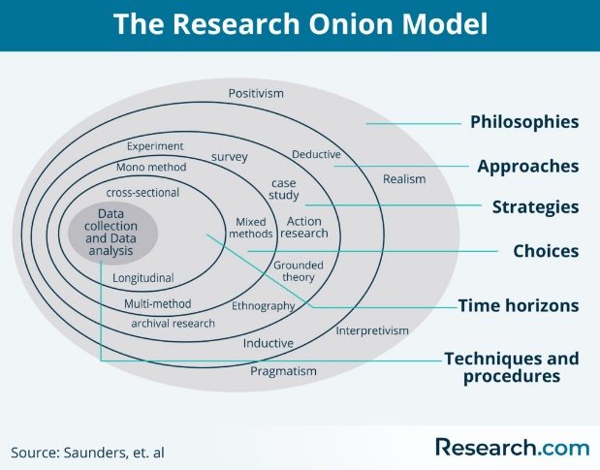
(Jean Monnet Centre Of Excellence In European Studies , 2023 )

3.3 Rationale for Methodological Choice
The selection of a suitable methodology is crucial in shaping the direction, scope, and credibility of any research project. For this dissertation, which evaluates the effectiveness of the Cuppa with a Copper initiative in enhancing community engagement with South Wales Police, questionnaires were selected as the primary research tool. This choice was informed by practical, methodological, and ethical considerations. The data gathered was analysed and presented using graphs and charts to highlight patterns and trends, which supported the formulation of informed recommendations.
Primary research involves collecting original data directly from participants, while secondary research draws upon information previously collected by others (Bryman, 2016 ). This study adopted a primary research approach to gather first-hand perspectives on the initiative.
This choice was based on several considerations:
- Practicality: Questionnaires are time-efficient and cost-effective, especially for a student researcher working under academic and financial constraints.
- Scalability: They allow simultaneous data collection from multiple respondents.
- Anonymity: Responses can be kept anonymous, encouraging honesty and reducing social desirability bias.
- Accessibility: Questionnaires can be distributed both online and in physical locations, such as police stations, libraries, and community centres. This questionnaire was a hard copy presented to the attendees during the sessions Cuppa with a Copper.

3.4 Sampling Strategy
A sample is defined as “a finite part of a statistical population whose properties are studied to gain information about the whole.” According to (Ghauri, 2020), it is essential to use a sample rather than attempting to study an entire population, which would be impractical.
A sample size of 30–70 respondents was considered appropriate for evaluating the Cuppa with a Copper initiative. This range was manageable, allowing for detailed analysis of qualitative feedback while remaining feasible within the study’s timeframe and resources. Importantly, in community engagement research, this size is often sufficient to reach as other responses become competitive, where additional responses yield little new information. Given that the participants were drawn from a relatively defined population, residents attending the initiative, the sample provides meaningful insights into perceptions of accessibility, trust, and effectiveness.
This study used a non-probability purposive sampling technique. Purposive sampling involves selecting participants based on specific characteristics or knowledge that are directly relevant to the research objectives (Bryman, 2016 ).
This means that participants were chosen because they had direct experience or awareness of the Cuppa with a Copper initiative, rather than being selected at random. Unlike probability sampling, where everyone has an equal chance of being chosen, purposive sampling allows the researcher to focus on people who are most likely to provide relevant and useful insights.
This approach was well suited to the project because the aim was to understand community perceptions of Cuppa with a Copper. Surveying the general public at random would have been less effective, as many people may not have had any knowledge of the scheme. By targeting individuals who had either attended or were familiar with the events, the research was able to collect feedback that directly related to the study’s objectives.

3.5 Data Collection Method

Questionnaires were an appropriate data collection method for this project, particularly given the practical constraints of time and resources. Compared with interviews or focus groups, questionnaires allowed for the efficient collection of data from multiple participants simultaneously, ensuring broad input without compromising the overall quality of responses. They were distributed to members of the public attending Cuppa with a Copper sessions at various locations across the City and County of Swansea.
The questionnaire includes both closed-ended and optional open-ended questions. Closed-ended items enable statistical analysis and the identification of patterns, whereas open-ended questions allow respondents to provide more detailed explanations and deeper insights.
The use of questionnaires at these events offered a flexible and accessible way for participants to contribute. Attendees were able to complete the surveys at their own pace, which encouraged more thoughtful and honest responses. Because respondents had first-hand experience of the initiative, the data collected was directly aligned to the research objectives.
Anonymity was another strength of this method, reducing social desirability bias and enabling participants to share candid views, particularly on sensitive issues, such as trust in policing.
In the research onion framework, the time horizon refers to the period over which the research is conducted. This study adopted a cross-sectional design, capturing data at a single point in time. This approach aligned with the project’s scope and the academic deadlines associated with dissertation submission.

3.6 Data Analysis
Quantitative data will be analysed using descriptive statistics, such as frequencies and percentages, to identify patterns and trends. The results will be displayed through graphs and charts for visual clarity. If open-ended responses are provided, a basic thematic analysis will be conducted to categorise recurring themes. This mixed analytical approach enables both breadth and a limited degree of depth in the findings, providing a nuanced understanding of community engagement levels.

3.7 Ethical Considerations
Ethical considerations are of paramount importance in social research. This study received full ethical approval following the submission of a comprehensive ethics form. Participants were fully informed of the research aims, the voluntary nature of participation, and their right to withdraw at any time without penalty.
From an ethical standpoint, questionnaires represent a relatively low-risk method. Participation was entirely voluntary, with respondents free to decline or withdraw at any stage. Informed consent was obtained through a clear explanation of the research purpose, intended data use, and assurances of confidentiality. Importantly, the distribution of questionnaires by Police Community Support Officers (PCSOs) at the events did not raise ethical concerns. Their involvement was not perceived as leading or coercive; they simply handed out the forms and explained that participation was optional. This ensured responses remained independent and unbiased.

3.8 Limitations of the Methodology
The methodology used in this study allowed for practical, ethical, and organised data collection, but there are some limitations. The sample size was small because of time and resource constraints, so more detailed methods like focus groups were not possible. Questionnaires made it easy to collect data from multiple participants, but the study could not follow people over time to see if their attitudes towards police engagement changed. This means the findings mainly show a snapshot of opinions at one point in time.
Another limitation is the participation of PCSOs. Since the research was carried out within South Wales Police, PCSOs might not have felt completely free to give critical or negative feedback. They could have given answers that made the police look better, which means the data may not fully reflect their true views.
Even with these limitations, the study still provides useful information about how people see the Cuppa with a Copper initiative and shows where South Wales Police could improve community engagement. These limitations also reflect the points in the Strategic Policing Requirement and Policing Vision 2025, which stress the need for careful, evidence-based approaches to building public trust.

3.9 Conclusion
The methodology adopted in this research balances practical efficiency, ethical integrity, and methodological appropriateness. Questionnaires have been selected for their accessibility, cost-effectiveness, and ability to collect a broad range of public opinions relevant to the 'Cuppa with a Copper' initiative.
The chosen approach ensures that the voices of diverse community members are captured in a structured, ethical, and systematic manner. The findings will offer meaningful insights into how South Wales Police can improve community engagement, contributing to an evidence-based understanding of public-police interaction.

Chapter 4 Analysis of Results

4.1 Introduction
The research component of this study employed a mixed methods design to assess public perceptions of the Cuppa with a Copper initiative. The primary data collection tool was a structured questionnaire consisting of twelve questions, which included both closed and open-ended questions to elicit qualitative insights. A total of 47 members of the public completed the questionnaire during April –June 2025. The participants were self-selected, responding through in-person events over numerous locations in the City and County of Swansea. Venues included local libraries as well as supermarket coffee shops and Swansea Market.
The rationale behind the use of a questionnaire was twofold: firstly, to gather a breadth of data on public awareness, satisfaction, and perceptions; secondly, to give respondents space to express views in their own words. This approach aligns with (Bryman, 2016 ) recommendation for mixed methods in social research, particularly when exploring attitudes towards public institutions like the police.

Chapter 3 identified the methods as to how the research would be carried out. This analysis will aim to achieve the second and third objective which are:
- Establish the views of the members of the public
- Establish the view of the PCSO’s
The first questionnaire was distributed to members of the public who attended sessions, while the second was directed at PCSOs who facilitated them. In total, 47 public responses were collected from across the city of Swansea, which included locations such as the Mumbles, Swansea city centre, and Morriston. Three contrasting areas of Swansea with very different demographic and socio-economic profiles.
- Mumbles is an affluent suburb with a large, retired population and relatively low levels of recorded crime.
- Morriston has a more mixed population, including long-term residents, and is often associated with concerns about anti-social behaviour and youth-related issues.
- The city centre attracts a diverse group of residents, workers, and visitors, with a more transient population and visible public order issues.
In addition to the public survey, eight PCSOs completed a separate questionnaire, providing operational insight into how the sessions were delivered, the challenges faced, and the impact observed.

4.2 Response Rate and Venue Impact
The public questionnaire achieved a 67% response rate, with 47 surveys completed out of 70 distributed. This is a strong return rate, indicating that attendees were generally engaged and willing to provide feedback.
The venue where sessions were held influenced the level of participation. Sessions hosted in community centres and local libraries produced the highest number of completed questionnaires. These venues provided a comfortable, familiar environment where residents were more likely to stay, talk with PCSOs, and take time to complete the survey.
In contrast, sessions held in open public spaces, such as the coffee shop in Morrisons and Swansea Market produced fewer completed responses. In these locations, participants often attended more casually, dropping in for shorter periods, which made them less likely to engage in detailed feedback.
Geographical variation was also apparent. In Mumbles, residents were keen to engage and fill in the questionnaire, often taking time to write detailed responses. The high completion rate here reflected both the availability of time among the largely retired population and their willingness to interact with PCSOs. In Morriston, response rates were also strong, as participants wanted to raise issues that directly affected their community. However, in the city centre, fewer questionnaires were returned, as many attendees engaged briefly and did not stay long enough to complete the survey.

This demonstrates how both venue choice and community profile shape participation levels in feedback exercises.

4.3 Public Questionnaire Analysis

4.3.1 Demographics
Of the 47 respondents, 56% were aged 55 and over, showing a clear dominance of older residents in attendance. This trend was particularly evident in Mumbles, where many attendees were retired and had the time to attend sessions held during the day. According to the 2021 Census for Swansea statistics show that 20% of the population in Mumbles is over the age of 65. (Swansea Council , 2021 ) The Oystermouth ward profile April 25 shows that 65–74-year-olds make up 16% of the population and over 75-year-olds total 14.1% of the population. (Swansea Council , 2025)
Meanwhile, 25% of respondents were aged 35–54, representing middle-aged, often working adults. These attendees were more common in Morriston, where residents made the effort to attend because of specific local concerns, such as anti-social behaviour.
Only 11% of respondents were under 35, highlighting a significant underrepresentation of younger adults. The majority of this small group were from the city centre, reflecting more spontaneous attendance from younger workers or passers-by. This suggests that session timing and format currently favour older, retired residents and make attendance more difficult for younger demographics. One challenge highlighted by national research is the lack of engagement from younger people, particularly those from Generation Z. Recent figures show that only 44% of Gen Z report confidence in the police, compared to around 67% of the wider public. This makes them the only generation where fewer than half express trust in policing. Younger people are also less likely to attend community meetings or initiatives, as they tend to prefer digital forms of communication and interaction over face-to-face events. (The Police Foundation , 2024)
Gender distribution was fairly balanced overall, with 53% female, 43% male, and 4% preferring not to disclose or identifying as non-binary. Female respondents were more likely to attend in Mumbles and Morriston, often describing their attendance in terms of reassurance and community connection. Male respondents were slightly more likely to raise specific issues, such as traffic concerns or anti-social behaviour.
Together, these findings show that Cuppa with a Copper is particularly attractive to older, retired residents, while younger working-age people remain less engaged.

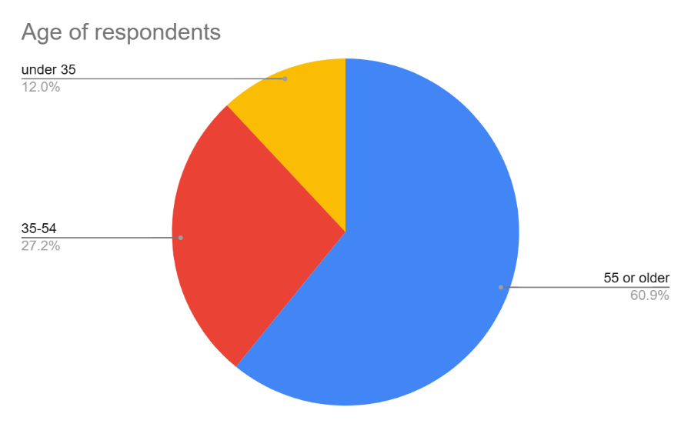

4.3.2 Awareness and Motivations
When asked how they first became aware of the sessions, the majority of respondents (53%) cited social media, showing that online promotion is currently the most effective form of outreach. Word of mouth accounted for 17%, while 15% became aware through posters or flyers, often in community venues such as libraries. A further 10% had been directly invited by PCSOs, and the remaining 5% through other sources, such as local newsletters.
The reasons for attending varied by area:
- In Mumbles, many respondents attended mainly for reassurance and community connection. Several older participants described the event as “a chance to have a friendly chat” rather than an opportunity to raise pressing issues.
- In Morriston, respondents were motivated by specific community concerns, including anti-social behaviour, drug use, and youth facilities. Many saw the sessions as a valuable chance to raise their voice in a more informal and less intimidating setting than a police station.
- In the city centre, attendance was often spontaneous. Some participants described attending “out of curiosity” or because they happened to be nearby. Issues raised here tended to be practical and immediate, such as road safety or street drinking.
These patterns show that motivation to attend is shaped by both community characteristics and personal needs.

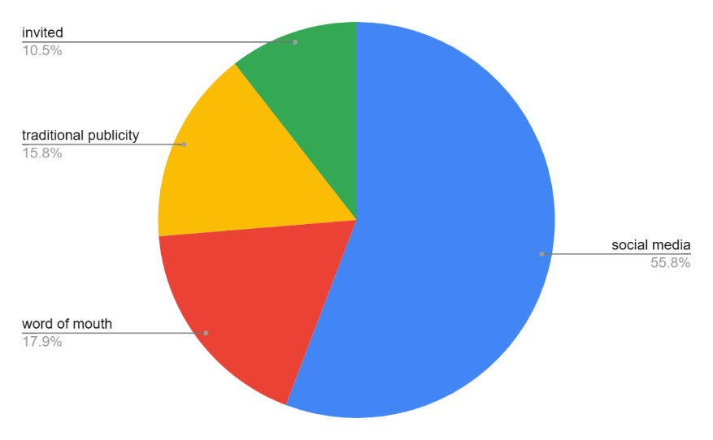

4.3.3 Comfort and Approachability
Participants were asked to rate how approachable they found PCSOs before and after attending the sessions.
- Before attending, only 11% described PCSOs as “very approachable,” with 38% selecting “somewhat approachable.” The majority (51%) were neutral or unsure.
- After attending, perceptions improved significantly. 43% rated PCSOs as “very approachable,” 44% as “somewhat approachable,” and just 13% remained neutral.
This demonstrates a clear shift in perceptions, with many attendees leaving the sessions feeling more positive about their local PCSOs.
This change was most notable in the city centre, where initial perceptions were more neutral. After engaging in conversation, participants described PCSOs as “friendly,” “easy to talk to,” and “down to earth.” In Mumbles and Morriston, where residents already felt some connection with local PCSOs, the sessions reinforced existing trust and added to feelings of reassurance.
The results show that Cuppa with a Copper successfully improves perceptions of police approachability across all locations, even among those who began with neutral or uncertain views.

4.3.4 Issues Raised
When asked what issues they had raised with PCSOs, the responses reflected clear local differences:
- Anti-social behaviour (32%): Most common in Morriston, where residents described groups of youths causing disruption.
- Drug use (26%): Also mainly raised in Morriston, where concerns about drug activity in public spaces were prominent.
- Road safety (21%): Frequently raised in the city centre, where high traffic and pedestrian activity created daily frustrations.
- Youth engagement/facilities (15%): Highlighted mainly in Morriston, where residents expressed concern about a lack of activities for young people.
- Other issues (6%): Included noise, parking, and neighbourhood disputes, mentioned across all areas.
In Mumbles, fewer specific issues were raised. Instead, residents often used the opportunity to discuss more general topics, such as police visibility and reassurance.
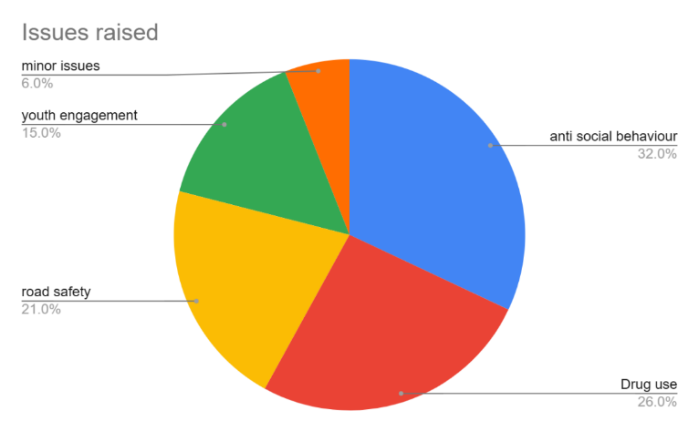

4.3.5 Satisfaction and Future Attendance
When asked about their overall satisfaction with the initiative:
- 55% said they were very satisfied,
- 28% somewhat satisfied,
- 13% were neutral,
- and only 4% expressed dissatisfaction.
Satisfaction was highest in Mumbles, where participants appreciated the reassurance element, and in Morriston, where residents felt they had been given a voice. Neutral responses were more common in the city centre, where casual attendees may not have developed a long-term connection to the initiative.
Future attendance potential was also strong:
- 81% said they would attend again,
- 15% said maybe,
- 4% said no.
Again, older residents in Mumbles and Morriston were most likely to commit to attending future sessions. Younger and working-age respondents were less certain, often citing timing as the main barrier.
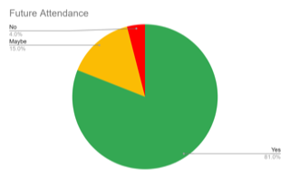

4.4 PCSO Questionnaire Analysis

4.4.1 Profile of Respondents
Eight PCSOs completed the survey, offering insight into how the initiative worked in practice. The responses came from a mix of officers at different stages of their careers, combining fresh perspectives with those of more experienced staff.

4.4.2 Views on Effectiveness
PCSOs were asked to rate how effective they felt Cuppa with a Copper was.
- 75% described the sessions as effective or very effective
- 25% described them as moderately effective

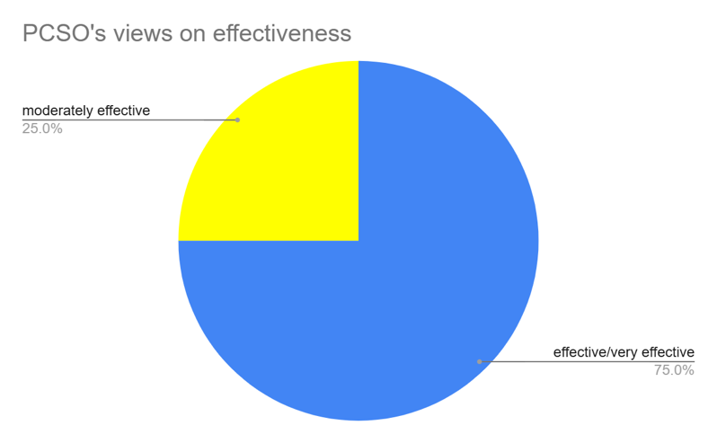

The research showed that no PCSOs felt the initiative was ineffective.
Their comments showed that the sessions were seen as a valuable opportunity to improve visibility and build trust with communities. PCSOs noted that residents often felt more comfortable raising issues in this informal environment compared to a formal police setting.
However, some highlighted that the sessions did not always reach all parts of the community. In particular, working-age adults and younger residents were rarely seen at events. This matched what the public survey revealed, showing strong alignment between community experiences and PCSO observations.

4.4.3 Observations on Demographics
PCSOs’ accounts reinforced the statistical findings from the public survey. They consistently reported that older residents formed the majority of attendees, particularly in Mumbles and Morriston. When it came to younger people, PCSOs reported very limited engagement. They suggested that this was due to the timing of events, which were usually held during weekday mornings or afternoons.

4.4.4 Barriers and Challenges
While generally positive about the initiative, PCSOs did identify some key challenges:
- Timing – Daytime sessions were convenient for older residents but excluded working-age adults and younger people.
- Venues – Community centres and libraries worked well, but open spaces sometimes attracted fewer committed participants.
- Publicity – Although social media reached many, it was not always effective in targeting younger or less engaged groups.

Follow-up, PCSOs expressed concern that issues raised in sessions were not always followed through as thoroughly as they would like, which could undermine long-term trust.

4.4.5 Recommendations from PCSOs
PCSOs made several practical suggestions to improve the initiative:
- Holding some sessions during evenings or weekends to allow working adults and younger residents to attend.
- Rotating venues to include leisure centres, or workplaces, which might attract different audiences.
- Strengthening follow-up by providing attendees with clear updates on what had been done about the issues they raised.
- Exploring targeted outreach to younger people, for example by linking sessions with schools, colleges, or youth groups.
These recommendations show that PCSO’s saw the value of the initiative but also recognised its limitations in terms of inclusivity and sustainability.

4.5 Comparative Findings
By comparing the public and PCSO surveys, several important themes emerged.
- Both groups agreed that Cuppa with a Copper improved perceptions of police approachability.
- Both noted that older residents were the main attendees.
- Both identified anti-social behaviour and drug use as significant concerns in areas like Morriston.
- Both valued the sessions as a way to build trust and gather community insights.

4.6 Differences in emphasis:
Public respondents focused heavily on satisfaction and reassurance, while PCSOs placed more emphasis on operational challenges, such as timing and follow-up.

The public tended to describe their experiences positively, with 83% reporting satisfaction, while PCSOs rated the effectiveness slightly lower at 75%, reflecting their awareness of the initiative’s limitations.

4.7 Conclusion
The findings from both public and PCSO surveys show that Cuppa with a Copper has been a valuable initiative for community engagement in Swansea. It successfully improves perceptions of police approachability, builds trust, and provides a platform for residents to raise issues in a relaxed environment.
However, the initiative currently appeals most strongly to older, retired residents. These groups appreciate the reassurance and opportunity to maintain contact with PCSOs. Younger and working-age residents are underrepresented, largely due to the timing of sessions during the day.
The type of issues raised varied by area and this shows that the initiative adapts naturally to different community contexts, but also highlights the need for tailored approaches in each location.
PCSOs themselves confirmed the value of the initiative but also identified operational challenges, particularly around timing, venue choice, and follow-up. Their recommendations suggest that small changes—such as introducing evening or weekend sessions, rotating venues, and improving feedback to attendees—could make the initiative more inclusive and impactful.
In summary, Cuppa with a Copper has proven effective in its current form but has clear scope for improvement. It is strongest at providing reassurance to older residents, but with some adaptations, it could extend its reach to younger people and working adults, ensuring that all sections of the community feel equally represented and engaged.

Chapter 5 Findings and Conclusions
This research has involved establishing context, designing the methodology, and analysing quantitative data. The findings revealed recurring themes that align with those identified in the literature review. This concluding chapter brings together the key results, reflecting on the effectiveness of the Cuppa with a Copper initiative in supporting community engagement. It summarises how the initiative has influenced public perceptions of policing and contributed to building trust and accessibility. The chapter also provides recommendations for improving and sustaining the initiative, followed by a reflection on the research process and its broader implications for policing and future study.

5.1 The achievement of the objectives
The researcher set several objectives, and this part will evaluate how each objective has been achieved. By examining previous engagement initiatives, collecting the views of Police Community Support Officers (PCSOs), gathering feedback from members of the public, and reviewing these findings collectively, the dissertation provides a balanced assessment of the effectiveness of Cuppa with a Copper as a tool for community engagement.
Objective 1: Evaluate the local initiative to help with community engagement.

The first objective assessed the importance of police–community engagement, framed against the South Wales Police Crime & Justice Plan 2025–2029. (South Wales Police and Crime Commissioner, 2020). The Plan sets out a vision for a trusted, transparent, and responsive service, emphasising the need to understand and respond to community priorities. Engagement is therefore not optional but central to legitimacy, public confidence, and effective problem-solving. The findings confirm that initiatives like Cuppa with a Copper bring this vision into practice by creating accessible, two-way dialogue between officers and residents, directly supporting the Plan’s strategic aim of strengthening trust and partnership with communities.
Objective 2: To establish the views of PCSO’s involved in community initiatives
The second objective focused on capturing the experiences of PCSOs directly involved in the delivery of the initiative. PCSOs reported that the sessions provided a unique opportunity to engage with residents in a relaxed environment, enabling conversations that might not occur during routine patrols. They highlighted benefits, such as increased approachability, opportunities to gather community intelligence, and the chance to strengthen relationships with regular attendees. However, several challenges were also identified, including variation in attendance across different venues, time pressures alongside other operational responsibilities, and the need for greater organisational support in promoting the events. Overall, PCSOs expressed a generally positive view of Cuppa with a Copper, while also recognising that its success is dependent on careful planning and consistent commitment.
Objective 3: To establish the views of members of the public
The third objective was to evaluate the views of the public, achieved through the collection and analysis of questionnaire responses. The majority of respondents expressed positive perceptions of the initiative, noting that it provided a welcoming and informal forum to raise concerns, ask questions, and better understand local policing priorities. Many participants felt that the initiative improved the visibility and approachability of PCSOs, which in turn increased confidence in local policing. Nevertheless, some limitations were raised. A number of respondents suggested that awareness of the initiative was low in certain areas, while others recommended a greater variety of venues and times to reach different demographics. Importantly, the findings confirmed that when members of the public are aware of and able to attend the sessions, they value the opportunity to engage directly with officers in a non-confrontational setting.
Objective 4: To evaluate the best practices for community engagement
The final objective was to review the combined findings from the literature, PCSO feedback, and public responses in order to assess the overall effectiveness of the initiative. Collectively, the results demonstrate that Cuppa with a Copper makes a positive contribution to community engagement, particularly in building trust, enhancing visibility, and facilitating open communication. The initiative aligns with wider evidence that informal engagement fosters legitimacy and public confidence. However, its impact is constrained by practical issues, such as inconsistent attendance, reliance on PCSOs’ availability, and variable promotion across communities. To maximise effectiveness, the initiative should be supported by a broader strategy of community engagement, ensuring consistency, sustainability, and alignment with wider policing priorities. A broader strategy of engagement would mean moving beyond one off community events to a more co-ordinated and sustained policing approach. By aligning Cuppa with a Copper events with neighbourhood policing plans and partnership activities, a more cohesive approach could be established in addressing community concerns. This approach would ensure engagement activities could be planned to reach a wider range of communities using both face to face as well as digital platforms.

5.2 Overall Conclusion
By addressing each of the research objectives, this dissertation has shown that Cuppa with a Copper holds significant potential as a tool for enhancing police–community relations. Both PCSOs and members of the public recognise its value in creating a space for dialogue, trust-building, and collaboration. Yet, like many engagement initiatives, its long-term impact depends on overcoming practical barriers and embedding it within a strategic framework of legitimacy and partnership working. The findings suggest that while Cuppa with a Copper cannot, on its own, resolve broader challenges of confidence and engagement, it represents an important and effective step in strengthening the relationship between South Wales Police and the communities it serves.

5.3 Main Findings
5.3.1 Positive Impact on Approachability
The analysis of primary data revealed that the informal setting of Cuppa with a Copper significantly improved perceptions of officer approachability. Participants highlighted that the sessions allowed them to interact with officers in a non-enforcement context, making the police seem more approachable and relatable.
5.3.2 Contribution to Trust and Confidence
The initiative was found to positively influence public trust and confidence in local policing. Attendees valued the opportunity to discuss concerns directly, gain reassurance, and understand policing priorities in their area, reinforcing the notion that transparency and accessibility are key to building community trust.
5.3.3 Limitations in Reach and Inclusivity
While the initiative was well received by those who attended, data indicated that participation tended to attract the same groups of people. This highlighted a need to extend outreach to harder-to-engage communities in order to ensure inclusivity and equitable impact.
5.3.4 Alignment with Literature
The findings corroborate themes identified in the literature review, particularly the importance of visibility, accessibility, and proactive community engagement in enhancing police legitimacy. The initiative demonstrates that structured, face-to-face engagement can be an effective tool in fostering positive police–community relationships.
5.3.5 Dependence on Consistency and Integration
The long-term impact of Cuppa with a Copper was shown to depend on its consistent delivery and integration with wider community engagement strategies. Sporadic sessions or lack of follow-up could reduce effectiveness and limit the initiative’s potential to build sustained trust.
5.4.1 Recommendation One: Broaden Community Reach
The initiative should be expanded to target underrepresented and harder-to-engage groups. This could be achieved by hosting sessions in a variety of community settings such as faith centres or youth clubs, rather than relying solely on community centres, libraries or open venues. Collaboration with local networks and community leaders would also help promote events to audiences who may not ordinarily attend. Timings also need to be reviewed, as the research found that weekday events during the morning or afternoon proved difficult for attendance for those who worked. Evening or weekend sessions could be a solution as well as digital online meetings rather than face to face events. Using a digital platform could increase the younger generation or Gen Z to partake in these community initiatives.
5.4.2 Recommendation Two: Increase Consistency and Visibility
Cuppa with a Copper should be delivered on a regular basis across different neighbourhoods to ensure accessibility and continuity. Clear promotion of events, using both digital platforms and traditional methods such as posters and local noticeboards, would increase visibility and encourage wider participation.
5.4.3 Recommendation Three: Embed Feedback Mechanisms
The introduction of simple, anonymous feedback forms at each session would provide valuable insights into participant experiences. This feedback should be analysed and used to adapt future events, ensuring that community voices directly shape engagement strategies.
5.4.4 Recommendation Four: Integrate with Broader Engagement Strategies
The initiative should not operate in isolation but be integrated into wider community policing approaches. Issues raised during sessions must be followed up through appropriate channels, demonstrating responsiveness and reinforcing public confidence in police accountability.
5.4.5 Recommendation Five: Support Officer Development
Officers involved in the initiative should be provided with training in communication and community engagement skills to maximise the benefits of these informal interactions. Encouraging reflective practice would also allow officers to share learning and develop best practice for building rapport and addressing community concerns.

5.5 Reflection
5.5.1 Personal Learning and Development
Undertaking this research has provided valuable insight into both the practical and academic aspects of policing. Engaging with the Cuppa with a Copper initiative as a focus highlighted the importance of community engagement in shaping public perception and building trust. Personally, the study reinforced the significance of listening to community concerns, understanding diverse perspectives, and appreciating the role of informal interactions in improving police and public relationships.
5.5.2 Methodological Considerations
The research process highlighted the strengths and limitations of quantitative methods in capturing public perceptions. While surveys provided clear trends and measurable outcomes, they offered limited depth regarding individual experiences or motivations. Reflecting on this suggests that future research could benefit from a mixed-methods approach, incorporating qualitative interviews or focus groups to gain richer insight into community perspectives.
5.5.3 Implications for Practice
The study has practical implications for policing practice. It emphasises the need for consistency, inclusivity, and integration of engagement initiatives into routine operations. Reflecting on the findings demonstrates that initiatives like Cuppa with a Copper have the potential to strengthen trust, but their effectiveness depends on ongoing commitment, structured feedback, and officer development.
5.5.4 Future Considerations
In considering the implementation of these recommendations, their relative effort, impact, and feasibility have been taken into account. Recommendations such as broadening community reach and increasing consistency are likely to deliver high value in terms of improving engagement and trust, though they require careful planning, officer time, and promotion resources. Embedding feedback mechanisms and supporting officer development are lower-cost, highly measurable initiatives that can be implemented more quickly and provide actionable insights to refine future sessions. Integration with broader policing strategies will require coordination but is essential for sustaining impact. Overall, the achievability of these recommendations has been considered, with priority given to actions that balance value, resource requirements, and measurability. Future research could expand this project with a larger sample size to more robustly assess outcomes and further inform strategic decision-making.

Chapter 6 Bibliography

References
Andy Myhill, 2006. Community Engagement In Policing Lessons From The Literature, London : Home Office .
Bradford, B. & Jackson, J., 2009. Crime, policing and social order: on the expressive nature of public confidence in policing. [Online]
Available at: https://pubmed.ncbi.nlm.nih.gov/19703172/
[Accessed 20th April 2025].
Bryman, A., 2016 . Social Research Methods. 5th ed. Oxford : Oxford University Press.
College of Policing , 2013. Engagement. [Online]
Available at: https://www.college.police.uk/app/engagement-and-communication/engagement
[Accessed 11th April 2025].
Ghauri, P., 2020. Research Methods In Business Studies. 5th ed. Cambridge : Cambridge University Press.
Goldstein, H., 1990. Problem - Oriented Policing. [Online]
Available at: https://www.ojp.gov/ncjrs/virtual-library/abstracts/problem-oriented-policing-1
[Accessed 20th April 2025 ].
HMICFRS, 2022. South Wales PEEL Assessments 2021/2022, London : His Majesty 's Inspectorate of Constabulary and Fire & Rescue Services .
HMICFRS, 2024 . State of Policing: The Annual Assessment of Policing in England and Wales 2023, London : His Majesty's Inspectorate of Constabulary and Fire & Rescue Services.
Home Office , 2023. Policing productivity review , London : Uk Government .
House of Commons , 2009. Home Affairs Committee Policing Priorities- Oral evidence transcripts , London : The Stationery Office .
Independent Office for Police Conduct , 2024 . Communications and engagement plan 2023-2027. [Online]
Available at: https://www.policeconduct.gov.uk/sites/default/files/documents/Communications-engagement-strategy-2023-2027.pdf
[Accessed 20th April 2025 ].
Jean Monnet Centre Of Excellence In European Studies , 2023 . Research Methods: What are research methods?. [Online]
Available at: https://jmce.ukma.edu.ua/laboratory/teaching/methods
[Accessed 12 May 2025 ].
National Police Chief's Council , 2016. Policing Vision 2025. [Online]
Available at: https://assets.college.police.uk/s3fs-public/policing_vision_2025.pdf
[Accessed 11 April 2025].
Nick Tilley, 2009. Evidence-Based Policing and Crime Reduction. Evidence based policing and crime reduction , 3(4), pp. 381-387.
Saunders , M., Lewis , P. & Thronhill , A., 2019. Research Methods For Business Students. 8th ed. Harlow: Pearson Education Limited.
Science, 2021 . Community Policing does not build citizen trust in police or reduce crime in the Global South. Science , 374(6571), p. 12 .
Skogan, W. G., 2004 . Community Policing: Can It Work. [Online]
Available at: https://www.ojp.gov/ncjrs/virtual-library/abstracts/community-policing-can-it-work
[Accessed 20th April 2025 ].
South Wales Police , 2025. About Us. [Online]
Available at: https://www.southwaleslistens.co.uk/Content/Pages/About-Us
[Accessed 11th April 2025].
South Wales Police and Crime Commissioner, 2020. South Wales Police Crime and Justice Plan 2025 - 2029 , Cardiff : South Wales Police and Crime Commissioner.
Stuart Lister , Deborah Platts Fowler , Andrew Stainforth , 2006. Community Engagement. [Online]
Available at: https://www.n8research.org.uk/media/CommunityEngagement_EvidenceReview.pdf
[Accessed 11th April 2025 ].
Swansea Council , 2021 . 2021 Census First Results. [Online]
Available at: https://www.swansea.gov.uk/2021censusresults?lang=en
[Accessed 2nd June 2025 ].
Swansea Council , 2025. Mumbles Ward Profile. [Online]
Available at: file:///C:/Users/SWP8583/Downloads/Mumbles_Ward_Profile_Apr25.pdf
[Accessed 2nd June 2025 ].
The Police Foundation , 2024. The Police have a problem with Gen Z. [Online]
Available at: https://www.police-foundation.org.uk/2024/06/the-police-have-a-problem-with-gen-z/
[Accessed 2nd June 2025 ].
University of Cambridge , 2016. Policing: Two officers 'on the beat' prevent 86 assaults and save thousands in prison costs, Cambridge: Science Daily.

Chapter 7 – Appendices

7.1 APPENDIX A – Questionnaire for members of the public
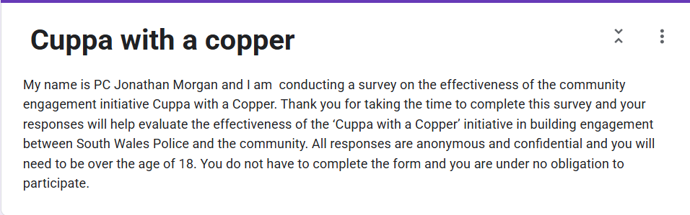




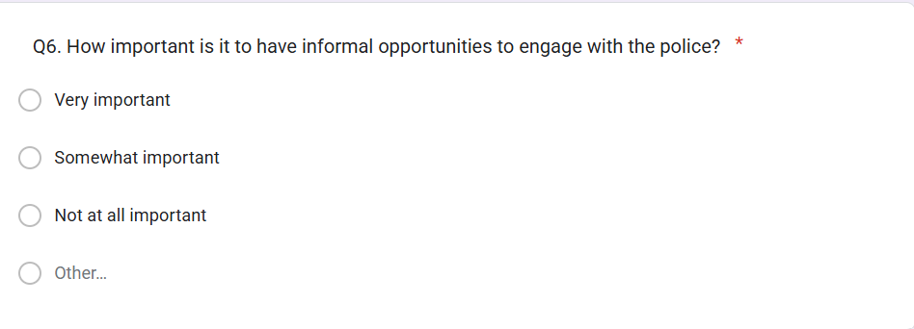

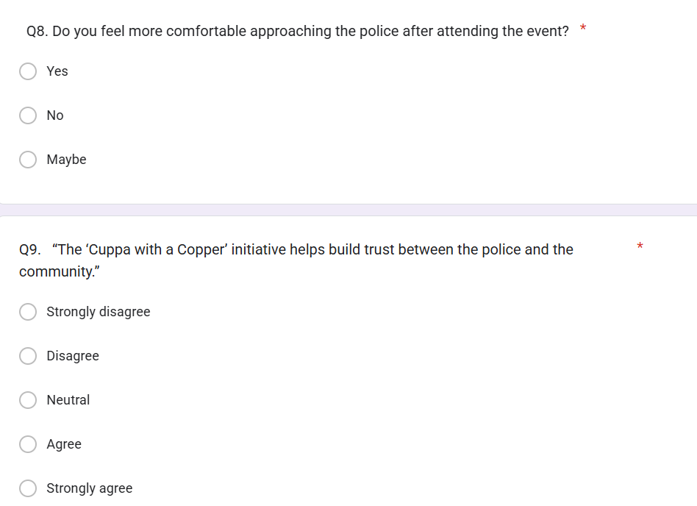
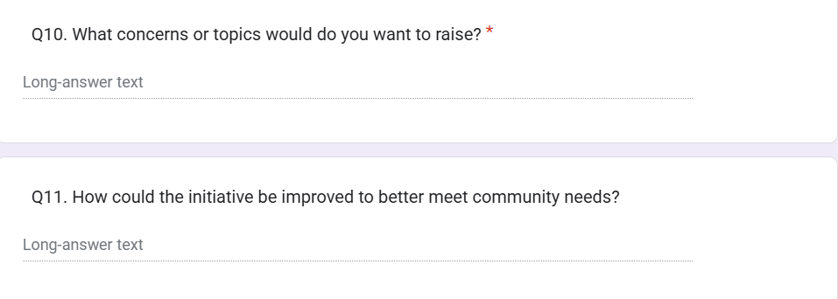
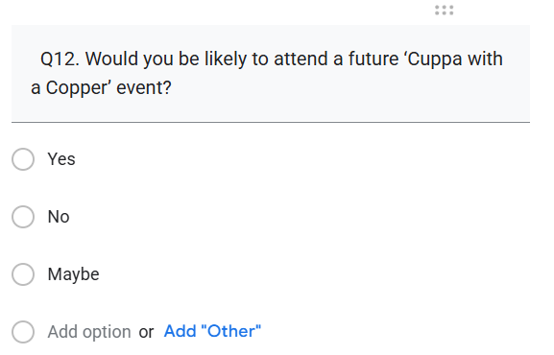

7.2 APPENDIX B Questionnaire for PCSO’S
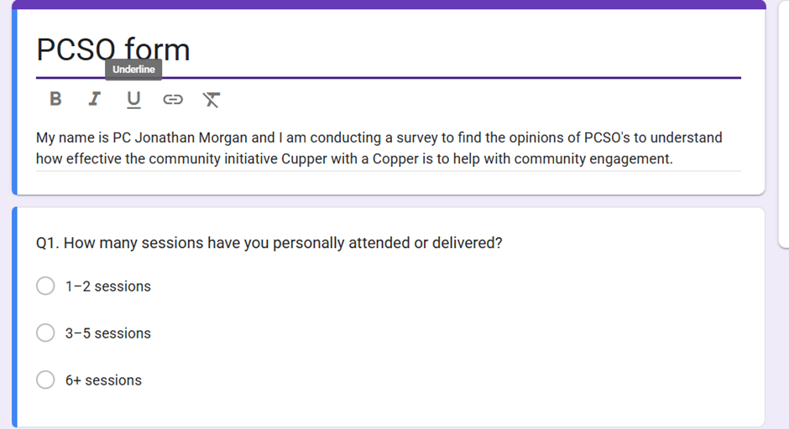

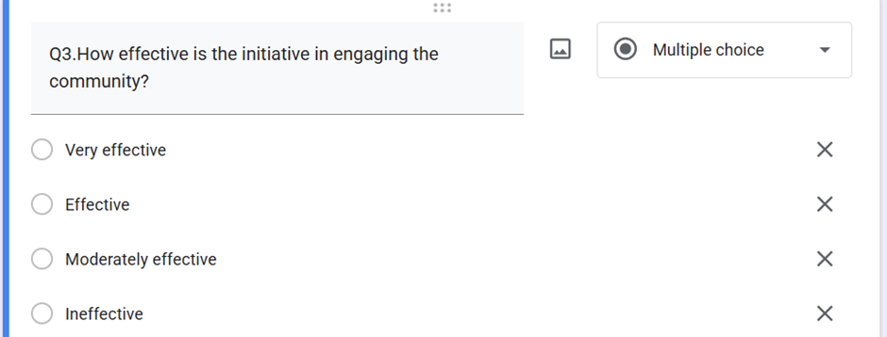
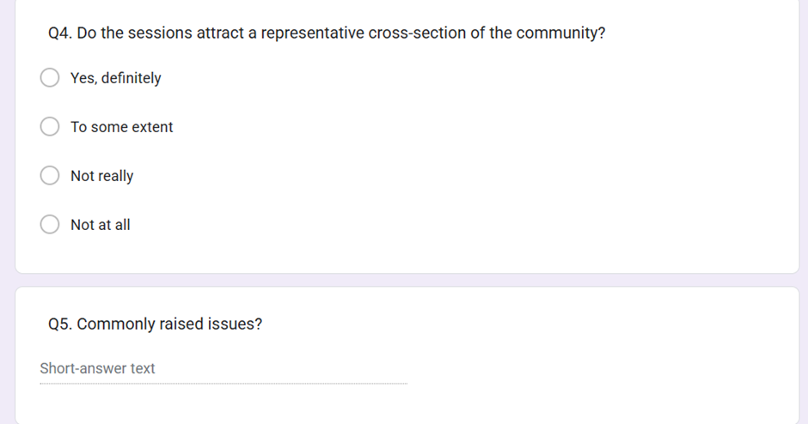
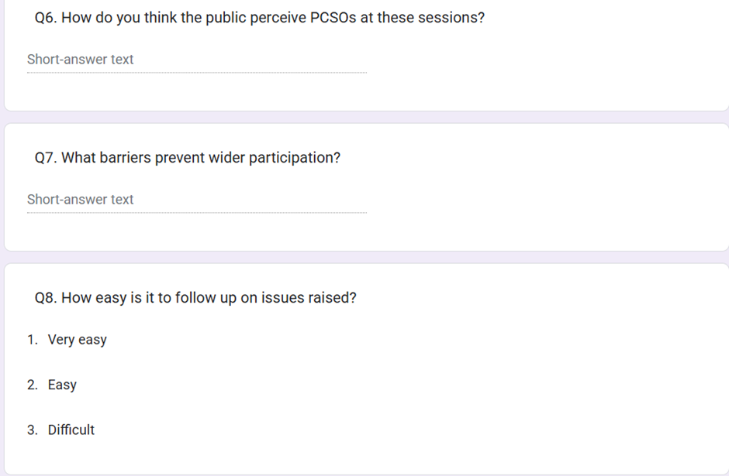
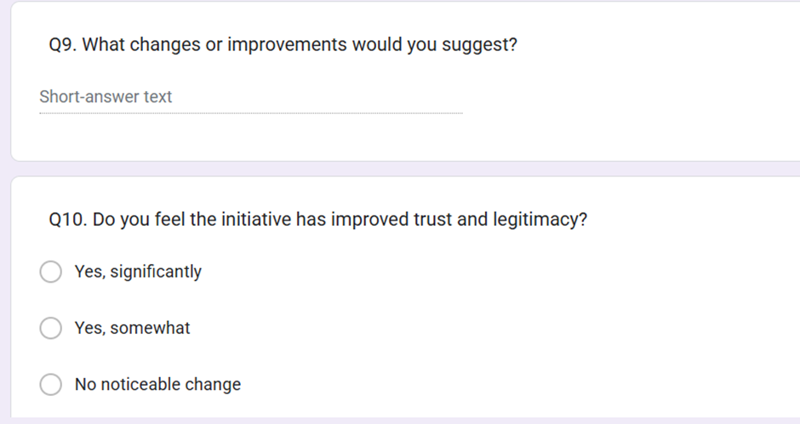

7.3 Appendix C Research Proposal Form



UNDERGRADUATE DISSERTATION
RESEARCH PROPOSAL FORM

Please complete the following research proposal and submit it to Turnitin.

Which project option are you taking? Please tick:

8,000-word project:

NAME:  Jonathan Morgan | STUDENT ID No.:  2236252
DRAFT RESEARCH TITLE QUESTION:
INTRODUCTION:
How can a local initiative “cuppa with a copper” help with community engagement.

The purpose of this report is to explore how a local community engagement project can help with community engagement. I have chosen to do this topic as I have experienced community policing first hand during my probation period and would like to explore different aspects of this type of policing.

I think this is an important project to research as ground roots policing is crucial in preventing serious crime within a community. A local initiative is an important part of keeping the community safe and building up trust and relationships within groups of a community can all help towards a safer place to live.

In regards to reading I have looked at the Crime Commissioner for South Wales crime plan and Priority 1 is all about prevention of crime and anti-social behaviour to keep people safe and confident in their homes and communities. I therefore believe this will be a worthy research project as it will be interesting to find out how these different initiatives have made an impact on community engagement.

SUMMARY OF RESEARCH OBJECTIVES:

- Evaluate the local initiative to help with community engagement.
- Establish the views of PCSO’s
- Establish the views of the members of the public
- What are the best practises?

The information I want to collect through this report is how can community trust be enhanced and I will evaluate the local initiative that has been set up by local police to see whether or not this is helping with community engagement.

I will conduct research with both community support officers and members of the local community, and I will conduct questionnaires for my research and provide these to both sides of the community.

The questionnaires will consist of different questions regarding community engagement. The questionnaires will be different to members of the public to community police officers.

LITERATURE REVIEW:

From looking at this research topic, there are many examples and case studies which show the impact on community engagement. Some of them are the following.

In my literature review I will be analysing the gap between the local police and members of the public to see if there is a common issue which is widening the gap between communities and the police.

The analysis will closely look at the type of people who attend this local initiative.

SUMMARY OF RESEARCH –SURVEY METHOD:

To conduct my research, I will be sampling groups who attend the community project “Cuppa with a copper”.

These methods will be suited to my research as they will give opinions and qualitative data to help show how community engagement is vital in policing.

I also want to discover whether this community engagement project is impacting the public opinion of community policing and policing as a whole.

SUMMARY OF SAMPLING FRAMEWORK:

I am going to be asking members of the public who attended initiatives such as cuppa with a copper.
I will speak with police staff members who are part of the neighbourhood policing team to explore ways of engagement and community participation.

ETHICAL ISSUES:

Confidentiality and privacy – I will ensure that all those involved in any surveys, professional discussions are kept private and aware of their privacy and confidentiality.

The questionnaires will be served as a paper copy to the members and to PCSO’S and police officers. When this survey has been carried these surveys will be kept in a secure location.

When comparing all the surveys and analysing the data and creating pie charts I will use my works laptop which is a password protected device. I will also encrypt the document, and this will also be password protected to where I will be the only person to know the password.
TIME SCALE:
I intend to start my research and analysis in March 2025 and hope to complete this by June 2025. I will then start to write up my findings and answer my research questions from June 2025 onwards.
REFERENCE LIST:

7.4 Appendix D Application for Ethical Approval

APPLICATION FOR ETHICAL APPROVAL

RESEARCH STUDENTS
This form is to be completed by the student within SIX months for full-time students and TWELVE months for part time students, after the commencement of the research degree or following progression to Part Two of your course.

Once complete, submit this form via the MyTSD Doctoral College Portal at (https://mytsd.uwtsd.ac.uk).

This document is also available in Welsh.

RESEARCH STAFF ONLY
All communications relating to this application during its processing must be in writing and emailed to pgresearch@uwtsd.ac.uk , with the title ‘Ethical Approval’ followed by your name.

STUDENTS ON UNDERGRADUATE OR TAUGHT MASTERS PROGRAMMES should submit this form (and receive the outcome) via systems explained to you by the supervisor/module leader.

In order for research to result in benefit and minimise risk of harm, it must be conducted ethically. A researcher may not be covered by the University’s insurance if ethical approval has not been obtained prior to commencement.

The University follows the OECD Frascati manual definition of research activity: “creative work undertaken on a systematic basis in order to increase the stock of knowledge, including knowledge of man, culture and society, and the use of this stock of knowledge to devise new applications”. As such this covers activities undertaken by members of staff, postgraduate research students, and both taught postgraduate and undergraduate students working on dissertations/projects.

The individual undertaking the research activity is known as the “principal researcher”.

Ethical approval is not required for routine audits, performance reviews, quality assurance studies, testing within normal educational requirements, and literary or artistic criticism.

Please read the notes for guidance before completing ALL sections of the form.

This form must be completed and approved prior to undertaking any research activity. Please see Checklist for details of process for different categories of application.

SECTION A: About You (Principal Researcher)
1 | Full Name: |  | Jonathan Morgan
2 | Tick all boxes that apply: |  | Member of staff: | ☐ | Honorary research fellow: | ☐
 | Undergraduate Student | ☒ | Taught Postgraduate Student | ☐ | Postgraduate Research Student | ☐

3 | Institute/Academic Discipline/Centre: | UWTSD
4 | Campus: | SWANSEA
5 | E-mail address: | 2236252@student.uwtsd.ac.uk
6 | Contact Telephone Number: | 07875509566
 | For students:
7 | Student Number: | 2236252
8 | Programme of Study: | Professional Police Practice
9 | Director of Studies/Supervisor:

SECTION B: Approval for Research Activity
1 | Has the research activity received approval in principle?  (please check the Guidance Notes as to the appropriate approval process for different levels of research by different categories of individual) |  | YES | ☒ | NO | ☐
 |  |  |  |  | Date
2 | If Yes, please indicate source of approval (and date where known): Approval in principle must be obtained from the relevant source prior to seeking ethical approval | Research Degrees Committee |  | ☐
2 |  | Institute Research Committee |  | ☐
2 |  | Other (write in) |  | ☐

SECTION C: Internal and External Ethical Guidance Materials
 | Please list the core ethical guidance documents that have been referred to during the completion of this form (including any discipline-specific codes of research ethics, location-specific codes of research ethics, and also any specific ethical guidance relating to the proposed methodology). Please tick to confirm that your research proposal adheres to these codes and guidelines. You may add rows to this table if needed.
1 | UWTSD Research Ethics & Integrity Code of Practice | ☒
2 | UWTSD Research Data Management Policy | ☒
3 | [List any other relevant documents here] | ☐

SECTION D: External Collaborative Research Activity
If there are external collaborators then you should gain consent from the contact persons to share their personal data with the university. If there are no external collaborators then leave this section blank and continue to section E.
1 | Institution
2 | Contact person name
3 | Contact person e-mail address
4 | Is your research externally funded? |  | YES | ☐ | NO |  | ☐
5 | Are you in receipt of a KESS scholarship? |  | YES | ☐ | NO |  | ☐
6 | Are you specifically employed to undertake this research in either a paid or voluntary capacity? | Voluntary | YES | ☐ | NO | ☐
7 |  | Employed | YES | ☐ | NO | ☐
8 | Is the research being undertaken within an existing UWTSD Athrofa Professional Learning Partnership (APLP)? | If YES then the permission question below does not need to be answered. | YES | ☐ | NO |  | ☐
9 | Has permission to undertake the research has been provided by the partner organisation? | (If YES attach copy)  If NO the application cannot continue | YES | ☒ | NO |  | ☐

Where research activity is carried out in collaboration with an external organisation
10 | Does this organisation have its own ethics approval system? | YES | ☐ | NO | ☐
 | If Yes, please attach a copy of any final approval (or interim approval) from the organisation (this may be a copy of an email if appropriate).

SECTION E: Details of Research Activity
1 | Indicative title: | How can local initiatives help with community engagement.
2 | Proposed start date: |  | Proposed end date:
Introduction to the Research (maximum 300 words per section)
Ensure that you write for a Non-Specialist Audience when outlining your response to the points below:
- Purpose of Research Activity
- Proposed Research Question
- Aims of Research Activity
- Objectives of Research Activity
Demonstrate, briefly, how Existing Research has informed the proposed activity and explain
- What the research activity will add to the body of knowledge
- How it addresses an area of importance.
3 | Purpose of Research Activity  The purpose of this report is to explore how local community engagement projects can help with community engagement. I have chosen to do this topic as I have experienced community policing first hand during my probation period and would like to explore different aspects of this type of policing.  I think this is an important project to research as ground roots policing is crucial in preventing serious crime within a community. Local initiatives are an important part of keeping the community safe and building up trust and relationships within groups of a community can all help towards a safer place to live.  In regards to reading I have looked at the Crime Commissioner for South Wales crime plan and Priority 1 is all about prevention of crime and anti-social behaviour to keep people safe and confident in their homes and communities. I therefore believe this will be a worthy research project as it will be interesting to find out how these different initiatives have made an impact on community engagement.  (this box should expand as you type)
4 | Research Question  How can local initiatives help with community engagement.  (this box should expand as you type)
5 | Aims of Research Activity  - Evaluate local initiatives to help with community engagement.  - How can community trust be enhanced  - Impact of community projects  - Analyse the data from findings  - Conclude the findings of this research project and make recommendations into the findings.  (this box should expand as you type)
6 | Objectives of Research Activity  The information I want to collect through this report is how can community trust be enhanced and I will evaluate local initiatives that are set up by local police to see whether or not these help with community engagement.  I will conduct research with both community support officers and also members of the local community and I will conduct questionnaires for my research and provide these to both sides of the community.  The questionnaires will consist of different questions regarding community engagement. The questionnaires will be different to members of the public to community police officers.  (this box should expand as you type)
Proposed methods (maximum 600 words)
Provide a brief summary of all the methods that may be used in the research activity, making it clear what specific techniques may be used. If methods other than those listed in this section are deemed appropriate later, additional ethical approval for those methods will be needed. You do not need to justify the methods here, but should instead describe how you intend to collect the data necessary for you to complete your project.
7 | I am going to be asking members of the public who attended initiatives such as cuppa with a copper.  I will speak with police staff members who are part of the neighbourhood policing team to explore ways of engagement and community participation.  (this box should expand as you type)
Location of research activity
Identify all locations where research activity will take place.
8 | Swansea  (this box should expand as you type)
Research activity outside of the UK
If research activity will take place overseas, you are responsible for ensuring that local ethical considerations are complied with and that the relevant permissions are sought. Specify any local guidelines (e.g. from local professional associations/learned societies/universities) that exist and whether these involve any ethical stipulations beyond those usual in the UK (provide details of any licenses or permissions required). Also specify whether there are any specific ethical issues raised by the local context in which the research activity is taking place, for example, particular cultural and/or legal sensitivities or vulnerabilities of participants. If you live in the country where you will do the research then please state this.
9 | N/A  (this box should expand as you type)

10 | Use of documentation not in the public domain: Are any documents NOT publicly available? | NO | ☒
10 |  | YES | ☐
11 | If Yes, please provide details here of how you will gain access to specific documentation that is not in the public domain and that this is in accordance with the current data protection law of the country in question and that of England and Wales.  (this box should expand as you type)

 | Does your research relate to one or more of the seven aims of the Well-being of Future Generations (Wales) Act 2015? | YES | NO
12 | A prosperous Wales | ☐ | ☒
13 | A resilient Wales | ☐ | ☒
14 | A healthier Wales | ☐ | ☒
15 | A more equal Wales | ☐ | ☒
16 | A Wales of cohesive communities | ☐ | ☒
17 | A Wales of vibrant culture and thriving Welsh language | ☐ | ☒
18 | A globally responsible Wales | ☐ | ☒
19 | If YES to any of the above, please give details:
 | (this box should expand as you type)

SECTION F: Scope of Research Activity
 | Will the research activity include: | YES | NO
1 | Use of a questionnaire or similar research instrument? | ☒ | ☐
2 | Use of interviews? | ☒ | ☐
3 | Use of focus groups? | ☒ | ☐
4 | Use of participant diaries? | ☐ | ☒
5 | Use of video or audio recording? | ☐ | ☒
6 | Use of computer-generated log files? | ☐ | ☒
7 | Participant observation with their knowledge? | ☐ | ☒
8 | Participant observation without their knowledge? | ☐ | ☒
9 | Access to personal or confidential information without the participants’ specific consent? | ☐ | ☒
10 | Administration of any questions, test stimuli, presentation that may be experienced as physically, mentally or emotionally harmful / offensive? | ☐ | ☒
11 | Performance of any acts which may cause embarrassment or affect self-esteem? | ☐ | ☒
12 | Investigation of participants involved in illegal activities? | ☐ | ☒
13 | Use of procedures that involve deception? | ☐ | ☒
14 | Administration of any substance, agent or placebo? | ☐ | ☒
15 | Working with live vertebrate animals? | ☐ | ☒
16 | Procedures that may have a negative impact on the environment? | ☐ | ☒
17 | Other primary data collection methods. Please indicate the type of data collection method(s) below. | ☐ | ☒
 | Details of any other primary data collection method:  (this box should expand as you type) | ☐ | ☒
If NO to every question, then the research activity is (ethically) low risk and may be exempt from some of the following sections (please refer to Guidance Notes).

If YES to any question, then no research activity should be undertaken until full ethical approval has been obtained.

SECTION G: Intended Participants
If there are no participants then do not complete this section, but go directly to section H.

 | Who are the intended participants: | YES | NO
1 | Students or staff at the University? | ☒ | ☐
2 | Adults (over the age of 18 and competent to give consent)? | ☒ | ☐
3 | Vulnerable adults? | ☐ | ☒
4 | Children and Young People under the age of 18? (Consent from Parent, Carer or Guardian will be required) | ☐ | ☒
5 | Prisoners? | ☐ | ☒
6 | Young offenders? | ☐ | ☒
7 | Those who could be considered to have a particularly dependent relationship with the investigator or a gatekeeper? | ☐ | ☒
8 | People engaged in illegal activities? | ☐ | ☒
9 | Others. Please indicate the participants below, and specifically any group who may be unable to give consent. | ☐ | ☒
 | Details of any other participant groups:  (this box should expand as you type) | ☐ | ☒

Participant numbers and source
Provide an estimate of the expected number of participants. How will you identify participants and how will they be recruited?
10 | How many participants are expected? | I expect there will be 20 -30 participants  (this box should expand as you type)
11 | Who will the participants be? | Members of the public , police officers and police staff , PCSO  (this box should expand as you type)
12 | How will you identify the participants? | I will refer these persons to numbers and will not disclose any names or addresses.  (this box should expand as you type)

 | Information for participants: | YES | NO | N/A
13 | Will you describe the main research procedures to participants in advance, so that they are informed about what to expect? | ☒ | ☐ | ☐
14 | Will you tell participants that their participation is voluntary? | ☒ | ☐ | ☐
15 | Will you obtain written consent for participation? | ☒ | ☐ | ☐
16 | Will you explain to participants that refusal to participate in the research will not affect their treatment or education (if relevant)? | ☐ | ☐ | ☒
17 | If the research is observational, will you ask participants for their consent to being observed? | ☐ | ☐ | ☒
18 | Will you tell participants that they may withdraw from the research at any time and for any reason? | ☒ | ☐ | ☐
19 | With questionnaires, will you give participants the option of omitting questions they do not want to answer? | ☒ | ☐ | ☐
20 | Will you tell participants that their data will be treated with full confidentiality and that, if published, it will not be identifiable as theirs? | ☒ | ☐ | ☐
21 | Will you debrief participants at the end of their participation, in a way appropriate to the type of research undertaken? | ☒ | ☐ | ☐
22 | If NO to any of above questions, please give an explanation
 | (this box should expand as you type)

 | Information for participants: | YES | NO | N/A
24 | Will participants be paid? | ☐ | ☒ | ☐
25 | Is specialist electrical or other equipment to be used with participants? | ☐ | ☒ | ☐
26 | Are there any financial or other interests to the investigator or University arising from this study? | ☐ | ☒ | ☐
27 | Will the research activity involve deliberately misleading participants in any way, or the partial or full concealment of the specific study aims? | ☐ | ☒ | ☐
28 | If YES to any question, please provide full details
 | (this box should expand as you type)

SECTION H: Anticipated Risks

Outline any anticipated risks that may adversely affect any of the participants, the researchers and/or the University, and the steps that will be taken to address them.

If you have completed a full risk assessment (for example as required by a laboratory, or external research collaborator) you may append that to this form.
1 | Full risk assessment completed and appended? |  | Yes | ☒
1 |  |  | No | ☐
2 | Risks to participants  For example: sector-specific health & safety, emotional distress, financial disclosure, physical harm, transfer of personal data, sensitive organisational information
 | Risk to participants:  N/A  (this box should expand as you type) | How you will mitigate the risk to participants:  (this box should expand as you type)
3 | If research activity may include sensitive, embarrassing or upsetting topics (e.g. sexual activity, drug use) or issues likely to disclose information requiring further action (e.g. criminal activity), give details of the procedures to deal with these issues, including any support/advice (e.g. helpline numbers) to be offered to participants. Note that where applicable, consent procedures should make it clear that if something potentially or actually illegal is discovered in the course of a project, it may need to be disclosed to the proper authorities
N/A

(this box should expand as you type)
4 | Risks to the investigator  For example: personal health & safety, physical harm, emotional distress, risk of accusation of harm/impropriety, conflict of interest
 | Risk to the investigator:  N/A  (this box should expand as you type) | How you will mitigate the risk to the investigator:  (this box should expand as you type)
5 | University/institutional risks  For example: adverse publicity, financial loss, data protection
 | Risk to the University:  N/A  (this box should expand as you type) | How you will mitigate the risk to the University:  (this box should expand as you type)
6 | Environmental risks  For example: accidental spillage of pollutants, damage to local ecosystems
 | Risk to the environment:  N/A  (this box should expand as you type) | How you will mitigate the risk to environment:  (this box should expand as you type)

 | Disclosure and Barring Service
 | If the research activity involves children or vulnerable adults, a Disclosure and Barring Service (DBS) certificate must be obtained before any contact with such participants. | YES | NO | N/A
7 | Does your research require you to hold a current DBS Certificate? | ☐ | ☐ | ☒
8 | If YES, please give the certificate number. If the certificate number is not available please write “Pending”; in this case any ethical approval will be subject to providing the appropriate certificate number.

SECTION I: Feedback, Consent and Confidentiality

1 | Feedback  What de-briefing and feedback will be provided to participants, how will this be done and when?
The research results will be kept for my own use. From this participants will not be contacted however I will provide my contact details should they wish to receive this information.

(this box should expand as you type)
2 | Informed consent  Describe the arrangements to inform potential participants, before providing consent, of what is involved in participating. Describe the arrangements for participants to provide full consent before data collection begins. If gaining consent in this way is inappropriate, explain how consent will be obtained and recorded in accordance with prevailing data protection legislation.
The survey and project will be fully explained to all participants.

(this box should expand as you type)
3 | Confidentiality / Anonymity  Set out how anonymity of participants and confidentiality will be ensured in any outputs. If anonymity is not being offered, explain why this is the case.
No personal information will not be disclosed and all data will be protected.

(this box should expand as you type)

SECTION J: Data Protection and Storage

 | Does the research activity involve personal data (as defined by the General Data Protection Regulation 2016 “GDPR” and the Data Protection Act 2018 “DPA”)? | YES | NO
1 | “Personal data” means any information relating to an identified or identifiable natural person (‘data subject’). An identifiable natural person is one who can be identified, directly or indirectly, in particular by reference to an identifier such as a name, an identification number, location data, an online identifier or to one or more factors specific to the physical, physiological, genetic, mental, economic, cultural or social identity of that natural person. Any video or audio recordings of participants is considered to be personal data. | ☐ | No
 | If YES, provide a description of the data and explain why this data needs to be collected:
2 | (this box should expand as you type)
 | Does it involve special category data (as defined by the GDPR)? | YES | NO
3 | “Special category data” means sensitive personal data consisting of information as to the data subjects’ –  (a) racial or ethnic origin,  (b) political opinions,  (c ) religious beliefs or other beliefs of a similar nature,  (d) membership of a trade union (within the meaning of the Trade Union and Labour Relations (Consolidation) Act 1992),  (e) physical or mental health or condition,  (f) sexual life,  (g) genetics,  (h) biometric data (as used for ID purposes), | ☐ | No
 | If YES, provide a description of the special category data and explain why this data needs to be collected:
4 | (this box should expand as you type)

 | Will data from the research activity (collected data, drafts of the thesis, or materials for publication) be stored in any of the following ways? | YES | NO
5 | Manual files (i.e. in paper form)? | ☐ | ☒
6 | University computers? | ☐ | ☒
7 | Private company computers? | ☐ | ☒
8 | Home or other personal computers? | ☐ | ☒
9 | Laptop computers/ CDs/ Portable disk-drives/ memory sticks? | ☒ | ☒
10 | “Cloud” storage or websites? | ☐ | ☒
11 | Other – specify: | ☐ | ☒
12 | For all stored data, explain the measures in place to ensure the security of the data collected, data confidentiality, including details of backup procedures, password protection, encryption, anonymisation and pseudonymisation:
Laptop is password protected and I am the only person who has access to the device.
(this box should expand as you type)

 | Data Protection
 | Will the research activity involve any of the following activities: | YES | NO
13 | Electronic transfer of data in any form? | ☒ | ☒
14 | Sharing of data with others at the University outside of the immediate research team? | ☐ | ☒
15 | Sharing of data with other organisations? | ☐ | ☒
16 | Export of data outside the UK or importing of data from outside the UK? | ☐ | ☒
17 | Use of personal addresses, postcodes, faxes, emails or telephone numbers? | ☐ | ☒
18 | Publication of data that might allow identification of individuals? | ☐ | ☒
19 | Use of data management system? | ☐ | ☒
20 | Data archiving? | ☐ | ☒
21 | If YES to any question, please provide full details, explaining how this will be conducted in accordance with the GDPR and Data Protection Act (2018) (and any international equivalents, where appropriate):
 | (this box should expand as you type)
22 | List all who will have access to the data generated by the research activity:
Myself

(this box should expand as you type)
23 | List who will have control of, and act as custodian(s) for, data generated by the research activity:
Myself

(this box should expand as you type)
24 | Give details of data storage arrangements, including security measures in place to protect the data, where data will be stored, how long for, and in what form. Will data be archived – if so how and if not why not.
All information is for myself

(this box should expand as you type)
25 | Please indicate if your data will be stored in the UWTSD Research Data Repository (see https://researchdata.uwtsd.ac.uk/ ). If so please explain. (Most relevant to academic staff)
 | (this box should expand as you type)
26 | Confirm that you have read the UWTSD guidance on data management (see https://www.uwtsd.ac.uk/library/research-data-management/) | YES | ☒
27 | Confirm that you are aware that you need to keep all data until after your research has completed or the end of your funding | YES | ☒

SECTION K: Declaration
The information which I have provided is correct and complete to the best of my knowledge. I have attempted to identify any risks and issues related to the research activity and acknowledge my obligations and the rights of the participants.

In submitting this application I hereby confirm that I undertake to ensure that the above named research activity will meet the University’s Research Ethics and Integrity Code of Practice which is published on the website: https://www.uwtsd.ac.uk/research/research-ethics/
1 | Signature of applicant: | Jonathan Morgan | Date:  09/02/2025

For STUDENT Submissions:
2 | Director of Studies/Supervisor: |  | Date:
3 | Signature: |  | Date:

For STAFF Submissions:
4 | Academic Director/ Assistant Dean: |  | Date:
5 | Signature: |  | Date:

Checklist: Please complete the checklist below to ensure that you have completed the form according to the guidelines and attached any required documentation:
☒ | I have read the guidance notes supplied before completing the form.
☒ | I have completed ALL RELEVANT sections of the form in full.
☐ | I confirm that the research activity has received approval in principle
☐ | I have attached a copy of final/interim approval from external organisation (where appropriate)
☐ | I have attached a full risk assessment (where appropriate) ONLY TICK IF YOU HAVE ATTACHED A FULL RISK ASSESSMENT
☒ | I understand that it is my responsibility to ensure that the above named research activity will meet the University’s Research Ethics and Integrity Code of Practice.
☒ | I understand that before commencing data collection all documents aimed at respondents (including information sheets, consent forms, questionnaires, interview schedules etc.) must be confirmed by the DoS/Supervisor, module tutor or Academic Director.

RESEARCH STUDENTS ONLY
Once complete, submit this form via the MyTSD Doctoral College Portal at (https://mytsd.uwtsd.ac.uk).

RESEARCH STAFF ONLY
All communications relating to this application during its processing must be in writing and emailed to pgresearch@uwtsd.ac.uk , with the title ‘Ethical Approval’ followed by your name.

STUDENTS ON UNDERGRADUATE OR TAUGHT MASTERS PROGRAMMES should submit this form (and receive the outcome) via systems explained to you by the supervisor/module leader.

