
Level 4

MODULE CODE: BMST4003

WORD COUNT: 1500 WORDS
MODULE TUTOR: Kerry Nicholas
PROGRAMME: BSc Sport and Exercise Therapy
MODULE: Professional Skills for Sports Therapists
MODULE TITLE: Discuss the benefits of regular exercise.
HAND IN DATE: 09/12/2022

Jordan Discombe – Student (2214228)

Taking part in regular exercise is said to have many physical and mental benefits.

Introduction

Before we begin to understand the physical and mental benefits of regular exercise, it is important to gain a definition of what physical activity and what physical exercise are. Physical activity is defined as “any bodily movement produced by skeletal muscle that results in energy expenditure” whilst physical exercise is defined as “a type of physical activity consisting of planned, structured, and repetitive bodily movement done to improve and/or maintain one or more components of physical fitness” (American College of Sports Medicine, 2018). The physical benefits of regular exercise have long been established in modern medicine, with studies spanning the last 43 years reiterating the positive benefits to our health through physical exercise (Thomas, 1979). The development and understanding of mental health however has come on leaps and bounds in recent years, as proven by a study carried out during lockdown which showed the positive impacts on our mood created by regular exercise (Brand, Timme and Nosrat, 2020). The World Health Organisation (WHO) reiterate that some form of physical activity is better than none, however, doing more is what you need for optimum health. It was previously stated that physical exercise has proven to be an extremely useful tool in health enhancement (Knuttgen, 2003).

The Effects of Regular Exercise
People who suffer with cardiovascular disease, coronary artery disease, hypertension, stroke, osteoporosis, Type 2 Diabetes mellitus, metabolic syndrome, obesity, certain types of cancers, depression, functional health and who are at risk of falls are all thought to benefit from some form of physical activity (Luan et al., 2019). Although most of these benefits are prevalent at a later age, physical activity has a very important role in the motor and psychological development in the paediatric population (Bukvić, Ćirović and Nikolić, 2021).
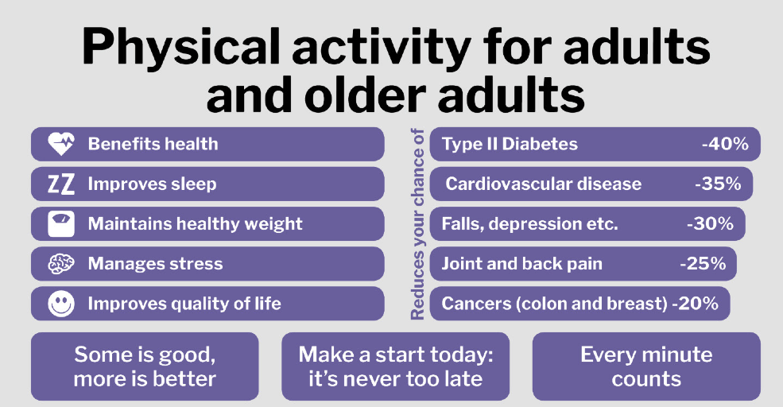

(Fig 1) (Department of Health and Social Care, 2019)

Cardiovascular Disease

Cardiovascular disease is thought to be the leading course of major morbidity and all cause mortality in most of the world (Sanchis-Gomar et al., 2021). Previous data suggests that regular physical activity is beneficial for cardiovascular health and frequent exercise is associated with a decrease in cardiovascular mortality as well as the risk of developing cardiovascular diseases (Al-Mallah, Sakr and Al-Qunaibet, 2018). In addition to merely changing well-known risk factors for systemic cardiovascular disease, regular exercise can also improve cardiovascular health through non-traditional mechanisms (Fiuza-Luces et al., 2018). Loss of muscle strength and mass is thought to be a forgotten hallmark of, and also a risk factor for cardiovascular disease that can be largely reversed with resistance (strength) training (Fiuza-Luces et al., 2018). Generally, higher levels of physical activity and cardiorespiratory fitness are correlated with the reduced risk of cardiovascular disease, cardiovascular related death and all-cause mortality (Sanchis-Gomar et al., 2021). Decades of scientific investigations have fortified the protective effects of cardiorespiratory fitness, exercise training, and physical activity against the development of cardiovascular disease (Ozemek et al., 2018). Contradictory to this is that too much training with little rest or no rest could potentially tip the balance back towards being harmful (Sharman, La Gerche and Coombes, 2014). However more research is still needed to detail the amount of physical activity needed to benefit towards the reduced risks or treatment of cardiovascular disease without being a detriment to overall health.

Benefits for those suffering with Diabetes

There is a direct relationship between the risk of type 2 diabetes and other factors such as age, obesity and lack of exercise (Standl et al., 2020). Furthermore, research has revealed that regular exercise has an extremely important role in controlling diabetes by promoting a healthier lifestyle (Francesconi et al., 2019). Diabetes is a disease which is thought to be on the rise, and a recent journal concluded that 424.9 million people had diabetes in 2017, with an estimation of 628.6 million people by 2045. This represents an increase of 48% worldwide (Standl et al., 2020). Research has revealed that exercise has an extremely important role in controlling diabetes (Mousavi Gilani and Khazaei Feizabad, 2019). In the same journal it noted that regular exercise has a positive impact on self-esteem, mental health and promoting life quality among diabetics (Mousavi Gilani and Khazaei Feizabad, 2019). Exercise as a regular physical activity at a medium to vigorous intensity is found to be an efficient influencer that would switch back most of the known type 2 diabetes mellitus factors toward healthier positions (Amanat et al., 2020). However, there are reported issues with prescribing exercise for people with type 2 diabetes, it has been found that diabetic patients may suffer from a wide range of musculoskeletal disorders, this can cause pain and some dysfunctions in the patients and affect the treatment negatively or reduce the quality of life (Sozen et al., 2018). This may cause problems in the implementation of exercise programs, which are very important in the treatment of patients with Diabetes Mellitus (Sozen et al., 2018). Although these studies suggest exercise can help in the fight to reverse type 2 diabetes, it is thought to only put diabetes into remission and therefore should be looked at as a preventative measure rather than a cure (Sgrò et al., 2021).

COVID 19

The issue with exercise as a form of treatment is that we now live a more sedentary life which could be a cause for concern in trying to get the population to exercise (Park et al., 2020). (Freese et al., 2018) discusses how evolution has been a cause in the rise of a sedentary lifestyle and a decline in physical activity and physical exercise. The inventions of modern technology such as the refrigerator, cars and the world wide web in the last three decades has contributed to this way of life (Freese et al., 2018). An even closer event COVID-19 which spread across the globe resulted in quarantine measures and social isolation being implemented in many countries to help prevent the spread of the disease (Garcovich et al., 2020). The risks of this however, meant the potential reduction of physical activity or physical exercise due to the limitations imposed (Pérez-Rodrigo et al., 2021) Fig 2 from (Woods et al., 2020) shows how COVID-19 and the issues with quarantine could cause on public health. Where COVID-19 in some cases would attack the nervous system (Fu and Levine, 2013), the quarantine itself contributing to the effects of depression (Tang et al., 2020) and exercise a reported benefit of both these problems (Bukvić, Ćirović and Nikolić, 2021). More research may be needed to help define a better strategy in coping with further outbreaks against the effects quarantine has on limiting the positive effects of physical activity.
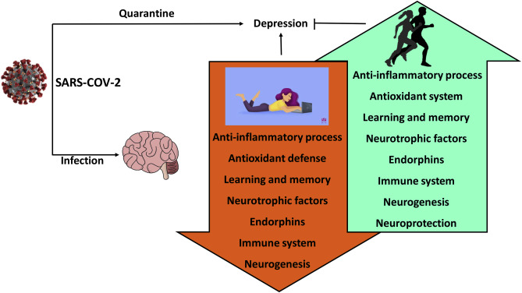
(Fig 2) (Bukvić, Ćirović and Nikolić, 2021)

Age Related Benefits

The population is ageing worldwide at a phenomenal pace from approximately 900 million ≥ 60 years old in 2015 to approximately 2 billion in 2050 (Organization, 2019). This predicts the numbers will more than double over the next 27 years (Organization, 2019). The issue with this is aging is associated by a progressive rise in chronic diseases with an impact on social and healthcare costs (Carta et al., 2021). (Rodgers et al., 2019) lists other age-related factors such as obesity, frailty and diabetes to name a few. One of these chronic diseases is Sarcopenia and in the past it has been mentioned by (Cruz-Jentoft et al., 2010) as a disease that affects the muscle’s and causes them to waste away leading to a decrease in muscle mass, muscle strength and overall performance. This combined loss of muscle mass and strength with aging is associated with greater morbidity and mortality in the elderly (Barajas-Galindo et al., 2021). Early treatment is therefore essential, and physical exercise is the therapeutic approach that has given the best results (Barajas-Galindo et al., 2021). The promotion of a healthy lifestyle and physical exercise, and the avoidance of sedentariness have been associated with having a positive effect for frail older adults by enhancing their independence and most likely reducing health-related costs (Izquierdo et al., 2016). Despite some risks involved with prescribing exercise to older adults it could be morally wrong if exercise wasn’t prescribed because of this (Izquierdo et al., 2016).

Conclusion

Whilst many studies show the benefits of regular exercise both physically and mentally many conclude that on its own it might not be enough to promote overall quality of life (Fletcher et al., 2018). A specific dose response relationship between extent and duration of exercise and the reduction in cardiovascular disease risk and mortality remains unclear (Nystoriak and Bhatnagar, 2018). Further studies are needed to identify the mechanisms that impact cardiovascular benefits of exercise to develop more effective exercise regimens, test the interaction of exercise with diet and develop pharmacological interventions for those unwilling or unable to exercise (Nystoriak and Bhatnagar, 2018). Previous studies suggest more research maybe needed to better distinguish the relationship on the optimal levels of exercise for cardiovascular health benefits due to the risks to much exercise can impose (O’Keefe et al., 2012). Therefore, regular exercise maybe considered effective for many health benefits but insufficient on its own with better guidance needed around frequency, intensity, time and type of exercise and linked benefits with diet and sleep (Fletcher et al., 2018)

WORD COUNT 1542/1500

References

Al-Mallah, M.H., Sakr, S. and Al-Qunaibet, A. (2018). Cardiorespiratory fitness and cardiovascular disease prevention: An update. Current atherosclerosis reports, 20(1), p.1.
‌Amanat, S., Ghahri, S., Dianatinasab, A., Fararouei, M. and Dianatinasab, M. (2020). Exercise and type 2 diabetes. Physical exercise for human health, 1228, pp.91–105.
‌American College of Sports Medicine (2018). ACSM’s guidelines for exercise testing and prescription. 10th ed. Wolters Kluwer.
Barajas-Galindo, D.E., González Arnáiz, E., Ferrero Vicente, P. and Ballesteros-Pomar, M.D. (2021). Effects of physical exercise in sarcopenia. a systematic review. Endocrinología, diabetes y nutrición (English ed.), 68(3), pp.159–169.
‌Bukvić, Z., Ćirović, D. and Nikolić, D. (2021). The importance of physical activity for the development of motor skills of younger school age children. Medicinski podmladak, 72(2), pp.34–39.
‌Carta, M.G., Cossu, G., Pintus, E., Zoccheddu, R., Callia, O., Conti, G., Pintus, M., Gonzalez, C.I.A., Massidda, M.V., Mura, G., Sardu, C., Contu, P., Minerba, L., Demontis, R., Pau, M., Finco, G., Cocco, E., Penna, M.P., Orrù, G. and Kalcev, G. (2021). Active elderly and health—can moderate exercise improve health and wellbeing in older adults? Protocol for a randomized controlled trial. Trials, 22(1).
‌Cruz-Jentoft, A.J., Baeyens, J.P., Bauer, J.M., Boirie, Y., Cederholm, T., Landi, F., Martin, F.C., Michel, J.-P. ., Rolland, Y., Schneider, S.M., Topinkova, E., Vandewoude, M. and Zamboni, M. (2010). Sarcopenia: European consensus on definition and diagnosis: Report of the European working group on sarcopenia in older people. Age and ageing, 39(4), pp.412–423.
‌Department of health and social care (2019). UK chief medical officers’ Physical activity guidelines. gov.uk. Available at: https://assets.publishing.service.gov.uk/government/uploads/system/uploads/attachment_data/file/832868/uk-chief-medical-officers-physical-activity-guidelines.pdf.
‌Fiuza-Luces, C., Santos-Lozano, A., Joyner, M., Carrera-Bastos, P., Picazo, O., Zugaza, J.L., Izquierdo, M., Ruilope, L.M. and Lucia, A. (2018). Exercise benefits in cardiovascular disease: beyond attenuation of traditional risk factors. Nature reviews cardiology, [online] 15(12), pp.731–743.
‌Fletcher, G.F., Landolfo, C., Niebauer, J., Ozemek, C., Arena, R. and Lavie, C.J. (2018). Promoting physical activity and exercise. Journal of the American college of cardiology, 72(14), pp.1622–1639.
‌Francesconi, C., Niebauer, J., Haber, P., Weitgasser, R. and Lackinger, C. (2019). Lifestyle: Physical activity and training as prevetion and therapy of type 2 diabetes mellitus (Update 2019)]. Wiener Klinische Wochenschrift, [online] 131(Suppl 1), pp.61–66.
‌Freese, J., Klement, R.J., Ruiz-Núñez, B., Schwarz, S. and Lötzerich, H. (2018). The sedentary (r)evolution: Have we lost our metabolic flexibility? F1000Research, [online] 6.
‌Fu, Q. and Levine, B.D. (2013). Chapter 13 - Exercise and the autonomic nervous system. ScienceDirect. Available at: https://www.sciencedirect.com/science/article/abs/pii/B9780444534910000134.
‌Izquierdo, M., Rodriguez-Mañas, L., Casas-Herrero, A., Martinez-Velilla, N., Cadore, E.L. and Sinclair, A.J. (2016). Is it ethical not to prescribe physical activity for the elderly frail? Journal of the American medical directors association, 17(9), pp.779–781.
‌Knuttgen, H.G. (2003). What is exercise? a primer for practitioners. The physician and sportsmedicine, 31(3), pp.31–49.
‌Luan, X., Tian, X., Zhang, H., Huang, R., Li, N., Chen, P. and Wang, R. (2019). Exercise as a prescription for patients with various diseases. Journal of sport and health science, 8(5), pp.422–441.
‌Mousavi Gilani, S.R. and Khazaei Feizabad, A. (2019). The effects of aerobic exercise training on mental health and self-esteem of type 2 diabetes mellitus patients. Health psychology research, 7(1).
Nystoriak, M.A. and Bhatnagar, A. (2018). Cardiovascular effects and benefits of exercise. Frontiers in cardiovascular medicine, [online] 5(135).
‌O’Keefe, J.H., Patil, H.R., Lavie, C.J., Magalski, A., Vogel, R.A. and McCullough, P.A. (2012). Potential adverse cardiovascular effects from excessive endurance exercise. Mayo clinic proceedings, [online] 87(6), pp.587–595.
‌Organization, W.H. (2019). Global Action Plan on Physical Activity 2018-2030: More active people for a healthier world. Google books: World health organization. Available at: https://books.google.co.uk/books?hl=en&lr=&id=RnOyDwAAQBAJ&oi=fnd&pg=PA48&dq=Organization
‌Ozemek, C., Laddu, D.R., Lavie, C.J., Claeys, H., Kaminsky, L.A., Ross, R., Wisloff, U., Arena, R. and Blair, S.N. (2018). An update on the role of cardiorespiratory fitness, structured exercise and lifestyle physical activity in preventing cardiovascular disease and health risk. Progress in cardiovascular diseases, 61(5-6), pp.484–490.
‌Park, J.H., Moon, J.H., Kim, H.J., Kong, M.H. and Oh, Y.H. (2020). Sedentary lifestyle: Overview of updated evidence of potential health risks. Korean journal of family medicine, 41(6), pp.365–373.
‌Pérez-Rodrigo, C., Gianzo Citores, M., Hervás Bárbara, G., Ruiz-Litago, F., Casis Sáenz, L., Arija, V., López-Sobaler, A.M., Martínez de Victoria, E., Ortega, R.M., Partearroyo, T., Quiles-Izquierdo, J., Ribas-Barba, L., Rodríguez-Martín, A., Salvador Castell, G., Tur, J.A., Varela-Moreiras, G., Serra-Majem, L. and Aranceta-Bartrina, J. (2021). Patterns of change in dietary habits and physical activity during lockdown in Spain due to the COVID-19 pandemic. Nutrients, [online] 13(2), p.300.
Rodgers, J.L., Jones, J., Bolleddu, S.I., Vanthenapalli, S., Rodgers, L.E., Shah, K., Karia, K. and Panguluri, S.K. (2019). Cardiovascular risks associated with gender and aging. Journal of cardiovascular development and disease, [online] 6(2), p.19.
‌Sanchis-Gomar, F., Lavie, C.J., Marín, J., Perez-Quilis, C., Eijsvogels, T.M.H., O’Keefe, J.H., Perez, M.V. and Blair, S.N. (2021). Exercise effects on cardiovascular disease: from basic aspects to clinical evidence. Cardiovascular research, 118(10).
‌
Sharman, J.E., La Gerche, A. and Coombes, J.S. (2014). Exercise and cardiovascular risk in patients with hypertension. American journal of hypertension, 28(2), pp.147–158.
Sozen, T., Calik Basaran, N., Tinazli, M. and Ozisik, L. (2018). Musculoskeletal problems in diabetes mellitus. European journal of rheumatology, 5(4), pp.258–265.
Sgrò, P., Emerenziani, G.P., Antinozzi, C., Sacchetti, M. and Di Luigi, L. (2021). Exercise as a drug for glucose management and prevention in type 2 diabetes mellitus. Current opinion in pharmacology, 59, pp.95–102.
‌Standl, E., Khunti, K., Hansen, T.B. and Schnell, O. (2020). The global epidemics of diabetes in the 21st century: current situation and perspectives. European journal of preventive cardiology, 26(2), pp.7–14. Available at: https://academic.oup.com/eurjpc/article/26/2_suppl/7/5925429.
‌‌‌Tang, F., Liang, J., Zhang, H., Kelifa, M.M., He, Q. and Wang, P. (2020). COVID-19 Related depression and anxiety among quarantined respondents. Psychology & Health, pp.1–15.
Thomas, G.S. (1979). Physical activity and health: Epidemiologic and clinical evidence and policy implications. Preventive medicine, 8(1), pp.89–103.
Woods, J.A., Hutchinson, N.T., Powers, S.K., Roberts, W.O., Gomez-Cabrera, M.Carmen., Radak, Z., Berdkes, I., Boros, A., Boldogh, I., Leeuwenburgh, C., Coelho-Junior, H.J., Marzetti, E., Cheng, Y., Liu, J., Durstine, J.L., Sun, J. and Ji, L.L. (2020). The COVID-19 pandemic and physical activity. Sports medicine and health science, 2(2), pp.55–64.
‌

‌

