Jodie Chung
2203184
Graphic Design
Module: ADAD5003 Research in context, Donna Williams
Investigate the digital graphic design revolution of the mid 1980s. Discuss the work of 3 designers who embraced this new technology to challenge the past and define the future.
(2324 words)
Prior to the rise of digital software and technology, graphic design relied entirely on handcrafted manual techniques such as letterpress or hand-drawn layouts. The landscape saw a major shift in the mid-1980s and early 90s with the advancements in technology like the Macintosh computer and software. This innovation widened the horizons for designers to experiment and explore with layers and new typefaces, marking a revolutionary change in graphic design. For the first time, this software enabled both designers and non-designers to challenge the traditional representation of graphic design. People could now manipulate elements with greater flexibility, stretching, scaling, and combining various imagery. With the Macintosh, the possibilities were endless, eliminating the barrier for entry, the necessity for drawing skills to design. Now individuals only need to understand basic concepts like light, harmony, and composition which over time can be acquired through observation.
This investigation will explore the layers of how the digital revolution profoundly influenced and changed contemporary graphic design focusing on three pioneers who adapted and utilized the new tools at their disposal. These visionaries created visually compelling works that laid the foundation for contemporary graphic design. The diverse styles that emerged allowed designers to challenge the traditional norms shown in design before. Defying those who went against the technology clinging to traditional techniques rooted in typesetting machines and manual layout methods who were sceptical of the transition away from familiar methods, but the shift to digital platforms became inevitable.
An early pioneer who embraced and incorporated technology as an innovative design tool is April Grieman. After attending the Kansas City Art Institute, she moved to and graduated from the Basel School of Design in Switzerland, where she was mentored by Wolfgang Weingart. Weingart, known for deviating from the strict principles of the Swiss style, significantly influenced April's approach to design. April gained recognition for her avant-garde exploration of typography and image placement, evolving her work into transmedia projects. She is particularly acknowledged for introducing the New Wave design style to the United States. This style, associated with postmodernism, provided designers with greater artistic freedom. Unlike the rigid rules of the Swiss style, New Wave allowed for the stretching and testing of design guidelines, challenging the notion that typography must always be aligned and orderly. Some likened it to a "softer, more commercialized punk culture" (Eskilson, 2007, p. 349).
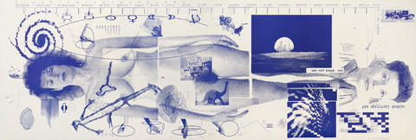
When the advancement of technology came along unlike other designers who were afraid of it taking away the hands-on methods of graphic design, Greiman purchased her first Macintosh in 1984 and decided looked beyond and chose to exploit the digital tools by layering pixels and collages of photographs as we can see in her biographical poster from Design Quarterly titled Does it make sense. This was a life-sized image of her naked body surrounded in scientific imagery and symbols, her technique utilising the mac to create a collage of chaotic imagery which linked to technology and pixels. There’s obvious mistakes put onto the artwork, but they feel purposeful to contribute to the composition and overall work, abandoning the phrase less is more as the art can visually interact with views to create designs that feel thrilling.
Figure1. Greiman, A. (1986) Design Quarterly issue 133 poster

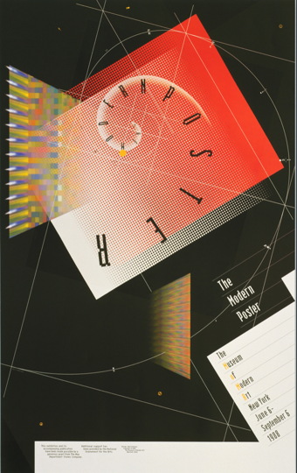
Another iconic project from Greiman was her interactive piece called “The Modern Poster” which was a beautiful fusion of image, type and Greiman’s signature style of a chaotic environment. As we can see the way the text curves around the swirl that’s layered on top of the different coloured shapes and then more visual components to make the image feel three dimensional. This was created entirely on Mac technology and published on diskette, a removeable disk for storing data, people were able to engage with the contents presented on the poster and unlock layers of visual information. This level of understanding is what established April as a designer who understood the potential behind computers and how multimedia tools can widen the creative horizons. Greiman’s dynamic choice in visuals and how she produced new systems of design is closely related to her want to convey information and emotion at the same time as she saw graphic design’s main role to communicate and educate clearly.
Figure 2. Greiman, A. (1988) The modern poster

Greiman's outlook on technology was unwaveringly optimistic, regarding it as an ongoing catalyst for creative growth and how it “provides continuing expansion of creative opportunities” (Meggs, 1992, p. 85). In the contemporary scenario where technology has become common in design firms, her forward-thinking stance resonates with the current landscape of the industry. The utilization of Mac computers and design software becoming an industry standard additionally emphasizes the significance of her insight in the perpetually advancing field of design. Modernised technology like the Mac doesn’t become a replacement for a designer’s innate intuition but a tool used to expand a creator’s horizons and aid in the creative process therefore it’s called “hybrid imagery”. (Burns, 1992, p85)
Rudy Vanderlans is a designer who’s recognised for his experimental editorial design on the magazine Émigré which he published, edited, and designed from 1984 to 2005 as it was one of the first publications to be designed on the Macintosh computers, exerting a strong influence on designers of that era. Vanderlans pursued graphic design studies at the Royal Academy of Fine Art in The Hague from 1974 to 1979, where he developed an appreciation for grids and structural precision akin to Swiss design principles. Reflecting on this period, he noted, "It led me to believe design is very exact. It was about perfect line lengths and perfect word spacing" (Vanderlans, 1993, p. 9).
Initially Émigré focused on exhibiting works and topics important to the designers who contributed to the magazine exploring themes related to international culture and travel influencing creative works. However approximately seven issues into its run, the magazine underwent a thematic shift dedicated emphasis on graphic design and the magazine was known for “the magazine that ignore boundaries” as it has an exploration into type and grid structures, specifically those that went against Rudy’s strict Dutch training. Rudy and his wife, Zuzana Licko first discovered the Mac through a magazine called MacWorld which was an advertisement trying to promote the use of Mac’s to produce illustrations. Which prompted them to experiment with the computer to create illustrations. Becoming early adopters of this transformative technology, they leveraged it to create digital layouts, marking a significant evolution in their design practices (Burns, 1992, p 36.)
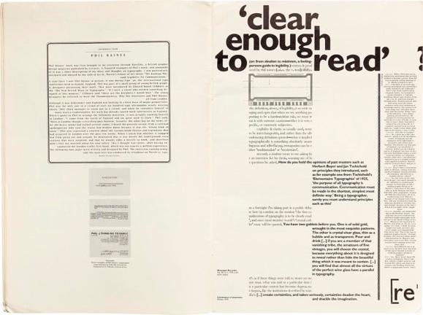
While Vanderlans initially used the Mac for basic mcpaint illustrations, and like a typesetting machine going between the drawing tablet and mac (Burns, 1992, p39) but as he developed more of an understanding of the mac, his approach to designing Émigré redefied conventional page composition. Rejecting standardized layouts and abandoning any pre-set grid structure, he changed the visual language of page design. In Émigré Issue 18, for instance, he experimented with the size and how it bends around the body text that pops all over the page, disrupting the conventional alignment and formatting seen in traditional page layouts.
Figure3. Vanderlans, R. (1991) Émigré 18

At the same time, Zuzana began to create fonts with the Mac and a bitmap font tool, leading to proliferation of typefaces as there was now greater ease and flexibility in creating as Rudy states “They’re highly unusual typefaces that are nonetheless designed with a great detail of mastery” (Burns, 1992, p40) and they became a source of funding for Émigré. Despite its ground-breaking nature, this unconventional design approach faced criticism from figures like Massimo Vignelli, a prominent designer of the time. Vignelli was a severe critic who disparaged Émigré's designs and fonts as lacking depth, refinement, elegance, or a sense of history (Émigré, 1998). However, Licko claims that we “read best what you read most” as typefaces are used more regularly, we get accustomed, and legibility is a process for users. Zuzana’s successes are inspiration to many as she surpassed a male dominated field and with no traditional training, just through their access to the Mac technology, both Vanderlans and Licko helped define a technology-driven future in design.
Having the Mac for their work Rudy talks about the ability to work fast and precise with it and those who believed that design like swiss was “rational” he acknowledges that the machine is perfect to create “rational” looking designs. Although, they still do acknowledge the importance of preserving processes like the letterpress while recognizing their eventual obsolescence, although people have argued the unauthenticity of machines and inhumanity behind it, others forget there is still a human behind the computer leading the ideas.
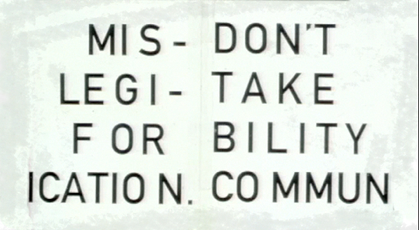
The final artist, David Carson entered the graphic design world late in his life at age 26, with being primarily being self-taught he rose to popularity through his unique style of “expressive deconstruction” (Eskilson, S. 2007, p372) which might be due to his lack of formal training there was no real limitations for his creativity. Carson's work often presented a broken-up appearance, intending to create an expressive effect, employing disorder effects, blurry photos, and unconventional text styles. Carson embraced computer tools in his graphic design work, to experiment with the boundaries of legibility. He regularly pushed the criteria for legibility by cramming text together, overlapping with images and more text but despite the apparent chaos in his style, Carson's work consistently delivered. In a 2003 TED talk titled Design and Discovery, “Don’t mistake legibility with communication” Carson emphasized the distinction between legibility and communication, asserting that readability does not equate to effective communication impactful messages.
Figure 4. Carson, D. (2003) Design and Discovery

His most recognisable job was when he worked for the alternative music magazine Ray Gun where he was able to attract a large readership interested in his flair as he took editorial design down a wild road as every cover felt like an unruly typographic design. Ray Gun explored angles on the pop cultural currents of the 1990s adopting a chaotic, grunge typography style which was described as “like a societal complaint if you will: everything was getting too clean” (2012) by Carlos Segura a Chicago-based graphic designer. This rise in grunge typography was linked to the introduction of the Mac computer as now instead of having to design by hand younger designers and typographers were able to use the computer to their advantage, unconstrained to one type of method much like David’s work which included the ripping and rearranging of type, liberating designers from traditional constraints.
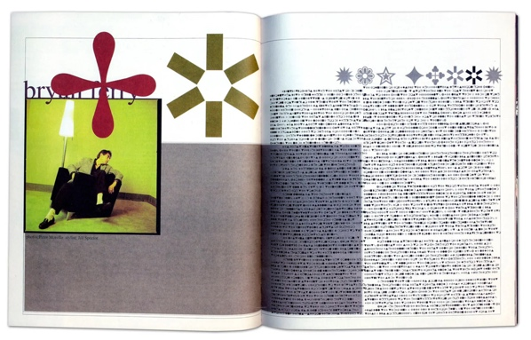
One of Carson’s most notable spreads he designed for Ray Gun is the 1994 issue which consisted of an interview with singer Bryan Ferry, where he found it so lacklustre and therefore decided to convert the text to an illegible font called Zapf dingbats. This represents Carson’s methods as he was known for experimenting with irregular typefaces. However, a sense of order stands out in this chaos of information coming from the page layout as the text is boxed neatly even with the lack of symmetry in the amount of text given there’s an encouragement to engage with the page, as the photo of Bryan Ferry looking over aligns with the emotions behind the text. The representation behind this design represents his defiance against conventional systems, as Carson likes to experiment publicly not afraid of how people may react as long as the work eventually interacts with the readers. (Blackwell, 1995) Linking back to the quote about legibility speaks volumes in this magazine spread as although you can’t read the spread it still speaks to you beyond words and through elements like the composition or font choice, as many of his work does the same by inviting the reader in to engage with the design.
Figure 5. Carson, D. (1994) Ray Gun issue
Overall, David Carson’s name will always resonate as an icon who pushed the boundaries of traditional design through his ability to incorporate the emerging digital tools such as MacPaint and typesetting tools to define the visual communication of the mid-80s and early '90s with his distinctive page layouts to change colours and headlines. He became a reminder to emerging designers to push boundaries and continue to experiment to evolve graphic design as, he was able to make what was considered “bad” typography and graphics into art that people appreciated and wanted to replicate in their work.
In conclusion, the graphic design of the mid-80s was a pivotal moment of transformation for the visual communications industry due to the evolution of technology especially, the usage of digital imaging and desktop tools powering designers to adapt and evolve. The legacy of this time and the designers it produced will set the stage for contemporary design, allowing emerging designers in the 21st century to shape the way they play with technology and shape a vibrant landscape. More importantly, on reflecting on the designers from the time who have illuminated a new path of creativity, like Carson and his unconventional typography and dynamic layouts, becoming a frontrunner in going against traditional norms pushed by older designers. Each designer has found a unique way to use the Mac even with most being educated with similar traditional methods, therefore it’s not always having to following the traditional route to success in design but rather how you take those “rules into your own hands. An essential rule of design has always stayed the same, to preserve the essence of design as people’s desire for visual communication for them to relate to and understand has never been greater.
Now with the internet and the profession of graphic design increasing in popularity and integrating with motion graphics, UI, music, and more technology is such a major component to graphic design. It’s so integral to society with delivering information to an even more massive audience, entertainment, and jobs such as social media management, that wasn’t available back then is now, designers have a duty to adapt relentlessly, whether it’s to technological changes or cultural changes to represent their times.

Books:
Blackwell, L. (1995) The end of print: the graphic design of David Carson. San Francisco: Chronicle Books

Blackwell, Lewis. and Jacobs, K. (1997) David Carson: 2ndsight : grafik design after the end of print. London: Laurence King.

Eskilson, S. (2007) Graphic design: a new history. London: Laurence King Pub

Greiman, A. (1990) Hybrid imagery: The fusion of technology and graphic design. New York: Watson Guptill

VanderLans, R., Licko, Z. and Gray, M.E. (1993) Emigre: graphic design into the digital realm. New York: Van Nostrand Reinhold.

Meggs, P.B. (1992) Meggs' History of Graphic Design. 2nd edn New York: Van Nostrand Reinhold

Websites:
Carson, D. (2019). Design and discovery. [online] Ted.com. Available at: https://www.ted.com/talks/david_carson_design_and_discovery. [Accessed 20 Nov 2023]

Emigre. (n.d.). Emigre: Essays - Critical Conditions:Zuzana Licko, Rudy VanderLans, and the Emigre Spirit. [online] Available at: https://www.emigre.com/Essays/Emigre/CriticalConditionsandtheEmigreSpirit [Accessed 19 Nov 2023)

inkbotdesign.com. (2023). April Greiman: A Pioneer In Graphic Design - 2023 Biography. [online] Available at: https://inkbotdesign.com/april-greiman/ .[Accessed 28 Nov 2023]

Meggs, P.B. (2019). Graphic design - The digital revolution | Britannica. In: Encyclopædia Britannica. [online] Available at: https://www.britannica.com/art/graphic-design/The-digital-revolution. [Accessed 28 Nov 2023]

Shetty, S. (2012). The Rise And Fall Of Grunge Typography. [online] The Awl. Available at: https://www.theawl.com/2012/08/the-rise-and-fall-of-grunge-typography/ [Accessed 20 Nov 2023]

Typotheque (2004). Typotheque: Rudy VanderLans, editor of Emigre article on Typotheque by David Casacuberta and Rosa Llop. [online] Available at: https://www.typotheque.com/articles/rudy-vanderlans-editor-of-emigre [Accessed 19 Nov 2023]

Images:
Figure 1. Greiman, A. (1986). Design Quarterly issue 133. [offset lithograph] Available: https://www.sfmoma.org/artwork/96.366/ (Accessed 19 Nov 2023)

Figure 2. Greiman, A. (1988) The modern poster. [offset lithograph] Available:https://www.moma.org/collection/works/4981 (Accessed 27 Nov 2023)

Figure 3. Vanderlans, R. (1991). Emigre 18. [Magazine spread] Available: https://www.ivarhagendoorn.com/blog/2022/12/30/emigre-magazine-archive/ (Accessed 19 Nov 2023)
‌
Figure 4. Thomas, C. (2013) Legibility Vs Communication in Design - David Carson's point of view. [Ted Talk]. Available from: https://postmodernmovieposter.wordpress.com/2013/12/30/legibility-vs-communication-in-design-david-carsons-point-of-view/ (Accessed: November 21 2023)

Figure 5. Carson, D. (1994) Ray Gun. [Magazine spread] Available: https://medium.com/@yopaulmiranda/david-carson-surfing-the-unconventional-waves-of-zapfs-dingbats-52a520186c64 (Accessed 1 Nov 2023)

