

Postgraduate/Distance Learning
Assignment coversheet & feedback form

THIS SHEET MUST BE THE FIRST PAGE OF THE ASSIGNMENT YOU ARE SUBMITTING (DO NOT SEND AS A SEPARATE FILE)

For completion by the student:
Student Name: Katherine Azima

Student University Email: 2219013@student.uwtsd.ac.uk
Module code:  HPCA7015  Module title:  Foundations of Cultural  Astronomy and Astrology | Student ID number:  2219013 |  |  | Educational support needs:  Yes/No  NO
Assignment title: A 2000 word essay on a topic in the subject area

Assignment due date: December 1st, 2022
This assignment is for the 1st ☐ module of the degree
I confirm that this is my original work and that I have adhered to the University policy on plagiarism.
Signed: Kat Azima
Email submission:if you are submitting this form via email, please tick this box □
(as a substitute for your signature) to confirm that you agree to the above declaration.
Assignment Mark
1st Marker’s Provisional mark
2nd Marker’s/Moderator’s provisional mark
External Examiner’s mark (if relevant)
Final Mark

NB. All marks are provisional until confirmed by the Final Examination Board.

For completion by Marker 1 :
Comments:

Marker’s signature: |  |  | Date:
For completion by Marker 2/Moderator:

Comments:

Marker’s Signature: |  | Date:
External Examiner’s comments (if relevant)

External Examiner’s Signature: |  | Date:
Katherine Azima – HPCA7015– Essay 2

Essay Based on Sky Journal
Word Count:

This paper explores the relationship between the sky at Lake Thoreau in Reston, located in the Piedmont region of Virginia in the United States. The aim of this research is to discuss the statement ‘Be clearly aware of the stars and infinity on high. Then life seems almost enchanted after all.’ from Vincent Van Gogh as it relates to my sky journal observations. This research was conducted using a phenomenological approach. This involved reflection upon my own personal responses to experiencing the sky. I captured thirty images of the first minute of the golden hour, between October 17th, 2022 to November 27th, 2022.
The statement by Van Gogh ‘Be clearly aware of the stars and infinity on high. Then life seems almost enchanted after all’ when it is unpacked, is an imperative statement that invites us to acknowledge and be conscious of the cosmos. But the second part of the statement ‘life seems almost enchanted after all’ uses the phrase ‘seems almost’ suggests that an enchanted view of life is really perhaps dubious or an illusion. It was Max Weber (1964-1920), German sociologist and influential theorist of disenchantment who famously argued that modern society became ‘disenchanted’ for valuing a scientific and rational understanding over a spiritual and emotive understanding of the world. British Scholar Patrick Curry, and author of the book ‘Enchantment. Wonder in Modern Life’ argues that a dismal of enchantment as a delusional can potentially lead to disengagement with our world with very negative consequences for the future of the planet. Curry defines ‘enchantment’ most simply as an experience of wonder. This he says can include variations of ‘awe, amazement and astonishment’ and that these experiences are fundamental to being alive. Using Curry’s theory of enchantment I will identify several themes within my observations which include, awe, relationship, liminality and uniformity.
To put Lake Thoreau, the location of the sky observation in context, it is a lake located in Reston, Virginia which one of the first American Residential Planned Communities founded in 1964. It was named after the initials of its founder, Robert E. Simon (RES-TON). Mr. Simon purchased 7,500 acres of undeveloped land after he sold the famous music venue Carnegie Hall in NYC. Mr. Simon one could argue was enchanted with the natural land as he says in his own words what persuaded him ‘to buy this piece of earth, however, was the serenity of the gently undulating land, half in woods, half in open fields, traversed by clear running streams.’ Reston has gone from undeveloped land to a population of over 64000. My family and I live about 3.5 miles from Lake Thoreau, aptly named after American naturalist and transcendentalist Henry David Thoreau. Our home is an 8 minute drive to the lake. Reston in fact has 5 lakes that were built practically for the purpose of catching storm water runoff as well as being a habitat for a diversified ecosystem.
I choose to look at the sky specifically at Lake Thoreau because it happens to be my favourite lake in Reston where the sunset can often be quite spectacular. I choose to observe and capture the first minute of the beginning of the ‘golden hour’ period. To precisely identify the golden hour time period I downloaded a Golden Hour Calculator App named ‘Helios - Magic Hour Calculator that allowed me to work out the timing more precisely. The ‘golden hour’ from my experience as an amateur photographer has always been a very special and unique point in time where the sun which we mainly experience as bright strong daylight, transforms into a warm, gentle and delicate golden glow that seems to make just about everything in the space that it touches more beautiful. A formal definition from the Cambridge Dictionary describes the ‘golden hour’ as the ‘the period of the day just before the sun sets or after it rises, when the light is redder and softer than usual so that photographs taken in it have a pleasing quality’. The golden hour is far more than just ‘pleasing’ or for the purpose of taking photographs. For me the ‘golden hour’ is truly enchanting.

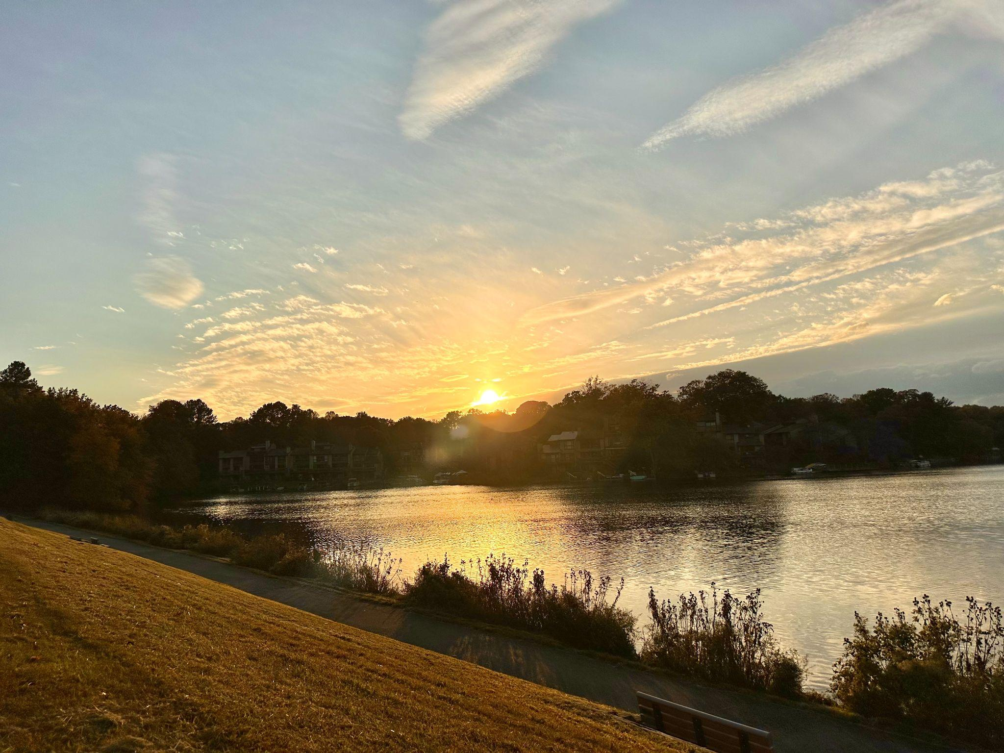
Figure 1: My very first sky observation on October 17th, 2022 at 5:56pm EST.
Photo: Katherine Azima.
Awe
Enchantment as Curry states can include variations of ‘awe, amazement and astonishment’. He says that these experiences are ‘fundamental to being alive’. One thing I found rather amazing was the dramatic change when clouds took over the scene. How astonishing to see how the sky and overall landscape shift without the light of the sun during rainy and cloudy days. As I note in my sky journal,
‘It’s amazing how the townhomes are suddenly so visible on a cloudy day when the sun is not there to shine brightly in my face and blackout the townhomes behind it. The very first sky observation I remember how I was struck how I couldn’t see the details of the townhomes because I was blinded by the sun. The lake looks heavy without the reflection of the sunlight. Everything seems to impact each other. The rain is beating down hard. It’s cold and dreary. I appreciate the sun more than ever today.’

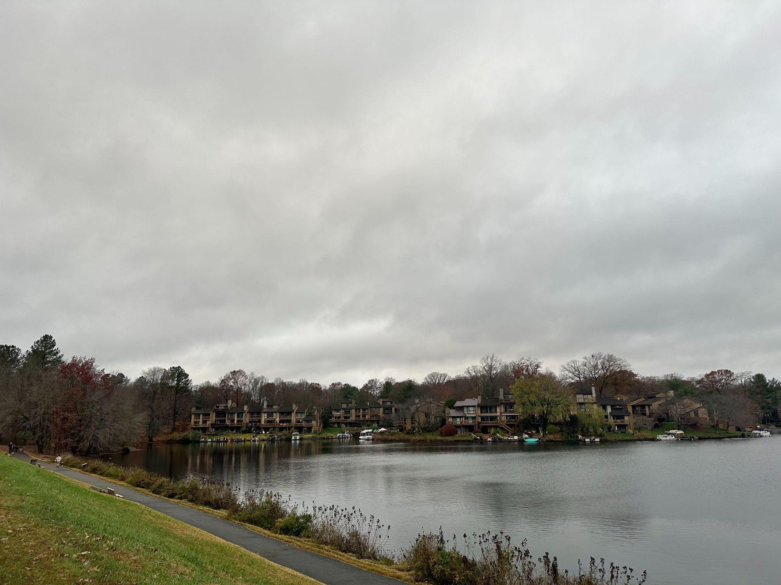
Figure 2: A rainy and cloudy day on the lake on November 11th, 2022 at 4:25pm EST.
Photo: Katherine Azima.

Early on in my observations, on day four I was struck and in awe by the sheer beauty of the sky.

‘The clouds in the sky today look like delicate brushstrokes. The ripples and reflections on the lake remind me of one of Van Gogh’s painting ‘Starry Night Over the Rhone’. It’s no wonder that the Greek word ‘Cosmos’ roughly translates as beautiful order and adornment. The sky, nature, the cosmos is truly a sight to behold and leaves me in awe.’

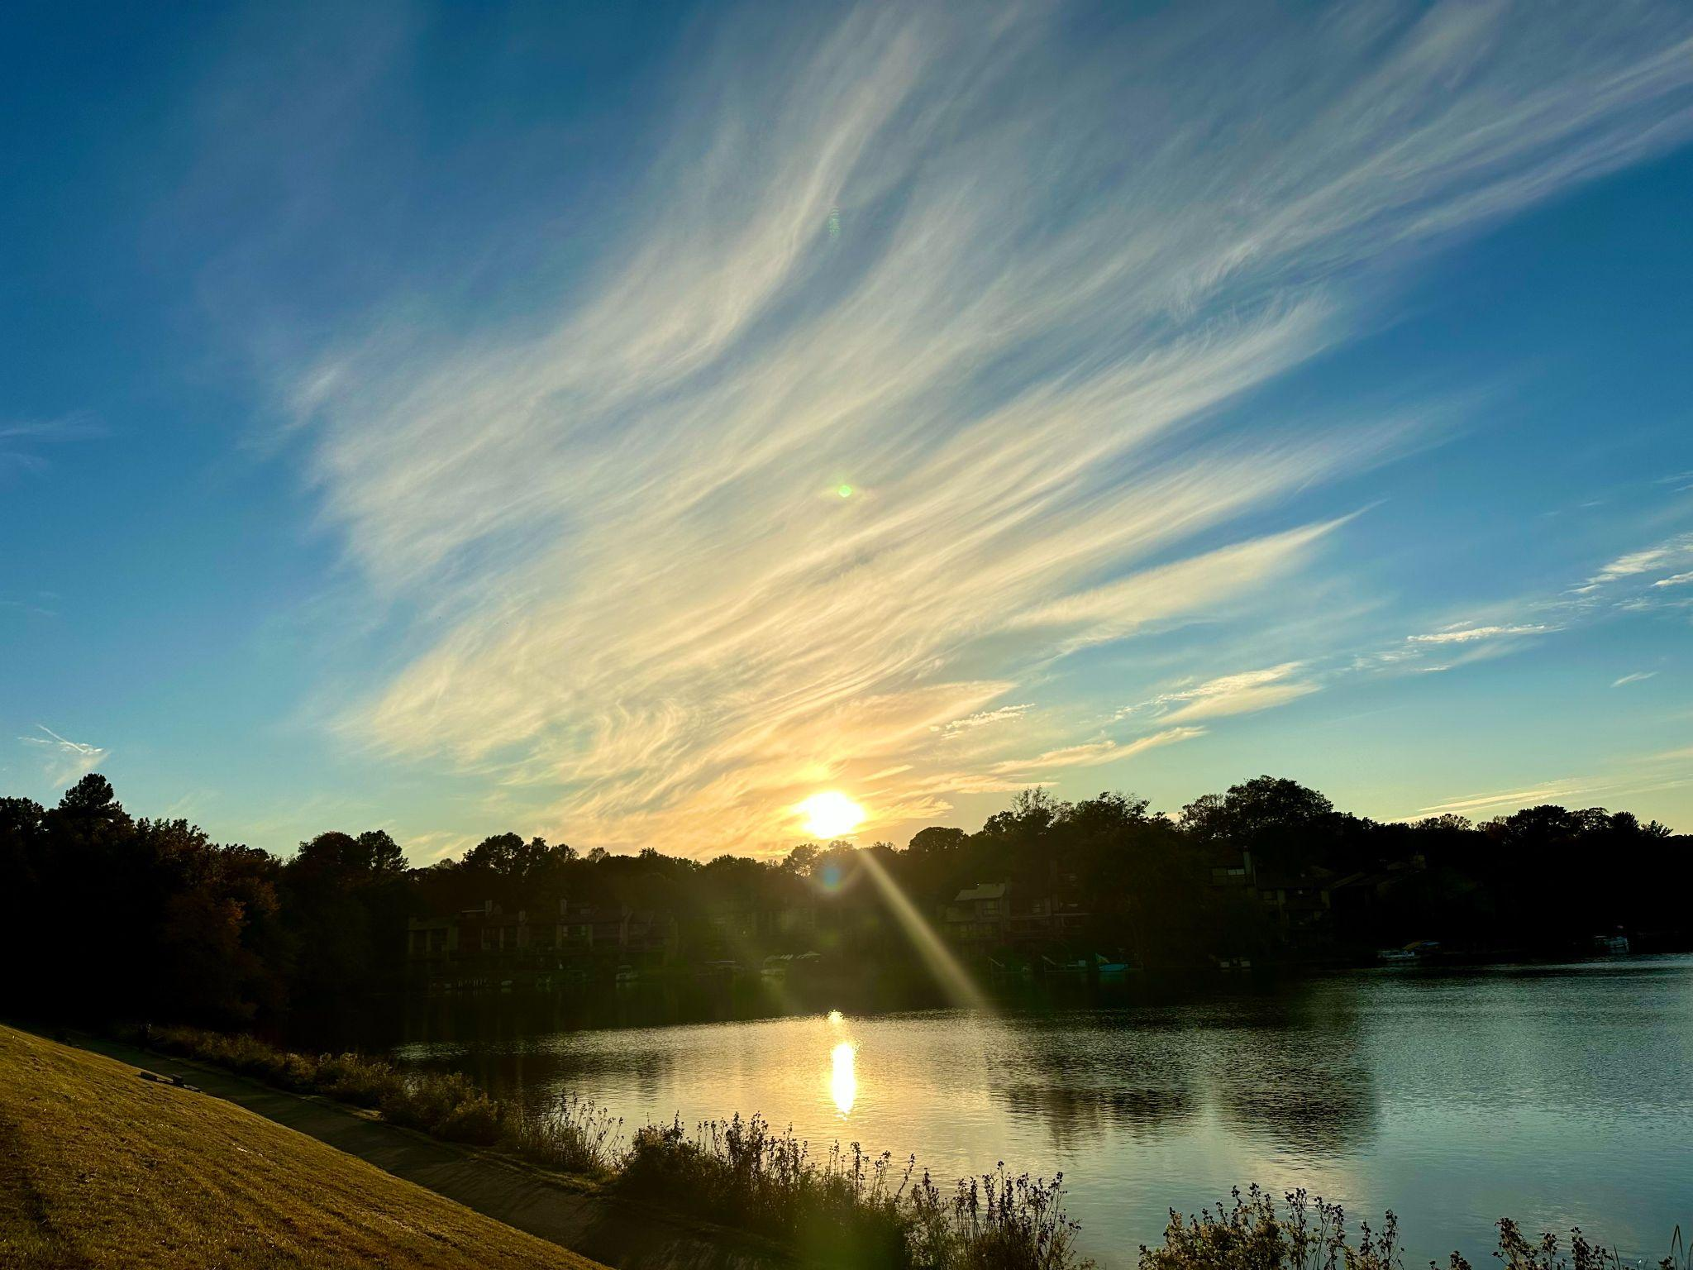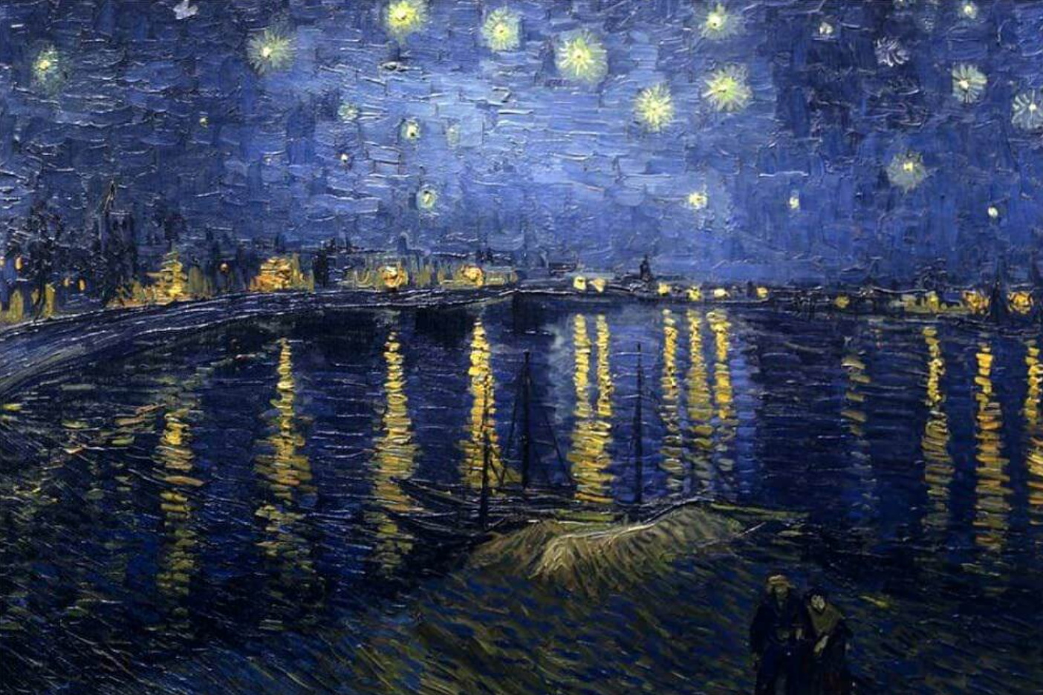
Figure 3 Left: The painted sky, October 20th, 2022 at 5:52pm EST. Photo: Katherine Azima. Figure 4 Right: Starry Night Over the Rhone by Vincent Van Gogh, 1888

Photo: Katherine Azima.

‘You're my golden hour
The color of my sky
You set my world on fire
And I know, I know everything's gonna be alright’
- Kacey Musgraves

Relationship
One of the key themes uncovered in my sky observations was that the sky was never something I looked at in isolation but rather always in ’relationship’ that is to myself, people, animals, cars, cyclists, the landscape and the weather. A note I made in the sky journal describes this well.
‘The sky is so beautiful today but all I can think about is how cold it is, the wind and cold is penetrating my bones. There are no cyclists, runners or families walking their dogs today. The golden glow of the sun hitting the clouds and lake so gently and delicately gives no indication of how incredibly uncomfortable this weather is making me feel.’

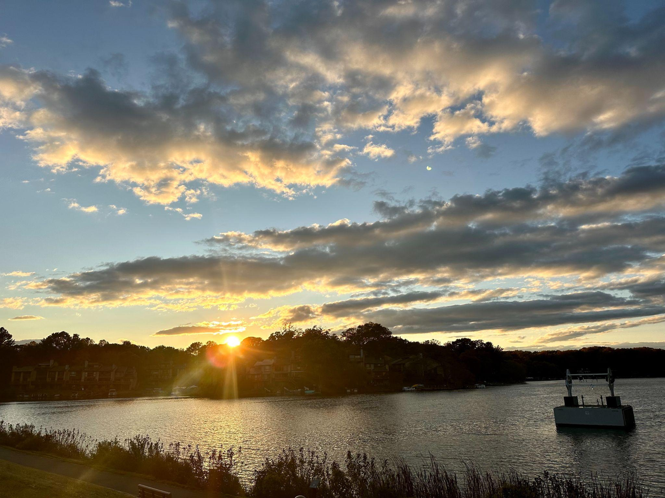
Figure 5: A cloudy sky on October 18th, 2022 at 5:54pm EST. Photo: Katherine Azima.


Figure 6: My dog Coconut as we drive up to the lake, November 6th, 2022 at 4:30pm EST. Photo: Katherine Azima. Figure 5: My daughter Darya at golden hour at the lake, November 21st, 2022 at 4:11pm EST. Photo: Katherine Azima.

Many of the early days of observation consisted of me driving alone to the lake. But as the golden hour period shifted earlier and earlier throughout the day, especially after daylight savings time switched over, I would pick up my daughter from school with our puppy in tow and head to the lake. As I note in my sky journal;

‘I asked Darya if she wanted to come with me today to go see the golden hour and she said yes. I love how she’s appreciating this special golden hour time together. She’s blasting her favourite tunes on our way to the lake and when we get there she pulls the window down and looks out and up to the sky with me. Everytime I look behind me Coconut has his snout out the window also looking out, breathing in the fresh air and probably thinking how he can get the ducks in the lake. Seeing my two loves enjoying the scene with me is enchanting indeed.’

Liminality
Curry states that ‘Places which enchant are often liminal or riparian, as edges and boundaries - debatable ground between the sea and the land say, or between wilderness and domestication. Observing the sky at Lake Thoreau during Golden Hour was a conscious choice to explore this period of liminality. On October 20th, 2022, I got stuck behind a school bus on my way to the lake and I missed seeing the sun as I note in my sky journal:
‘Because of a school bus I almost killed myself to get here on time to catch the golden. The sun had made its descent beneath the horizon just as those thirty kids were descending the school bus. Dare I admit that I almost cut the line to get past? I feel a deep sense of disappointment to have missed seeing today’s sun because of unexpected traffic. But as the old adage goes time really does not wait for anyone.’

Was this a live example of disenchantment at play? When I reflect back on this day, it’s more apparent that I was very mechanistically and rationally trying to make my way to the lake to capture the photo for my essay versus enjoying the process and the gift that was ultimately in front of me which was an exquisite painting in the sky.

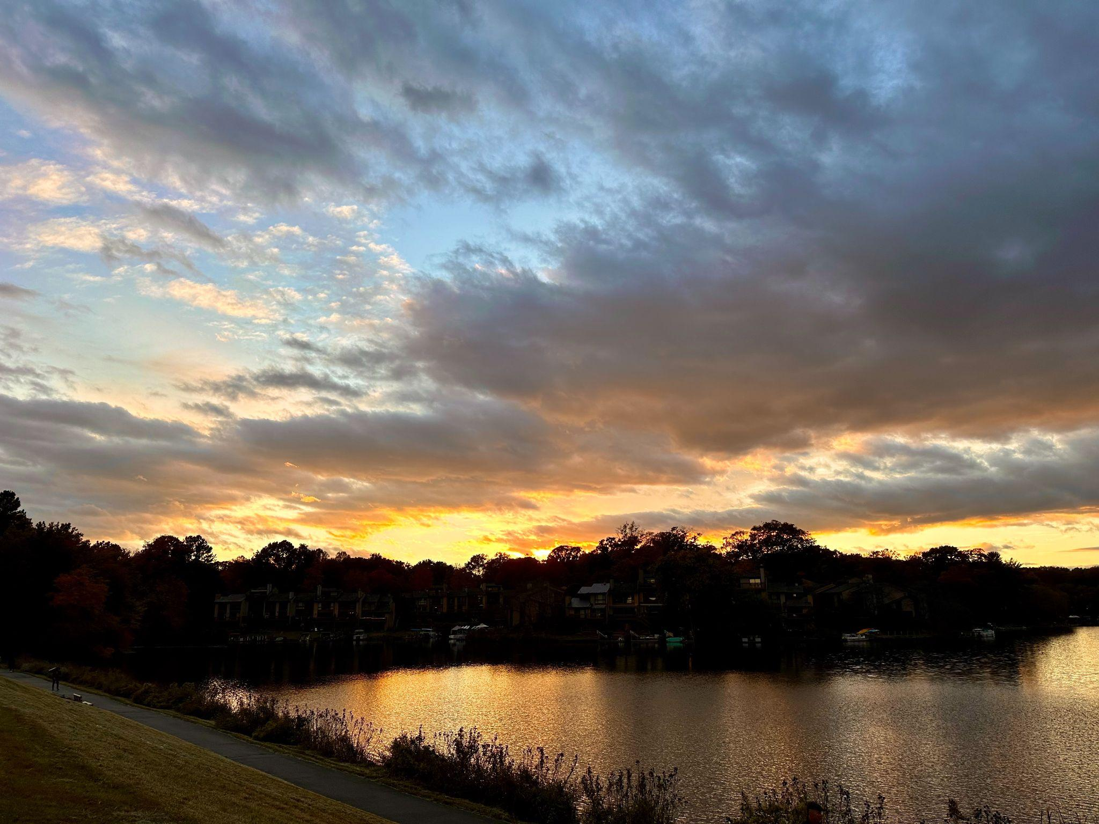
Figure 6: An unexpected an exquisite sunset, October 20th, 2022 at 6:16pm Photo: Katherine Azima

Uniformity

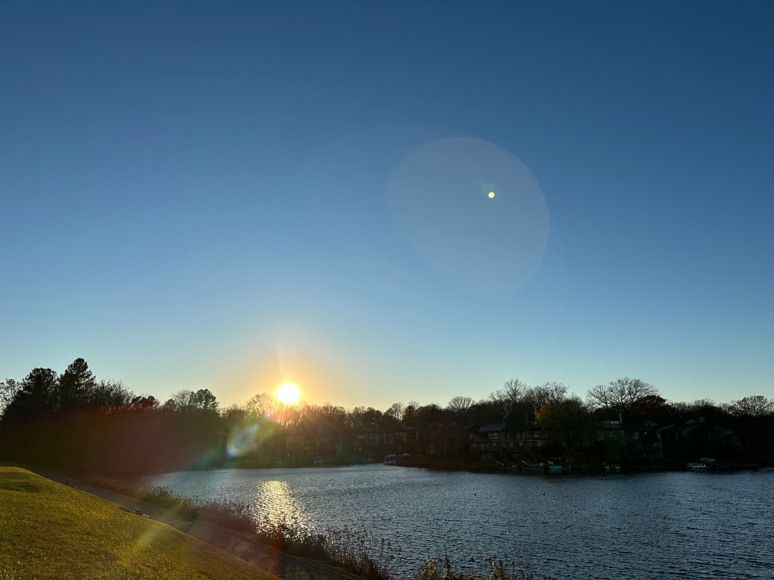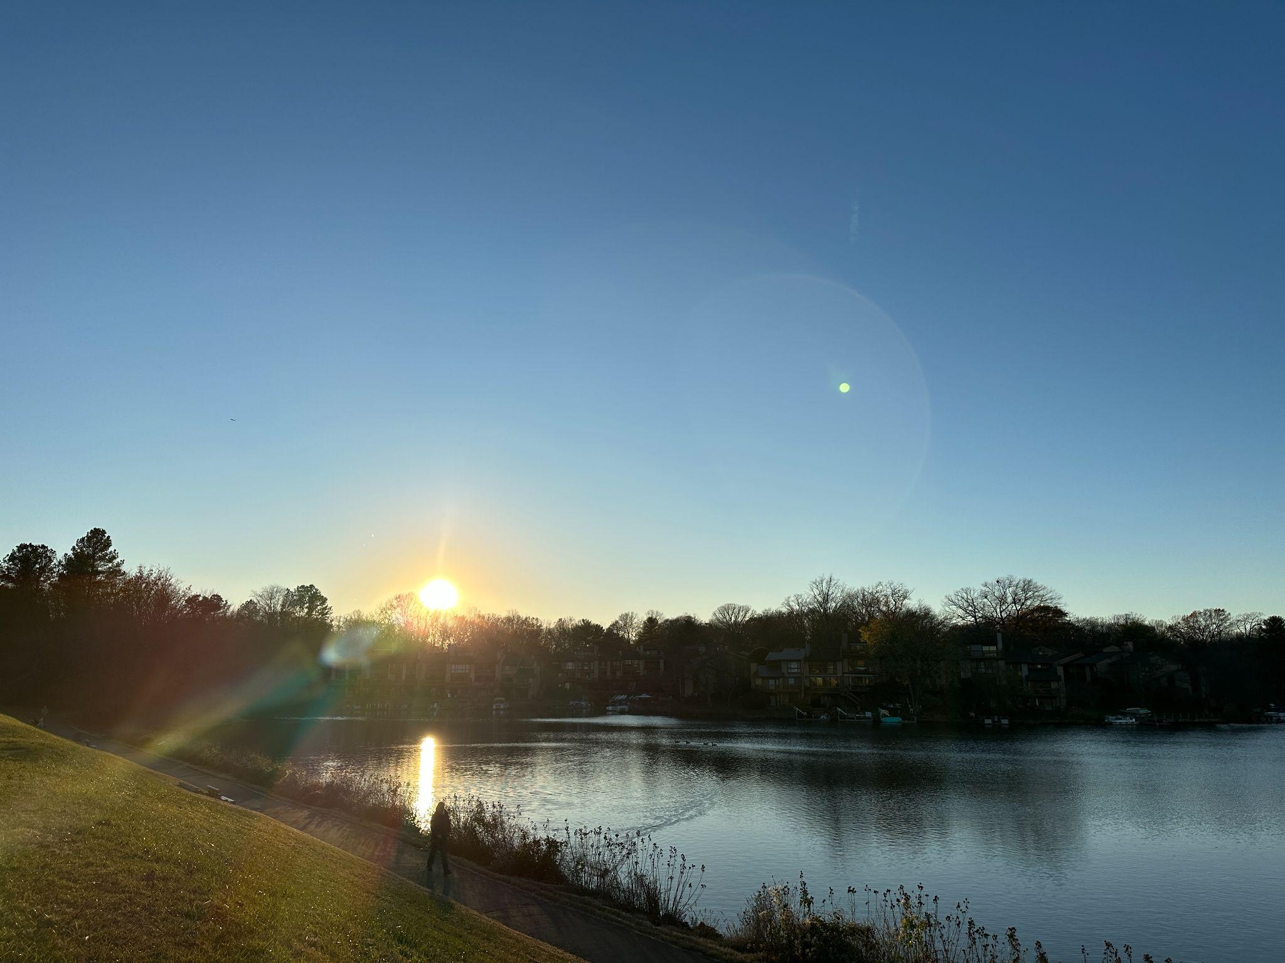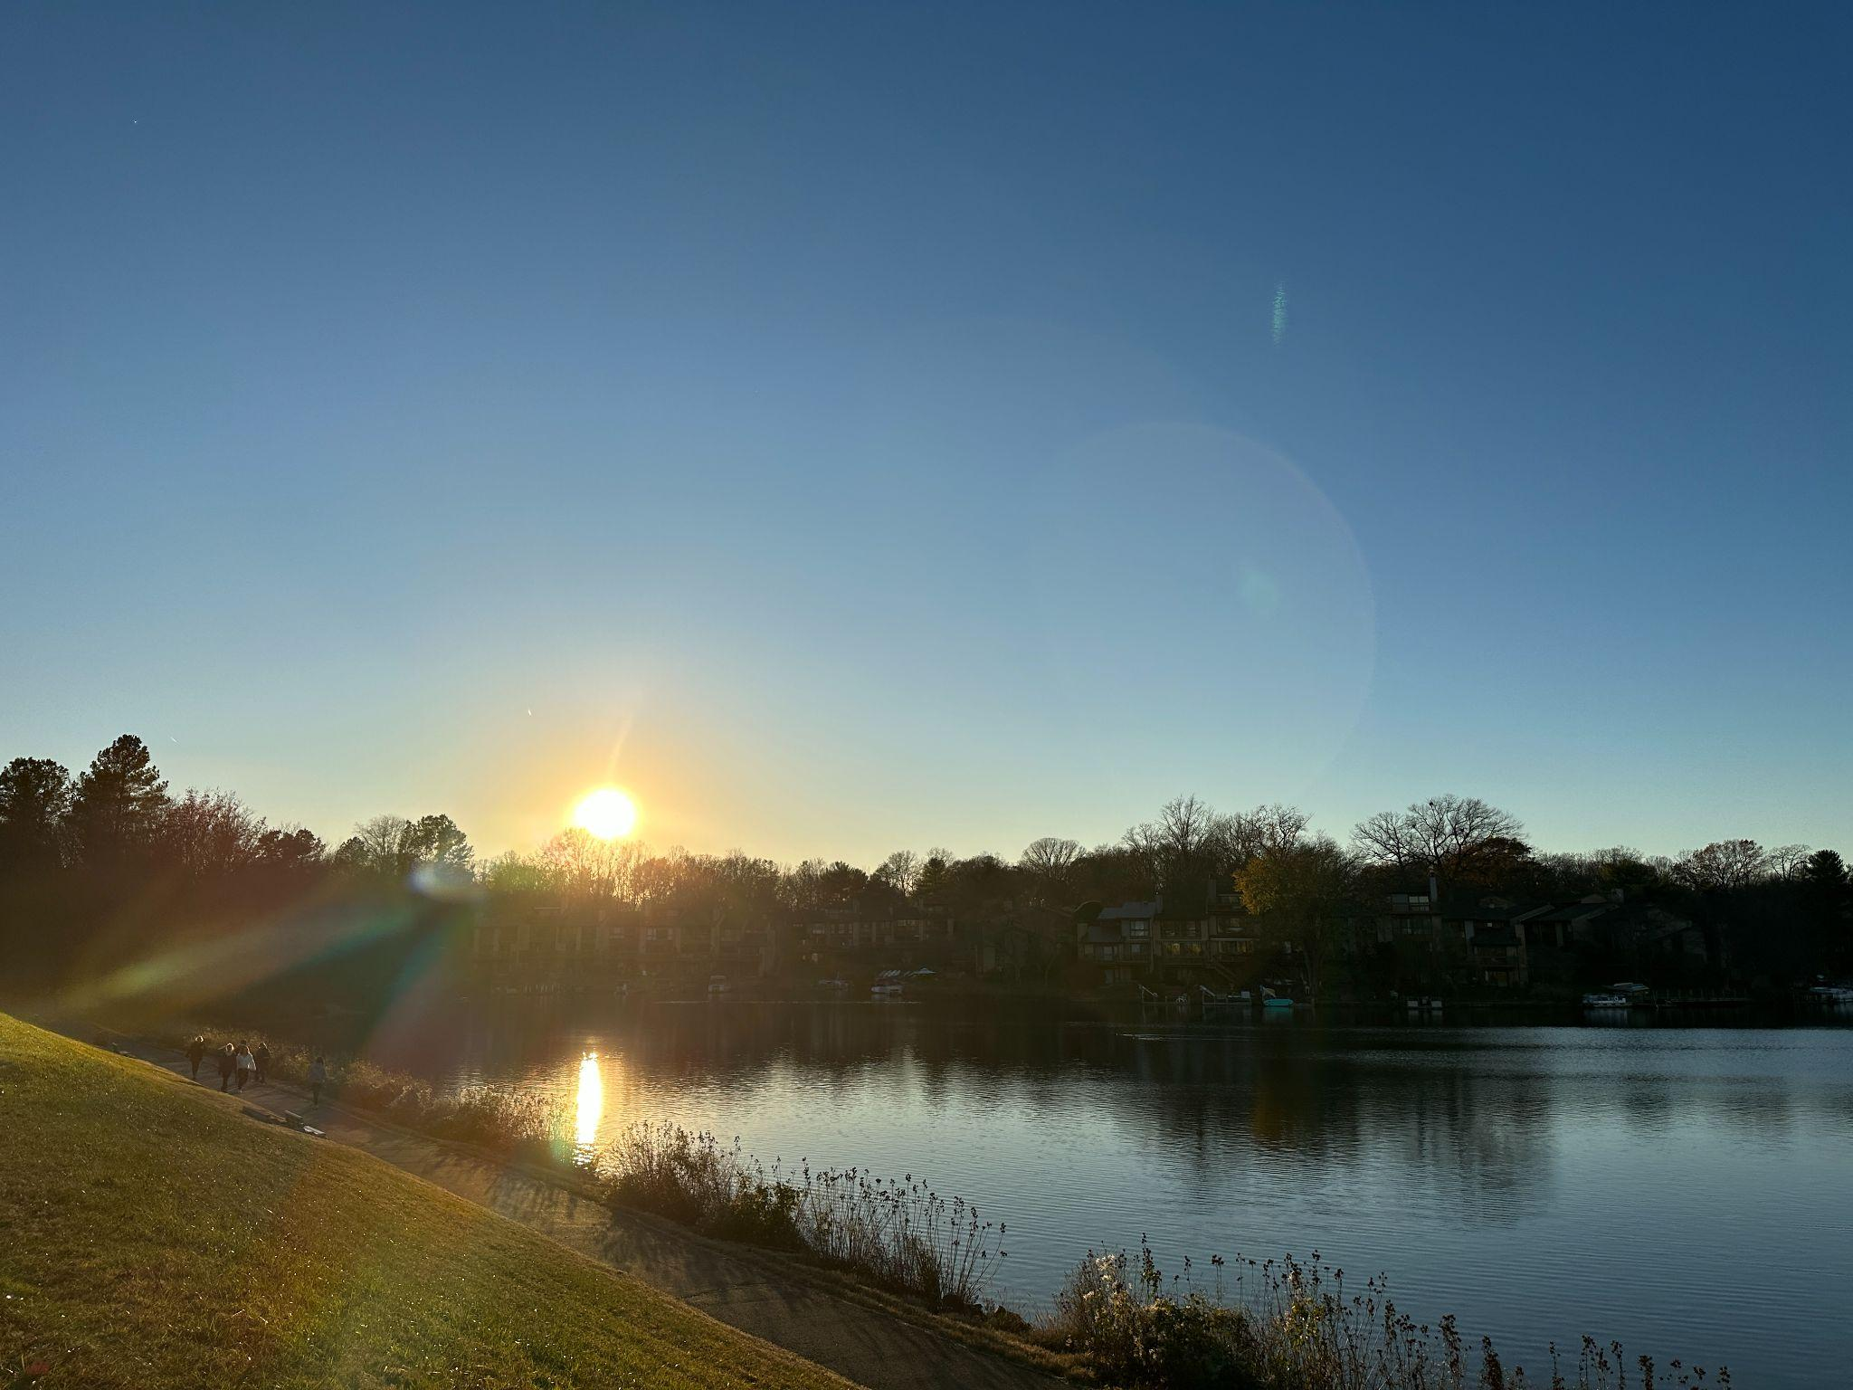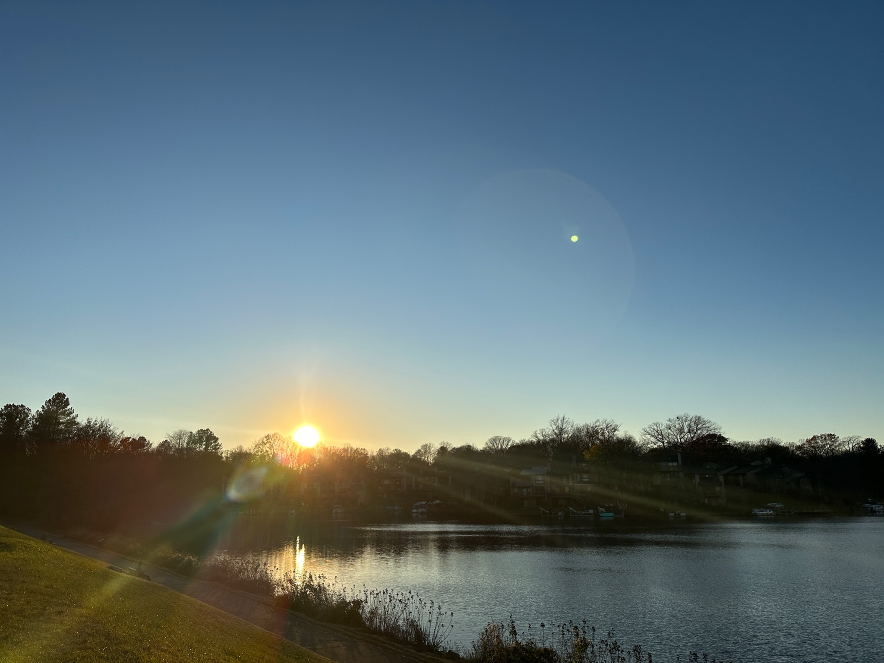
Figure 7: Four consecutive days of blue skies, first minute of golden hour on
November 19-22, 2022.Photo: Katherine Azima

As Curry states, ‘Coverserley, where uniformity and homogeneity reign, so does disenchantment’ Quite interestingly, I experienced many days of blue skies as captured by my photographs that show the homogeneity of the sun and blue skies I experienced. I note in the sky journal:

‘I hear that old adage ‘familiarity breeds contempt’ in my head. I feel like it’s groundhog day. It's been 5 consecutive days of the same blue sky. The sky is beautiful but it’s the same and the same is not exciting or wonderous. How can I be disappointed by the sun glowing against this perfect azure background but I am. Where are the clouds? Where is the rain? Where is the drama?.’

After thirty days of observing the sky at Lake Thoreau, in Reston, VA I had many experiences of enchantment, which Patrick Curry describes as a ‘sense of awe, amazement and astonishment’. Even on the days where the sun was absent I was able to find awe and wonder in how different those scenes looked and made me feel. So much of enchantment is a state of mind and when one opens their heart to enchantment it is there for the taking. These wondrous experiences are as Curry says fundamental to being alive and as Van Gogh says we should be clearly aware of the stars and infinity on high because when we take the time to look to the sky humanity can indeed be inspired with spiritual or philosophic insights that can be the antidote to any disenchantment we may feel or face.

Vincent Van Gogh and Ronald de Leeuw. The Letters of Vincent Van Gogh., (London, Penguin Books, 1997), p.392
Cambridge Dictionary [accessed November 15, 2022] https://dictionary.cambridge.org/us/dictionary/english/golden-hour
Reston, Compiled by the Reston Historic Trust and Museum, (Reston, 2015) p. 2
Kristinia S. Alcorn, In His Own Words, Stories from the Extraordinary Life of Reston’s Founder, Robert E. Simon Jr., (Great Owl Books, 2016) p. 65
Reston, Compiled by the Reston Historic, (Reston, 2015) p. 40
Helios - Magic Hour Calculator, By Matic Conradi, Downloaded from Apple App Store
Weber, Max. ‘Wissenschaft als Beruf,’ (‘Science as a Vocation’) in Gesammlte Aufsaetze zur Wissenschaftslehre, Tubingen, 1922, pp. 524-55. Originally a speech given at Munich University, 1918, published in 19l9 by Duncker & Humblodt, Munich.
Patrick Curry, Enchantment, Wonder in Modern Life, (Edinburgh, Floris Books, 2019), Back Cover
Patrick Curry, Enchantment, (Edinburgh, Floris Books, 2019), p.7
Patrick Curry, Enchantment, (Edinburgh, Floris Books, 2019), p.88
Patrick Curry, Enchantment, (Edinburgh, Floris Books, 2019), p.7
US Census Data, Reston CDP Virginia, https://www.census.gov/quickfacts/restoncdpvirginia [accessed Octoober 29th, 2022]
Katherine Azima, Sky Journal, October - November 2022,
Kacey Musgraves, Golden Hour Song Lyrics, Golden Hour Album, MCA Nashville Records, 2018

