

TRAFFIC ACCIDENT SEVERITY PREDICTION USING MACHINE LEARNING

Name: NAVEEN DANDLA
Student ID: 2406062
Supervisor: Divya Chidambaram
Second Marker: Nik Whitehead
Date of submission: 25-11-2025.

DECLARATION
I, Naveen Dandla declare that I am the sole author of this Project; that all references cited have been consulted; that I have conducted all work of which this is a record, and that the finished work lies within the prescribed word limits.
This work has not previously been accepted as part of any other degree submission.

Signed : .............................................

Date : 25-11-2025.

FORM OF CONSENT
I Naveen Dandla hereby consent that my Project of “TRAFFIC ACCIDENT SEVERITY PREDICTION USING MACHINE LEARNING”, submitted in candidature for the M.Sc. Applied Computing, if successful, may be made available for inter-library loan or photocopying (subject to the law of copyright), and that the title and abstract may be made available to outside organisations.

Signed __________________________

Date: 25-11-2025.

Abstract
The accuracy of forecasting the severity of traffic accidents has become a key challenge because of the consequences of its public safety and policymaking. Despite the UK fatality rates are decreasing, serious injuries are increasing, and it is a clear indication that there is an urgent need to use sophisticated data-driven techniques to comprehend and reduce road hazards. The conventional statistical models did not tend to measure the non-linear and complex nature between the many factors that affect the severity of the accidents. In order to overcome this challenge, the study has used ensemble-based machine learning (ML) models that include Random Forest, Gradient Boosting, AdaBoost, and Bagging, to improve the predictive power, interpretability, and reliability of the accident severity classification.
The study has applied the CRISP-DM framework to the secondary data of variables, including the traffic flow, weather condition, lighting, vehicle type and road category to make the process structured and iterative. The processing of data involved imputation of blank data, the encoding of categorical variables, and removal of class imbalance through the SMOTE procedure. The best performing model that was tested was the Random Forest classifier, which is robust and generalisable. The most effective model was implemented via a Flask-based Web interface to give real-time severity of accidents. In this way, the results indicated that the most significant factors affecting the severity of the accidents were the road geometry, lighting, weather, and the number of vehicles. The study has been established that ensemble ML models have successfully enhanced predictive results compared to conventional procedures. In the future, the study has mentioned that policymakers and government transport authorities can facilitate data-driven safety solutions including adaptable road design and smart monitoring systems to limit the severity of incidents.

Table of Contents
Chapter 1: Introduction 12
1.1 Background 12
1.2 Problem Statement 12
1.3 Research Aim 13
1.4 Objectives 13
1.5 Questions 13
1.6 Hypothesis 14
1.7 Rationale and Novelty of the research 15
1.7.1 Rationale 15
1.7.2 Novelty 15
Chapter 2: Literature Review 16
2.1 Introduction 16
2.2 Understanding Severity in traffic accidents 16
2.3 Factors leading to traffic accidents 17
2.4 Role played by ML models in predicting accident severity 18
2.5 Comparison of performance of ML and DL and traditional methods for understanding severity of accidents 22
2.6 Theoretical Underpinning 23
2.6.1 Haddon’s Matrix Theory 23
2.6.2 Human Factors Theory 24
2.7 Gaps 25
2.8 Conceptual framework 26
2.9 Summary 27
CHAPTER 3: RESEARCH AND/OR DEVELOPMENT METHODOLOGY 28
3.1 Introduction 28
3.2 Research Design 28
3.2.1 Experimental hypothesis 28
3.2.2 Input and data sources 28
3.2.3 Software and hardware requirements 29
3.2.4 Experimental procedure 29
3.2.5 Validity, Reliability and Generalizability 30
3.3 Development methodology 30
3.3.1 Chosen methodology 30
3.3.2 Development tools and materials 31
3.3.3 Procedures 32
3.4 Ethical considerations 33
3.5 Summary 33
Chapter 4: DESIGN AND IMPLEMENTATION 34
4.1 Introduction 34
4.2 Design Stage 34
4.2.1 Data exploration and pre-processing 34
4.2.2 Workflow of the Proposed Prediction System 37
4.2.3 Data visualisation and understanding 38
4.2.4 Model design 42
4.3 Implementation Stage 46
4.3.1 Process of implementation 46
4.3.2 Experimentation and testing 46
4.3.3 Problem and limitations 47
4.4 Summary 47
Chapter 5: Results and discussion/ Evaluation 48
5.1 Introduction 48
5.2 Overview of the implemented system 48
5.3 Model evaluation and performance results 49
5.3.1 Gradient boosting 49
5.3.2 Bagging classifier 50
5.3.3 ADABoost classifier 52
5.3.4 Random forest classifier 54
5.3.5 Comparison of predictive models 55
5.4 Model deployment 57
5.5 Discussion of results 61
5.6 Evaluation of research objectives and comparison with existing literature 62
5.6.1 Methodologies, gaps and trends observed in past studies related to prediction of traffic accident severity 62
5.6.2 Influence of environmental driver and road related factors on the severity of accidents 63
5.6.3 Effectiveness of ensemble models like Bagging, Random Forest, ADABoost and Gradient Boosting classifiers be developed in predicting accident severity 65
5.6.4 Analysis of evaluation metrics like F1-score, recall, accuracy, ROC-AUC and precision in predicting accident severity and integration using Flask 66
5.6.5 Recommendations to the policymakers and transport authorities based on the outcome of the best-performing ML models 66
5.7 Summary 67
Chapter 6: Conclusions and Recommendations 68
6.1 Conclusions 68
6.2 Limitations of the study 70
6.3 Recommendations 71
6.4 Future work 71
Chapter 7: Reflection 73
7.1 Personal learning and development 73
7.2 Future improvements and lessons learned 74
References 76
Bibliography 82
Appendices 84
Appendix 1: Project timeline 84

List of Figures
Figure 2.1 Haddon’s Matrix Theory 24
Figure 2.2 Human Factors theory 25
Figure 2.3 Conceptual Framework 26
Figure 3.1: CRISP-DM framework 31
Figure 4.1: Showing first five rows of the dataset 34
Figure 4.2: Information about the dataset 35
Figure 4.3: Data pre-processing and class distribution 36
Figure 4.4 Machine Learning Workflow for Accident Severity Prediction 37
Figure 4.5: Correlation between accident severity and other variables 38
Figure 4.6: Distribution of number of vehicles by accident severity 39
Figure 4.7: Accident severity by day of week 39
Figure 4.8: Accident severity by weather conditions 40
Figure 4.9: Proportion of driver gender by accident severity 40
Figure 4.10: Fatal injuries by type of collision 41
Figure 4.11: Applying SMOTE technique 42
Figure 4.12: Implementation of gradient boosting model 43
Figure 4.13: Bagging classifier 44
Figure 4.14: Implementation of ADABoost classifier 44
Figure 4.15: Random forest classifier 45
Figure 5.1: Gradient boosting confusion matrix 49
Figure 5.2: Performance metrics 50
Figure 5.3: Bagging classifier confusion matrix 50
Figure 5.4: Performance metrics 51
Figure 5.5: Confusion matrix of AdaBoost 52
Figure 5.6: Classification report 53
Figure 5.7: Confusion matrix of the random forest model 54
Figure 5.8: Classification report 55
Figure 5.9: Comparison of evaluation metrics 56
Figure 5.10: Web application using Flask 57
Figure 5.11: Predicting slight injury 58
Figure 5.12: Predicting fatal injury 59
Figure 5.13: Predicting serious injury 61

List of Tables
Table 1: Description of the key variables 14
Table 2: Software and hardware requirements 29
Table 3: Materials and tools table 32
Table 4: Performance of predicted models 56

Chapter 1: Introduction

1.1 Background
The UK faces a huge concern in terms of road accidents where in 2023 around 1695 people were killed leading around 28697 people seriously injured [6]. Even though the death rates have reduced around 5% since 2022, serious injuries have not declined. The casualty rate per severity also changes based on the type of users, for example, car occupant had the largest share of serious injuries and death rates, however, motorcyclists and pedestrians are at a very high risk when 10-years average is considered. As per the report by [7], in the UK, there has been a general decline in the number of people killed in accidents from 1857 in 2010 to 1624 in 2023. However, serious injuries have increased from 20800 in past years to 28000 in recent times. This shows that even though deaths are declining, injuries are increasing, showing the improvement in strategies for improving safety of roads in the UK for reducing fatality.
With the advancement of technology, prediction of severity of traffic accidents have become more important in improving safety of roads for which recent studies have given importance to Machine Learning (ML) in this task. Thus, [4], showed that traditional statistical models like Logistic regression, even though useful, fails in capturing non-linearity and complexity in traffic accident data. The research showed the ML models most of the time are superior in terms of flexibility, helping to implement various impacting factors like behaviour of the driver, road and weather conditions.

1.2 Problem Statement
Prediction of severity of traffic accidents remains a key problem due to implications for policymaking and public safety. For example, [2] had shown the effectiveness of models like Logistic Regression and Random Forest, but showed persistent issues like lack of data related to casualty level, imbalance in class as well as dependence on a narrow set of predictions. Likewise, [3], had developed a hybrid RFCNN model using Convolutional Neural Network and Random Forest, which even though had good accuracy using accident related factors but faced problems like complexity in computation, dependent on extensive preprocessing as well as lack of real-world application. The findings show the limitations of existing methods, which either give importance to accuracy compromising transparency or using traditional methods like Logistic Regression when using heterogeneous traffic data.
The current project aims to solve the gaps by implementing ensemble based ML models like Bagging, Random Forest, Gradient Boosting and ADABoost classifiers, for improving interpretability and accuracy in prediction of accident severity. Unlike implementation of hybrid deep learning methods, the model can properly manage imbalance datasets and provide proper insights in terms of understanding the factors leading to accidents. By evaluating and comparing the results, the research is expected to contribute in improving the reliability of prediction and provide key recommendations to improve safety of roads.

1.3 Research Aim
The aim of this research is to investigate and predict traffic accident severity using machine learning

1.4 Objectives
The objectives of the project to meet the aim are stated below:
- To properly review past studies related to predicting traffic accident severity, understanding the findings and gaps.
- To analyse factors leading to accidents contributing to the severity of traffic accidents based on past data.
- To train ensemble based Machine Learning (ML) models like Bagging, Random Forest, ADABoost and Gradient Boosting classifiers for prediction of traffic accidents severity.
- To compare the performance of the models based on metrics like F1-score, ROC-AUC, accuracy, recall and precision and integrating the model using Flask.

1.5 Questions
The research questions of this research based on objectives are stated below:
- What methodologies, gaps and trends can be observed in past studies related to prediction of traffic accident severity?
- How driver, environmental, driver and road related factors influence the severity of accidents?
- How effectively can ensemble models like Bagging, Random Forest, ADABoost and Gradient Boosting classifiers be developed in predicting accident severity?
- Which models tend to perform better in terms of F1-score, recall, accuracy, ROC-AUC and precision in predicting accident severity and integrate using Flask?

1.6 Hypothesis
The research hypotheses are stated below:
H0: Ensemble ML models have no impact on enhancing the prediction accuracy of traffic accident severity.
H1: Ensemble ML models significantly impacts on enhancing the prediction accuracy of traffic accident severity.
A hypothesis can be defined as assumptions on relationships between two or more variables in a research study. It is actually a prediction that the study seeks to reject or confirm utilising data. Instead of simply describing the findings or results, hypothesis can help to test them against formal statement, making this study more objective.
Dependent Variable | Independent Variables | Control Variables
Severity of Accident | Context of traffic, condition of road and weather, Attributes of the location, Vehicle related information, Type of crash, Temporal factors | Feature Pipeline, Evaluation metrics, Handling of class imbalance, Training and testing ML models

Table 1: Description of the key variables

1.7 Rationale and Novelty of the research

1.7.1 Rationale
The justification of doing this research lies in the rising worldwide concern related to traffic accidents, leading to increasing damage to the economy, loss of life and injuries. Old statistical methods like descriptive statistics mostly fail for capturing non-linear relationships which are complex among factors impacting accident severity. Proper implementation of advanced ensemble models like Random Forest, Bagging, ADABoost and Gradient Boosting classifiers, the project aims to improve the accuracy of prediction and provide key recommendations. The project not only aims to improve academic knowledge but also provide strategies to transport authorities, policymakers and emergency services to improve road safety and reduce impacts faced due to accidents.

1.7.2 Novelty
The novelty of the project is based on the current trends related to accident severity which is not observed in past studies. For example, [1], even though the research focused on deep learning by implementing numeric-to-image transformation along with customised loss function, the limitations in terms of solving the problem of imbalance dataset as well as the lack of proper comparison with ensemble models shows the lack of accuracy of the findings. Thus, by incorporating Random Forest, ADABoost, Bagging and Gradient Boosting classifiers, the project tends to implement alternative methodological methods for improving predictive balance, efficiency in computation and interpretability across fatal crashes which are rare thus providing novel contribution by enhancing prediction and providing recommendations for improving road safety.

Chapter 2: Literature Review

2.1 Introduction
The chapter aims to examine the concepts related to accident severity along with the factors impacting it, showing both structural and behavioural dimensions. The chapter reviews studies evaluating severity in many aspects, from pedestrians in urban regions to crashes in highways, showing the impact of environmental conditions, geometry of roads and human error on accident severity. The chapter also discusses the role of ML models in providing proper prediction along with the implementation of theoretical models, helping to understand accident severity properly.

2.2 Understanding Severity in traffic accidents
Proper understanding of the concept of severity in traffic accidents is important as this helps in analysing the factors impacting severity and steps taken by governments to reduce this. Thus, [13], aimed to understand the key factors as well as type of accidents impacting severity of the injury in Seoul. Using a dataset from large cities with around 362298 cases from 2010 - 2018 and implementing mixed toolkits like clustering with ensemble and regression models, they observed that road, human and environmental factors are the major contributors. Key results showed that variables related to pedestrian-like people walking dominates severity, while factors like day, season and weather had less impact thus challenging basic assumptions related to severity.
On the other hand, [12], reviewed around 106 articles related to Autonomous Vehicles (AVs) safety from 2012 - 2023 to understand the factors leading to crash-severity and provide strategies related to policy and ethics. Evidence from Synthesising California DMV disengagement or crash shows that AVs are 1.6x more likely to be rear-ended in comparison to traditional cars leading injuries to be minor for AV occupants which is around 70.83% injuries. The results also showed that AVs have lesser collisions with pedestrians and broadside. The strength of the research includes analysis from a global perspective where 35% studies were from the US, 8% from the UK and 14% from China, helping to develop key strategies.
Moreover, [14], had evaluated around 128 patients who were hospitalised in Sao Paulo due to injuries sustained due to traffic accidents and linked disability and severity with factors leading to crash using cluster analysis, toxicology and decision trees. By diagnosing frequently, like traumatic injury of the brain and fractures in lower limbs, hit and run, usage of alcohol and longer stay increases severity, however pedestrians and elderly women had to face a high deal of disability.
However, [15], modelled the severity of injuries faced by pedestrians in Spain by using Bayesian Networks, for around 61177 pedestrian cases from 410974 accidents that happened between 2016 and 2019. Around 14.64% were serious or fatal injuries, risk increased due to distraction leading the probability of severe injury to 27.86% in this case in comparison to 20.73% overall, areas where high speed cars run, improper lighting and inadequate sidewalks. Strengths of the research include probabilistic sensitivity, implementing nationwide data in the analysis. However, the limitations include binary grouping of the outcomes as well as lack of unobserved heterogeneity.

2.3 Factors leading to traffic accidents
Road crashes mostly happen due to human behaviour, geometry of roadways and context of urban planning. Thus, [25], states that around 1.35m people every year die globally due to road accidents, with non-fatal injuries to be around 20 - 50m. As a result of which the economic loss is around 3% of the GDP. The findings showed that having a proper model is limited by fidelity of the data and revealed that the state of the vehicle and driver plays a key role in accidents. However the limitations include lack of empirical study leading to reduction in quality and not properly aligning with global statistics.
[26], moreover, aimed to implement mixed - traffic crash risk for nearly 13 West Bengal highway segments by using site-specific records and implementing Poisson modelling. The findings showed that corridors which are multi-lane observe around 0.5-1.5 crashes per km every year, which increases to 1-5 crashes per km every year in case of two lane roads. Daylight has less impact on roads which are multi-lane, but severity is higher, while night-time increases the risk of accidents due to contingency handling limits. Key limitations observed include lack of generalisation beyond corridors as well as lack of proper understanding traffic-mix confounding and enforcement.
[24], on the other hand, sought to understand the factors leading to increasing blackspots with the help of geospatial screening, factor analysis and spearman ranking. By framing the work based on national burden, the findings showed that there were around 4.37 crashes, 1.54 lakh fatalities where two-wheelers contributed 38%, trucks around 14.6%, cars around 13.7% and buses around 5.9%. The factors leading to the accidents include rising vulnerability that concentrates in PTW flows, rising blackspot happens due to geometry of roads like slope, distance sight and curvature as well as turbulence in traffic.
[27], conversely, conducted a study in Abu Dhabi combining data from a 2017 survey of around 1072 crashes which included drivers with 2014 crash GIS and conducted spatial hypotheses and test behaviour. Logistic regression revealed that careless driving was the key factor leading to road accidents especially among middle-aged drivers, however the reduction of risk occurred with high experience. As a result of which around 2620 injuries and 381 fatalities were observed in the UAE in 2021 for which urgency in strategy is needed. The limitations observed were depending on 2014 spatial snapshot which does not follow current trend and pattern, policies solely based on a single city reducing generalisation as well as lack of cross-sectional design.

2.4 Role played by ML models in predicting accident severity
With the advancement in technology like in ML and AI, their roles in reducing accidents have become a trend due to the capability of the models. Thus, [10], aimed at predicting the severity of highway crashes in Saudi Arabia by understanding the key factors. Using the dataset from Qassim from related crashes that happened in 2017-2019, the comparison of Xgboost, Random Forest and Logistic Regression was done after implementing class imbalance and interpreting the models using SHAP. XGBoost had the best performance achieving recall 70%, accuracy 71%, ROC-AUC 0.78 and F1 70% in multi class and accuracy of 94% with ROC-AUC of 0.98 in binary class. Key factors include road type, number of vehicles and lighting. Even though good interpretation and accuracy, external validity is not there to one period and provide.
However, [8], aimed to understand severity factors as well as predict hotspots in Portugal from 2016 - 2019. They implemented data related to road, traffic and time by training Decision Tree, Logistic Regression, Random Forest and Naive Bayes. The research also incorporated hierarchical clustering and DBSCAN for building rule based models. The incorporation of C5.0 rule shows determinants of severity, while Random Forest showed promising results in predicting different hotspots.
[9], on the other hand, had compared ML and statistical models for two key tasks, which are victim vs property damage on a sample which is moderately imbalanced and which is large. The second task involves classification of fatality and serious accidents within victim crashes in a sample which is highly imbalanced and small. The findings showed that ML models had not significantly outperformed logistic models in a sample which is small and highly imbalanced since there was a convergence in performance when the data was larger and moderately imbalanced. This caution against the claims of ML superiority, shows the importance of having a proper sample size as well as balance of class.
Conversely, [5], had reviewed around 56 studies from 2001 - 2021 in terms of comparing the methods for prediction of injury severity. The findings showed that Random Forest had the best result with 70% at times in top 29% of the studies with SVM at 53% in top 16% of the studies and Decision Trees at 31% in top 14% of the studies. The research stated that model evaluation should not only be based on accuracy, but focus should also be on heterogeneity which is unobserved, address casualty and also understand temporal instability. The limitation lies on the biases as well as inconsistent metric analysis of the articles leading to inaccurate results.
Contradictorily, [11], had implemented an enhanced version of multi-class prediction of severity by using integrated pipeline like MLP for doing preliminary prediction, under and oversampling for imbalance and stacking the outputs with base features in classifiers like Random Forest (RF), Decision Tree (DT) and XGBoost. The model combining MLP and RF had the best performance since it achieved 94%, with high F1 and recall scores across severe, minor and moderate classes. This design improved stability as well as generalisation, even though reproducibility and complexity at the time of multi-stage tuning might cause deployment problems.
[36], however, had conducted a critical review of the neural network methods for predicting severity of accidents, noting that these models are superior in comparison to statistical analysis like negative binomial regression and Poisson. Methods like RNN and CNN showed high accuracy, with CNN providing efficiency in processing image data related to the environment and roadways. The research, by citing statistics from WHO stated that in the world around 1.35m die yearly and the fatality rate has been 26.6 for every 100,000 in Africa while 20.7 in Southeast Asia. However, the limitations include small size of sample, opacity in black box and overfitting which hamper the operational adoption even though the numerical precisions were good for the deep learning models.
[28], conversely, implemented supervised ML methods for predicting risk of accident in maritime; afterwards the analysis extended to land transport. The results showed that the occurrence of accidents as well as prediction of severity benefited from ensemble classifiers and AIS data, but the transparency of the models as well as representativeness of the data is a problem. For example, the historical rate of loss fell from 5% during voyages that happened in the 16th century to 0.1% in modern shipping, showing the improvement in modelling leading the risks to be reduced. However, the experience of maritime is well aligned with road transport where lack of dataset can bias the prediction. The critical stance of the research in terms of the capability of the ML models is accurate but can hamper if proper data is not available.
[30], parallely, had implemented advanced analytics in conducting assessment related to severity of traffic accidents using hybrid ML. The models implemented features like socio-demographic and environmental which helped accuracies more than 85% for all classifiers. Xgboost, especially, had the best f1-score of more than 0.82, whereas logistic regression had the least f1-score of 0.65. The main contributors are fusion of features, showing that conditions of lighting as well as type of vehicle increases probability of severity by 20%. The limitations include temporal drift where models, trained on old data, fail to predict since the patterns of accidents change due to technology and policies.
[32], contradictorily, compared Random Parameter Binary Logit (RPBL) with SVM on crash data of Iranian trucks from 2011 - 2014. SVM, in case of non-linear separability performed better but RPBL provided coefficients which can be interpreted easily. Deviation to the left as well as fatigue tends to raise the likelihood of fatal crash when the fault is of the truck, while lanes which are unsafe and also the time of changing was significant in case of RPBL for all types of crashes. The dataset provided 18000 fatalities in Iran every year for which urgency in policy is needed. Limitations include lack of heterogeneity which is ignored by SVM, lack of external validation as well as generalisation due to focusing on one country.
[31], likewise, aimed to incorporate eight ML models for understanding the factors leading to accident severity in construction. The models include AutoML, SVM and Random Forest. The findings showed that Logistic Regression and Naive Bayes had 78.3% as F1score on raw data, while it was around 84% in case of AutoML. Handling of report and Accident type are the key factors, while management during emergency and safety training had moderate impact on outcome of severity due to which misclassifications happened in case of accidents types which were rare. Critically, while the enhancement in numbers is appreciated, the dependency on datasets which are reactive prevents proactive prevention.
[33], on the other hand, implemented a hybrid model which includes Bayesian Network and XGBoost for predicting severity during freeway crashes by including interactions between road and environmental factors. Implementing 11 features like time of crash, lighting and type of road section, the accuracy achieved by the model was 89.05% which outperformed traditional classifiers. SHAP values showed that protection of roadside as well as lighting are key factors in severity. Thus, the approach of interaction-aware critically enhanced the power to make decisions and provide appropriate recommendations. However, some limitations like lack of not implementing variables like age and driver experience may hamper the findings since the results might have become oversimplified due to the influence of environmental factors.
[29] with the help of ANN and logistic regression, had aimed to analyse the crash data of Rasht city from 2019-2020. ANN outperformed logistic regression as the accuracy score was around 98.9% in comparison to 89.17% achieved by logistic regression. Features like accidents happening between 6PM to 12AM as well as involvement of vehicles like KIA Pride had increased severity strongly. Weather and improper lighting as well as using vehicles which are of low quality also tends to raise the risk of severity. Despite ANN having the highest accuracy, the study faces limitations in terms of overfitting in local context as well as biases in datasets which are reactive.
[35], had conducted a comprehensive review of ML related to the prediction of accident severity, which includes variables like road, vehicle, environmental and drivers. The importance was on the ability of ML models to understand interactions which are complex in nature, not present in statistical analysis, with predictive accuracies often increasing beyond 90% for large datasets. However, challenges persists in terms of poor data quality, concerns in terms of privacy and improper interpretation of models. The research implemented standardised collection of data along with real-time integration with management of transport.
Thus, from the analysis, it can be stated that ML models from XGBoost and Random Forest to AutoML and deep learning, tend to perform better in comparison to statistical methods in predicting severity caused by accidents, since the accuracies are between 80% to 98%. Proper understanding of the role of explainability tools like SHAP has been observed along with advancement in neural networks. However, some limitations exist like gaps in interpretation, overfitting and lack of data representativeness. Thus, proper application is required especially for hybrid models to balance the accuracy and interpretability.

2.5 Comparison of performance of ML and DL and traditional methods for understanding severity of accidents
There are many methods of understanding the factors leading to severity of accidents however the accuracy depends on the capability of the methods. Thus, [18] had seeked to understand whether deep learning outperforms traditional methods or not in terms of severity classification. Implementing around 1627 real data related to the crash from Calabria in Italy, the researcher developed CNN and ANN classifiers and conducted a sensitivity analysis. ANN achieved 61.74% accuracy in comparison to 68.4% for CNN in test data. In the case of CNN, the most impactful variable was the number of vehicles while road elements were the least impacted variable. Key strengths include a proper head-to-head design while the limitations are related to lack of generalisation since the models are trained on a single region only along with lack of baseline models.
Moreover, [17], had aimed to compare ML classifiers for classifying injury severity based on around 2743 crashes involving three-whellers in Rawalpindi from 2017 - 2019. The models include Decision Jungle (10-fold CV), Tree and Random Forest with many metrics like recall, macro-precision and accuracy. The findings showed that decision jungle had the highest accuracy of 83.8%, correlates the worst injury severity with 20 - 30 age group, speed over 60 mph, peak on weekdays/off an bright sunny day. The core assumption related to ML which strength in analysing non-parametric variables persists, yet faces problems in terms of generalisation since it focuses on single city, fails to implement class imbalance, as well as no implementation of statistical methods like probit or logit models.
Likewise, [16], compared ML with traditional ordered Logistic Regression (LR) for predicting severity of motorcycle crashes between 2010 - 2019 in Portugal. The data was highly imbalanced where minor cases were around 90.9%, fatal around 2% and severe around 7.1% for which, ordered LR, SVM, Gradient Boosting, Decision Tree, Random Forest, KNN and XGBoost classifiers were implemented and SHAP was also used for explaining the results. After balancing the data using undersampling, ordered LR and RF turned out to be the best performance, revealing that classical models have the capability to provide similar results like ML when properly class imbalance is addressed and ordinal structure is incorporated. However, there are some limitations in terms of lack of transferability and bias due to under-sampling.
Similarly, [19], compared ML classifiers which are traditional on a RTA dataset of South Africa with an aim of doing robust prediction with missing data. The research evaluated Random Forest, ADABoost, KNN, Naive Bayes, Logistic Regression and SVM with five imputation methods as well as techniques of dimensionality reduction like Linear Discriminant Analysis and Principle Component Analysis. Implementation of Multivariate imputation by chained equations (MICE) and Random Forest achieved the best performance in all metrics, showing the impact of preprocessing. The limitations include lack of geographical features and no ordered probit models implementation. Thus, based on the analysis, it can be observed that ensemble models often provide appropriate results, but ordered models also have the capability to match the performance of ensemble models when data is properly pre-processed.

2.6 Theoretical Underpinning

2.6.1 Haddon’s Matrix Theory
For understanding the factors leading to accidents one of the most vital theories is Haddon’s Matrix theory. According to [20], this framework explains accidents based on factors like vehicle, human and environmental in three phases like pre-crash, crash and post-crash. For analysis of injury severity, it shows how the behaviour of drivers like exposure to alcohol and fatigue, conditions of roads like weather and lighting as well as features associated with vehicle safety like airbags collectively impacts the outcome of injury severity. The aspects of this theory can help in classifying types of injury severity which can help in developing ML models properly and identify the factors leading to accidents.
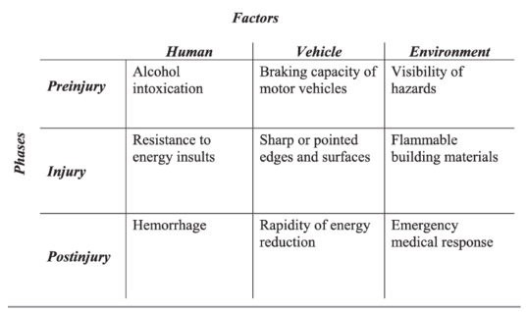

Figure 2.1 Haddon’s Matrix Theory
(Source: [21])

2.6.2 Human Factors Theory
Another vital theory for understanding the factors leading to accidents and injury severity is Human Factors theory. As per the view of [22], the theory states that accidents mostly happen due to chain active failures like distraction or speeding, latent conditions like improper designing of roads, weak enforcement. When there are holes in the defensive layers, accidents happen causing different types of injury. Implementation of the aspects of the theory in prediction of severity, traditional methods shows direct association between outcomes and risk factors, while MLs can provide hidden layers which interact with each other like how driver’s age, improper lighting and speeding increases the risk of fatality.
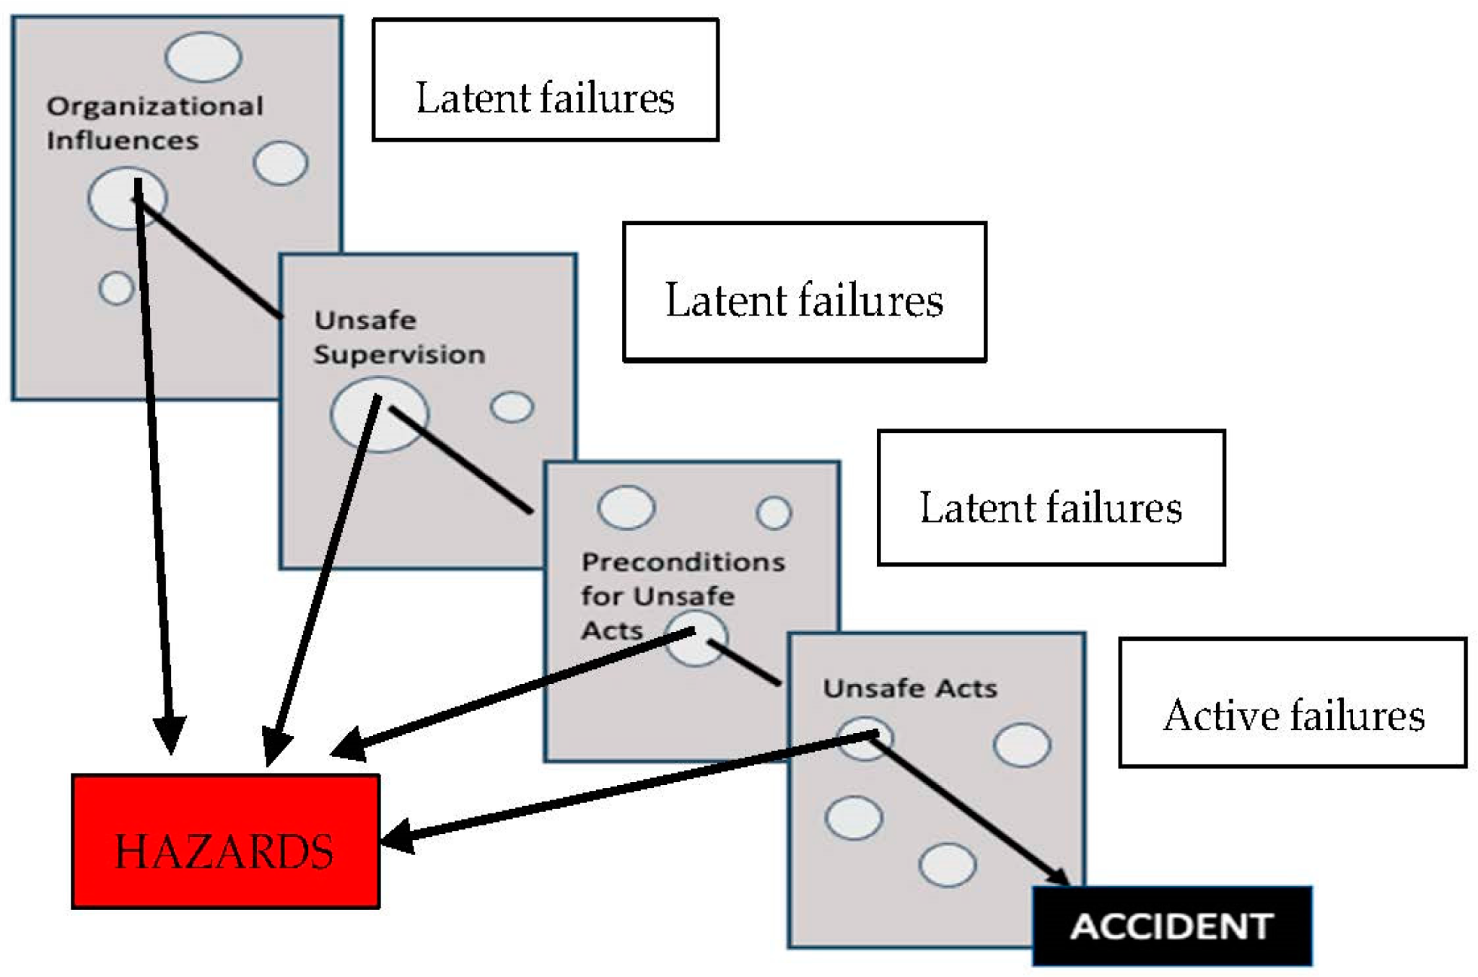

Figure 2.2 Human Factors theory
(Source: [23])

2.7 Gaps
Based on the literature review, it can be seen that there are some critical gaps in terms of inconsistency in quality of dataset, scalability and representativeness in some aspects. Past studies, which are focusing on single regions or cities have high accuracy of around 98.9%, but are not able to provide validation to other places which reduces generalisation. Imbalance of class is also a problem, where certain categories like minor accidents are ample in the dataset, while severe cases or fatal cases are not there in plenty, reducing the prediction’s robustness. Moreover, the dependence on datasets from hospitals, reports provided by the police and reactiveness limits the capability of the models in doing post-incident analysis, preventing proactive analysis. These factors tend to reduce application of the proposed ML models in real-world as well as transferability, showing the requirement of datasets which are comprehensive, balanced and longitudinal.
Another major gap observed is related to interpretation and methodological aspects. Even though the past studies have highlighted that advanced ML methods, like hybrid pipelines, deep learning and ensemble models tend to outperform traditional regression models in terms of accuracy, the black box nature of these modes tends to reduce the practical use in management at the time of emergency and policymaking. There are some studies which have properly implemented explainability tools like SHAP, properly, however the interaction between variables like infrastructural, environmental and behavioural are most of the time oversimplified. Temporal drifts also complicate dependencies, since models trained on data which are older tend to perform poorly when pattern of accident changes. Moreover, most of the study has less theoretical integration, depending most on empirical analyses for which proper requirement of models that can be interpretable is needed for properly understanding the factors leading to severity of accidents.

2.8 Conceptual framework
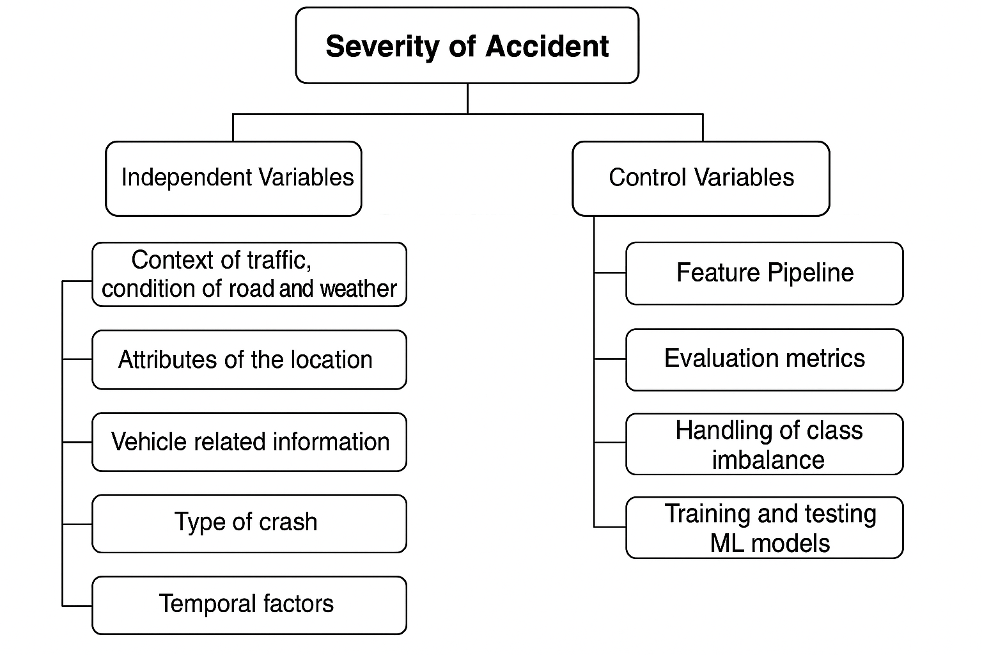

Figure 2.3 Conceptual Framework
The above figure shows the conceptual framework of this project. The framework shows that Severity of Accident as the target variable which is influenced by independent variables like conditions of weather and roads, location, information of vehicles, type of crash along with temporal factors. The above mentioned predictions show conditions of real-world scenarios shaping the outcome of accidents. For ensuring methodological rigor, control variables like feature pipeline, handling of class imbalance, evaluation metrics and pre-processing provides proper benchmarking as well as consistency in analysis. Thus, the framework shows how different factors leading to accidents interact while making the ML model analysis reliable.

2.9 Summary
The literature review showed that ML models tend to outperform conventional methods in case of prediction of accident severity, achieving accuracies between 80% - 98%. While deep learning and ensemble models show high predictive power, problems in terms of interpretability and overfitting remain. Moreover, changes in temporal factors as well as inadequate use of proactive data limits the application in real-world and robustness. Overall, the chapter shows that interpretable and hybrid ML models, which are trained and tested on high-quality and balanced datasets along with theoretical backing, plays a key role in understanding the factors leading to accident severity.

CHAPTER 3: RESEARCH AND/OR DEVELOPMENT METHODOLOGY

3.1 Introduction
The chapter focuses on the development methodology that helps in predicting traffic accident severity with the help of machine learning algorithms. The methodology chapter is going to explain the research approach that allows for achieving the objectives of the research. Additionally, the chapter highlights the way accident data was collected, preprocessed and analysed for the model development and evaluation process. The appropriate structured methodology helps in providing reliable information that can be generalised and validate the outcomes.

3.2 Research Design

3.2.1 Experimental hypothesis
The hypothesis, derived from Chapter 1, explores that gradient boosting and Random Forest classifiers can improve the accuracy of predicting traffic accident severity. In such circumstances, the null hypothesis of the research assumes that there is no significant impact of the prediction model in predicting accident severity, while the alternative hypothesis proposes a substantial and positive effect. Hence, the aim of the research is to examine the advantage of ensemble methods over traditional approaches in classifying accident severity.

3.2.2 Input and data sources
The secondary data collection method was used to predict accident severity using the machine learning models. The public road accident dataset has been collected to analyse the accident severity [37]. The dataset contained several information based on traffic flow, vehicle information, crash type, weather conditions, lighting, and road type. The attributes of the dataset were used as the independent variables for training the machine learning models, and the data variable Accident_severity was used as the target variable in the research. The road accident dataset was selected for its large size, reliability and diversity that can provide valid and meaningful insights into the accident severity predictions.

3.2.3 Software and hardware requirements
Category | Requirement | Purpose/Justification
Software | Python (with libraries: Pandas, NumPy, Scikit-learn, Matplotlib, Seaborn) | For data preprocessing, model training, evaluation, and visualization
Software | Jupyter Notebook | Interactive environment for coding, testing, and documenting experiments.
Software | Flask | To develop a lightweight web application for deploying the accident severity prediction model.
Hardware | Processor: Intel i5 | Ensures efficient computation for ML training tasks.
Hardware | RAM: 8GB minimum | Provides sufficient memory for handling large accident datasets.
Hardware | GPU | Accelerates the training of the ensemble models

Table 2: Software and hardware requirements

3.2.4 Experimental procedure
The road accident dataset was collected and preprocessed for predicting road accidents, and the first step was to handle missing values, encode categorical variables, address class imbalance, and normalise features. Machine learning models, such as Random Forest, gradient boosting, and AdaBoost, were trained and tested after preparing the road accident dataset. Hyperparameter tuning plays a vital role in improving model performance by enhancing predictive accuracy and decreasing underfitting or overfitting issues of the model architecture [38]. It is important to evaluate the model performance based on precision score, F1-score, classification report, and the confusion matrix. Thus, this approach helped in determining the best-performing model that was developed through Flask for developing a web-based application.

3.2.5 Validity, Reliability and Generalizability
The experimental procedure for predicting road accidents is validated, as a well-structured and large dataset was used to perform data preprocessing and model evaluation methods. Cross-validation and hyperparameter tuning helped in reducing the tendency of underfitting or overfitting issues to enhance the accuracy of the prediction model for predicting accident severity. The accident datasets across regions can be used, and this process helps in the generalisability of the experimental outcomes. Reporting standards, road conditions, and traffic laws are involved in predicting the accident severity.

3.3 Development methodology

3.3.1 Chosen methodology
The CRISP-DM framework was selected as the methodology provided appropriate structure to support machine learning and data science projects. The appropriate framework was selected to understand data, preprocessing, modelling and evaluating the outcomes (Refer to Figure 3.1). CRISP-DM framework can provide a flexible and iterative roadmap for data science projects that can align the project objectives [39]. The systematic approach helped in supporting data collection and the deployment process for predicting the accident severity. The structured workflow allows for performing feature engineering, modelling iteration, and data preprocessing methods and a web-based application is developed to support the prediction process of accident severity. However, the disadvantage of the CRISP-DM framework is that the framework is time-consuming due to repeated iterations. An efficient Jupyter notebook tool is used to support selecting the best model and improving the efficiency of the workflow.
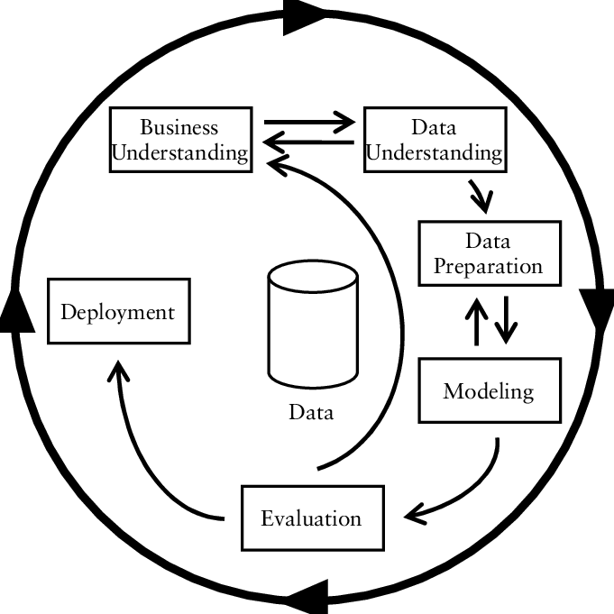

Figure 3.1: CRISP-DM framework
(Source: Influenced by [39])

3.3.2 Development tools and materials
Tool / Package | Purpose / Justification
pandas | Data manipulation, cleaning, and handling tabular datasets efficiently
numpy | Numerical computations, array operations, and mathematical support for ML tasks
matplotlib / seaborn | Data visualization to explore distributions, correlations, and patterns in accident data
LabelEncoder (scikit-learn) | Encoding categorical variables into numerical form for ML algorithms
train_test_split (scikit-learn) | Splitting the dataset into training and testing sets for model evaluation
RandomizedSearchCV (scikit-learn) | Hyperparameter tuning to optimize ML model performance
SMOTE (imblearn) | Handling class imbalance by oversampling minority classes
DecisionTreeClassifier | Base ML model for accident severity prediction
RandomForestClassifier | The ensemble method improves prediction accuracy through multiple decision trees.
GradientBoostingClassifier | Boosting method for robust classification performance.
BaggingClassifier | Ensemble technique reduces variance and improves stability.
AdaBoostClassifier | Adaptive boosting method enhances weak learners for better accuracy.
classification_report, confusion_matrix | Generating evaluation summaries to assess prediction results.
precision_score, recall_score, f1_score, accuracy_score | Performance metrics for comparing model effectiveness
joblib | Saving and loading trained models for deployment

Table 3: Materials and tools table

3.3.3 Procedures
Python, as a programming language, has been chosen as the language provides a rich ecosystem of libraries for managing data analysis and machine learning projects. Numpy, Pandas, and other data visualisation tools were used to perform numerical analysis, data preprocessing and develop a predictive model for analysing the raw dataset [40]. Jupyter Notebook, as an interactive platform, was used for coding, data preprocessing, and the visualisation process. The software tool helped in determining the best model for evaluating the accident severity based on the different data attributes, such as weather conditions, lighting, traffic flow, and others. Flask was used here to develop a lightweight web application that can integrate a trained model for predicting real-time data. Hence, the software tools are significant as they are highly efficient, open-source, and widely supported for handling large datasets, as well as implementing predictive models for understanding accident severity.

3.4 Ethical considerations
The research uses publicly available accident datasets, and the dataset stores information regarding the road accident without exposing personal data of individuals. Hence, this step helps in improving the confidentiality and privacy of the data analysis method. Secondary data from the public repository was selected as the collected data in this research can avoid misinterpretation and reduce bias. Therefore, the research promotes fairness and transparency that allows for improving road safety based on ethical standards.

3.5 Summary
It can be summarised that the methodology chapter outlined the structured workflow for predicting traffic accident severity using the machine learning models. Model evaluation techniques, as well as hardware and software tools, were discussed for supporting the entire procedure for predicting the accident severity. Ethical consideration, reliability and validity helped in collecting trustworthy outcomes for classifying the traffic accident severity.

Chapter 4: DESIGN AND IMPLEMENTATION

4.1 Introduction
Design and Implementation Chapter highlights the outcomes of the traffic accident severity using the prediction models. This chapter provides detailed requirements of the system that will provide clear steps for classifying traffic accident severity. Moreover, the main purpose of the chapter is to provide a step-by-step process from the data preprocessing, implementation, model design, and deployment to predict traffic accident severity. Hence, this chapter will provide transparency of the method used and demonstrate the way issues, such as class imbalance and missing values, were addressed. In a nutshell, the chapter will connect the theoretical research framework with practical development and real-world application of the traffic accident severity system.

4.2 Design Stage

4.2.1 Data exploration and pre-processing
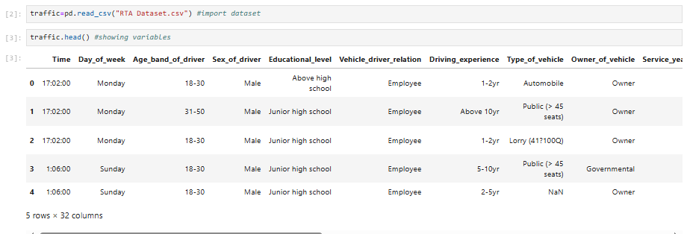

Figure 4.1: Showing first five rows of the dataset
The above figure shows that first five rows of the dataset that is applied for predicting accident severity.
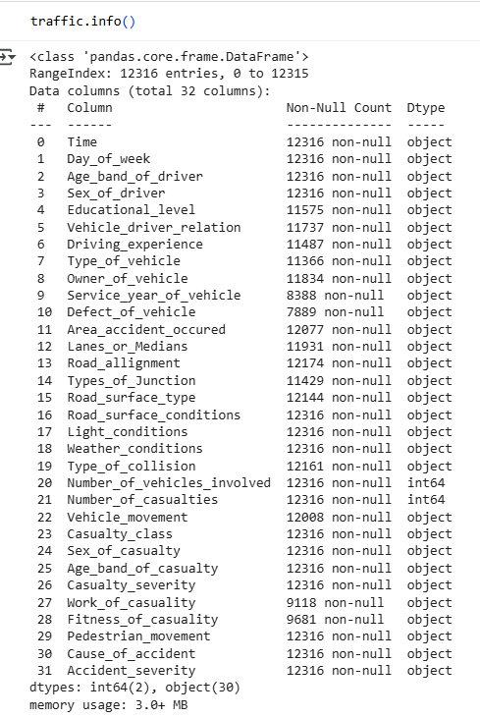

Figure 4.2: Information about the dataset
The exploration of the dataset which includes traffic.info() shows that there are around 12316 rows and 32 columns, having details of vehicles, demographics of driver, outcome of accidents and road environment. Most of the fields are categorical, with notable missing values in variables like Service_year_of_vehicle having 3928 nulls as well as Work_of_Casuality having 2205 null.
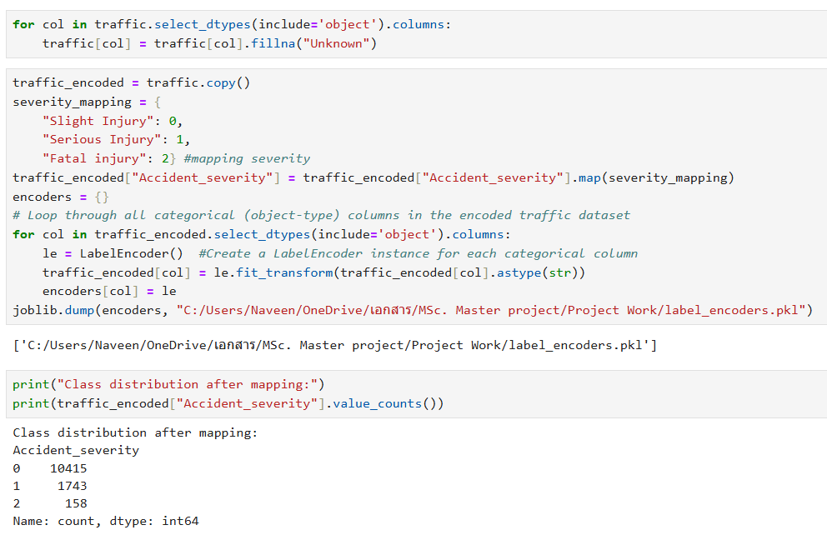

Figure 4.3: Data pre-processing and class distribution
This shows a clear requirement which is making sure that the data is complete without significant loss of data. The process of imputing the categorical null values as “Unknown” preserves the integrity of the data while reducing deletion of the data based on biasness. Moreover, changing the accident severity variable into categories which are ordinal aligns with the goal of the research of modelling gradation of risks associated with injury. This design shows a proper balance between maintaining granularity as well as creating data which can be used computationally.
The encoded mapping of severity shows a heavy imbalance of class where 10415 are Slight injury, 1743 are Serious Injury and 158 as fatal injury (Refer to Figure 4.3). This skewness shows a key problem which is faced when implementing real-world crash data, where cases related to severe and fatal injuries are rare but are very important for predictive modelling. If this is not addressed properly, the results would be biased in prediction of the majority class. Label Encoding of the categorical variables helps in standardising the inputs for machine learning models, making sure that the models are trained using numbers. The preprocessing steps show the importance of initial design, helping to shape the reliability, fairness and quality of the data and help predict accident severity properly.

4.2.2 Workflow of the Proposed Prediction System
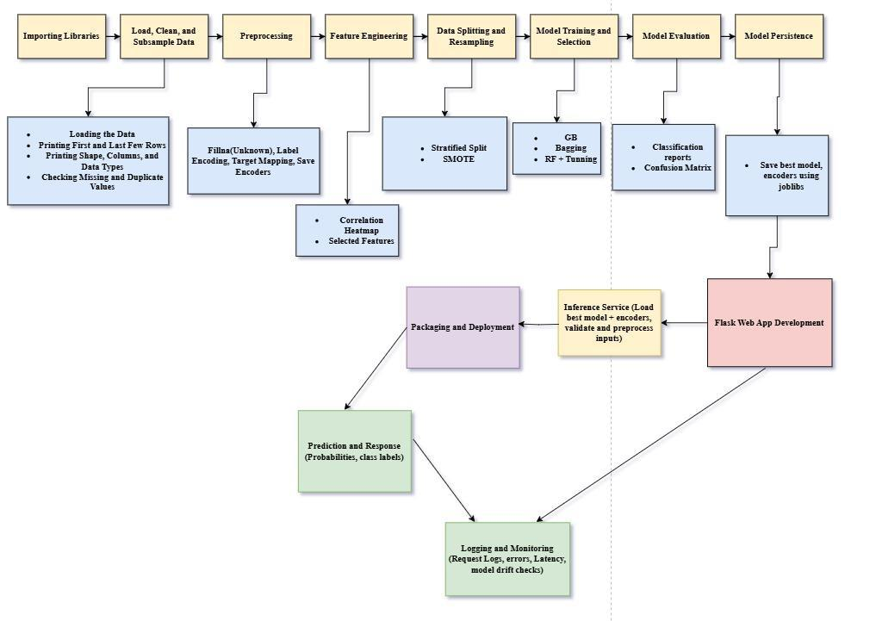

Figure 4.4 Machine Learning Workflow for Accident Severity Prediction
The above figure shows the workflow of the predictive modelling for predicting severity of accident. The figure shows that the workflow starts with exploration and data ingestion, where the dataset is loaded, inspected as well as visualised for understanding the structure as well as missing value. Preprocessing helps to ensure completeness by changing the nulls with Unknown, by mapping severity in ordinal classes, as well as encoding categorical variables making it compatible with ML. Feature engineering tends to implement correlation analysis as well as select the predictors for refining the inputs. A stratified train-test split along with SMOTE helps in addressing the problem of class imbalance, making sure minority classes are properly highlighted. Then ensemble models like Random Forest, Bagging, Gradient Boosting and ADABoost classifiers have been trained, tuned and evaluated based on confusion metrics, classification report and comparative metrics. Lastly, the best fitted model is saved for web development using Flask.

4.2.3 Data visualisation and understanding
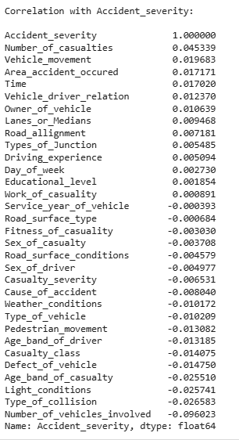

Figure 4.5: Correlation between accident severity and other variables
The correlation value shows that Vehicle_movement and Number_of_Casualities have a moderate correlation with accident severity which are 0.045 and 0.02 respectively. This shows that even though there is a relation, the direct impact might not be very significant. Moreover, Lanes_or_Medians and Area_accident_occured had a relationship which is substantial, showing that factors like layout and road environment is important in predicting accident severity. Conversely, other features like Work_of_casuality (-0.003), Driver_experience(-0.005) and Age_band_of_driver (-0.02) provide less correlation, showing that there might be the requirement of more robust engineering of features for improving the prediction power.
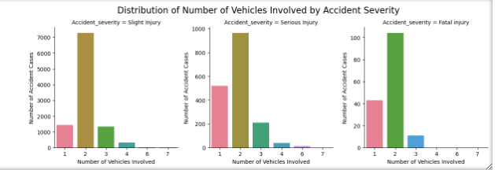

Figure 4.6: Distribution of number of vehicles by accident severity
The distribution plots provide key patterns in the dataset helping to understand accidents properly. For example, Distribution of Number of Vehicles with Accident Severity highlights that there is an overwhelming association of slight injuries with 2 vehicles, while there is an even distribution of fatal injuries among 1 - 3 vehicles. This shows the requirement for predictive models that highlights vehicle count as a key feature.
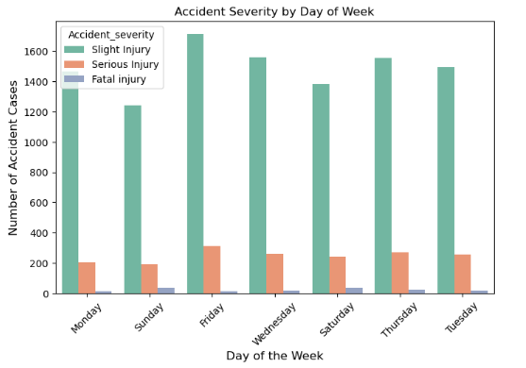

Figure 4.7: Accident severity by day of week

The Accident Severity by Day of Week shows that Friday has the highest frequency of accidents where maximum is Slight injury due to after office celebration leading to high traffic.
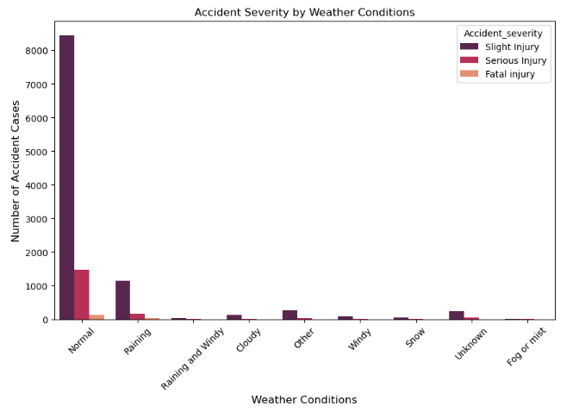

Figure 4.8: Accident severity by weather conditions
Conversely, weather conditions like normal and raining are associated with a high number of serious and slight injuries. Figure 4.8 shows that in normal weather, the chances of slight injuries in traffic accidents is more than the other injuries.
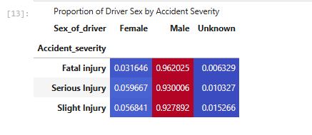

Figure 4.9: Proportion of driver gender by accident severity

Figure 4.9 illustrates that in traffic accidents, male drivers are involved predominantly across all severity levels, such as 96.20% of fatal injuries, 92.8% of slight injuries, and 93% of serious injuries. Moreover, the imbalanced gender distribution in the dataset significantly affected the outcomes of the analysis.
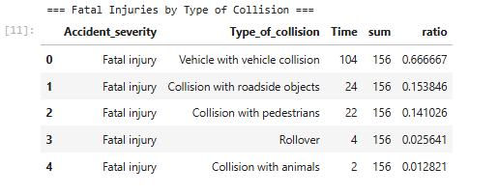

Figure 4.10: Fatal injuries by type of collision
Figure 4.10 explains that most fatal accidents happened due to vehicle-to-vehicle collisions (66.67%), pedestrian collisions (14.10%), and collisions with roadside objects (15.38%). Relatively rare types of collisions, such as rollover (2.56%) and collision with animals (1.28%), are the reasons for fatal accidents. Hence, the descriptive analysis indicates that vehicle-to-vehicle collision is the main reason for fatal accidents, and the outcome indicates the requirements of vehicle safety and collision-avoidance systems to decrease severe accident.
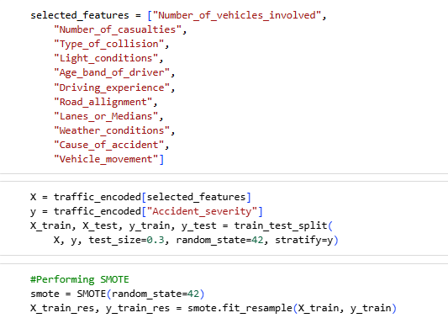

Figure 4.11: Applying SMOTE technique
SMOTE has been implemented for balancing the class after selecting the features based on findings of the correlation showing that the model is expected to provide unbiased results.

4.2.4 Model design
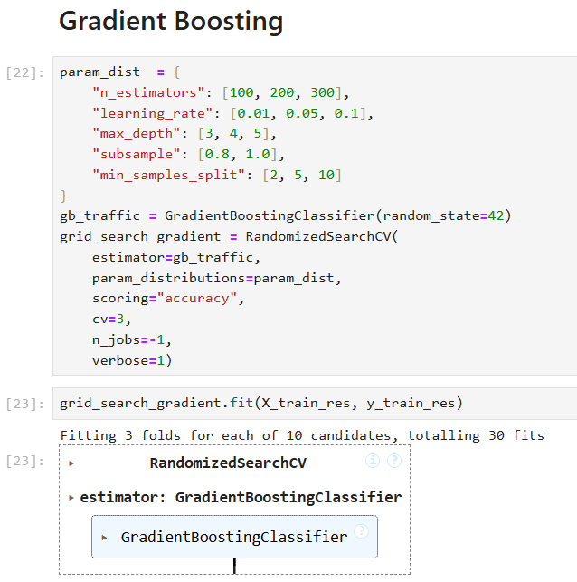

Figure 4.12: Implementation of gradient boosting model
The above table shows the process by which the models have been designed for predicting accident severity and also deploying the best model in real-world application. Gradient Boosting plays an important role in making model design since it constantly rectifies the mistakes made in the models that makes it more accurate and robust [47]. Its non-linear and complex relationship capability enables it to deal with unbalanced datasets and enhance predictive quality and balance regularisation and generalisation in practice. The Gradient Boosting has been fine - tuned with the help of RandomisedSearchCV where the main hyperparameters include max_depth, learning_rate and n_estimators. The best configuration with max depth of 4, learning rate of 0.1 and 300 estimators helps in balancing regularisation and predictive power. The working of the model includes correction of the errors iteratively from other models, increasing the effectiveness when data is imbalanced [41].
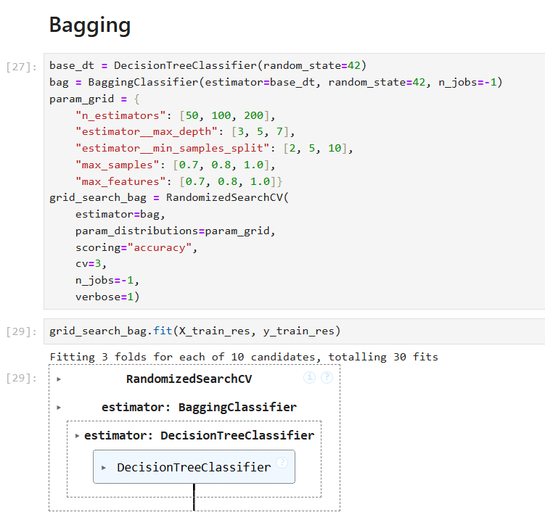
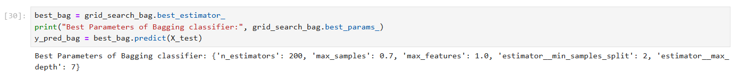

Figure 4.13: Bagging classifier
Combining Decision Trees with bagging is more effective in traffic accident severity prediction as it improves robustness, reflects different patterns using resampled data, and creates greater predictive stability in different accident conditions and data imbalances. Bagging enhances model stability and accuracy that eliminates variance and overfitting in the process of ensemble learning [48]. Bagging with Decision Tree as the base estimator has been optimised by including parameters like max features (Bagging), max samples (Bagging) and n_estimators (Bagging). In case of bagging the best configurations are 0.7 max features, 200 estimators and 0.7 max samples, helping in reducing variances after averaging the predictions from other trees.
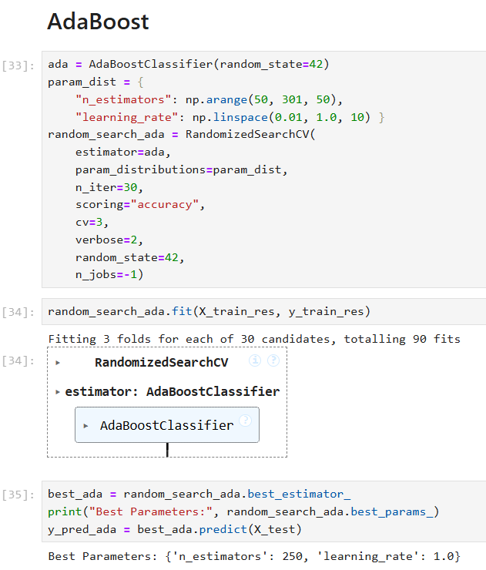

Figure 4.14: Implementation of ADABoost classifier

ADABoost classifier allows the successful combination and successive boosting of a series of weak classifiers that results in prediction with greater accuracy in the severity of a fault condition [49]. In the case of ADABoost with decision tree as the base estimator, learning rate of 1.0 and n_estimators of 250 is the best configuration, helping the accuracy to increase by adjusting the weights properly on misclassified samples. These methods are not very affected with overfitting and also capture complex interactions among the variables [42].
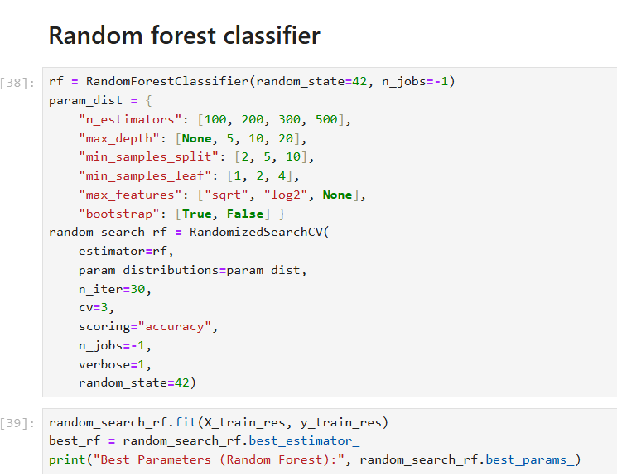

Figure 4.15: Random forest classifier
Random Forest consists of a collection of tree predictors in a manner that each tree is based on the values of a random vector that has been sampled independently [50]. From the above Figure 4.15, Random Forest has also been fine-tuned with n_estimators of 200, min_samples_split of 2 and max_depth of 20. This method, implementing many decision trees, tends to reduce overfitting while achieving high accuracy. The robustness of the model in handling complex data helps in understanding the importance of the features, leading to understanding the factors leading to accident severity.

4.3 Implementation Stage

4.3.1 Process of implementation
The process of implementation starts by implementing with the preprocessing of the categorical variables with the help of Label Encoder. The missing values were solved by filling with Unknown for categorical variables. The outcome variable was mapped into ordinal classes where Fatal Injury = 2, Slight Injury = 0 and Serious Injury = 1 making sure the compatibility is maintained with the ML models. For addressing the class imbalance, SMOTE has been implemented for creating synthetic samples for classes which are minor, making sure the dataset is balanced. Stratified sampling has been used for splitting into training and testing dataset making sure that the class distribution is preserved.
Next step of the implementation includes training of the models like Random Forest, Gradient Boosting, AdaBoost and Bagging has been done using RandomisedSearchCV. The hyperparameters which are best for improving the performance of the ML models were identified and were trained on the resampled data. This has helped in evaluating and deploying the best fitted model based on classification metrics for predicting real-world scenarios. This has helped to understand whether the ML models are capable of capturing non-linearity in complex real-world datasets.

4.3.2 Experimentation and testing
In the research, experimentation and testing phase was conducted to improve the validity of hypothesis testing using machine learning models. The data preprocessing method was the first step to handle missing data, and the label encoding process was applied to encode the categorical variables. Hence, the data preprocessing was the first step in the experimental task, and this step helps in balancing the dataset. The modified dataset was split into testing and training sets to maintain class distribution, and RandomSearchCV was applied here to decrease the underfitting or overfitting issue, as well as improve the model performance. The training models for traffic severity were analysed based on the test set using the relevant evaluation metrics, such as confusion metrics and the classification report. Misclassifications and the true classification rate assisted in deciding the best-performing model for classifying road accident severity. The outcomes of the predictive model help in providing reliability for real-world applications.

4.3.3 Problem and limitations
In classifying traffic accident severity, several limitations and issues were encountered that can influence the design and implementation of the accident severity prediction system. One of the major problems in the research was class imbalance, and the descriptive statistics and the pie chart were shown here. Slight injury was recorded as more than fatal and serious injury in the dataset. Class imbalance of the dataset affects the model's outcome in predicting the accident severity. Hence, the SMOTE technique was applied to balance the type of injury and enhance the effectiveness of the prediction model. Additionally, in the dataset, a data quality issue was observed, and data quality decreased the accuracy of the data preprocessing method, as well as affected the model outcomes. The imputation technique was applied here to improve data quality and decrease data biases. Rows containing missing values are required to be dropped to maintain the data quality in classifying the accident dataset. Additionally, the dataset contained more information regarding the accident severity and a heatmap was applied here to determine the relevant features that are strong in predicting the accident severity. Model deployment was performed using the Flask framework, and the system provided a controlled environment to predict traffic severity. Hence, in the real-world deployment, it is important to require integration with cloud hosting, real-time data feeds and large data pipelines.

4.4 Summary
It can be summarised that Chapter 4 explored the implementation of traffic severity prediction using several machine learning models, and the design step provided the details of requirement analysis, machine learning workflow, and data preprocessing and model design. It has been noticed that encoding categorical data, addressing class imbalance, and handling missing values have been performed to obtain reliable inputs. The random forest was the best model based on the model evaluation, and Flask was used to perform model deployment and ensure real-time applicability.

Chapter 5: Results and discussion/ Evaluation

5.1 Introduction
This chapter outlines the system outputs, evaluation and discussion of the presented traffic accident severity prediction system using ensemble machine learning methods. It focuses on evaluating the prediction system by presenting statistical evaluation metrics, such as accuracy, precision, recall, F1, and ROC-AUC. The chapter analyses and interprets the results obtained from earlier evaluation metrics, based on the research aims and the existing literature, and discusses how the models resolved data imbalance and accuracy in prediction challenges. Additionally, the chapter discusses the deployment of the prediction models using Flask for real-time application, evaluates and discusses the effectiveness of the ensemble prediction models, as well as their implications for road safety management and policy.

5.2 Overview of the implemented system
A web-based application has been designed to predict the severity of traffic accidents based on the implementation of machine learning (ML) techniques. In such circumstances, Python has been used for managing the backend connection of the application, and Flask has been applied here to manage the web framework. The web framework provides an interactive platform, and the user can input appropriate accident-related parameters, such as road surface, light conditions, and others. After submitting the relevant data, the system processes the user input through a trained ML model to predict the severity of the accident that is categorised as fatal, slight, or serious. The backend of the system is integrated with the best-performing model that was selected from the performance of the predictive model. In this case, handling missing values, encoding categorical variables and data preprocessing steps were involved to enhance the model reliability. A user-friendly and simple environment was presented by the Flask interface that helps both non-technical and technical users to predict accident severity based on the accident-related parameters. Thus, the system architecture helps in making communication between the user interface and the prediction engine. The user-friendly framework demonstrates that the ML model can be significantly applied to increase the accuracy of traffic safety analysis and help authorities make proactive decisions.

5.3 Model evaluation and performance results

5.3.1 Gradient boosting
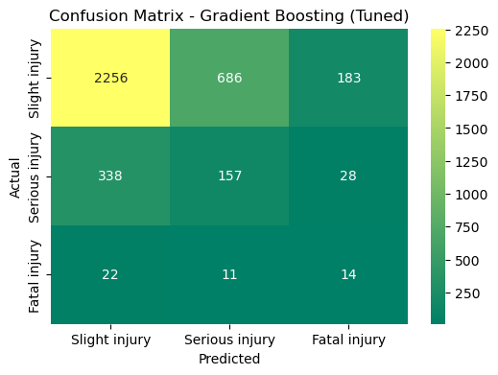

Figure 5.1: Gradient boosting confusion matrix
Figure 5.1 illustrates the performance of Gradient Boosting model in the prediction of the severity of traffic accidents with the aid of a confusion matrix. It demonstrates that the model was efficient in categorising 2,256 slight injuries, but often it was mistaken in categorising serious and fatal injuries as slight injuries with 338 serious and 22 fatal injuries being wrongly classified. Only 157 serious and 14 fatal cases were correctly recognized, which showed that there was poorer sensitivity to minority classes. The imbalance of data in the model shows a bias on the predominant category of slight injury in the model. Although it has been found to classify well when the number of classes is high, its failure to correctly classify severe cases indicates that additional optimisation or rebalancing is necessary.
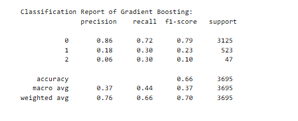

Figure 5.2: Performance metrics
The evaluation metrics in Figure 5.2 of the Gradient Boosting model are summarised in the classification report. It had a good precision (0.86) and a recall (0.72) of the slight injury category meaning that it has a good tendency to predict the majority of the categories. However, the performance was greatly reduced with serious (F1-score 0.23) and fatal (F1-score 0.10) injuries, with poor model sensitivity to infrequent classes. The general accuracy (0.66) and macro-average F1-score (0.37) indicate a lack of balance in all categories. The weighted average F1-score of 0.70 indicates the dominance of the majority. The implication of these findings is that despite the decent overall performance of the model, minorities should be improved in terms of recall and precision.

5.3.2 Bagging classifier
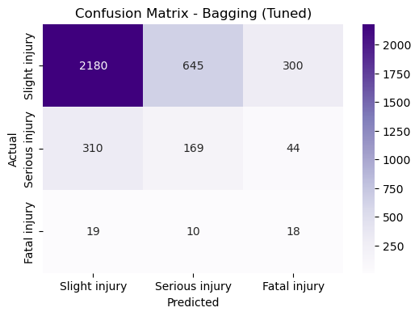

Figure 5.3: Bagging classifier confusion matrix

The confusion matrix of the tuned Bagging classifier in Figure 5.3 shows that the model was able to identify the correct number of images of slight injury, which is 2180 instances, which portrays good performance on the majority class. However, it had a problem with serious and fatal injuries and categorized a lot of them as minor injuries. There were only 169 and 18 serious and fatal injuries that were detected respectively. This trend is indicative of a general problem with imbalanced datasets, in which the classifier is biased in favor of the majority. Although Bagging enhances the general stability, its low sensitivity to the minority classes (serious and fatal injuries) lowers its prediction reliability to the extreme accidents outcomes.
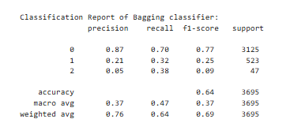

Figure 5.4: Performance metrics
According to the classification report in Figure 5.4, the overall accuracy is 64, and slight injuries are well performed (precision = 0.87, recall = 0.70, F1 = 0.77). But in case of serious (F1 = 0.25) and fatal injuries (F1 = 0.09), performance is poor because of underrepresentation of the data. The macro-average F1-score (0.37) exhibits poor balanced accuracy in all the classes, whereas the weighted average (0.69) displays prevalence of the majority class. These findings suggest that, despite Bagging being a reasonably working algorithm in general, it does not scale up to rare, but important cases, and that better class balancing or ensemble techniques can be used.

5.3.3 ADABoost classifier
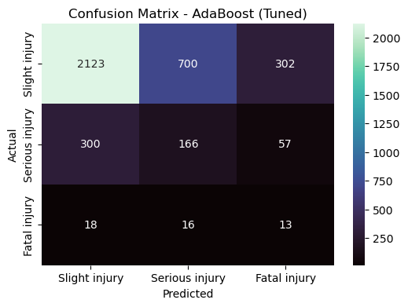

Figure 5.5: Confusion matrix of AdaBoost
Figure 5.5 illustrates the true and false classification rates of the AdaBoost model for predicting the accident severity. The model performed well in classifying the slight injury cases, and the correctly classified cases are 2123 as slight injury. The outcomes of the predicted model indicate that the strong capability of the model in addressing the majority class, and the performance of the model declines for fatal and serious injuries. The ADABoost model correctly identified 13 fatal injuries and 166 serious injury cases. The main strength of the predicted model is to provide higher accuracy in predicting slight injuries in traffic accidents. The predicted model is relatively ineffective in distinguishing the severity of accident outcomes based on key accident-related parameters and it is a weakness of the prediction model.
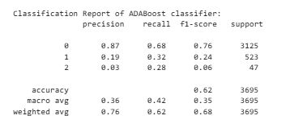

Figure 5.6: Classification report
Based on the classification report, it was noticed that the overall accuracy of the AdaBoost model is 62% and the accuracy indicates moderate performance of the prediction model. The precision score for the slight injury is 0.87and the F1-score of this injury is 0.76, indicating strong predictive power for classifying the majority class. According to the classification report, the performance of the AdaBoost model drops effectively for class 1 and class 2, which indicates serious and fatal injury cases, respectively. The macro average F1-score of the model is 0.35, and the value indicates the class imbalance in predicting the traffic accident severity. Moreover, the weighted average F1-score of the AdaBoost model is 0.68, indicating acceptable overall performance in classifying the severity of traffic accidents.

5.3.4 Random forest classifier
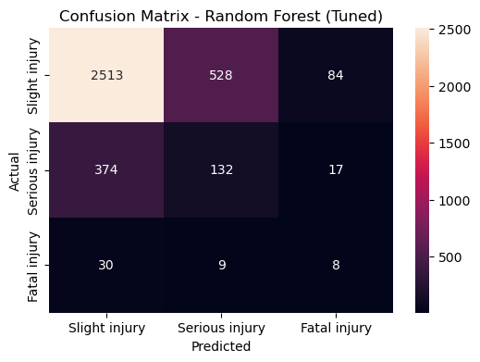

Figure 5.7: Confusion matrix of the random forest model
The tuned Random Forest model confusion matrix in Figure 5.7 demonstrates that the model has a high predictive capacity on the majority class, which is slight injuries, with 2,513 correct predictions. The model however fails to differentiate serious and fatal injuries which have been misclassified as minor injuries. Accurate prediction of serious and fatal injuries was only 132 and 8 respectively which indicates that it is hard to identify the minority classes. The result of this imbalance is that the common cases would be represented with high true positive rate but low sensitivity with severe cases. However, the general structure of the Random Forest provides a better learning and generalisation relative to the simpler models, and it provides a higher consistency of results across a variety of injury types.

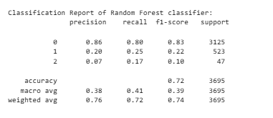

Figure 5.8: Classification report
In the classification report in Figure 5.8, the overall accuracy is 72 which is superior to Bagging classifier. Accuracy (0.86) and accuracy (0.80) are large in case of slight injury, but it significantly drops in the case of serious injuries ( F1 = 0.22) and fatal injury ( F1 = 0.10). The macro-average F1-score (0.39) indicates poor performance in all the classes and the weighted average (0.74) indicates predominance of the majority category. These results indicate that algorithms are poor in predicting rare, high severity accidents, presumably because of the class imbalance. However, it is more balanced and stable with respect to prediction than Bagging.

5.3.5 Comparison of predictive models
Model | F1-Score (Slight Injury) | F1-Score (Serious Injury) | F1-Score (Fatal Injury) | Recall (Slight Injury) | Recall (Serious Injury) | Recall (Fatal Injury) | Overall Accuracy
Random Forest | 0.83 | 0.22 | 0.1 | 0.8 | 0.25 | 0.17 | 0.72
AdaBoost | 0.76 | 0.24 | 0.06 | 0.68 | 0.32 | 0.28 | 0.62
Bagging Classifier | 0.77 | 0.25 | 0.09 | 0.7 | 0.32 | 0.38 | 0.64
Gradient Boosting | 0.79 | 0.23 | 0.1 | 0.72 | 0.3 | 0.3 | 0.66

Table 4: Performance of predicted models
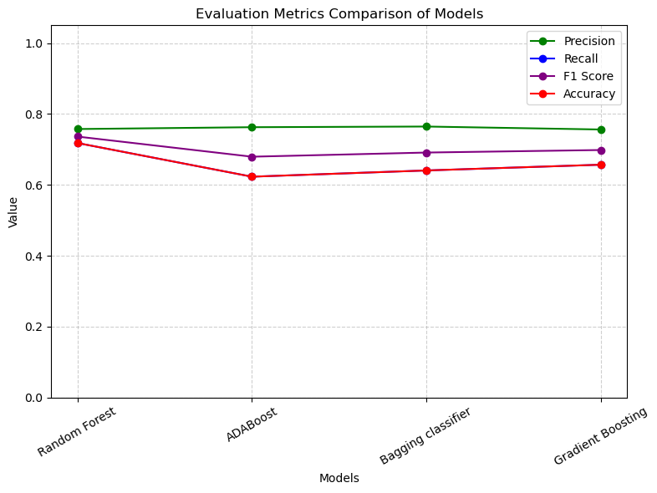

Figure 5.9: Comparison of evaluation metrics
Figure 5.9 and Table 4 show the comparison of the evaluation metrics of the predicted models, and it has been noticed that the random forest model performed well in predicting the accident severity. The AdaBoost model provided poor performance in classifying the accident severity, as the predicted model faces difficulty in addressing minority classes, and the recall, F1-score, and accuracy indicate that. Moreover, gradient boosting and bagging classifier models demonstrated consistent and moderate performance, but the outcomes of the predictive model did not surpass the random forest model. Based on Table 4, it has been noticed that the recall value for serious and fatal injuries is lower than the other predicted models and a similar view was noticed in the case of F1-score. The outcomes of the random forest model, according to Figure 5.9, illustrated the best balance between stability and accuracy for predicting the accident severity.

5.4 Model deployment
Model deployment plays a vital role in integrating the predicted model into a real-world environment, and this process helps users to interact with the application and obtain relevant outcomes. Based on the comparison of the prediction models, Random Forest is the best-performing model for predicting accident severity. The model has been used to make decisions regarding the traffic safety analysis using the web application.
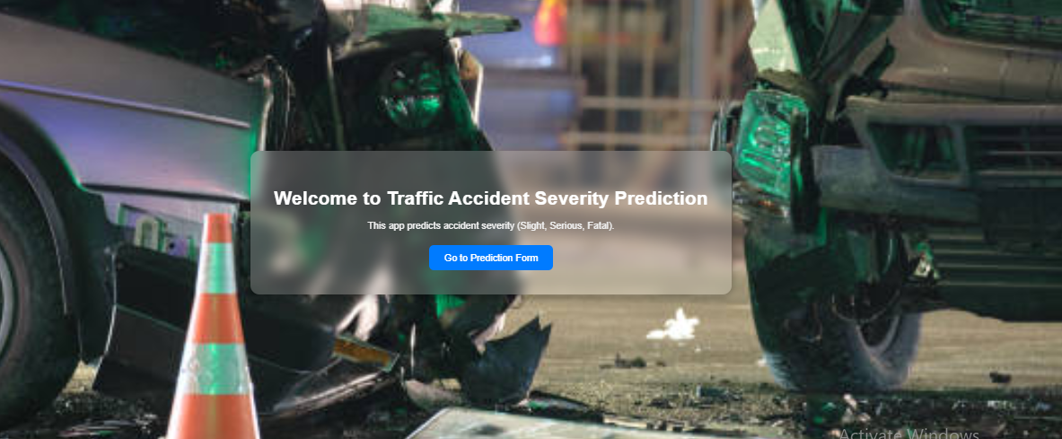

Figure 5.10: Web application using Flask
(Source: Extracted from Flask)
Figure 5.10 shows the web application that is developed using Flask as an interactive interface for predicting traffic severity according to the user-input parameters, such as vehicle type, weather condition, and road condition. The homepage of the web application helps users access the prediction form easily, and a trained ML model has been used to predict real-time severity, such as fatal, serious or slight injury. Hence, the Flask-based design assists in providing a practical web interface for analysing real-world traffic accident severity.

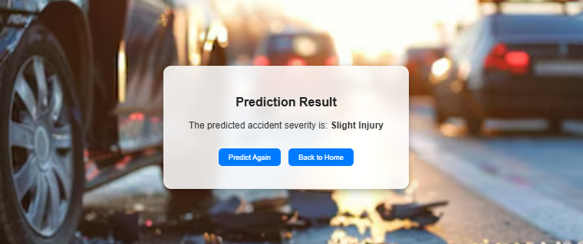

Figure 5.11: Predicting slight injury
(Source: Extracted from Flask)
In the prediction form, selected features have been used to predict the accident severity based on the accident-related parameters that were imported by the users. Based on the submitted user data, the ML model is used to classify the accident severity level. Figure 5.11 shows the predicted outcomes in the result page, and the navigation bar helps in providing the facility to access other pages of the application. It has been seen that the web interface predicted the accident severity level based on the user data.



Figure 5.12: Predicting fatal injury
(Source: Extracted from Flask)
Figure 5.12 shows the outcomes of the predicted model for predicting accident severity, and based on the user data, the severity of the accident is fatal injury. Therefore, it can be said that the random forest model performed well in predicting the accident severity level accurately.



Figure 5.13: Predicting serious injury
(Source: Extracted from Flask)
In this figure, the prediction interface shows “serious injury” based on the user input, and the outcomes indicate the ability of the system in classifying the accident severity based on the user input parameters.
Based on the web application framework, it has been noticed that the trained random forest model performed well in classifying three categories of accident severity based on the user input data. The selected features are effective in determining the accident severity, and the features of the system explore the flexibility of the model in meeting the purpose of the system and handling accident severity levels. Therefore, the web interface framework can provide proactive traffic safety analysis based on the trained random forest model.

5.5 Discussion of results
The chapter presented the outcomes and analysis of the established traffic crash severity prediction mechanism on the basis of ensemble machine learning models. The introduced system was able to deploy data preprocessing, feature engineering, and model deployment into a web-based framework, which served as an effective tool to predict the level of an accident severity. The comparison of the ensemble models revealed that the Random Forest classifier was the most stable, the most accurate and the most consistent model as opposed to the other models like Bagging, AdaBoost and Gradient Boosting. Although each of the models was effective in identifying the majority class, the sensitivity of all of them to identify serious and fatal injuries was lower, showing the imbalance of classes in the dataset.
The findings demonstrated the significance of preprocessing tools to enhance the accuracy of predictions and fairness, including encoding and oversampling. Although minority class detection is characterized by the difficulties, the ensemble models were successful in reflecting complicated relations between variables that impacted the severity of accidents, including road conditions, vehicle type, and environmental factors.
The implementation of the Random Forest model with Flask proved the usefulness of the system, which provides users with a convenient web interface to assess the severity levels in real-time. The implementation of this web-based solution demonstrated that this model could assist the work of decision-makers in the traffic authorities and provide the improvement of proactive safety management. Altogether, the findings prove that ensemble learning methods are a valid and useful framework to predict the severity of accidents and fill in the gap between the theoretical research and practical solutions of traffic safety.

5.6 Evaluation of research objectives and comparison with existing literature

5.6.1 Methodologies, gaps and trends observed in past studies related to prediction of traffic accident severity
The results of the current study confirm the previous reports on the issue of predicting the severity of traffic accidents with the help of machine learning, and also imply certain deviations connected with the performance and interpretability of the model. The results of past studies indicated that the ensemble learning models, especially the two methods, Random Forest and Gradient Boosting, are more predictive, and stable than traditional regression models [4] [5]. These findings are in line with the current study where the best overall performance was realised with the Random Forest model which exhibited high generalisation and strong robustness. Equally, Gradient Boosting and Bagging classifiers had moderate but stable performance, which is in line with previous works that indicated that ensemble-based methods have a potential of effectively dealing with non-linearity and variable interaction. However, in line with earlier research, the present study also indicates a reoccurring shortcoming, which is the fact that it is not sensitive to minority classes (serious and fatal injuries) [9]. The models, even those with the highest performance (Random Forest), did not perform well in terms of correctly classifying fatal accidents, which is also attributed to the problem of the imbalance in the dataset as observed in earlier studies. Such studies also highlighted the imbalance in classes skewed model learning towards common types of injuries including minor injuries, which is also evident in the current research even with the use of SMOTE to oversample. Regarding the effect of features, the literature and the study under consideration recognise the road geometry, weather conditions, vehicle number, and lighting as the primary factors that define the severity of the accident [10] [19]. The present research data visualisation proves previous research results, as it demonstrates that environmental and infrastructural conditions have a great influence on the result of an injury. The only area where the current research is slightly out of slog is in practical application. In contrast to the majority of the past studies, where the main aim of the projects was to develop the model, this project was able to deploy the Random Forest model with Flask and give a real-time and easy to use prediction system. This applied implementation builds on the scholarly contribution into a practical decision-support system of transport agencies. The results of the research prove the prevailing opinion in the literature on the fact that ensemble machine learning models are more effective than traditional solutions in predicting the severity of accidents. Nonetheless, in line with the earlier research, they also highlight that the issue of data imbalance and the prediction of the minority classes still persist as the unaddressed problems that demand the conceptual development of methods and real-time incorporation of data.

5.6.2 Influence of environmental driver and road related factors on the severity of accidents
The findings of the current study substantiate, to a greater extent, the conclusions of earlier studies concerning the severity of traffic accidents, especially regarding the aspects that specify the degree of severity and the effectiveness of ensemble machine learning models to predict the outcome of injuries. Past studies have found that a combination of human, environment and road related variables, including road geometry, lighting, and driving behaviour has an impact on the accident severity [15]. These observations are supported by the present research, because visual and statistical data indicated that the condition of roads, lighting, and the involvement of a vehicle contribute significantly to the consequences of accidents. As an example, such characteristics as the number of vehicles, the location where the accidents took place, and the type of collision were found to be important and associated with the level of severity in accordance with the previous studies indicating road conditions and factors connected with drivers as the key factors. The existing such as [20] and current studies highlight the predictive accuracy enhancement of ensemble machine learning methods, including Random Forest, Gradient Boosting, and Bagging, over the traditional regression models. This is proven by the results of the current study since all the ensemble methods proved to exhibit satisfactory accuracy rates, whereby, Random Forest showed the highest accuracy, and F1-score.
However, past literature and present research have a similar weakness in that they cannot accurately categorise the minority classes, especially the serious and fatal injuries. In spite of the implementation of SMOTE to balance the data, all the models were less sensitive and less accurate in relation to such uncommon outcomes. It is an indication of the challenges that have been observed in past research which has been conducted using highly imbalanced traffic data; most of the documented cases are minor injuries [44]. Thus, the current study is not a deviation of previous results, but instead, an addition to the continuous necessity of sophisticated data balancing and feature engineering methods in order to enhance sensitivity toward rare yet high-stakes outcomes. The practical implementation of the current research is where it builds upon what has been done before. In contrast to the previous studies in which the primary emphasis was put on the development of the models and their statistical validation, the given research implemented the most successful Random Forest model via Flask-based web application, which allowed making real-time predictions according to the variables entered by the users. This is a transition in the theoretical analysis to the application and shows how machine learning can be operationalised in decision support in road safety management. Results support previous studies and provide a useful, deployable solution that can bridge the gap between data-based modelling and practical, real-world systems of accident severity prediction.

5.6.3 Effectiveness of ensemble models like Bagging, Random Forest, ADABoost and Gradient Boosting classifiers be developed in predicting accident severity
The results of the current study align with the patterns of prior studies on the application of machine learning models in predicting the severity of traffic accidents. Like [10], [8] and [5], the current study determined that non-linear relationships, and interaction between variables of a complex nature, makes ensemble models like the Random Forest and Gradient Boosting much better than the traditional statistical models. Similar to [10], road type, number of vehicles and lighting were also found to be significant predictors of the severity of the accidents in the current study, which supports the fact that the environment and infrastructural factors have a strong impact on the result of the injury. In line with [5] and [33], this study confirms that random forest offers the best performance over the other methods of ensemble, and is better in terms of stability, generalisation and interpretability. But, similar to [9] and [32], it also found results that minority classes (serious and fatal injuries) feature a very negative performance of the models even after the introduction of SMOTE. This confirms the previous warning that machine learning models are successful in balanced datasets or in large datasets, but they find it extremely difficult to work with unequal data distribution and small samples. As per [11] and [30] the present study noted that boosting models, even though they have the ability to achieve great overall accuracy, have the tendency to misclassify the minority categories, thus the overall precision and sensitivity have a trade-off. Additionally, the results are similar to the ones of [35] and [28], which noted that data quality and representativeness are still important areas of concern when it comes to obtaining valid outcomes. The point of continuity to this research is where the actual implementation of the Random Forest model is applied through Flask to make developing a theoretical model a practical and interactive web application. Such applied integration makes up the gap observed in [29] and [36] where deployment and interpretability were constrained. Comprehensively, the results of the current research confirm the majority of previous results confirming the supremacy of ensemble learning and proving that the model explainability and balance of data are the crucial components in the development of the accident severity prediction.

5.6.4 Analysis of evaluation metrics like F1-score, recall, accuracy, ROC-AUC and precision in predicting accident severity and integration using Flask
Key evaluation metrics, such as accuracy, precision, recall, and F1-score, were used in analysing the performance of traffic accident severity and the relevant metrics helped in evaluating the best model to predict the accident severity. Each of the evaluation metrics of the prediction model offers unique insights into the effectiveness of the system. Based on the model performance evaluation, the random forest model has the ability to predict the traffic accident severity. According to existing literature, XGBoost and random forest provided higher predictive stability and robustness in classifying the accident severity ([11], [10], [33]). The ensemble models performed better than the other predictive models, as the ensemble model has the ability to capture non-linear and complex relationships between the data variables. In this research, the correlation technique was used to define the relationship between the target variables and other input variables, as well as this process helps in enhancing the accuracy of the prediction model to classify the accident severity. Similarly, [10] highlighted that the requirements of SHAP for showing the importance of the feature variables in the model predictions can improve the transparency of the project.
The integration of a trained model by applying the Flask framework increases the transparency of the prediction system by offering a web-based and user-friendly platform for enhancing the accuracy of real-time predictions. The deployment step in this research allows for enhancing the transparency of the prediction system and meeting the objectives of the research. Hence, the combination of strong model performance metrics with Flask deployment illustrates the way ML can significantly support road safety management in the real-world environment.

5.6.5 Recommendations to the policymakers and transport authorities based on the outcome of the best-performing ML models
Random forest classifier was the best-performing model to predict accident severity, and the best-performing model allows for providing key recommendations to transport authorities and policymakers to enhance accident prevention and traffic safety management. In this research, the key predictions of accident severity, such as the number of vehicles, the number of casualties, lighting, driver experience, and weather, offer vital insights for developing road safety. Based on the prediction outcome, it is important that policymakers focus on improving road infrastructure by installing guardrails or barriers in areas where escarpments and collisions with roadside objects are frequent. As per the view of [45], road alignment and median design can reduce accident severity and rates by minimising the impact of vehicle errors, separating conflicting traffic, and influencing driver behaviour. Therefore, median design and road alignment must be reviewed to decrease the likelihood of severe crashes during overtaking lane changes.

5.7 Summary
It can be summarised that the research developed a traffic accident severity prediction system using Flask and an ML model to classify accidents into fatal, serious or slight categories. Based on the performance metrics, the random forest model performed better in predicting the accident severity level. The web-based interface of the system assists the user in inserting values in accident parameters for predicting the accident severity level. Limited dataset diversity, data imbalance, and lack of real-time integration affected the prediction model performance. Therefore, the overall chapter illustrates the potential of ML in increasing the accuracy of traffic safety analysis and offers a foundation for future system improvements for predicting accident severity.

Chapter 6: Conclusions and Recommendations

6.1 Conclusions
Based on the above discussion, it has been concluded that the study was intended to explore and forecast the severity of traffic accidents using secondary quantitative analysis with the help of machine learning. It has relied on publicly accessible road accident data to create and compare various ensemble models, including Random Forest, Gradient Boosting, Bagging, and AdaBoost to evaluate their performance in categorising the level of accident severity. The research also was able to implement a web-based application with Flask that has bridged the gap between theoretical modelling and practical usability in terms of traffic safety analysis.
From the prior analysis, most of the past studies used effective ensemble models, including Random Forest, Gradient Boosting, XGBoost and deep learning models to predict the severity of accidents. These models have demonstrated superiority to the traditional regression models in terms of non-linearity and feature interaction. Moreover, numerous studies conducted in the past focused on the development of models without having deployment structured and real-time applications. Conversely, according to the results, the present research supported these trends, ensemble models have enhanced the accuracy of predictions but were unable to cope with rare classes, including serious and fatal injuries. Based on different ensemble models, the Random Forest model proved to be the most accurate, stable and generalised that was facilitated with its efficient address of non-linear interactions as well as different input dimensions. It also filled the deployment gap issues by implementing the Random Forest model with a Flask web system as the practical use unlike previous works. Therefore, objective 1 has been met successfully because the research justified previous findings, resolved an extant limitation and provided a practical, interpretable model framework of accident severity prediction.
Based on the previous chapters, it has been found that a set of driver behaviour, environmental conditions, and roadway geometry determines the severity of traffic accidents. Research has shown that irresponsible or distracted driving, especially among middle-aged or inexperienced drivers, is a major cause of accidents. The visibility and reaction time have also depended on other environmental factors that worsen the severity of accidents that including lighting, weather conditions, and time of day. In a similar manner, road-specific conditions, such as curves, slopes, and the arrangement of lanes, have also led to the high frequency of crashes and blackspots, specifically on the two-lane highways with poor geometry and poor signage. Further, the present study proved that drivers’ behaviour, car involvement, lighting and road conditions significantly predict the level of accidents. The statistical and visual tests showed that the results of the accidents and these variables were strongly correlated with the existing research. Thus, Objective 2 has been reached effectively since the results confirmed the prior evidence and offered empirical support through the application of machine learning-based modelling.
The literature review showed that ensemble models, including Random Forest, AdaBoost, Bagging, and Gradient Boosting have always proved to be much more accurate and stronger than other traditional statistical and deep learning models. Research indicated that non-linear interaction between variables, missing data and greater stability in classification could be effectively achieved using ensemble methods. Nevertheless, there have been restrictions on the imbalance of classes, the absence of generalisation among regions and a poor interpretability of the models. Based on the results, this study has established that ensemble models are more effective compared to the traditional models in terms of the accuracy of prediction of the severity of accidents. The best results were obtained with the Random Forest model that has a high level of generalisation and reliability. Competitive performance was also offered by Gradient Boosting and Bagging but at slightly low levels. Even though the unbalanced data has decreased sensitivity to fatal cases, ensemble models remained effective and stable in general. Consequently, the Objective 3 and additional hypothesis (H1) that ensemble models are significant to the accuracy of prediction in the severity of accidents classification has been fulfilled.
Based on the above chapter, ensemble models, including Random Forest and XGBoost performed better in all important evaluation metrics, including accuracy, F1-score, recall, precision, and ROC-AUC, while predicting the severity of accidents. XGBoost achieved outstanding performance with high recall and ROC-AUC, indicating its strength to detect serious cases of accidents. Random Forest had the best overall accuracy and F1-score that suggests good overall generalisation and equal classification among classes. Moreover, the Flask framework allowed the integration of the best-performing model of Random Forest to make predictions in real-time and on the web that increased the transparency and availability of the model. Therefore, Objective 4 has been successfully fulfilled, showing that ensemble ML models are effective to increase predictive accuracy and practical implementation in traffic accident severity analysis.

6.2 Limitations of the study
A significant limitation encountered in this study was limited managerial usability of the model developed because it was based on secondary data and limited geographical scope. The dataset was region and time-specific that restricted the future applicability of the model results in the policy-making in various traffic conditions. Moreover, the incompatibility with real-time data systems and the lack of cloud deployment limited the usability of the Flask interface at a large scale.
Methodologically, the research had multiple limitations that influenced its strengths of the study. The researchers relied on only secondary quantitative data that lacked critical variables, including driver behaviour, road infrastructure, and vehicle speed that have enhanced accuracy in prediction. Computational constraints as well constrained further hyperparameters tuning and avoided more sophisticated algorithms to boost performance. Conversely, the lack of real-life examples has posed restrictions on justification of ideas and affected validity and reliability of this study. Despite ensemble models, such as Random Forest and Gradient Boosting were used, the imbalance in the classes in the dataset favoured the majority (slight injuries) and this affected the fairness of the model.
The traffic accident dataset may not fully explore the accident scenarios, and the dataset was limited to specific time periods and regions, decreasing the generalisability of the prediction model. In the feature selection, road infrastructure, driver behaviour, and vehicle speed are not included in predicting the severity level of the accident. Additionally, the random forest model is dependent on historical data for the prediction of traffic severity, and it decreases the chances of correct prediction based on sensor-based and real-time information. In such circumstances, the flask interface has been used to predict the accident severity, and the interface is not optimised for cloud-based or large-scale operation. Based on the testing process, user evaluation was limited as a small group of testers was involved in testing the accident severity. Hence, the user evaluation may not fully capture real-world reliability or usability in classifying the traffic accident. These limitations have been acknowledged to provide transparency and scope of the research, along with to underscore the areas where future research can enhance data quality, balance and model performance to more accurate forecasts of accident severity.

6.3 Recommendations
In order to overcome the managerial limitations that have been highlighted in this study, a number of recommendations are offered in future research and application. In order to increase the generalisation and applicability of the model resulting in different traffic settings, the study can be necessary to enlarge the dataset in terms of the areas covered and long timeframes. Moreover, large-scale accessibility and real-time monitoring by transport authorities can also be enabled by the deployment of the Flask application on cloud systems including AWS and Google Cloud. The accuracy and responsiveness of the accident severity predictions can be enhanced by integrating real-time data streams provided by the IoT sensors, GPS equipment, and surveillance systems.
Regarding the methodological perspective, the mixed approach with the utilisation of quantitative and qualitative data can help to better understand human behaviour and decision-making process of drivers. The results of the models can be corroborated by using primary data collected in the form of surveys or interviews with traffic officers and drivers to ensure their interpretability. Moreover, enforcing more sophisticated methods of data balancing, such as the SMOTE and optimisation of hyperparameters with grid or Bayesian search, can be able to increase fairness and predictive quality.

6.4 Future work
In order to further enhance the relevance and usability of accident severity prediction, future research can build upon this study by addressing the critical limitations of the research and examining new avenues of concern. The research ought to strive to incorporate real-time information obtained via CCTV camera feeds, IoT sensors, and GPS system to make the model more responsive and predictive. Future research can also involve the use of advanced deep learning and hybrid models that utilise the combination of ensemble techniques and neural networks to enhance the performance of classification, especially in the minority classes, such as severe and fatal injuries. Furthermore, the cloud-based infrastructure will allow the model to be deployed that can make it scalable and allow new models to be updated continuously. Finally, engaging larger populations of users for evaluation while adopting human-centric design principles can improve the usability, reliability and real-world deployment potential by policy makers and transit authorities.

Chapter 7: Reflection

7.1 Personal learning and development
The experience of conducting research by investigating and predicting the severity of traffic accidents by applying machine learning has given me valuable academic, technical, and personal learning experiences. The project enabled the merging of theoretical knowledge on data analytics, machine learning algorithms, and ensemble modelling with real-world application using such tools as Python, Scikit-learn, and Flask. During this research, I have gained valuable insight into the ways secondary quantitative data have been applied to generate actionable information in a real-world issue like the analysis of traffic accidents. The experience has also reinforced my skills to use data preprocessing methods to enhance model accuracy and fairness, including missing values, balancing data through SMOTE and feature encoding.
The research highlights the design and implementation of the traffic severity project using ML models, as the outcomes of the model helped in providing valuable insights into methodological and technical aspects of data science projects. I found that the CRISP-DM framework helped me to follow a structured workflow for enhancing the accuracy of the prediction model. The structured framework helped me to stay organised, and this approach was helpful for connecting research objectives easily. The Jupyter notebook was used here for preparing the dataset, performing data visualisation to understand the patterns of the dataset. In such circumstances, I have faced issues in handling missing data in the dataset, and the dataset had a highly imbalanced class. Imputation techniques were applied to decrease data issues, and it is important to encode the categorical variables to enhance the accuracy of the data analysis method [43]. I have applied imputation techniques to handle missing data and prevent data bias that allows for performing machine learning algorithms. SMOTE technique is used to solve class imbalance issues in the raw dataset and decrease the model biases issue. Hence, the data preprocessing technique helped in learning accurate data preparation that allows for successfully handling the machine learning projects. Correlation heatmap was used to select the required features that allow for enhancing the effectiveness. Predictive models did not perform well and failed to provide outcomes without the data preprocessing step.
Several machine learning algorithms, such as Bagging, AdaBoost, gradient boosting, and random forest, have been used after improving the data quality. I have observed that a single classifier model might be sufficient, but after experimenting, the outcomes of comparing models provide effective insight into the weaknesses and strengths of the analysis. After that I have selected RandomsearchCV to perform hyperparameter tuning to improve the accuracy and effectiveness of the analysis. This approach helped me to select the best parameters that help select the best-performing model for predicting traffic severity and improve the effectiveness of the predictive model. The best model from the Jupyter notebook has been saved, and the best-performing model was used in Flask. A web-based interface using Flask allowed for connecting with the real-world scenario and made predictions regarding the traffic severity. This step helped me to align the project with the real-world context to make predictions in real-time. In a nutshell, the project strengthened my technical skills and allowed me to learn the importance of system design that can solve real-world problems.

7.2 Future improvements and lessons learned
I have found that the study has been a valuable experience that enabled me to bridge the gap between theoretical understanding of data analytics, ML, and system design and real-world data by relating it to actual traffic data. Nevertheless, similar to any technical project, there are aspects that I could have improved by having better planning, expanded data gathering, and more effective model optimisation. In the similar way, integration of real time and sensor-based data of IoT systems, GPS or traffic monitoring equipment is one of the main enhancements that I can incorporate in the next work. Further, geographical and temporal expansion of the dataset can increase the geographical and road type generalisability of the models. Regarding model performance, the Random Forest classifier was the best, but I also understood that more complex hybrid and deep learning models using XGBoost, LightGBM, and deep neural networks can be explored in the future. These approaches can help to improve the rate of prediction and solve the issue of class imbalance. I also understood that successful hyperparameter optimisation and cross-validation is necessary to enhance the robustness of the model and future research may employ more detailed methods such as Bayesian optimisation to help in selecting more effective parameters. As per my understanding, in future, I can enhance the project by adding real-time data and modern optimisation strategies. Accordingly, I need to enhance my technical skills as I continue to grow up and aim to master Python programming, data preprocessing, and Flask to deploy my models. This experience can help me boost my critical thinking, problem solving, and decision-making skills, particularly in dealing with data imbalance and choosing the best models.

References
[1] M. A. Rahim and H. M. Hassan, “A deep learning based traffic crash severity prediction framework,” Accident Analysis & Prevention, vol. 154, p. 106090, May 2021, doi: https://doi.org/10.1016/j.aap.2021.106090.
[2] I. C. Obasi and C. Benson, “Evaluating the effectiveness of machine learning techniques in forecasting the severity of traffic accidents,” Heliyon, vol. 9, no. 8, p. e18812, Jul. 2023, doi: https://doi.org/10.1016/j.heliyon.2023.e18812.
[3] M. Manzoor et al., “RFCNN: Traffic Accident Severity Prediction Based on Decision Level Fusion of Machine and Deep Learning Model,” IEEE Access, vol. 9, pp. 128359–128371, 2021, doi: https://doi.org/10.1109/access.2021.3112546.
[4] A. Jamal et al., “Injury severity prediction of traffic crashes with ensemble machine learning techniques: a comparative study,” International Journal of Injury Control and Safety Promotion, pp. 1–20, Jun. 2021, doi: https://doi.org/10.1080/17457300.2021.1928233.
[5] K. Santos, J. P. Dias, and C. Amado, “A literature review of machine learning algorithms for crash injury severity prediction,” Journal of Safety Research, vol. 80, Dec. 2021, doi: https://doi.org/10.1016/j.jsr.2021.12.007.
[6] Brake, “UK road death and casualty statistics,” Brake, Oct. 2023. https://www.brake.org.uk/get-involved/take-action/mybrake/knowledge-centre/uk-road-safety (accessed Sep. 22, 2025).
[7] Department for Transport, “Road safety statistics: data tables,” GOV.UK, Jun. 23, 2021. https://www.gov.uk/government/statistical-data-sets/reported-road-accidents-vehicles-and-casualties-tables-for-great-britain? (accessed Sep. 22, 2025).
[8] D. Santos, J. Saias, P. Quaresma, and V. B. Nogueira, “Machine Learning Approaches to Traffic Accident Analysis and Hotspot Prediction,” Computers, vol. 10, no. 12, p. 157, Nov. 2021, doi: https://doi.org/10.3390/computers10120157.
[9] P. Infante et al., “Comparison of Statistical and Machine-Learning Models on Road Traffic Accident Severity Classification,” Computers, vol. 11, no. 5, p. 80, May 2022, doi: https://doi.org/10.3390/computers11050080.
[10] I. Aldhari, M. Almoshaogeh, A. Jamal, F. Alharbi, M. Alinizzi, and H. Haider, “Severity Prediction of Highway Crashes in Saudi Arabia Using Machine Learning Techniques,” vol. 13, no. 1, pp. 233–233, Dec. 2022, doi: https://doi.org/10.3390/app13010233.
[11] J. Tang, Y. Huang, D. Liu, L. Xiong, and R. Bu, “Research on Traffic Accident Severity Level Prediction Model Based on Improved Machine Learning,” Systems, vol. 13, no. 1, p. 31, 2025, doi: https://doi.org/10.3390/systems13010031.
[12] D. Almaskati, S. Kermanshachi, and A. Pamidimukkala, “Investigating the impacts of autonomous vehicles on crash severity and traffic safety,” Frontiers in built environment, vol. 10, Mar. 2024, doi: https://doi.org/10.3389/fbuil.2024.1383144.
[13] H. Jeong, I. Kim, K. Han, and J. Kim, “Comprehensive Analysis of Traffic Accidents in Seoul: Major Factors and Types Affecting Injury Severity,” Applied Sciences, vol. 12, no. 4, p. 1790, Feb. 2022, doi: https://doi.org/10.3390/app12041790.
[14] A. C. Canonica et al., “Factors Contributing to Traffic Accidents in Hospitalized Patients in Terms of Severity and Functionality,” International Journal of Environmental Research and Public Health, vol. 20, no. 1, p. 853, Jan. 2023, doi: https://doi.org/10.3390/ijerph20010853.
[15] J. D. Febres, M. Á. Mariscal, S. Herrera, and S. García-Herrero, “Pedestrians’ Injury Severity in Traffic Accidents in Spain: A Pedestrian Actions Approach,” Sustainability, vol. 13, no. 11, p. 6439, Jan. 2021, doi: https://doi.org/10.3390/su13116439.
[16] K. Santos, B. Firme, J. P. Dias, and C. Amado, “Analysis of Motorcycle Accident Injury Severity and Performance Comparison of Machine Learning Algorithms,” Transportation Research Record, Jun. 2023, doi: https://doi.org/10.1177/03611981231172507.
[17] M. Ijaz, L. lan, M. Zahid, and A. Jamal, “A comparative study of machine learning classifiers for injury severity prediction of crashes involving three-wheeled motorized rickshaw,” Accident Analysis & Prevention, vol. 154, p. 106094, May 2021, doi: https://doi.org/10.1016/j.aap.2021.106094.
[18] S. S. Haghshenas, G. Guido, A. Vitale, and V. Astarita, “Assessment of the level of road crash severity: Comparison of intelligence studies,” Expert Systems with Applications, vol. 234, pp. 121118–121118, Dec. 2023, doi: https://doi.org/10.1016/j.eswa.2023.121118.
[19] T. Bokaba, W. Doorsamy, and B. S. Paul, “Comparative Study of Machine Learning Classifiers for Modelling Road Traffic Accidents,” Applied Sciences, vol. 12, no. 2, p. 828, Jan. 2022, doi: https://doi.org/10.3390/app12020828.
[20] W.-Q. Lin et al., “A study of using Haddon matrix to explore road environment improvement in school zones,” Research Square (Research Square), Jan. 2024, doi: https://doi.org/10.21203/rs.3.rs-3817211/v1.
[21] Mohr, P. Barach, and P. B. Batalden, “Microsystems in health care: Part 6. Designing patient safety into the microsystem,” ResearchGate, 2003. https://www.researchgate.net/publication/224974259_Microsystems_in_health_care_Part_6_Designing_patient_safety_into_the_microsystem (accessed Sep. 22, 2025).
[22] J. Reason, “The Contribution of Latent Human Failures to the Breakdown of Complex Systems,” Philosophical Transactions of the Royal Society B: Biological Sciences, vol. 327, no. 1241, pp. 475–484, Apr. 1990, doi: https://doi.org/10.1098/rstb.1990.0090.
[23] E. YALÇIN, G. A. A. Çiftçioğlu, and B. H. Guzel, “Human Factors Analysis by Classifying Chemical Accidents into Operations,” Sustainability, vol. 15, no. 10, pp. 8129–8129, May 2023, doi: https://doi.org/10.3390/su15108129.
[24] K. Athiappan et al., “Identifying Influencing Factors of Road Accidents in Emerging Road Accident Blackspots,” Advances in Civil Engineering, vol. 2022, pp. 1–10, Oct. 2022, doi: https://doi.org/10.1155/2022/9474323.
[25] A. Chand, S. Jayesh, and A. B. Bhasi, “Road traffic accidents: An overview of data sources, analysis techniques and contributing factors,” Materials Today: Proceedings, vol. 47, no. 15, pp. 5135–5141, Jan. 2021, doi: https://doi.org/10.1016/j.matpr.2021.05.415.
[26] S. Basu and P. Saha, “Evaluation of risk factors for road accidents under mixed traffic: Case study on Indian highways,” IATSS Research, vol. 46, no. 4, pp. 559–573, Dec. 2022, doi: https://doi.org/10.1016/j.iatssr.2022.09.004.
[27] K. Alkaabi, “Identification of hotspot areas for traffic accidents and analyzing drivers’ behaviors and road accidents,” Transportation Research Interdisciplinary Perspectives, vol. 22, p. 100929, Nov. 2023, doi: https://doi.org/10.1016/j.trip.2023.100929.
[28] S. Ahmed, M. A. Hossain, S. K. Ray, M. M. I. Bhuiyan, and S. R. Sabuj, “A study on road accident prediction and contributing factors using explainable machine learning models: analysis and performance,” Transportation Research Interdisciplinary Perspectives, vol. 19, p. 100814, May 2023, doi: https://doi.org/10.1016/j.trip.2023.100814.
[29] V. Najafi Moghaddam Gilani, S. M. Hosseinian, M. Ghasedi, and M. Nikookar, “Data-Driven Urban Traffic Accident Analysis and Prediction Using Logit and Machine Learning-Based Pattern Recognition Models,” Mathematical Problems in Engineering, vol. 2021, pp. 1–11, May 2021, doi: https://doi.org/10.1155/2021/9974219.
[30] M. F. I. Buian, R. A. Arde, M. M. Billah, A. Debnath, and I. M. Siddique, “Advanced analytics for predicting traffic collision severity assessment,” World Journal of Advanced Research and Reviews, vol. 21, no. 2, pp. 2007–2018, Feb. 2024, doi: https://doi.org/10.30574/wjarr.2024.21.2.0704.
[31] R. Zhu, X. Hu, J. Hou, and X. Li, “Application of machine learning techniques for predicting the consequences of construction accidents in China,” Process Safety and Environmental Protection, vol. 145, pp. 293–302, Jan. 2021, doi: https://doi.org/10.1016/j.psep.2020.08.006.
[32] A. Hosseinzadeh, A. Moeinaddini, and A. Ghasemzadeh, “Investigating factors affecting severity of large truck-involved crashes: Comparison of the SVM and random parameter logit model,” Journal of Safety Research, vol. 77, pp. 151–160, Jun. 2021, doi: https://doi.org/10.1016/j.jsr.2021.02.012.
[33] Y. Yang, K. Wang, Z. Yuan, and D. Liu, “Predicting Freeway Traffic Crash Severity Using XGBoost-Bayesian Network Model with Consideration of Features Interaction,” Journal of Advanced Transportation, vol. 2022, pp. 1–16, Apr. 2022, doi: https://doi.org/10.1155/2022/4257865.
[34] A. Rawson and M. Brito, “A survey of the opportunities and challenges of supervised machine learning in maritime risk analysis,” Transport Reviews, pp. 1–23, Feb. 2022, doi: https://doi.org/10.1080/01441647.2022.2036864.
[35] K. Kodepogu, V. B. Manjeti, and A. B. Siriki, “Machine Learning for Road Accident Severity Prediction,” Mechatronics and Intelligent Transportation Systems, vol. 2, no. 4, Dec. 2023, doi: https://doi.org/10.56578/mits020403.
[36] Md. E. Shaik, Md. M. Islam, and Q. S. Hossain, “A review on neural network techniques for the prediction of road traffic accident severity,” Asian Transport Studies, vol. 7, p. 100040, 2021, doi: https://doi.org/10.1016/j.eastsj.2021.100040.
[37] poojatelavane, “Road Traffic Accident Severity Prediction,” Kaggle.com, Jul. 15, 2022. https://www.kaggle.com/code/poojatelavane/road-traffic-accident-severity-prediction/input (accessed Sep. 23, 2025).
[38] Z. S. Kadhim, H. S. Abdullah, and K. I. Ghathwan, “Artificial Neural Network Hyperparameters Optimization: A Survey,” International journal of online and biomedical engineering, vol. 18, no. 15, pp. 59–87, Dec. 2022, doi: https://doi.org/10.3991/ijoe.v18i15.34399.
[39] A. M. Shimaoka, R. C. Ferreira, and A. Goldman, “Integrating CRISP-DM and eXtreme Programming in Agile Data Science Projects,” European Journal of Electrical Engineering and Computer Science, vol. 9, no. 4, pp. 1–7, 2025, doi: https://doi.org/10.24018/ejece.2025.9.4.739.
[40] A. Lavanya et al., “Assessing the Performance of Python Data Visualization Libraries: A Review,” International Journal of Computer Engineering In Research Trends, vol. 10, no. 1, pp. 29–39, 2023, doi: https://doi.org/10.22362/ijcert/2023/v10/i01/v10i0104.
[41] A. Manoharan, K. M. Begam, V. R. Aparow, and D. Sooriamoorthy, “Artificial Neural Networks, Gradient Boosting and Support Vector Machines for electric vehicle battery state estimation: A review,” Journal of Energy Storage, vol. 55, p. 105384, Nov. 2022, doi: https://doi.org/10.1016/j.est.2022.105384.
[42] scikit-learn, “sklearn.ensemble.BaggingClassifier — scikit-learn 0.23.1 documentation,” scikit-learn.org, 2025. https://scikit-learn.org/stable/modules/generated/sklearn.ensemble.BaggingClassifier.html (accessed Sep. 23, 2025).
[43] T. Thomas and E. Rajabi, “A systematic review of machine learning-based missing value imputation techniques,” Data Technologies and Applications, vol. 55, no. 4, pp. 558–585, Apr. 2021, doi: https://doi.org/10.1108/dta-12-2020-0298.
[44] A. Shangguan et al., “Predicting road traffic accident severity from imbalanced data using VAE attention and GCN,” Scientific Reports, vol. 15, no. 1, Oct. 2025, doi: https://doi.org/10.1038/s41598-025-17064-4.
[45] S. Coropulis, N. Berloco, P. Intini, and V. Ranieri, “Road design influence on driving behaviors: The influence of curve design, a case study,” Transport Economics and Management, vol. 3, pp. 104–116, Feb. 2025, doi: https://doi.org/10.1016/j.team.2025.02.006.
[47] A. I. Adler and A. Painsky, “Feature Importance in Gradient Boosting Trees with Cross-Validation Feature Selection,” Entropy, vol. 24, no. 5, p. 687, May 2022, doi: https://doi.org/10.3390/e24050687.
[48] J. Yang, S. Han, and Y. Chen, “Prediction of Traffic Accident Severity Based on Random Forest,” Journal of Advanced Transportation, vol. 2023, p. e7641472, Feb. 2023, doi: https://doi.org/10.1155/2023/7641472.
[49] S. S. Hussain and Syed, “AdaBoost Ensemble Approach with Weak Classifiers for Gear Fault Diagnosis and Prognosis in DC Motors,” Applied sciences, vol. 14, no. 7, pp. 3105–3105, Apr. 2024, doi: https://doi.org/10.3390/app14073105.
[50] X. Yuan, S. Liu, W. Feng, and G. Dauphin, “Feature Importance Ranking of Random Forest-Based End-to-End Learning Algorithm,” Remote Sensing, vol. 15, no. 21, p. 5203, Jan. 2023, doi: https://doi.org/10.3390/rs15215203.

Bibliography
[1] J. Niyogisubizo, E. Murwanashyaka, and E. Nziyumva, “A Comparative Study on Machine Learning-based Approaches for Improving Traffic Accident Severity Prediction,” International Journal of Engineering Research & Technology, vol. 10, no. 10, Nov. 2021, doi: https://doi.org/10.17577/IJERTV10IS100103.
[2] Dr. Cheugh, “International Journal of Computer Engineering in Research Trends,” International journal of computer engineering in research trends, Aug. 2022, doi: https://doi.org/10.22362/ijcert.
[3] R. Vanitha and M. Swedha, “Prediction of Road Accidents using Machine Learning Algorithms,” Social Science Research Network, May 18, 2023. https://papers.ssrn.com/sol3/papers.cfm?abstract_id=4460883
[4] L. Wundersitz and S. Raftery, “System failures and extreme behavior in fatal and injury crashes in South Australia,” Traffic Injury Prevention, pp. 1–9, Feb. 2025, doi: https://doi.org/10.1080/15389588.2025.2454945.
[5] M. Manzoor et al., “RFCNN: Traffic Accident Severity Prediction Based on Decision Level Fusion of Machine and Deep Learning Model,” IEEE Access, vol. 9, pp. 128359–128371, 2021, doi: https://doi.org/10.1109/access.2021.3112546.
[6] O. G. Dela Cruz, J. A. Padilla, and A. N. Victoria, “Managing Road Traffic Accidents: A Review on Its Contributing Factors,” IOP Conference Series: Earth and Environmental Science, vol. 822, no. 1, p. 012015, Jul. 2021, doi: https://doi.org/10.1088/1755-1315/822/1/012015.
[7] Z. Yan, X. Lu, and W. Hu, “Analysis of Factors Affecting Traffic Accident Severity Based on Heteroskedasticity Ordinal Logit,” ICTE 2019, Jan. 2020, doi: https://doi.org/10.1061/9780784482742.048.
[8] B. W. Al-Mistarehi, A. H. Alomari, R. Imam, and M. Mashaqba, “Using Machine Learning Models to Forecast Severity Level of Traffic Crashes by R Studio and ArcGIS,” Frontiers in Built Environment, vol. 8, Apr. 2022, doi: https://doi.org/10.3389/fbuil.2022.860805.
[9] R. D. Shirwaikar, “Predicting Accident Severity using Machine Learning,” Journal of Electrical Systems, vol. 20, no. 6s, pp. 2733–2746, May 2024, doi: https://doi.org/10.52783/jes.3282.
[10] S. K. Bhangu et al., “Machine Learning‐Assisted Prediction and Generation of Antimicrobial Peptides,” Small Science, vol. 5, no. 6, Mar. 2025, doi: https://doi.org/10.1002/smsc.202400579.
[11] M. R. Islam, A. I. Chowdhury, S. Shama, and M. Hasan, “Enhanced thyroid disease prediction using ensemble machine learning: a high-accuracy approach with feature selection and class balancing,” Discover Artificial Intelligence, vol. 5, no. 1, Jan. 2025, doi: https://doi.org/10.1007/s44163-025-00225-9.
[12] H. Torkey, E. Ibrahim, E. E.-D. Hemdan, A. El-Sayed, and M. A. Shouman, “Diabetes classification application with efficient missing and outliers data handling algorithms,” Complex & Intelligent Systems, Apr. 2021, doi: https://doi.org/10.1007/s40747-021-00349-2.
[13] Y. Xiong et al., “Machine learning-based prediction model for the efficacy and safety of statins,” Frontiers in Pharmacology, vol. 15, Jul. 2024, doi: https://doi.org/10.3389/fphar.2024.1334929.
[14] I. G. Ríos, E. Egea-López, and A. José, “ORIENTATE: automated machine learning classifiers for oral health prediction and research,” BMC Oral Health, vol. 23, no. 1, Jun. 2023, doi: https://doi.org/10.1186/s12903-023-03112-w.
[15] Y. Zhang et al., “DeepSecE: A Deep-Learning-Based Framework for Multiclass Prediction of Secreted Proteins in Gram-Negative Bacteria,” Research, vol. 6, Jan. 2023, doi: https://doi.org/10.34133/research.0258.

Appendices

Appendix 1: Project timeline
Task | Duration | Start Date | End Date
Analysing relevant academic papers | 10 days | 26/08/2025 | 08/09/2025
Defining research design | 3 days | 09/09/2025 | 11/09/2025
Data collection | 5 days | 12/09/2025 | 18/09/2025
Model selection | 2 days | 19/09/2025 | 22/09/2025
Data preprocessing | 6 days | 23/09/2025 | 30/09/2025
Building and training models | 7 days | 01/10/2025 | 09/10/2025
Evaluating model performance | 6 days | 10/10/2025 | 17/10/2025
Developing a web interface | 14 days | 20/10/2025 | 06/11/2025
Summarising findings | 5 days | 07/11/2025 | 13/11/2025
Draft dissertation chapters | 7 days | 14/11/2025 | 24/11/2025
Dissertation submission | 1 day | 25/11/2025 | 25/11/2025

