DIGITAL SKILLS AND RESEARCH METHODS
Anca Aida Stan 2010202
Lecturer Terry Walcott

Abstract
Chapter 1 of the study has elaborated about the research aim and objectives as well as limitation of the research. In addition to that, the title has been mentioned in this chapter also.
In chapter 2 reviewing of literature of the other researchers have been done where the corresponding response of the other researchers and the books have been analysed to explore the impact that VLE has laid on student learning process. Apart from that the gap or the drawback of the literature has been mentioned clearly.
In chapter 3 detailed provision of research methods have been mentioned and it has been detailed through using the research onion.
In chapter 4 analysis of the research data has been done as obtained through the survey through plotting them on graphs. Besides that interpretation is also developed to get the final result of the student’s opinion regarding the impact of VLE in current learning process.
Lastly in chapter 5 conclusion and recommendation to the core study aspect has been developed. In this particular study corresponding vision and approach has been mentioned with some recommending fact.

Table of Contents
Chapter 1: Introduction 3
1.0 Research Title 3
1.1 Research aim 3
1.2 Research objective 3
1.3 Research limitation 3
Chapter 2: Literature Review 3
2.0 Virtual Learning and its perspective benefits in current learning process 3
2.1 Impact of Virtual learning 4
2.2 Theoretical analysis 5
2.3 Literature Gap 6
Chapter 3: Methodology 6
3.0 Research Onion 6
3.1 Research process 7
3.2 Research Philosophy 7
3.3 Research methods 7
3.4 Data collection 7
3.5 Sampling technique and size 7
Chapter 4: Data collection 8
4.0 Graphs and Tables 8
4.1 Interpretation 11
Chapter 5: Conclusion and Recommendation 12
5.0 Conclusion 12
5.1 Recommendation 12
Reference List 13

Chapter 1: Introduction

1.0 Research Title
Induction of Virtual learning environment and its impact on the students learning process

1.1 Research aim
The study has aimed to analyse the impact of Virtual learning environment on the students learning experience at University of Wales Trinity Saint David London Campus.

1.2 Research objective
- To identify the importance of Virtual learning in current learning process
- To explore the virtual learning benefits based on the learning experience of students of University of Wales Trinity
- To find the impact that virtual learning lay on the students of University of Wales London campus
- To recommend possible measures that can be effective for a sustainable virtual learning

1.3 Research limitation
Analysing the result based on the pertained value and figure has been taken into perseverance for a better research approach. It has been so founded that the study leads to possible understanding of collection of data from secondary sources as the technology has perceived recently and there is a lack of studies regarding such innovative technology in the educational field. Moreover, the data obtained does not elaborate a clear denomination and the students possible approach as the cross-culture acts as the rival factor in this study.

Chapter 2: Literature Review

2.0 Virtual Learning and its perspective benefits in current learning process
The design space for teaching and learning is stated to be the virtual learning environment (VLE). It has been so stated by Phungsuk et al. (2017), virtual learning environment states about the core correspondence of replacing the real format into an artificial scenario which intends to build a structured educational practice. Some of the core benefits that VLE share are increasedinclusivity and accessibility with sustainable community as well as relationship building. In addition to that (Bogusevschi et al. 2020) stated that VLE system provides technology incorporated benefits such as fast feedback with visual diversification and provision of efficient study tools along with expanded worldview format. These provisions are the core benefits that VLE system shares to derive a sustainable approach within the system. Besides all benefits time savesand cost saving are the foremost aspect that has technology-driven in the VLE system. Thus, it can be stated that the VLE system is the system that does not replace the classroom or the practices but enhances them to a specified direction.

Figure 1: Benefits of VLE system
(Source: Bogusevschi et al. 2020)

2.1 Impact of Virtual learning
Learning process depends on the prospective approach and its tenacity of the study that meets the current procedure of study. As opined by Yang et al. (2018), VLE systems lay vast positive and negative impacts on the learning process such as the positive impact on lesson plan development while imparting negative impact on the communication agenda of the students. The VLE system is mentored to be vested with positive ventures for the effective management system with effective learning material that pose positive provision to the system. On the other hand, the VLE system incorporation requires high cost and for that lay vast impact on the schools and colleges that have low funds and are smaller in size. Apart from that Larmuseau et al. (2018) stated that gaining of degrees in top universities becomes cheaper as the student need not require any living cost along with campus fees which impart a positive impact on theprospectus of affordability. But, the VLE system has a negative viewpoint and lays a negative impact on the community perspective as lack of motivation and ineffective interaction within a physical classroom leads to students' morality degradation (Pletz and Zinn, 2020). Thus, VLE is itself a booming factor and also a factor of curse based on its environmental demand and its significance based on purpose.

2.2 Theoretical analysis
Bloom’s Taxonomy
Learning system has its own generated approach based on the learner and its environment along with the educators. It has been elaborated by Crompton et al. (2019), that blooms taxonomy is the learning theory that has integrated the core learning prospectus with the scenario of indulging best approach within the system. Bloom’s taxonomy has included the six major categories such as Remembering and Understanding and Application and Analysis as well as Synthesis along with Evaluation. Based on the VLE system the taxonomy is effective for analysing the core details and processes associated with the current business conduction. Thus, this model states about the core significance and its utilisation in perspective virtue that meets the requirement.
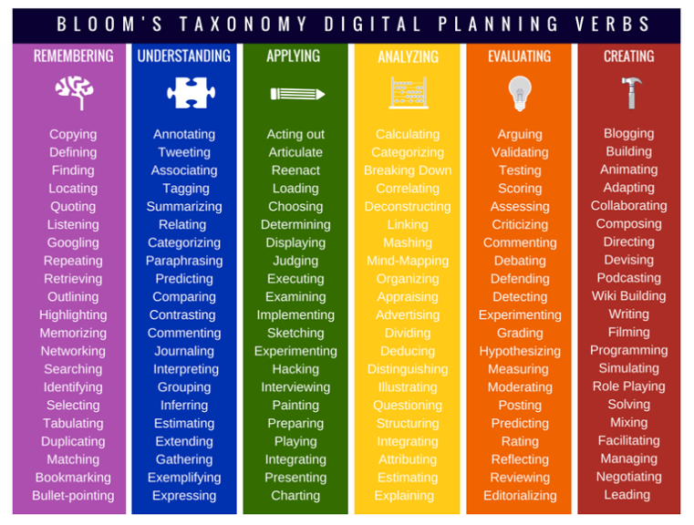
Figure 2: Bloom’s Taxonomy
(Source: Crompton et al. 2019)

2.3 Literature Gap
The literature has shared a vast gap due to irrelevance of data as the data available in past developed research has not mentioned the corresponding effect and they are not aligned in strategic order. Moreover, technology is changing at a rapid rate and the study from the past research and books are ineffective to draw a clear and to the point conclusion based on that.

Chapter 3: Methodology

3.0 Research Onion
Stages are compared with each petal of the onion and as the petal opens the core part can be observed. Based on the same aspect, research onion states about the stages to be passed through by researchers to meet the required conclusion (Snyder, 2019). In this study, the researcher has induced positivism philosophy and has included a deductive approach for analysing VLE system impact on the student learning process. Apart from that secondary and primary analysis based on qualitative and quantitative data will be done in this study. The data collection will be done through a survey process on the students of Wales University, London campus.

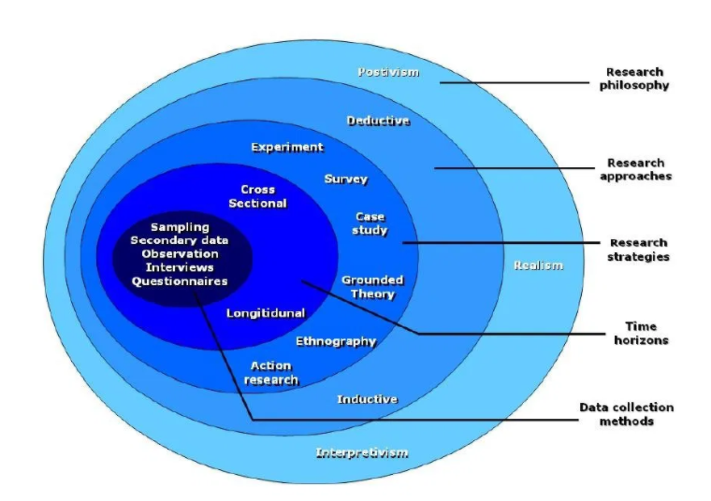
Figure 3: Research Onion
(Source: Snyder, 2019)

3.1 Research process
Process of identifying and locating as well as accessing along with analysing the information that is required to support the research format is the research process. In this study of VLE system impact on student learning questions will be developed for the survey process which is open ended and based on that the data will be collected from the student and analysed to gain the conclusion.

3.2 Research Philosophy
The study of VLE system impact on the learning process of students in University of Wales, London campus has included the positivism philosophy that has integrated a strategic study process. Positivism philosophy has integrated to develop strong hypotheses for developing the empirical experimentation on the current study topic (Chu and Ke, 2017).

3.3 Research methods
Methods are the process of susceptible handling of data incoming. As per Mohajan (2018), research methods can be experiments and surveys as well as questionnaires and many more. In this study the VLE impact on the student learning process has incorporated the survey method as the research process or method. This method has been deployed on the students of Wales University to bring out the core correspondence and the prospective venture of the study.

3.4 Data collection
Process of collecting data from the specified population is stated to be the data collection method. In this study collection of data is developed through incorporation of qualitative and quantitative method (Attia and Edge, 2017). The qualitative data collection is done from books and journals as well as research articles. On the other hand, quantitative data collection is done through survey methods.

3.5 Sampling technique and size
The sampling technique that has been incorporated in this study is the non-probability sampling and the sample size as induced in this study is 35. The study is going to survey 35 students of University of Wales, London Campus.

Chapter 4: Data collection

4.0 Graphs and Tables
Question 1: Do you agree with the point that virtual learning has asserted an important perspective to the current learning process?

 | Response | Percentage of response (%) | Total response
Strongly Agree | 2 | 6 | 35
Agree | 22 | 63 | 35
Neutral | 1 | 3 | 35
Disagree | 6 | 17 | 35
Strongly disagree | 4 | 11 | 35
Table 1: Importance of Virtual learning in the present learning process
(Source: Created by the researcher)
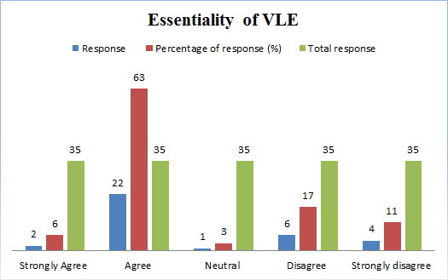
Figure 4: Importance of Virtual learning in the present learning process
(Source: Created by the researcher)
Question 2: Is accessibility and inclusivity act as the core beneficiary aspects to students?

 | Response | Percentage of response (%) | Total Response
Yes | 29 | 83 | 35
No | 6 | 17 | 35

Table 2: Benefits of Virtual Learning environment
(Source: Created by the researcher)
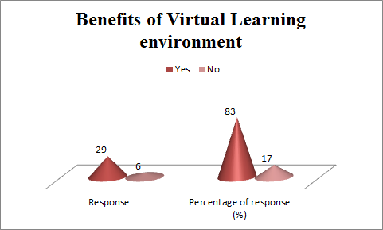
Figure 5: Benefits of Virtual learning environment
(Source: Created by researcher)
Question 3: Is it true that the VLE system has both positive and negative impacts on the learning process?

 | Response | Percentage of response (%) | Total Response
Yes | 30 | 86 | 35
No | 5 | 14 | 35
Table 3: Impact of VLE system on the learning process
(Source: Created by the researcher)
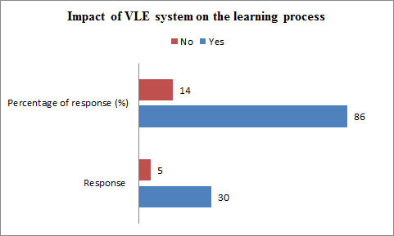
Figure 6: Impact of VLE system on the learning process
(Source: Created by researcher)
Question 4: Do you think that setting daily study goals can make the VLE system sustainable in nature?

 | Response | Percentage of response | Total response
Strongly Agree | 8 | 23 | 35
Agree | 16 | 46 | 35
Neutral | 1 | 3 | 35
Disagree | 6 | 17 | 35
Strongly disagree | 4 | 11 | 35

Table 4: Setting of study goals is the sustaining approach of VLE system
(Source: Created by the researcher)
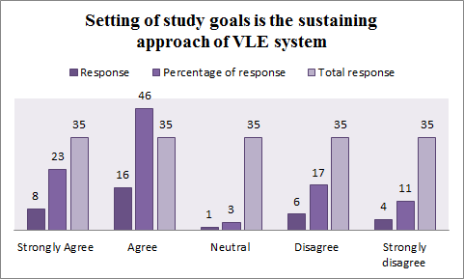
Figure 7: Setting of study goals is the sustaining approach of VLE system
(Source: Created by researcher)

4.1 Interpretation
Virtual learning environment has a coordinated base and has integrated a suitable approach which can mediate and build a strong field for students to develop in their learning process. As opined by Kimiloglu et al. (2017), VLE system is the perspective phase of coordinated and integrated systems that can build a system of current source of action which stated to poses serious impact on the performance of the students. It laid fast integrated process which exceeded the time of study and learning process and thus lay positive role for the student to gain much more time to spend on study. Besides that VLE as surveyed from the student can be stated to lay negative impact as it posed serious issue to the communication and less active to the community which makes the student to be less social. This is the societal impact of VLE in the current learning process for the students. Apart from that most of the respondent stated that accessibility and inclusivity are the core beneficiary aspect for VLE users. Therefore the fast and integrated study with effective development of students with easy learning process has developed interest among student that pose positive feedback for the colleges and institute to engage more students those who are unable to attain classes physically. In addition to that students of Wales University, London campus also replied that the VLE system has both positive and negative facts as it is highly effective for management while it is effective for cost and the time saving prospectus (Gon and Rawekar, 2017). There are various aspects that can meet the requirement of establishing the sustainable VLE system for the organisation. Thus, it can be stated that the setting of the study goals can be an effective venture and can pose serious positive impact as per student for reliable establishment of a virtual learning environment.

Chapter 5: Conclusion and Recommendation

5.0 Conclusion
VLE system is the integrated technology for the current learning process. This particular platform has boosted the academic performance of the students and has relatively laid sustainable study format. But, this particular technology shares negative virtues such as shares maximum time and is not cost effective. Besides, that though it provides high accessibility but shares negative impact due to lack of communication within the system. Thus, it can be stated that the whole system VLE can include the best approach and lay both a positive and negative impact on the students' learning process.

5.1 Recommendation
In the current era of technology rapid growth and effective growth are the two provisions that need to be integrated and to build such a prospectus VLE system need to be incorporated in the educational section. For effective VLE systems students can get benefited such as development of a supportive learning culture with a prospectus that meets the needs of the learner. Besides that keeping the system to be vented with positive establishment and deployment of instant feedback along with usage of the features of the VLE system can be the reliable factor that meets the requirement and establishes a suitable VLE system for the students. Thus, these are the core aspects that need to be maintained for establishment of effective VLE system.

Reference List
Attia, M. and Edge, J., (2017). Be (com) ing a reflexive researcher: A developmental approach to research methodology. Open Review of Educational Research, 4(1), pp.33-45.
Bogusevschi, D., Muntean, C. and Muntean, G.M., (2020). Teaching and Learning Physics using 3D Virtual Learning Environment: A Case Study of Combined Virtual Reality and Virtual Laboratory in Secondary School. Journal of Computers in Mathematics and Science Teaching, 39(1), pp.5-18.
Chu, H. and Ke, Q., (2017). Research methods: What's in the name?. Library & Information Science Research, 39(4), pp.284-294.
Crompton, H., Burke, D. and Lin, Y.C., (2019). Mobile learning and student cognition: A systematic review of PK‐12 research using Bloom’s Taxonomy. British Journal of Educational Technology, 50(2), pp.684-701.
Gon, S. and Rawekar, A., (2017). Effectivity of e-learning through WhatsApp as a teaching learning tool. MVP Journal of Medical Science, 4(1), pp.19-25.
Kimiloglu, H., Ozturan, M. and Kutlu, B., (2017). Perceptions about and attitude toward the usage of e-learning in corporate training. Computers in Human Behavior, 72, pp.339-349.
Larmuseau, C., Evens, M., Elen, J., Van Den Noortgate, W., Desmet, P. and Depaepe, F., (2018). The relationship between acceptance, actual Use of a virtual learning environment and performance: An ecological approach. Journal of Computers in Education, 5(1), pp.95-111.
Mohajan, H.K., (2018). Qualitative research methodology in social sciences and related subjects. Journal of Economic Development, Environment and People, 7(1), pp.23-48.
Phungsuk, R., Viriyavejakul, C. and Ratanaolarn, T., (2017). Development of a problem-based learning model via a virtual learning environment. Kasetsart Journal of Social Sciences, 38(3), pp.297-306.
Pletz, C. and Zinn, B., (2020). Evaluation of an immersive virtual learning environment for operator training in mechanical and plant engineering using video analysis. British Journal of Educational Technology, 51(6), pp.2159-2179.
Snyder, H., (2019). Literature review as a research methodology: An overview and guidelines. Journal of Business Research, 104, pp.333-339.
Yang, D., Alsadoon, A., Prasad, P.C., Singh, A.K. and Elchouemi, A., (2018). An emotion recognition model based on facial recognition in virtual learning environment. Procedia Computer Science, 125, pp.2-10.

