
Skills for the Workplace
Module Assignment Submission
Student Name: | Gareth Thomas
Student Number: | 2011839
Module No: | BMSK4004
Module Title: | Problem Solving and Decision Making

Statement of Confirmation of Authenticity
By the act of making this submission, the student declares that this is the work of the student named above. The work has not, in whole or in part, been knowingly presented elsewhere for assessment, or where assessment has been built on a previous assessment, this has been identified. Where materials have been used from other sources it has been properly acknowledged. If this statement is untrue, the student acknowledges that an assessment offence has been committed.
Attention is drawn to the plagiarism and unfair practice policies of UWTSD.

Table of Contents
Problem. 4
Description. 4
Scope 4
Impact 4
Nature of problem 5
Idea generation 5
Brainstorming 5
Brainstorming diagram 7
Root cause 9
Ishikawa diagram 9
The 5 W’s 10
THE 5 WHYs 11
Solutions 11
Decision making 11
Grid Analysis 11
Weighted grid analysis 12
What is Parim? 13
S.W.O.T Analysis on Parim. 14
Annual cost analysis of the Parim system 15
Cost benefit analysis 16
Annual Benefit to Cost Ratio. 16
Plan Implementation 17
Smart Objective 17
Gantt chart. 18
Stakeholders 19
Stakeholders versus shareholders 19
Stakeholder Mapping 20
Stakeholder mapping 21
A Stakeholder Map 21
Monitoring 22
Run trend chart 22
Flow charts 22
Formal meetings 22
Informal meeting 22
One to one 22
Monitoring Progress 23
Run/trend chart 23
Run trend chart 23
Communication 23
Communication plan 24
Conclusion. 25
References 26
Appendix 1 28
Appendix 2 28
Appendix 3 29
Appendix 4 29
Appendix 5 30
Appendix 6 30

Problem.

Description.
This is an historic problem, that arose within the company who I am employed by and during this assignment the reader will be guided through the process of identifying the problem using helpful tools all the way through to monitoring the plan, and all the stages in between.
Approximately 18 months ago a member of office staff left, he was the person assigned to deal with the time sheets and in turn the wages. This is the example of the problem that the assignment will be dealing with.
He was not the most professional at his job, and there were always wages that were wrong and people being owed money, it was happening so often it became a problem, but after he left the company, it created another problem, which was almost as bad as the first and this was who or what was going to deal with the time sheets.
Initially the Human Resources staff were allocated this as a new role, but after a three-monthly review although the wages were now correct, the extra workload on the H.R. department meant that their roles were being compromised due to being distracted by the timesheets and wages. During the review the lady responsible for the HR department said she would need more hours in which to complete this role as well as her own, and as she was only part time it would not be feasible for her to do but did mention training someone or even employing a person to do this.
This left the company with a problem as defined by Oxford Languages (n.d.) as,
“a matter or situation regarded as unwelcome or harmful and needing to be dealt with and overcome.”
A problem will bring along other problems associated with the initial problem, these include scope and impact.

Scope
In this instance the scope of the problem had far reaching implications on the effective running of the company and its cash flow and finances, and the payroll structure as a whole which was now compromised.
This in turn would affect all employees and clients

Impact
The impact it had on the employees was that numerous employees left the company and found employment elsewhere often with competitor companies, they were concerned with the unrest with the wages situation as they had been promised that when the employee left, things would be more regulated, and a new improved system would be put into place.
Another impact was that of morale amongst remaining employees, some of whom had already informed management that they would not be doing any overtime, due to the fact that if their wages were not correct, they would now be refusing any overtime that was offered.
If the employees were refusing to do any overtime to cover people who had already left the company because of the problem, this left a shortfall of staff to cover their shifts which in turn meant that the company found difficulty in fulfilling their contractual obligations to the client and ended up with the company turning down a number of lucrative contracts due to lack of manpower.

Nature of problem
The nature of the problems stemmed from an administration issue that had a knock-on effect to other problems, so once the nature of the problem had been diagnosed, it transpired that by solving the administrative problems within the company, there would be non-financial benefits and financial benefits.
The main benefit would be that staff were paid correctly, this would increase staff morale and make them more acceptable to do any overtime, this in turn would create a retention of staff who would rather stay within the company,
This would in turn enable the management to tender for new contracts as they would now have personnel to fill the roles, this would increase profitability for the company.

Idea generation

Brainstorming
The management then called a meeting and invited all employees to attend, in order to try and rectify the issue during the meeting they initiated a BRAINSTORMING meeting Osborn, A.F. (1953) which is
“a group problem-solving technique that involves the spontaneous contribution of ideas from all members of the group conducted several brainstorming sessions also: the mulling over of ideas by one or more individuals in an attempt to devise or find a solution to a problem “…as defined by Webster, M. (2019).
Another definition is
Brainstorming is a method used within a team in order to come up with ideas to solve clearly defined problems.
In controlled conditions and a free-thinking environment, teams approach a problem by such means as “How Might We” questions.
They produce a vast array of ideas and draw links between them to find potential solutions.
“Brainstorming is a paradigm-preserving approach to creative problem solving that enables us to gain insights into problems that otherwise we might overlook. It enables us to bring to mind those other solutions that somehow always seem to evade us when we most need them.” Proctor, T. (2006).
This is a tool that can be used but there are guidelines to follow in order to make it an effective tool.
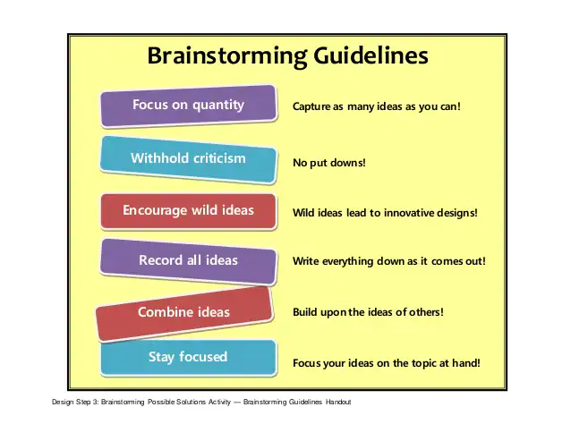
(Shelly Wilke, 2016)

Brainstorming diagram

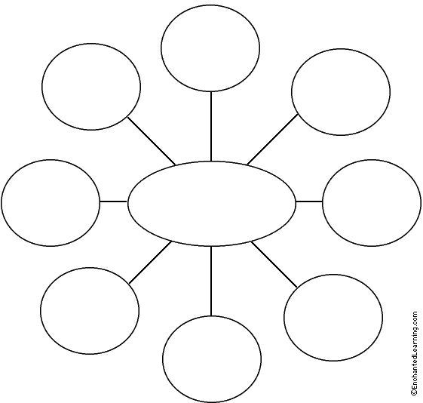
All go self-employed and paid on invoice
Paid directly by client

Outsourcing to a 3rd party company

Paid cash
Get paid weekly

Get a robot to do wages

Fill in our own timesheets

Employ somebody competent
Problem:
Wage Discrepancies

Once the ideas above had been generated, they were put into a table and the pros and cons were highlighted

Employ somebody competent: -
Yes, it would be an advantage but would have a financial cost and the downside of this would be that they would need training in the role and whilst training the same problem may arise.
Fill in our own timesheets: -
This would be good for employees, but the company would still need somebody to generate the wages and to check their timesheets cost implications

Get a robot to do the wages: -
This sounds stupid but could there be an application the company could use
Get paid weekly: -
Somebody would still need to generate the wages and the problem would still exist and as the company are paid on invoice it would not be a viable option
Get paid cash: -
This would not be viable as somebody would still need to generate the wages to be paid and also has legal implications.
Outsourcing to a 3rd party: -
Cost implications
All go self-employed: -
This would be of no use to employees as a few have mortgages etc and to do this all employees would have to be made redundant from their existing contracts and this has a financial cost
Paid directly by client: -
As employees work on numerous sites this would be hard to keep track of but if it was kept track of somebody would need to check and this would create a cost

After analysing the brainstorming meeting there only seemed one option that was viable and that was to get a robot to do the wages, this is not as silly as it first appears, and although the person said it jokingly, after some discussion it was decided the company would look into a suitable application.
After scouring the internet looking for suitable applications and working systems the team found four appropriate apps, although they all had their own merits and were suitable to assist in solving the problem, the team now had another problem and that was which application should be used by the company.
This now became a decision-making problem but with the various tools at their disposal it became an easier process.
But firstly, the team needed to define the root cause of the problem.

Root cause

Ishikawa diagram
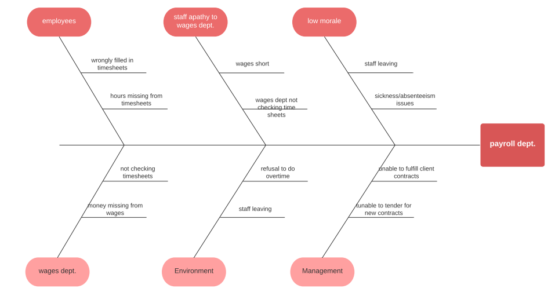
Kaoru Ishikawa (1989).
There are various tools to help identify the root cause of a problem above is Ishikawa diagram that the team feel is a better tool for the problem at hand.
But there are also others for example the 5 W’s and the 5 WHYS.

The 5 W’s

This is a method of asking relevant questions about a problem taken up for improvement. ... The last W (why) is often asked five times so that one can drill down to get to the core of a problem.
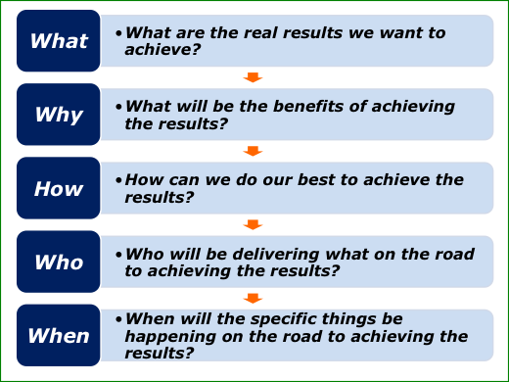
(The Positive Encourager, n.d.)

THE 5 WHYs
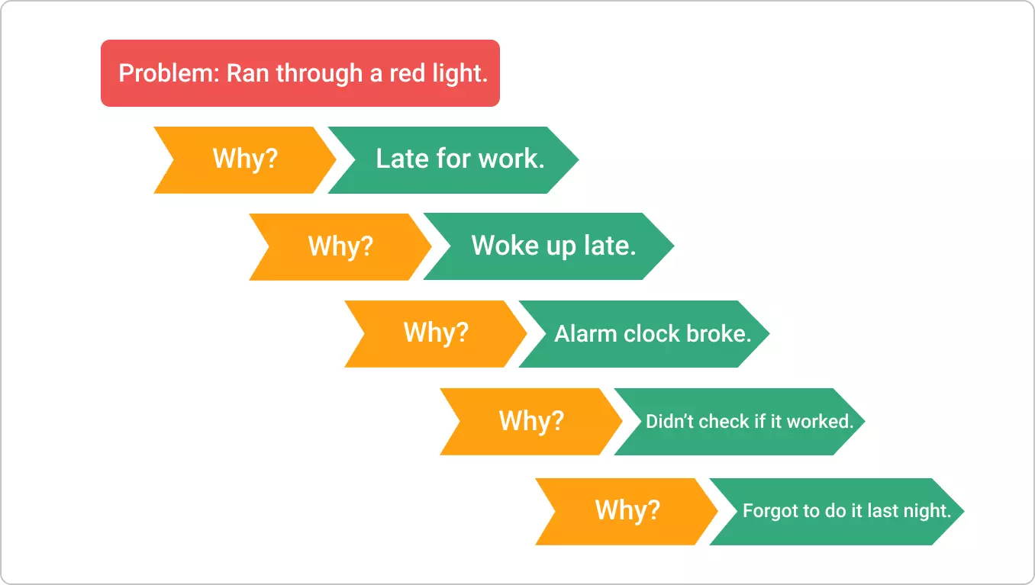
Kanbanize (2021).

Solutions

Decision making
In order for the team to make an informed decision there are numerous tools at our disposal that can help, some of these tools will be used to help the team solve the problem at hand in a professional and matter of fact manner, and in a way that it can be shown to stake holders, so it makes sense on paper rather than by way of discussion.

Grid Analysis
The main benefit of using Grid Analysis for decision making and idea evaluation is to make the process more objective. By using a concrete set of criteria with distinct weights, the decision-maker can inject a certain amount of rationality in the process and, subsequently, more easily justify their decision to others if needed.
The applications sourced were
Deputy – https://www.deputy.com/ (Appendix 1)
Parim - https://parim.co/ (Appendix 2)
TimeGate - https://teamsoftware.com/en-gb/software/timegate/ (Appendix 3)
Bitrix24 - https://www.bitrix24.com/ (Appendix 4)
BambooHR – https://www.bamboohr.com/ (Appendix 5)
The way in which we decided which one would be the best option for the company was to use a (weighted) Grid Analysis.
Grid analysis (also known as Decision Matrix, Pugh Decision Matrix, Weighted Scorecard and others) is a framework for evaluating ideas and making decisions which uses a set of weighted criteria to rank the ideas. ... Each criteria, in turn, is weighted according to its importance to the decision-maker. As defined by Kalinchenko, D. (2021).
One of the biggest advantages of using a Grid Analysis for decision making is to ensure the process is more objective.
And by using a concrete set of criteria with distinct weights, the decision-maker can insert an amount of rationality into the decision-making process and therefore make it easie to justify the decision stakeholders and management, if required.
Factors | Cost | G.P.S Location of Clock In/Out | Employee Directory | User Friendliness | Bolt-on’s / Features | Time Management | Total
to | 10 | 10 | 10 | 10 | 10 | 10
BambooHR | 3 | 3 | 6 | 4 | 7 | 5 | 280
Parim | 8 | 8 | 9 | 7 | 9 | 9 | 500
TimeGate | 5 | 6 | 9 | 8 | 5 | 7 | 400
Bitrix24 | 2 | 1 | 6 | 3 | 8 | 2 | 220
Deputy | 7 | 5 | 5 | 6 | 3 | 8 | 340

Weighted grid analysis

Key
1 2 3 4 5 6 7 8 9 10
Poor Average Good

The team all had their favoured applications and as they all had their own redeeming features or pros and cons, it was decided to create a Grid Analysis and discover an outright winner.

What is Parim?
Parim was the most effective application for the needs of the company with the highest mark on the grid analysis.
The benefits of the Parim app were that it was user friendly, for both management and the employees, and all shifts covered the previous day could be authorised by management which only takes at most 5 minutes to complete. At first the office manager and the owner decided to complete this task themselves, but after a week it was decided that the supervisor could authorise the previous days shifts, and as they were already being paid there was no extra expenditure.
It was also decided that the supervisors would also train the staff in how to use the application as part of their duties. But it would be sent off to the already outsourced payroll and HR. dept. (MOOREPAY HR https://www.moorepay.co.uk/(Appendix 6)) and as the company were already using Moorepay there was no extra expense to the plan. Which once a month was sent off to them to generate the wages and would only take the manager 15 minutes to complete and send off.
The only cost Parim would incur would be the rental of the application.

S.W.O.T Analysis on Parim.

STRENGTHS WEAKNESSES
Money saving  Time saving  More efficient  User friendly  Free updates on technology  Mobile phone friendly  Easy to populate  GPS location  Emails sent to employees directly from app  Personalised online schedule  Multiple control accounts (5)  Able to customise app to suit business needs | Relies on internet coverage  Requires smartphone technology  Needs resyncing regularly
Bolt-on’s available  Ability to see available shifts  Ability to apply for available shifts | Operator error  No internet coverage
OPPORTUNITIES THREATS
The Parim applications advantages are that it gives part-ownership of a person’s individual wages to the employee themselves along with the HR department, as they have the app on their phone, and they have to sign into it at the start of their shift and sign out at the end of the shift and the HR department authorises the shift.
So as long as the employee signs in and out correctly and hr authorise shifts daily and send off figures monthly there should be no discrepancies, although HR have the ability to make amendments if the employee has forgotten to sign in.
It can also prepopulate the rotas for specific sites where contracted staff are assigned to, and if there is a gap in the rota the management will put up available shifts for other employees to apply for, if there is still a shift that needs to be covered then management will then ring staff to check their availability.

Annual cost analysis of the Parim system
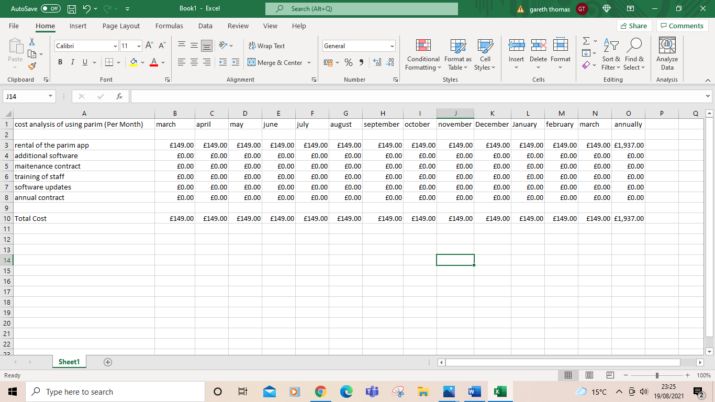

The rental package that the team decided to use was the Professional Package which includes unlimited numbers of users but is limited to up to 4000 hours for all users per month.
The main reason that Parim was selected was its user-friendly attributes.
And the package selected incorporates any additional software updates, and an ongoing maintenance contract, and as it is a rolling contract there is no annual contract to subscribe to.
There is an advantage to the system where there are add on features which may be of use at a later stage although these addons will incur a cost.

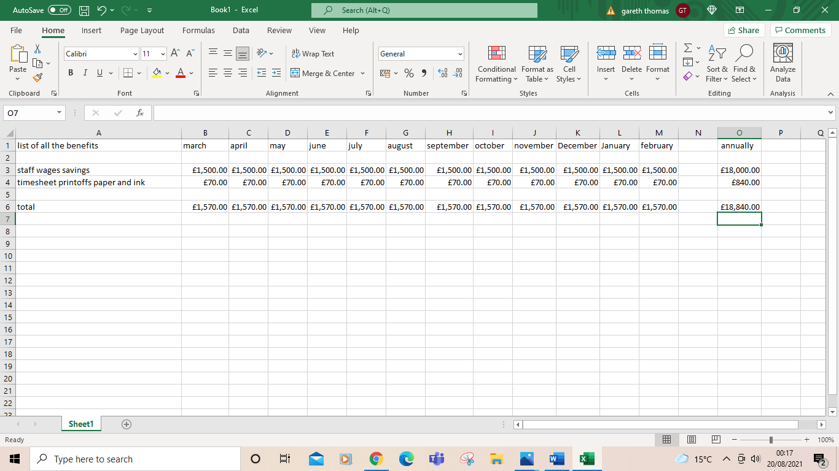
Cost benefit analysis

The main benefit/saving is the wages of the person who used to do the timesheets and the employee’s hours in order to generate the wages which was £18,000.00 per annum which equates to £346.15 per 35-hour week which is £9.89 per hour, which is just above minimum wage.
It also takes into account the ink and paper used to print off the timesheets (called white sheets by employees). they were always printed off but not sent to employees unless requested but were kept in files as a record of employees working hours and referred to in case of queries by employees.

Annual Benefit to Cost Ratio.

Annual Benefit to cost ratio = total benefits = 18,840 = 9.72:1
Total costs 1,937

Net monthly benefit= monthly benefit - monthly cost = annual monthly cost
1,570 – 149 = 1,421
In order to turn the monthly benefit into an annual benefit x 12
Annual benefit = 17,052

The figures show the annual benefit to cost ratio, and the net monthly and net annual benefit, the reason for this is that the management wanted to trial Parim as an option for 12 months, in order to monitor its progress, with management as they are the people who populate the system and the employees as they are the ones who use it.

Plan Implementation

Smart Objective

Specific. | The goal is to set up a workforce organisational application called Parim in order to enable employees to sign on/off shift and apply for shifts digitally,  And to also minimise wages queries as Parim will generate employee personal timesheets.
Measurable. | It can be measured by lack of wages queries per month with use of such tools as a run flow chart or other such tools.
Achievable. | The objective is achievable and needs to be monitored regularly and adjustments made if nescessary to keep the plan on track.
Relevant. | This goal is being set in order to save the company money and to enable both staff and employers to be responsible for their own timesheets.
Timed. | This will be a 12-month project but will be monitored on a month-by-month basis although results should be noticed within the first 2 months (this will be a training period for staff) although spikes are expected during the summer months as part time staff are employed for festivals and won’t be familiar with the system at first.
Doran, G. (1981).

An objective is a statement which describes what an individual, team or organisation is hoping to achieve. ... Objectives are 'SMART' if they are specific, measurable, achievable, (sometimes agreed), realistic (or relevant) and time-bound, (or timely). (Managers.org.uk, 2019).

Gantt chart.
A Gantt chart is a;
“Project management timelines and tasks are converted into a horizontal bar chart, showing start and end dates, as well as dependencies, scheduling and deadlines, including how much of the task is completed per stage and who is the task owner.”
(APM, 2019)

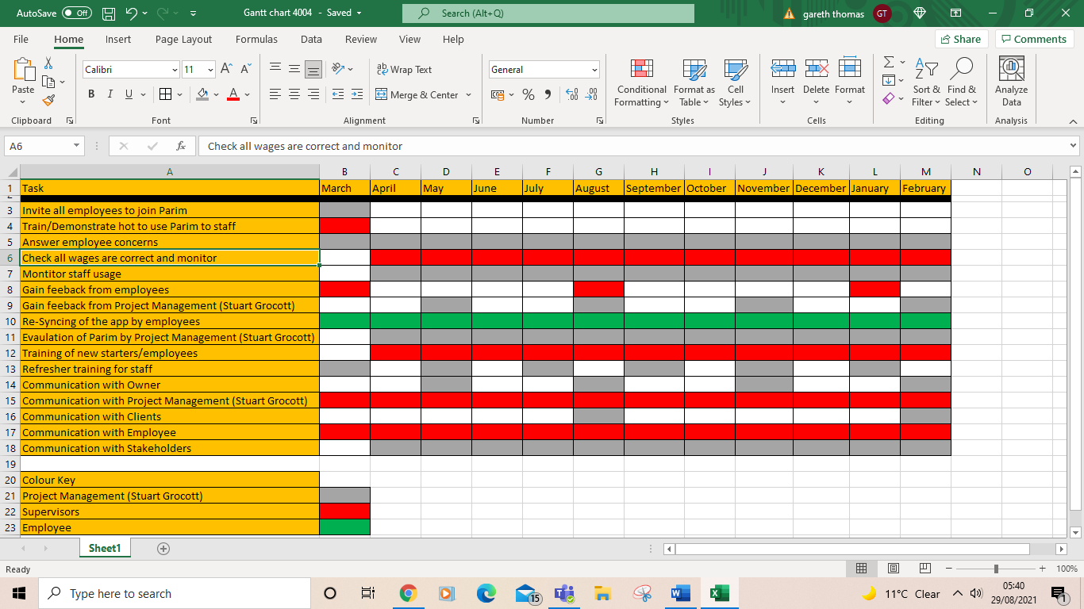
Above is a Gantt chart and it is used in the implementation stage of the plan
The Gantt chart is a popular project management tool that provides visual of what needs to be done and when.
Gantt charts are excellent for tracking project schedules because they help you see interdependencies between tasks and who is responsible for each task.

Stakeholders

Stakeholders versus shareholders
Some mistakenly believe that the words “stakeholder” and “shareholder” are interchangeable. But the involvement and the investment of a stakeholder and shareholder in a company/business differ greatly.
Due to a shareholder having a financial interest (due to a monetary investment also known as a share) in the company this will mean that they also have a stake in the company/business, which means that they are also a stakeholder.
A shareholder is always a stakeholder, but a stakeholder is not always a shareholder.
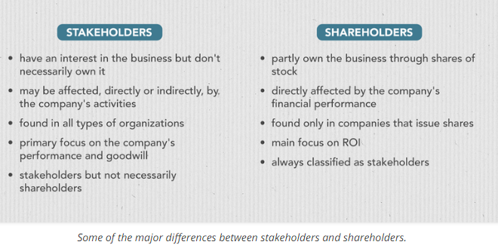
PlaybookUX. (n.d.).
A Stakeholder is defined
“a person with an interest or concern in something, especially a business.”
Fernando J, (2021)
A Shareholder is defined as,
“A shareholder, also referred to as a stockholder, is a person, company, or institution that owns at least one share of a company’ stock which is known as equity. Because shareholders are essentially owners in a company, they reap the benefits of a business’ success…….”
Hayes. (2020).
A stakeholder is a person or entity that has an interest in the companies / success/failure.
A stakeholder can be affected or even affect the companies’ policies or objectives
There are 2 main types of stakeholders. They can be either internal stakeholder, or these stakeholders have a direct relationship within the company/business either by being an:
- employee,
- the owner,
- management,
- shareholder.
External stake holders are usually 3rd parties who do not have a direct relationship with the company but are likely to be affected by the actions of the company/business an example of external stakeholders is:
- Investors/banks
- Suppliers
- Customers /clients
- Creditors
- Employees families
Although stakeholders fall into two categories, they can all feel the impact in some way or another by varying degrees of scope and impact.
An example:
- A company who downsizes
- It needs less materials
- The suppliers sell less materials
- The supplier is impacted
- But it may mean the supplier needs to also downsize and lay staff off, which is the scope.

Stakeholder Mapping
Now that the stakeholders have been identified, in order to communicate effectively the team, need to follow a formula in order to decide
- Who needs the information?
- What information they need?
- Why they need that information?
When they need that information, and how best are we going to communicate, and how to deliver that information to them, and in what medium,
i.e., email /letter/newsletter/one to one/briefings/noticeboards etc.
A tool used to decide who gets what information, how much, and how often is holders in an effective on their power and influence within the company, and a way to decide this is by using a stakeholder map.

Stakeholder mapping
Stakeholder mapping allows a team to understand how the team can communicate and inform stakeholder holders in an effective manner.
Stakeholder mapping can be used at the start of a new project to organise the communication process and are helpful when a project consists of different groups of people with varying degrees of power and interest.

A Stakeholder Map

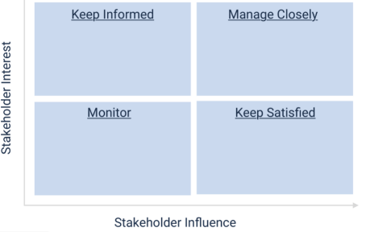
Clients

Shareholders
Employees
Stakeholders

Owner

Mitchell. et al. (1997)
In order for the team to populate this map correctly there a few ground rules to follow:
- Manage closely
This needs to be populated by high power and highly interested people.
- Keep satisfied
This needs to be populated with high power less interested people.
- Keep informed
Needs to be populated with low power but highly interested people.
- Monitor
Populated by people with less power and less interest.

Monitoring
Now that the team has identified a problem, sought out solutions using various tools at their disposal, and identified stakeholders and a way to communicate effectively with them, the next stage in the process is to monitor and evaluate their chosen solution to the problem.
Again, they have tools at their disposal in order to monitor and keep things on course for them to have a favourable outcome.
Here is a list of some of the tools that they can use.

Run trend chart
They assist improvement teams to work out the aims by depicting how well/poorly a project is performing. And help in determining when changes are beneficial by showing a pattern of data that can observed as changes are made.

Flow charts
It helps to clarify processes, steps that do not add any value and also identifies.

Formal meetings
A formal meeting is a pre-planned meeting of at least 2 people who have gathered with the aims of achieving a common goal through verbal interaction. Formal meetings are typically led by a chairperson with the discussions and agreements recorded in a written form known as minutes. And also have an agenda and has a chairperson in control of the meeting.

Informal meeting
An informal meeting is a meeting which is less heavily planned and regulated than a formal business meeting, and as such doesn’t have any of the defining features of a formal business meeting, such as minutes, a chairperson and a set agenda.

One to one
a meeting between two people in an organization – typically a manager and an employee. It’s used to give feedback, keep each other in the loop, and resolve issues.

Monitoring Progress

Run/trend chart

At the time of the implementation of the Parim application there are 100 employees all of whom average 35 to 40 hours per month will be using the system, but from May to September the workforce will increase, with subcontractors and part time staff to being employed to cover the festival season, these employees will also be using the system.

Run trend chart
The reason why the team picked this method to monitor the plan is so that it can be read at a glance and the employee Wage discrepancies can be seen and any rise can be dealt with immediately. And as there is a month between paydays this acts as a built-in buffer.
As Parim was rolled out January, the figures for February climbed slightly, but after investigation it turned out that certain members of staff needed more instruction on how to use the application.
The graph shows a steady decline until June when it spiked again, the reason for this was an influx of temporary staff, to work at festivals.
As the temporary staff familiarised themselves with the system, the spike started to drop, and by September it was negligible.

Communication
To help the communication process and to keep everybody informed we will refer back to the stakeholder analysis in order to give the right people the right amount of information in a medium that best serves them. A tool that assists the team is a communication plan.

Communication plan
Project title | Parim
Project manager | Stuart Grocott
Executive sponsor | Safestyle Security
Principal stakeholder | Darren Edwards
Date | 28/08/2021

Deliverable info  (what) | Recipients  (who) | Delivery method  (how) | Schedule  (when) | Who’s responsible  (owner)
Project info | Owner  Management  Shareholders  Employees | Formal meetings  Emails  Briefings  One to one (as required). | Before project commences | Stuart Grocott
Project status | Stuart Grocott  Supervisors | Formal meetings  briefings | As needed | Stuart Grocott
Timeline update | Owner  Management  Supervisors  Stakeholders | Newsletter  Email  Briefings  One to one | Monthly | Stuart Grocott  Supervisors
Project updates.  Action item status. | Shareholders  Supervisors | Formal meetings  Emails  One to ones  briefings | 5th of the month | Stuart Grocott
Project risks | Employees  Owner  Shareholders | Formal Meeting | As needed | Stuart Grocott

A communication plan is a plan that assigns a task to an individual or groups in order to allow the groups or individuals to identify their roles and timings within the project.
This outlines the objectives and scope of the project and serves as an official point of reference for the project team, larger company, and stakeholders.

Conclusion.
The problem was brought to a satisfactory conclusion using effective methods and tools at the team’s disposal.
Although the issue was resolved it will still need to be monitored regularly by the tools already in place, and if changes occur, the strategies in place will need to be adapted accordingly.
The company is more than happy with the outcome as employees are now being paid correctly, but more importantly they are happy with the financial savings they have made throughout the 12-month trial period as highlighted in the cost benefit analysis, so much so that they have kept the system in place but are still looking to improve on the Parim system currently in use.
The process used in solving this problem is the way that the company deal with all other issues that arise.

References
APM (2019). What is a Gantt chart? | APM. [online] Apm.org.uk. Available at: https://www.apm.org.uk/resources/find-a-resource/gantt-chart/.
Doran, G. (1981). There’s a SMART Way to Write Management’s Goals and Objectives. Management Review (Saranac Lake, New York), 70, 35–36.–.
Fernando, J. (2021). Stakeholder. [online] Investopedia. Available at: https://www.investopedia.com/terms/s/stakeholder.asp.
Hayes, A. (2020). Shareholder. [online] Investopedia. Available at: https://www.investopedia.com/terms/s/shareholder.asp.
Kalinchenko, D. (2021). How to Use Grid Analysis for Idea Evaluation - Rationalize.io. [online] rationalize.io. Available at: https://rationalize.io/2021/03/09/using-grid-analysis-for-idea-evaluation/ [Accessed 13 Aug. 2021].
https://parim.co/ (Date Accessed – 31/08/2021)
https://teamsoftware.com/en-gb/software/timegate/ (Date Accessed – 31/08/2021)
https://www.bamboohr.com/ (Date Accessed – 31/08/2021)
https://www.bitrix24.com/ (Date Accessed – 31/08/2021)
https://www.deputy.com/ (Date Accessed – 31/08/2021)
https://www.moorepay.co.uk/(Date Accessed – 31/08/2021)
Kanbanize (2021). 5 Whys: The Ultimate Root Cause Analysis Tool. [online] Kanban Software for Agile Project Management. Available at: https://kanbanize.com/lean-management/improvement/5-whys-analysis-tool.
Kaoru Ishikawa (1989). Introduction to quality control. S L.: Chapman-Hall.
Managers.org.uk. (2019). Management & Leadership. [online] Available at: https://www.managers.org.uk.
Mitchell, R. K., Agle, B. R., & Wood, D. J. (1997). Toward a Theory of Stakeholder Identification and Salience: Defining the Principle of Who and What Really Counts. The Academy of Management Review, 22(4), 853–886. https://doi.org/10.2307/259247
Osborn, A.F. (1953). A Manual of instruction for use in conjunction with the textbook Applied imagination, principles and procedures of creative thinking. New York: Scribner.
PlaybookUX. (n.d.). User Experience Templates You Can’t Ignore in 2020. [online] Available at: https://www.playbookux.com/user-experience-templates/.
Proctor, T. (2006). Creative problem solving for managers: developing skills for decision making and innovation. 2nd ed. London: Routledge.
Oxford Languages (n.d.). Oxford Languages and Google - English. [online] languages.oup.com. Available at: https://languages.oup.com/google-dictionary-en/ [Accessed 12 Aug. 2021].
Shelly Wilke (2016). Cub creative activity3_handout_v2_tedl_dwc. [online] Available at: https://www.slideshare.net/shellymulholland/cub-creative-activity3handoutv2tedldwc [Accessed 28 Aug. 2021].
The Positive Encourager. (n.d.). Slide02. [online] Available at: https://www.thepositiveencourager.global/l-accepting-leadership-package/slide02-64/ [Accessed 29 Aug. 2021]
Webster, M. (2019). Definition of BRAINSTORMING. [online] Merriam-webster.com. Available at: https://www.merriam-webster.com/dictionary/brainstorming [Accessed 12 Aug. 2021].
Work, Wages, and Profits: Their Influence on the Cost of Living. HL Gantt - 1910 - Engineering magazine


Appendix 1

Appendix 2


Appendix 3
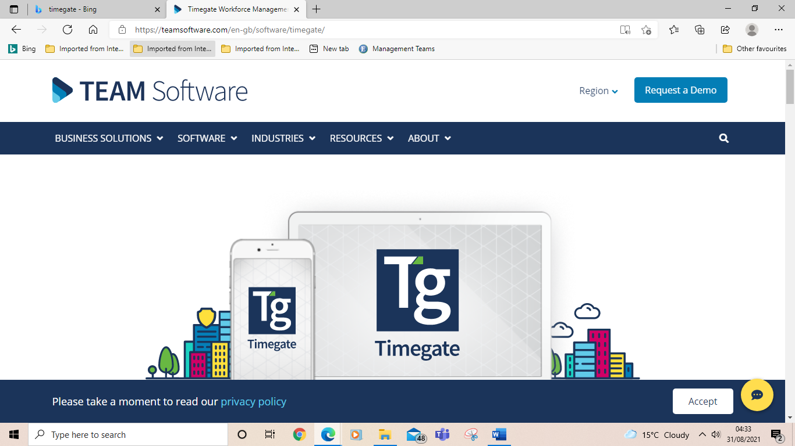

Appendix 4
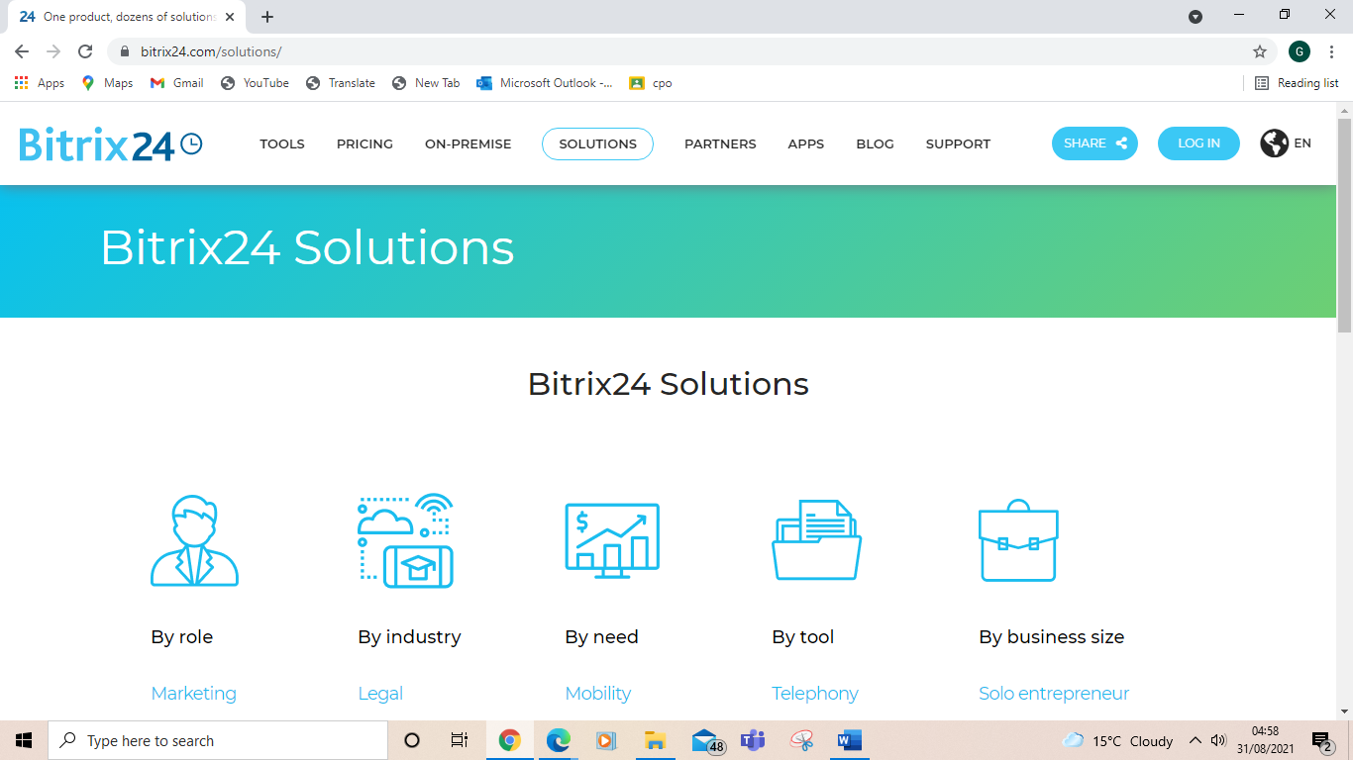

Appendix 5


Appendix 6


