Sandra Richards-Davies (1909084)
Project Management for Sustainability (BMSP6013) Assignment 1 April 2022 submitted day 7 post deadline
Question Provide a critical assessment of the usefulness of project management tools and techniques for managing a project. Seek to provide a good level of analysis of various approaches. You should demonstrate appropriate awareness of the ability to plan the implementation of a project and consider the management of appropriate stakeholders and of risk.

CONTENTS

Abstract
- Introduction
  - what is a project?
  - Project management and Manager

2 Strategy, tools, and techniques
2.1 Competency Framework
2.2 Methodologies / Tools and Techniques
Figure 1 PRINCE 2 Methodology in Project Management

3. Organizational culture
3.1 Stakeholders
4. Soft skills in project management
Figure 2 Some reasons for project failure
5. Conclusion
6. References

Abstract
Or consideration it would be deemed “common sense” that project management tools and techniques are essential for effective project management. “A project infers that diverse work activities are carried out for a finite period with one or more defined objectives (Turner and Muller, 2003)” (Moore, 2005).

The definition makes now reference to how the objectives will be met opening the questions to does it matter how the objective is met if it is met?

Thamhain (1999) conducted a study on project managers’ awareness about how to use PMTT “and found that project managers used only 28% of PMTT given in the study and more so they had only 50% basic knowledge about use of those tools. (Zaman, 2014 ).

Yet, Richard Morreale (2009) says that successful project management is a combination of approximately 20% hard skills and 80% soft skills (Morreale, 2009), so if project management focusses on working with stakeholders, does this mean that soft skills now rate more highly that academic knowledge?

- Introduction

This report aims to provide a critical assessment of the usefulness of project management tools and techniques for managing a project. Projects are undertaken at all levels in organisations, and it is generally accepted that the adequate use of project management means, and methodology will provide results.

Numerous difficult problems that businesses and other organisations face daily demands the application of modern management methods and disciplines for a more efficient functioning and productivity. It is suggested that the best-known project management methodologies are: “PMI, IPMA, APM, YUPMA, PRINCE 2, etc” (Berić, 2018).

This report will demonstrate an appropriate awareness of the ability to plan the implementation of a project and consider the management of appropriate stakeholders and soft skills in relation to project management. In conclusion the report will be approached with an objective ontological position relying on facts and informed opinions of theorists in the field to achieve a balanced conclusion.

1.2 What is a Project?

The Project Management Institute, 2017 defines a project as a “temporary endeavour undertaken to create a unique product, service or result” (Project Management Institute, 2017). Projects it would seem are undertaken to achieve goals by producing “deliverables” “A deliverable is defined as any unique and verifiable product, result, or capability to perform a service that is required to be produced to complete a process, phase, or project. Deliverables may be tangible or intangible” (Project Management Institute, 2017).

“A project infers that diverse work activities are carried out for a finite period with one or more defined objectives (Turner and Muller, 2003)” (Moore, 2005).

It is also of value to note that, project-based workplaces are considered to be places of short-term dealings and involvement and can be particularly challenging for the people charged with managing implementation and performance within them (Moore, 2005), An example historically, of the most established and largest project based industry would appear generically to be the construction industry.

  - Project Management and Manager

In the early 1990s project management was considered as managerial tool that helped businesses to attain corporate objectives” (Zaman, 2014 ).

Yet Today with the rapid expansion and global connection of business, project management is concerned with a much wider range of intervals and levels of complexity. It discourages the thinking and concern of projects as a business process, focusing instead on the technical or physical aspects of the work involved. “Projects today are a core business process for most organisations” (Maylor, 2001). Industries such as IT, management consultancy, product design and manufacture, are increasingly project-based.
Nonetheless, even in today's competitive environment implementation of project management is of paramount importance as project management is to deal successfully with increasing challenges of project complexity, customer requirements and risks, etc. yet the aim of the project is still to achieve the business objectives.
Implementation of project management is necessary in an efficient execution of various projects and enterprises. An expansion in enterprise management execution is closely linked to the expansion of knowledge in project management and training of competent enterprise managers.

On the other hand, knowledge expansion is in turn connected with procedures and methodologies planned in management practice” (Berić, 2018). There is a growing awareness within project-based sectors of the relationship between performance and managers competencies.

“The project management theory and practice have provided us with many practically applicable behavioural competencies and job-task competencies. The results reveal that while their job-task competencies are highly specific to the industry in which they work, the behavioural competencies of superior project managers are mostly generic in nature and apply to a range of other management positions” (Moore, 2005).
This is reiterated by Richard Morreale (2009) who says that successful project management is a combination of approximately 20% hard skills and 80% soft skills. The hard skills relate to the actual processes, procedures, tools, and techniques comprising planning, organising, monitoring, and controlling, while the soft skills relate to the project managers attitudes and behaviours (Morreale, 2009).
- Strategy, tools, and techniques

Porter (1991) said “strategy is the act of aligning a company and its environment. That environment, as well as the firm`s own capabilities, are subject to change. Thus, the task of strategy is to maintain a dynamic, not a static balance” (Albana Berisha Qehaja, 2017). Buttrick (2000) focusses his emphasis on strategy and the role of Strategy analysis of a project failure shows that the lack of a clear strategy is a root cause of failure. Buttrick (2000) went on to say that more than 80 per cent of all problems at the project level are caused by failures at a board level in firms to provide clear policy and priorities. (Maylor, 2001).

2.1 Competency frameworks
Project managers being given a clear competency framework to inform them of the organisation’s expectations can assist the project manager to contribute more effectively to their personal development by enabling understanding of effective performance requirements for the project. Competency frameworks can be used to underpin performance management and development functions (Brophy and Kiely, 2002). (Moore, 2005).
This approach views competencies as either the behaviour enabling people to carry out their task, or the underlying characteristics of a person that result in superior performance (Mansfield, 1999). Competency is therefore concerned with generic underlying characteristics (‘behavioural competencies’).
2.2 Methodologies / Tools and Techniques

Literature suggests that the project management methodology for an efficient project represents a set of approaches and best practices and specific project management styles to achieve positive outcomes. (Berić, 2018).

Some of the most recognised methodologies in the world of project management include the following:

a) PMI methodology
b) IPMA methodology
c) PRINCE2 methodology
d) YUPMA methodology
e) APM methodology
f) HBS methodology
g) Agile methodologies and others.

The list above is neither exclusive nor exhaustive. The theory and practice of project management propose and apply several approaches. These methodologies are mainly suggested by national or international project management associations as well as by certain organisations and institutions (Jovanovic, 2017).

Prince 2 (Projects in a Controlled Environment)

is a process-based project management methodology that aims at improving the organization, management, and control of the project phases from beginning to end. The approach in PRINCE2 with agile project management is outcome-based which means that more emphasis in on the result rather than planning out the project meticulously.

Prince 2 has originated from the United Kingdom and is reported that in the 1980s it had become the most “popular project management worldwide”

The diagram below provides a visual depiction of the PRINCE 2 methodology, starting with the business case working around the circle in a clockwise approach.
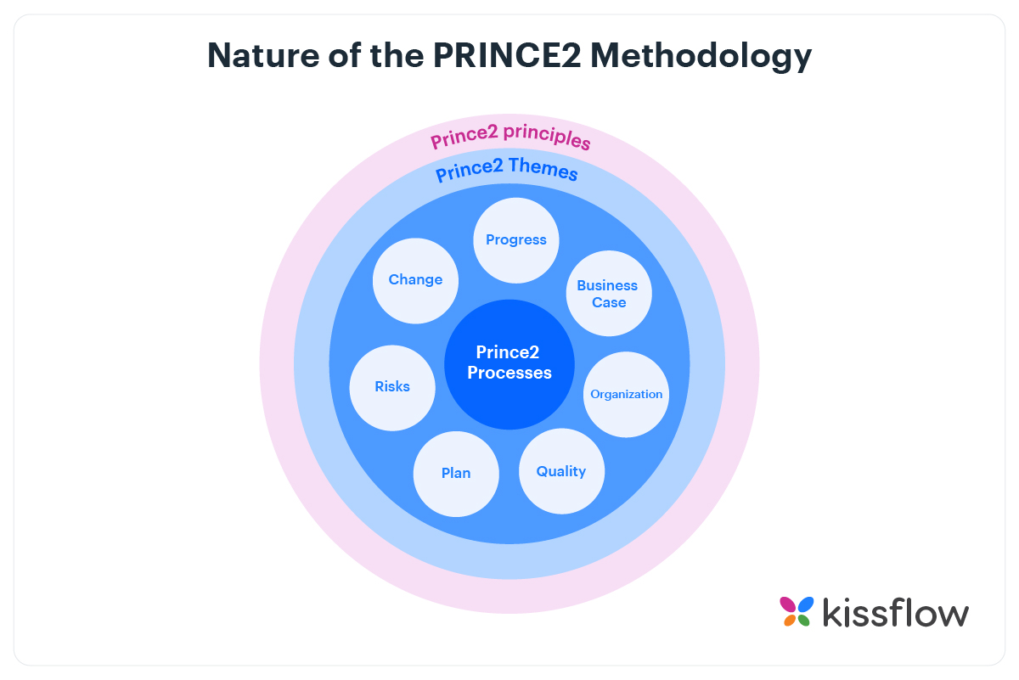Figure 1 (Project, 2021) PRINCE 2 Methodology in Project Management (Project, 2021).

The methodology themes above in figure 1 guides the project managers and planning team as to how the principles are put into practice using the 7 themes of Prince 2.

Whilst this approach is flexible and can be applied to any project. Documentation is a key part of the different stages of any project. Whilst this helps in keeping the project on track and submitting information to the board for review and quality checks.
Some of the types of documents in PRINCE 2 project management methodology include but are not limited to: “a business case” “a risk register” “quality register” “lessons log” etc. and coordinate the various processes and project management activities within order to complete the project within the approved budget (Project, 2021).
Still though, a research project carried out in 1999, says that the literature directs on how Project Management Tools and Techniques are used out of several available PMTT. Thamhain (1999) conducted a study on project managers’ awareness about how to use PMTT “and found that project managers used only 28% of PMTT given in the study and more so they had only 50% basic knowledge about use of those tools and techniques. Similar finding was observed from a survey conducted by White and Fortune” (2002). (Zaman, 2014 ).
- Organizational culture

“Is defined as the set of values, beliefs, and behavioral norms that guide how members of the organization get work done” (Project, 2021). Organizational factors were accredited to team effectiveness. “Organizational context is defined as management processes, organizational culture, and organizational systems that exist within an organization” (Project, 2021). Early studies have confirmed that companies that place emphasis on key managerial components, such as customers, stakeholders, employees, and leadership outperform those that do not have these cultural characteristics (Kotter & Heskett, 1992; Wagner & Spencer, 1996). Project
Today, successful project management cannot be secured by meeting just the three traditional “criteria, cost, schedule and criteria”. Mallak (1991) said that “We must meet the cost, schedule, and quality criteria and, in doing so, we must satisfy the stakeholders of the project “ (Mallak, 1991).
3.1 Stakeholders
To satisfy our stakeholders, we must know who they are, and can apply tools such as stakeholder analysis using a power and interest grids to establish this information. Stakeholders, opens project management of the environment, organisation framework, strategy and change management, as such managing the expectations of the stakeholders and being aware of how the project managers actions are viewed by the stakeholders.
Yet Mallak (1991) argues that satisfying stakeholders is a compromise and argues that stakeholder “satisfaction relies on information about the three success criteria plus assurances on data and information accuracy and reliability” (Mallak, 1991). To manage and design strategies for satisfying the stakeholders, we must know the categories of stakeholders and their special interests.
We can be in a better position to meet the stakeholder's expectations if the stakeholder buys into the expectations given the constraints. To satisfy our stakeholders, we supply them with accurate, timely information about our project's cost, schedule, and quality. But satisfaction goes beyond merely providing information--satisfaction dep
Project managers can use several tools to manage stakeholders: 1) systems to provide information and assurances; 2) conflict management processes; 3) consensus and persuasion processes; 4) interpersonal communication; and 5) stakeholder analyses. These are not typical project management tools, but they are management tools you must apply to projects. (Mallak, 1991).
How to measure stakeholder satisfaction? We can simply ask them. We can meet with them regularly or periodically. We can call them on a regular basis to provide updates and answer any questions and concerns.
For larger groups, conducting a survey would be a reasonable option. Press conferences help in satisfying the more organizationally distant stakeholders such as the public, users, neighbourhood groups, and environmental groups.
Project managers must be proactive towards their stakeholders, supplying them with information before they ask for it. Project managers who understand who their stakeholders are, the individual stakeholder agendas, stakeholder power and how it's exercised, how to satisfy their stakeholders, and actively and sincerely seek and address stakeholder concerns will dramatically increase their potential to manage projects successfully. (Mallak, 1991).

- Soft skills in project management

“Soft skill reflects a person’s relationship with other people through his character traits and interpersonal skills. It focuses more on who people are, rather than what they know” (Jena, 2017). The aim is to make the work environment easier to manage through subtle behaviours and communication. Soft skills can include elements such as adaptability and flexibility, problem solving, creative thinking, conflict resolution, time management, self-awareness, and self-motivation to achieve a goal through effective teamwork.
It can be suggested that leadership quality can depend on the soft skills. “It is the interpersonal people skills, social skills, communication skills, attitudes, social intelligence and emotional intelligence quotients is what matters” (Jena, 2017).
“Communication skill helps the project manager to inform the team members regarding the changes. It is normally said that a project manager spends approximately 85% of his time on communicating. Effective communication is the key to proper execution of the project” (Jena, 2017).
Jena (2017) says that there are few reasons for which sometimes project fails, and these are outlined in figure 2.
Project Failure Reasons | Skill Responsible For Project Failure
Lack of experience and training of a project manager | Both soft skills and hard skills
Project manager fails to manage expectations | Both soft skills and hard skills
Lack of leadership in all five phases of project management | Soft skill
Project manager fails to identify document | Soft skills are more important
Figure 2 Some reasons for project failure (Jena, 2017).
- Conclusion

Several studies suggest that success of a project influences by the proper use of project management tools and techniques (Pinto and Slevin, 1988; Cash and Fox, 1992; Hatfield, 1995; Thamhain, 1996). On the other hand, according to several researchers such as Cash and Fox, 1992; Hatfield, 1995; Thamhain, 1996; Kerzner, 2000 failure of the project may be caused by the improper use, due to lack of knowledge of project management tools and techniques (Berić, 2018).
Berić, (2018) also indicated that it has been found that general characteristics of traditional methodologies such as PMI, IPMA, APM, and YUPMA make them more adequate for application in larger complex projects, but research also establishes a strong link between project management practice and project performance,
Literature establishes strong relationship between Project Management practice and project performance (Furumo et al., 2006; Besner and Hobbs, 2006; White and Fortune, 2002) discussed the use of different Project Management tools, techniques and methodologies and observed considerable differences in their use. To lead projects successfully project managers should be skilled to manage project activities relating to initiating, planning, executing, monitoring, and controlling and closing. (PMI, 2008).
This is further supported by 2005; Shenhar, 1996; Spundak, 2014; Wells, 2012) who all agree that an efficient project management is not possible without an appropriate methodology (Berić, 2018).
However there remains a strong claim and research to support the theory that culture, and soft skills are essential in terms of project management. Early studies have confirmed that companies that place emphasis on key managerial components, such as customers, stakeholders, employees, and leadership outperform those that do not have these cultural characteristics (Kotter & Heskett, 1992; Wagner & Spencer, 1996). Project.

This is reiterated by Richard Morreale (2009) who says that successful project management is a combination of approximately 20% hard skills and 80% soft skills. The hard skills relate to the actual processes, procedures, tools, and techniques comprising planning, organising, monitoring, and controlling, while the soft skills relate to the project managers attitudes and behaviours (Morreale, 2009).

On the balance of probability, it can be hypothesised that the technical “hard skills” can be taught to project managers as part of a training development, or academic criteria to meet the criteria and competency framework for a project management positions and knowledge in techniques and tools. Whilst on the other hand, culture, and soft skills appear to be human characteristics which are less able to be learnt and then delivered consistently and in a meaningful way to colleagues and all stake holders.

Based on the literature accessed for this report, which is acknowledged as limited, the indication is that only 28% of project managers are regularly using project management tools and techniques, suggesting that they are not as useful as stated in theory, although it is also essential to remember that 50% only had basic knowledge about the tools. Yet 85% of soft skills is communication and this is recognised as being used on a more regular basis suggesting that in changing times when stakeholders are more interested in the projects which impact on them, that soft skills are used more frequently due to human interaction and impacting on use of formal tools requiring documentation.

REFERENCES

Albana Berisha Qehaja, E. K. (2017). Strategic Management Tools And Techniques Usage: A Qualitative Review. Acta Universitatis Agricultural Et Silviculturae Mendelianae Brunensis Vol 65, 585-600.
Berić, P. J. (2018). Analysis of the available project management methedologies. Journal of Sustainable Business and Management Solutions in Emerging Economies, 3-13.
Jena, A. S. (2017). Importance of Soft Skills in Project Management. International Journal of Scientific Research and Management, , 6173-6180.
Mallak, L. (1991). SATISFYING STAKEHOLDERS FOR SUCCESSFUL PROJECT MANAGEMENT. Computers & Industrial Engineering, 429--433.
Maylor, H. (2001). Beyond the Gantt Chart:Project Management Moving on. European Management Journal Vol.19, 92-100.
Moore, M.-I. C. (2005). What Makes a good project manager. Human Resource Management Journal, Vol 15, no 1, , 25-37.
Morreale, R. (2009, Jan 24th). The Ideal Project Manager Specification. Retrieved from We are project Smart: https://www.projectsmart.co.uk/index.php#hero
Project. (2021, 11 24). Understanding PRINCE2 Methodology in Project Management. Retrieved from https://kissflow.com/project/prince2-project-methodology/: https://kissflow.com/project/prince2-project-methodology/
Project Management Institute. (2017). A Guide to the project management body of knowledge. Project Management Institute.
Zaman, R. D. (2014 ). Limited Use of Project Management Tools and Techniques: Determining and Evaluating the Reasons . Academia Arena , 1-11.

