Ensure you have a suitable environment open, and that you have a working instance of Jupyter Notebook.

- Open Anaconda Navigator and ensure you are in the environment that you set up. Click ‘Launch’ on the Jupyter Notebook tab.
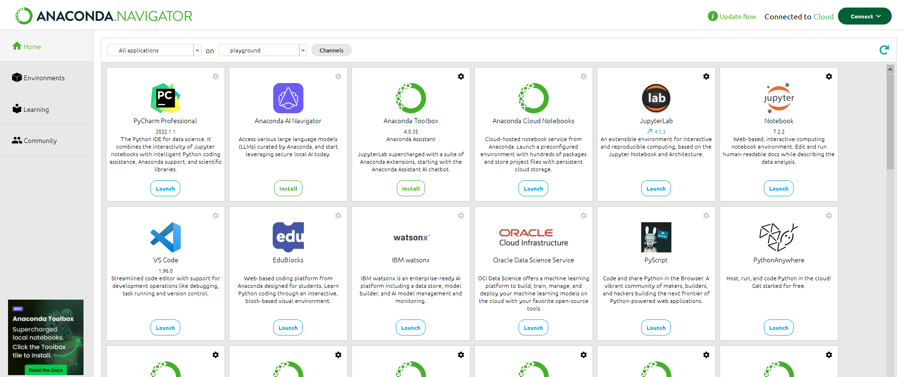

- Once the Jupyter Notebook tab opens in a browser window, choose ‘New’ and in the dropdown menu choose ‘Python 3 (ipykernel)’.
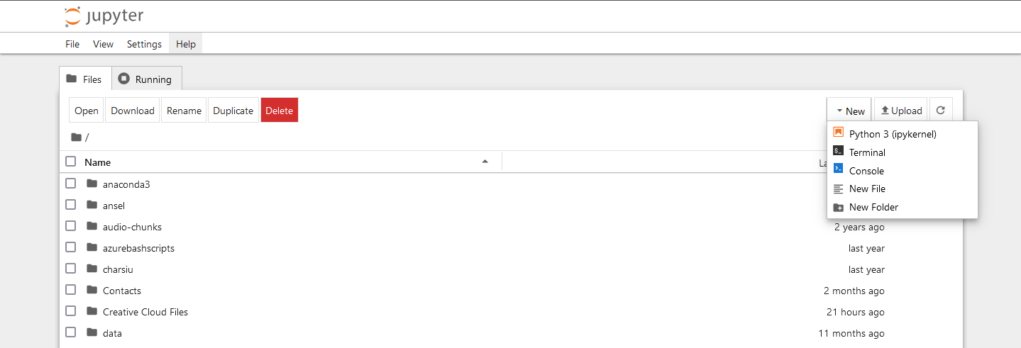

- Once a notebook window is opened, you can start coding. Ensure ALL CODE is typed from the GREYED CELL in the images.
Firstly import the packages you will need. For this tutorial you will need:
  - Neighbors and datasets (from sklearn)
  - train_test_split (from sklearn)
  - numpy
  - pandas
  - seaborn
  - matplotlib.pyplot
Numpy, Pandas, Seaborn and matplotlib.pyplot will be imported using an alias (a variable to use in stead of the full name). This will be quite common with several packages. Importing packages will always be the first step. Once you have coded a cell in Notebook, you will need to click the ‘run’ button to run that cell (looks like a play button, see below).

# Import dependencies and packages needed
from sklearn import neighbors, datasets
from sklearn.model_selection import train_test_split
import numpy as np
import pandas as pd
import seaborn as sn
import matplotlib.pyplot as plt

- As a note, remember you can name your notebook to be saved for later reference.

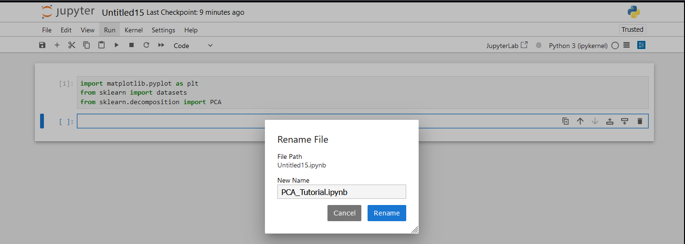

- Now import the dataset using pandas, and store it in a variable. This imports a .csv file that you will have to download first, then point the notebook to that file or folder. The csv file is available in Moodle.
The correct file path needs to be in the brackets. I suggest you create a folder for your datasets and store it in there. You can then use that file path for your import (i.e. …Desktop/data/diabetes.csv).
Then print the first 5 lines (you can print as many lines as you like by entering a number in the brackets as a parameter. Try it).
Run the cell.
# import the dataset (stored in a variable)
diabetes = pd.read_csv("diabetes.csv")
# Inspect the data(first five rows, or this can be changed by including how many rows within the brackets)
diabetes.head()

What does this look like as far as shape of the data?
What attributes are included?

- We now split the dataset into training set and test set. The common split in this case is 25:75 or 20:80. We will use 20:80. For this we use the train-test-split method and create two new variables ‘train’ and ‘test’.
We can then inspect the data by using .info() method after one of the new variables.
Run the cell.
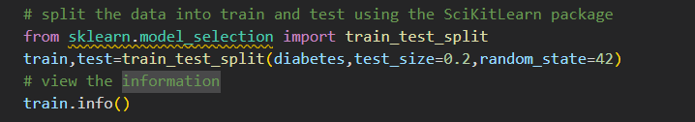
What do you see?
How many columns are listed?
Can you relate this back to the data table above?
Notice the data types.
- We now need to prepare the data by denoting the attributes and the labels. Attributes will be the X and labels will be y. Both test and training sets need to be done.
# Ensure only labels are saved in y variables
y_train=train['Outcome']
y_test=test['Outcome']

- In the same cell, we now need to drop (remove) the attributes we don’t want or need in our X dataset. ‘Outcome’ because it is now our labels, and ‘PatientId’ because it is irrelevant to our analysis and predictions.
#drop the unwanted / irrelevant columns, features are stored in X variables
X_train=train.drop(['PatientId','Outcome'],axis=1)
X_test=test.drop(['PatientId','Outcome'],axis=1)

- Recheck the dataset info. Run the whole cell with steps 7, 8 and 9.
# view the information
X_test.info()

Can you see the difference?
- Run the following cell to show the parameters that can be fine tuned.
# this step is just to demonstrate the adjustable parameters within the algorithm and not a necessary step
neighbors.KNeighborsClassifier().get_params()

At this stage we will only be setting the n-neighbors parameter, but what do the other parameters do?
Check on the Scikit Learn website:
https://scikit-learn.org/1.5/modules/generated/sklearn.neighbors.KNeighborsClassifier.html

- Create a model using the algorithm from sklearn, store it in a variable.
# Create a model for K-Nearest Neighbours and include parameters
model = neighbors.KNeighborsClassifier(n_neighbors=3)

- Fit the training data to the model to train it. Run the cell with steps 11 and 12.
# fit the data to the model, both features and labels to train it
model.fit(X_train, y_train)

- Predict with the model using the test dataset and print the predictions. Run the cell.
# use the model to classify the datapoints within the test set
y_pred2=model.predict(X_test)
# print predicted classifications
y_pred2
What does the prediction look like?
- We can print the test labels (the ground truth) to see what the predictions should look like.
# print test labels (ground truth) that is compared to classifier
y_test

- We now evaluate the model’s predictions against the ground truth test data. The metrics show how accurate and precise the model is through the confusion matrix and classification report, as well as showing the recall and f1-score as we learned in the data lectures. Run this cell.
# display the metrics of the model's classification through confusion matrix and classification report
# (accuracy / precision / recall / f1)
from sklearn import metrics
print(metrics.confusion_matrix(y_test, y_pred2))

print(metrics.classification_report(y_test, y_pred2, digits=3))

How accurate is the model overall?
What can you learn from this?

- We will now use Pandas to create a dataframe. This will allow us to view the predictions and ground truths side by side. It will also allow us to generate a heatmap confusion matrix. Run the cell.
# use Pandas to create a dataframe to view the ground truth and classifications side by side
data = {‘Actual’: y_test,
‘Predicted’: y_pred2}
df = pd.DataFrame(data)
print(df)
What do you notice from the output?

- Now using Seaborn, we can generate a heatmap confusion matrix from the dataframe and plot it using matplotlib.pyplot. For the fun of it we will reprint the classification report too. Run the cell.
# Use Seaborn to create a confusion matrix heatmap and MatPlotLib to display
confusion_matrix = pd.crosstab(df['Actual'], df['Predicted'], rownames=['Actual'], colnames=['Predicted'])
sn.heatmap(confusion_matrix, annot=True)
plt.show()
print(metrics.classification_report(y_test, y_pred2, digits=3))

- Import two more packages that will allow us to run gridsearch to try different k values to find the best option. By doing this we can finetune parameters and we will be using gridsearchcv a lot to do this.
# Create an iterative grid search to tune the parameters
import joblib
from sklearn.model_selection import GridSearchCV

- Now we create a function to help us view and choose the best results and best parameters from the knn classifier.
# Create a function to show the results of the classifier under different parameter values
def print_results(results):
print('Best Parameters: {}\n'.format(results.best_params_))

means = results.cv_results_['mean_test_score']
stds = results.cv_results_['std_test_score']
for mean, std, params in zip(means, stds, results.cv_results_['params']):
print('{} (+/-{}) for {}'.format(round(mean, 3), round(std * 2, 3), params))

- Create the model as before and store in a variable. At this point we will also create an object array for the parameters that we can feed into the gridsearch for crossvalidation.
# Create a model using the KNN algorithm
knn = neighbors.KNeighborsClassifier()
# Set the parameters to be tuned
parameters = {
'n_neighbors' : [3, 5, 7, 9, 11]
}

- Create a gridsearch, feeding in the model and parameter variables and feed the number of folds for the crossvalidation (in the same way we did the kfold crossvalidation). That gets put into a variable ‘cv’.
# instantiate the grid search
cv = GridSearchCV(knn, parameters, cv=5)

- Use the ‘cv’ variable to fit the training data to and display the results output by the ‘cv’ variable.
# fit the training data to the model
cv.fit(X_train, y_train.ravel())
# display the model evaluation with the different parameter values (K value)
print_results(cv)

- Run the cell.
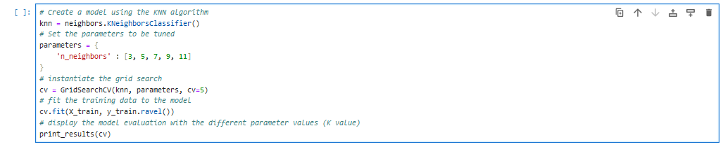
What are the results that get output?
What is the best n_neighbors parameter to use?

- We can show the best parameters to use with a method. It is also possible to alter multiple parameters with this method and iterate through all combinations to find the best.
# show the best paramters for classification (not a necesary step unless you are saving best parameter models to compare)
cv.best_estimator_.get_params()

What are the parameters for the best model?

