Portfolio – 8 Elements

Module code: BMIH4001
Portfolio

Student Name:Adina Constantin
Submission Date:22/02/2024
Table of Contents
Introduction 3
Task 1: Mode of Assessment 3
1.1 Discussion of My Understanding of Reflective Writing, Academic Essays, and Academic Reports 3
1.2 My Strengths in Understanding of Reflective Writing, Academic Essays, and Academic Reports and its Role in My Studies 4
1.3 My Areas of Improvement and Guidance Provided by the University to Improve it 4
Task 2 Citation and Referencing 4
2.1 Discussion of My Understanding of Harvard Referencing and its Relevance 4
Task 3: Reflective Essay and Action Plan 5
3.1 Strategies to Address Time Management Issues for Professional Development 5
Task 4: Industry Event Reflection 6
Task 5: Communication and Interpersonal Skills Interview 8
Task 6: Integrate images into your portfolio of evidence - 200 Words 9
Task 7: Legal Issues – Health and Safety Poster 9
Conclusion 13
References 14

Introduction
Skills are a significant part of personality development, and it is necessary to have the good skills and capabilities to excel in professional and personal life. Organisations require skilled and experienced individuals to carry out their workforce. Expertise in the different skills and capabilities helps to enhance one’s career and future growth. Educational institutions act as a significant role in shaping the skills and capabilities of learners and teach them a range of skills efficiently for their personality development. The first task will discuss my understanding of Reflective Writing, Academic Essays, and Academic Reports and it will also discuss my areas of improvement and the guidance provided by the university to improve it. The second task will discuss my understanding of Harvard Referencing and its relevance and the third strategy to address time management issues for professional development. The fourth task will discuss the industry event reflection the fifth task will discuss communication and Interpersonal Skills Interview and finally, it will provide a conclusive statement on the topic.

Task 1: Mode of Assessment

1.1 Discussion of My Understanding of Reflective Writing, Academic Essays, and Academic Reports
Reflective writing, academic essays, and reports are the parts of academic writing that have helped me to improve my writing skills and to present the information appropriately. Reflective writing has helped me as a medium of self-analysis and critical analysis of my personal experience and growth. It has helped me to better understand myself and has played a significant role in my self-awareness and growth (Cottrell, 2019). Academic essays are significant tools for the expression of ideas, thoughts, and arguments, and they have helped me demonstrate my knowledge and understanding of the topic. Reflective writing fosters reasoning and critical thinking, reflective writing has assisted me in drawing the lessons from my experiences that will improve my knowledge and skill set. I can develop and enhance my writing abilities my written communication skills. Reports help with prompt decision-making and follow-up actions. Reports are just another tool for efficient communication. I can also evaluate my knowledge and abilities through reports. Once information is obtained, the most important factor is how it is arranged and presented.

1.2 My Strengths in Understanding of Reflective Writing, Academic Essays, and Academic Reports and its Role in My Studies
My writing abilities have improved by academic writing assignments including essays, reports, and reflective writing. A range of abilities, including research, critical thinking, attention to detail, organisation, and time management, have allowed me to deliver my essays, reports, and reflective writing in an understandable and concise manner (Migdal et al., 2015). These potentials are a crucial component of my skill set and have assisted me in presenting essays, reports, and reflective writing in an appropriate manner. It has helped me express my thoughts in a clear and succinct manner. My capacity to carry out in-depth study has given me the capacity to comprehend the subject matter thoroughly and to provide the content in an accurate manner. It has helped me develop my critical thinking skills and strengthen my evidence-based decisions. Organising skills have enabled me to restructure my work and properly present my information. Time management skills have helped me in setting goals, planning, and making appropriate use of time. Each of these skills has played a critical role in my personality development and my capabilities.

1.3 My Areas of Improvement and Guidance Provided by the University to Improve it
In my academic writing, I must further improve my editing, proofreading, and grammatical skills. During my academic writing, I make grammatical errors and mistakes that affect my academic writing. It is necessary to have good grammatical skills to make the report clear and concise. Editing the academic work comprises reviewing and polishing the writing to ensure that it is clear, concise, and error-free (Walker, 2021). It is the significant steps in the writing procedure that help me produce quality work. University professors will provide me with guidance so that I can upgrade my writing skills. I will attend their classes, lectures, and seminars at my university so that I can improve my academic skills. Moreover, I will also practise, go through books, and attend training sessions to improve my skills and capabilities.

Task 2 Citation and Referencing

2.1 Discussion of My Understanding of Harvard Referencing and its Relevance
Harvard referencing is among the widely utilised citation formats in UK universities, each student must understand the basic concepts of the Harvard system. Parenthetical referencing is also known as "Harvard referencing," which denotes utilising Harvard citations in the body of your work as opposed to footnoting. In academic writing, referencing, or citing sources is essential. In my academic writing it has helped me to present the plagiarism free content and has helped me to give credit for other academic sources. Citing original sources in my essay, report and reflective writing demonstrate my prior research and my capability to back up my arguments (Carey, 2020). Harvard Referencing allows ethical research and professionalism in my academic writing by offering an accepted method of comprehending the work of other scholars. It maintains intellectual property rights and fosters transparency by letting readers follow the origins of concepts and the information. Such referencing encourages academic interaction by offering a recognised vocabulary for cross-disciplinary reference. It enables me to interact with previous publications, advance knowledge, and participate in ongoing academic conversations. By using such a referencing style, I can show that I have engaged with relevant knowledge and customised my work within a larger academic the structure.
Harvard Referencing additionally improves my calibre and credibility of academic writing. Precise and regular citation techniques give arguments credibility by showcasing accountability and close attention to detail. Additionally, making a clear distinction between original concepts and content that has been taken out, controls plagiarism in my academic writing. Using such references assists me with the appropriate information so that I can make my writing more authentic or appropriate (Cottrell, 2021). I can get the articles in a different context that will help me to present my information clearly and concisely. I have also learned the process of presenting information and writing skills through different scholarly sources. My understanding of Harvard Referencing has evolved from viewing it as a technical requirement to recognizing it as a foundational aspect of scholarly integrity and communication. Embracing this referencing style not only ensures adherence to academic conventions but also reflects my commitment to ethical scholarship and the advancement of knowledge.

Task 3: Reflective Essay and Action Plan

3.1 Strategies to Address Time Management Issues for Professional Development
Time management is the art of effective management of time and it allows me to make proper utilisation of the time in my daily roles and responsibilities. It allows me to complete the responsibilities in the appropriate periods and allows me to prioritise my work so that I can fulfil the necessary tasks beforehand. It is necessary to manage my time appropriately so that I can properly perform my duties. However, I am procrastinating and that eats up all my time in my life. I always face the challenges of managing my time in my responsibilities. It harms my roles and responsibilities. To address my time management skills, I have to learn different time management skills. To efficiently manage my time, I must prioritise the tasks and I will make a list of urgent and important tasks (Mullins, 2019). I will work on the urgent tasks first and do the important tasks after the completion of the tasks. Moreover, I will plan my work before the initiation of the tasks and make a detailed description of tasks and their timing before starting it. It will help me to prioritise my tasks and perform my duties in a detailed manner and it will also provide the guideline map for systematically doing the work. I will be punctual towards my roles and responsibilities so that I can give proper timing to each task and do have the time for myself. Moreover, I will create an organised workspace that can help me focus on my work and prevent the wastage of time on distractions. I will do my duties in a comfortable place where no one can disturb or interrupt me in my work procedure (McMillan and Weyers, 2021). I will give my special attention to the single tasks so that it can improve the task's qualities and help me to do the tasks adequately.

Task 4: Industry Event Reflection
Professionals can network, learn about new trends, and understand more about new insights into cutting-edge technology at industry events. As I reflect on these events, I find myself having all sorts of feelings of excitement and inspiration, and mild anxiety. Industry events are exciting times indeed for me and bring me much fun (Bladen et al., 2022). The prospect of mingling with like-minded people, brainstorming new moves and uncovering inventive solutions makes me really inspired and perpetuates my determination to improve constantly. Meeting industry leaders and experts can become a kind of motivation, reminding me of the huge potential and infinity of paths in this field.
In addition, seeing innovative technologies and successful examples can inspire us greatly. Knowing about real-world uses or examples of success stories not only broadens one's horizons it also kindles my passion for creativity and meaningfully contributing to the industry’s development. But there were also moments of anxiety and indecision. Industry meetups are frequently where potential problems and dynamics hindering the industry are brought into relief by technical advancements (Skeete et al., 2020). It may seem intimidating at times but there are occasions when we can adapt and innovate. Intrinsically, however, navigating through such ambivalence sometimes leaves me feeling like I have a handle on nothing and am uncertain where the future lies for the field.

Seeking out mentors, colleagues, or industry associations will provide critically important advice in moments like this. Talking to seasoned professionals who have worked through similar problems can help in better understanding the situation. Furthermore, attending workshops for training or looking for opportunities to develop professionally can facilitate my equipping with the skills and knowledge necessary to navigate through an uncertain future. In the final analysis, industry events act as a tonic in promoting growth and development, providing outlets for learning, connecting, and self-blame (Allen et al., 2022). They may evoke a range of emotions, from excitement to apprehension, but they have essential significance when it comes to shaping the future of our developing industry and advancing collective progress. My engagement in these events serves as a constant reminder of the value of resilience, adaptation, and a never-ending pursuit of understanding in navigating the marketplace's always-changing terrain.

Task 5: Communication and Interpersonal Skills Interview
As I prepare for the communication and interpersonal skills-focused hotel-industry interview, I find myself reflecting on my strengths and weaknesses in these areas concerning the jobs here that I've done. I have a knack for being able to communicate effectively with both guests and colleagues. For a hotel industry in which exceptional customer service is only provided by those who can express themselves clearly and pleasantly, and team members get along well with their colleagues, I do this quite well because I am particularly concerned about guests' needs, pay attention and listen patiently, and react to their demands in a timely fashion (Hargie, 2021). Furthermore, my communication style can change with the situation to cater for everyone from multi-faceted personality types to different settings, and thus ensure that the exchanges are both professional and personable.

Another strength I have is my cooperative nature, which suits the hotel industry's team-oriented way of doing things. I like to collaborate closely across departments and fulfil together a single purpose, be it the smooth running of operations or giving guests an unforgettable experience. Being able to build relationships with people and work effectively with them also creates a harmonious working atmosphere that raises productivity across the board (Hockey, 2020). On the other hand, every one of us has some deficiencies, I've identified several instances where I might be more loquacious. One of them is when it comes to assertiveness. I try my best to be agreeable, reasoning things out and handling them tactfully. Still, there are times when being assertive is the only way forward, especially when we are dealing with guests who have a complaint or complaints about our colleagues.
Developing assertiveness skills will boost my confidence and give me a more assertive voice while still maintaining professionalism and respect on top of all that. Moreover, I am aware of the importance of trying to improve my listening skills in an ongoing way. As a good listener by nature, I continue to work on the skill through techniques such as active listening paraphrasing, clarifying questions and feedback approaches Being a better listener will help me understand guests' needs and complaints more accurately providing more personalised service than ever before makes for more satisfaction (Middlemiss et al., 2019). My aptitude for communication and interpersonal skills makes me a good fit for the hotel industry. Nevertheless, I'm determined to continually learn and grow in these areas. By focusing on areas that require improvement, which include aggressiveness and engaged listening, my goal is to increase my performance in hotel sector jobs and keep providing excellent service to both visitors and co-workers.

Task 6: Integrate images into your portfolio of evidence - 200 Words
I've injected organic life into my portfolio Combining with pertinent images to augment and supplement my written work spreads and pages. The images clarify the concepts and theories associated with each task, professionally conveying real life in full multimedia to the reader. Task 4's crowded conference hall, is an image dark with pulsating energy which is the core element in this kind of event the excitement and socialising opportunities it harbours. Task 5 has pictures of successful communication, two people talking together, which emphasize the importance also of human relations in the workplace. Furthermore, regarding Task 7, the image of a health and safety poster I conjured up visually depicts the key messages, making them easier to remember and have more of an impact. I hope to produce a coherent and visually attractive portfolio by collecting these images so that it can reflect not only my writing ability but also my creative talent as well as attention to detail.

Task 7: Legal Issues – Health and Safety Poster
Title: Prioritise Health and Safety in the Workplace
Subtitle: Protect Yourself, Protect Your Colleagues
Introduction
- Welcome to our initiative to raise awareness of workplace safety and health!
- Encouraging everyone to work in a safe atmosphere is the poster's main goal, which also emphasises the significance of sanitation and security in working environments.
Key Messages
1. Safety First
- In everything you do, put safety first.
- Be sure you take all the required safety measures to avoid mishaps and harm (Khan et al., 2022).
2. Know the Risks
- Recognise possible risks in your place of employment.
- Notify your supervisor right once of any dangerous actions or situations.
3. Safety Equipment
- As needed, put on the proper protective wear and equipment.
- Ascertain that the machinery is kept up-to-date and functional.
4. Emergency Procedures
- Acquaint oneself with emergency protocols, encompassing escape routes and gathering locations.
- In an emergency, maintain composure and adhere to orders (Rantsatsi et al., 2020).
5. Hygiene and Cleanliness
- To stop the propagation of sickness and disease, practise excellent hygiene.
- To reduce hazards, maintain a tidy and well-organized workstation.
6. Training and Education
- Take part in the company's wellness and security training programmes.
- Keep up with the rules and regulations about health and safety that are pertinent to your position.
7. Support Each Other
- Promote a secure and healthful workplace by cooperating as a team (Halagarda and Wójciak, 2022).
- To properly handle safety problems, promote candid dialogue and teamwork.
Conclusion
- Recall that everyone has a part to play in ensuring the safety and health of workers.
- We can make the workplace more secure and nutritious for everyone if we abide by these rules and watch out for one another.
- I appreciate your dedication to my well-being and protection!
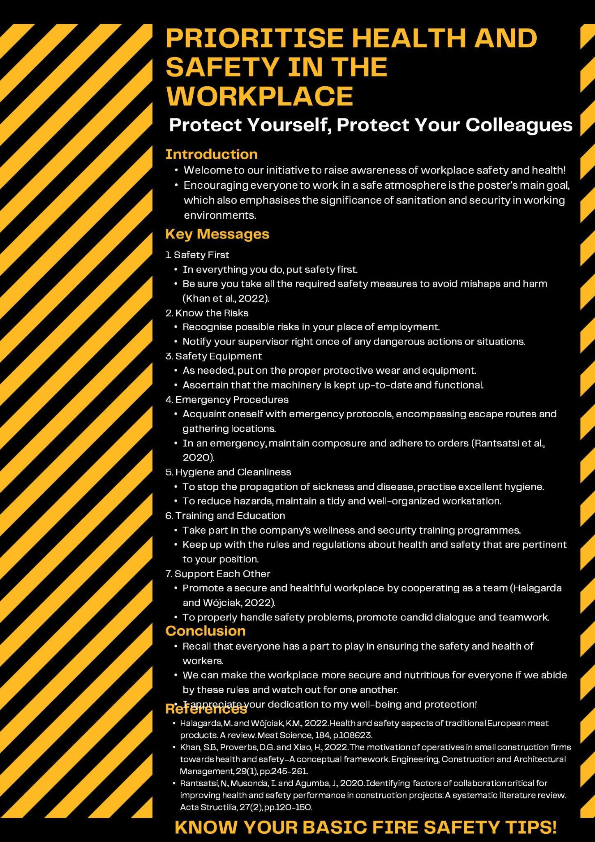
In an attractive and compact form, this health and safety poster delivers key messages effectively. With its vivid colour scheme and straightforward text, it is eye-catching. Also, icons that are easily linked to the story help reinforce the images. There are several important aspects, such as risk awareness, safety equipment, emergency procedures, and hygiene practices, that such a poster should touch upon. At the same time, it relies on a collegial attitude toward safety, urging teamwork and a network among co-workers. On balance, the result is a useful and lively publicity adjunct to fostering health precautions in industry.

Conclusion
The tasks shown here give a bird's eye view of some various academic and practical skills essential for success. Reflective writing, academic essays and reports illustrate the ability to analyse events critically and to communicate ideas. As shown by the Harvard Referencing example in Section 2, confidence in citation and referencing techniques keeps your work academically and professionally honest. Time management skills, also reflected on in Task 3, are important for professional development with suggestions on improvement or encouragement to others available. Industry event reflections and communications skills in Tasks 4 and 5 underscores the need for adaptability and interpersonal competence in the workplace. The inclusion of images in Task 6 is even more noteworthy because it makes the portfolio creative and interactive. And creating a health and safety poster as in Task 7 indicates an awareness of legal responsibilities in protecting labour. In brief, these exercises represent a comprehensive approach to evaluating and cultivating the essential competencies that everyone needs to succeed in academia and professional life.

References
Allen, J., Harris, R., Jago, L., Tantrai, A., Jonson, P. and D'Arcy, E., 2022. Festival and special event management. John Wiley & Sons.
Bladen, C., Kennell, J., Abson, E. and Wilde, N., 2022. Events management: An introduction. Taylor & Francis.
Carey, P. et al (2020) New perspectives Microsoft Office 365: Office 2019 introductory. Boston: Cengage.
Cottrell, S. (2019) Study skills handbook, 5th Edition.,Palgrave Macmillan: Basingstoke
Cottrell, S. (2021) Skills for success: Personal development and employability Palgrave Study Guides), 4 th Edition.London: Red Globe Press.
Halagarda, M. and Wójciak, K.M., 2022. Health and safety aspects of traditional European meat products. A review. Meat Science, 184, p.108623.
Hargie, O., 2021. Skilled interpersonal communication: Research, theory and practice. Routledge.
Hockey, J., 2020. Interviews as ethnography? Disembodied social interaction in Britain. In British subjects (pp. 209-222). Routledge.
Khan, S.B., Proverbs, D.G. and Xiao, H., 2022. The motivation of operatives in small construction firms towards health and safety–A conceptual framework. Engineering, Construction and Architectural Management, 29(1), pp.245-261.
McMillan, K. &amp; Weyers, J. (2021) The study skills handbook 4 th Edition: Harlow: Pearson Education.
Middlemiss, L., Ambrosio-Albalá, P., Emmel, N., Gillard, R., Gilbertson, J., Hargreaves, T., Mullen, C., Ryan, T., Snell, C. and Tod, A., 2019. Energy poverty and social relations: A capabilities approach. Energy research & social science, 55, pp.227-235.
Migdal, N. Taylor &amp; Francis (2015) Hotel law: Transactions, management and franchising, Abingdon: Routledge.
Mullins, L. J. (2019) Organisational behaviour in the workplace. Harlow: Pearson Education
Rantsatsi, N., Musonda, I. and Agumba, J., 2020. Identifying factors of collaboration critical for improving health and safety performance in construction projects: A systematic literature review. Acta Structilia, 27(2), pp.120-150.
Skeete, J.P., Wells, P., Dong, X., Heidrich, O. and Harper, G., 2020. Beyond the EVent horizon: Battery waste, recycling, and sustainability in the United Kingdom electric vehicle transition. Energy Research & Social Science, 69, p.101581.
Walker, J. (2021) Introduction to hospitality 8 th Edition.Harlow: Pearson

