Research in Practise
Dissertation Proposal
crime, landscape, unawareness

Student Name: Hannah Davies
Student Number: 2203436
Course: BA(Hons)documentary photography and visual activism

illustration references
Meiselas, S. (1997) *Reframing History*. New York: International Center of Photography.
Misrach, R. (1999) *Desert Cantos*. New York: Aperture.
Ristelhueber, S. (1992) *Fait*. Paris: Éditions Hazan.
Simon, T. (2002) *The Innocents*. London: Phaidon.
Vergara, C. J. (2005) *How the Other Half Worships*. New Brunswick, NJ: Rutgers University Press.
Forensic Architecture (2018) *The Killing of Zak Kostopoulos*. Available at: https://forensic-architecture.org/investigation/death-zak-kostopoulos (Accessed: 30 April 2025).

Crime, Landscape, Unawareness
An Independent Research Document Proposal

Not all harm is visible. In cities and towns across the world, public space quietly absorbs moments of violence, loss, and neglect. These incidents: a fatal accident, a police killing, a moment of collective trauma, often leave little behind to mark them. With no plaque, no media attention, and no memorial, the site becomes familiar again. People walk by without knowing, and the place fades into normality. These moments are not just forgotten they are often actively erased, shaped by collective discomfort or systemic neglect. What is absent from view still lingers in memory, infrastructure, and experience, waiting for someone to look more closely. In this essay, I will explore three keywords; crime, landscape, and unawareness, supported by a minimum of three photographic case studies, discussed in relation to visual artists, writers, and theorists. A short context of this writing is to examine how these terms intersect conceptually and visually, and how they may offer a framework for understanding how photography engages with the hidden or overlooked aspects of everyday environments. This research will attempt to link the three keywords to form a question for my independent research document, exploring areas of interest via observation, spatial analysis, and visual interpretation.
Crime
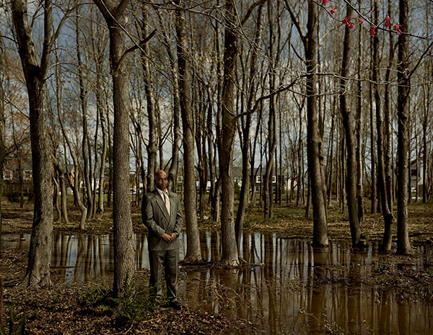
Crime is often understood as a breach of law, resolved through policing, prosecution, and punishment. However, many acts of harm remain unresolved or are erased from public record altogether. Crime, in a broader sense, also includes structural violence, wrongful conviction, and systemic failures that go unacknowledged. As sociologist David Garland (2001) argues, modern society is shaped not just by the crimes it punishes but by how it manages public fear and selectively distributes justice. Some events are remembered, others are forgotten, often based on whose lives are considered worthy of public attention. This imbalance between what is punished and what is forgotten reveals how crime is not a fixed concept, but one shaped by politics, history, and power. As Johan Galtung (1969) argues, some of the most damaging forms of violence are “structural” embedded in institutions that create inequality and suffering without direct physical acts.
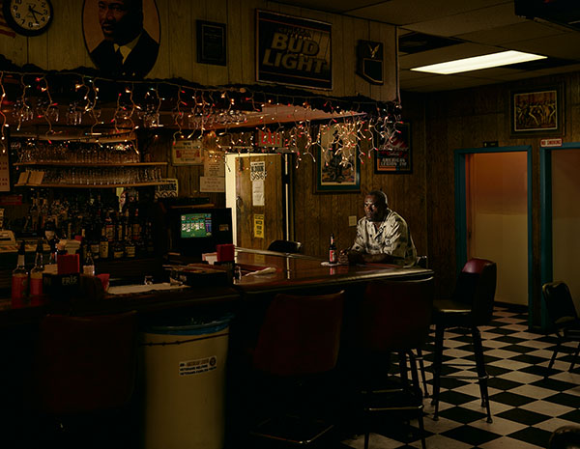
Photography can respond to this imbalance by reactivating visibility. In The Innocents (Simon, 2002), Taryn Simon photographed individuals who had been wrongfully convicted, placing them in sites related to their accusations: from suburban streets to empty storefronts. These images are calm and non confrontational, but paired with their accompanying narratives, they become loaded with tension. Simon’s project reveals that crime can live on in a location even when there is no longer any visible sign. Her work critiques the idea of photographic truth, asking the viewer to consider how easily evidence and meaning can be misread. As Charlotte Cotton notes, Simon’s photographs “deliberately understate visual drama in favour of psychological complexity,” pushing the audience to reconsider how we construct narratives from images and context (Cotton, 2009, p. 191).

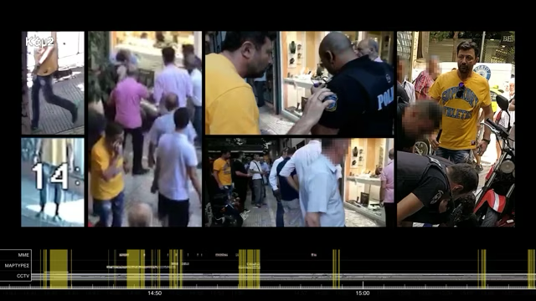
In a more investigative approach, Forensic Architecture uses spatial analysis to examine acts of state violence that have been denied or ignored. In their 2018 investigation into the death of Zak Kostopoulos, the team used video, mapping, and architectural modelling to reconstruct the killing and challenge the official account. Eyal Weizman (2017), founder of the group, describes this method as “counter forensics”, the act of using spatial and visual data to produce alternative forms of justice. Their work reveals that crime is not always remarkable or visible, and that absence itself can be a form of a cover-up.
Crime, as a concept, extends far beyond the boundaries of legal codes and courtroom outcomes. It encompasses the lingering effects of harm: the unresolved grief, systemic failures, and societal neglect that continue long after an event is over. Crime can manifest not only in acts of violence but also in the silencing of those acts, in the refusal to acknowledge responsibility, and in the erasure of memory from public consciousness. As a framework for critical thinking, it invites reflection on how power operates through absence, how justice can be withheld through inaction, and how social structures determine what is named as wrongdoing and what is not.
Landscape
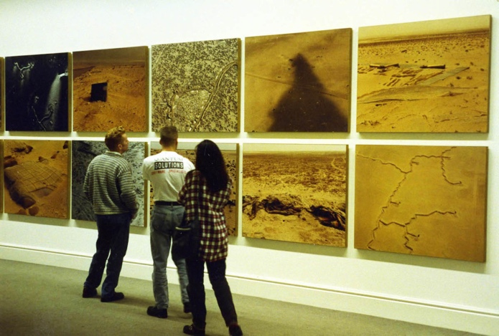
Landscape is more than scenery, it is shaped by cultural memory, social structures, and historical events. As Denis Cosgrove (1984) argues, landscape is “a way of seeing” that reflects systems of power. What we choose to see and what we choose to forget is embedded in how we design, manage, and photograph space. In urban settings, sites of violence or trauma may be cleaned up, rebuilt, or allowed to decay in ways that erase their past. This creates what Kenneth Foote (1997) terms “sanitised landscapes,” where traces of harm are removed to avoid discomfort or controversy. Such landscapes are not passive; they actively shape how history is understood and remembered. The absence of physical markers or public memory at sites of conflict or suffering can make these places appear neutral, even peaceful, despite their histories. As geographer Tim Cresswell (2004) notes, all spaces are inscribed with meaning often political whether we recognise it or not. When harm is concealed or forgotten, landscape becomes a tool of silence. Examining landscape through this lens reveals it not just as a visual subject, but as a contested site of narrative control, where memory and forgetting are managed through design, maintenance, and representation.

Documentary photography can push back against this sanitisation by showing how space holds memory. In Fait (1992), Sophie Ristelhueber photographs the aftermath of the Gulf War in Kuwait through landscapes marked by craters, wreckage, and abandoned infrastructure. The absence of people in the images shifts the focus to the terrain itself: damaged, silent, and scarred. Ristelhueber’s work invites the viewer to read the landscape as a form of evidence, a surface where violence has been absorbed rather than erased.
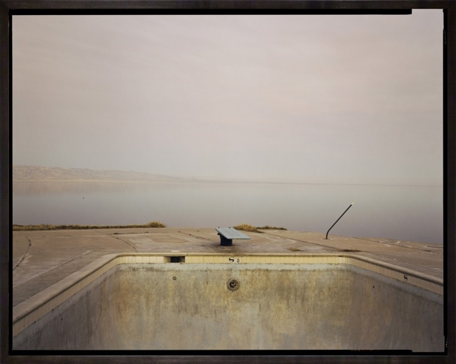
A similar treatment of space can be found in Richard Misrach’s Desert Cantos, a series that explores the American Southwest, including sites used for nuclear testing and chemical storage. His photographs are aesthetically composed and seemingly serene, but the contexts they represent; environmental harm, militarisation, long-term contamination create a tension between beauty and devastation. Misrach asks us to confront the hidden histories within familiar or overlooked terrain, encouraging a reconsideration of what landscape really shows.

Both projects demonstrate that landscape is not simply a physical setting, but a constructed and interpreted space shaped by cultural, political, and historical forces. Landscapes can embody memory or act as tools of erasure, depending on how they are framed and represented. In photography, landscape becomes a site of enquiry not only about what is visible, but also about what has been concealed or forgotten. As a concept, it invites contemplation on how environments absorb the consequences of human action and how visual practices can uncover these layers. Landscape can develop into a analytical structure for examining power, permanence, and the traces of unseen harm embedded in everyday terrain.
unawareness
Unawareness is a condition of modern life, often shaped by routine, distraction, and repetition. Philosopher Tim Ingold (2000) describes perception as an embodied process shaped by movement, we learn to tune out what doesn’t seem relevant. Similarly, Michel de Certeau (1984) explains that people navigate cities through habit, following familiar paths and barely noticing their surroundings. This creates a kind of blindness, not out of choice, but as a consequence of living within systems that reward efficiency over attention. Beyond urban navigation, unawareness can be understood as a cultural and psychological adaptation a filtering mechanism developed to cope with information overload and the demands of fast-paced environments. In many cases, what is overlooked is not invisible, but simply no longer perceived as meaningful. The things we ignore are often those we’ve seen too many times, passed without consequence, or been taught not to question. Sociologist Georg Simmel (1903) referred to this as the “blasé attitude” a psychological response to urban overstimulation, where individuals dull their reactions to remain functional. Unawareness, then, is not just the absence of knowledge, but the result of habituated disconnection. Exploring it reveals how perception is shaped not only by what we choose to see, but by what our environments train us to ignore.
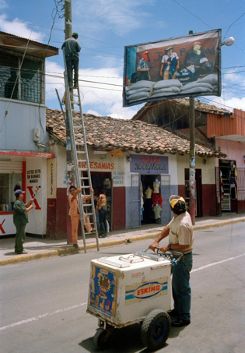
Photography can disrupt this automatic seeing by inviting a slower, more reflective gaze. In Reframing History (1997), Susan Meiselas returns to locations of political protest in Nicaragua, installing large prints of her own archival images directly onto the buildings where the events occurred. These overlays collapse time, bringing the past into the present. Viewers are confronted with the history embedded in their surroundings, history they may have otherwise ignored. Meiselas creates a public dialogue between image and place, asking people to re-engage with what has been forgotten.
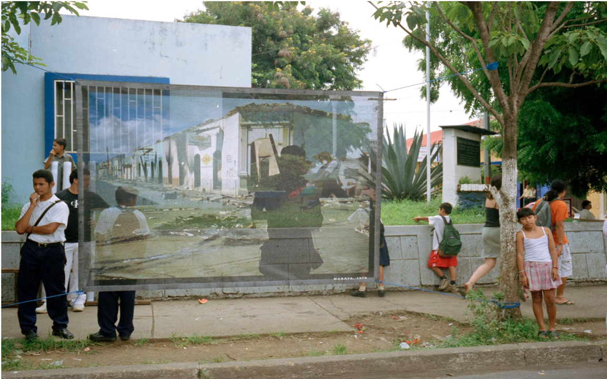
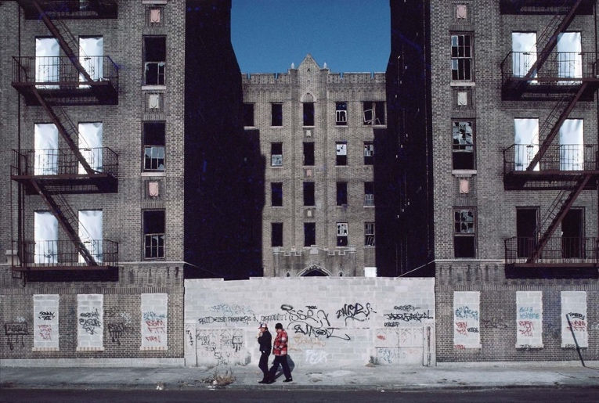
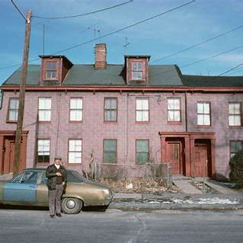
Camilo José Vergara adopts a different method: long-term repetition. Over several decades, he has documented the transformation of American inner cities by photographing the same buildings and streets over time. His images don’t show dramatic change at once; instead, they build a slow archive of decline, gentrification, or resilience. By returning to the same sites, Vergara reveals what others overlook: the gradual erosion of community, the disappearance of structures, and the shifting meaning of place.

This ongoing visual archive is made tangible in one image from The New American Ghetto, where two men walk past a massive, sealed-off housing block, its windows shattered or boarded, its entryways obstructed with concrete. The building looms, scarred by abandonment, yet it registers as just another part of the street. The figures in the foreground pass by casually not out of indifference, but because the structure’s deterioration has become familiar. The scene embodies how unawareness forms not through absence, but through overexposure. The visual cues of decline no longer shock; they settle into the background. Vergara’s photographic series doesn’t seek drama it quietly observes the way harm embeds itself in everyday space. In doing so, it invites reflection on how lived environments shape what we perceive, ignore, or come to accept without question.
These works show that unawareness is not simply the absence of knowledge, but a condition shaped by habit, distraction, and social norms. It reflects how individuals and societies learn to stop noticing whether through repetition, desensitisation, or cultural avoidance. Photography that challenges this condition can serve as a visual intervention, interrupting familiar ways of seeing and prompting a renewed awareness of space and history. As a concept, unawareness opens further analysis into collective memory, perception, and the politics of attention. Offering fertile ground for exploring how visual practices can unsettle what has come to feel ordinary.
In conclusion crime, landscape, and unawareness are not just separate themes they interact constantly. A crime can take place in a space that, over time, loses its connection to the event, the landscape absorbs the impact, but unless someone draws attention to it, the site becomes visually neutral. Unawareness allows all of this to happen not as deliberate forgetting, but because of how people move through and interpret the world. This cycle of harm, forgetting, and erasure is sustained by cultural habits, spatial design, and institutional silence. Throughout this essay, each keyword has been examined from the emotional and spatial inheritance of crime to the ideological role of landscape, to the psychological condition of unawareness. However, the real power of these terms lies in their overlap. Together, they form a framework for thinking about how harm is visually managed, how it disappears into the everyday, and how photography might work against that disappearance. Each of these concepts could generate its own line of inquiry, ranging from studies of urban trauma and spatial justice to investigations into collective memory, public forgetting, and visual ethics. However, the question that feels most urgent and compelling and the one I believe would be most appropriate for my independent research is: “How can documentary photography expose everyday urban spaces linked to past crimes or deaths that are otherwise ignored or unseen by the public?” This question brings together the three keywords into a focused, visually, and socially grounded investigation. It opens up space to explore how photography can function as a tool for spatial reactivation, historical witnessing, and ethical visibility. It also suggests a practical dimension: how photographers can engage with overlooked spaces in ways that are thoughtful, respectful, and politically conscious. As a future area of research, this question offers both a strong theoretical foundation and a deeply human significance, one that invites attention not only to what we see, but to what we miss.

Bibliography
Butler, J. (2009) *Frames of War: When Is Life Grievable?* London: Verso.
Cotton, C. (2009) *The Photograph as Contemporary Art*. 2nd edn. London: Thames & Hudson.
Cosgrove, D. (1984) *Social Formation and Symbolic Landscape*. London: Croom Helm.
de Certeau, M. (1984) *The Practice of Everyday Life*. Berkeley: University of California Press.
Foote, K. E. (1997) *Shadowed Ground: America’s Landscapes of Violence and Tragedy*. Austin: University of Texas Press.
Garland, D. (2001) *The Culture of Control: Crime and Social Order in Contemporary Society*. Oxford: Oxford University Press.
Ingold, T. (2000) *The Perception of the Environment: Essays in Livelihood, Dwelling and Skill*. London: Routledge.
Weizman, E. (2017) *Forensic Architecture: Violence at the Threshold of Detectability*. New York: Zone Books.

