BMIH6002
Managing Food and Beverage Operations

Assessment Component 1

Learning Log

Student name: Katerina Hristova
Student ID: 2232205
Lecture name: Jessica Newport

Table of Contents
Introduction 3
Section 1: Role Reflection 4
1. Role Overview and Key Responsibilities 4
2. Key Skills for Effective Supervision 4
3. Examples of effective/ineffective supervision 5
4. Action Plan for Professional Development 5
Section 2: Development Journey 6
1. Comparison with Previous Food & Beverage Placement (Level 4) 6
2. Reflection on Learning from Modules 6
Section 3: Service Improvement Proposal 7
1. Area for Improvement 7
2. Justification for improvement 7
3. Improvement Plan 8
4. Enhancing Performance and Technical Knowledge 8
Conclusion 9
References 10

Introduction
My placement was in Ashford International Hotel & Spa (Start date: 02/05 & End date: 10/07). Food and beverage operations managers are in charge of all processes involved in supplying food to customers. The creation of a visible task checklist by the housekeeping supervisor for the crew was one of the more successful ones. Operations are positively impacted by good supervision, while operations and the organisation are negatively impacted by bad supervision. I was compelled to work quickly and pay closer attention to business etiquette, such professionally greeting visitors and upselling.
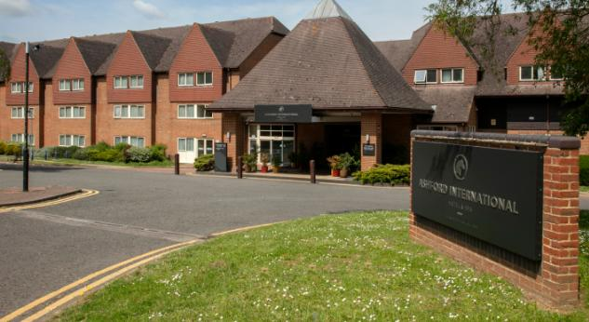
Figure: The organisation (Hagg, 2013).

Section 1: Role Reflection

1. Role Overview and Key Responsibilities
Role held during placement and key responsibilities: In the frame of my placement at Ashford International Hotel & Spa, I was able to experience working in various areas of the hotel namely Food & Beverage, Housekeeping and Leisure, and Hotel Administration (Reception and Sales). I had three key areas of responsibility that were departmental. Assignments in the Food & Beverage department were Food Preparation and Service, which included setup of dining rooms and hygiene and customer satisfaction (ASET, 2017).
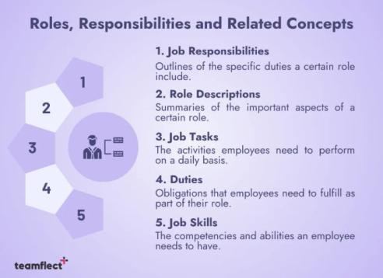
Figure: Roles, Responsibilities & Related Concepts (Cousins et al., 2020)

2. Key Skills for Effective Supervision
Leadership: Dealing with different departments I was able to see and acquire many valuable skills that are needed in supervision. I also witnessed how effective leadership could motivate a team and how it could facilitate the smooth flow of activities.
Problem-solving: The importance of problem-solving also became apparent to me. Specifically, when managing guest complaints or last-minute requests (Fallon et al., 2010).
Communication: It is another skill, which I enhanced, with guests and team members. I had to speak loudly, be calm and listen attentively.
Adaptability: The other essential skill was flexibility, especially in interchanging roles within different departments or working a busy shift (Fanthorne, 2004).
Reflection on personal strengths and weaknesses: As a person, I was reliable and willing to learn, but I noticed that I need to concentrate more on my confidence as a leader and on my multitasking under pressure.

3. Examples of effective/ineffective supervision
Example 1- Effective supervision: I observed both good and bad supervision where the personnel felt empowered and where the absence of supervision caused a slowdown. Among the successful ones was when the housekeeping supervisor developed a visible task checklist for the team (Hagg, 2013).
Example 2- Ineffective supervision: One day during a breakfast service, ineffective supervision occurred; there was a misunderstanding due to poor instruction.
Impact on operations: These instances demonstrated how management can influence the work of the team and the satisfaction of the guests. Good supervision influences operations positively and bad supervision has a negative influence on the operations and also on the organisation (Johnston et al., 2012).
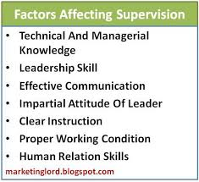
Figure: Factors of effective supervision (Martin, 2020)

4. Action Plan for Professional Development
Improving skills: I will enhance time management and pressurized decision-making to develop professionally. One of the tasks that I will accomplish is taking a brief course on leadership and supervision, which offers me an alternative to specializing in team management in the hospitality sector. This will assist in being forceful when giving orders, and when providing solutions (Vallen et al., 2014).
Training programs: I also intend to further develop my communication skills, which will include practising active listening skills and the techniques of providing constructive feedback positively. To be more flexible, I will request to be given feedback in case of any further shifts or placements and assess what went right or wrong.

Section 2: Development Journey

1. Comparison with Previous Food & Beverage Placement (Level 4)
Similarities and differences between current and past placement: My previous assignment was at a small city hotel, where the restaurant had fewer clients and the menu was less complicated. In Ashford, the operation was larger, breakfast and dinner services were busier, and I needed to serve guests as well as conference attendees. It was more challenging as it was bigger and the pressure was greater (Walker, 2021).
Hotel types, operations and experiences: At Ashford, I was forced to work in haste and be more conscious of professional practices such as welcoming guests formally and the practice of upselling. The other variation was the teamwork structure. I only remember that at my Level 4 placement, we only had two or three individuals on shift.
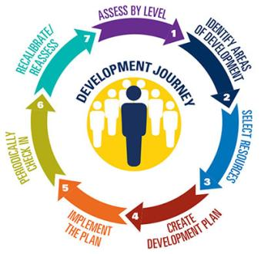
Figure: Development journey (Wood et al., 2013)

2. Reflection on Learning from Modules
Level 4 – Food & Beverage Operations
This module backed me with the fundamental knowledge regarding the operation of food and beverage departments in hospitality. The theories could be applied to reality during my placement.
Level 5- Sustainable hospitality & Tourism management
My placement had numerous connections with this module as it was based on the concept of sustainability. At Ashford, the hotel promoted the idea of minimizing waste and utilizing resources again (Peh, 2021).

Section 3: Service Improvement Proposal

1. Area for Improvement
Identified key areas: The area I have selected to make improvement is the speed of service to the guests during breakfast in the Food and Beverage section. When I was on placement at Ashford International Hotel & Spa, I realised that the breakfast service was always hurried and hectic at times. Visitors were forced to wait too long to get tea, coffee, or clean tables (Fanthorne, 2004).
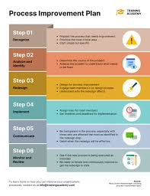
Figure: Process improvement proposal (Cousins et al., 2020)

2. Justification for improvement
Firsthand observations: My proposal is grounded on personal observations and the feedback of peers. I frequently heard members of the team complain that mornings were the worst part of the day.
Colleague feedback: There was, says, one morning when we ran out of clean cups and I had to wash some in a hurry. This slowed down service and we appeared to be unprepared. This would benefit guests and staff alike and would speak well of the hotel in terms of its reputation (Vallen et al., 2014).

3. Improvement Plan
Actionable 3 steps:
First, a short morning briefing before the breakfast shift should be conducted to define roles and press the preparedness. This would prevent confusion and delays.
Second, we can set things such as cups, cutlery, and condiments ready the previous night to buy some time in the morning.
Third, it can be beneficial to have a floating staff member during peak hours to fill in the gaps in a short period. These small adjustments would result in a quicker and smoother service and guests would begin their day on a more positive note (Gyllenhammar et al., 2023).

4. Enhancing Performance and Technical Knowledge
Enhancing performance criteria: I have to work on my performance and technical knowledge to comply with the Food and Beverage service standards. The first is through learning efficient skills that save time (Bhushan et al., 2021).
Technical knowledge: I would also like to enhance my product knowledge, i.e., know the ingredients of the breakfast items, so I can easily answer the questions that the guests have. The second method would be to educate more on service sequence. The structure for teamwork was the other alternative. All I can recall is that there were only two or three people working shifts at my Level 4 placement.

Conclusion
The pace at which customers are served at breakfast in the Food and Beverage sector is the area I have chosen to improve. I saw both effective and ineffective supervision, when staff members felt empowered and where a lack of oversight resulted in a slowdown. These examples showed how team performance and guest happiness may be impacted by management. I discovered that the breakfast service at Ashford International Hotel & Spa was occasionally rushed and frantic while I was on placement there.

References
ASET (2017) Good Practice Guide for Workbased and Placement Learning in Higher Education. Sheffield: ASET.
Bhushan, B., Sinha, P., & Sagayam, K. M. (2021). Untangling blockchain technology: A survey on state of the art, security threats, privacy services, applications and future research directions. Computers & Electrical Engineering, 90, 106897.
Cousins, J. & Weekes, S. (2020) Food and Beverage Service. 10th Ed. London: Hodder Education.
Fallon, M. & Rutherford, D. (2010) Hotel Management and Operations. London: Wiley.
Fanthorne, C. (2004) Work Placements – Survival Guide for Students. Basingstoke: Macmillan.
Gyllenhammar, D., & Hammersberg, P. (2023). How to facilitate improvements in public service systems: propositions for action. International Journal of Quality & Reliability Management, 40(6), 1429-1448.RHN
Hagg, E. (2013) Internship Guide: Work Placements Step by Step. 5th Ed. The Hague: Eleven International Publishing.
Johnston, R., Clark, G. & Shulver, M. (2012) Service Operations Management: Improving Service Delivery. 5th Ed. London: Pearson.
Martin, A. (2020) The Practical Guide to Understanding and Raising Hotel Profitability. Abingdon: Routledge.
Peh, W. (2021). Lean six sigma implementation for it service delivery: case study and improvement plan proposal (Doctoral dissertation, Open University Malaysia (OUM)).
Vallen, G.K. & Vallen, Jerome J. (2014) Check-In Check- Out: Managing Hotel Operations. 9th Ed. Harlow: Pearson Education Limited.
Walker, J.C. (2021) Introduction to Hospitality. 8th Ed. Harlow: Pearson Education Limited.
Wood, R.C. (2013) Key Concepts in Hospitality Management. London: SAGE Publications Ltd.

