PILOT STUDY ON EXPLORING THE INTERCONNECTEDNESS BETWEEN AI ADOPTION, STANDARD OPERATING PROCESSES AND WORKFORCE CAPABILITY: IMPLICATIONS FOR STRATEGIC HR PLANNING IN A UK FINTECH SME

Student ID: 2521135
Course: Converting Research to Practice
Course Code: LCDB7010
Lecturer: Prof. Amare Desta

Table of Contents
Abstract 4
1.0 Introduction 5
1.1 Background 5
1.2 Problem Statement 5
1.3 Research Aim and Research Questions 6
1.4 FinTech Operations. 6
1.5. Challenges with AI Adoption 7
1.6. Pilot Study Scope and Rationale. 8
2.0 Literature Review 8
2.1 AI Adoption in FinTech: Automation, Fraud Detection and Algorithmic Decision-Making 8
2.2 Standard Operating Processes and Process Formalisation 9
2.3 Workforce Capability and Skill Gaps 10
2.4 Theoretical Foundation 11
2.5 Conceptual Framework 13
3.0 Methodology 15
3.1 Research Design 15
3.2 Data Collection 18
3.3 Sample 18
3.4 Instrument Design 18
3.5 Data Analysis 19
3.6 Ethical Consideration 20
4.0 Results and Findings 20
4.1 Overview 20
4.2 Task Automation and the Redistribution of Work 21
4.3 SOP Transformation 22
4.4 New Skill Requirements 22
4.5 Difficulties with Human-AI Interaction. 23
4.6 Summary of Themes 23
5.0 Discussion and Limitation 24
5.1 Discussion 24
5.1.1 Interconnection of AI Adoption, SOP Transformation and Workforce Capability 24
5.1.2 Managerial Implications 25
5.2 Limitations 26
5.2.1 Suggestions for Future Research 26
6.0 Conclusion and Implication 27
6.1 Conclusion 27
6.2 Practical and Theoretical Implications 27
PART TWO: REFLECTIVE ACCOUNT ON PILOT STUDY 28
References 32
Appendices 38

Abstract
FinTech is becoming more and more infused with artificial intelligence, influencing not only the technological infrastructures but the way in which work is structured and carried out. Despite the fact that the factors and advantages of AI adoption have been studied on large scales, less focus has been made on what happens in organisations after adoption, especially on standard operating procedures (SOPs) and workforce competences. This pilot study fills this gap by examining these dynamics in one of the UK FinTech SME using an exploratory qualitative design. The data were processed through an open-ended questionnaire, which will be given to employees working in operational, data, and technical positions and interact with AI on a daily basis. The socio-technical systems theory, dynamic capabilities theory and strategic HRM inform the study conceptualising the adoption of AI as not a linear process but a process of evolution of interaction among technology, processes and people.
The results show that AI implementation is not associated with an overall coordinated organisational change. As much as AI disrupts work and lessens manual workload, SOP changes seem to be rather reactionary and they are not frequently structured or owned. At the same time, workers are noted to have new skills requirements, especially in the interpretation of outputs and use of judgement, which is currently not sufficiently covered in formal training. There is also uncertainty on how well AI outputs should be relied on and how quickly support mechanisms in organisations are evolving.
Finally, the implementation of AI in FinTech SMEs is more of a continuous, unbalanced adaptation of the technology than a one-off implementation process. Technology, processes, and workforce capability change out of phase, which generates mismatches with significant implications to long-term strategic HR planning and the sustainability of AI integration.

Keywords: Artificial intelligence (AI), Fintech, Small and medium sized enterproses (SMEs), Business process management (BPM), Standard operating procedures (SOPs), workforce capability,socio-technical systems, dynamic capabilities, institutional theory, human resources management (HRM)

1.0 Introduction

1.1 Background
Over the past decade, artificial intelligence has ceased being a broadly integrated theory to an element of the organisational continuous, particularly in the financial services sector, where it is gradually becoming a determiner of decision-making, process formulation, and work performance. This transformation lies within the bigger FinTech revolution, which is outlined by Gomber et al. (2018) as the intersection of technological innovation, the alteration of financial models, and the introduction of new capital streams into the existing systems. This already manifests itself in practice. The example of a COiN platform created by J.P. Morgan relies on natural language processing to read legal documents more efficiently and companies such as Morgan Stanley use machine learning to help with more complex financial decisions (Maple et al., 2023).
In the meantime, machine learning, natural language processing, deep learning, and predictive analytics have already become a major component of the core activities of the company such as fraud detection, credit scoring, compliance, and algorithmic trading (Khan et al., 2024; Aderemi, 2025). This tendency is justified by the trends in investments, the total value of financing FinTech in the world is estimated at 164.1 billion in 2022 (KPMG, 2023), which means the further growth of the trend and the rise in the expectations of digital competence (Dwivedi et al., 2021; Olasiuk et al., 2023).

1.2 Problem Statement
The UK FinTech SMEs are in a highly regulated and competitive market where regulatory pressures and market dynamics speed up the adoption of AI. Although studies on AI and its effects on performance outcomes (revenue, customer experience and competition) have been conducted, little has been done to consider its effects on an organisation internally. Specifically, the interaction between AI adoption and the transformation of standard operating procedures (SOPs) and the workforce capability in a single organisational environment is not well understood empirically.
FinTech SMEs increase the intensity of these challenges, with regulatory expectations being strong, less formalised HR systems, and limited resources to develop structured capability (Harney and Alkhalaf, 2020). Thus, organisations do not have a point of reference on how to match AI implementation and sustainable processes and staff development without a better understanding. This study addresses this gap by examining these interactions within a UK FinTech SME to inform more proactive and integrated HR planning.

1.3 Research Aim and Research Questions
This paper seeks to examine how AI adoption, standard operating processes, and workforce capability are interconnected within a UK FinTech SME. It will also discuss what this interconnectedness implies on strategic HR planning. The research questions that guide the study are as follows:

Primary Research Question: What is the impact of AI adoption on the standard operating procedures and workforce capability and what do these effects suggest about strategic HR planning in a UK FinTech SME?
Sub-questions:
- What is the current AI adoption in the SME and what organisational change does it elicit?
- What is the impact of AI adoption on standard operating processes creation or change?
- What are some of the workforce capability gaps that arise due to the adoption of AI?
- What is the informal HR structure in the SME to meet these capability demands?
- What strategic HR planning can enable sustainable AI adoption?

1.4 FinTech Operations.
FinTech organisations operate in high-risk environments that involve financial transactions, sensitive information, and stringent regulatory environments, in which consistency and reliability are essential (Bagwe, 2025; Parisa et al., 2024). SOPs in this context operate both as control more of a control and accountability mechanism coupled with a guide of the procedure. Business process management (BPM) entails the ongoing process modelling, monitoring and redesign rather than the business processes existing in the fixed state (Dumas et al., 2013). This is critical in FinTech where a small failure can lead to major financial or compliance consequences.
The introduction of AI makes such structures more complicated. As an example, fraud detection automation needs changes to the decision rules, exception management, and employee interpretation of the system output (Papić, 2025). Whereas other researches consider process standardisation to be structured and cyclic (Goel et al., 2023; Agustina and Mujanah, 2024), that presupposes the existence of coordination, which is not always present in SMEs.

1.5. Challenges with AI Adoption
Though AI is linked to efficiency, it has a complicated organisational effect. Instead of removing work, it transfers the functions of execution to control, and the employees should be able to process outputs and make decisions in unspecified circumstances (Bessen, 2019). Such demands can be more than the original design of jobs. Although the importance of adaptability and technical skills is acknowledged (Babashahi et al., 2024), organisations often do not have systematic methods of cultivating them, thus leading to reactive capability development.
The other effect of AI adoption is on employee experience. The inability to convey the role change efficiently can increase the level of job insecurity and psychological stress (Nazareno et.al, 2021). In the meantime, digital literacy, data comprehension, AI ethics awareness are more in demand (Priyanghaa, 2025), and might prove difficult to develop among less formal training systems in SMEs.
These barriers represent a larger organisational issue. The deployment of AI must be gradual in line with the capability of technology and processes, and the workforce (Agrawal et al., 2023). The misalignment with SMEs is greater, and the gaps between the implementation and operations, as well as workforce preparedness, are more intense.

1.6. Pilot Study Scope and Rationale.
The existing studies of FinTech focus more on the benefits of technology and performance outcomes, but no much has been accomplished to record internal organisational disruption. Particularly, there is a dearth of empirical studies on the relationship between the adoption of AI and SOP transformation and workforce capability in practice. Additionally, SMEs are prone to deploy AI without sufficient thinking of the organisational changes required (Rudko et al., 2021), leading to the lack of congruency between technology, processes, and workforce ability. This will compromise the intended AI benefits. The research addresses this gap by examining how adoption of AI, SOPs, and workforce capability interact in a FinTech environment. It is holistic in that the change in one dimension influences the other. Under the question, How does AI adoption impact the SOPs and workforce capability within a FinTech organisation, the research will have both theoretical and practical advice on how to align technology, processes and workforce development. Within the scope of this pilot study, the feasibility and acceptability of using an open-ended qualitative questionnaire with employees in a busy FinTech SME will be accessed. Also, this pilot study will be used to explore whether the proposed conceptual framework and guiding propositions capture how AI adoption, SOP change and workforce capability are experienced in practice.

2.0 Literature Review

2.1 AI Adoption in FinTech: Automation, Fraud Detection and Algorithmic Decision-Making
Gomber et al. (2018) define the FinTech revolution as a technology-capital-new business-model convergence that is fundamentally transforming the financial services architecture. Practically, machine learning is now the foundation of such core functions as lending money to customers (loan approvals), credit scoring, customer risk profile, and fraud detection, performed on a scale and speed that is beyond human ability (Kadam et al., 2025).
Nonetheless, the implementation of AI in FinTech is not merely a technological upgrade, but is highly institutional. Akhtar et al. (2024) reveal that one of the factors that influence adoption is individual innovativeness and financial literacy, along with regulatory frameworks and institutional support systems. This defies the traditional framing of the Technology Acceptance Model (TAM) which is, to a considerable extent, the explanation of the adoption in terms of perceived usefulness and ease of use (Junior et al., 2025). Iman (2020) criticises this weakness by noting that TAM fails to recognize the importance of regulatory pressures, market competition, and institutional constraints that greatly influence FinTech settings. Conversely, institutional theory provides a better explanation because DiMaggio and Powell (1983) state that in many cases organisations do not necessarily embrace technologies because of efficiency reasons but because of coercive, normative, and mimetic pressures. In FinTech SMEs, specifically those within the Financial Conduct Authority (FCA) regulation, regulatory compliance is a decisive actor that directly organizes adoption choices, as well as system design demands.

Another essential issue that arises as a result of AI implementation is explainability. Rai (2020) notes the black box character of most AI systems, especially deep learning models, whose decision-making process is usually not transparent even to the creators of the model.
Frederiks et al. (2022) also support the role of regulatory pressure as the most effective force to advance AI adoption in the financial service sector over the internal organisational preparedness and choice of managers. This implies that AI implementation in FinTech is not as discretionary as it is structural, and it has important ramifications on organisational governance and procedural alignment.

2.2 Standard Operating Processes and Process Formalisation
The processing of the transactions, fraud escalation, and resolution of customer complaints are examples of operational activities that in business process management (BPM) terms, are usually controlled by organised procedures that allow organisations to show regulatory compliance and operational control to auditors and stakeholders ( Van der Aalst, 2013). Integrating AI does not eradicate SOPs but instead changes their scope, content, and governance logic especially with an ever more algorithmically mediated decision-making process.
The process of formalisation of processes is more of an iterative and incremental phenomenon than a single-time phenomenon. Goel et al. (2023) interpret standardisation as a cyclic process, of preparing, reviewing, updating, maintaining, distributing, archiving, and training. Likewise, Van der Aalst (2013) points out that business process management needs to be continuously modelled, observed, and redesigned to sustainably transform digital transformation. Dumas et al. (2013) build upon this point of view by separating process discovery, analysis, and redesign, which are further complicated by the implementation of AI into operational systems.
According to Aleš et al., (2024), AI creates value when processes are standardised in the first place since structured inputs and well-defined rules can promote algorithmic efficiency. But Rosemann et al. (2024) include a more integrative perspective, and AI does not only perform processes, but also allows them to be discovered and redesigned. It is substantiated by Agustina and Mujanah (2024), who demonstrate that AI-based workflow automation within SMEs tends to generate completely new process architectures and not just digitise the ones that already exist.

2.3 Workforce Capability and Skill Gaps
Babashahi et al. (2024) highlight technical proficiency and adaptability as core competencies in AI-enabled settings, but observe that organisations are often reactive to skill gaps post hoc instead of being proactive in their planning. Autor (2015) offers a more comprehensive view of the labour market, suggesting that automation does not remove jobs altogether but just restructures them by substituting with routine work and creating more job demands in non-routine cognitive and relational work.
This argument is further refined by Bessen (2019), who shows that the result of employment is based on the elasticity of demand and the speed of organisational adaptation. When automation is applied to high-growth areas like FinTech, it can increase jobs in general, but in reconfigured jobs with new skills required.
Nonetheless, SMEs have structural limitations to developing these capabilities. Harney and Alkhalaf (2020) reveal that HRM practices in SMEs tend to be informal, under-resourced, and reactive, thus restricting their ability to engage in systematic workforce development. Therefore, building capabilities in reaction to the use of AI is usually disjointed and sporadic. Bandara et al. (2025) adopt dynamic capability perspective on AI driven HRM, which shows that organisations need specialized capabilities to manage data, model and deployment bias instead of expecting these to emerge from one-off training activities. This supports the view w that the critical skill gaps in data literacy, AI supervision, ethical decision-making could not be addressed within the traditional training frameworks and demand continuous organisational learning.
Additionally, Nazareno et al.(2021) also point out that AI-based job restructuring may lead to an poor employee well being, including feelings of job insecurity and psychological distress, especially when employees feel that the organisation is not sufficiently supportive of them. Using the dynamic capabilities framework, Drydakis (2022) suggests that workforce adaptability investment by SMEs can have more sustainable results in terms of AI integration.

2.4 Theoretical Foundation
To comprehend the interrelationship of AI implementation, standard operating procedures (SOPs), and workforce ability, it is necessary to have a clear theoretical basis more than descriptive literature. In this paper, we will take a multi-theoretical approach to the study by relying on four complementary theories to explain this multifaceted phenomenon, acknowledging their respective weaknesses at the same time.
First, the Socio-Technical Systems Theory (STS) (Trist and Bamforth, 1951) views organisations as two systems that are interdependent, the technical (technology, tools, processes and information) and the social (people, relationships, and organisational structures) systems. Although the individual systems can be optimised to achieve short-term benefits, their combination is what can lead to long-term effectiveness. Amanollahnejad et.al,(2026) have used STS for AI integration and showed that the implementation of technology should be in harmony with the organisational structures. Their longitudinal SME studies have demonstrated that leadership, data infrastructure and workforce factors are more decisive to success than the technology itself.
Second, the Dynamic Capabilities Theory (Teece et. al, 1997; Teece, 2007) provides a strategic perspective, which concerns how an organisation is able to sense opportunities, capture them, and reorganise resources, when faced with change. As demonstrated, AI has increased these functions especially in the speed of sensing and the use of resources within SMEs. Cimino et al. (2025) observe that AI implementation is best in organisations that already have developed adaptive capabilities and organisations that do not have these capabilities find it difficult to benefit. The theory can be used in this research to understand the strategic response to AI-driven change by FinTech SMEs.
Third, the Institutional Theory (DiMaggio and Powell, 1983; Scott, 2001) describes the manner in which the external pressure influences organisational behaviour, through regulation, norms, and expectation. These pressures are especially high in FinTech, as they are regulated. Frederiks et al. (2022) reveal that regulatory uncertainty may even promote AI adoption since companies attempt to gain legitimacy by making themselves appear innovative. They also point to coercive forces of regulators like the Financial Conduct Authority (FCA) in the digital transformation process. Nevertheless, it fails to clarify the implications of the adoption to internal process, SOP redesigning, and the capability of the workforce.
Lastly, HRM capability frameworks, which are based on resource-based view (Barney, 1991) and strategic HRM (Wright and McMahan, 1992) highlight the importance of human capital in attaining competitive advantage. These frameworks emphasize the fact that organisational performance does not solely rely on technology but also non-technical resources like leadership, culture and governance (Ulrich et al., 2024).
Each of the theories alone can only offer a partial view of AI adoption in FinTech SMEs. STS is the explanation of interdependence within the system, but it lacks strategic orientation. Collectively, these theories give a holistic perspective of how the integration of AI is transforming processes and workforce capability in SMEs.

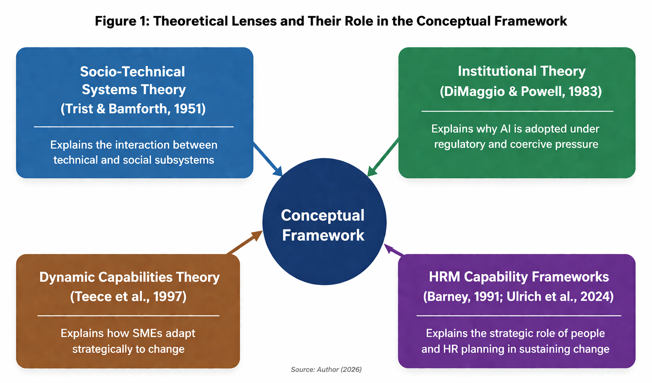
Figure 2.1: Theoretical Lenses and Their Role in the Conceptual Framework (Author, 2026)

2.5 Conceptual Framework
The four theoretical perspectives outlined in Section 2.4 is being built on, which leads to this study developing a conceptual framework that explains the relationship between AI adoption, standard operating procedures (SOPs), and workforce capability as recursive rather than linear. Unlike traditional models that treat AI adoption as a causal input leading to organisational outcomes, this framework conceptualises an ongoing cycle of interaction:
- AI Adoption → Standard Operating Procedure Change
- Standard Operating Procedure Change → Reveals Workforce Capability Gaps
- Capability Gap → Creates Demand for Strategic Human Resource Planning
- Strategic Human Resource Planning → Shapes Conditions Under Which Sustainable Use of AI Can Be Adopted Over Time
This recursive form is based on the fact that change in an organisation is not a step-by-step process. Rather, the elements keep on influencing and redefining the others in the course of time. Indicatively, when AI is introduced into operations, SOP redesign may be required, and this means capability differences among the employees will be revealed.
Recursiveness of the model is also favored by the existing literature. The process of formalisation of process in organisations is also ongoing and includes repeat cycles of review, revision and training (Goel et al., 2023). Human resource planning in SMEs tends to be in lag of operational change, introducing a time gap between processes and capabilities (Harney and Alkhalaf, 2020). This gap is captured in the framework where it is realised that every element is continually adapting to the other.
The model is also placed in an institutionalized FinTech context by the Institutional Theory, where the acceptance of AI is driven by external factors, unlike internal choices (DiMaggio and Powell, 1983; Frederiks et al., 2022). Lastly, in line with Yin (2018), this framework is operationalised in terms of guiding propositions, as opposed to hypotheses that are set in stone, and this gives the flexibility to empirical insights to sharpen the relationships found. This may be symbolized as;
- P1: AI adoption in the FinTech SME has led to some noticeable changes in the nature of work, including the automation of tasks, the different ways decision-making is shared and new demands being placed on operations.
- P2: These changes have influenced some necessary modifications to standard operating processes, including the development of new documents, updated workflows, and revised compliance procedures.
- P3: The reconfiguration of processes has exposed workforce capability gaps, areas where employees lack the skills, knowledge, or confidence to work effectively with AI tools and AI-modified processes.
- P4: The organisation's HR function, in its current form, is not fully equipped to identify, prioritise, or address these capability gaps in a strategic and forward-looking manner.
This pilot study doesn’t thoroughly test these propositions, but instead uses them as a guide to focus on the key areas identified by the conceptual framework. The goal is to collect data and analyse data that sheds light on these important constructs. A more in-depth examination will come later in the full case study, which will take a closer look at how AI adoption, standard operating processes, and workforce capabilities interact with each other. The relationships between these factors may be more complicated or structured differently than the framework currently suggests.
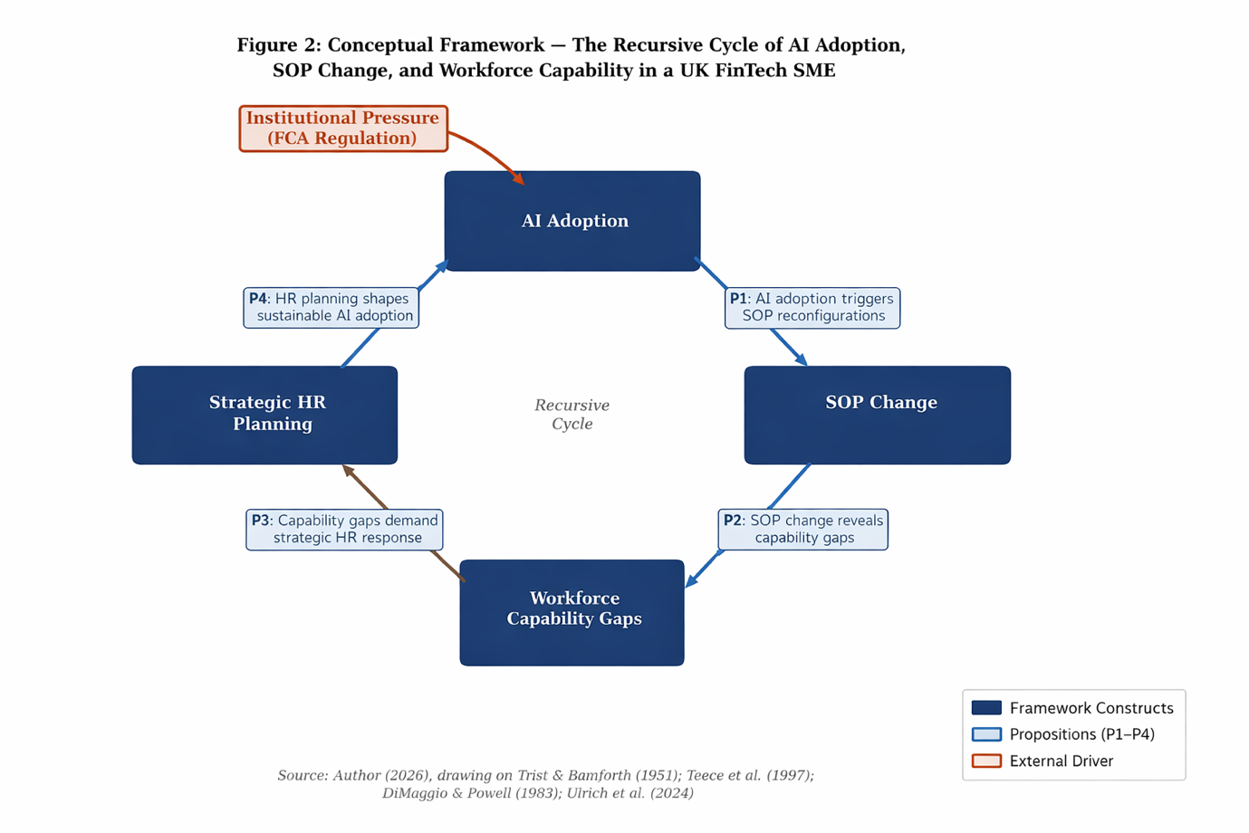
Figure 2.2: The Recursive Cycle of AI Adoption, SOP Change, and Workforce Capability (Author, 2026)

3.0 Methodology

3.1 Research Design
This study adopts a qualitative pilot research design grounded in an interpretivist philosophy. Interpretivism is aimed at comprehending how people interpret their experiences and meanings that they assign to them (Creswell & Poth, 2018). It presupposes that social reality is made by subjective interpretations that depend on the personal roles and situations (Saunders et al. 2019).
The paper thus seeks to encapsulate and examine these varied views to gain a clearer insight into how AI-driven change is viewed in practice. The use of a pilot study design is not due to limitations but a methodological choice. Pilot studies are important in research design testing, evaluating the data collection methods, and uncovering emerging trends or concerns (Malmqvist et al., 2019). The pilot was used to test the suitability of an open-ended questionnaire in producing the kind of data needed for the main study. It also investigates how applicable the conceptual framework is to a UK FinTech SME in this study and considers the recursive relationships between AI adoption, SOP changes, and workforce capability. Results will be used to design a follow-up qualitative case study of larger scale.
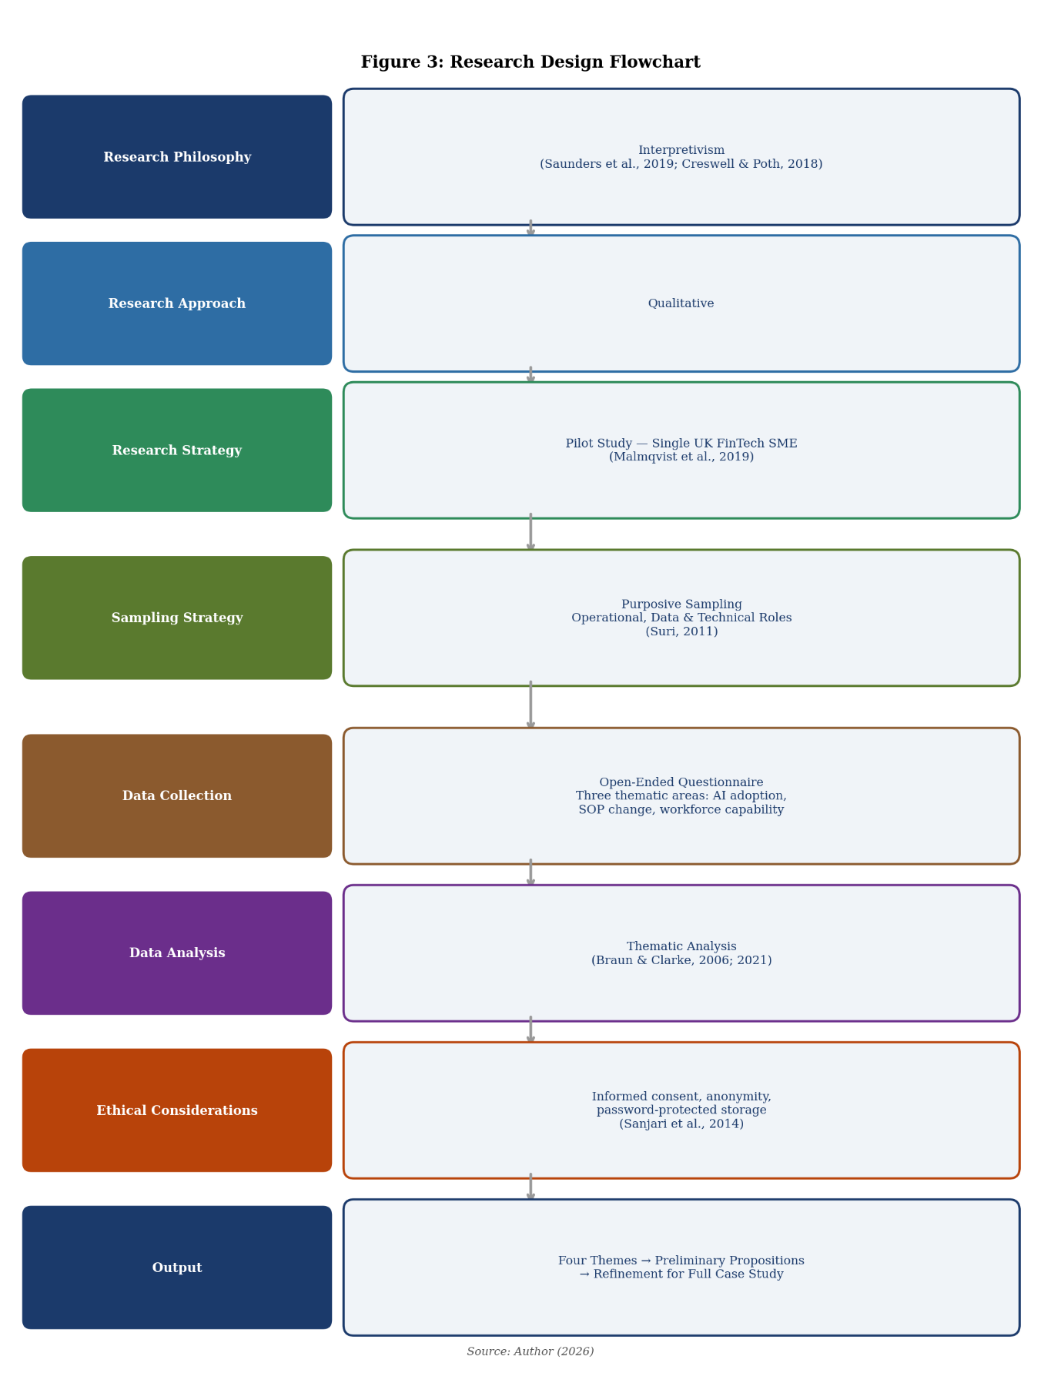
Figure 3.1: Research Design Flowchart (Author, 2026)

3.2 Data Collection
Data were collected through an open-ended qualitative questionnaire administered to employees of a single UK FinTech SME. The choice of an open-ended questionnaire over semi-structured interviews was used in majorly because of the demanding busy schedules of Fintech employees, scheduling interviews would have created unnecessary barriers to participation, instead allowing employees to complete the questionnaire at a time and place that suited them most. This felt more realistic and the flexibility seemed to make participation genuinely easier for everyone.
The questionnaire explored three main areas aligned with the three core constructs of the study. The first section asked participants about their use of AI tools in their daily work, what tools they use, how frequently, and for what purposes. The second section looked at how older workflows were being adjusted or quietly replaced over time, who was responsible for modifications, and how structured the process of change had been. The third section invited participants to reflect on their own skills, confidence, relating to collaboration with AI, as well as support for training relating to these skills.

3.3 Sample
The purposive sampling was used to select participants so that the selection could be deliberate so that the participants could be those with the best experience and knowledge to the research question in qualitative research, quantity is never a focus but relevance (Suri, 2011).
When designing the sample, people in the operations, data analysis and technical departments were given the greatest consideration. The idea was just to get the opinion of those who had real-life experiences with AI in their day-to-day activities. Practical examples of changes in workflow was not expected and some of their answers contained such examples. It was a good source of insight into the adoption of AI, and its implications in the Fintech SME context.

3.4 Instrument Design
The questionnaire was designed after a number of revisions. It was meant to ensure that questions were not made too technical and far-fetched. This was achieved through streamlining the words to ensure the participants did not feel that they were supposed to provide highly professional answers and be concerned about not sounding right.
- AI Adoption that specialized on the current usage of AI in the organization and the kind of takes it can support.
- Standard Operating Processes (SOPs) that examined how and whether workflows and processes have changed since the implementation of AI.
- Workforce Capability that looked into the capabilities that one needs to have to work with AI systems, training, and the support that the organization may offer.
The design was such that the responses could be systematically analyzed yet still given an opportunity to share their experiences using their own words (Braun and Clarke, 2021).

3.5 Data Analysis
After the responses were received the analysis was done using thematic analysis approach. According to available literature, this technique is appropriate when doing exploratory work since it allows repetition of ideas and patterns to be naturally developed out of what people actually wrote (Braun and Clarke, 2006).
The initial procedure was to read all the responses a few times. Slow readings are made to be sure that the connections required to be identified are not overlooked. The pauses at this point actually assisted the patterns to begin to emerge. Then there was coding, or checking off common themes like workflow adjustments, skill adjustments, or times of confusion over new systems. There were codes which were re-released and re-released, and others were re-released once or twice, but which nevertheless had actual weight.
Once coded, then similar ideas were clustered into larger themes. These themes encompassed common experiences among participants, such as how to collaborate with new tools or how to convert old habits. All themes were meticulously made to ensure that they remained faithful to what people had actually said.
Short snatches were chosen among the responses in the last stage to give life to the themes. The wording of the participants was preserved to maintain their original meaning and to maintain the transparency and respectfulness of the reporting (Braun and Clarke, 2021).

3.6 Ethical Consideration
The whole research process was based on ethical considerations. Participation was voluntary. All the participants were given a clear information that expounded the purpose of the study and their rights. They were informed that they could withdraw at any time in case they were not comfortable (Sanjari et al., 2014).
The success of this work was dependent on protecting confidentiality in the first place. No personal information was gathered in the questionnaire, and thus, there is no trace of the respondents with each answer. This maintained anonymity throughout the beginning.
All data were stored in password protected systems and only had access according to the requirements of the research. Although these steps were made in accordance with the general guidelines, they were also based on a higher feeling of responsibility, a personal obligation to handle the stories of the participants with care and respect.

4.0 Results and Findings

4.1 Overview
The data from the questionnaires was analysed using thematic analysis and the gathered themes linked together to present first insights into the recursive relationships between the elements of the conceptual framework from Section 2.5. These themes provide insights on automation of tasks and distribution of work as well as how current processes of working with AI are transformed sometimes reactively, new skills that are required and also challenges that remain when working with AI interact with humans.

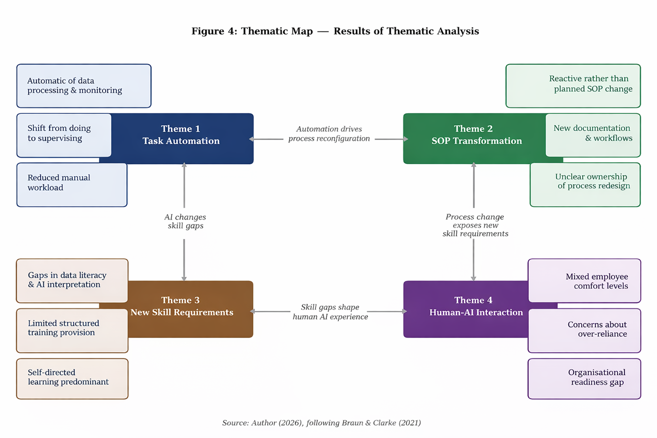
Figure 4: Thematic map illustrating themes and subthemes (Source- Author, 2026, following Braun & Clarke, 2021)

4.2 Task Automation and the Redistribution of Work
In all the 10 respondents, AI was always reported as being integrated into transaction monitoring, fraud detection, compliance and decision support, which means it is central to business operations. The participants generally concurred that AI minimized the amount of manual labor and enhanced speed and efficiency. As an example, one participant said that AI assists in flagging transactions and prioritisation of work, another participant said that onboarding could be completed in several minutes with the help of biometric AI, which does not cause delays caused by manual verification.
But other than efficiency benefits there was a greater trend towards redistribution of work as opposed to replacement. 7 respondents explicitly talked about a transition towards execution to oversight. One of the senior managers pointed out that he was in charge of the system utilization, and the staff who are operating on the frontline pointed out that flagged transactions must still be checked by a human. Even in highly automated processes, like the onboarding process, exceptions and edge cases still needed human intervention.
Although it coincides with Gomber et al. (2018) and Kadam et al. (2025), the results present new information to the existing literature since they demonstrate that AI does not eradicate but changes human functions.

4.3 SOP Transformation
Every 10 participants noted that adoption of AI resulted in transformation of organisational processes, albeit to different levels and forms. About 8 participants observed heightened formalisation in certain aspects especially compliance and transaction management. According to one participant, the processes such as record keeping and approvals have become more organized, a factor that is in line with how AI requires more cohesive workflows to ensure that it generates consistent outputs.
Meanwhile, 9 of them highlighted a deficiency in systematic implementation. Process updates were very reactive: “Procedures occur when required and not as a component of an organized rollout. The SOP changes were divided into responsibilities whereby some of the organizations attributed it to the IT or operations, others to the leadership and none had a uniform ownership model.
The results demonstrate that transformation is not a planned, but an emergent, iterative and disproportionate one, particularly, in an instance of SMEs, although AI can be considered a catalyst of process redesign (Van der Aalst, 2013; Dumas et al., 2013). The recursiveness of change is further supported by the fact that SOPs are never planned but always changed with time as changes.

4.4 New Skill Requirements
The development of hybrid skill needs, a mix of technical knowledge and business and operational knowledge, had a high consensus among 9 people. Participants emphasized the significance of the interpretation of AI outputs and the understanding of system behaviour, and one reported, “There is a lack of cross-functional understanding. This is an indication of the transition into the positions where one is expected to possess analytical and contextual decision-making skills as well.
Nevertheless, 8 participants indicated severe inadequacies in training delivery. The education was mostly informal, referred to as on the job or project based and there were minimal formal development routes. This has led to lack of uniformity in the level of capabilities, specifically to the employees who are not so familiar with digital systems.
The results are consistent with Babashahi et al. (2024) which found that reactive capability development is predominant in AI adoption situations. In line with Bandara et al. (2025), two important gaps in capabilities are data literacy and AI supervision.

4.5 Difficulties with Human-AI Interaction.
The respondents indicated a difference in trust and comfort with AI systems. Although 6 participants noted confidence in using AI as an aid tool, they continuously stressed its limitations and the need to monitor it by humans. Conversely, it was found that 4 participants were unsure especially when the outputs of the systems were not clear: “It is not always obvious what to do. This ambiguity was particularly apparent in operation positions, where the system output is a key component of decision-making.
One overwhelming concern among 8 participants was the disconnect between technology, processes and workforce preparedness. Some of the respondents noted how AI systems are developing faster than the organisation structures and one of the respondents remarked, the technology is ahead of the organisation. This points to a lack of a connection between implementation and organisational preparedness.
In agreement with Priyanghaa (2025), these findings imply that there is a socio-technical alignment of incompleteness in issues, rather than just because of technical limitations. The confidence in AI is conditional depending on clear procedures and competence enough, which are still in development. This illustrates the importance of making sure that the technology adoption is coordinated with organisational readiness to attain successful adoption.

4.6 Summary of Themes
All these results show that the implementation of AI is a multi-dimensional organisational change, rather than an increase in efficiency. AI transfers work to supervision, shifts SOP adaptation to be persistent, reactive, and develops the issue of human-AI interaction. Significantly, these themes cement a recursive dynamic, whereby technology, processes, and the capability of workforce is in a state of continual influence and response to each other. This affirms the holistic nature of the research and indicates a primary contribution: AI implementation in FinTech SMEs is not as technologically capable as it is driven by the organisational capability to manage the endemic incompatibility of interconnected systems.

5.0 Discussion and Limitation

5.1 Discussion

5.1.1 Interconnection of AI Adoption, SOP Transformation and Workforce Capability
The findings of this pilot study confirm the main idea of the conceptual model: the process of AI adoption, SOP transformation, and workforce capability are interrelated phenomena that are recursively linked, but not independent. The use of AI has also initiated process transformation throughout the organisation, but this has been more of a reactive and unplanned nature, as opposed to being a planned and gradual transformation. This is indicative of the incompatibility pointed out by Goel et al. (2023), who say that standardisation of sustainable processes should involve coordination.
The appearance of new skills demands, in particular, data literacy, interpretation of AI outputs, and process monitoring directly stem not only from the adoption of AI but also from updated SOPs. The capabilities necessary to perform change along with the processes themselves evolve. However, the organisation has failed to come up with an organised reaction to these capability gaps. Training is still responsive, informal and skewed. This validates Babashahi et al. (2024) and Bandara et al. (2025), who recognize the aspect of capability development as a key but poorly studied aspect of AI adoption.
One of the main results is the shift of work to execution to supervision. This is also in line with Autor (2015) who estimated that automation would cause a decrease in routine jobs and an increase in non-routine, judgment-based jobs. Employees are now more likely to monitor, validate and interpret AI outputs instead of acting directly in this organisation. This change is a paradigmatic shift in the design of work, which demands new skills.
The recursive reasoning behind the framework can be seen in the following way: The implementation of AI will lead to change in SOPs; the change will reveal gaps in capabilities; the gaps will create risks that can threaten the future of AI. This dynamic can be associated with Dynamic Capabilities Theory (Teece, 2007), in which organisations are forced to constantly change resources in response to technological change.
Nonetheless, the results also question the current models. Although the framework (Section 2.5) proposes that the gaps in capabilities are to drive strategic HR planning, the evidence that there is such a feedback loop is non-existent. HR planning has been a big omission. This builds on Harney and Alkhalaf (2020) who show that HRM in SMEs is not only reactive but also fails to act despite obvious capability gaps. This is contrary to assumptions in Alzeiby et al. (2025) and Ulrich et al. (2024) that skill gaps awareness results in HR intervention. The process of awareness to action in resource-constrained, regulated SMEs seems conditional and delayed. This contradiction does not nullify the framework but puts more emphasis on the necessity to conduct further research on the circumstances in which the gaps in capabilities are translated into HR actions.

5.1.2 Managerial Implications
The findings indicate that the implementation of AI within FinTech SMEs cannot be approached as a technological one. Rather, it needs a concomitant matching of technology, processes and people. Outsourcing AI to IT alone poses a risk of causing misalignment whereby systems change quicker than organisational structures and workforce preparedness. Managers need to be more integrated and proactive. The adoption of AI should incorporate strategic HR planning at an early stage instead of being introduced in response. This is also in line with Alzeiby et al. (2025), who demonstrate that AI can only boost workforce management in the presence of people strategy and technology strategy, and with Ulrich et al. (2024), who highlight that it is important to align the workforce capability with the technological change.
In practice, it involves creating organized capability-building programs that predetermine the needs in skills, as opposed to informal and on-the-job learning. The ownership of SOP redesign should also be clear so as to document, communicate and train process changes. Moreover, organisations must focus on transparency in the operation of AI systems to lessen the level of uncertainty and enhance employee confidence. In the case of SMEs, it means that instead of responding to the changes, they should be planned, making sure that the use of AI investments is sustained by coherent processes and workforce development plans.

5.2 Limitations
There are a number of limitations to this study. First, being a pilot study with a small sample, the results are not generalisable in the broader FinTech industry. Rather, they offer speculative understanding of organisational dynamics in a particular situation. Second, the data collection method was based on questionnaire responses and this restricted the level of insight. This approach, in contrast to interviews, does not provide the opportunity to probe and ask follow-up questions, which limits the ability to delve deeper into the complex experiences. Lastly, the research is limited to one organisation, and adoption of AI can be quite different among various companies based on size, structure and strategy. These shortcomings indicate that there is a need to conduct more studies to confirm and generalize the results.

5.2.1 Suggestions for Future Research
A qualitative case study will be used as the next stage of this study, with semi-structured interviews. This will enable more in-depth investigation of the connections revealed in the conceptual framework and how people experience AI-driven change in practice. Document analysis (e.g., SOPs, training materials, internal communications) will also be included in the study to triangulate results and give a more holistic picture of the transformation of AI adoption, process transformation, and workforce capability with time. This will overcome the constraints of the pilot study and help draw more context-specific insights

6.0 Conclusion and Implication

6.1 Conclusion
This pilot research aimed at investigating the relationship between AI implementation, SOPs, and workforce competence within a UK FinTech SME. The results give the first empirical indications that these components are mutually dependent and co-evolve in a recursive process. The adoption of AI is not just a technological intervention; it causes more significant organisational changes in processes and workforce expectations.
Though the organisation has gained in terms of efficiency, less manual workload, and better decision support due to the use of AI, the gains have come with challenges. SOP modifications have been very reactive and capability gaps have arisen without proper organisational reaction. The adaptation has been done by individual employees, usually without a structured support. Despite being grounded in one case, the results point to the structural issues, which FinTech SMEs face, such as regulatory concerns, resource constraints, and inadequate HR practices.

6.2 Practical and Theoretical Implications
Theoretically, the research has added value to the socio-technical systems thinking as it empirically supports the interdependence of AI adoption, SOP transformation, and workforce capability. The recursive model suggested in Section 2.5 is statistically justified to some extent, which supports the idea of integrated, systems-level analysis of digital transformation (Amanollahnejad et al., 2026; Makarius et al., 2020).
In practice, the findings highlight that AI implementation, process redesign, and human capital development should be coordinated and organized. The HR planning should turn into active rather than reactive planning and anticipate the capability needs before the implementation. SOP redesign must be based on ownership and communication that is well structured with the aid of training. Lastly, organisations need to mitigate the psychological effects of AI implementation by being transparent and engaged, so that employees can be aware of how AI will affect their jobs and future in the organization.

PART TWO: REFLECTIVE ACCOUNT ON PILOT STUDY
This is a reflective account of the processes and experiences involved in carrying out a pilot study on my chosen research topic. At the beginning of this pilot study on research topic: Exploring the interconnectedness between AI adoption, Standard operating procedures (SOPs), and Workforce capability in a small UK fintech SME, I anticipated the journey to be challenging but manageable. I had a clear research focus and an interest in how technology influences organisational life. My personal interest in working in SMEs environment played a big role in this. From what I had seen, SMEs tend to be lean, informal, and constantly evolving. That made me curious about how something as structured as AI fits into such environments, and how it affects processes, people, and the skills organisations need. What I wasn’t prepared for, was how the pilot study itself was going to reveal a great deal about the reality of conducting research.

I began my study by reading as much as I could find on AI, Digital Transformation, Automation and the Workforce Capabilities. It was a challenge to stay afloat in the deluge of content on these topics, there is a mountain of research done on organisations’ adoption of AI, the mechanics of putting together adequate Standard Operating Procedures, and the potential changes to future workforces. However, very little research explores all of these topics within the context of an organisation. It was this void that provided the main direction of my

As I kept reading, I also began to feel how crowded the academic space around AI has become. There seem to be another paper everytime. Even keeping up was going to be a task, let alone doing something original. The tides of literature shifted in my head, and I started to feel a bit lost. But then I started to feel the need to pin things down, to remember what my own study was trying to look at. Eventually gaining a foothold in the literature, I then turned my attention to the more practical work of accessing a participating SME, to kick-start the study. I assumed access would be straightforward, but the reality was very different. The fintech SME I eventually worked with had a small team, and everyone was already stretched across multiple responsibilities. At this stage, I could see how access was going to shape the entire study.
I initially planned to carry out semi-structured interviews with participants, but this proved to be logistically very challenging, as the participants were under pressure and busy. As a result, I opted for an open-ended questionnaire. Whilst this wasn’t my first choice, it seemed the best option as it was more flexible and gave participants the chance to respond in their own time. Though, it had the potential to lack depth.

I also spent a lot of time designing the online questionnaire. My first version had 22 questions and took a while to complete; I later shortened it to 12 questions. I was trying to find a balance between keeping it simple enough for participants to complete and open enough to get meaningful responses. What I didn’t realise (until it was too late) is that online surveys typically don’t get detailed open-ended responses. Instead, people fire off brief answers without leaving room for follow-up questions. I often wished I could have just asked for a clarification or more detail, but the structure of the survey wasn’t set up to handle that.

Once all the responses had been collected, the process of analysis began. The method chosen for this study was thematic analysis, which seemed fairly straightforward to read, but doing it in practice felt very different. I had to read and re-read the responses carefully trying to understand what participants were actually saying rather than what I thought they meant. Without tone of voice or body language, interpretation became more difficult. The responses were grouped under similar themes and as themes were developed, it was essential not to over-interpret the data. The process was slow, sometimes frustrating, but it was a discipline-inducing activity that forced one to slow down.

Working under time pressure added an extra dimension, as all aspects of the report had to be completed at the same time, literature review, data collection, analysis and report writing. It was a heavy load to manage and did not allow for time to reflect on the evolving process. In addition, several “unforeseen obstacles” were encountered when attempting to gain access to some of the key participants, but these ultimately led to increased critical thinking and fast track learning.

One of the key things I learned was about organisational context in relation to access. I worked with a small fintech start-up and this informed my research approach in fundamental ways. The team was very stretched (everyone had multiple roles) and it was hard to get people to complete a short survey. People were willing to help but had very little time. Consequently, the responses I got were short and I wasn’t able to delve as deeply as I had hoped. This made me realise that access is not just about gaining entry to a space or organisation, it affects the study in fundamental ways.
it can shape the kind of data you get and, ultimately, the direction of the study.

The pilot has also challenged some of my initial assumptions about the project, particularly the role of organisation size in influencing access to those required for the study. In fact the opposite has been the case and I now feel that I have to rethink how I might ‘get to’ the stakeholders and participants for the main study in order to gather higher quality data.
The pilot was still really valuable. It helped me frame things more as a researcher (identifying a gap, figuring out research questions, designing a study around them). Saw some differences between what real world data looks like vs. what the literature states. Even with limited responses, I got a few glimpses into the human and organisational aspects of AI adoption. Interestingly it's not just technical shift, there are pretty strong cultural and structural considerations as well.

My research skills were also strengthened during this short period. I was able to read and absorb large amounts of literature, compare and contrast different approaches, and critically evaluate results in the light of current theory and evidence. I also gained insight into how to manage time, to think on one’s feet and to adjust to the unexpected.

The pilot was not perfect, it felt a bit rushed in some ways and I could see areas where things could be improved but it has been an invaluable learning experience for me. It gave me a more realistic understanding of what research involves, not neat or straight, but messy, with things being uncertain, and evolving. There has been a lot of frustration and moments of confusion but also some 'lightbulb moments' and with the new found awareness and understanding I feel I am better placed to design a main study.

References
Aderemi, M. (2025). The Intersection of AI, banking and fintech in seamless financial services. World Journal of Advanced Research and Reviews, 25(3), pp.1516–1526. doi:https://doi.org/10.30574/wjarr.2025.25.3.0613.
Agrawal, A., Gans, J.S. and Goldfarb, A. (2023) 'Artificial intelligence adoption and system-wide change', Journal of Economics and Management Strategy, 33(2). doi:10.1111/jems.12521.
Agustina, L. and Mujanah, S. (2025) 'Reengineering business processes in SMEs using AI-based workflow automation tools', International Conference of Innovation and Community Engagement, 1(01).
Akhtar, M., Salman, A., Ghafoor, K.A. and Kamran, M. (2024) 'Artificial intelligence, financial services knowledge, government support, and user innovativeness: exploring the moderated-mediated path to fintech adoption', Heliyon, 10(21). doi:10.1016/j.heliyon.2024.e39521.
Aleš Zebec and Mojca Indihar Štemberger (2024). Creating AI business value through BPM capabilities. Business process management journal. doi:https://doi.org/10.1108/bpmj-07-2023-0566.
Alzeiby, E.A., Islam, N., Shaik, A.S. and Yaqub, M.Z. (2025) 'AI adoption in enterprises for enhanced strategic human resource management practices', Journal of Enterprise Information Management, 38(5), pp.1441–1464. doi:10.1108/JEIM-08-2024-0444.
Amanollahnejad, A., Fosso-Wamba, S., Shabbir, M.S. and Pakseresht, A. (2026) 'Aligning socio-technical systems: rethinking AI adoption and digital transformation in SMEs', Information Systems Management, 43(2), pp.1–15. doi:10.1080/10580530.2025.2612175.
Autor, D.H. (2015). Why Are There Still so Many Jobs? the History and Future of Workplace Automation. Journal of Economic Perspectives, 29(3), pp.3–30. doi:https://doi.org/10.1257/jep.29.3.3.
Babashahi, L., Barbosa, C.E., Lima, Y., Lyra, A., Salazar, H., Argôlo, M., Almeida, M.A. de and Souza, J.M. de (2024). AI in the Workplace: a Systematic Review of Skill Transformation in the Industry. Administrative Sciences, [online] 14(6), p.127. doi:https://doi.org/10.3390/admsci14060127.
Bagwe, C. (2025) 'Streamlining compliance and risk management with RegTech solutions', International Journal of Computer Science and Information Technology, 16(3). doi:10.5121/ijcsit.2024.16302.
Bandara, R.J., Biswas, K., Akter, S., Shafique, S. and Rahman, M. (2025). Addressing Algorithmic Bias in AI‐Driven HRM Systems: Implications for Strategic HRM Effectiveness. Human Resource Management Journal. doi:https://doi.org/10.1111/1748-8583.12609.
Barney, J. (1991) 'Firm resources and sustained competitive advantage', Journal of Management, 17(1), pp.99–120
Bessen, J. (2019). Automation and Jobs: When Technology Boosts Employment. Economic Policy, 34(100), pp.589–626. doi:https://doi.org/10.1093/epolic/eiaa001.
Braun, V. and Clarke, V. (2006) 'Using thematic analysis in psychology', Qualitative Research in Psychology, 3(2), pp.77–101.
Braun, V. and Clarke, V. (2021) Thematic Analysis: A Practical Guide. London: SAGE.
Cimino, A., Troise, C., Corvello, V. and Bresciani, S. (2025). Artificial intelligence and dynamic capabilities: how startups can thrive in entrepreneurial ecosystems amid disruptive change. International Entrepreneurship and Management Journal, [online] 21(1). doi:https://doi.org/10.1007/s11365-025-01146-w.
Creswell, J.W. and Poth, C.N. (2018). Qualitative inquiry & research design: Choosing among five approaches. Thousand Oaks: Sage Publications, Inc.
DiMaggio, P.J. and Powell, W.W. (1983) 'The iron cage revisited: institutional isomorphism and collective rationality in organisational fields', American Sociological Review, 48(2), pp.147–160.
Drydakis, N. (2022) 'Artificial intelligence and reduced SME business risks: a dynamic capabilities analysis', Review of Managerial Science, 16, pp.1223–1248.
Dumas, M., La Rosa, M., Mendling, J. and Reijers, H.A. (2013) Fundamentals of Business Process Management. Berlin: Springer.
Dwivedi, R., Edwards, J., Eirug, A., Galanos, V., Ilavarasan, P.V., Janssen, M., Jones, P., Kar, A.K., Kizgin, H., Kronemann, B., Lal, B., Lucini, B. and Medaglia, R. (2021). Artificial Intelligence (AI): Multidisciplinary Perspectives on Emerging challenges, opportunities, and Agenda for research, Practice and Policy. International Journal of Information Management, 57(101994), p.101994. doi:https://doi.org/10.1016/j.ijinfomgt.2019.08.002.
Frederiks, A.J., Costa, S., Hulst, B. and Groen, A.J. (2022). The early bird catches the worm: The role of regulatory uncertainty in early adoption of blockchain’s cryptocurrency by fintech ventures. Journal of Small Business Management, 62(2), pp.1–34. doi:https://doi.org/10.1080/00472778.2022.2089355.
Goel, K., Bandara, W. and Gable, G. (2023). Conceptualizing Business Process Standardization: A Review and Synthesis. Schmalenbach Journal of Business Research, 75. doi:https://doi.org/10.1007/s41471-023-00158-y.
Gomber, P., Kauffman, R.J., Parker, C. and Weber, B.W. (2018) 'On the fintech revolution: interpreting the forces of innovation, disruption, and transformation in financial services', Journal of Management Information Systems, 35(1), pp.220–265.
Harney, B. and Alkhalaf, H. (2020) 'A quarter-century review of HRM in small and medium-sized enterprises: capturing what we know, exploring where we need to go', Human Resource Management, 60(1), pp.5–29.
Iman, N. (2020) 'The rise and rise of financial technology: the good, the bad, and the verdict', Cogent Business and Management, 7(1), 1725309. doi:10.1080/23311975.2020.1725309.
Junior Ladeira, W., Hasan Jafar, S. and de Oliveira Santini, F. (2025). A meta-analysis of technological adoption of financial services: investigating risk and trust perception effects. International Journal of Bank Marketing, 44(3), pp.1–29. doi:https://doi.org/10.1108/ijbm-02-2025-0156.
Kadam, S., Khan, S., Sahni, S. and Arya, V. (2025). Assessing the Transformative Role of Artificial Intelligence in Financial Services: A Systematic Review and Implications for Future Research. Journal of Economic Surveys. doi:https://doi.org/10.1111/joes.70044.
Khan, M.A., Alhumoudi, H., Alakkas, A., Minhaj, S.M. and Alhashem, M. (2024). The present scenario of artificial intelligence and machine learning in financial services: An empirical study. Journal of Infrastructure, Policy and Development, 8(11), p.8818. doi:https://doi.org/10.24294/jipd.v8i11.8818.
KPMG (2023). Global analysis of fintech investment. [online] Pulse of Fintech. Available at: https://assets.kpmg.com/content/dam/kpmg/xx/pdf/2023/02/pulse-of-fintech-h2-22-web-file.pdf.
Makarius, E.E., Mukherjee, D., Fox, J.D. and Fox, A.K. (2020). Rising with the machines: A sociotechnical framework for bringing artificial intelligence into the organization. Journal of Business Research, [online] 120, pp.262–273. doi:https://doi.org/10.1016/j.jbusres.2020.07.045.
Malmqvist, J., Hellberg, K., Möllås, G., Rose, R. and Shevlin, M. (2019). Conducting the Pilot Study: a Neglected Part of the Research Process? Methodological Findings Supporting the Importance of Piloting in Qualitative Research Studies. International Journal of Qualitative Methods, 18(1), pp.1–11.
Maple, C., Szpruch, L., Epiphaniou, G., Staykova, K., Singh, S., Penwarden, W., Wen, Y., Wang, Z., Hariharan, J. and Avramovic, P. (2023). The AI Revolution: Opportunities and Challenges for the Finance Sector. [online] arXiv.org. doi:https://doi.org/10.48550/arXiv.2308.16538.
Nazareno, L. and Schiff, D.S. (2021). The impact of automation and artificial intelligence on worker well-being. Technology in Society, [online] 67(67), p.101679. doi:https://doi.org/10.1016/j.techsoc.2021.101679.
Olasiuk, H., Kumar, S., Singh, S. and Tetiana Ganushchak (2023). Mapping Research Clusters of Artificial Intelligence for Financial Services Using Topic Modelling: A Machine Learning Insight. pp.1–6. doi:https://doi.org/10.1109/gcitc60406.2023.10426342.
Papić, T. (2025). Artificial Intelligence As A Strategic Tool For SME Growth: From Process Automation to Knowledge Intelligence. SCIENCE International Journal, 4(4), pp.113–118. doi:https://doi.org/10.35120/sciencej0404113p.
Parisa Elahidoost, Mendez, D., Unterkalmsteiner, M., Fischbach, J., Feiler, C. and Streit, J. (2024). Practices, Challenges, and Opportunities When Inferring Requirements From Regulations in the FinTech Sector - An Industrial Study. arXiv (Cornell University), [online] pp.137–145. doi:https://doi.org/10.1109/rew61692.2024.00024.

Priyanghaa, D.M. (2025). AI Adoption in HR: Resistance, Readiness, and the Role of Change Management. Journal of Marketing & Social Research, [online] 2, pp.104–110. doi:https://doi.org/10.61336/jmsr/25-08-10.
Rai, A. (2020). Explainable AI: from Black Box to Glass Box. Journal of the Academy of Marketing Science, 48(1), pp.137–141. doi:https://doi.org/10.1007/s11747-019-00710-5.
Rosemann, M., Jan vom Brocke, Amy Van Looy and Santoro, F. (2024). Business process management in the age of AI – three essential drifts. Information Systems and e-Business Management, 22, pp.415–429. doi:https://doi.org/10.1007/s10257-024-00689-9.
Sanjari, M., Bahramnezhad, F., Fomani, F.K., Shoghi, M. and Cheraghi, M.A. (2014). Ethical challenges of researchers in qualitative studies: the necessity to develop a specific guideline. Journal of Medical Ethics and History of Medicine, 7(14), p.14.

, M., Lewis, P. and Thornhill, A. (2019) Research Methods for Business Students. 8th edn. Harlow: Pearson.
Scott, W.R. (2001) Institutions and Organizations. 2nd edn. Thousand Oaks: SAGE.
Suri, H. (2011) 'Purposeful sampling in qualitative research synthesis', Qualitative Research Journal, 11(2), pp.63–75.
Teece, D.J., Pisano, G. and Shuen, A. (1997) 'Dynamic capabilities and strategic management', Strategic Management Journal, 18(7), pp.509–533.
Teece, D.J. (2007). Explicating Dynamic Capabilities: the Nature and Microfoundations of (Sustainable) Enterprise Performance. Strategic Management Journal, 28(13), pp.1319–1350. doi:https://doi.org/10.1002/smj.640.
Trist, E.L. and Bamforth, K.W. (1951) 'Some social and psychological consequences of the longwall method of coal-getting', Human Relations, 4(1), pp.3–38.
Ulrich, M.D., Way, S.A. and Wright, P.M. (2024). Building strategic human capabilities that drive performance. The International Journal of Human Resource Management, 35(20), pp.1–33. doi:https://doi.org/10.1080/09585192.2024.2408026.
Van der Aalst, W.M.P. (2013) 'Business process management: a comprehensive survey', ISRN Software Engineering. doi:10.1155/2013/507984.
Wright, P.M. and McMahan, G.C. (1992) 'Theoretical perspectives for strategic human resource management', Journal of Management, 18(2), pp.295–320.

Appendices
Appendix A: Qualitative Questionnaire
Exploring the interconnectedness between AI Adoption and Standard Operating Procedures and Workforce Capability: Implication for Strategic HR Planning in A UK Fintech Company

Interview Questions
Section 1: Background Information
- What is your current role in the firm, and how long have you been working in this organization?
- How closely do you work with digital systems or AI-based tools in your role?

Section 2: AI Adoption
- How is AI currently being used within the operational processes of the firm? Please describe the main tools or systems you use.
- What were the main goals when AI tools were introduced? How does this compare with what has happened in practice?
- Can you describe a specific example of how AI has affected how work is done in your organisation — either positively or negatively
- Have you experienced any challenges or difficulties when using AI systems? If so, please describe

Section 3: Impact on Standard Operating Processes (SOPs)
- Since AI was introduced, have any processes, procedures, or ways of working changed significantly? If so, how?
- Were any new procedures created, or existing ones updated, as a result of AI adoption? Who was responsible for this?
Section 4: Workforce Capability and Skills
- What new skills or knowledge have employees needed to develop to work effectively with AI tools? Have you noticed any gaps?
- What training or support , if any , has been provided to help employees adapt to AI-driven changes?
- How comfortable do you feel relying on AI tools in your daily work? Please explain your experience.
- Has your organisation made any changes to recruitment, workforce planning, or HR strategy since adopting AI? If so what changed and who led the process?
- In your opinion , how well is your organisation managing the people side of AI adoption(such as skills, processes, and planning)? What would you improve?
- Is there anything else you would like to share about how AI has affected your organisation’s operations, processes, or people?
- Were any of the questions unclear or difficult to answer? Please explain.

