  LOCATION Swansea | LLEOLIAD abertawe
LEVEL 5 | LEFEL 5
EXAMINATION PERIOD | CYFNOD ARHOLIADAU
May 2019 | Mai 2019

MODULE CODE: ACDA5002
Electronics 1

TIME: 2 Hours – Laboratory based exam
answer all questions

Questions are not equally weighted - make note and distribute your time accordingly

Equipment or materials required – PC running Proteus

ANSWER ALL QUESTIONS

QUESTION ONE Answer Q1 as a hard copy using the blank sheets/exam book provided.
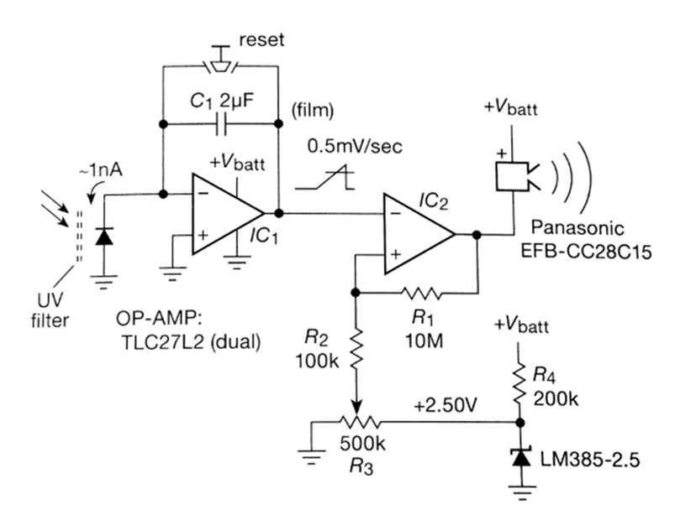

The Circuit above shows a purely analogue implementation of a simple ‘suntan timer’ where the light falling on a photodiode causes the sounder to operate after a time period that can be adjusted by the 500K potentiometer.
The circuit below is an alternative implementation based around an ATmega microcontroller.
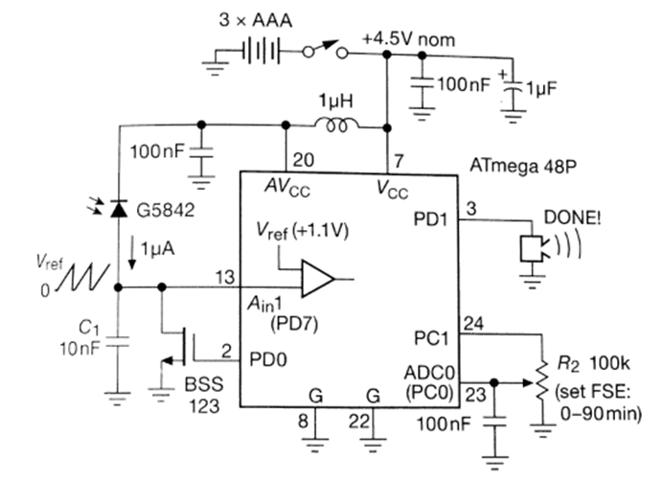
Explain the principle of operation of:
- the analogue version (15 marks)
- the microcontroller version, detailing the function and purpose of each component and every pin of the microcontroller. (35 marks)

QUESTION TWO

- Using the analogue circuit given in Question one, simulate IC2 and its surrounding circuitry (R1 – R4 and the LM385) using proteus to demonstrate its principle of operation.
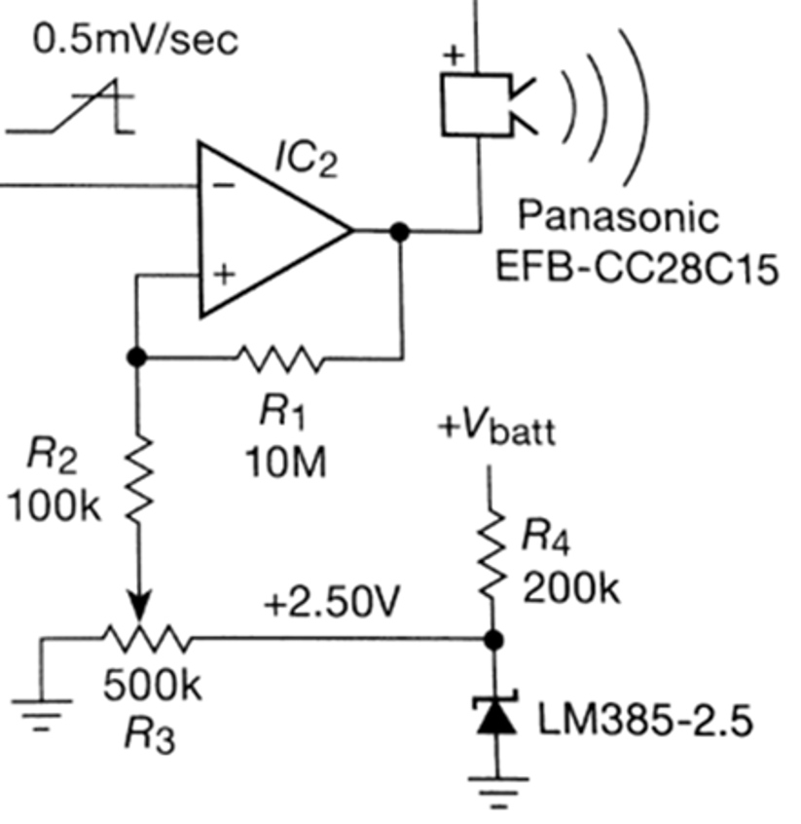
Instead of using IC1 to generate the input sawtooth ramp, directly inject a similar voltage source from a Proteus function generator which you will need to configure. Also swap the buzzer for an LED. Choose a ramp frequency of a couple of seconds so its easily visible on the LED.
When you have completed this task, call the supervisor over so they can see it in operation. ( 20 marks)
Save your simulation to disk. Name it ‘TaskA_<your name>’ and upload it to the appropriate link on Moodle (your supervisor will demonstrate where this is located)
- Now, you are required to replace the function generator with your own circuitry that generates an approximated sawtooth waveform from clocked, discrete digital logic using 74xx series ICs.
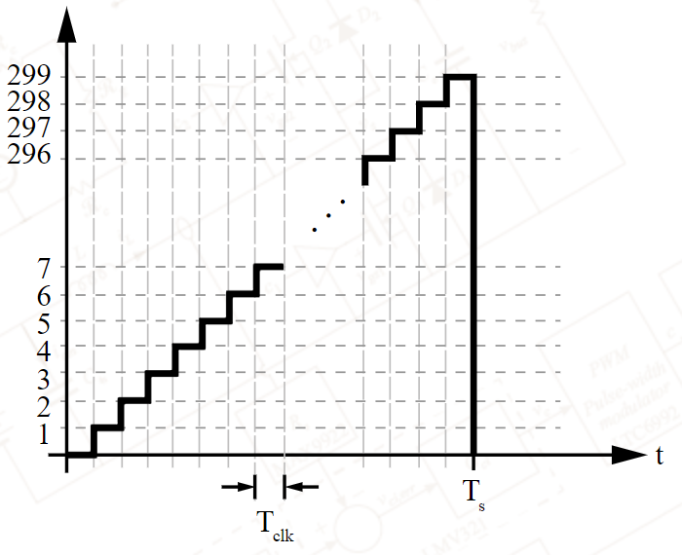
Use a minimum of 4 bits to give at least 16 analogue steps.
When you have completed this task, call the supervisor over so they can see it in operation. (20 marks)
Save your simulation to disk. Name it ‘TaskB_<your name>’ and upload it to the appropriate link on Moodle (your supervisor will demonstrate where this is located)
- Provide an explanation on how your digital sawtooth circuit operates. Answer this as a hard copy using the blank sheets/exam book provided. (10 marks)

